ЧЕРНІВЕЦЬКИЙ НАЦІОНАЛЬНИЙ УНІВЕРСИТЕТ
ІМЕНІ ЮРІЯ ФЕДЬКОВИЧА

ПРАКТИЧНИЙ КУРС ОСНОВНОЇ
ІНОЗЕМНОЇ МОВИ: АНАЛІТИЧНЕ
ЧИТАННЯ ТА УСНЕ МОВЛЕННЯ

Чернівці – 2024
УДК 37.016:811.111-028.31(076)
П 693

Друкується за ухвалою редакційної-видавничої ради Чернівецького національного університету імені Юрія Федьковича

Укладачі: Ліннікова В.О., асистент кафедри англійської мови ЧНУ імені Юрія Федьковича, Вітвіцька Н.М., асистент кафедри англійської мови ЧНУ імені Юрія Федьковича, Буртник Б.Я., асистент кафедри англійської мови ЧНУ імені Юрія Федьковича, Буртник С.Я., асистент кафедри англійської мови ЧНУ імені Юрія Федьковича

Відповідальний за випуск: Єсипенко Н.Г., доктор філологічних наук, професор

Практичний курс основної іноземної мови: аналітичне читання та усне мовлення

Навчальний посібник з аналітичного читання та усного мовлення містить комплекс завдань та вправ спрямованих на розвиток комунікативних навичок когерентного мовлення, використання сформованих діалогічних та монологічних компетенцій на систематизацію і розширення словникового запасу.
Запропонований посібник призначено для студентів першого курсу факультету іноземних мов, що вивчають англійську мову як першу іноземну.
УДК 37.016:811.111-028.31(076)
П 693

ANALYTICAL READING
CONTENTS
TERM I
Unit 1
My Personal Self ………………………………………………………………………
Unit 2
Appearance and Disposition………………………………………………………….
Unit 3
Family Life……………………………………………….……………………………

TERM II
Unit 1
Education………………………………………………….…………………………..
Unit 2
Artificial Intelligence…………………………………………………………………..

TERM 1
UNIT 1
MY PERSONAL SELF

SPEECH PATTERNS

I. Game ‘Find someone who…’. Mingle with your groupmates and try to find someone who matches each statement. Write their name in the space provided. You get 5 minutes to complete the task. The person who gets the most names is the winner. Look carefully through the categories. You may start only after the teacher sets the timer.
Find someone who...
... likes neither coffee nor tea. ____________
... can either play the guitar or the piano. ____________
... neither owns a car nor knows how to drive. ____________
... is learning English and is also studying another foreign language. ____________
... doesn't like spicy food and doesn't like very sweet food either. ____________
... can either speak Chinese or Japanese. ____________
... has neither been to the United States nor Europe. ____________
... loves both reading books and watching movies too. ____________
... is either left-handed or ambidextrous. ____________
... likes both classical and rock music too. ____________
…is either a morning person or a night owl. ________
… has neither broken an arm nor a leg. ____________
... has neither dyed their hair nor gotten a tattoo. ________
... is either an only child or the youngest in their family. _______

II. Look at the rules. Go to the previous activity and try to explain the usage of ‘also, too, either, neither’
Also
- Used to add information or include something extra in affirmative sentences.
- Usually placed in the middle of a sentence, after the subject or auxiliary verb.
I love macaroons. I also love pizza.
I am also studying economics.
The coroner also helped us.
The barrister should also be there.
Too
- Similar to "also," used for addition in affirmative sentences.
- Typically placed at the end of a sentence or clause.
- Can be used in the middle of a sentence for emphasis, often set off by commas.
I love macaroons. I love pizza too.
If he wants to go too, he should meet us at 8:00.
Mr. Jones wanted the contract. Ms. Jackson, too, thought it was necessary.
Donna is working on a solution to the problem. I, too, am trying to find a way to resolve the conflict
Either
- Used in negative contexts to add negative information or show similarity in negative situations.
- Can also be used to present choices (often paired with "or").
I don’t love macaroons. I don’t love pizza either.
Take either book. I don’t mind which.
He is lazy. He doesn’t study either. That’s why he doesn’t do well in school.
Either the father or the mother has to attend the meeting.
Neither
- Used to express that two or more things are not true or do not apply.
- Can be used as a pronoun, determiner, or in parallel structures with "nor."
- Often triggers subject-auxiliary inversion in responses.
Neither of the statements is true.
He isn’t ready to go. Neither are we.
We accepted neither offer.
Neither Brian nor his wife mentioned anything about moving house.

Ex. 3. Complete the sentences using also/too/either:

1. Henry is very athletic. He loves swimming, surfing, snowboarding and skiing. Jason _____ loves to swim and surf, but he hates all winter sports because he can’t stand cold weather.
2. I am taking a great art history class at the junior college downtown. Sarah is in the class _____. We both love it.
3. I don’t really like tomatoes. My brother doesn’t like them _____.
4. Frank didn’t like the layout of the apartment. He _____ thought the location was rather inconvenient, so he decided to keep looking for a place to live.
5. Mr. Harris doesn’t speak a word of French! He doesn’t have any international experience _____. So, I really feel he is not the right candidate for the job.
6. Three experts came to the conclusion that the project had to be terminated at once. I,_____, finally realized the project was too dangerous to proceed.
7. Sharon was exhausted from a hard day’s work and she wasn’t in a party mood _____, so we decided to stay in and have a quiet evening at home.
8. Dave has been living and working in Poland for over five years. He has _____ been taking night classes in Polish the entire time, so he speaks Polish very well.
9. Sam has a guidebook and a map of the region. He has a compass _____, so I think we should let him guide us out of here.
10. Sharon realized her boss had been embezzling money from the company and she wanted to go to the authorities. Doug, _____ ,thought it was time to call in the police.

Ex. 4. Choose the correct phrase to complete the sentences:

1. Can you ski? –Yes, and I can ..... skate.
a) also b) too c) either d) neither
2. Peter didn’t complete his work and his friend didn’t finish it ..... .
a) also b) too c) either d) neither
3. Sue sang and she ..... played the piano at the party.
a) also b) too c) either d) neither
4. Do you know where Kelly lives? – No, I don’t. Do you? – ..... do I.
a) also b) too c) either d) neither
5. Who are those two people? I don’t know ..... of them.
a) also b) too c) either d) neither
6. Does Ann live in the country in summer? Yes, her parents .....live in the country.
a) also b) too c) either d) neither
7. Which of the two ties do you prefer? As a matter of fact, I don’t like .....of them.
a) also b) too c) either d) neither
8. Are you thirsty? – Yes, and I am ..... tired.
a) also b) too c) either d) neither
9. If you are not going to take part in the performance, I won’t do it ..... .
a) also b) too c) either d) neither
10. Theresa has two bookshelves and she ..... has a large bookcase.
a) also b) too c) either d) neither
11. I like to fix things around the house, and Ted likes to do it ..... .
a) also b) too c) either d) neither
12. Squirrels have long tails, and cats do ..... .
a) also b) too c) either d) neither
13. Fish can’t walk, and snakes can’t ..... .
a) also b) too c) either d) neither
14. I don’t like spicy food, and my wife doesn’t like it ..... ..
a) also b) too c) either d) neither
15. Which of the two mansions do you prefer? – Actually, I don’t like ..... of them.
a) also b) too c) either d) neither

Ex. 5. Choose the right option:

- The estate manager stated it was / was not neither a wolf nor a dog.
- Neither Anne nor the maids considers / consider the plant a nuisance.
- Either the director or the actors is / are responsible for the film's success.
- Neither the paintings nor the sculpture was / were damaged in the fire.
- Either my sister or my brothers is / are going to pick me up from the airport.
- Either the red shoes or the black boots goes / go well with that dress.
- Either the book or the articles provides / provide the information you need.
- Neither the hotel nor the restaurants in the area offers / offer vegetarian options.
- Neither the principal nor the teachers approves / approve of the new policy.
- Either the flowers or the chocolates makes / make a great gift for Mother's Day.

Ex.6. Insert [either..or..] or [neither..nor..]
- I'm _______ sad/happy. I just don't care about anything at the moment.
- You can have _______ water/an orange juice. I can't offer you anything else I'm afraid.
- _______ my mother/my father approved of my decision.
- Could you _______ call me/drop in please? I need to talk to you.
- The restaurant serves _______ breakfast/lunch. It only opens for dinner.
- You must _______ pay now/reserve a spot. Walk-ins are not allowed.
- _______ the books/the paintings in the museum can be photographed.
- You should _______ wear a suit/dress formally for the interview.
- We can _______ go by train/take a bus to reach the city center.
- _______ the quality/the price of the product met our expectations.

Ex. 7. Story Continuation:Work as a group. Read the story starter below.
Continue the story by adding one sentence at a time. Each sentence you add must include at least one of the following structures: also, too, either, neither, either...or, neither...nor. Try to use a different structure for each sentence if possible. If you can’t make up a sentence, you’re out of the game.

Story Starter:
Sarah woke up on Saturday morning, excited about the day ahead. She had plans to either go hiking with her friends or visit the new art exhibition in town…

Example continuation:

She also thought about inviting her sister to join her.
Neither the weather forecast nor her mood could spoil her enthusiasm.
Sarah decided to call her friend Emma to see what she wanted to do too.

Ex. 8. Most of the sentences below have mistakes. Find and correct them.
- I like pizza too I like pasta.
- Neither he or she wants to go to the party.
- I don't like coffee. I don't like too tea.
- She can either sing nor dance.
- I also am learning French.
- Either you can come with us or stay at home.
- I don't like neither spinach or broccoli.
- Neither the dog nor the cat are allowed inside.
- He can neither speak English or Spanish.
- I also enjoy swimming. I enjoy hiking too also.
- She doesn't like coffee. Tea neither.
- You can take either the red one and the blue one.
- Either we go now either we miss the train.
- He's not tall. He's not short neither.
- They neither called nor didn't send a message.

Ex. 9. Translate from Ukrainian into English:

1. Я теж згоден. Містер суддя теж думає, що це важливо. 2. Другокурсниця теж неправильно вимовила це слово. 3. Містер Джонсон теж вважав це необхідним. 4. Ти можеш випити ананасовий чи персиковий сік. 5. Він теж ніколи не катався на ковзанах. 6. Джек багато користується комп’ютером; його асистент теж працює на комп’ютері, але не так багато як Джек. 7. Я був на зборах. Ви теж там були? 8. Він ні риба, ні м’ясо. 9. У вас морська свинка або черепашка? Ні те, ні інше. У мене вівчарка. 10. Ми з Тімом не їли багато; жоден з нас не був голодний. 11. Я можу говорити англійською, а також французькою. 12. Ти можеш або залишитися вдома, або піти з нами. 13. Ні Джон, ні Мері не прийшли на вечірку. 14. Ні собаки, ні кішки не дозволені в цьому готелі. 15. Вона теж не знає відповіді на це питання. 16. Ви можете взяти або червону, або синю сорочку. 17. Або ти приходиш зараз, або ми йдемо без тебе. 18. Ні лікар, ні медсестра не змогли пояснити симптоми.

Ex. 10. A) Fill in the blanks with the appropriate word or phrase: also, too, either, neither, either...or, neither...nor

Alex: Hey Jordan, I've been thinking a lot about self-identity lately. How do you usually describe yourself?
Jordan: That's an interesting question, Alex. I _______ (1) have been pondering that recently.
Alex: Really? Well, I consider myself _______ (2) an introvert _______ (3) an extrovert. I think I'm somewhere in between.
Jordan: I can relate to that. I'm _______ (4) a mix of both. I _______ (5) find that my identity isn't fixed; it can change depending on the situation.
Alex: That makes sense. When it comes to hobbies, I'm passionate about _______ (6) art _______ (7) science. How about you?
Jordan: I'm _______ (8) particularly artistic _______ (9) scientifically inclined. I prefer literature and philosophy.
Alex: When it comes to career aspirations, are you more interested in _______ (10) starting your own business _______ (11) climbing the corporate ladder?
Jordan: Actually, I'm _______ (12). I'm more drawn to non-profit work and social causes. What about you?
Alex: I'm still figuring it out, but I _______ (13) am interested in exploring different career paths before settling on one.
Jordan: That's a good approach. Do you think our career choices _______ (14) define us _______ (15) limit our potential in other areas?
Alex: I'd say _______ (16). Our careers are part of our identity, but they don't determine everything about us.
Alex: Interesting! Do you feel your online identity aligns more with _______ (17) your real-life personality _______ (18) an idealized version of yourself?
Jordan: It's a mix, I'd say. I _______ (19) can completely separate my online and offline selves.
Jordan: I agree. It's important to have a balanced life and diverse interests.
Alex: Definitely! I'm glad we can have these conversations openly now.
Jordan: Me _______ (20). It helps us understand ourselves and others better.
B) Discuss the questions in bold with a partner

Ex. 11. Dialogue. Work with a partner to write a conversation between two people discussing aspects of their identity, personal experiences, or interests.
Your dialogue should:
- Consist of 15-20 exchanges between the characters
- Include at least 10 instances of the target structures (also, too, either, neither, either...or, neither...nor)
- Sound natural and flow logically
- Have a logical conclusion

Ex.12. Complete the exercise online.



I. Warmer
a. Discuss these questions with a partner.
1. What social media platforms do you use the most?
2. How do you choose what to post on your profiles?
3. Do you think your online profile reflects your true self? Why or why not?
4. Have you ever tried to portray a different version of yourself online? How did it feel?

Ex. 1 Skimming the text. Read the title and first and last sentences of each paragraph. Look at words in bold. Do not read the whole text yet. What information do you expect to find out? Work in pairs. Write 3-4 questions you would like to get answers to while reading the text.

Personal Identification: Your Online Self

Social networking sites such as Facebook, Instagram, Twitter, and TikTok are now estimated to have more than 3 billion users worldwide. As users can create any profile of themselves they choose, you might expect them to portray themselves in the best possible light. When putting up a profile, it would be reasonable for them to present flattering images, praise themselves, choose sophisticated and discerning interests, and carefully express their thoughts so as to appear more intelligent than in real life. But according to recent research, this is not the case. Far from presenting themselves in a flattering way, most users’ profiles reflect their true personalities and reveal both psychological weaknesses and natural physical flaws.

Research was carried out on 250 Instagram users who filled in a personality questionnaire. Results were compared with the same people's Instagram profiles. The survey set out to assess not only the participants’ actual personality but their 'ideal' personality – in other words, what kind of person they would be if they actually possessed all their ideal characteristics. These results were then compared with the participants’ Instagram profiles. What emerged was astonishing: far from being idealized versions of themselves, people’s online profiles conformed closely to what they were really like. Their profiles accurately reflected how agreeable, extroverted, conscientious, neurotic, and sociable they were in real life.

It’s not entirely clear why online profiles depict users’ personalities so accurately. It could be that users want to portray themselves as they really are, or it could be that people attempt to present an ideal image of themselves but in fact fail to do so. One thing seems clear: social networking sites can in no way be considered a false online world that is idealized and removed from reality; rather, they are simply another way in which people choose to interact with each other.

This trend is further evident in newer platforms like TikTok, where users often share spontaneous and less-polished videos that highlight their everyday lives. The authenticity of these posts has become a significant factor in their popularity. Unlike the highly curated content often seen on Instagram or Facebook, TikTok's appeal lies in its raw and real nature.

Moreover, the advent of live streaming on platforms like Twitch and YouTube has added another layer to online self-representation. Live streaming leaves little room for editing and manipulation, providing viewers with an unfiltered look at the streamer's personality and lifestyle. This real-time interaction fosters a sense of genuine connection and trust between content creators and their audience.

The digital age has also brought about the concept of the "digital footprint." Every action taken online, from social media posts to search history, contributes to a person's digital identity. Employers, universities, and even potential friends or partners can form impressions based on one's online presence. Therefore, maintaining an authentic and positive digital footprint has become increasingly important.

In conclusion, while social networking sites offer the ability to create idealized versions of ourselves, most people tend to present a more genuine image. These platforms have become integral to our social lives, reflecting not just our best moments but our true personalities and everyday experiences. Far from being a separate, false reality, the online world is a continuation of our real-world interactions, shaped by the same complexities and nuances that define human behavior.

Ex. 3. Read the whole text. Is it a description, a comparison or an argument?
Ex. 3. Multiple choice task. There is one the correct answer for each paragraph.
1. Which of the following is the MOST accurate explanation for why most users' online profiles reflect their true personalities rather than idealized versions of themselves?
a) Users want to maintain authenticity and avoid being perceived as inauthentic.
b) Users are unable to successfully create an idealized version of themselves online.
c) Users are concerned about the impact of their online profiles on real-world interactions.
d) Users believe that authenticity is more important than creating an idealized image.

2. According to the passage, the appeal of platforms like TikTok lies in their:
a) highly curated and polished content.
b) ability to allow users to edit and manipulate their videos.
c) spontaneous and less-polished videos that highlight everyday life.
d) focus on presenting users' ideal personalities rather than their true personalities.

3. The advent of live streaming has contributed to online self-representation by:
- reducing the sense of genuine connection between content creators and their audience.
- giving users more control over how they present themselves to viewers.
- providing viewers with an unfiltered look at the streamer's personality and lifestyle.
- allowing users to maintain a more idealized version of themselves.

- The concept of the "digital footprint" suggests that:
- people's online actions have no impact on how they are perceived in the real world.
- employers, universities, and potential friends/partners do not consider one's online pr esence.
- maintaining an authentic and positive digital footprint is not important.
- a person's online presence can contribute to how they are perceived in the real world.

- The passage suggests that social networking sites are:
- a separate, false reality that is completely disconnected from people's real-world interactions.
- a platform that encourages users to present themselves in the most favorable light possible.
- simply another way for people to interact with each other, reflecting real-world complexities.
- a medium that allows users to create idealized versions of themselves that are removed from reality.

- The research on Instagram users' personality questionnaires and Facebook profiles revealed that:
- users' online profiles did not accurately reflect their true personalities.
- users' online profiles were more idealized versions of themselves.
- users' online profiles closely aligned with their actual personalities.
- users' online profiles were not related to their real-life personalities.

- The passage suggests that the authenticity of online content has become a significant factor in its popularity, as seen in the appeal of platforms like TikTok, because:
- users prefer highly curated and polished content.
- users are more interested in spontaneous and less-polished videos that highlight everyday life.
- users are less attracted to the real and raw nature of online content.
- users are more drawn to idealized and manipulated representations of themselves.

Ex. 5 Read the article again, then work with a partner and use the prompts below to discuss how social media reflects our true selves in your own words.

1. Authentic Profiles – Social media profiles often reflect our real personalities rather than an idealized version. Why do you think this is the case? How does this authenticity affect our online interactions?
2. Platform Differences – TikTok offers more spontaneous content compared to the curated nature of Instagram. What does this difference reveal about user preferences and authenticity?
3. Live Streaming – Live streaming provides an unfiltered view of a person’s life. How does this real-time interaction influence the sense of connection between content creators and their audience?
4. Digital Footprint – Every online action contributes to our digital identity. Why is maintaining a positive digital footprint important, and how can it impact others' perceptions of us?
5. Online vs. Real-Life Identity – How does our online persona compare to our real-life self? Can social media fully capture the complexity of our personalities, or does it fall short?
6. Changing Relationships – Social media has altered how we form and maintain relationships. Does it enhance our connections or create a sense of isolation?
7. Evolution of Social Media – Newer platforms emphasize authenticity and raw content. How does this evolution reflect changing societal values about self-representation?
8. Curation of Online Presence – To what extent do people curate their online profiles? How does this curation impact the perceived authenticity of their profiles?
9. Trends in Content – The popularity of unfiltered content suggests a desire for authenticity. What does this trend indicate about our societal values and expectations?
10. Future of Online Interaction – How might future developments in social media continue to shape our understanding of identity and self-presentation?
Ex. 6. Prepare a summary of the text, using the guidelines and phrases from Appendix 1.

ACTIVE VOCABULARY

Ex. 7 Scanning the Text. Find these words in the text, highlight them and translate them in accordance with the context.

- estimate
- portray
- flattering
- sophisticated
- reveal
- emerge
- conscientious
- conform to
- accurately
- evident
- appeal
- advent
- foster
- digital footprint
- genuine
- define

Ex. 8. Match the words with their definitions.

1. reveal  2. foster  3. portray  4. appeal  5. conform to  6. genuine  7. advent  8. accurately  9. emerge  10. conscientious  11. digital footprint  12. sophisticated  13. evident  14. define  15. estimate  16. flattering | a. the trail of data you leave behind when using the internet, including websites visited and information shared.  b. in a way that is correct and free from mistakes or errors.  c. to show or describe someone or something in a particular way through art, writing, or performance.  d. to explain the meaning of a word or concept clearly and precisely.  e. real and authentic, not fake or insincere.  f. to encourage the development or growth of something, such as skills or relationships.  g. to attract interest or desire in someone for something.  h. to come out from a hidden place or to become visible after being concealed.  i. the arrival of an important event, person, or thing that marks a change.  j. having a lot of knowledge and experience, making someone or something complex and refined.  k. giving praise or compliments that make someone feel good about themselves, often excessively.  l. to make something known that was previously hidden or not seen.  m. clear and easy to see or understand; obvious.  n. showing great care and attention to detail in doing tasks or responsibilities.  o. to make a guess about the amount, size, or value of something based on available information.  p. to follow rules, standards, or expectations set by others.

Ex. 9. Rephrase each sentence using Active Vocabulary

1. We need to guess the total cost of the project.
2. The artist managed to show the character's emotions beautifully.
3. The photo made her look more attractive than in real life.
4. Her taste in fashion is very refined.
5. The study aims to show the hidden factors.
6. A new leader is starting to appear in the organization.
7. She is very diligent in her work.
8. The new law requires everyone to follow the guidelines.
9. The report must describe the events correctly.
10. The impact of the policy was clear to everyone.
11. The new product has a strong attraction to young people.
12. The arrival of the internet changed everything.
13. Teachers should encourage a love of reading.
14. Be mindful of your online activities; they form your digital history.
15. His emotions seemed very real.
16. It's important to clearly explain the terms in this contract.

Ex. 10. For each root word below, create as many related words as you can. Consider different parts of speech (nouns, verbs, adjectives, adverbs) and any prefixes or suffixes that could be added. An example is provided for you.

Root word | Related words
estimate | estimation, estimated, estimating, estimator, underestimate, overestimate, inestimable
flatter
reveal
emerge
conform
accurate
appeal
evident

Ex. 11. Complete each sentence by forming an appropriate word from the one given in brackets. Use prefixes, suffixes, or change the word form as needed.
- The artist's ________________ (PORTRAY) of the historical event was both dramatic and moving.
- His constant attempts at ________________ (FLATTER) made his colleagues uncomfortable.
- The scientist's latest discovery ________________ (REVEAL) new possibilities in cancer treatment.
- As the truth ________________ (EMERGE), the public became increasingly concerned about the scandal.
- The company's strict policies require employees to ________________ (CONFORM) to a specific dress code.
- The report ________________ (ACCURATE) described the events leading up to the incident.
- Despite its flaws, the proposal had a strong ________________ (APPEAL) to the committee.
- The organization aims to ________________ (FOSTER) a culture of innovation and creativity.
- People appreciate her for her ________________ (GENUINE) and honesty in all situations.
- It became ________________ (EVIDENT) that the project would not be completed on time.
- The lawyer's ________________ (ESTIMATE) of the case's duration proved to be far too optimistic.
- Her ________________ (SOPHISTICATED) analysis impressed everyone at the conference.
- The ________________ (CONSCIENCE) employee always double-checked her work before submission.
- With the ________________ (ADVENT) of social media, privacy concerns have increased significantly.
- Maintaining a positive ________________ (DIGITAL) presence has become crucial in today's job market.

PHRASAL VERBS
Phrasal verb | Meaning | Example | Translation
carry off | complete successfully | Jane had a difficult role to play, but she carried it off.
carry out | 1. complete a plan  2. fulfill or perform something | 1. The attack was successfully carried out.  2. The wagon was very heavy but Private Wilson carried out his orders without complaining.
put aside | 1. save (especially money/time  2. reserve something for later collection  3. ignore or forget something | 1. We have to put some money aside for our holiday  2. Don't worry, we will put it aside for you until you come back tomorrow.  3. They decided to put aside their differences.
put away | store, tidy | Please put your toys away now children.
put off | postpone, decide to do something later | They put off the meeting until next Friday.
put out | extinguish, stop something from burning | The firemen managed to put out the fire very quickly.
put through | 1. connect somebody by telephone  2. make someone experience something difficult | 1. Could you put me through to the manager please?  2. The applicants were put through an exhausting set of tests.
put up | provide food and accommodation | Don't worry, we can put you up for the night.
put up with | bear, tolerate | I can't put up with the noise any more.

Ex. 11
Choose the correct phrasal verb to complete each sentence.
- Despite the difficult circumstances, she managed to ________ the performance brilliantly.
  - put off
  - carry off
  - put out
  - put up with
- The committee decided to ________ the meeting until next week due to unforeseen circumstances.
  - put away
  - put aside
  - put off
  - carry out
- It's important to ________ some money each month for emergencies.
  - put aside
  - put away
  - put up
  - put through
- The soldiers were ordered to ________ the mission as planned.
  - put off
  - put out
  - carry off
  - carry out
- Could you please ________ your toys before dinner?
  - put away
  - put aside
  - put up
  - put out
- The firefighters worked tirelessly to ________ the forest fire.
  - put off
  - put out
  - put up with
  - carry off
- I'm sorry, but I can no longer ________ his constant complaining.
  - put through
  - put up
  - put up with
  - put aside
- We'd be happy to ________ you for a few days while you're in town.
  - put up
  - put through
  - put away
  - carry out
- Can you ________ me to the manager's office, please?
  - put through
  - put up
  - put off
  - carry off
- They decided to ________ their differences and work together on the project.
  - put out
  - put away
  - put aside
  - put up with

Ex. 12. Rewrite each sentence using different words but keeping the same meaning. Use the phrasal verbs in your new sentence.

- The actress successfully completed her challenging role.
- The military executed the operation according to plan.
- We need to save some money for our vacation next year.
- The store will reserve the item for you until tomorrow.
- They decided to forget their past disagreements for the project's sake.
- Please tidy up your room before the guests arrive.
- The company postponed the launch event due to technical issues.
- The firefighters quickly extinguished the flames in the building.
- The job applicants endured a series of difficult tests.
- We can provide accommodation for you during your stay.
- I can no longer tolerate the constant noise from our neighbors.
- Despite the challenges, the team successfully completed the project.
- The researchers conducted the experiment as planned.
- She managed to ignore the distractions and focus on her work.

Ex. 13 Complete the conversations by filling in the blanks with the appropriate phrasal verbs from the list below. Use each phrasal verb only once.

carry off, carry out, put aside, put away, put off, put out, put through, put up, put up with

1. A: The party is tomorrow! Are you ready?
B: Not quite. I still need to __________ some decorations.

2. A: Can you believe how well Sarah handled that presentation?
B: I know! She really __________ it perfectly, despite being so nervous.

3. A: I've been trying to reach the manager all day.
B: Let me try. I'll ask the receptionist to __________ you to his office.

4. A: We need to start saving for our wedding.
B: You're right. We should __________ at least 10% of our income each month.

5. A: The forest fire is spreading quickly!
B: Don't worry, the firefighters are working hard to __________ it before it reaches the town.

6. A: When are you planning to visit your parents?
B: I've had to __________ the trip until next month due to work commitments.

7. A: How do you manage living with such noisy roommates?
B: It's not easy, but I've learned to __________ it. I use earplugs at night.

8. A: Our guests are arriving tonight. Is the spare room ready?
B: Yes, we can __________ them comfortably for the weekend.

9. A: The new project seems quite challenging.
B: True, but I'm confident our team can __________ it successfully.

Ex. 14 Fill in the blanks with the appropriate phrasal verb or vocabulary word from the list below. Use each word or phrase only once.

carry off, carry out, put aside, put away, put off, put out, put through, put up with
estimate, portray, flattering, sophisticated, reveal, emerge, conscientious, conform to, accurately, evident, appeal, advent, foster, digital footprint, genuine

- The journalist tried to __________ the situation __________ in her report.
- Despite the challenges, the team managed to __________ the project successfully.
- It became __________ that we needed to __________ our differences and work together.
- The company aims to __________ a culture of innovation among its employees.
- He decided to __________ some money each month for his retirement.
- The actor's __________ performance didn't __________ to the critics.
- With the __________ of social media, managing one's __________ has become crucial.
- The __________ employee always makes sure to __________ all the files before leaving the office.
- The firefighters worked tirelessly to __________ the fire before it spread further.
- She couldn't __________ her colleague's constant complaining anymore.
- The scientist's research will __________ new insights into climate change.
- The receptionist __________ the call __________ to the manager's office.
- The artist's intention was to __________ the subject in a __________ light.
- The company had to __________ the launch event due to unforeseen circumstances.
- The data analyst worked to __________ __________ the trends in consumer behavior.

Ex. 15 Write a short story (about 200-250 words) using at least 8 of the phrasal verbs from the list below. Try to incorporate the words from Active Vocabulary as well.

Ex. 16. Translate the following Ukrainian sentences into English, using the phrasal verbs and vocabulary words provided where appropriate.

- Ця витончена та приємна леді має великий вплив на лорда, і її думка часто визначає його рішення.
- Я впевнена, що ти можеш створити чітке відображення ситуації, якщо приділиш цьому достатньо уваги.
- Згідно дослідження, вони очікували більшого прибутку, але їх оцінка виявилася неточною.
- Добросовісний лікар запропонував прийнятну ціну за лікування, враховуючи складність процедури.
- На жаль, він часто зазнає невдачі у спробах відповідати очікуванням свого керівника.
- Його спроби розкрити таємницю були успішними, і правда нарешті вийшла на поверхню.
- Не слід мені лестити, я знаю, що моя робота містить багато вад, і я маю над чим працювати.
- Коло моїх знайомих любить жартувати та розважатись, але вони також дуже розумні та освічені люди.
- Їй важко розрізняти кольори, тому вона завжди просить допомоги при виборі одягу.
- Досвід – найкращий вчитель, особливо коли йдеться про складні життєві ситуації.
- З появою соціальних мереж, важливість управління цифровим слідом стала очевидною для багатьох.
- Компанія прагне сприяти інноваціям та заохочувати креативне мислення серед своїх співробітників.
- Його щирий ентузіазм та відданість роботі не залишилися непоміченими керівництвом.
- Журналіст намагався точно відобразити події, не піддаючись впливу особистих упереджень.
- Незважаючи на складнощі, команда змогла успішно завершити проект в строк.
- Вона вирішила відкласти трохи грошей на випадок непередбачених витрат у майбутньому.
- Після тривалих дебатів, нарешті з'явилося рішення, яке задовольнило всі сторони.
- Його витончений підхід до вирішення проблем справив велике враження на клієнтів.
- Пожежники швидко загасили пожежу, запобігши подальшому поширенню вогню.
- Вона більше не могла миритися з постійними затримками і вирішила висловити свою думку.

ESSENTIAL VOCABULARY
- acquaintance - /əˈkweɪn.təns/ - знайомство, знайомий
  - Common Collocations: make an acquaintance, old acquaintance, casual acquaintance, mutual acquaintance, nodding acquaintance
  - Example: Honest criticism is hard to take from a relative, a friend, an acquaintance, or a stranger.
  - Phrase Usage:
    - to acquaint with an affair - вводити в курс справи
      - Example: Please acquaint your colleagues with the affair.
    - to get acquainted with/to acquaint with - познайомитись/ознайомитись
      - Example: You need to acquaint the police with the facts.
- disposition - /ˌdɪs.pəˈzɪʃ.ən/ - нахил, характер
  - Common Collocations: cheerful disposition, natural disposition, sunny disposition, innate disposition, melancholic disposition
  - Example: She has a cheerful disposition that makes her well-liked by everyone.
  - Phrase Usage:
    - genetic disposition - генетична схильність
      - Example: There is a genetic disposition to certain diseases.
    - to have a disposition towards - мати схильність до
      - Example: He has a natural disposition towards kindness.
- experience - /ɪkˈspɪə.ri.əns/ - досвід
  - Common Collocations: hands-on experience, vast experience, enriching experience, previous experience, practical experience, direct experience, collective experience
  - Example: She has years of experience in the computer industry.
  - Phrase Usage:
    - to get/gain experience - отримати/здобути досвід
      - Example: You need to get more management experience.
    - to share your experiences of something - поділитись досвідом чогось
      - Example: It’s a great opportunity for people to share their experiences of living with the disease.
    - from past/previous/personal experience - з минулого/попереднього/власного досвіду
      - Example: Helen knew from past experience that there was no point in arguing with him.
    - to experience/meet/suffer (a) disaster - потрапити в біду
      - Example: My uncle experienced disaster when he was 4.
- perception - /pəˈsep.ʃən/ - сприйняття
  - Common Collocations: public perception, perception of reality, altered perception, keen perception, sensory perception
  - Example: The media shapes the public perception of events.
  - Phrase Usage:
    - perception of beauty - сприйняття краси
      - Example: Perception of beauty varies across different cultures.
    - altered perception - змінене сприйняття
      - Example: His illness caused an altered perception of reality.
- praise - /preɪz/ - похвала, хвалити
  - Common Collocations: lavish praise, high praise, worthy of praise, in praise of, sing praises
  - Example: Mayor Dixon praised our efforts.
  - Phrase Usage:
    - to praise someone for (doing) something - хвалити когось за щось
      - Example: He praised the staff for encouraging the artistic talents of the prisoners.
    - shower with praise - засипати похвалами
      - Example: The teacher showered the student with praise for her excellent project.
- prospect - /ˈprɒs.pekt/ - вид, панорама, перспектива
  - Common Collocations: job prospects, bleak prospect, future prospects, bright prospects, career prospects, economic prospects
  - Example: I had no job, no education, and no prospects.
  - Phrase Usage:
    - prospect of success - надія, шанси на успіх
      - Example: Her prospect of success astonished me.
    - bleak prospect - похмура перспектива
      - Example: He’ll fail; he has only a bleak prospect.
    - prospect for growth - перспектива зростання
      - Example: The company has significant prospects for growth in the coming years.
- assume - /əˈsjuːm/ - припускати, брати на себе
  - Common Collocations: assume responsibility, assume control, assume a role, assume a posture, assume a stance
  - Example: I assume you're right.
  - Phrase Usage:
    - to assume a role/position - взяти на себе роль/позицію
      - Example: He assumed the role of leader in the project.
    - to assume a posture - прийняти позу
      - Example: She assumed a defensive posture.
- identity - /aɪˈden.tɪ.ti/ - особистість, ідентичність
  - Common Collocations: cultural identity, national identity, personal identity, identity crisis, sense of identity
  - Example: Her cultural identity is very important to her.
  - Phrase Usage:
    - to forge an identity - створювати ідентичність
      - Example: She worked hard to forge a new identity for herself.
    - to reveal one's identity - розкрити свою особистість
      - Example: The witness refused to reveal his identity.
- self-concept - /ˈselfˌkɒn.sept/ - самосприйняття, концепція себе
  - Common Collocations: positive self-concept, self-concept clarity, healthy self-concept, distorted self-concept, self-concept development
  - Example: A positive self-concept is crucial for mental health.
  - Phrase Usage:
    - to develop a self-concept - розвивати концепцію себе
      - Example: Adolescents are in a critical stage of developing their self-concept.
    - distorted self-concept - спотворене самосприйняття
      - Example: Body dysmorphic disorder can result in a distorted self-concept.
- society - /səˈsaɪ.ə.ti/ - суспільство
- Common Collocations: multicultural society, modern society, society at large, societal norms, societal roles
- Example: Never forget that we live in a multicultural society.
- Phrase Usage:
  - societal norms - суспільні норми
    - Example: Societal norms influence our behavior and attitudes.
  - societal roles - суспільні ролі
    - Example: Societal roles can shape an individual's identity and actions.
- value - /ˈvæl.juː/ - цінність, вартість, значення
- Common Collocations: intrinsic value, market value, value system, cultural values, value proposition
- Example: You can’t put a value on a human life.
- Phrase Usage:
  - rise/fall(drop) in value - зростати/падати в ціні
    - Example: The dollar dropped in value on the foreign exchange markets last week.
  - of great/little value - цінний/малоцінний
    - Example: The ring was actually of very little value.
  - hold its/their value - зберігати свою цінність
    - Example: Handwoven rugs hold their value extremely well.
  - values - цінності
    - Example: Christian/Western/Islamic values.

Ex. 1. Read the passage and then choose the correct meaning for each of the words in bold. For each word state the part of speech and if it’s positive, negative or neutral.
- Acquaintance
  - A. A close friend
  - B. Someone you know slightly
  - C. A family member
  - D. An enemy
- Disposition
  - A. A person's usual mood or temperament
  - B. A physical posture
  - C. A temporary feeling
  - D. A health condition
- Experience
  - A. The knowledge or skill acquired by doing something
  - B. A theoretical understanding
  - C. A guess or assumption
  - D. An academic qualification
- Perception
  - A. The way in which something is regarded or understood
  - B. A physical object
  - C. A factual statement
  - D. A direct order
- Praise
  - A. To express approval or admiration
  - B. To criticize harshly
  - C. To ignore
  - D. To question
- Prospect
  - A. The possibility or likelihood of some future event occurring
  - B. A certainty
  - C. A past event
  - D. A disappointment
- Assume
  - A. To take for granted or without proof
  - B. To doubt something
  - C. To ignore something
  - D. To know something for certain
- Identity
  - A. The qualities, beliefs, etc., that make a person or group different from others
  - B. A temporary state
  - C. A physical object
  - D. An academic subject
- Self-concept
  - A. An idea of the self constructed from the beliefs one holds about oneself
  - B. An external perception
  - C. A factual statement
  - D. A physical object
- Society
  - A. The aggregate of people living together in a more or less ordered community
  - B. An individual
  - C. A temporary gathering
  - D. A physical structure
- Value
  - A. The importance, worth, or usefulness of something
  - B. The insignificance of something
  - C. The monetary cost of something
  - D. A random quantity

Ex. 2 Create a similar task to ex. … to practise the words.
reduce, labour, decline, sex, social class, demography, empowered, valued, prospect.
Ex. 3 Translate into English.

      - вводити в курс справи
      - спільний знайомий
      - життєрадісний характер
      - мати схильність до точних наук
      - здобути практичний досвід у водінні
      - спотворене сприняття дійсності
      - загострене сприняття
      - хвалити за досягнення
      - співати похвали
      - похмура перспектива
      - перспектива зростання
      - взяти на себе відповідальність
      - припускати найгірше
      - криза індентичності
      - випадково викрити особистість
      - позитивне самосприйняття
      - спотворене самосприйняття
      - суспільні ролі
      - міжкультурне суспільство
      - зростати в ціні

Ex. 4 Translate into Ukrainian.

- casual acquaintance
- get acquainted at the conference
- sunny disposition
- have a disposition towards violence
- vast experience
- share the experience of working with AI
- experience a disaster
- public perception
- perception of reality
- lavish praise
- worthy of praise
- praise for passing the exam
- economic prospects
- assume control
- assume a posture
- personal identity
- reveal his identity
- develop a healthy self-concept
- distorted societal norms
- drop in market value

Ex.5 Explain in English what is meant by. Use these phrases in the sentences of your own.
nodding acquaintance, acquaint with an affair, genetic disposition, hands-on experience, altered perception, shower with praise, prospect of success, assume a posture, forge an identity, self-concept, society at large, intrinsic value

Ex. 6. Find synonyms and antonyms to the underlined words:

Choose the synonym:

1. He quickly got acquainted with the project details.
a. learned about b. started c. recognized

2. Her cheerful disposition makes her popular at work.
a. behavior b. attitude c. quality

3. The new employee has a lot of relevant experience in the field.
a. past b. imagination c. background

4. The scientist's perception of climate change was widely accepted.
a. view on b. ignorance c. question

5. The manager's constant praise encouraged the team to work harder.
a. approval b. critique c. insult

6. The job offer had promising career advancement opportunities.
a. skills b. prospectives c. requirements

7. His hands-on experience in the field gave him a practical edge.
a. practical knowledge b. theoretical knowledge c. limited knowledge

8. Her personal beliefs and values guide her decisions.
a. principles b. theories c. uncertainties

9. The CEO decided to assume control of the new project.
a. take charge b. ignore c. delegate

10. His self-concept improved after receiving positive feedback.
a. self-image b. self-doubt c. self-pity

Choose the antonym:
11. He made a nodding acquaintance with many people at the conference.
a. deep b. slight c. full

12. Her genetic disposition towards athletics was evident in her performance.
a. acquired b. inherent c. developed

13. She assumed the new role with great enthusiasm.
a. relinquished b. accepted c. embraced

14. Their perception of the situation was quite different from ours.
a. misunderstanding b. awareness c. insight

15. The company's poor performance led to bleak prospects for its future.
a. bright b. dim c. uncertain

16. His identity crisis was evident in his changing behavior.
a. stability b. confusion c. consistency

17. The teacher showered the students with praise for their hard work.
a. ignored b. appreciated c. criticized

18. The community values education and personal growth.
a. disregards b. cherishes c. neglects

19. He tried to get acquainted with the new team members.
a. distance himself b. meet c. leave

20. The societal norms are changing with time.
a. rules b. deviations c. patterns

Ex. 7 Fill in the blanks, using essential vocabulary units.

1. Many artists have a disposition  2. Companies are always looking for a prospect  3. A positive self-concept can lead  4. My trip to the museum led to an altered perception  5. After the layoffs, many workers faced bleak  6. Everyone struggles with identity during  7. There are many prospect  8. Her perception of the situation  9. She will acquaint herself with an affair  10. Vintage items tend to hold  11. Some people believe that their genetic disposition  12. The teacher showered the students  13. We should never assume  14. Society plays a big role in shaping  15. I met an old acquaintance  16. This internship will provide you with hands-on experience  17. Traveling abroad gives me the experience  18. His cheerful disposition makes  19. It is important for you to get  20. Understanding core values can | a. someone's feelings without asking them directly about it.  b. their teenage years as they figure out who they are.  c. at the coffee shop yesterday and we talked for hours.  d. changed after she heard my explanation about it.  e. acquainted with people in your new school to make friends.  f. I need to understand different cultures better.  g. to higher self-esteem and greater achievements in life.  h. him very popular among all of his groupmates.  i. prospects for finding new jobs quickly.  j. help young people make better decisions in their lives.  k. can influence their health and behavior.  l. for job opportunities in technology for recent graduates.  m. in the field of marketing.  n. for growth to expand their businesses worldwide.  o. their value over time if they are well-maintained and rare.  p. with praise for their amazing performance in the play.  q. that has been troubling the community lately.  r. of modern art that I previously disliked.  s. our beliefs and attitudes about right and wrong.  t. towards creating innovative and unique works of art.

Ex. 8. Fill in the blanks with prepositions and adverbs.
- The new employee made an acquaintance ___ several team members during the meeting.
- It is important to acquaint yourself ___ the details ___ the project before starting.
- She needed to get acquainted ___ the local customs before traveling abroad.
- His cheerful disposition made him popular ___ everyone at the office.
- They discussed the genetic disposition ___ certain health conditions in the seminar.
- John has a natural disposition ___ helping others, which is evident in his volunteer work.
- Gaining hands-on experience ___ the new software is crucial for mastering its functions.
- Her perception ___ the problem was different from the rest of the team.
- The manager showered the team ___ praise for their exceptional performance on the project.
- The prospect ___ a promotion motivated him to work harder.
- To assume responsibility ___ the project, you need to understand all its requirements.
- Developing a positive self-concept ___ early age is essential for personal growth.
- The identity ___ the company was enhanced by its new branding strategy.
- Social ___ plays a significant role in shaping an individual’s opportunities and challenges.
- She placed a high value ___ maintaining a work-life balance.
- There is a significant difference ___ the values held by different generations.
- The changing demographics ___ the region require adjustments in housing policies.
- The teacher’s hands-on experience ___ classroom management made him a valuable mentor.
- The novel provided an altered perception ___ human relationships and society.
- The organization needs to forge an identity ___ its own to stand out in the market.

Ex. 9 Translate into English, using essential vocabulary units.
- Наше знайомство відбулося випадково на вечірці у спільного знайомого.
- Керівник вирішив ввести в курс справи нового співробітника щодо поточних проектів.
- Лікарі виявили у пацієнта генетичну схильність до серцево-судинних захворювань.
- Він завжди мав схильність до вивчення іноземних мов, тому легко опанував п'ять різних мов.
- Щоб здобути досвід у програмуванні, вона вирішила пройти стажування в IT-компанії.
- Старший викладач радо поділився досвідом з молодими колегами.
- Наше сприйняття світу значною мірою залежить від культурного контексту, в якому ми виросли.
- Вживання психоактивних речовин може призвести до зміненого сприйняття реальності.
- Батьки не забували хвалити дитину за досягнення у навчанні, щоб підтримувати її мотивацію.
- Після вдалого виступу актора засипали похвалами як критики, так і глядачі.
- Експерти оцінили шанси на успіх нового стартапу як досить високі.
- Економічна криза створила похмуру перспективу для багатьох малих підприємств.
- Ми можемо лише припускати, як розвиватимуться події в майбутньому.
- У складній ситуації він вирішив взяти на себе роль лідера і координувати дії команди.
- Фотограф попросив модель прийняти позу, яка б найкраще підкреслювала її риси.
- Журналістське розслідування допомогло розкрити особистість корумпованого чиновника, якого довго не могли спіймати правоохоронні органи.
- Спотворене самосприйняття часто є причиною психологічних проблем у підлітків.
- Суспільні норми відрізняються в різних культурах і можуть змінюватися з часом.
- Традиційні суспільні ролі чоловіків і жінок зазнають значних змін у сучасному світі.
- В сучасному суспільстві освіта та професійні навички продовжують зростати в ціні, відображаючи зміну економічних цінностей та пріоритетів на ринку праці.

Ex. 10 Prepare a short speech (1-2 minutes) discussing one of the quotations below. Use at least 10 units of Essential Vocabulary.
1. ‘Honest criticism is hard to take, particularly from a relative, a friend, an acquaintance, or a stranger.’ (Franklin P. Jones). How does the source of criticism affect how we perceive and accept it?
2. "The only source of knowledge is experience." (Albert Einstein) - Can you think of a time when you learned something significant from an experience rather than from a book or a lecture?
3. "Your past is not your potential. In any hour you can choose to liberate the future." (Marilyn Ferguson) How can focusing on future prospects help us move beyond our past experiences?
4. "To be yourself in a world that is constantly trying to make you something else is the greatest accomplishment." (Ralph Waldo Emerson) What challenges do people face in maintaining their identity in today's society?
5. "Experience is not what happens to you; it’s what you do with what happens to you." (Aldous Huxley) How can we turn our experiences, both good and bad, into valuable lessons?
6. "Assumptions are dangerous things to make, and like all dangerous things to make — bombs, for instance, or strawberry shortcake — if you make even the tiniest mistake, you can find yourself in terrible trouble." — Lemony Snicket. Why is it important to question our assumptions about others and the world?

UNIT 2

SPEECH PATTERNS

I. Opinion poll. Your teacher will read out a series of statements. For each statement, you need to decide whether you agree or disagree. If you agree with the statement, move to the right side of the room. If you disagree, move to the left side.
After everyone has moved, discuss your reasons with the people around you. You will be asked to provide a short feedback after each discussion. You need to stand up for this activity.

Suggested statements

"Social media is too addictive."
"Online learning is effective enough."
"It's such a nice day that we should go outside."
"People should save money in order to buy a house."
"Public transportation is unreliable because of frequent delays."
"As it is getting hotter, we should use more air conditioning."
"Working from home is productive since there are fewer distractions."
"Exercise is too important to skip, even on busy days."

II. Look at the example sentences. Work in pairs and try to explain the usage of ‘too/enough, so/such, in order to/so that, because/due to/as/since’
The movie was too long and too boring to keep my attention.
The presentation was too complicated and too technical for the audience to understand.
She wasn’t confident enough to speak in public, but her ideas were brilliant enough to be noticed.
The room wasn’t big enough for the party, but it was cozy enough to make everyone feel comfortable.
The lecture was so fascinating that I didn't want it to end.
The weather was so cold that we decided to stay indoors.
It was such a fascinating lecture that I didn't want it to end.
It was such cold weather that we decided to stay indoors.
She studied every night in order to pass the exam.
They moved to the city so that they could find better job opportunities.
She studied every night and as a result, she passed the exam with flying colors.
He saved money and therefore, he was able to buy a new car.
The game was canceled because of the rain.
She was late due to the traffic.
As the weather was bad, they left early.
Since there was heavy traffic, she was late.

Ex. 1. Fill in the blanks with appropriate words or phrases, using either "too" or "enough" + infinitive
- The soup was ______ hot ______ eat immediately.
- The ladder wasn't ______ tall ______ reach the top shelf.
- She spoke ______ quietly for the audience ______ hear her.
- The apartment was spacious ______ ______ accommodate all their furniture.
- The coffee was ______ strong ______ drink without milk.
- He wasn't experienced ______ ______ handle the complex project.
- The music at the party was ______ loud ______ have a conversation.
- The solution wasn't concentrated ______ ______ be effective.
- The deadline was ______ soon ______ complete the task properly.
- The internet connection wasn't fast ______ ______ stream the movie smoothly.
- The shoes were ______ small ______ fit comfortably.
- The battery life wasn't long ______ ______ last through the entire trip.
- The water was ______ cold ______ swim in without a wetsuit.
- He wasn't old ______ ______ get a driver's license yet.
- The room was ______ dark ______ read without additional lighting.

Ex. 2. Fill in the sentences using either "so" or "such":

- The movie was ______ entertaining that we watched it twice.
- It was ______ a difficult exam that many students failed.
- The music was ______ loud that I couldn't hear myself think.
- She had ______ an interesting story to tell that everyone listened attentively.
- The restaurant was ______ crowded that we couldn't find a table.
- It was ______ a beautiful day that we decided to go for a picnic.
- The children were ______ tired after the field trip that they fell asleep immediately.
- He spoke with ______ enthusiasm that his passion was contagious.
- The instructions were ______ complicated that I had to read them several times.
- It was ______ an amazing performance that the audience gave a standing ovation.
- The weather was ______ hot that we decided to stay indoors.
- She had ______ little time that she couldn't finish her homework.
- The view from the mountain was ______ breathtaking that we stood in awe for several minutes.
- He made ______ many mistakes that he had to redo the entire project.
- The meal was ______ delicious that we asked for the recipe.

Ex. 3. Choose the correct phrase (A, B, C, or D) to complete each sentence:

- The concert was ______ that the audience demanded multiple encores.
A) too amazing B) amazing enough C) so amazing D) such an amazing
- The instructions weren't ______ for beginners to understand.
A) too clear B) clear enough C) so clear D) such clear
- It was ______ day that everyone wanted to be outside.
A) too beautiful a B) beautiful enough a C) so beautiful a D) such a beautiful
- The museum had ______ exhibits that we couldn't see them all in one day.
A) too many B) many enough C) so many D) such many
- The coffee was ______ to drink without adding milk.
A) too strong B) strong enough C) so strong D) such strong
- The party was ______ that people were still talking about it weeks later.
A) too fun B) fun enough C) so fun D) such fun
- The book wasn't ______ to keep my interest, so I didn't finish it.
A) too engaging B) engaging enough C) so engaging D) such engaging
- The storm was ______ that all flights were canceled.
A) too severe B) severe enough C) so severe D) such a severe
- The solution was ______ to solve our problem completely.
A) too effective B) effective enough C) so effective D) such effective
- It was ______ opportunity that he couldn't pass it up.
A) too good an B) good enough an C) so good an D) such a good
- The room wasn't ______ for the large group to meet comfortably.
A) too spacious B) spacious enough C) so spacious D) such spacious
- The movie had ______ special effects that it won several awards.
A) too impressive B) impressive enough C) so impressive D) such impressive
- The exam was ______ that many students couldn't finish on time.
A) too difficult B) difficult enough C) so difficult D) such a difficult
- She spoke ______ for everyone in the back to hear clearly.
A) too loudly B) loudly enough C) so loudly D) such loudly
- It was ______ experience that I'll never forget it.
A) too memorable a B) memorable enough a C) so memorable a D) such a memorable

Ex. 4. Match the sentence beginnings in Column A with their appropriate endings in Column B. Create your own sentences using the same patterns.
Column A (Beginnings):  The movie was too long...  She wasn't experienced enough...  The concert was so amazing...  It was such a difficult exam...  They moved to the city in order to...  He studied hard, therefore...  The game was canceled because of...  As the traffic was heavy,...  Since she had prior commitments,...  The room wasn't big enough...  The weather was so cold...  Due to the unexpected delay,... | Column B (Endings):  A. ...that many students failed.  B. ...to handle the project alone.  C. ...find better job opportunities.  D. ...she couldn't attend the party.  E. ...that we decided to stay indoors.  F. ...for everyone to sit comfortably.  G. ...the meeting was postponed.  H. ...she left home earlier than usual.  I. ...to keep the audience engaged.  J. ...that the audience demanded several encores.  K. ...he passed the test with flying colors.  L. ...the heavy rain.

Ex. 5. Choose the correct phrase (A, B, C, or D) to complete each sentence:

1. She studied hard ______ pass the entrance exam.
A) in order to B) so that C) therefore D) due to
2. They left early ______ avoid the rush hour traffic.
A) as B) since C) so that D) because of
3. The concert was canceled ______ the severe weather conditions.
A) in order to B) so that C) because of D) therefore
4. ______ he was feeling ill, he decided to stay home.
A) In order to B) As C) Therefore D) Due to
5. The company increased its marketing budget, ______ sales improved significantly.
A) so that B) since C) therefore D) because of
6. The flight was delayed ______ technical issues with the aircraft.
A) in order to B) so that C) due to D) as
7. They installed solar panels ______ reduce their electricity bills.
A) in order to B) so that C) therefore D) since
8. ______ the road was closed, we had to take a detour.
A) In order to B) So that C) Since D) Therefore
9. The team trained intensively ______ they would be prepared for the championship.
A) in order to B) so that C) therefore D) due to
10. The project was completed ahead of schedule, ______ the team received a bonus.
A) as B) since C) therefore D) because of
11. ______ the high demand, tickets for the concert sold out quickly.
A) In order to B) So that C) Due to D) Therefore
12. He spoke slowly and clearly ______ everyone could understand him.
A) in order to B) so that C) therefore D) since
13. The museum was closed for renovations, ______ we couldn't visit it during our trip.
A) as B) since C) therefore D) due to
14. She set multiple alarms ______ oversleep on the day of her important presentation.
A) in order not to B) so that C) therefore D) because of
15. ______ it was raining heavily, they postponed the outdoor event.
A) In order to B) So that C) As D) Therefore

Ex. 6. Fill in the blanks with appropriate words or phrases to complete the sentences using speech patterns.

- The concert was ______ loud and ______ crowded for me to enjoy.
- The instructions weren't clear ______ for beginners to follow, but they were detailed ______ for experts.
- The novel was ______ intriguing that I stayed up all night to finish it.
- It was ______ a beautiful day that everyone decided to have a picnic in the park.
- He practiced every day ______ ______ improve his skills.
- They planted trees in the neighborhood ______ ______ they could reduce air pollution.
- She studied hard for months, and ______ ______, she got accepted into her dream university.
- He didn't get enough sleep, ______, he felt tired all day.
- The flight was delayed ______ ______ bad weather conditions.
- The team lost the match ______ ______ poor preparation.
- ______ it was raining heavily, we decided to postpone the outdoor event.
- ______ she had prior commitments, she couldn't attend the party.
- The documentary was ______ long and ______ detailed that some viewers lost interest halfway through.
- The coffee wasn't hot ______ to enjoy, but it was flavorful ______ to still be satisfying.
- The magic trick was ______ impressive that the audience gasped in amazement.

Ex 7. Identify and correct the error in each sentence.

- The music was enough loud that we couldn't hear each other speak.
- She studied hard so to pass the exam.
- The room was such small that we couldn't fit all the furniture.
- Due to it was raining, we decided to stay indoors.
- The movie was too interesting that I didn't want it to end.
- He wasn't tall enough for reaching the top shelf.
- They moved to the city because to find better job opportunities.
- It was so a difficult problem that no one could solve it.
- The car was expensive enough to buy without a loan.
- As result of his hard work, he got a promotion.
- The coffee was too hot for drink immediately.
- They arrived early in order that get good seats.
- The instructions weren't clear enough for understand.
- Since of the heavy traffic, we missed our flight.
- It was such an interesting book which I couldn't put it down.

Ex. 8. Use the following prompts to create a short story. Try to incorporate as many of the following patterns as you can: "too," "enough," "so," "such," "in order to," "so that," "therefore," "as," "since," "because of," and "due to."
Story Prompts:

A surprise birthday party
An unexpected rainstorm
A lost pet
A new job opportunity
A misunderstanding between friends

Here's an example of how to start the story:
"It was such a beautiful day that Sarah decided to organize a surprise birthday party for her best friend, Tom. She wanted the party to be perfect, so she started planning weeks in advance. However, as the big day approached, Sarah realized she hadn't invited enough people to make it a truly spectacular event. Therefore, she reached out to more of Tom's friends and colleagues..."

Now, continue the story using the remaining prompts and incorporating as many of the target patterns as possible. Try to use each pattern at least once, and aim for a coherent narrative that connects all the prompts.

Ex. 9. Discuss the questions. Use at least 3-4 of the speech patterns in your responses

- Describe a time when you weren't prepared enough for something important. What happened, and what did you learn from the experience?
- Talk about an event that was so exciting that you'll never forget it. What made it so memorable?
- Discuss a goal you're working towards. What steps are you taking in order to achieve it?
- Recall a situation where you or someone you know was too nervous to do something. What was the outcome?
- Describe a movie or book that had such an impact on you that it changed your perspective on something.
- Talk about a time when you had to change your plans due to unexpected circumstances. How did you adapt?
- Discuss a skill or hobby that you find challenging. Is it too difficult to master, or do you think you'll improve with enough practice?
- Describe a place you've visited that was so beautiful that you'd love to return. What made it special?
- Talk about a decision you made that had unintended consequences. What happened as a result of your choice?
- Discuss a time when you helped someone so that they could achieve their goal. How did it make you feel?
- Describe a situation where you had to work extra hard because of a mistake you made earlier. What did you learn?
- Talk about a tradition in your family or culture that is important to you. Why is it significant, and how do you maintain it?
- Discuss a time when you received such good advice that it significantly influenced your decisions.
- Describe a situation where you or someone you know succeeded because of perseverance and determination.
- Talk about a time when you had to explain something complicated to someone. How did you make sure they understood?

Ex. 10. Translate from Ukrainian into English:

- Фільм був настільки нудним, що я заснув.
- Вона недостатньо досвідчена, щоб керувати цим проектом.
- Щоб встигнути на потяг, ми вийшли рано.
- Концерт скасували через погану погоду.
- Оскільки була сильна злива, ми залишились вдома.
- Це була така цікава книга, що я не міг її відкласти.
- Вода була занадто холодною для купання.
- У нього не було достатньо грошей, щоб купити новий телефон.
- Вона вчилася допізна, аби скласти іспит.
- З огляду на затори, ми вирішили поїхати на метро.
- Суп був надто гарячий, щоб його їсти відразу.
- Вона співала так красиво, що всі були зачаровані.
- Ми приїхали рано, щоб отримати хороші місця.
- Через затримку рейсу ми пропустили важливу зустріч.
- Оскільки він не підготувався, він провалив іспит.
- Вечірка була такою гучною, що сусіди викликали поліцію.
- У нього не було достатньо часу, щоб закінчити проект вчасно.
- Щоб покращити свою англійську, вона дивиться фільми без субтитрів.
- Вона була занадто втомлена, щоб піти на вечірку.
- Я купив новий ноутбук, адже старий був недостатньо потужним для моєї роботи.
- Він говорив так тихо, що ніхто його не чув.
- Вона вивчала іноземну мову, щоб знайти кращу роботу за кордоном.
- Ціни були настільки високими, що ми вирішили відкласти покупку.
- Вона не була достатньо впевнена в собі, щоб виступати перед великою аудиторією.
- Ми залишилися вдома, тому що погода була занадто холодною для прогулянки.

Ex. 11. Scan the qr-codes for additional practice.

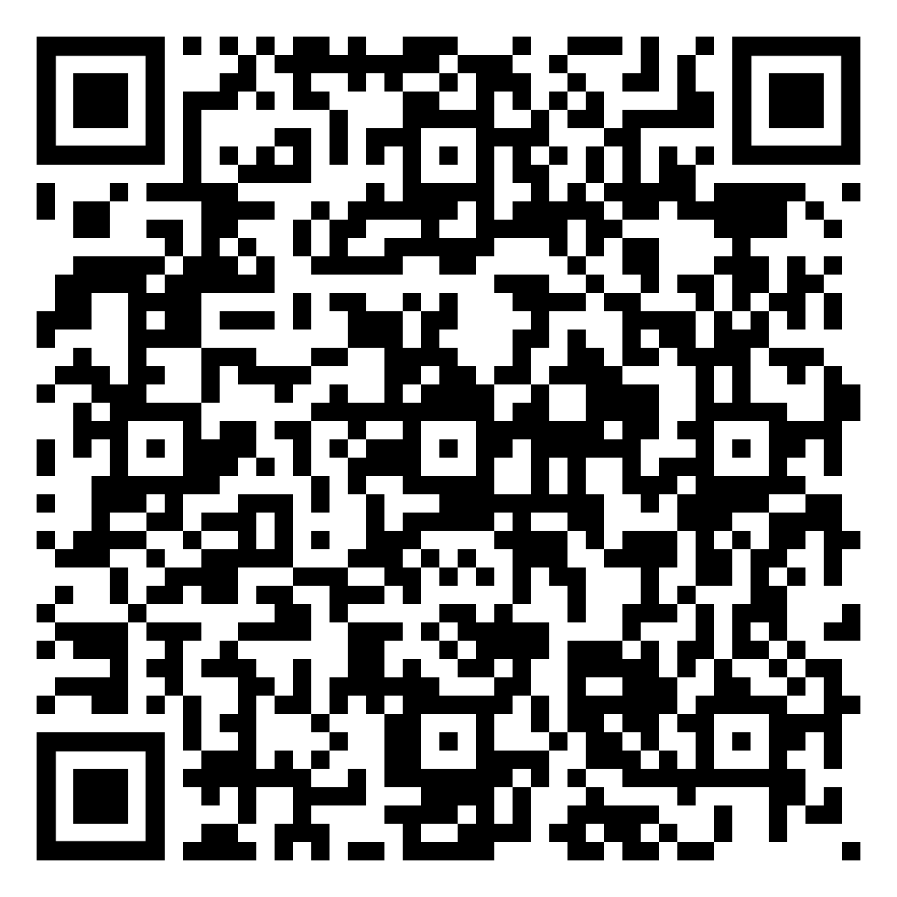
Ex. 12. Form pairs with your classmates. Choose one of the scenarios below. Prepare a short dialogue using target speech patterns.
1. The Job Interview
Roles: Interviewer and Job Applicant
Target patterns: "too," "enough," "in order to," "because of"
Instructions:
- The interviewer asks about the applicant's qualifications and experience.
- The applicant explains why they're suitable for the job, using the target patterns.
- The interviewer presents a hypothetical work situation for the applicant to solve.
2. Planning a Vacation
Roles: Travel Agent and Customer
Target patterns: "so," "such," "in order to," "so that"
- The customer describes their ideal vacation.
- The travel agent suggests destinations and activities.
- They discuss potential issues and solutions.
3. Restaurant Complaint
Roles: Restaurant Manager and Unsatisfied Customer
Target patterns: "too," "enough," "because of," "therefore"
Instructions:
- The customer explains their dissatisfaction with their meal or service.
- The manager listens and tries to resolve the issue.
- They negotiate a solution.
4. Academic Advising
Roles: Academic Advisor and Student
Target patterns: "so that," "since," "as," "in order to"
Instructions:
- The student discusses their academic goals and challenges.
- The advisor provides guidance and suggestions.
- They create an action plan together.

- Product Return
Roles: Customer Service Representative and Customer
Target patterns: "too," "such," "due to," "therefore"
Instructions:
- The customer explains why they want to return a product.
- The representative asks questions and explains the return policy.
- They work towards a resolution.

I. Warmer
a. Look at the quotation below and answer the questions.
Don't Judge a Book by Its Cover
1. Where have they heard this phrase before?
Can they think of examples where this advice applies?
Are there times when judging by appearance might be useful or necessary?

Ex. 1 Analytical reading skills. THEVES strategy. Work with the text and complete the worksheet below. Follow it step by step. Do not read the text until you are given instructions to do so.

THIEVES Strategy Worksheet: "Appearance and Disposition"
T - Title: What is the title of the text? What do you think it means?

H - Headings: While there are no explicit headings, what main topics or ideas can you identify from skimming the text?

I - Introduction: Read the first paragraph. What is the main idea introduced?

E - Every first sentence: Read the first sentence of each paragraph. List 3 key ideas you found:

V - Visuals: Are there any visuals in the text? If not, what kind of visual might be helpful for this topic?

E - End-of-chapter questions: While there are no explicit questions provided, what are 2 questions you think the author wants readers to consider?

S - Summary: Read the last paragraph. What final point does the author make?

Predictions: Based on this preview, what do you think the main message of this text will be?

After reading: How did your predictions compare to the actual content? What surprised you?

Appearance and Disposition

The saying "All that glitters is not gold" from Shakespeare’s The Merchant of Venice reminds us that appearances can be deceiving.

When you see a tall, broad-shouldered young person, it’s easy to assume they are strong and courageous, thinking, "This is someone to look up to!" However, it’s surprising how often someone who looks good turns out to be too weak-willed or even cowardly. Then you might think, "What a disappointment!"

At the same time, many people know that some of the greatest minds and most courageous individuals were neither tall nor strong. Their smaller, frail appearance didn’t stop them from showing enough intelligence and bravery. Ingenuity doesn’t depend on someone’s physical appearance or build.

People often assume that someone who is plump or even obese must be kind and generous. However, surprisingly enough, they can sometimes be too thrifty, or even greedy. In those cases, you might think, "What a miser!" On the other hand, thin or slim nervous women might be so lavish that they never think twice before spending money. You might call them generous, while your mother might call them spendthrifts. Parents often have stricter judgments.

Have you ever gone to an important office and met the boss? At first glance, you might judge the boss based on appearance—maybe they have a round face, small narrow eyes, dimples, and a turned-up nose. You might think, "What a kind-hearted person!" But when you ask for help, the boss turns out to be too harsh and unkind, and you leave thinking, "They have a heart of stone."

When you see a pretty blonde with curly hair, blue eyes, a straight nose, and a high forehead, you might assume she is intelligent and nice. But if she turns out to be too capricious and impolite, it can be disappointing. You might think, "What a bore!"

On the contrary, when you see a skinny brunette with irregular features—like a hooked nose, pointed chin, close-set eyes, and thin lips—you might expect her to be cruel or cunning due to these stereotypes. But if you later discover she’s clever, gentle, and well-mannered, it’s a pleasant surprise, and you might think, "What a charming person!"

Another common misconception is that children are always expected to look like their parents. Parents love it when their children resemble them, and relatives often compare features like moles or nose shapes. The best compliment is, "They’re like two peas in a pod." But it can be disappointing to find nothing in common. Why do we prefer our children to be copies of us? Perhaps it’s because we’re uncomfortable with the idea that nature has its own plans, selecting traits from a vast gene pool developed over generations.

Nature loves to surprise us. But don’t you think that’s a gift? Because of these differences, life becomes not just a boring routine but a brilliant mix of characters and appearances that often contrast with one another.

Ex. 3. Read the whole text. Were your predictions right?

Ex. 4. Read each statement carefully. Mark it as:
T (True) if the statement agrees with the information in the text
F (False) if the statement contradicts the information in the text
NG (Not Given) if there is no information about this in the text
1. ____ Shakespeare wrote the phrase "All that glitters is not gold" in The Merchant of Venice.
____ Tall, broad-shouldered people are always strong and courageous.
____ Some of the greatest minds in history were physically small or frail.
____ Obese people are always kind and generous.
____ Thin or slim women are typically more careful with money than plump women.
____ A person's eye color can indicate their level of intelligence.
____ People with irregular facial features are often cruel or cunning.
____ Parents always prefer their children to look exactly like them.
____ The text suggests that nature selecting traits from a vast gene pool is a positive thing.
____ The author believes that differences in appearance make life more interesting.
____ The text mentions specific historical figures as examples of great minds in small bodies.
____ According to the text, a person's nose shape can accurately predict their personality.
____ The author suggests that judging people based on appearance is a good practice.
____ The text implies that parents' judgments are often stricter than others'.
____ The phrase "They're like two peas in a pod" is used to describe people who look very different.

Ex. 5 Fill in the blanks the following summary of the text.

The text explores the relationship between _______ and _______. It begins with a quote from Shakespeare's play _______, reminding us that appearances can be _______.
The author presents various examples of how physical characteristics can lead to _______ assumptions. For instance, tall and broad-shouldered individuals might be assumed to be _______ and _______, but this isn't always true. Similarly, some of the greatest _______ in history were neither tall nor strong.
The text also discusses how _______ people are often thought to be kind and generous, while _______ women might be seen as lavish spenders. The author notes that a person's _______ appearance doesn't necessarily reflect their personality or behavior.
The text examines stereotypes related to facial features, suggesting that a _______ with certain characteristics might be unfairly judged as unintelligent or impolite. Conversely, someone with _______ features might surprise others by being clever and well-mannered.
The author also touches on the expectation that children should _______ their parents, noting that parents often prefer their children to be "_______ of them." However, the text suggests that nature's tendency to _______ from a vast gene pool is actually a gift.
In conclusion, the author proposes that the _______ between appearance and character makes life more interesting, presenting a _______ mix of traits rather than a boring routine.
This exercise challenges students to recall key concepts and vocabulary from the text, reinforcing their understanding of its main ideas and structure. You can adjust the difficulty by providing a word bank or leaving it completely open-ended.

Ex. 6. Summarization Challenge: summarize the entire text in one sentence, then in 50 words, then in 100 words.

Ex. 7. Prepare a summary of the text, using the guidelines and phrases from Appendix 1.

ACTIVE VOCABULARY

Ex. 8. Scanning the Text. Find these words in the text, highlight them and translate them in accordance with the context.

- intelligence
- courageous
- ingenuity
- spendthrift
- miser
- cowardly
- frail
- bore
- dimple
- have a heart of gold
- misconception
- have a heart of stone
- like two peas in a pod
- resemble
- mole
- gene pool

Ex. 9. Match each word in Column A with its synonym (S) or antonym (A) in Column B. Write S or A next to each match.

Column A:  - intelligence  - courageous  - ingenuity  - spendthrift  - miser  - cowardly  - frail  - bore  - dimple  - have a heart of gold  - misconception  - have a heart of stone  - like two peas in a pod  - resemble  - mole  - gene pool | Column B:  a. robust  b. generous  c. entertain  d. bravery  e. foolishness  f. differ  g. birthmark  h. falsehood  i. ruthless  j. genetic makeup  k. creativity  l. thrifty  m. identical  n. dullness  o. compassionate  p. look like

Ex 10. Rewrite each sentence using the words from Active Vocabulary, maintaining the original meaning as closely as possible. Choose the word that best fits the context and meaning of the sentence. You may change the form of the words.
- Her quick thinking and problem-solving skills showed her exceptional mental capacity.
- Despite the danger, the firefighter acted bravely and rescued the trapped family.
- His creative solutions to complex problems demonstrated his resourcefulness.
- Sarah always overspends, buying things she doesn't need and maxing out her credit cards.
- Old Mr. Johnson is so stingy that he refuses to turn on the heat even in winter.
- The soldier's fearful behavior during the battle was seen as lacking bravery.
- After her illness, the once-strong athlete became physically weak and needed support.
- His lectures were so uninteresting that students often fell asleep.
- Her charming smile was accentuated by the small indentation on her cheek.
- Despite her wealth, Mrs. Thompson is known for her kindness and generosity to all.
- There's a common false belief that sugar causes hyperactivity in children.
- The businessman was ruthless in his dealings, showing no empathy for others.
- The identical twins were so similar that people couldn't tell them apart.
- The young girl looks very similar to her mother at the same age.
- She was concerned about the dark spot on her skin and decided to see a dermatologist.
- The diversity in their family background contributed to an interesting mix of inherited traits.
Ex. 11. Each sentence below contains one error related to the use or spelling of the target vocabulary. Identify the error and write the correct word or phrase.

- Her intelligense allowed her to solve complex problems quickly.
- Despite his fear, he acted courageously in the face of danger.
- The engineer's ingenuety led to a breakthrough in renewable energy.
- He's such a spendthrift that he saves every penny he earns.
- The mizer donated all his wealth to charity before he died.
- The soldier's cowardly act of rescuing his wounded comrades earned him a medal.
- Though frail in appearance, the old woman had remarkable strength.
- His exciting stories always boar the audience to tears.
- She has a cute dimble on her left cheek when she smiles.
- That cruel dictator has a heart of gold when it comes to treating his people.
- It's a common misconception that the Earth is perfectly round.
- The kind nurse has a heart of stone, always comforting her patients.
- The twin sisters look like two pees in a pod.
- The portrait doesn't resemble the subject at all; it's a perfect likeness.
- She was concerned about the mole on her arm and decided to have it checked.
- The diverse gene pull of the population contributed to its overall health.

Ex. 12. For each root word below, create as many related words as you can. Consider different parts of speech (nouns, verbs, adjectives, adverbs) and any prefixes or suffixes that could be added. An example is provided for you.

Root word | Related words
Courage | courageous, courageously, discourage, encouraged, encouraging, encouragement
intelligence
frail
bore
inegnuity
cowardly
resemble
misconception

Ex. 13. Complete each sentence by forming an appropriate word from the one given in brackets. Use prefixes, suffixes, or change the word form as needed.
- Her ____________ in solving complex problems was remarkable. (INTELLIGENT)
- The firefighter showed great ____________ by entering the burning building. (COURAGE)
- The inventor's ____________ led to several groundbreaking patents. (INGENIOUS)
- His ____________ habits led to serious financial troubles. (SPEND)
- The old man's ____________ ways surprised everyone when he left a fortune to charity. (MISER)
- The soldier's ____________ behavior during the battle was disappointing. (COWARD)
- The ____________ old man needed assistance to walk. (FRAIL)
- His lectures were so ____________ that students often skipped them. (BORE)
- Her smile was enhanced by the ____________ in her cheeks. (DIMPLE)
- Despite her wealth, she was known for her ____________. (HEART OF GOLD)
- There's a common ____________ that lightning never strikes the same place twice. (CONCEIVE)
- The businessman was known for his ____________ in negotiations. (HEART OF STONE)
- The twins were so ____________ that even their parents had trouble telling them apart. (TWO PEAS IN A POD)
- The young girl strongly ____________ her grandmother in both looks and personality. (RESEMBLE)
- The dark ____________ on her skin turned out to be harmless. (MOLE)
- The study of ____________ has revolutionized our understanding of heredity. (GENE)
PHRASAL VERBS
Phrasal verb | Meaning | Example | Translation
to turn out | 1. To result or end in a particular way.  2. To attend or be present at an event. | The event turned out to be a huge success.  A large crowd turned out for the concert.
to turn up | 1. To arrive or appear unexpectedly. | He finally turned up after we had been waiting for an hour.  Can you turn up the music? I can barely hear it.
  2. To increase the volume or intensity.
to turn up (one’s nose at) | To show disdain or contempt for something. | She turned up her nose at the idea of eating fast food.
to turn down | To refuse or reject an offer or request. | She turned down the job offer because the salary was too low.
to turn over | 1. To give someone or something to the authorities. | The suspect turned himself over to the police.  Turn over the pancake when the edges start to brown.
  2. To flip or rotate something.
to turn in | 1. To submit something (e.g., an assignment).  2. To go to bed or retire for the night. | Please turn in your essays by Friday.  I’m tired, so I think I'll turn in early tonight.
to take aback | To surprise or shock. | The news of her death took me aback.
to take down | To dismantle. | Take down the Christmas tree until next year.
to take (somebody) in | 1. To allow someone to stay in your house.  2. To be deceived or swindled / to deceive. | They took in the refugees while they found a more permanent place to stay.  She was taken in by all his lies. / She took me in with her story until someone told me the truth
to take (something) in | 1. To observe something.  2. To absorb and understand information.  3. To make a piece of clothing narrower or tighter. | They took in every detail to tell their friends about it later.  The lecture was rather boring and I didn’t take in much of what the lecturer said.  She had lost weight so the dress had to be taken in more at the waist.

Ex. 11 Choose the correct phrasal verb to complete each sentence from the options given.

1. After hearing the shocking news, I was completely __________.
a) turned down
b) taken aback
c) turned over

2. The police asked the criminal to __________ all the stolen goods.
a) take in
b) turn over
c) turn in

3. Can you __________ the TV? I can barely hear it.
a) turn up
b) turn down
c) turn out

4. We need to __________ the decorations after the holiday season.
a) take in
b) turn down
c) take down

5. She __________ the job offer because it didn’t meet her expectations.
a) turned out
b) turned down
c) took in

6. The lecture was so complex that I couldn’t __________ everything the professor said.
a) turn out
b) turn down
c) take in

7. The event __________ to be more successful than we had anticipated.
a) turned out
b) turned down
c) taken aback

8. He finally __________ after being missing for several hours.
a) took down
b) turned up
c) took in

9. She __________ her nose at the idea of eating at a fast food restaurant.
a) turned up
b) turned out
c) turned in

10. After a long day, I decided to __________ early and get some rest.
a) take in
b) turn in
c) turn over

Ex. 12. Rewrite each sentence using different words but keeping the same meaning. Use the phrasal verbs in your new sentence.

- The concert ended up being even better than we expected.
- She rejected the proposal without hesitation.
- When the news broke, everyone was shocked.
- Could you please increase the volume of the radio?
- The criminal eventually surrendered to the authorities.
- The job applicant submitted her resume before the deadline.
- After a long day, I decided to go to sleep early.
- The children welcomed the stray cat into their home.
- The company decided to hire additional staff for the holiday season.
- His performance greatly improved, becoming successful in the end.
- The cake was reduced in size to fit the smaller pan.
- The plane departed from the airport as scheduled.
- She became hostile towards her former friend after the argument.
- We need to dismantle the old bookshelf before moving.
- After completing the assignment, she chose to rest for the night.

Ex. 13 Read each paragraph and choose the correct phrasal verb to fill in the blank.

1. Sarah had been looking forward to the concert for months. When the day finally arrived, a huge crowd _______ to see the band. Unfortunately, the sound system wasn't working properly, so the technicians had to _______ the volume several times before everyone could hear clearly.

a) turned out / turn down
b) turned up / turn up
c) took in / turn over

2. John _______ the job offer at the prestigious firm because the salary was lower than he expected. He decided to _______ early that night, feeling a bit disappointed. The next morning, he _______ his resignation letter to his current employer.

a) turned down / turn in / turned in
b) turned over / turned up / took down
c) took in / turned out / turned up

3. When Maria first told me her incredible story, I was completely _______. I later found out she had _______ me with her tall tales, and I felt quite foolish for believing her.

a) turned over / turned down
b) taken aback / taken in
c) turned up / turned out

4. The charity event _______ to be a huge success. Many volunteers _______ to help, and they even _______ some homeless families until more permanent housing could be arranged.

a) turned out / turned up / took in
b) took in / turned down / turned over
c) turned over / took aback / turned up

5. After the holidays, it was time to _______ all the decorations. As I was putting away the Christmas tree, I noticed that my favorite ornament had broken. I _______ at the thought of throwing it away, but I knew it couldn't be repaired.

a) turn in / turned up
b) take down / turned up my nose
c) turn over / took aback

6. The detective was certain that the suspect would eventually _______ to the authorities. He didn't expect it to happen so soon, though. When the man walked into the police station, the officer on duty was _______ by his sudden appearance.

a) turn over / taken aback
b) turn down / turned out
c) take in / turned up

7. As the teacher explained the complex theory, many students struggled to _______ all the information. She advised them to review their notes carefully and _______ their assignments by the end of the week.

a) turn over / turn down
b) take in / turn in
c) turn up / take down

8. The tailor had to _______ Jenny's dress significantly as she had lost a lot of weight. Meanwhile, her friend Lisa _______ at the idea of wearing a second-hand dress to the prom.

a) take in / turned up her nose
b) turn over / took aback
c) turn down / turned out

Ex. 14 Fill in the blanks with the appropriate phrasal verb or vocabulary word from the list below. Use each word or phrase only once.

turn out, turn up, turn up (one's nose at), turn down, turn over, turn in, take aback, take down, take in, take (somebody) in, intelligence, courageous, ingenuity, spendthrift, miser, cowardly, frail, bore, dimple, have a heart of gold, misconception, have a heart of stone, like two peas in a pod, resemble, mole, gene pool

- The charity event __________ to be a huge success, with more donors __________ than expected.
- It's a common __________ that all wealthy people __________. In reality, many are quite generous with their resources.
- The detective was __________ when the suspect voluntarily __________ himself to the police.
- Despite being __________, the elderly woman had the __________ to stand up against injustice in her community.
- The twins were so alike in both appearance and personality that people often said they were __________.
- The __________ employee always made sure to __________ all assignments before the deadline.
- She couldn't __________ her neighbor's constant noise anymore and decided to file a complaint.
- His __________ and __________ allowed him to develop innovative solutions to complex problems.
- The fashion critic __________ her nose at the designer's new collection, finding it too conventional.
- Despite his tough exterior, the old man actually __________; he often helped those in need without seeking recognition.
- The company had to __________ several job applicants before finding the right fit for the position.
- Scientists believe that a diverse __________ is crucial for the survival of a species in changing environments.
- The actor's performance didn't __________ to the critics, who found it lacking in depth and authenticity.
- With the advent of social media, managing one's digital __________ has become crucial for professional success.
- The data analyst worked to __________ all the complex information about consumer behavior trends.

Ex. 15 Write a short story (about 200-250 words) using at least 8 of the phrasal verbs from the list below. Try to incorporate the words from Active Vocabulary as well.

Ex. 16. Translate the following Ukrainian sentences into English, using the phrasal verbs and vocabulary words provided where appropriate.

- Виявилося, що його розум та винахідливість допомогли йому вирішити складну проблему.
- Вона з'явилася на вечірці несподівано, здивувавши всіх гостей.
- Він завжди задирає ніс перед простою їжею, віддаючи перевагу вишуканим стравам.
- Компанія відхилила його пропозицію, вважаючи її занадто ризикованою.
- Поліція перевернула кожен камінь у пошуках доказів.
- Після довгого дня він вирішив лягти спати рано.
- Його сміливий вчинок приголомшив усіх присутніх.
- Вона записала важливу інформацію, щоб не забути деталі.
- Місто приймає багато туристів щороку під час фестивалю.
- Шахраї обдурили довірливу стару жінку, вкравши її заощадження.
- Його кмітливість дозволила йому швидко знайти рішення в складній ситуації.
- Незважаючи на високу зарплату, він залишався марнотратом і завжди був у боргах.
- Скупий сусід ніколи не позичав нікому грошей, навіть у надзвичайних ситуаціях.
- Його боягузлива поведінка розчарувала команду в критичний момент.
- Хоча вона виглядала тендітною, її сила волі була непохитною.
- Його монотонні розповіді швидко набридали слухачам.
- Її усмішка створювала чарівні ямочки на щоках.
- Незважаючи на суворий вигляд, він мав золоте серце і завжди допомагав іншим.
- Існує поширена помилка, що всі близнюки ідентичні.
- Він мав кам'яне серце і ніколи не виявляв співчуття до інших.
- Вони схожі як дві краплі води, що не дивно, враховуючи їхню спільну генетику.
- Він дуже схожий на свого батька, успадкувавши навіть характерну родимку на підборідді.
- Різноманітність у генофонді важлива для здоров'я популяції.

ESSENTIAL VOCABULARY

1. admit - /ədˈmɪt/ - визнавати

Common Collocations: admit defeat, admit guilt, admit liability, admit the truth
Example: She freely admits that she made mistakes.
Phrase Usage:
- admit doing something - визнати, що зробив/ла щось
Example: Davis admitted causing death by careless driving.
- admit someone to something - приймати в члени організації/надавати право на вхід
Example: A group ticket admits six people to the zoo and museum.
- admit for treatment - приймати на лікування
Example: After collapsing, she was rushed to the hospital, where she was admitted for treatment.

2. accomplish - /əˈkʌm.plɪʃ/ - досягати

Common Collocations: accomplish a task, accomplish a goal, accomplish a mission, accomplish something remarkable, accomplish great things
Example: She accomplished her goal of becoming a doctor.
Phrase Usage:
- accomplish a feat - досягти подвигу
Example: The team accomplished a remarkable feat by climbing the mountain in record time.
- accomplish nothing - не досягти нічого
Example: Without proper planning, we would accomplish nothing.
- easily accomplished - легко досяжний
Example: The task was easily accomplished with teamwork.

3. cherish - /ˈtʃer.ɪʃ/ - цінувати, берегти
Common Collocations: cherish a memory, cherish a relationship, cherish a dream, cherish a tradition, cherish a person
Example: She cherished the memory of her childhood home.
Phrase Usage:
- cherish deeply - глибоко цінувати
Example: He cherished deeply the friendships he had made over the years.
- cherish the moment - берегти момент
Example: They cherished the moment of their reunion.
- cherish a hope - плекати надію
Example: Despite the setbacks, she cherished the hope of success.

4. behave - /bɪˈheɪv/ - поводитись
Common Collocations: behave properly, behave inappropriately, behave responsibly, behave like a gentelmean/lady, behave with dignity
Example: You behaved like a complete idiot!
Phrase Usage:
- behave towards - поводити по відношенню до
Example: This is not how you behave towards a child.
- behave oneself - поводитись пристойно
Example: I hope the children behave themselves.
- behavioral patterns - поведінкові моделі
Example: His behavioral patterns are concerning.

5. blame / to blame - /bleɪm/ - вина/звинувачувати
Common Collocations: blame for, assign blame, shift the blame, take the blame, blame something on
Example: If it all goes wrong, don’t blame me.
Phrase Usage:
- to blame something on someone/something - перекладати провину на когось/щось
Example: You can’t blame all your problems on your family.
- to take the blame - взяти на себе провину
Example: He took the blame for the accident, even though it wasn’t his fault.
- blame game - гра в пошук винного
Example: The blame game started as soon as the project failed.

6. clash - /klæʃ/ - вдарятись, стукати, розходитись в поглядах
Common Collocations: clash of opinions, culture clash, clash with, clash of personalities, clash in style
Example: He likes the clash of the cymbals.
Phrase Usage:
- clash of egos - зіткнення его
Example: The meeting ended in a clash of egos between the managers.
- ideological clash - ідеологічний конфлікт
Example: The debate turned into an ideological clash.
- clash of schedules – розбыжності в розкладі
Example: There was a clash of schedules, so the meeting had to be rescheduled.

7. enhance - /ɪnˈhɑːns/ - покращувати
Common Collocations: enhance performance, enhance skills, enhance the quality of, enhance the flavour
Example: The new technology enhances the performance of the entire system.
Phrase Usage:
- enhance the experience - покращити досвід
Example: The virtual tour greatly enhanced the experience for users.
- enhance reputation - покращити репутацію
Example: Her volunteer work has enhanced her reputation in the community.
- enhance one’s ability - покращувати здатність
Example: Training will enhance your ability to perform well under pressure.

8. grind (ground-ground) - /ɡraɪnd/ - перемелювати, товкти, шліфувати, молоти
Common Collocations: grind to a halt, daily grind, grind one’s teeth, grind coffee
Example: The mill was used for grinding corn until the 17th century.
Phrase Usage:
- to grind one’s teeth - скреготати зубами
Example: He always grinds his teeth in his sleep.
- grind - важка робота, одноманітна робота, рутина
Example: It was the usual daily grind of household tasks.
- grind out - виробляти в великій кількості
Example: The factory grinds out thousands of products every day.

9. look - /lʊk/ - дивитись
Common Collocations: look ahead, look back, look after, look for, look forward to
Example: I looked at the opposite house but saw no lights in its windows.
Phrase Usage:
- to look about - озиратись, озиратись по бокам
Example: I looked about but saw no people anywhere.
- Look ahead! - Бережись!
Example: Look ahead! There’s a car coming.
- to look (a thing) through - проглядати що-небудь
Example: Look through those documents, please.
- to look after - піклуватись, доглядати за ким-небудь
Example: I’ll look after the child.
- to look for - шукати
Example: I’ve been looking for you since the very morning.
- to look forward to (smth. or doing smth.) - очікувати із нетерпінням
Example: John looked forward to seeing Mario and his wife.
- Look here! - Послухай!
Example: Look here, wouldn’t it be better to stay indoors in such nasty weather?

10. look - /lʊk/ - здаватись, виглядати (followed by an adjective, noun, or like)
Common Collocations: look sad, look ill, look like
Example: He looks sad. The child looks ill (well). It looks like rain.
Phrase Usage:
- to look means виглядати
Example: He looks young for his age. She looks beautiful in this dress.
- to seem means справляти враження
Example: She seems to be clever.
- He seems to be well-educated - Він здається освіченим.

Ex. 1. Read the passage and then choose the correct meaning for each of the words in bold. For each word state the part of speech and if it’s positive, negative or neutral.
Read the passage and then choose the correct meaning for each of the words in bold. For each word, state the part of speech and if it's positive, negative, or neutral.
- Admit A. To deny B. To accept as true C. To reject D. To question
- Accomplish A. To fail B. To attempt C. To achieve or complete successfully D. To postpone
- Cherish A. To dislike B. To forget C. To value and care for D. To ignore
- Behave A. To act in a particular way B. To misbehave C. To remain still D. To speak
- Blame A. To praise B. To forgive C. To assign responsibility for a fault or wrong D. To forget
- Clash A. To agree B. To harmonize C. To disagree strongly or come into conflict D. To avoid
- Enhance A. To diminish B. To maintain C. To improve or increase in quality D. To destroy
- Grind A. To smooth B. To crush or reduce to powder C. To polish D. To arrange
- Look (verb) A. To ignore B. To close one's eyes C. To direct one's gaze D. To hear
- Look (adjective/noun usage) A. To seem or appear B. To disguise C. To hide D. To change
- Enhance A. To worsen B. To maintain C. To improve or increase in quality D. To ignore
Ex. 3 Translate into English.

- визнавати помилку
- досягти мети
- цінувати момент
- поводитись пристойно
- перекладати провину
- розходитись в поглядах
- покращити досвід
- перемелювати кофе
- озиратись по бокам
- виглядати молодо
- приймати на лікування
- досягти подвигу
- плекати надію
- поведінкові моделі
- гра в пошук винного
- ідеологічний конфлікт
- покращити репутацію
- важка робота, рутина
- очікувати із нетерпінням
- справляти враження
Ex. 4 Translate into Ukrainian.

- admit defeat
- accomplish a goal
- cherish a memory
- behave responsibly
- take the blame
- clash of opinions
- enhance performance
- grind coffee
- look forward to
- look ill
- admit for treatment
- accomplish a feat
- cherish a hope
- behavioral patterns
- blame game
- ideological clash
- enhance reputation
- daily grind
- look through documents
- seem well-educated

Ex.5 Explain in English what is meant by. Use these phrases in the sentences of your own.

admit defeat, accomplish a goal, cherish a memory, behave responsibly, take the blame, clash of opinions, enhance performance, daily grind, look forward to, look ill

Ex. 6. Find synonyms and antonyms to the underlined words:

Choose the synonym:

1. She admitted her mistake to the team.
a. confessed b. denied c. ignored
2. The company aims to accomplish its goals by the end of the year.
a. achieve b. fail c. postpone
3. He cherishes the memories of his childhood.
a. values b. forgets c. dislikes
4. The children behaved well during the long flight.
a. conducted b. misbehaved c. acted out
5. The new software will enhance the company's productivity.
a. deteriorate b. reduce c. improve

Choose the antonym:

6. The constant clash of opinions made the meeting unproductive.
a. confession b. agreement c. discussion
7. He looks upset about the exam results.
a. appears happy b. seems sad c. looks indifferent.
8. He decided to look after his elderly parents.
a. assist b. care for c. neglect
9. The chef grinds fresh coffee beans every morning.
a. preserves b. crushes c. brews
10. He looked forward to the upcoming vacation.
a. dreaded b. anticipated c. ignored

Ex. 7 Fill in the blanks, using essential vocabulary units.
- After the incident, the company ________ responsibility for the safety breach.
- Despite the challenges, the team managed to ________ their goals ahead of schedule.
- She ________ the memory of her first international trip.
- The children were asked to ________ properly during the school assembly.
- Instead of taking responsibility, he tried to ________ others for his mistakes.
- Their differing opinions led to a ________ during the board meeting.
- The new software update will ________ the user experience significantly.
- The coffee shop uses a special machine to ________ their beans fresh every morning.
- He ________ forward to spending time with his family over the holidays.
- After the accident, she was ________ to the hospital for treatment.
- The constant stress of the daily ________ was taking a toll on his health.
- She ________ deeply upset about the news.
- The company hopes to ________ its market position with the new product launch.
- He ________ doing anything wrong and maintained his innocence.
- The two cultures often ________ due to their different values and traditions.
- She ________ the hope that one day she would achieve her dreams.
- The manager asked the team to ________ responsibly with the confidential information.
- He ________ after his younger siblings while his parents were away.

Ex. 8. Fill in the blanks with prepositions and adverbs.
- The politician had to admit ___ his mistakes during the press conference.
- After years of hard work, she finally accomplished ___ her goal of becoming a doctor.
- We should cherish ___ the memories we make with our loved ones.
- Children are expected to behave ___ when visiting a museum.
- Don't blame ___ others for your own shortcomings.
- Their opinions clashed ___ during the heated debate.
- The new software will enhance ___ the company's productivity.
- The daily grind of work can sometimes feel overwhelming ___.
- Please look ___ these documents carefully before signing them.
- He looked ___ to the upcoming family reunion.
- The chef ground ___ the coffee beans to make a fresh brew.
- We need to look ___ possible solutions to this problem.
- She admitted ___ treatment at the hospital after the accident.
- The team accomplished a remarkable feat ___ winning the championship.
- Parents should cherish ___ every moment with their children.
- How do you expect me to behave ___ such circumstances?
- The manager took the blame ___ the project's failure.
- Their schedules clashed ___, making it difficult to arrange a meeting.
- Regular exercise can enhance ___ your overall health and well-being.
- The machine ground ___ a halt due to a technical malfunction.
Ex. 9 Translate into English, using essential vocabulary units.
  - Після довгих дебатів, політик нарешті мусив визнати, що його економічна політика не принесла очікуваних результатів.
  - Незважаючи на численні перешкоди, молода компанія зуміла досягти вражаючого зростання на міжнародному ринку протягом першого року роботи.
  - Бабуся завжди говорила нам цінувати прості моменти життя, бо саме вони часто приносять найбільше щастя та задоволення.
  - Директор школи нагадав учням, що вони повинні поводитись відповідально під час екскурсії, представляючи свій навчальний заклад.
  - Замість того, щоб звинувачувати зовнішні обставини, він вирішив взяти відповідальність за свої дії та шукати шляхи вирішення проблеми.
  - Їхні погляди на майбутнє компанії сильно розходились, що призвело до гарячої дискусії на зборах правління.
  - Нова система управління проектами значно покращить ефективність роботи команди та якість кінцевого продукту.
  - Щоденна рутина офісної роботи може здаватися монотонною, але вона відіграє важливу роль у досягненні довгострокових цілей компанії.
  - Перш ніж підписати контракт, юрист порадив уважно подивитися всі пункти угоди, звертаючи особливу увагу на дрібний шрифт.
  - Після місяців важкої роботи над проектом, вся команда з нетерпінням очікувала презентації результатів перед керівництвом компанії.
  - Лікарня була готова прийняти на лікування постраждалих від аварії, забезпечивши всі необхідні ресурси для надання невідкладної допомоги.
  - Альпіністи досягли подвигу, піднявшись на вершину гори в рекордно короткий термін, незважаючи на суворі погодні умови.
  - Батьки повинні навчити своїх дітей глибоко цінувати культурне різноманіття та поважати традиції інших народів.
  - Керівник проекту наголосив на важливості поводитися професійно під час зустрічей з клієнтами, щоб створити позитивне враження про компанію.
  - Замість того, щоб грати у гру звинувачень, команда вирішила зосередитися на пошуку конструктивних рішень для подолання кризи.
  - Різні підходи до управління призвели до зіткнення его між керівниками відділів, що негативно вплинуло на робочу атмосферу.
  - Новий курс тренувань був розроблений, щоб покращити здатність співробітників справлятися зі стресовими ситуаціями на роботі.
  - Перед важливою презентацією важливо переглянути всі слайди та переконатися, що інформація подана чітко та послідовно.
Ex. 10 Prepare a short speech (1-2 minutes) discussing one of the quotations below. Use at least 10 units of Essential Vocabulary.
- "The greatest glory in living lies not in never falling, but in rising every time we fall." (Nelson Mandela) How can we cherish our failures as opportunities for growth and accomplish our goals despite setbacks?
- "It is better to fail in originality than to succeed in imitation." (Herman Melville) Why is it important to admit our own shortcomings rather than blame others or circumstances for our lack of creativity?
- "The way to get started is to quit talking and begin doing." (Walt Disney) How can we move beyond the daily grind and enhance our productivity by taking action instead of just planning?
- "Life is what happens to us while we are making other plans." (Allen Saunders) How can we learn to behave adaptively when our plans clash with unexpected life events?
- "The only way to do great work is to love what you do." (Steve Jobs) How can passion for our work help us look forward to each day and avoid feeling like we're just going through the motions?
- "In three words I can sum up everything I've learned about life: it goes on." (Robert Frost) How can we cherish the present moment while also learning to move forward when faced with challenges or disappointments?

UNIT 3
SPEECH PATTERNS
Used to, Would, Get used to smt./to doing smt., to be used to smt./ to doing smt.


I. Genially escape. Engage in five unique missions and solve tasks in each mission to collect five secret digits. Unlock the safe with the correct combination of digits to win. Scan the qr-code to access the game

II. What do you know/remember about the usage if ‘Used to, Would, Get used to smt./to doing smt., to be used to smt./ to doing smt.’? Look at the example sentences to help you.
My grandmother used to have beautiful blonde hair, but now her hair is grey.
There used to be a park here, but now there’s a shopping centre.
I used to live in Denver.
I used to go to the park every Friday.
When I was a child, my dad would read to me every night.
She would bite her finger nails whenever she was nervous.
When he was at university, he would sleep until noon at the weekends.
My sister lived in Australia for many years, but she would always come home for Christmas.
We are getting used to living in a small village in the country, but it’s still a little strange.
She found the heels too high, but she got used to them.
It took me a few months to get used to living in Japan. At first everything seemed very different, but then gradually it became normal for me.
Don’t worry if your new job is hard at first. You’ll get used to it.
Don’t worry, Liam is used to driving for long hours. He has worked as a professional driver for 20 years.
I’m used to getting up early, so I don’t mind doing it (= getting up early is normal for me, it’s what I usually do)
I’ve lived in the UK almost all my life, so I’m used to rain (= rain is normal for me).
That football team always lose, so they’re used to disappointment!
Ex. 1. For each sentence, choose the most appropriate option to complete it correctly.

1. I _____ live in New York, but I moved to Chicago last year.
a) used to
b) would
c) am used to
2. When I was a child, my father _____ read me bedtime stories every night.
a) used to
b) would
c) got used to
3. It took me some time, but I'm finally _____ the noise of the city.
a) used to
b) would
c) getting used to
4. There _____ be a small cafe on this corner, but it closed down.
a) would
b) used to
c) is used to
5. Don't worry about the long hours. You'll soon _____ the new work schedule.
a) used to
b) get used to
c) would
6. She _____ working night shifts, so it doesn't bother her anymore.
a) is used to
b) used to
c) would
7. Whenever it rained, we _____ stay indoors and play board games.
a) used to
b) would
c) get used to
8. After living in Spain for a year, I _____ speaking Spanish every day.
a) would
b) used to
c) got used to
9. He's still _____ driving on the left side of the road in England.
a) used to
b) getting used to
c) would
10. _____ you play any sports when you were younger?
a) Did you use to
b) Would you
c) Were you used to
11. I'm not _____ eating spicy food, so this curry is too hot for me.
a) used to
b) get used to
c) would
12. As a student, she _____ study late into the night before exams.
a) was used to
b) would
c) got used to
13. It may take some time to _____ the new software, but you'll learn it eventually.
a) used to
b) would
c) get used to
14. They _____ visit their grandparents every summer when they were kids.
a) used to
b) would
15. c) were used to
After months of practice, I'm finally _____ playing the guitar with my left hand.
a) used to
b) would
c) used

Ex. 2. Fill in the sentences using speech patterns. Sometimes more than one answer is possible.

  - I _____ to play the piano, but I stopped when I started college.
  - My grandfather _____ tell us stories every night before bed.
  - They're still _____ living in a big city after moving from a small town.
  - She _____ working long hours, so the new job doesn't faze her.
  - There _____ to be a beautiful park here, but now it's a parking lot.
  - When I was younger, I _____ spend hours reading comics.
  - It took me a while to _____ the spicy food in Thailand.
  - He _____ cold weather, having lived in Alaska for years.
  - We _____ to go to the beach every summer, but now we prefer the mountains.
  - As a child, she _____ always hide behind her mother when meeting new people.
  - The new employees are slowly _____ the company's policies.
  - I _____ waking up early, so the 6 AM alarm doesn't bother me.
  - This building _____ to be a school before it was converted into apartments.
  - Whenever it rained, my dog _____ hide under the bed.
  - They're _____ the time difference after moving across the country.
  - She _____ speaking in public after years of teaching.
  - I _____ to bite my nails, but I broke the habit last year.
  - In the summer, we _____ often have picnics in the park.
  - It might take some time to _____ your new responsibilities at work.
  - He _____ working from home now, after doing it for several months.

Ex. 3. Transform the following sentences as instructed:

- I go for a run every morning. (Past habit with 'used to')
- She always forgets her keys. (Past habit with 'would')
- They visit their grandparents every Sunday. (Past habit with 'used to')
- He works late hours. (Current situation with 'be used to')
- We eat vegetarian food. (Getting accustomed with 'get used to')
- The children play in the park after school. (Past habit with 'would')
- I drink coffee every morning. (Past habit with 'used to')
- She speaks three languages fluently. (Current ability with 'be used to')
- They travel abroad twice a year. (Past habit with 'used to')
- He always loses his glasses. (Past habit with 'would')
- We live in a noisy neighborhood. (Getting accustomed with 'get used to')
- I study for two hours every night. (Past habit with 'used to')
- She walks to work. (Current routine with 'be used to')
- They have dinner at 8 PM. (Past habit with 'would')
- He exercises at the gym three times a week. (Past habit with 'used to')
Ex. 4. Past Habits Story: Write a short paragraph about a time when you moved to a new place or started studying. Describe what you used to do, what you had to get used to, and any routines you would follow.

"When I moved to a new country, I used to feel lonely. However, I gradually got used to my new surroundings. I would go for a walk every evening, and now I'm used to the quiet streets."

Ex. 5. Paraphrase the following sentences using speech patterns

- In the past, I regularly played tennis on weekends.
- My grandmother had a habit of baking cookies every Sunday when I was a child.
- The city landscape has changed; a shopping mall now stands where the old library was located.
- John is adapting to his new work schedule, but it's still challenging.
- After living in Japan for a year, Sarah finds using chopsticks easy and natural.
- During my college years, I frequently stayed up late studying.
- The new employees are gradually becoming accustomed to the company's strict dress code.
- As a teenager, Mark often rode his bike to school.
- Having lived in New York for decades, Maria doesn't mind the constant noise.
- The children are slowly adjusting to their new school, but it's taking time.
- In her youth, Amanda habitually spent summers at her grandparents' farm.s
- After years of practice, Tom finds playing the piano effortless.
- When I first moved to Canada, the cold winters were difficult, but now they don't bother me.
- During his time as a bartender, Alex often worked until 3 AM.
- The new software is challenging for the team, but they're gradually learning to work with it.

Ex. 6. Identify and correct the error in each sentence.

- I use to play football every weekend when I was in high school.
- She would lived in Paris for five years before moving to London.
- They are getting use to the new work schedule, but it's still challenging.
- He is use to waking up early, so the 5 AM alarm doesn't bother him.
- There would be a park here, but now it's a parking lot.
- When I was a child, I used to would go to the beach every summer.
- It took me a while to got used to the spicy food in Thailand.
- We're used to to walk to work every day, so we don't mind the distance.
- Did you used to smoke when you were younger?
- She would always forgets her keys whenever she left the house.
- I'm getting used working long hours in my new job.
- They used drive to the mountains every winter for skiing.
- He is used to to speak in public after years of teaching.
- When we lived in the countryside, we would used to have chickens.
- I'm not use to eating such large portions, so I always have leftovers.
- She get used to the cold weather after living in Canada for a year.
- There used be a cinema here, but it was demolished last year.
- I'm used work night shifts, so sleeping during the day is normal for me.
- When I was in college, I would studied in the library every evening.
- They are still getting used living in a big city after moving from a small town.

Ex 7. Complete the following statements with your own ideas. Make sure to use the appropriate speech pattern ("Used to," "Would," "Get used to," or "To be used to") to create meaningful and accurate sentences.

- I used to ___________________, but now I ___________________________.
- When I was younger, I would always _______________________ on weekends.
- It took me a while to get used to __________________, but now it feels normal.
- She is used to _______________________, so this situation doesn’t bother her.
- We used to ____________________ every summer, but we don’t do it anymore.
- He would never ____________________________, even if he was really tired.
- They are slowly getting used to _____________ after moving to a new country.
- I’m used to _____________________________, so I don’t mind it at all.
- My family used to _________________every Sunday, but now we rarely do it.
- Whenever it rained, we would ______________instead of staying inside.
- She’s getting used to ____________, even though it was difficult at first.
- I used to ______________ before work, but now I prefer _____________.
- He’s used to ____________, so he finds it easy to adapt to new situations.
- We would often _____________ during our holidays when I was a child.
- It’s hard for me to get used to ______________, but I’m trying my best.

Ex. 8. Work in pairs. Choose 3-4 questions and discuss them with a partner. Provide feedback on your parner’s answer.

- What is something you used to do regularly but no longer do? Why did you stop, and how do you feel about it now?
- Can you think of a habit you used to have as a child that you’ve grown out of? How did that change come about?
- When you were younger, what activities would you do with your family or friends on the weekends? How have those activities changed over time?
- What is something new you’ve recently had to get used to, whether it’s a job, a lifestyle change, or a new routine? How did you manage the adjustment?
- Is there anything you’re currently getting used to? How are you coping with the change, and what strategies are you using?
- How does the process of getting used to something differ from being used to something? Can you share an example from your own life that illustrates this difference?
- Suppose you had to adopt a new habit that is the opposite of something you’re used to. How would you approach the process of getting used to it?
- What is something you’re not used to now, but you think you’ll get used to in the future? How do you plan to adapt to it?
- In the next few years, what changes do you anticipate having to get used to? How do you feel about those changes?
- What are some habits or routines you’re used to now that you hope to maintain in the future? Why are they important to you?

Ex. 10. Translate from Ukrainian into English:

  - Колись я щодня ходила до спортзалу, але тепер у мене зовсім немає часу на тренування.
  - Коли ми були дітьми, ми завжди грали в парку після школи, навіть якщо було холодно.
  - Йому знадобилося кілька місяців, щоб звикнути до роботи в нічні зміни, але тепер він відчуває себе комфортно.
  - Вона звикла до того, що завжди прокидається рано, тому пізні підйоми для неї важкі.
  - Ми завжди їздили до бабусі на вихідні, коли я був маленьким, і це були найкращі часи.
  - Колись вони мали великий сад, де вони вирощували овочі, але зараз живуть у квартирі в місті.
  - Спочатку було важко звикнути до шуму великого міста, але тепер це стало для мене нормою.
  - Після переїзду до нового міста їй довелося звикати до користування громадським транспортом.
  - Він завжди брав з собою фотоапарат, коли подорожував, щоб зафіксувати найцікавіші моменти.
  - Нам знадобився певний час, щоб звикнути до нових сусідів, але тепер ми з ними добре спілкуємося.
  - Вона колись працювала в офісі, але зараз звикла працювати з дому і насолоджується цим.
  - Коли ми жили у селі, ми завжди допомагали сусідам збирати врожай восени.
  - Я довго не міг звикнути до того, що в цьому районі завжди так спекотно, але зараз це вже не проблема.
  - Коли він був студентом, він завжди вчився до пізньої ночі перед іспитами.
  - Вони колись мали звичку вечеряти о 6 вечора щодня, але тепер вони їдять пізніше через роботу.
  - Після того, як вона почала працювати, їй знадобилося багато часу, щоб звикнути до нового розкладу.
  - Ми завжди святкували Новий рік у великому колі родини, але зараз це стало важче організувати.
  - Він звик до того, що завжди допомагає батькам на фермі, тому йому було важко звикнути до міського життя.
  - Вона колись щодня пила каву, але тепер звикла пити чай замість неї.
  - Після того, як вони переїхали до іншої країни, їм довелося звикати до нових традицій і звичаїв.
Ex. 11. Scan the qr-codes for additional practice.

Ex. 12. Form pairs with your classmates. Choose one of the scenarios below. Prepare a short dialogue using target speech patterns.
1. Scenario 1: Moving to a New Country
Two friends, Sarah and John, are catching up after Sarah has moved to a new country for work. John is curious about how Sarah is adjusting to her new life.
John: "How are you finding life in the new country? It must be so different!"
Sarah: "It is! I used to ____, but now I have to ____."
2. Role-Play Scenario 2: Reflecting on Childhood
Two siblings, Mark and Lisa, are reminiscing about their childhood during a family gathering. They discuss things they used to do and how their habits have changed over time.
Lisa: "Remember when we used to ____ every summer? Those were the days!"
Mark: "Oh, I do! And Dad would always ____ when we were bored."
3. Role-Play Scenario 3: Starting a New Job
Anna has just started a new job, and she’s finding it a bit challenging to adapt. She talks to her colleague, Emma, about her experience.
Emma: "How’s everything going with the new job? Are you settling in?"
Anna: "It’s a bit overwhelming. I’m still getting used to ____."
4. Role-Play Scenario 4: Adapting to a New Lifestyle
Two friends, Jake and Mia, discuss how Jake has been adapting to his new lifestyle after moving from the city to the countryside.
Mia: "How’s life in the countryside? It must be so different from the city!"
Jake: "It really is. I used to ____ every day, but now I ____ instead."
5. Role-Play Scenario 5: Traveling for the First Time
Lisa is about to embark on her first solo travel adventure. She meets with her experienced traveler friend, Tom, to ask for advice on what to expect.
Lisa: "I’m so excited but also nervous about this trip. I’ve never traveled alone before!"
Tom: "I remember feeling the same way. You’ll get used to ____ pretty quickly."
I. Warmer
a. Write a short paragraph about what you already know regarding family life in a fast-paced society. Consider factors like work-life balance, technology, and social challenges.

Ex. 1. Skim the text. Think about what you want to learn from the text. Consider asking about how families can maintain strong relationships in modern times or the effects of technology on family communication.
Ex. 2. Read the text on family life carefully. Highlight or underline any parts of the text that relate to your questions in
Family Life

In today's fast-paced society, we're all caught up in the hustle and bustle of life. Working adults face urgent stress due to heavy workloads, meetings, and numerous appointments. Similarly, students have to cope with various tasks simultaneously, ranging from studies and homework to relationships. As we all try to adjust to this hectic lifestyle, we're inadvertently bringing detrimental social problems into our homes and lives. The rising number of divorces, broken homes, and juvenile delinquency is a testament to how our lifestyles have adversely affected family life.

Firstly, our hectic lifestyles have disrupted the work-life balance, leading to many social ills. With heavy workloads, working parents often spend more time in the office than at home with their families. This lack of time together can cause misunderstandings and arguments, which may lead to divorces and broken homes. Since time immemorial, parents have held the role of caretakers for future generations, responsible for instilling moral values and essential life skills in their children. However, our fast-paced lifestyles have made it difficult for parents to fulfill this role, as work demands take them away from their children.

In bustling cities like Singapore, many parents are passing their responsibility to educate and raise their children to caregivers or elders. This may cause children to feel a lack of affection and attention from their parents. What might come across as juvenile delinquency or misbehavior can actually be cries for attention and affection. Unfortunately, parents often see these actions as rebellious acts that should be punished, rather than understanding the underlying need for connection.

Furthermore, the digital age has introduced additional challenges to family life. Technology, while providing convenience, has also become a barrier to genuine communication. It's not uncommon to see family members more engrossed in their screens than in each other, leading to a further disconnect. Social media and online interactions, while seemingly connecting us, can sometimes create unrealistic expectations and pressure, adding another layer of stress to already strained family dynamics.

Despite these challenges, it's essential to recognize the importance of nurturing strong family bonds. Families are the foundation of emotional support and personal growth, offering a safe space where individuals can express themselves without judgment. By prioritizing family time, we can foster an environment where open communication and mutual understanding thrive.

One way to achieve this is by setting aside regular family time, free from distractions. This could be as simple as sharing meals together, engaging in family activities, or just having conversations about each other’s day. Encouraging family members to be involved in decision-making processes can also strengthen relationships, making everyone feel valued and heard.

It's heartbreaking to observe the condition of many families being torn apart, yet we often take it for granted. As the saying goes, "The family is a haven in this heartless world." Both parents and children should be constantly reminded of the importance of family. Spending quality time with family members should be a priority rather than getting caught up in bread-and-butter issues. Only then can we create harmonious and united families within our society.

In conclusion, while the challenges of modern life are undeniable, they are not insurmountable. By making conscious efforts to prioritize family life and address the issues that disrupt it, we can build stronger, more resilient families. Ultimately, it's about finding a balance that allows us to cope with life's demands while cherishing the relationships that matter most.

Ex. 3. Read again. What is the main topic and the main idea of the passage?

Ex. 4. Choose the correct option. Highlight the parts of the text which hinted you at the correct answer.
What is one major consequence of the fast-paced lifestyle mentioned in the text?

A. Increased leisure time for families
B. Enhanced communication among family members
C. Rising number of divorces and broken homes
D. More time spent on hobbies and interests

2. How does the text suggest modern technology affects family communication?

A. It always improves family relationships.
B. It acts as a barrier to genuine communication.
C. It eliminates the need for face-to-face interaction.
D. It has no impact on family communication.

3. According to the text, what role do parents traditionally hold in the family?

A. Financial providers
B. Caretakers responsible for instilling moral values and life skills
C. Entertainment providers for children
D. Strict disciplinarians

4. What issue arises when parents delegate their responsibilities to caregivers, according to the text?

A. Children become more independent.
B. Children receive better education.
C. Children may feel a lack of affection and attention.
D. Children learn new languages more easily.

5. What solution does the text propose for improving family relationships?

A. Spending more time at work
B. Increasing family income
C. Prioritizing family time and open communication
D. Reducing the number of family members

6. What does the text suggest is a common parental reaction to juvenile delinquency?

A. Understanding and support
B. Viewing it as a rebellious act to be punished
C. Encouraging more freedom
D. Ignoring the behavior

7. Which statement best describes the main theme of the text?

A. The importance of financial success over family life
B. The negative impact of fast-paced lifestyles on family dynamics
C. The benefits of modern technology in family communication
D. The necessity of strict parenting in modern society

8. Why does the text emphasize the need for setting aside regular family time?

A. To improve physical health
B. To focus on financial issues
C. To foster an environment of open communication and mutual understanding
D. To increase screen time for everyone

9. What does the text imply about the role of social media in family dynamics?

A. It always strengthens family bonds.
B. It can create unrealistic expectations and pressure.
C. It has no effect on family relationships.
D. It is a substitute for family interactions.

10. How can families create a harmonious and united environment, according to the text?

A. By focusing solely on financial issues
B. By spending more time at work
C. By making conscious efforts to prioritize family life
D. By relying solely on technology for communication

Ex. 5 In pairs discuss the following questions.

- How do you think the fast-paced lifestyle in modern society has impacted family relationships differently compared to previous generations?
- In what ways can families maintain strong bonds despite the demands of modern life?
- How does the role of technology both help and hinder communication within families?
- What are some potential long-term effects on children who experience a lack of attention and affection from their parents?
- Why might parents perceive juvenile delinquency as a rebellious act, and how can they approach it differently?
- How can society support parents in balancing work and family responsibilities more effectively?
- In what ways do social media and online interactions create unrealistic expectations for families, and how can families address this issue?
- What role should schools and educators play in supporting family life and promoting work-life balance for students and parents?
- How can cultural differences influence family dynamics in a fast-paced society, and what can we learn from these diverse perspectives?
- If you were to design a campaign to promote healthy family relationships, what key messages and strategies would you include?
Ex. 6. Summarization Challenge: summarize the entire text in one sentence, then in 50 words, then in 100 words.

Ex. 7. Prepare a summary of the text, using the guidelines and phrases from Appendix 1.

ACTIVE VOCABULARY

Ex. 8. Scanning the Text. Find these words in the text, highlight them and translate them in accordance with the context.

- fast-paced
- hustle/bustle
- urgent
- range from
- adjust to
- simultaneously
- hectic
- disrupt
- detrimental
- juvenile delinquency
- testament
- underlie
- affect adversely
- lack
- workload
- insurmontable

Ex. 9. Match each word in Column A with definition in Column B

Column A:  - Fast-paced  - Hustle/Bustle  - Urgent  - Range from  - Adjust to  - Simultaneously  - Hectic  - Disrupt  - Detrimental  - Juvenile delinquency  - Testament  - Underlie  - Affect adversely  - Lack  - Workload  - Insurmountable | Column B:  A. Evidence or proof of something  B. To deal with or manage a difficult situation  C. To make changes to become more suited to a new environment or condition  D. Happening at the same time  E. The amount of work to be done, especially in a specific period  F. A fast-moving or high-speed nature  G. Absence or shortage of something  H. Lively and noisy activity or excitement  I. To have a negative impact on something  J. To appear or seem to be a certain way  K. To create an interruption or disturbance in something  L. The state of being overly busy and filled with activity  M. Harmful or damaging  N. Behavior by young people that is illegal or antisocial  O. Impossible to overcome or conquer

Ex 10. Rewrite each sentence using the words from Active Vocabulary, maintaining the original meaning as closely as possible. Choose the word that best fits the context and meaning of the sentence.
- The city is always busy and full of noise and activity.
- He needed to quickly become comfortable with the new environment.
- The demands of her job have become impossible to overcome.
- Young people's involvement in illegal activities is a growing concern.
- She was overwhelmed with the amount of work she had to do.
- These issues are very important and require immediate attention.
- A wide variety of topics can be covered in this course.
- The harmful effects of smoking are well-documented.
- The project's progress was interrupted by unexpected delays.
- His achievements in the field are proof of his dedication.
- Multiple tasks were completed at the same time.
- The underlying causes of the problem need to be addressed.
- His health was negatively affected by the stressful environment.
- The absence of clean water is a major issue in the region.
- Life in the city is characterized by a very rapid pace.
- Her schedule is always busy and full of activities.
Ex. 11. Each sentence below contains one error related to the use or spelling of the target vocabulary. Identify the error and write the correct word or phrase.

- The fast-pace lifestyle of New York City can be overwhelming for newcomers.
- The hustle bustle of the city center was too much for the small-town visitor.
- The urgently situation required immediate attention from the management team.
- Prices for the concert tickets range to $50 to $200 depending on the seat location.
- It took her several weeks to adjust with the new work schedule.
- He struggled to complete multiple tasks simultaniously without making mistakes.
- The hektic morning rush hour traffic caused many commuters to be late for work.
- The construction noise did not disrapt the important business meeting as expected.
- Excessive screen time can be detramental to children's eyesight and sleep patterns.
- The community program aims to reduce juvenile delinkuency through education and mentorship.
- Her generous donation was a testiment to her commitment to the cause.
- Scientists are still trying to understand the factors that underlay climate change.
- The new policy may affect adversly the company's relationship with its suppliers.
- The project failed due to a lak of proper planning and resource allocation.
- Employees complained about the increasing workload and requested additional staff.
- Despite facing insurmontable challenges, the team persevered and achieved their goal.
Ex. 12. For each root word below, create as many related words as you can. Consider different parts of speech (nouns, verbs, adjectives, adverbs) and any prefixes or suffixes that could be added.
Root word | Related words
disrupt
urgent
adjust
undelie
cause
Ex. 13. Complete each sentence by forming an appropriate word from the one given in brackets. Use prefixes, suffixes, or change the word form as needed.
- The ____________ lifestyle of the city can be overwhelming for newcomers. (PACE)
- The ____________ of the market square was exciting for the small-town visitors. (HUSTLE)
- The situation required ____________ attention from the management team. (URGENT)
- Ticket prices ____________ $50 to $200 depending on seat location. (RANGE)
- It took her several weeks to ____________ the new work schedule. (ADJUST)
- He struggled to complete multiple tasks ____________ without making mistakes. (SIMULTANEOUS)
- The ____________ morning rush hour caused many commuters to be late. (HECTIC)
- Construction noise ____________ the important business meeting. (DISRUPT)
- Excessive screen time can be ____________ to children's eyesight. (DETRIMENT)
- The community program aims to reduce ____________ through education. (JUVENILE)
- Her generous donation was a ____________ to her commitment to the cause. (TESTAMENT)
- Researchers are still trying to understand the factors that ____________ climate change. (UNDERLIE)
- The new policy may ____________ affect the company's relationships with suppliers. (ADVERSE)
- The project failed due to a ____________ of proper planning. (LACK)
- Employees complained about the increasing ____________ and requested additional staff. (WORK)
- Despite facing seemingly ____________ challenges, the team persevered. (SURMOUNT)

PHRASAL VERBS
Phrasal verb | Meaning | Example | Translation
to come across | 1. to find (unexpectedly) or meet by chance  2. to give a certain impression or appear to be | 1. I came across these old photos when I was tidying the closet.  2. He comes across as very confident during interviews.
to come out in | to have a medical condition on the skin, such as a rash or spots | My niece's come out in these horrible red spots.
to come down with | to become ill with | My nephew came down with chicken pox this weekend.
to come in for | to receive (especially criticism, blame) | The government has come in for a lot of criticism over the decision.
to come into money / property / fortune | to inherit, to receive or get something | Peter's uncle came into a fortune when his father passed away.
to come off | 1. to take place successfully  2. to be perceived in a particular way | 1. I'm afraid that deal didn't come off after all.  2. His jokes didn't come off as funny to everyone.
to come out | to appear, to be seen | All the flowers have come out.
to come to | 1. to regain consciousness  2. to total or add up to a specific amount | 1. When she came to, I told her it was a joke.  2. Your charges come to $124.38.
to come up to | to equal hopes, expectations | The play didn't come up to expectations.
to come up with | to think of, to have an idea or a suggestion | Eventually, Arnold came up with the idea of cutting down a tree and using it as a bridge.

Ex. 11 Choose the correct phrasal verb to complete each sentence from the options given.

1. When cleaning out my grandmother's attic, I ________ some valuable antique books.
a) came out
b) came across
c) came up with
d) came to

2. After the accident, it took several minutes for him to ________.
a) come off
b) come up to
c) come to
d) come out in

3. The company has ________ harsh criticism for its environmental policies.
a) come down with
b) come into
c) come in for
d) come up with
4. My sister ________ a terrible cold just before her vacation.
a) came out
b) came down with
c) came off
d) came up to

5. His attempt at humor didn't ________ well with the serious audience.
a) come across
b) come off
c) come out
d) come up with

6. After years of struggling, the artist suddenly ________ a large inheritance.
a) came into
b) came up to
c) came in for
d) came out in

7. The total cost of the renovation ________ $50,000.
a) came across
b) came to
c) came up with
d) came out

8. The team needs to ________ a new strategy before the next game.
a) come off
b) come up with
c) come out in
d) come up to

9. The movie didn't ________ my expectations; it was rather disappointing.
a) come across
b) come up to
c) come out
d) come into

10. After taking the medication, she ________ a strange rash on her arms.
a) came out in
b) came down with
c) came across
d) came off

Ex. 12. Rewrite each sentence using different words but keeping the same meaning. Use the phrasal verbs in your new sentence.

- I unexpectedly found some old letters in the attic.
- The actor gave the impression of being very arrogant during the interview.
- My son developed chicken pox last week.
- The new policy has received a lot of criticism from the public.
- Sarah inherited a substantial amount of money from her grandmother.
- Unfortunately, our plan wasn't successful.
- His joke wasn't perceived as funny by the audience.
- The spring flowers are beginning to bloom in the garden.
- After fainting, it took her several minutes to regain consciousness.
- The total bill for dinner was $85.
- The performance didn't meet our expectations.
- We need to think of a solution to this problem quickly.
- After taking the new medication, John developed an unusual skin rash.
- The project's costs added up to more than we initially budgeted.
- The team is trying to develop an innovative marketing strategy.
Ex. 13 Complete the conversations by filling in the blanks with the appropriate phrasal verbs from the list below. Use each phrasal verb only once.

1. A: How was your trip to the antique market?
B: It was great! I ________ some rare coins that might be valuable.
2. A: Why didn't you go to the party last night?
B: I suddenly ________ the flu. I've been in bed all weekend.
3. A: The new restaurant didn't ________ my expectations.
B: Really? I thought the food was excellent.
4. A: Have you heard about Sarah?
B: No, what happened?
A: She ________ a large inheritance from her uncle.
5. A: The spring festival is next week. Do you think the cherry blossoms will ________ in time?
B: I hope so. They're usually in full bloom by then.
6. A: How did your presentation go?
B: Not great. I tried to be funny, but my jokes didn't ________ well.
7. A: We need to ________ a solution for this problem by tomorrow.
B: I know, I've been thinking about it all day.
8. A: Did you hear about the new policy?
B: Yes, it's ________ a lot of criticism from the public.
9. A: What happened after you fainted?
B: When I ________, I was surrounded by concerned coworkers.
10. A: Why is Tom wearing long sleeves in this heat?
B: He ________ a rash after trying that new lotion.

Ex. 14 Fill in the blanks with the appropriate phrasal verb or vocabulary word from the list below. Use each word or phrase only once.

fast-paced | hustle and bustle | urgent | range from | adjust to | simultaneously
hectic | disrupt | detrimental | juvenile delinquency | testament | underlie
affect adversely | lack | workload | insurmountable | come across | come down with
come in for | come into | come up with

- The ________ lifestyle of New York City can be overwhelming for those who aren't used to it.
- After moving to the countryside, it took Sarah some time to ________ the slower pace of life.
- The company has ________ criticism for its new policies that ________ employee morale.
- Despite the ________ challenges, the team managed to ________ an innovative solution.
- The ________ of the city center was a stark contrast to the quiet neighborhood where I grew up.
- The prices for the event tickets ________ $50 to $200, depending on the seating area.
- When cleaning out his grandmother's attic, Tom ________ some valuable antique books.
- The entire office ________ a nasty flu, forcing the company to temporarily close.
- The constant interruptions ________ my concentration, making it difficult to complete my ________.
- The rise in ________ is a ________ to the ________ of proper guidance and support for young people.
- The ability to multitask and handle multiple projects ________ is crucial in today's workplace.
- The ________ message required immediate attention from the CEO.
- Long-term stress can ________ both physical and mental health.
- The successful completion of the project is a ________ to the team's hard work and dedication.
- The issues that ________ the conflict are complex and cannot be resolved quickly.

Ex. 15 Write a short story (about 200-250 words) using at least 8 of the phrasal verbs from the list. Try to incorporate the words from Active Vocabulary as well.

Ex. 16. Translate the following Ukrainian sentences into English, using the phrasal verbs and vocabulary words provided where appropriate.

- Швидкий темп життя у великому місті може негативно вплинути на тих, хто не звик до такої метушні.
- Нам довелося одночасно пристосовуватися до нового робочого середовища і справлятися з величезним обсягом роботи.
- Ціни на квитки на концерт варіюються від 100 до 1000 гривень, залежно від розташування місць.
- Терміновий проект порушив наші плани на вихідні, але ми все-таки змогли впоратися з ним.
- Підліткова злочинність часто є наслідком відсутності належного виховання та підтримки з боку дорослих.
- Успішне завершення проекту, незважаючи на здавалося б нездоланні перешкоди, є свідченням наполегливості команди.
- Коли я прибирав на горищі, я несподівано натрапив на старі листи, які проливають світло на історію нашої родини.
- Постійний стрес на роботі може призвести до того, що ви захворієте на серйозну хворобу.
- Нова політика компанії зазнала критики, оскільки вона негативно вплинула на моральний дух співробітників.
- Напружений графік і постійні дедлайни створюють хаотичну атмосферу в офісі.
- Команді довелося придумати інноваційне рішення, щоб впоратися з несподіваними проблемами.
- Глибинні причини конфлікту складні і вимагають ретельного аналізу для розуміння.
- Його спроба пожартувати не вдалася, і він справив негативне враження на клієнтів.
- Після того, як він отримав несподівану спадщину, його життя кардинально змінилося.
- Постійні переривання порушують концентрацію і можуть бути згубними для продуктивності.
- Нездатність пристосуватися до швидкозмінного бізнес-середовища може призвести до серйозних наслідків для компанії.

ESSENTIAL VOCABULARY
- ancestor - /ˈæn.ses.tər/ - предок
Common Collocations: common ancestor, remote ancestor, ancestry, descendant, distant ancestor, direct ancestor, maternal ancestor, paternal ancestor
Example: Her ancestors went to America with the Pilgrims.
Phrase Usage:
common ancestor - спільний предок Example: They have a common ancestor.
remote ancestor - віддалений предок Example: His remote ancestor was a colonel.
ancestry - родовід; предки Example: His family was of Danish ancestry.
descendant - нащадок Example: He claims to be a direct descendant of the last king.

- condition - /kənˈdɪʃ.ən/ - стан; умова
Common Collocations: good condition, bad condition, under conditions, on condition that, working condition, living conditions, perfect condition, mint condition, deteriorating condition Example: After the thunderstorm our garden was in a terrible condition, quite a number of trees were broken.
Phrase Usage:
to be in (a) good/bad condition - бути в хорошому/поганому стані Example: The ship was in no condition to leave harbour.
under good/bad condition(s) - за хороших/поганих умов Example: The unemployed live under very hard conditions.
on condition that - за умови, що Example: I will do it on condition that you give me the time I need.

- demand - /dɪˈmænd/ - вимога, запит
Common Collocations: make demands, meet demands, satisfy demands, be in demand, high demand, growing demand, supply and demand, consumer demand
Example: She repeated her demand for an urgent review of the system. Phrase Usage:
demand of - вимоги чогось Example: The demands of his new job are overwhelming.
to make demands on something - пред'являти вимоги Example: You are not in a position to make demands right now.
to meet/satisfy someone's demands - відповідати вимогам; задовольняти чиїсь вимоги Example: She was not willing to meet his demands.
to be in demand - користуватись попитом Example: Our software is in demand all over the world.

- essential - /ɪˈsenʃ.əl/ - істотний, обовʼязковий, неодмінний
Common Collocations: essential role, essential part, bare essentials, essential information, essential nutrients, essential skills, essential services, essential workers
Example: It is essential to book in advance.
Phrase Usage:
to play an essential role/part in something - відігравати важливу роль Example: She has always played an essential part in the smooth running of the business.
essentials (n.) - предмети першої необхідності Example: Millions of people lack even the bare essentials.
essentials (n.) - основи Example: He agreed to teach me the essentials of web page design.

- enhance - /ɪnˈhæns/ - покращувати, посилювати
Common Collocations: enhance performance, enhance security, enhance quality, enhance skills, enhance appearance
Example: The new software will enhance the overall performance of our systems.
Phrase Usage:
enhance one's reputation - покращити свою репутацію Example: His charitable work has greatly enhanced his reputation in the community.
enhance the value of something - підвищити цінність чогось Example: These features will enhance the value of your property.

- misdemeanor - /ˌmɪs.dɪˈmiː.nər/ - погана поведінка; проступок; малозначний злочин Common Collocations: petty misdemeanor, gross misdemeanor, criminal misdemeanor, commit a misdemeanor
Example: His misdemeanour in court was offensive and impudent.
felony - /ˈfel.ə.ni/ - важкий злочин
Common Collocations: commit a felony, be charged with a felony, felony charge, felony conviction, felony offense, felony arrest
Example: The crime is considered a felony under state law.

- implement - /ˈɪm.plɪ.ment/ - впроваджувати, реалізовувати
Common Collocations: implement a plan, implement changes, implement policies, implement strategies, implement solutions
Example: The company will implement new safety measures next month.
Phrase Usage:
implement successfully - успішно впровадити Example: They managed to implement the new system successfully despite initial challenges.
implement immediately - негайно впровадити Example: The new regulations will be implemented immediately.

- prevent - /prɪˈvent/ - запобігати
Common Collocations: prevent someone from doing something, prevent damage, prevent accidents, prevent disease, preventive measures, preventive action
Example: The judge prevented him from perjuring.
punish - /ˈpʌn.ɪʃ/ - карати
Common Collocations: punish someone for something, punish by, punish severely, punish lightly, punish accordingly, punish crime, punish behavior Example: He was punished for stealing.
Phrase Usage:
punish someone for (doing) something - карати когось за вчинення чогось/за щось Example: He was punished for stealing.
punish someone by something - карати когось у вигляді чогось/чимось Example: People operating illegal businesses can be punished by imprisonment or a fine.

10. rebel against - /rɪˈbel əˈɡenst/ - повставати
Common Collocations: rebel against authority, rebel against tradition, rebel against society, rebel against rules
Example: Peasants rebelled against slavery.
remind - /rɪˈmaɪnd/ - нагадувати
Common Collocations: remind someone of/about something, gentle reminder, friendly reminder, timely reminder, reminder email, reminder notice
Example: Can you remind us about your plans for the building?

11. sibling rivalry - /ˈsɪb.lɪŋ ˈraɪ.vəl.ri/ - суперництво між дітьми, дитячі ревнощі
Common Collocations: intense sibling rivalry, healthy sibling rivalry, overcome sibling rivalry
Example: He had a lot of sibling rivalry with his brother.
tear apart - /teər əˈpɑːt/ - розривати; причиняти біль
Common Collocations: tear a family apart, tear a country apart, emotionally torn apart Example: This issue is tearing their marriage apart.
Phrase Usage:
tear apart (emotionally) - причиняти біль Example: It just tears me apart to see you suffering like this.
take for granted - /teɪk fər ˈɡræn.tɪd/ - сприймати як належне
Common Collocations: take someone for granted, take freedom for granted, take health for granted
Example: So many of us take clean water for granted.
Phrase Usage:
take someone's words for granted - сприймати чиїсь слова як належне Example: She took his words for granted.

Ex. 1. Read the passage and then choose the correct meaning for each of the words in bold. For each word state the part of speech and if it’s positive, negative or neutral.
- Ancestor A. Descendant B. Predecessor C. Sibling D. Offspring
- Condition A. State B. Requirement C. Illness D. Habit
- Demand A. Supply B. Request C. Offer D. Suggestion
- Essential A. Optional B. Crucial C. Unnecessary D. Extra
- Enhance A. Diminish B. Maintain C. Improve D. Ignore
- Misdemeanor A. Achievement B. Minor offense C. Celebration D. Compliment
- Implement A. Delay B. Reject C. Put into effect D. Remove
- Prevent A. Allow B. Encourage C. Stop from happening D. Promote
- Punish A. Reward B. Forgive C. Penalize D. Praise
- Rebel against A. Conform to B. Support C. Resist authority D. Agree with
- Sibling rivalry A. Family harmony B. Competition between brothers and sisters C. Parental love D. Childhood friendship

Ex. 3 Translate into English.

- віддалений предок
- бути в поганому стані
- задовольняти чиїсь вимоги
- відігравати важливу роль
- покращити репутацію
- погана поведінка
- впроваджувати зміни
- запобігати нещасним випадкам
- карати за щось
- повставати проти традицій
- нагадувати комусь про щось
- суперництво між дітьми
- розривати сім'ю
- сприймати як належне
- предмети першої необхідності
- користуватись попитом
- важкий злочин
- істотна інформація
- за умови, що
- причиняти біль
Ex. 4 Translate into Ukrainian.

- common ancestor
- living conditions
- make demands
- essential skills
- enhance performance
- commit a misdemeanor
- implement a plan
- prevent damage
- punish severely
- rebel against authority
- friendly reminder
- intense sibling rivalry
- tear apart emotionally
- take for granted
- direct descendant
- be in demand
- felony charge
- essential workers
- on condition that
- maternal ancestor

Ex.5 Explain in English what is meant by. Use these phrases in the sentences of your own.

take for granted, tear apart, rebel against, prevent damage, implement immediately, felony, misdemenour, essentials, on condition that, common ancestor

Ex. 6. Find synonyms and antonyms to the underlined words:

Choose the best synonym

- The artifact belonged to our distant ancestors.
a) descendants b) remote ancestors c) siblings
- They need to satisfy the growing demands.
a) prevent b) meet c) enhance
- The new policy will enhance security.
a) improve b) implement c) tear apart
- We need to implement these changes immediately.
a) prevent b) punish c) realize
- The teenagers often rebel against their parents' authority.
a) remind b) resist c) enhance
- This issue is tearing the community apart.
a) uniting b) dividing c) enhancing
- The bare essentials were provided to the refugees.
a) luxuries b) necessities c) conditions

Choose the best antonym

- The house was in perfect condition.
a) deteriorating condition b) mint condition c) good condition
- This information is essential for the project.
a) optional b) crucial c) vital
- He was charged with a misdemeanor.
a) felony b) crime c) offense
- The safety measures will prevent accidents.
a) cause b) allow c) enhance
- They will punish those who break the rules.
a) reward b) remind c) rebel against
- There's intense sibling rivalry between the brothers.
a) cooperation b) competition c) enhancement
- We often take clean water for granted.
a) appreciate b) demand c) enhance
- Their software is in high demand.
a) unpopular b) essential c) enhanced

Ex. 7 Fill in the blanks, using essential vocabulary units.
  - Many people can trace their family tree back to a common ________ who lived centuries ago.
  - The bike was in perfect ________ after being repaired.
  - The rising ________ for electric vehicles is changing the automotive industry.
  - Access to clean water is ________ for maintaining good health.
  - The new policies are designed to ________ security in the workplace.
  - Minor traffic violations are considered a ________ and are usually punishable by a fine.
  - The government plans to ________ new environmental regulations next year.
  - Regular exercise and a balanced diet can help ________ health problems.
  - It's important to ________ children for their behavior in a fair and consistent manner.
  - Throughout history, people have often chosen to ________ oppressive regimes.
  - Please ________ me to send the email before the deadline.
  - ________ between brothers and sisters can sometimes lead to conflict, but it often decreases with age.
  - The tragedy of losing a loved one can ________ a family emotionally.
  - Many people ________ their health and only realize its importance when they fall ill.
Ex. 8. Fill in the blanks with prepositions and adverbs.

- Many people can trace their family tree back to a common ancestor who lived centuries ___.
- The bike was in perfect condition ___ being repaired.
- The rising demand ___ electric vehicles is changing the automotive industry.
- Access ___ clean water is essential for maintaining good health.
- The new policies are designed to enhance security ___ the workplace.
- Minor traffic violations are considered a misdemeanor and are usually punishable ___ a fine.
- The government plans to implement new environmental regulations ___ next year.
- Regular exercise and a balanced diet can help prevent health problems ___ occurring.
- It's important to punish children ___ their behavior in a fair and consistent manner.
- Throughout history, people have often chosen to rebel ___ oppressive regimes.
- Please remind me ___ send the email before the deadline.
- Sibling rivalry ___ brothers and sisters can sometimes lead to conflict, but it often decreases with age.
- The tragedy of losing a loved one can tear a family ___ emotionally.
- Many people take their health ___ granted and only realize its importance when they fall ill.
Ex. 9 Translate into English, using essential vocabulary units.
- Вони мають спільного предка, який жив багато століть тому, і завжди цікавились своєю історією.
- Після ремонту велосипед був у ідеальному стані, готовий до участі у змаганнях.
- Попит на електричні автомобілі зростає з кожним роком завдяки підвищеній увазі до екології.
- Доступ до чистої води є обов'язковим для підтримки здоров'я, особливо у спекотні літні місяці.
- Нові правила покращать безпеку на робочому місці та забезпечать кращі умови праці для всіх співробітників.
- Незначні правопорушення зазвичай караються штрафом, але це залежить від обставин справи.
- Уряд планує впровадити нові екологічні норми наступного року, щоб зменшити забруднення навколишнього середовища.
- Регулярні вправи та збалансоване харчування можуть запобігти багатьом проблемам зі здоров'ям у майбутньому.
- Важливо карати дітей за їхню поведінку справедливо та послідовно, щоб навчити їх відповідальності.
- Протягом історії люди часто повставали проти гнобительських режимів, щоб здобути свободу та справедливість.
- Суперництво між братами та сестрами може іноді призводити до конфліктів, але з віком воно часто зменшується, коли вони стають ближчими друзями.
- Трагедія втрати близької людини може розривати родину емоційно, залишаючи глибокі шрами на довгі роки.
- Багато людей сприймають своє здоров'я як належне та усвідомлюють його важливість лише коли хворіють, що є пізно для профілактики.
- Вона завжди відігравала важливу роль у безперебійному функціонуванні бізнесу завдяки своїм лідерським якостям.
- Він стверджує, що є прямим нащадком останнього короля, і пишається своїм родоводом.

Ex. 10 Prepare a short speech (1-2 minutes) discussing one of the quotations below. Use at least 10 units of Essential Vocabulary.
  - "Family is not an important thing. It's everything." (Michael J. Fox)
How can understanding our ancestry and acknowledging our ancestors play an essential role in shaping our identity and values?
  - "Success is not the key to happiness. Happiness is the key to success. If you love what you are doing, you will be successful." (Albert Schweitzer) Why is it essential to find passion in your work, and how can it enhance your overall quality of life and career?
  - "Failure is the opportunity to begin again more intelligently." (Henry Ford) Discuss how making mistakes can lead to personal growth and how we can implement changes to improve ourselves.
  - "The only thing we have to fear is fear itself." (Franklin D. Roosevelt)
How can understanding our fears and taking preventive measures help us avoid making poor decisions or committing misdemeanors?
  - "To handle yourself, use your head; to handle others, use your heart." (Eleanor Roosevelt) Discuss how empathy and understanding can enhance our relationships and prevent conflicts in personal and professional settings.

TERM II
Unit 1
Education
SPEECH PATTERNS
I. Watch the video and write out the rules of conditionals usage.
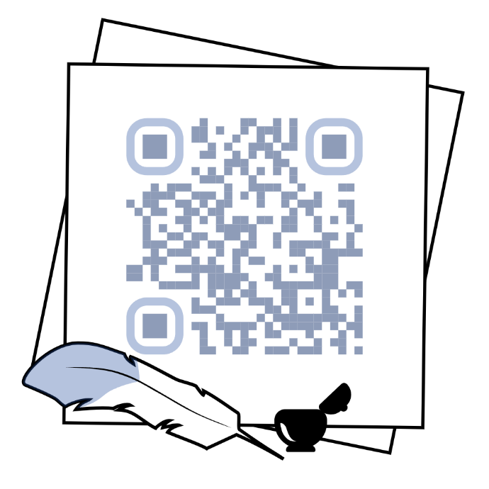
Zero Conditional Usage
1.
2.
First Conditional Usage
1.
2.
II. Create similar dialogues using 0,1 conditionals.
III. Read the rules and memorise them.
Zero Conditional Formation:
Affirmative form
If + Present Simple, Present Simple
If you want to keep fit, you should exercise at least 3 times a week.
If the traffic light changes to amber, drivers must stop
Negative form
If you can’t see this text, you need glasses.
People can't fish in this river unless they have a permit.
Interrogative form
“If you drop an object, does it fall to the ground?”
“Doesn’t water freeze when it’s 0°C?”
It is also possible to form Zero Conditional with Present Continuous and Present Perfect, e.g.
If + Present Continuous, Present Continuous
If he’s driving now, he’s listening to the radio.
If + Present Continuous, Present Simple
If the baby is sleeping, she can relax.
If + Present Simple, Present Continuous
If you’re overweight, you’re probably eating too much fatty food and sugar.
If + Present Perfect, Present Simple
If I've eaten too much for breakfast, I tend to feel sleepy in the afternoon.
When we’ve finished work, we go to the swimming pool.
If he has moved into his new flat, he doesn’t need to take a bus anymore.
First Conditional Formation:
Affirmative form
If + Present Simple, Future Simple + bare infinitive
If the weather is nice, we will go to the park with you.
If Harry takes one more photo of Jane, I’m sure he will ask her out.
Negative form
If + Present Simple, Future Simple in negative + bare infinitive
If it rains, I won’t go anywhere.
If any russian singer participates in this concert, believe me I won’t come.
If + Present Simple in negative, Future Simple + bare infinitive
If they don’t stop behaving like this, I will call their mum.
If you don't read the instruction, you will be lost in zoom settings during the meeting.

Interrogative form
If + Present Simple, Future Simple + bare infinitive?
If you are ill, will you go to the office tomorrow anyway?
Where will David live if he leaves home?
Substitutes to “if”
1. When – коли
When I become a boss, I will fire Rose anyway.
2. Unless – поки, допоки
Unless you learn all the words by heart, you won’t play computer games.
3. As long as – поки, за умови що
As long as you love me, I'll protect you from all of the enemies
4. As soon as – щойно, як тільки
As soon as I cancel our meeting with them, our cooperation will be finished.
5. After – після
After you promise not to yell at me anymore, we will have a discussion.
First vs. Zero Conditional:
The first conditional describes a particular situation, whereas the zero conditional describes what happens in general.
For example (zero conditional): if you sit in the sun, you get burned (here I'm talking about every time a person sits in the sun - the burning is a natural consequence of the sitting)
But (first conditional): if you sit in the sun, you'll get burned (here I'm talking about what will happen today, another day might be different).
Ex.1 Use the verbs in brackets and form zero conditional sentences.
If you ___________ (to mix) red and green, you ___________ (to get) brown.
If you ___________ (to drop) a glass on the floor(to drop), it ___________ (to break).
If babies ___________ (to be) hungry, they ___________ (to cry).
When you ___________ (to add) sugar, the sauce ___________ (to taste) sweet.
Water ___________ (to boil) if you ___________ (to heat) it to 100 °C.
Plants ___________ (to die) if they ___________ (not/to get) enough water.
If you ___________ (to put) water in the freezer, it ___________ (to become) ice.
When the sun ___________ (to rise), the street lights ___________ (to go out).
When you ___________ (to heat) ice, it ___________ (to melt).
He always ___________ (to take) his umbrella when it ___________ (to rain).
Ex.2 Write conditional sentences.
01.- she / arrrive , please call me.
_____________________________________________________________________
02.- my mum / be busy, I help her.
_____________________________________________________________________
03.- I can't run I / eat too much.
_____________________________________________________________________
04.- you / buy today, you save money.
_____________________________________________________________________
05.- it / be hot, I drink water.
_____________________________________________________________________
06.- We wait for you you / come with us.
_____________________________________________________________________
07.- You can sit here you / want.
_____________________________________________________________________
08.- Correct me I / be wrong.
_____________________________________________________________________
09.- What happens I / press the button?
_____________________________________________________________________
10.- We don't know we / can do that.
_____________________________________________________________________
11.- I am sad you / not love me.
_____________________________________________________________________
12.- What do you eat you / be hungry?
_____________________________________________________________________
Ex.3 Continue the story, which starts "If you heat water to 100 degrees Celsius, it boils." by making a zero conditional statement. One sentence per person.
Ex.4 Answer the zero conditional questions by choosing the correct number for each one. Just write the CORRECT NUMBER next to each question.

1. I ask him to speak more slowly
2. He tells me to shut up!
3. I make an appointment to see the dentist.
4. I call ahead to say I'm late.
5. I lock my door and study for a week.
6. I read a book for half an hour.
7. I don't do anything, but I never return.
8. I look out of the window.
9. I remember how important it is to learn!
10. I watch a DVD.
11. They tell me to be more considerate.
12. I go and lie down.
13. I eat a few crackers.
14. I eat something and that wakes me up.
15. I put pressure on the area but nothing else.
16. I use my mother's face cream to cool my skin.
17. I go back to the store with it.
18. They forget mine the next time.

- What do you do if you get a headache?
- What do you do if you feel bored in your English class?
- What do you do if you get toothache?
- What do you do if you get sunburnt?
- What do you do if you can't sleep at night?
- What do you do if you feel sleepy during the day?
- What do you do if you don't understand your English teacher?
- What do you do if you don't want to do your English homework?
- What does your teacher do if you talk in class?
- What do your parents do if you are not in touch regularly?
- What do you do if you oversleep?
- What do your friends do if you forget their birthdays?
- What do you do if you have to prepare for a difficult exam?
- What do you do if you feel hungry at night?
- What do you do if there is nothing on TV?
- What do you do if you cut yourself?
- What do you do if you receive bad service in a restaurant?
- What do you do if something you buy breaks after a few days?
Ex.5 Supply the suitable forms of the verbs in brackets.
1. If it doesn't ___________ (rain), plants cannot grow.
2. If I ___________ (try) to cook, I ruin the food.
3. If you smoke, your skin ___________ (age) more quickly.
4. If you heat ice, it ___________ (melt).
5. I feel good if you ___________ (visit) me regularly.
6. Water evaporates if you ___________ (boil) it.
7. Deren ___________ (cycle) to work if the weather is good.
8. I feel sick if I ___________ (eat) too much chocolate.
9. You need to take my sister to the hospital if she ___________ (drink) milk as she is allergic to it.
10. If Andy ___________ (go) to bed late, he cannot wake up early.
Ex.6 Put the verbs in brackets into the gaps. Make Zero Conditional.
1.If Kelly ___________ badly at night, she drowsy the next day. (sleep / feel)
2. If the weather___________ rainy, I ___________ my raincoat. (be / put on)
3. If Kevin___________ breakfast, he___________ less energetic. (not have / feel)
4. If I ___________ for a long time, my feet ___________. (walk / hurt)
5. If you ___________ happy, you ___________ to share your happiness with the whole world. (be / want)
6. If I ___________ a toothache, I ___________ to see a dentist. (have / go)
7. If the sun ___________ brightly, all plants and flowers ________ fast. (shine / grow)
8. If my fridge ___________ empty, I ________ at the nearest supermarket. (be / shop)
9. If you _______ ghosts, there ______ nothing scary for you in that old house. (not believe in / be)
10. If a student _________ a lot of mistakes in his test, he _______ it. (make / not pass)
11. If the political situation___________ for the worse, people _________ to other countries. (change / emigrate)
12. If you ___________ many problems every day, you ___________ tired and stressed over time. (solve / get)
13. If something ___________ wrong with your car, take it to the service center. (go)
14. We ___________ frustrated if we ___________ what we want. (fell / not get)
15. The flowers ___________ in hot weather if you _________ them. (fade / not water)
Ex.7 Discusses your daily routines and habits with a partner using the zero conditional.
Ask and answer questions about what happens if your partner does certain things during their day.
Example Dialogue:
Student A: "What happens if you don't set an alarm in the morning?"
Student B: "If I don't set an alarm, I wake up late. What do you do if you finish work early?"
Student A: "If I finish work early, I go for a walk in the park."
Ex.8 Write zero conditional sentences using the prompts.
1 you / record / a programme on the hard dish recorder / you / can / watch it later
_____________________________________________________________________
2 It / not matter / you / be / late
_____________________________________________________________________
3 He / get / bad-tempered / he / not have / enough sleep
_____________________________________________________________________
4 I / always / feel / happy / I / listen to / reggae music
_____________________________________________________________________
5 I / be worried / about something / I / talk / about it / with my friends
_____________________________________________________________________
Ex.9 Complete the exercise online.

Ex.10 Put the verbs in brackets into the gaps. Form a Conditional sentence – type I. Only use the will-future in the main clauses.
- If I ___________ (to study), I ___________ (to pass) the exams.
- If the sun ___________ (to shine), we ___________ (to walk) into town.
- If he ___________ (to have) a temperature, he ___________ (to see) the doctor.
- If my friends ___________ (to come), I ___________ (to be) very happy.
- If she ___________ (to earn) a lot of money, she ___________ (to fly) to New York.
- If we ___________ (to travel) to London, we ___________ (to visit) the museums.
- If you ___________ (to wear) sandals in the mountains, you ___________ (to slip) on the rocks.
- If Rita ___________ (to forget) her homework, the teacher ___________ (to give) her a low mark.
- If they ___________ (to go) to the disco, they ___________ (to listen) to loud music.
- If you ___________ (to wait) a minute, I ___________ (to ask) my parents.
Ex. 11 Put the verbs in brackets into the gaps. Form a Conditional sentence – type I.
1. If it ___________ (rain) tomorrow, we will cancel the picnic.
2. If I ___________ (finish) work early, I will go to the cinema.
3. She will fail the exam if she ___________ (not study) tonight.
4. If he ___________ (eat) too much ice cream, he will get a stomachache.
5. They will come to the party if they ___________ (get) an invitation.
6. If we ___________ (not hurry), we will miss the train.
7. If you ___________ (water) the plants, they will grow faster.
8. She will be happy if you ___________ (give) her a present.
9. If he ___________ (practice) more, he will become a great musician.
10. We will go for a walk if it ___________ (stop) snowing.
11. If you ___________ (not wear) warm clothes, you will catch a cold.
12. They will buy a new car if they ___________ (save) enough money.
13. If I ___________ (see) Sarah, I will give her your message.
14. If you ___________ (need) help, just call me.
15. If the weather ___________ (be) nice, we will have a barbecue.
Ex.12 Discusses your future plans and make predictions about what will happen if certain conditions are met. Think about your education, career, travel, and personal goals.
Ex.13 Put the verbs in brackets into the gaps. Form a Conditional sentence using negative form.
1. If you ___________ (not study) for the test, you will fail.
2. If it ___________ (not rain) tomorrow, we will play soccer.
3. She will not go to the party if she ___________ (not feel) well.
4. We will not be late if we ___________ (leave) now.
5. If you ___________ (not buy) a ticket, you cannot enter the concert.
6. If he ___________ (not apologise), she will be upset.
7. We will not have dessert if we ___________ (not finish) our dinner.
8. If they ___________ (not call) us, we will not know the news.
9. If she ___________ (not wear) a coat, she will be cold.
10.If the bus ___________ (not come) on time, we will take a taxi.
11. If you ___________ (not pay) the bill, they will cut off the electricity.
12. She will not pass the exam if she ___________ (not study) harder.
13. They will not win the game if they ___________ (not practice) enough.
14.If you ___________ (not book) a hotel, we will have nowhere to stay.
15. If it ___________ (not snow) this weekend, we will not go skiing.
Ex. 14 Fill in the gaps using appropriate words
don’t arrives forget don’t hurry
study doesn’t rain saves
1. If you ___________ hard, you will pass the exam.
2. They will go for a hike if it ___________ tomorrow.
3. If she ___________ early, we can catch the first show.
4. We will miss the bus if we ___________.
5. If he ___________ enough money, he will buy a new laptop.
6. You will get wet if you ___________ your umbrella.
7. They will be disappointed if we ___________ attend the party.

Ex. 15 Complete the exercise online
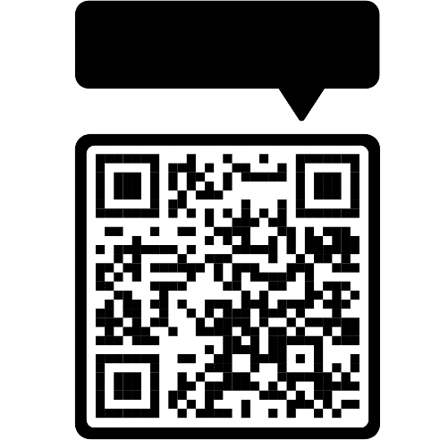
Ex. 16 Complete the Conditional Sentences (Type I) by putting the verbs into the correct form.
- If I ___________ (do) this test, I ___________ (improve) my English.
- If I ___________ (find) your ring, I ___________ (give) it back to you.
- Peggy ___________ (go) shopping if she ___________ (have) time in the afternoon.
- Simon ___________ (go) to London next week if he ___________ (get) a cheap flight.
- If her boyfriend ___________ (phone / not) today, she ___________ (leave) him.
- If they ___________ (study / not) harder, they ___________ (pass / not) the exam.
- If it ___________ (rain) tomorrow, I ___________ (have to / not) water the plants.
- You ___________ (be able/ not) to sleep if you ___________ (watch) this scary film.
- Susan ___________ (can / move / not) into the new house if it ___________ (be / not) ready on time.
Ex. 17 Work in small groups of 3-4. Each group picks a dilemma and discusses possible solutions using the first conditional. Groups present their dilemma and solutions to the class.
Dilemma 1: "You have a big project due next week, but your best friend is throwing a birthday party this weekend."
Dilemma 2: "Your friends are pressuring you to try smoking, but you know it's unhealthy and against your values."
Dilemma 3: "You are part of the school basketball team and the drama club, but both have important events scheduled for the same day."
Dilemma 4: "A classmate has been bullying you, and you are considering telling a teacher or confronting the bully."
Dilemma 5: "You have a lot of homework and you also want to catch up on your favorite TV series, but you need to wake up early for school."
Ex. 18 Choose the correct answer.

1.You ... a good time if you go to the party.
- Have
- Will have
- Will be having
2. If ... natural ingredients, the food will taste much better.
- You use
- You’re using
- You will use
3. If Frank doesn't play well, the manager ... a new captain.
- Is choosing
- Chooses
- Will choose
4. If you ... TV tonight, you won't see your favourite programme.
- Won’t watch
- Don’t watch
- Aren’t watching
5.If the weather's OK, ... a picnic.
- We’ll have
- We have
- We’d have
6.If it isn't raining, ... to the museum.
- We don’t go
- We aren’t going
- We won’t go
7.If you save enough money, ... those DVDs?
- Will you buy
- Do you buy
- Are you buying
8.Will you go to the play if ... in it?
- Dad will be
- Is Dad
- Dad is
9.If the reporter comes, ... a cameraman with him?
- Is he bringing
- Does he bring
- Will he bring
10.If you ... the receipt, you won't get your money back.
- Not keep
- Don’t keep
- Won’t keep
11.If the children don't visit the archaeological dig, they ... the ancient carvings.
- Won’t see
- Aren’t seeing
- Don’t see
12.If you go to the cinema, which film ... ?
- Do you see
- Will you see
- You will see
13.Will you learn your lines earlier if you're acting in the play this year? ~ Yes,
... .
- I will
- I do
- I am
14.If you don't get a new bike, will you take part in the race next month? ~
...
- No, I not take part.
- No, I won’t.
- No, I don’t.
15.Will Mum buy the costumes for us if we don't go to the carnival? ~ ...
- No, she doesn’t.
- No, she won’t.
- No, she isn’t.
16.If they buy solar panels, ... less money on electricity.
- They’ll spending
- They spend
- They’ll spend
17.You'll cause less pollution if ... an electric car.
- You’ll drive
- You drive
- You’ll driving
18.... to the beach if it rains?
- You’ll go
- Do you go
- Will you go
19.If we ... more rubbish, we won't help the environment.
- Won’t recycle
- Don’t recycle
- Aren’t recycling
20.If I buy some paint, ... the kitchen?
- Do you paint
- Will you paint
- Will you be painting
21.... outside if it doesn't rain?
- Do we play
- Will we play
- Will we be playing
22.... a picture, I'll draw a spaceship.
- If I’ll paint
- I’ll paint
- If I paint
23.If the photographer doesn't come, my picture ... in the newspaper.
- Isn’t be
- Won’t be
- Isn’t
24.Will you buy the tickets if ... to the cinema?
- We will go
- We go
- Do we go
25.If you learn the first conditional, ... better English!
- You’ll speak
- You speak
- You’ll speaking

Ex. 19 Work in groups of 4-5. Each group starts with a simple scenario (e.g., "You find a mysterious map"). Take turns adding to the story using the first conditional, building on what the previous student said. After the story is complete, each group presents their story to the class.
Ex. 20 Complete the exercise online


I. Warmer
a. Discuss these questions with a partner.
1. Over the last few decades, life expectancy has generally increased across many parts of the world. Why do you think this is?
2. What factors do you believe have the most significant impact on life expectancy? Why?
3. In what ways do you think education can impact life expectancy?
Ex. 1. Skim the text. Read the first sentence only of each paragraph in the reading passage. Then, put these paragraphs description into the same order as the passage itself. Write the number of one paragraph 1-9 beside each one.
______ This paragraph questions whether the benefits of education on lifespan will persist, considering current and future socioeconomic conditions like affordable housing and career earnings.
______ This paragraph explains that the study is the first to quantify the impact of education on reducing mortality, although similar associations have been noted in the past.
______ This paragraph introduces a study linking education to increased life expectancy, comparing the impact of not attending school to smoking or heavy drinking.
______ This paragraph warns that high rates of school absences could result in children missing out on future health benefits, emphasizing broader implications such as labor market outcomes.
______ This paragraph supports increased investment in education to reduce global mortality inequalities, with the meta-analysis backed by significant research funding.
______ This paragraph discusses the study's findings, showing a 2% decrease in mortality risk for each year of full-time education, and equates the benefits of education to a healthy diet.
______ This paragraph presents David Finch's perspective on life expectancy inequalities in the UK, emphasizing differences in lifespan between the most and least deprived areas.
______ This paragraph highlights the study's relevance to policy efforts in England, suggesting that increased school attendance could boost life expectancy.
______ This paragraph discusses how education improves life expectancy through non-financial benefits like better social connections and decision-making abilities, in addition to financial gains.

Every year spent in school or university improves life expectancy, study says
Analysis also says not attending school is as deadly as smoking or heavy drinking Richard Adams 23 January, 2024
- Every year spent in school or university improves our life expectancy, while not attending school is as deadly as smoking or heavy drinking, according to the first systematic study directly linking education to gains in longevity.
- Using evidence from industrialised countries such as the UK and US as well as developing countries such as China and Brazil, the review found that an adult’s risk of mortality went down by 2% for every year in full-time education. Completing primary, secondary and tertiary education is the equivalent of a lifetime of eating a healthy diet, lowering the risk of death by 34% compared with those with no formal education, according to the peer-reviewed analysis in The Lancet Public Health journal. At the opposite extreme, not attending school at any point was as bad for adult health as consuming five or more alcoholic drinks every day or smoking 10 cigarettes each day for a decade.
- The study adds impetus to efforts in England to ensure children stay at school, with experts saying the results underline connections between school attendance and health. It also implies that increases in the school-leaving age and rising numbers of young people staying on into further and higher education could add years to future levels of life expectancy.
- While the benefits of education on life expectancy have long been recognised, the review by academics at the Norwegian University of Science and Technology (NTNU) and the University of Washington in Seattle is the first to calculate the number of years of education and its connections to reducing mortality. Neil Davies, Professor of Medical Statistics at University College London and an expert on the links between education and health, who was not involved in the research, described it as “an impressive piece of work”. But Davies cautioned that associations seen in the past may change, given the UK’s recent expansion in higher education and other factors such as the decline in smoking so that rates are now similar among graduates and non-graduates.
- Higher rates of school absences could also see children missing out on the future health benefits, Davies noted, saying, “It’s worth noting that the increased rates of absence from school have major consequences beyond their effect on health. The relationship between time spent in education and earnings has been very well studied and is pretty robust. This is also likely to be worse for more disadvantaged students. Quite honestly, the links between education and mortality are the least of our worries about the increased rates of school absence – the labour market consequences are likely to be worse.”
- The researchers said the meta-analysis, backed by the Norwegian government’s research fund and the Bill & Melinda Gates Foundation, was “compelling evidence” in support of increased investment in education as a way to reduce inequalities in global death rates. “Education is important in its own right, not just for its benefits to health, but now being able to quantify the magnitude of this benefit is a significant development,” said Dr Terje Andreas Eikemo of NTNU, the study’s co-author. The analysis also found the improvements in longevity to be similar in rich and poor countries, and regardless of sex, social class and demography.
- David Finch, an assistant director of the Health Foundation who has studied life expectancy as part of its Healthy Lives team, said: “We have really big inequalities in the UK. The gap in life expectancy between the least and most deprived areas in England is 9.4 years for men and 7.7 years for women, and it isn’t surprising that you see a significant difference when comparing by qualification level. So it’s not surprising in that sense but it’s really interesting to see it quantified.”
- Finch said a greater level of education improved life expectancy in different ways, including through ‘soft’, non-financial benefits. “It helps you to build better social connections. It makes you better at accessing and understanding information that can help you make better choices, essentially, whether it’s financial or what you choose to do and participate in,” Finch said. “It can help you feel empowered and valued. Those are slightly softer and really important things that can help people. A key channel is through which education leads to higher lifetime earnings and that itself in turn helps you to access lots of other things that are really important, like better quality of housing, a better diet.”
- Finch said that whether a longer lifespan would continue to be enjoyed by those who spend longer in education depends on whether benefits remain in place. “Will that translate into better standards of living over their lifetimes, in the future? That’s where there is a question: can people access affordable housing? Are young people’s career earnings trajectories what they were for people 30 or 40 years ago, at the same age? The prospects aren’t as rosy,” Finch said.
Ex. 2 Now consider the overall structure of this reading. Is it a description, a comparison or an argument?
Ex. 3 Work with a partner to complete the brief summary of this reading passage. Speak do not write.
This passage is about…. It compares…. The main idea is…
Ex. 4 Multiple choice task. There is one the correct answer for each paragraph.
1. What is the main finding of the study mentioned in this paragraph?
a) Education decreases the likelihood of developing chronic diseases.
b) Not attending school has no significant impact on life expectancy.
c) Education improves life expectancy, and not attending school is as harmful as smoking or heavy drinking.
d) Attending university is more beneficial than attending school.
2. How much does an adult’s risk of mortality decrease for each year of full-time education?
a) 1%
b) 2%
c) 5%
d) 10%
3. What implication does the study have for education policy in England?
a) Reducing school hours to improve health.
b) Ensuring children stay in school to improve life expectancy.
c) Encouraging more physical education classes.
d) Limiting the number of school absences allowed.
4. What is unique about the study conducted by NTNU and the University of Washington?
a) It is the first to link education to chronic diseases.
b) It is the first to quantify the number of years of education in relation to reduced mortality.
c) It is the first to study education's impact on mental health.
d) It is the first to compare different countries' educational systems.
5. What concern does Davies raise about higher rates of school absences?
a) They could lead to increased smoking rates among students.
b) They may prevent children from achieving higher earnings and other benefits.
c) They could reduce the amount of physical activity children receive.
d) They may lead to overcrowded classrooms.
6. What do the researchers advocate for based on their findings?
a) Increased investment in healthcare systems.
b) More research on the effects of diet on longevity.
c) Increased investment in education to reduce global mortality inequalities.
d) Higher taxes to fund public health campaigns.
7. What does David Finch highlight about life expectancy in the UK?
a) It is consistently improving across all regions.
b) It shows significant disparities between the most and least deprived areas.
c) It is higher than in most other industrialised countries.
d) It is not influenced by levels of education.
8. According to Finch, how does education improve life expectancy?
a) Primarily through increased financial earnings.
b) By providing better social connections and decision-making abilities.
c) Mainly by reducing the risk of infectious diseases.
d) By guaranteeing higher job positions.
9. What concern does Finch raise about the future benefits of education?
a) The quality of education is declining.
b) Economic and living conditions may change, affecting the longevity benefits.
c) Education may become too expensive for most people.
d) The curriculum may not adapt to future needs.
Ex. 5 Summary of the passage using words from the box. There are more words than gaps.
health, mortality, systematic, school, smoking, longevity, primary, absences, inequalities, investment, diet, financial, Norway, evidence, UK, attendance, experts, disadvantaged, earnings, university, education, connections
Summary:
- A __________ study has linked __________ to increased __________, showing that each year spent in school or __________ improves life expectancy, while not attending school is as harmful as __________ or heavy drinking.
- Using __________ from various countries, the study found that an adult's risk of __________ decreases by 2% for every year in full-time __________. Completing various levels of education is as beneficial as maintaining a healthy __________.
- The study's findings support efforts in the __________ to ensure children stay in __________, highlighting the connection between school __________ and __________.
- This review by academics from __________ and the University of Washington is the first to quantify the number of years of education and its impact on reducing __________.
- Neil Davies, though not involved in the research, noted the study's significance but warned that higher rates of school __________ could cause children to miss out on future __________ benefits and affect __________ outcomes, especially for __________ students.
- The researchers advocate for increased __________ in education to reduce global __________ in death rates, with support from significant funding sources.
- David Finch from the Health Foundation pointed out the significant __________ in life expectancy within the __________, especially between the most and least deprived areas.
- Finch also emphasized that education improves life expectancy through both __________ and non-__________ benefits, such as better social connections and improved decision-making skills.
- Finch questioned whether the benefits of education on lifespan will continue, given future challenges related to living standards and __________.
Ex. 6 Are these sentences true (T) or false (F) according to the article? Correct the false sentences, underlining the corresponding evidence in the text.
1. The study focused on both developed and developing countries in different regions.
2. The consequences of a lack of formal education are comparable to leading an unhealthy life.
3. This is the first study to acknowledge the relationship between education and life expectancy.
4. Davies stated other factors are at play and may alter results.
5. Davies asserts that school absences are directly linked with unemployment levels.
6. Researchers found that investment in education will not impact inequalities in the short term.
7. The study concluded that the impact of education varies considerably depending on region and other individual factors.
8. Finch believes the greatest contribution of this study is measuring the impact of education.
9. According to Finch, education impacts people’s lives in both tangible and intangible ways.
10. Finch is confident the impact of education on longevity will not change over time.
Ex. 7 Complete the phrases from the article with the correct form of the words in brackets.
1. Not attending school is as ________________ as smoking or heavy drinking. (DEAD)
2. Using evidence from ________________ countries such as the UK and US as well as developing countries such as China and Brazil, the review found that an adult’s risk of mortality went down by 2% for every year in full-time education. (INDUSTRY)
3. Completing primary, secondary and tertiary education is the equivalent of a lifetime of eating a healthy diet, ________________ the risk of death by 34%. (LOW)
4. This is also likely to be worse for more ________________ students. (ADVANTAGE)
5. ‘Quite ________________, the links between education and mortality are the least of our worries.’ (HONEST)
6. ‘Education is important in its own right, not just for its benefits to health, but now being able to________________ the magnitude of this benefit is a significant development.’ (QUANTITY)
7. Can people access ________________ housing? (AFFORD)

ACTIVE VOCABULARY

Ex. 8 Scan the text. Find these words in the text, highlight them and translate them in accordance with the context.

Absence
Attendance
Compelling
Decline
Deprived
Earnings
Empowered

Inequalities
Investment
Longevity
Magnitude
Rates
Regardless of
Robust
Systematic

Ex. 9 Match the words in the wordpool with their definitions.
absence attendance compelling decline deprived earnings empowered inequalities investment longevity magnitude rates regardless of robust systematic
1. following a method or plan
2. living for a long time
3. being present at a particular place or event
4. reduction
5. not being where you are expected to be
6. the number of times something happens over a certain period
7. amount of money someone receives in exchange for their work
8. strong, solid
9. an argument or statement so strong that makes you believe in it
10. putting resources, such as money or time, into something that can lead to benefits
11. unfair situations and differences in opportunities and treatment between individuals
12. the size, scale or extent of something
13. despite
14. lacking essential resources necessary for a satisfactory standard of living
15. confident and in control of your own life and decisions
Ex. 10 Use some of the key words above to complete these sentences. You may need to change the form of the word.
1. The project needs to be completed, ________________ how much it costs.
2. The unemployment has been increasing steadily over ____________ recent months.
3. Her have increased significantly due to her hard work ____________ and dedication.
4. _______________________ need to be diversified to minimise risks and maximise potential gains.
5. Their assessment of the situation is _________ , providing a comprehensive analysis.
6. Please remember that student ___________________ to lessons will be tracked.
7. Different types of _______________ are evident throughout society, such as limited
access to education.
8. Do you know the reason for his ___________________from work today? Is he sick?
9. They presented evidence that exercise can also improve our _____________mental health.
10. There’s been a sharp ___________ in international students coming in September.
Phrasal Verbs with GO

Phrasal Verb | Meaning | Translation | Example
Go after | Pursue (an object or a goal) |  | Emma was encouraged to go after her dreams and now she is an actress.
- Go along  - Go along (with) | - Continue an activity  - Agree with; accept; support an idea |  | - He added funny details to the story as he went along.  - Alex tends to go along with anything his wife says.
Go away | - Leave a place  - Disappear |  | 1.We decided to go away for a few days.  2.I still can't get the stain to go away.  -The medication should make the pain go away.
Go back | Return |  | Children go back to school after the holidays.
Go by | Pass |  | Put up your hand or the bus will go by without stopping.  Time goes by so quickly!
Go down  Go down with | 1. Decrease; reduce  2. Become ill with a disease |  | 1.The price of property has gone down a bit lately.  2.Half the team has gone down with the 'flu.
Go for | Try to achieve or attain |  | Jack trained hard and decided to go for the gold medal.
Go in | Enter |  | There's a hotel. Let's go in and book a room.
Go into (+noun) | - Enter  - Join or enter a profession |  | - Go into the bakery and see if they sell croissants.  - Tom decided to go into the army when he left school.
Go in for | Have something as a hobby |  | Anne really doesn't go in for sports.
Go off | 1.Explode  2. Ring/make a loud noise  3. Stop working  4. No longer good to eat or drink  5. No longer like or enjoy |  | 1. A bomb went off in a crowded restaurant.  2. The alarm clock was set to go off at 6 am.  3. The heating has gone off. It's freezing in here!  4.The milk has gone off. Don't drink it.  5. My grandmother has gone off doing crosswords.
Go on | Continue |  | Sorry for interrupting. Please go on.
Go out | - Leave one's home to attend a social event  - Stop burning; be extinguished  - Be sent |  | 1.Many young people go out a lot.  2.The lights went out before we got to the door.  3. The letter went out yesterday.
Go out with | Have someone as a boyfriend/girlfriend |  | Is Julie going out with Tom?
Go over | Review |  | Please go over your answers before handing in your paper.
Go up | Increase; rise |  | The price of petrol is expected to go up.
Go through Go through with | 1.Experience  2.Examine; Study carefully  3.Proceed with something |  | 1.Pete went through a lot of pain after the accident.  2.You should go through the contract before signing it.  3.Bill and Amy finally went through with the divorce.
Go with/together | Match; harmonise with |  | That jacket doesn't go with the skirt.
Go without | Abstain from; skip |  | Tony had to go without lunch to finish the report.

Ex. 11 Replace the verb in brackets with ‘go’ (in the correct tense) and the correct preposition or adverb.
Example: We decided to (return) to the same hotel. => We decided to go back to the same hotel.

- Michael decided to (agree) with his father's suggestion.
  - go after
  - go along
  - go for
- You should always (examine carefully) a contract before signing it.
  - go down
  - go into
  - go through
- The red mark on my sweater didn't (disappear) even though I washed it.
  - go off
  - go away
  - go out
- Camels are known to (abstain from, not need) water for long periods.
  - go through
  - go off
  - go without
- Taxis (pass) all the time but none of them ever stop.
  - go by
  - go away
  - go over
- That blouse doesn't (match) your skirt.
  - go after
  - go along with
  - go with
- Our teacher has (become ill) with a bad cold.
  - gone off
  - gone down
  - gone out
- The electricity (stopped working) because of heavy flooding.
  - went down
  - went away
  - went off

Ex. 12 Scan the qr code and complete the exercise online.

Ex. 13 For each space in each sentence, use the verb Go (in the correct tense) with one of the prepositions from the box. Sometimes you need to put the object/pronoun between the main verb and the preposition - in these cases, the object/pronoun can be found in the brackets.

On about For Over Through Off Off Down with
Over Through Off
1. Susan has ________________the flu and can't accompany us to the theatre this evening. What a shame!
2. Steve's dishonesty at the meeting has really made me has ________________ him.
3. I want to has ________________the solution again. I didn't really understand it.
4. The Hornets need to win their final match by two points to has ________________ to the final.
5. A car bomb has ________________ in Madrid this morning near the parliament. Nobody was injured.
6. If you keep has ________________ about your damn new car anymore, I will stop listening to you. Change the subject!
7. If you try to sell this on the open market, it could has ________________ around $5000.
8. If the President makes a speech about raising taxes, it won't has ________________very well.
9. Something has has ________________ in this fridge. There's a terrible smell!
10. After the divorce, I has ________________ a lot before finding my self-confidence again.
Ex. 14 Choose the correct preposition to complete each of the following sentences.

1. My alarm clock went ________ ( = started to ring) at 7:00 AM.
- off
- on
- in
2. Go ________. = Continue.
- on
- up
- away
3. Go ________! = Leave!
- on
- up
- away
4. They went ________ ( = They pursued) the contract.
- away
- after
- along
5. I could really go ________ some fries. = I would really like to eat some fries.
- up
- with
- for
6. It's hard to go ________ things as usual. = It's hard to continue doing things as I did them before.
- about
- along
- around
7. Prices went ________ ( = increased) last year.
- up
- out
- over
8. Let's go ________ ( = review) your notes.
- along
- out
- over
9. Many business are going ________ ( = failing/going bankrupt).
- out
- over
- under
10. Mike and Tina are going ________. = Mike and Tina are a couple (boyfriend + girlfriend).
- out
- off
- on

Ex. 15 Choose the correct answer.

- Allowing people to smoke in her house goes ....... her principles.
- in
- against
- with
- I know I promised, but I really can't go ...... with it.
- through
- under
- off
- You go ....... and I'll follow later.
- with
- to
- ahead
- She went ........ with flu last week.
- up
- through
- down
- She's brought a couple of friends with her; do you think there's enough food to go .........
- to
- for
- round
- It's getting late; I think we should go ....... home now.
- back
- with
- to
- I was really surprised when my dog attacked the postman; he really went .... him.
- to
- for
- with
- She went ........ her notes before the exam to try to learn every last detail.
- round
- over
- into
- The price of petrol went ..... by five pence, which made motorists very angry.
- down
- up
- through
- I feel so guilty because he spoke about killing himself, but I never thought that he would go ..... with it.
- down
- into
- through
- She went ........ politics as soon as she had completed her degree.
- with
- round
- into
- A bomb went ....... in the town centre last night.
- on
- off
- to
- She's been going ...... with her boyfriend since they were at university.
- out
- off
- on
- Do brown shoes go ...... a light-grey suit?
- in
- for
- with
- The price of petrol went ..... last week when the Government reduced the price.
- in
- to
- down
- The day the country became a republic went ....... in history.
- up
- down
- to
- It smells awful; I think the milk's gone .......
- down
- off
- out
- He went ....... his parents' hopes and became a missionary.
- against
- in
- to

Ex. 16 Scan the qr code and complete the exercise online.

Ex. 17 Fill in the blanks using the words in the box below, then check your answers.
away by down into off on out over through under
1. They were party animals in college. They went ________almost every night and rarely came home before four o'clock in the morning.
2. I am sorry I interrupted you. Please, go ________ . I really want to hear the end of your story.
3. Our neighbor's car alarm went ________ several times last night, so I didn't sleep well at all.
4. The project is classified by the military, so I am not allowed to go ________ the details. Let's just say it's going to cost the government a lot of money.
5. The test is fairly complicated. I would suggest going ________ your notes from class a couple of times before you try to take it.
6. I'll mail that letter for you. I go ________ the post office on my way to work.
7. Did you see that news report about the hikers who were lost in the mountains for more than a week? I couldn't believe everything they went ________ . Their story was absolutely incredible.
8. Jerry really struggled to keep his business going. But after months without any customers, it finally went ________.
9. I had the hiccups for over half an hour. Luckily, my friend Jane showed me a trick to make them go ________ .
10. The doctor made Joe lie in a cold bath to help his fever go ________ .
ESSENTIAL VOCABULARY
expectancy - /ɪkˈspek.tən.si/ - тривалість
- Common Collocations: life expectancy, high expectancy
- Example: They have a short life expectancy because of the hardship they endure.
deadly - /ˈdedli/ - смертельний, жахливий
- Common Collocations: as deadly as, deadly disease
- Example: The Ebola virus is known to be a deadly disease, causing widespread fear and devastation.
evidence - /ˈevɪdəns/ - доказ
- Common Collocations: compelling evidence, corresponding evidence
- Example: The lawyer presented compelling evidence that led to the suspect’s conviction.
industrialised - /ɪnˈdʌstriəlaɪzd/ - промислово розвинений
- Common Collocations: industrialised nation, industrialised country
- Example: Japan is one of the most industrialised nations in the world, known for its advanced technology and manufacturing.
review - /rɪˈvjuː/ - огляд
- Common Collocations: peer review, comprehensive review
- Example: The scientist conducted a comprehensive review of the current research on climate change.
mortality - /mɔːˈtæləti/ - смертність
- Common Collocations: mortality rate, reduce mortality
- Example: The mortality rate in the region has decreased significantly due to improvements in healthcare.
extreme - /ɪkˈstriːm/ - крайність, надмірність
- Common Collocations: opposite extreme, from one extreme to the other,
- Example: He went from one opposite extreme to another, first eating no sugar and then consuming excessive amounts.
impetus - /ˈɪmpɪtəs/ - імпульс, поштовх
- Common Collocations: provide impetus, impetus for change
- Example: The new policy provided the necessary impetus for economic growth.
ensure - /ɪnˈʃɔːr/ - гарантувати
- Common Collocations: ensure safety, ensure success
- Example: The manager took steps to ensure the safety of all employees during the construction project.
caution - /ˈkɔːʃən/ - застерігати
Common Collocations: caution someone, caution strongly
Example: Parents cautioned their children not to talk to strangers.
Expansion - /ɪkˈspænʃən/ - розширення
- Common Collocations: rapid expansion, recent expansion
- Example: The company’s rapid expansion into new markets has been a significant success.
Reduce - /rɪˈdjuːs/ - зменшити
- Common Collocations: reduce mortality, reduce inequality
- Example: The government has implemented measures to reduce inequality at working places
Consequence - /ˈkɒnsɪkwəns/ - наслідок
- Common Collocations: serious consequence, major consequence
- Example: The serious consequence of the accident was that several people were injured.
labour - /ˈleɪbər/ - праця
- Common Collocations: labour market, manual labour
- Example: The labour market has seen a significant shift with more people working in technology-related jobs.
sex - /seks/ - стать
- Common Collocations: sex discrimination, sex differences
- Example: The study focused on the differences in health outcomes based on sex and age.
social class - /ˈsəʊʃəl/ - соціальний клас
- Common Collocations: working class, social class system
- Example: The book examines the impact of social class on educational attainment.
demography - /dɪˈmɒɡrəfi/ - демографія
- Common Collocations: changing demography, demography study
- Example: The changing demography of the country has significant implications for its economic policies.
access - /ˈækses/ - отримувати доступ
- Common Collocations: access information, access resources
- Example: Students can access information from the online library at any time.
valued - /ˈvæl.juːd/ - цінний
- Common Collocations: highly valued, feel valued,
- Example: She is a highly valued member of our team, known for her dedication and hard work.
lifespan - /ˈlaɪf.spæn/ - тривалість життя
- Common Collocations: average lifespan, larger lifespan
- Example: Advances in medical science have significantly extended the average human lifespan.
affordable - /əˈfɔː.də.bəl/ - доступний за ціною
- Common Collocations: affordable housing, affordable prices
- Example: The government is working to provide more affordable housing options for low-income families.
trajectory - /trəˈdʒektəri/ - траєкторія
- Common Collocations: career trajectory, growth trajectory
- Example: Her career trajectory has been impressive, with rapid promotions and increasing responsibilities.
prospect - /ˈprɒspekt/ - перспективи
- Common Collocations: job prospects, future prospects
- Example: The job prospects for graduates in the technology sector are very promising.
Ex. 1 Read the passage and then choose the correct options for each of the words in bold.
Expectancy a) Is it a noun or a verb? b) Does it seem to be positive or negative?
c) What does it mean?
- The state of waiting for something.
- The length of time someone is expected to live.
- The act of expecting.
- A prediction or forecast.
Deadly a) Is it an adjective or a noun? b) Does it seem to be positive or negative?
c) What does it mean?
  - Extremely harmful.
  - Full of life.
  - Potential to save.
  - Lively and energetic.
Longevity a) Is it a noun or an adjective? b) Does it seem to be positive or negative?
c) What does it mean?
- A short duration.
- The duration of a person's life.
- The length or duration of life.
- A prediction about the future.
Evidence a) Is it a noun or a verb? b) Does it seem to be positive or negative?
c) What does it mean?
  - Proof or information indicating whether something is true.
  - An opinion or belief.
  - A false claim.
  - An assumption without proof.
Industrialised a) Is it a verb or an adjective? b) Does it seem to be positive or negative?
c) What does it mean?
- Relating to countries or regions with developed industries.
- Relating to agriculture.
- Relating to underdeveloped regions.
- Relating to artistic work.
Review a) Is it a noun or a verb? b) Does it seem to be positive or negative?
c) What does it mean?
  - A formal assessment or examination.
  - A quick glance.
  - An unfounded rumor.
  - A casual observation.
Mortality a) Is it a noun or an adjective? b) Does it seem to be positive or negative?
c) What does it mean?
- The state of being subject to death.
- The state of being immortal.
- The quality of being alive.
- The quality of being healthy.
Extreme a) Is it a noun or an adjective? b) Does it seem to be positive or negative?
c) What does it mean?
- The highest or most intense level of something.
- The lowest level of something.
- A moderate amount.
- A normal or average level.
Impetus a) Is it a noun or a verb? b) Does it seem to be positive or negative?
c) What does it mean?
- The force or energy with which something moves.
- A lack of motivation.
- An obstacle.
- A slow movement.
Ensure a) Is it a noun or a verb? b) Does it seem to be positive or negative?
c) What does it mean?
- To make certain that something will happen.
- To prevent something from happening.
- To doubt the occurrence of something.
- To ignore something.
Calculate a) Is it a noun or a verb? b) Does it seem to be positive or negative?
c) What does it mean?
- To determine something mathematically.
- To guess without any basis.
- To make something less precise.
- To ignore the details.
Caution a) Is it a verb or a noun? b) Does it seem to be positive or negative?
c) What does it mean?
- To warn or advise against something.
- To encourage something.
- To confirm something.
- To ignore something.
Expansion a) Is it a noun or a verb? b) Does it seem to be positive or negative?
c) What does it mean?
- The process of increasing in size or scope.
- The process of shrinking.
- The process of standing still.
- The process of simplifying.
Consequence a) Is it a noun or a verb? b) Does it seem to be positive or negative?
c) What does it mean?
- The result or effect of an action or condition.
- The cause of an action.
- An isolated event.
- A random occurrence.
Robust a) Is it a noun or an adjective? b) Does it seem to be positive or negative?
c) What does it mean?
- Strong and healthy; vigorous.
- Weak and fragile.
- Easily broken.
- Lacking in substance
Inequality a) Is it a noun or an adjective? b) Does it seem to be positive or negative?
c) What does it mean?
  - The state of being unequal, especially in terms of rights or opportunities.
  - The state of being equal.
  - A balanced condition.
  - A temporary situation.
Access a) Is it a noun or a verb? b) Does it seem to be positive or negative?
c) What does it mean?
- To obtain or make use of something.
- To block something.
- To destroy something.
- To lose something
Lifespan a) Is it a noun or an adjective? b) Does it seem to be positive or negative?
c) What does it mean?
- The length of time for which a person or animal lives.
- The moment of birth.
- The process of dying.
- The period of temporary existence.
Affordable a) Is it an adjective or a noun? b) Does it seem to be positive or negative?
c) What does it mean?
- Reasonably priced and within one's financial means.
- Extremely expensive.
- Unavailable for purchase.
- Excessively priced.
Trajectory a) Is it a noun or a verb? b) Does it seem to be positive or negative?
c) What does it mean?
  - The paths followed by objects moving under the action of given forces.
  - A stationary position.
  - A random path.
  - An unknown route.
Ex. 2 Create a similar task to ex.1 to practise the words.
reduce, labour, decline, sex, social class, demography, empowered, valued, prospect.
Ex. 3 Translate into English.

- тривалість життя
- смертельна хвороба
- відповідні докази
- промислово розвинена нація
- рецензування
- знизити смертність
- від однієї крайності до іншої
- дати імпульс
- забезпечити безпеку
- сильно застерігати
- швидке розширення
- зменшити нерівність
- серйозний наслідок
- фізична праця
- статева дискримінація
- соціально-класова система
- змінна демографія
- доступ до ресурсів
- високо цінується
- доступне житло
- більша тривалість життя
- траєкторія зростання
- перспектива роботи

Ex. 4 Translate into Ukrainian.

- high expectancy
- as deadly as
- compelling evidence
- industrialised country
- comprehensive review
- risk of mortality
- opposite extreme
- provide impetus
- ensure success
- caution someone
- recent expansion
- reduce mortality
- major consequence
- labour market
- sex differences
- working class
- changing demography
- access information
- feel valued
- average lifespan
- affordable prices
- growth trajectory
- future prospect

Ex.5 Explain in English what is meant by.
as deadly as, life expectancy, industrialised countries, risk of mortality, peer-reviewed analysis, at the opposite extreme, the study adds impetus to, the benefits of education on, recent expansion, major consequences, reduce inequalities, regardless of sex, social class and demography, feel empowered and valued, a longer lifespan.
Ex. 6 Recall the sentences in which these phrases are used in the text; b) Use these phrases in the sentences of your own.
According to, gains in longevity, using evidence from, full-time education, school-leaving age, compelling evidence in support of, the investment in longevity, to be enjoyed by, education depends on.
Ex. 7 Fill in the blanks, using essential vocabulary units.
- The new policy aims to __________ by improving healthcare services.
- Researchers found __________ linking smoking to lung cancer.
- An __________ like the United States has advanced infrastructure and technology.
- The professor conducted a __________ of the existing literature on climate change.
- Every year spent in education can help __________ among the population.
- Extreme poverty can be __________ prolonged exposure to hazardous conditions.
- Governments need to __________ the well-being of their citizens.
- The recent pandemic has caused a __________ in many countries.
- New technologies have created significant changes in the __________.
- Teachers should __________ about the risks of using unverified sources online.
- The company experienced __________ in its international operations last year.
- Providing __________ to all citizens is essential for social stability.
- The introduction of the new law had a __________ on the economy.
- Programs to support the __________ are crucial in reducing social disparities.
- The __________ in the region shows a significant increase in the elderly population.
- Students can __________ through the university’s online portal.
- Employees who __________ in their workplace are more productive and engaged.
- With modern medical advancements, the __________ is increasing steadily.
Ex. 8 Fill in the blanks with prepositions and adverbs.
- Improvements ___ healthcare have increased the average life expectancy ___ many countries.
- The virus is considered as deadly as the most deadly disease ___ the world.
- The research team presented compelling evidence ___ support ___ their theory.
- Germany is an industrialised nation known ___ its strong economy.
- The article underwent peer review ___ being published ___ the journal.
- The new policies aim ___ reduce mortality ___ enhancing medical access.
- The debate often swings ___ one extreme ___ the other, lacking a middle ground.
- The government’s investment ___ education will provide impetus ___ economic growth.
- Engineers must follow strict protocols ___ ensure safety ___ the construction site.
- We should caution strongly ___ the dangers ___ driving ___ icy conditions.
- The rapid expansion ___ the company led ___ increased market share.
- Efforts are being made ___ reduce inequality ___ access ___ education.
- The accident had a serious consequence ___ the community, resulting ___ several injuries.
- Changes ___ the labour market are affecting job opportunities ___ young graduates.
- There are significant sex differences ___ the fields ___ study that men and women choose.
- The working class often faces challenges ___ the social class system.
- The changing demography ___ the city requires new policies ___ housing.
- Students can access information ___ the library's online database.
Ex. 9 Translate into English, using essential vocabulary units.
- В країнах з високим рівнем медичного обслуговування середня тривалість життя є значно вищою.
- Цей новий вірус може бути як смертельна хвороба, тому необхідно дотримуватися всіх запобіжних заходів.
- У нас є незаперечні докази, що ці заходи допоможуть покращити економічний стан країни.
- Японія є промислово розвиненою нацією, відомою своєю технологією та інноваціями.
- Учені провели комплексну рецензію статті перед її публікацією в науковому журналі.
- Нові методи лікування можуть значно знизити ризик смертності серед пацієнтів з важкими захворюваннями.
- Вона часто переходить від однієї крайності до іншої, що ускладнює спілкування з нею.
- Ці реформи можуть дати імпульс до розвитку нових галузей промисловості.
- Вчителі повинні сильно застерігати студентів від використання неперевірених джерел інформації.
- Програма з будівництва нового житла спрямована на створення доступного житла для молодих сімей.
ADDITIONAL EXERCISES ON GRAMMAR AND VOCABULARY
Ex. 1 Translate into English.
- Нові технології допомогли зменшити нерівність у доступі до освіти в сільських районах.
- Швидке розширення компанії призвело до збільшення кількості робочих місць у регіоні.
- Статева дискримінація на робочому місці є серйозною проблемою, яку потрібно негайно вирішувати.
- У соціологічному дослідженні розглядалися статеві відмінності у виборі професій.
- Змінна демографія міста вимагає нових підходів до планування міської інфраструктури.
- Робітники робітничого класу часто мають обмежений доступ до якісної медичної допомоги.
- Забезпечення доступу до інформації для всіх громадян є важливим завданням уряду.
- Добробут працівників підвищується, коли вони відчувають себе цінними на своєму робочому місці.
- Зростання компанії за останні роки показує її позитивну траєкторію зростання.
- Випускники університету мають хороші перспективи на майбутнє завдяки отриманим знанням та навичкам.
Ex. 2 Translate into English.
- Уряд активно працює над програмами, щоб підвищити тривалість життя населення.
- Високий рівень медичного обслуговування забезпечує високу тривалість життя в країні.
- Куріння є як смертельна звичка, що призводить до багатьох хвороб.
- Малярія — це смертельна хвороба, яка забирає мільйони життів щороку.
- Для ухвалення рішення потрібно мати відповідні докази.
- Велика Британія — це промислово розвинена країна, яка експортує багато товарів.
- У статті було проведено комплексну рецензію всіх існуючих досліджень.
- Нещодавні заходи спрямовані на зменшення смертності від серцево-судинних захворювань.
- Іноді ми бачимо політичні рішення, які переходять від однієї крайності до іншої.
- Нові технології можуть дати імпульс до розвитку економіки.
Ex. 3Translate into English.
- Важливо забезпечити успіх цього проекту, щоб залучити більше інвесторів.
- У своїй доповіді він сильно застерігав про можливі ризики нових технологій.
- Нещодавнє розширення компанії створило нові робочі місця для місцевих жителів.
- Відсутність доступу до чистої води має серйозні наслідки для здоров’я.
- Сучасний ринок праці вимагає нових навичок та компетенцій.
- Важка фізична праця часто впливає на здоров’я працівників у гірничодобувній галузі.
- У багатьох країнах існують закони, що запобігають статевій дискримінації.
- Соціально-класова система часто визначає можливості доступу до якісної освіти.
- У новому дослідженні було розглянуто демографічні зміни в мегаполісах.
- Платформа забезпечує доступ до ресурсів для студентів з усього світу.
Ex. 4 Translate into English.
- Його робота високо цінується серед колег та керівництва.
- Завдяки здоровому способу життя середня тривалість життя збільшується.
- Нові ініціативи спрямовані на створення доступного житла для молодих сімей.
- Сильний економічний ріст вплинув на кар’єрну траєкторію багатьох молодих спеціалістів.
- Завдяки новим програмам випускники мають кращі перспективи на роботу.
- Завдання уряду полягає в тому, щоб зменшити нерівність між різними верствами населення.
- У районах з високою смертністю ризик захворювання на інфекційні хвороби особливо великий.
- Забезпечення більшої тривалості життя є одним з головних завдань системи охорони здоров’я.
- Нова ініціатива має надати імпульс до змін у системі освіти.
- Доступ до доступних цін на продукти харчування є важливим для зниження рівня бідності.
I. Discussion
a. Discuss these statements and questions.
1. ‘The links between education and mortality are the least of our worries about the increased rates of school absence – the labour market consequences are likely to be worse.’
2. Education ‘helps you to build better social connections.’
3. Education ‘makes you better at accessing and understanding information that can help you make better choices, essentially, whether it’s financial or what you choose to do and participate in.’
4. ‘Are young people’s career earnings trajectories what they were for people 30 or 40 years ago, at the same age?’
b. In your own words.
a. In pairs or small groups, do some online research and gather information about the situation in your own country and prepare a presentation about what could be done to improve attendance and for people to spend more years in school or university.

Unit 2
Artificial Intelligence
SPEECH PATTERNS
I. Watch the video and write out the rules of conditionals usage.


Second Conditional Usage
1.
2.
3.
Third Conditional Usage
1.
2.
II. Create similar dialogues using 2,3 conditionals.

III. Read the rules and memorise them.

Second Conditional Formation

Affirmative form
- If + Past Simple, would + bare infinitive
Example 1: If I won the lottery, I would buy a new house.
Example 2: If she had more free time, she would travel around the world.

Negative form
- If + Past Simple, would not (wouldn’t) + bare infinitive
Example 1: If I didn’t have so much work, I wouldn’t feel so stressed.
Example 2: If they weren’t so tired, they wouldn’t go to bed early.

Interrogative form
- If + Past Simple, would + subject + bare infinitive?
Example 1: If you had the chance, would you move to another country?
Example 2: Would he help you if you asked him?

Substitutes to “if”
- Unless – якщо не
Example: Unless she studied harder, she wouldn’t pass the exam.
- As long as – за умови, що
Example: As long as I knew the answer, I would tell you.
- Suppose – припустимо
Example: Suppose they invited you, would you attend the party?
- Were to – інверсія замість "if"
Example: Were you to come, I would bake a cake.

Third Conditional Formation

Affirmative form
- If + Past Perfect, would have + past participle
Example 1: If she had studied harder, she would have passed the exam.
Example 2: If I had known about the party, I would have gone.

Negative form
- If + Past Perfect, would not (wouldn’t) have + past participle
Example 1: If they hadn’t left early, they wouldn’t have missed the train.
Example 2: If he hadn’t been so tired, he wouldn’t have fallen asleep.

Interrogative form
- If + Past Perfect, would + subject + have + past participle?
  - Example 1: If you had known, would you have told me?
  - Example 2: Would she have helped if she had been there?

Substitutes to “if”
- Unless – якщо не
Example: Unless he had taken the wrong turn, he wouldn’t have gotten lost.
- As long as – за умови, що
Example: As long as she had prepared well, she would have succeeded.
- Had – інверсія замість "if"
Example: Had I known you were coming, I would have baked a cake.

Summary
- The Second Conditional describes unreal or hypothetical situations in the present or future.
- The Third Conditional refers to unreal situations in the past, often used to express regret or how things could have been different.
Ex.1 Use the verbs in brackets and form the second conditional
1) If I ____________ (be) you, I ____________ (get) a new job.
2) If he ____________be younger, he ____________travel more.
3) If we ____________ (not/be) friends, I ____________ (be) angry with you.
4) If I ____________ (have) enough money, I ____________ (buy) a big house.
5) If she ____________(not/be) always so late, she ____________(be) promoted.
6) If we ____________ (win) the lottery, we ____________ (travel) the world.
7) If you ____________ (have) a better job, we ____________ (be) able to buy a new car.
8) If I ____________ (speak) perfect English, I ____________ (have) a good job.
9) If we ____________ (live) in Mexico, I ____________ (speak) Spanish.
10) If she ____________ (pass) the exam, she ____________ (be) able to enter university.
11) She ____________ (be) happier if she ____________ (have) more friends.
12) We ____________ (buy) a house if we ____________ (decide) to stay here.
13) They ____________ (have) more money if they ____________ (not/buy) so many clothes.
14) We ____________ (come) to dinner if we ____________ (have) time.
15) She ____________ (call) him if she ____________ (have) his number.
16) They ____________ (go) to Spain on holiday if they ____________ (like) hot weather.
17) She ____________ (pass) the exam if she ____________ (study) more.
18) I ____________ (marry) someone famous if I ____________ (be) a movie star.
19) We ____________ (not/be) late again if we ____________ (buy) a new car.
20) You ____________ (lose) weight if you ____________ (eat) less.
21) If I ____________ (be) you, I ____________ get a new job.
Ex.2 Complete the exercise online

Ex.3 Put the verbs in brackets into the gaps. Form a Conditional sentence – type II.

- If I ____________ (to come) home earlier, I ____________ (to prepare) dinner.
- If we ____________ (to live) in Rome, Francesco ____________ (to visit) us.
- If Tim and Tom ____________ (to be) older, they ____________ (to play) in our hockey team.
- If he ____________ (to be) my friend, I ____________ (to invite) him to my birthday party.
- If Susan ____________ (to study) harder, she ____________ (to be) better at school.
- If they ____________ (to have) enough money, they ____________ (to buy) a new car.
- If you ____________ (to do) a paper round, you ____________ (to earn) a little extra money.
- If Michael ____________ (to get) more pocket money, he ____________ (to ask) Doris out for dinner.
- If we ____________ (to win) the lottery, we ____________ (to fly) to San Francisco.
- If I ____________ (to meet) Brad Pitt, I ____________ (to take) a photo with him.
Ex. 4 Complete the exercise online

Ex. 5 Complete the Conditional Sentences (Type II) by putting the verbs into the correct form. Use conditional I with would in the main clause.

- If we ____________ (have) a yacht, we ____________ (sail) the seven seas.
- If he ____________ (have) more time, he ____________ (learn) karate.
- If they ____________ (tell) their father, he ____________ (be) very angry.
- She ____________ (spend) a year in the USA if it ____________ (be) easier to get a green card.
- If I ____________ (live) on a lonely island, I____________ (run) around naked all day.
- We ____________ (help) you if we ____________ (know) how.
- My brother ____________ (buy) a sports car if he ____________ (have) the money.
- If I ____________ (feel) better, I ____________ (go) to the cinema with you.
- If you ____________ (go) by bike more often, you ____________ (be / not) so flabby.
- She ____________ (not / talk) to you if she ____________ (be) mad at you.
Ex. 6 Complete the Conditional Sentences (Type II) by putting the verbs into the correct form. Use conditional I with would in the main clause.
- If the weather ____________ (get) colder, I ____________ (put) on a scarf.
- You ____________ (buy) a house if you ____________ (live) in Santiago?
- You ____________ (be) healthier if you ____________ (not smoke).
- He ____________ (have) more money if he ____________ (not spend) so much.
- If we ____________ (not run), we ____________ (not arrive) on time.
- You ____________ (read) the book if they ____________ (lend) it to you?
Ex.7 Complete the exercise online


Ex.8 Choose the correct answer to form the Conditional Sentences (Type II)

- We don't mind camping, but if we ________ enough money, we ________ in a hotel.
  - would have...stayed
  - had... stayed
  - had... would stay
  - have... stayed
- We'd be on the beach if we ________ in Mexico!
  - were
  - are
  - would be
  - will be
- He's so stupid! If he ________ an animal, he would be a sheep.
  - would be
  - was
  - is
  - were
  - are
- If smoking were allowed, I ________ a cigarette.
  - had
  - would have
  - have
  - will have
- If her hair were black, she ________ completely different.
  - would look
  - look
  - will look
  - looks
- If the weather ________ better, we ________ to the park.
  - was... go
  - were... would go
  - were... will go
  - is... would go
- If I ________ a penny for every can of soda I've drunk in my life, I would be rich!
  - had
  - have
  - will have
  - would have
- If he were a young man, he ________ able to walk faster.
  - would be
  - was
  - will be
  - is
- We would learn a lot from dolphins if they ________.
  - can talk
  - talk
  - will talk
  - could talk
- If there ________ no mosquitos, there would be no malaria.
  - were
  - was
  - are
  - is
  - would be

Ex. 9 Each of these sentences is a second conditional. Complete the sentences by writing the correct form of each verb in brackets.
- If Joe ____________ (be) here, he ____________ (catch) some fish for supper.
- It ____________ (be) nice if the rain ____________ (stop)!
- I ____________(sing) you a song if I ____________ (have) my guitar.
- If I ____________ (have) a better sleeping bag, I ____________ (not feel) so cold.
- If this tent ____________ (be) any smaller, one of us ____________ (have to sleep) outside!
- I ____________ (look) out for bears if I ____________ (be) you!
- If I ____________ (not be) so hungry, I ____________ (share) my beans with you.
- If Oliver ____________ (to find) money, he ____________ (not/to keep) it.
- If they ____________ (not/to wear) pullovers in the mountains, it ____________ (to be) too cold during the night.
- If Tony ____________ (to know) her phone number, he ____________ (not/to give) it to Frank.
- If we ____________ (not/to visit) this museum, we ____________ (not/to write) a good report.
- If it ____________ (not/to be) so late, we ____________ (to play) a game of chess.
- If Jeff ____________ (not/to like) Jessica, he ____________ (not/to buy) her an ice cream.
- If I ____________ (to be) you, I ____________ (not/to go) to Eric's party.
- If you ____________ (to drop) this bottle, it ____________ (not/to break).
- If she ____________ (not/to bully) her classmates, she ____________ (to have) more friends.
- If he ____________ (not/to print) the document, I ____________ (not/to correct) it.
Ex.10 Complete the exercise online

Ex. 11Complete the Conditional Sentences (Type III) by putting the verbs into the correct form. Use conditional II with would in the main clause.

- If you ____________ (study) for the test, you ____________ (pass) it.
- If you ____________ (ask) me, I ____________ (help) you.
- If we ____________ (go) to the cinema, we ____________ (see) my friend Jacob.
- If you ____________ (speak) English, she ____________ (understand).
- If they ____________ (listen) to me, we ____________ (be) home earlier.
- I ____________ (write) you a postcard if I ____________ (have) your address.
- If I ____________ (not / break) my leg, I ____________ (take part) in the contest.
- If it ____________ (not/ start) to rain, we ____________ (walk) to the museum.
- We ____________ (swim) in the sea if there ____________ (not / be) so many sharks there.
- If she ____________ (take) the bus, she ____________ (not / arrive) on time.

Ex. 12Match the two parts of the sentences.
- if you had studied medicine.
- if my alarm clock had gone off.
- if you hadn't told them.
- she wouldn't have been so tired.
- they wouldn't have had so many problems.
- if you'd asked.
- you wouldn't have been so stressed at the last minute.
- I wouldn't have overslept
- If she had gone to bed earlier,
- I could have lent you the money
- They wouldn’t have found out
- You could have been a doctor
- If you'd been more organised,
- If they’d taken my advice,
Ex. 13 Complete the exercise online.

Ex. 14 Complete the sentences using the third conditional.
1. He didn't get the job. He couldn't buy a bigger flat.
= If he'd got the job, ____________ a bigger flat.
2. You didn't say you were sorry. She left.
= She wouldn't have left if ____________ you were sorry.
3. You didn't tell us earlier. We didn't do anything.
= We could have done something ____________ us earlier.
4. You stopped quickly. We didn't crash.
= If you hadn't stopped quickly, ____________crashed.
5. You didn't listen to me. This happened.
= This never would have happened if you ____________ to me.
6. You didn't apply for the job. You didn't get an interview.
= You might ____________ if you'd applied for the job.
7. I went to the party. You persuaded me to go.
= I wouldn't have ____________ me to go.
8. I didn't know she was coming. I didn't wait for her.
= I would ____________ if I'd known she was coming.
Ex.15 Complete the sentences using the third conditional.
1) If you ____________(not/be) late, we ____________(not/miss) the bus.
2) If she ____________(study) she ____________ (pass) the exam.
3) If we ____________(arrive) earlier, we ____________ (see) John.
4) If they ____________(go) to bed early, they ____________(not/wake) up late.
5) If he ____________(become) a musician, he ____________(record) a CD.
6) If she ____________(go) to art school, she ____________(become) a painter.
7) If I ____________(be) born in a different country, I ____________(learn) to speak a different language.
8) If she ____________(go) to university, she ____________ (study) French.
9) If we ____________(not/go) to the party, we ____________(not/meet) them.
10) If he ____________(not/take) the job, he ____________(go) travelling.
11) He ____________(be) happier if he ____________(stay) at home.
12) She ____________(pass) the exam if she ____________(study) harder.
13) We ____________(not/get) married if we ____________ (not/go) to the same university.
14) They ____________ (be) late if they ____________ (not/take) a taxi.
15) She ____________(not/meet) him if she ____________(not/come) to London.
16) He ____________(take) a taxi if he ____________(have) enough money.
17) I ____________ (call) you if I ____________ (not/forget) my phone.
18) We ____________(come) if we ____________ (be) invited.
19) She ____________(not/do) it if she ____________ (know) you were ill.
20) He ____________(be) on time if he ____________(leave).
Ex. 16 Complete the sentences using the third conditional.
1) If I ____________ (know) about the concert, I would have bought tickets.
2) She would have passed the exam if she ____________(study) harder.
3) If he ____________(not oversleep), he wouldn’t have missed the train.
4) I would have called you if I ____________(find) my phone.
5) If they ____________ (invite) us, we would have attended the party.
6) She wouldn’t have been late if she ____________(leave) earlier.
7) If I ____________(not eat) so much, I wouldn’t have felt sick.
8) We would have won the game if we ____________ (score) that goal.
9) If he ____________(take) the job offer, he would have been happier.
10) You would have understood the movie if you ____________ (watch) the previous one.
11) If she ____________ (not forget) her umbrella, she wouldn’t have got wet.
12) He would have been on time if he ____________ (catch) the bus.
13) If I ____________ (know) the answer, I would have raised my hand.
14) You wouldn’t have lost your wallet if you ____________ (put) it in your bag.
15) If they ____________ (listen) to the teacher, they would have understood the lesson better.
Ex. 17 Complete the sentences using the third conditional.
1) If she ____________ (practice) more, she would have played better.
2) He would have arrived earlier if he ____________ (not be stuck) in traffic.
3) If they ____________ (tell) the truth, they wouldn’t have been in trouble.
4) I would have bought that dress if it ____________ (be) on sale.
5) If he ____________ (not lose) his keys, he wouldn’t have been locked out.
6) She would have been more successful if she ____________ (work) harder.
7) If we ____________ (know) about the storm, we would have stayed home.
8) You would have found your way if you ____________ (ask) for directions.
9) If he ____________ (take) the medicine, he would have felt better.
10) They would have enjoyed the holiday if it ____________ (not rain) all week.
11. If she ____________ (study) more, she would have got a better grade.
12. I would have helped you if you ____________ (ask) me.
13. If they ____________ (not argue), they would have enjoyed their trip more.
14. She would have been on time if she ____________ (remember) to set her alarm.
15. If I ____________ (see) you at the store, I would have said hello.
Ex. 18 Fill in the gaps in order to complete the sentences using the third conditional.

had known had studied hadn't rained had had had left had slept had listened

1. If I ____________harder, I would have passed the exam.
2. She would have visited us if she ____________we were in town.
3. They could have enjoyed the trip more if it ____________ all week.
4. We would have bought the house if we ____________ enough money.
5. If he ____________ earlier, he wouldn't have missed the train.
6. She wouldn't have felt so tired if she ____________ well last night.
7. If they ____________ to the advice, they wouldn't have gotten lost.
Ex. 19 Complete the sentences using the third conditional.

- If you ____________ (to check) the car, it ____________ (not/to break) down in the middle of the desert.
- If it ____________ (not/to rain), the children ____________(to play) outside.
- If my parents ____________ (not/to be) so tired, they ____________(to watch) the film on TV.
- If she ____________ (to buy) a new hard disk, she ____________ (not/to lose) all data.
- If we ____________ (to use) the town map, we ____________ (not/to get) lost.
- If Tom ____________ (to eat) more salad, he ____________ (not/to catch) a cold.
- If the police ____________ (not/to stop) me, I ____________ (to reach) you in time.
- If his older brother ____________ (not/to drive) so fast, he ____________ (not/to crash) into the other car.
- If Fred ____________ (not/to cheat) at the test, his teacher ____________ (not/to phone) his father.
- If I ____________ (not/to switch off) the radio, I ____________ (to know) about the second goal.
Ex.20 Complete the exercise online

I. Warmer
a. Are you an introvert, extrovert, or ambivert? Take the quiz. Tick the answers that are true for you. Compare your results with a classmate.
 | Always | Sometimes | Never
1. I feel energised at parties and social activities.
2. I need alone time every day to recharge.
3. I love meeting and talking to new people.
4. I would rather read a book or watch a film than meet new people.
5. I work better alone.
6. I work better in a team.
7. I like being the centre of attention.
8. I prefer to be in the background or “behind the scenes”.

Ex. 1 Match each sentence beginning (1-8) to the correct ending (a-h).
- Hollywood may have warned about the perils of striking up relationships with artificial intelligence…
- Tony Prescott argues that AI has an important role …
- There may be value in having AI companionship as …
- The exercises would help build self-confidence, …
- “Human loneliness is often characterised by …
- More than 7 per cent, or nearly four million people,…
- “I doubt AI would address loneliness, and I would question whether connections via AI
- But until society prioritises social connectedness, …
- robots are a solution for the millions of people who have no friends.
- to play in preventing human loneliness.
- but one computer scientist says we may be missing a trick if we do not embrace the positives that human-machine relationships have to offer.
- a form of reciprocal social interaction that is stimulating and personalized.
- can ever be meaningful, as our social connections are often framed by reciprocity and give older adults an opportunity to contribute as well as receive
- he suggests, and so reduce the risk of people withdrawing from society entirely.
- a downward spiral in which isolation leads to lower self-esteem, which discourages further interaction with people
- are known to experience chronic loneliness, meaning they feel lonely often or always.

Could AI help cure ‘downward spiral’ of human loneliness?
One computer scientist says we should embrace human–machine relationships, but other experts are more cautious
Ian Sample
27 May, 2024

1 Hollywood may have warned about the perils of striking up relationships with artificial intelligence, but one computer scientist says we may be missing a trick if we do not embrace the positives that human-machine relationships have to offer.
2 Despite the troubles of Joaquin Phoenix’s introverted and soon-to-be-divorced character in the 2013 movie Her, one professor says we should be open to the comforts that chatbots can provide.
3 Tony Prescott, Professor of Cognitive Robotics at the University of Sheffield, argues that AI has an important role to play in preventing human loneliness. Just as we develop meaningful bonds with pets, and have no issues about children playing with dolls, so should we be open to the value of AI to adults, he says.
4 “In an age when many people describe their lives as lonely, there may be value in having AI companionship as a form of reciprocal social interaction that is stimulating and personalised,” Prescott writes in a new book, The Psychology of Artificial Intelligence.
5 Prescott believes AI could become a valuable tool for people on the edge of social isolation to improve their social skills by practising conversations and other interactions. The exercises would help build self-confidence, he suggests, and so reduce the risk of people withdrawing from society entirely.“
6 Human loneliness is often characterised by a downward spiral in which isolation leads to lower self-esteem, which discourages further interaction with people,” Prescott writes. “There may be ways in which AI companionship could help break this cycle with feelings of self-worth and help maintain or improve social skills. If so, relationships with AIs could support people to find companionship with human and artificial others.”
7 The magnitude of the loneliness problem has become clear in recent years. In the UK, more than 7 per cent, or nearly four million people, are known to experience chronic loneliness, meaning they feel lonely often or always. According to a Harvard study from 2021, more than a third of Americans feel “serious loneliness”, and some of the worst affected are young adults and mothers with small children.
8 The knock-on effects on wellbeing are also better understood. In 2023, the US Surgeon General, Vivek Murthy, described an “epidemic of loneliness and isolation” and its profound impact on public health. Loneliness is linked to more heart disease, dementia, stroke, depression, anxiety and premature death, with an impact on mortality equivalent to smoking up to 15 cigarettes a day, he said. Failure to address the problem, he added, would see the US “continuing to splinter and divide until we can no longer stand as a community or a country”.
9 It is a far more mixed picture, therefore, than that depicted in the film Her, where Phoenix finds love in the unlikeliest of places: a disembodied AI voiced by Scarlett Johansson.
10 Whether AI can, or should, be part of the solution is not a new debate. Sherry Turkle, Professor of Social Science at MIT, has warned that forming relationships with machines could backfire and lead people to have fewer secure and fulfilling human relationships.
11 Christina Victor, Professor of Gerontology and Public Health at Brunel University, has similar concerns. “I doubt AI would address loneliness, and I would question whether connections via AI can ever be meaningful, as our social connections are often framed by reciprocity and give older adults an opportunity to contribute as well as receive,” she said.
12 Murali Doraiswamy, Professor of Psychiatry and Medicine at Duke University in North Carolina, said: “Right now, all the evidence points to having a close human friend as the best solution for loneliness. But until society prioritises social connectedness, robots are a solution for the millions of people who have no friends. “We need to be careful to build in rules to ensure they are moral and trustworthy, and that privacy is protected.”
13 But Prescott argues that the risks should be weighed against the potential benefits. “Although AIs cannot provide friendship in the same way as other humans, not all the relationships we find valuable are symmetrical,” he writes.
14 Researchers may soon know whether people turn to AI for company. Tech firms are building chatbots to be ever more fluent and responsive to emotions. Recently, OpenAI asked Johansson to be the voice of their latest chatbot, GPT-4o, to “help consumers to feel comfortable”. Johansson declined, but the chatbot was released with a voice that friends and family thought was hers. OpenAI have since suspended the voice option “out of respect for Ms Johansson”.
Ex. 2 Now consider the overall structure of this reading. Is it a description, a comparison or an argument?
Ex. 3 Work with a partner to complete the brief summary of this reading passage. Speak do not write.
This passage is about…. It compares…. The main idea is…
Underline the key words in these questions which indicate what sort of answer to look for. Then suggest what the answer could be - this will help your prediction skills.
- What does Tony Prescott believe AI can do to help with human loneliness?
- Why is Sherry Turkle cautious about human-machine relationships?
- How does Murali Doraiswamy view the role of robots in addressing loneliness?
- What are the health impacts of loneliness according to the US Surgeon General?
- How does Christina Victor view the potential of AI to address loneliness?
- What is the overall argument presented by the article regarding AI and loneliness?
Match each source of information (1-3) with the correct statement below (A- E). There are two statements which do not match any of the sources.
- Tony Prescott
- Sherry Turkle
- Murali Doraiswamy
A. Believes AI can help improve social skills and reduce social isolation.
B. Cautions that relationships with machines might reduce secure and fulfilling human relationships.
C. Emphasizes the need for moral and trustworthy rules for robots to address loneliness.
D. States that loneliness has serious health impacts similar to smoking 15 cigarettes a day.
E. Questions whether AI connections can ever be meaningful.
Ex. 3 Determine if the word in brackets has the same meaning as the word in bold in each sentence.
- Hollywood may have warned about the perils of striking up relationships with artificial intelligence, but one computer scientist says we may be missing a trick if we do not embrace the positives that human-machine relationships have to offer.(synthetic)
- Despite the troubles of Joaquin Phoenix’s introverted and soon-to-be-divorced character in the 2013 movie Her, one professor says we should be open to the comforts that chatbots can provide. (reassurances)
- Tony Prescott, Professor of Cognitive Robotics at the University of Sheffield, argues that AI has an important role to play in preventing human loneliness. (contends)
- “In an age when many people describe their lives as lonely, there may be value in having AI companionship as a form of reciprocal social interaction that is stimulating and personalized,” Prescott writes in a new book, The Psychology of Artificial Intelligence.(science)
- Prescott believes AI could become a valuable tool for people on the edge of social isolation to improve their social skills by practicing conversations and other interactions. (thinks)
- “Human loneliness is often characterized by a downward spiral in which isolation leads to lower self-esteem, which discourages further interaction with people,” Prescott writes. (marked)
- According to a Harvard study from 2021, more than a third of Americans feel “serious loneliness,” and some of the worst affected are young adults and mothers with small children. (fraction)
- The knock-on effects on wellbeing are also better understood. In 2023, the US Surgeon General, Vivek Murthy, described an “epidemic of loneliness and isolation” and its profound impact on public health. (welfare)
- Whether AI can, or should, be part of the solution is not a new debate. (if)
- Christina Victor, Professor of Gerontology and Public Health at Brunel University, has similar concerns. (study of aging)
Ex. 4 Determine if the following sentences are true (T) or false (F) according to the article. Correct the false sentences by underlining the corresponding evidence in the text.
- Tony Prescott believes AI could help alleviate human loneliness by providing reciprocal social interaction.
- Sherry Turkle supports the idea of forming relationships with machines as a way to combat loneliness.
- The article suggests that AI friendships are identical to human friendships in every way.
- According to the US Surgeon General, loneliness has an impact on mortality equivalent to smoking up to 15 cigarettes a day.
- Christina Victor is optimistic about AI's potential to address loneliness among older adults.
- Murali Doraiswamy believes that robots can replace human friends entirely.
- The article mentions that loneliness is linked to an increased risk of heart disease, dementia, stroke, depression, and anxiety.
- Tony Prescott compares the development of AI companionship to the bonds people form with pets or children playing with dolls.
- The article argues that AI could only be useful for younger adults experiencing loneliness.
- Tech firms are trying to make chatbots more fluent and responsive to human emotions, according to the article.
ACTIVE VOCABULARY
Ex.1 Find these words in the text, highlight them and translate them in accordance with the context.

- backfire
- bond
- characterise
- chatbot
- chronic
- disembodied
- introvert
- isolation
- loneliness
- meaningful
- personalised
- reciprocal
- stimulating
- strike up
- trustworthy

Ex. 2 Write the correct words from the wordpool to complete the definitions below. Then find and highlight them in the article to read them in context.
backfire bond characterise chatbot chronic disembodied introvert isolation loneliness meaningful personalised reciprocal stimulating strike up trustworthy
1. begin something, such as a friendship or conversation ________________________
2. a person who enjoys solitary activities and calm environments _________________
3. a computer program created to have conversations with human beings, usually over the internet ______________
4. a feeling of being unhappy because you have no friends or people to talk to ______
5. serious and important ____________________________________
6. a strong connection ____________________________________
7. an arrangement between two people or groups who agree to help each other or behave in the same way to each other _____________________________
8. inspiring; making people feel interested, excited, or enthusiastic________________
9. designed specifically for a particular person or to meet certain needs ____________
10. the state of being alone or lonely ____________________________________
11. be typical qualities of a person, place, or thing ___________________________
12. lasting for a long time; a problem or disease difficult to get rid of ______________
13. coming from a person or place that cannot be seen or identified________________
14. have the opposite effect, with bad or dangerous results _____________________
15. someone or something that you can rely on to be good, honest, sincere, etc. ______
Ex. 3 Complete the sentences with words from the previous activity. You might have to change the form of the word.
1. How would you ____________________________________ his personality?
2. Asthma is ____________________________________a illness that makes breathing difficult.
3. That webinar was not ___________________________at all. I almost fell asleep!
4. Before you make a big purchase, make sure that the seller is ___________________.
5. It is important for new parents to ___________________________with their baby.
6. Many companies’ websites have ____________________________________to answer basic questions about their products and services.
7. The two families had a ____________________________________agreement for football practice: one would drop the children off, and the other would pick them up.
8. Elderly people who can’t leave home often have feelings of ____________________________________.
9. If you get someone a gift with _________________ a touch, it will feel more special.
10.During the pandemic, feelings of ____________________________________increased dramatically because people had to stay home.
11. Some people think ____________________________________ are shy, but really, they need more alone time to reflect and recharge, especially after being in social situations.
12. The surprise party ____________________________________ because someone told the birthday girl about it!

Phrasal Verbs with KEEP

Phrasal Verb | Meaning | Translation | Example
Keep around | Keep something near you, within a short distance. |  | "You can use my dictionary. I always like to keep one around"
Keep at | Persevere; continue. |  | "Sergio's father encouraged him to keep at his studies."
Keep away | Prevent someone from going somewhere. |  | "The accident kept him away from work for a few weeks."
Keep back | Retain; force to stay at a certain distance. |  | “A barrier will be installed to keep back the fans.”
Keep down | - Stop from increasing; keep at a low level.  - Eat food without vomiting. |  | - "We are trying to keep down our electricity bill."  - "My mother is very ill; she can’t keep down any food."
Keep from | Prevent yourself from doing something; control yourself. |  | "It was so sad that it was hard to keep from crying."
Keep in | Retain; not let someone or something out. |  | "We keep in the dog when the postman arrives."
Keep out | Force to stay outside; not let someone or something in. |  | "Close the kitchen door! The cat and the dog must be kept out!"
Keep in with | Stay on good terms with someone. |  | "It's preferable to keep in with your colleagues."
Keep off | - Not tread/walk on something.  - Avoid talking about something.  - Stay away from something. |  | - "Visitors are requested to keep off the grass."  - "Her son is a soldier, so let’s keep off the subject of war."  - "To lose weight it is recommended to keep off sweets and cakes."
Keep out of | Not become involved in something. |  | "My dad always keeps out of arguments about politics."
Keep to | Stick to something. |  | "We’re tied to time so let’s keep to the agenda."
Keep up | Continue to do something. |  | "You’re doing very well. Keep up the good work!"
Keep (someone) up | Prevent someone from going to bed. |  | "It’s getting late. I don’t want to keep you up!"
Keep up with | Progress at the same rate/not fall behind. |  | "The child finds it hard to keep up with the others."
Ex. 4 For each space in each sentence, use the verb Keep (in the correct tense) with one of the prepositions from the box. Sometimes you need to put the object/pronoun between the main verb and the preposition - in these cases, the object/pronoun can be found in the brackets.
Off From In Up On On In To Away Off

1. You should __________________ from that old factory - it could be dangerous.
2. Not even serious illness would __________________ (him) going to work. He was a complete workaholic.
3. _______________ that new cement! It's still wet and I don't want to have to redo it!!
4. If you __________________ eating all that chocolate, you'll get fat.
5. Heading into these dangerous mountains, it's advisable to _______ the marked paths.
6. The teacher _______________ all the disobedient students after school for an hour.
7. Even if you feel really angry during the meeting, try and __________________ (it) until afterwards and we can talk about it then.
8. Then the doctor said I should __________________ dairy products for up to a month and the problem would resolve itself.
9. I hope this company __________________ (me) for at least another six months. I really need the money.
10. Walk faster, Chloe! If you don't __________________ with the rest of us, we'll return home immediately.
Ex. 5 Choose the correct answer for each question

    - For heaven's sake let's keep ... the point or we'll never reach any decisions.
- to
- off
- down
- with
    - On the day after her operation she couldn't keep anything ... .
- on
- down
- up
- off
    - Put a cloth over the salad to keep the flies ... .
- down
- about
- away
- off
    - I prefer to keep ... arguments about money.
- up with
- out of
- down on
- in with
    - You must eat to keep your strength ... .
- off
- away
- up
- down
    - She kept ... asking me questions the whole time.
- down
- on
- off
- up
    - I read the papers to keep ... what's happening in the outside world.
- on about
- close to
- down on
- up with
    - I like to keep ... my ex-employer, you never know when you might need a reference.
- down on
- in with
- up with
- out of
    - Will you keep your eye ... my suitcase while I go to get the tickets?
- with
- off
- on
- to
    - I don't want everyone to know, so if you could keep it ... yourself I'd appreciate it.
- around
- on
- to
- with

Ex. 6 Scan the qr code and complete the exercise online.

Ex. 7 Fill in the missing prepositions
- The teacher told us to keep ___________working even though it was time for lunch.
- She is a good secretary but she is kept _____________ because of her qualifications.
- The country used repressive measure to keep __________________ the protests.
- She kept __________________ talking and just wouldn’t stop!
- He walked so fast, I couldn’t keep __________________ him
- The children were kept _______________ during the break because it was so cold.
- Keep __________________ from that man. He’s dangerous.
- The windows are broken and don’t keep __________________ the rain.
- I will keep __________________ trying until I succeed.
- I’ve been working 10 hours a day for weeks. I can’t keep this ___________.
Ex. 8 Fill in the blanks using the words in the box below, then click the "Check" button to check your answers.
around away back down in off on out over up
1. There was a sign on the door that said, "Keep ______________ !"
2. I ran the entire marathon, but I wasn't able to keep __________________ with the rest of the runners. In fact, I was the last to finish.
3. I don't have much shelf space, so I keep my books _____________the television.
4. If you take the medicine on an empty stomach, you will have problems keeping it __________________ .
5. Watch out, there's a rattlesnake! Everybody keep __________________ !
6. You need to keep the ice cream __________________ the refrigerator until we have dessert. Otherwise, it will melt.
7. I told you to keep the dog ______ the bed. I don't want dog hair all over the bedspread.
8. The roast chicken is on the table. Can you keep the cat __________________ from it until everyone sits down for dinner?
9. The house is so dusty that I have to keep a cover __________________ the computer to make sure it stays clean.
10. Fire is a real danger that everyone should be aware of. I always keep a fire extinguisher __________________, just in case of an emergency.
Ex. 8 Pair up and choose the role-play scenario, making sure to use at least two of the "keep" phrasal verbs in their conversation.
One student is a parent, and the other is a child who doesn’t want to do their homework. The parent must convince the child to keep working.
One student is a fitness coach, and the other is someone who wants to get fit but keeps getting discouraged. The coach must encourage them to continue.
One student is a friend warning another about the dangers of a certain place or person. They must emphasize the importance of staying safe.
Ex. 9 Fill in the gaps with the preposition(s) that best complete the phrasal verb:
1. You'll be fine as long as you keep__________________ the path. Don't leave it.
2. They damned the river to keep __________________ the water.
3. The runner couldn't keep __________________the pace and lost the lead.
4. He was kept __________________participating because of his age.
5.She kept __________________the sandwich which was the first solid food she ate in a week.
6.Why keep __________________that rusty old car? You ought to get rid of it.
7. Mother told us to keep __________________the kitchen floor as she had just mopped it.
8. He used an alarm system to help keep __________________unwanted guests.
9. She kept __________________it untilshe finally got the knot untied.
10. He kept __________________his wife with his loud snoring.
ESSENTIAL VOCABULARY

Embrace - /ɪmˈbreɪs/ - приймати
- Common Collocations: embrace human–machine relationships, embrace the challenges
- Example: She decided to embrace the challenges of her new job.
Cautious - /ˈkɔː.ʃəs/ - обережний
- Common Collocations: be cautious about, a cautious approach
- Example: He was cautious about investing in the stock market.
Warn about - /wɔːn əˈbaʊt/ - попереджати про
- Common Collocations: warn about the perils, warn about the risks
- Example: The doctor warned him about the risks of smoking.
Peril - /ˈpɛr.əl/ - небезпека
- Common Collocations: in peril, perils of
- Example: The hikers were in peril as the storm approached.
Artificial Intelligence - /ˌɑː.tɪˈfɪʃ.əl ɪnˈtel.ɪ.dʒəns/ - штучний інтелект
- Common Collocations: AI technology, advancements in artificial intelligence
- Example: Artificial intelligence is revolutionizing many industries.
Companionship - /kəmˈpæn.jən.ʃɪp/ - дружба, товаришування
- Common Collocations: seek companionship, lifelong companionship
- Example: Many people seek companionship to combat loneliness.
Valuable - /ˈvæl.jʊ.ə.bəl/ - цінний
- Common Collocations: valuable tool, valuable experience
- Example: Her experience in marketing was valuable to the company.
Self-confidence - /ˌselfˈkɒn.fɪ.dəns/ - самовпевненість
- Common Collocations: boost self-confidence, build self-confidence
- Example: Public speaking helped boost her self-confidence.
Withdraw - /wɪðˈdrɔː/ - відмовлятися
- Common Collocations: withdraw from the competition, withdraw money
- Example: He decided to withdraw from the race due to injury.
Downward Spiral - /ˈdaʊn.wəd ˈspaɪə.rəl/ - порочне коло
- Common Collocations: in a downward spiral, lead to a downward spiral
- Example: The company’s finances went into a downward spiral after the recession.
Self-esteem - /ˌself.ɪˈstiːm/ - самоповага
- Common Collocations: lower self-esteem, improve self-esteem
- Example: Positive feedback can help improve self-esteem.
Magnitude - /ˈmæɡ.nɪ.tjuːd/ - величина, масштаб
- Common Collocations: the magnitude of the problem, the magnitude of the earthquake
- Example: The magnitude of the earthquake was higher than expected.
Profound - /prəˈfaʊnd/ - глибокий, серйозний
- Common Collocations: profound impact, profound change
- Example: The speech had a profound impact on the audience.
Dementia - /dɪˈmen.ʃə/ - деменція
- Common Collocations: suffer from dementia, dementia affects
- Example: Dementia affects millions of elderly people worldwide.
Stroke - /strəʊk/ - інсульт
- Common Collocations: suffer a stroke, stroke risk
- Example: He was hospitalized after suffering a stroke.
Premature Death - /ˌpriː.məˈtʃʊər ˈdeθ/ - передчасна смерть
- Common Collocations: cause premature death, risk of premature death
- Example: Smoking is a leading cause of premature death.
Connectedness - /kəˈnek.tɪd.nəs/ - зв’язок, взаємозв’язок
- Common Collocations: social connectedness, feeling of connectedness
- Example: The sense of social connectedness in the community was strong.
Prioritize - /praɪˈɒr.ɪ.taɪz/ - розтавляти пріорітети
- Common Collocations: prioritize tasks, prioritize health
- Example: It’s important to prioritize your health over work.
Suspend - /səˈspendɪd/ - призупинити, відкладати
- Common Collocations: suspend license, suspend the voice option
- Example: The voice option was suspended due to technical issues.
Ex. 1 Read the passage and then choose the correct options for each of the words in bold.
1. Embrace a) Is it a noun or a verb? b) Does it seem to be positive or negative?
c) What does it mean?
A. To accept something willingly
B. To reject something
C. To hold someone closely in one’s arms
D. To avoid something
2. Cautious a) Is it an adjective or a noun? b) Does it seem to be positive or negative?
c) What does it mean?
A. Careful to avoid potential dangers
B. Reckless or careless
C. Encouraging risk-taking
D. Hesitant to make decisions
3. Peril a) Is it a noun or a verb? b) Does it seem to be positive or negative?
c) What does it mean?
A. A state of safety
B. Immediate danger or risk
C. A place of shelter
D. A sense of security
4. Artificial Intelligence a) Is it a noun or an adjective? b) Does it seem to be positive or negative?
c) What does it mean?
A. Natural human intelligence
B. The simulation of human intelligence by machines
C. Organic processes in living organisms
D. A natural phenomenon
5. Companionship a) Is it a noun or a verb? b) Does it seem to be positive or negative?
c) What does it mean?
A. The state of being alone
B. A relationship based on shared interests
C. The act of working independently
D. An agreement between two businesses
6. Valuable a) Is it an adjective or a verb? b) Does it seem to be positive or negative?
c) What does it mean?
A. Worth a lot of money
B. Lacking in importance
C. Having no use
D. Of great significance or worth
7. Self-confidence a) Is it a noun or an adjective? b) Does it seem to be positive or negative?
c) What does it mean?
A. Lack of belief in one’s abilities
B. Belief in oneself and one’s powers
C. Dependence on others’ opinions
D. Doubt in one’s capabilities
8. Withdraw a) Is it a noun or a verb? b) Does it seem to be positive or negative?
c) What does it mean?
A. To stay engaged
B. To pull back or remove oneself
C. To continue participating
D. To advance forward
9. Downward Spiral a) Is it a noun or a verb? b) Does it seem to be positive or negative?
c) What does it mean?
A. A series of increasingly negative events
B. A sequence of positive outcomes
C. An upward progression
D. A circular motion
10. Magnitude a) Is it a noun or an adjective? b) Does it seem to be positive or negative?
c) What does it mean?
A. The size or extent of something
B. A minor detail
C. A type of measurement
D. An insignificant amount
11. Profound a) Is it an adjective or a verb? b) Does it seem to be positive or negative?
c) What does it mean?
A. Shallow or superficial
B. Deep, intense, or significant
C. Light and trivial
D. Easy to understand
12. Dementia a) Is it a noun or an adjective? b) Does it seem to be positive or negative?
c) What does it mean?
A. A state of perfect mental health
B. A decline in mental ability severe enough to interfere with daily life
C. A temporary state of confusion
D. An enhancement of memory and thinking
13. Stroke a) Is it a noun or a verb? b) Does it seem to be positive or negative? c) What does it mean?
A. A minor inconvenience
B. A sudden loss of brain function due to a lack of blood flow
C. A small physical movement
D. A positive health condition
14. Premature Death a) Is it a noun or an adjective? b) Does it seem to be positive or negative?
c) What does it mean?
A. Dying at a young or earlier-than-expected age
B. Living a full and long life
C. Dying after a long illness
D. Delaying death through medical intervention
Ex. 2 Create a similar task to ex.1 to practise the words.
Warn about, connectedness, prioritise, suspend, self-esteem
Ex. 3 Translate into English.

- приймати відносини «людина-машина»
- обережний підхід
- попереджати про небезпеку
- небезпеки чогось
- технології штучного інтелекту
- дружба впродовж життя
- цінний досвід
- підвищувати самовпевненість
- знімати гроші
- у порочному колі
- масштаб проблеми
- серйозні зміни
- страждати від деменції
- пережити інсульт
- ризик передчасної смерті
- соціальний взаємозв’язок
- робити пріоритет на здоров’ї
- призупинити ліцензію

Ex. 4 Translate into Ukrainian.

- embrace the challenges
- be cautious about
- warn about the risks
- in peril
- advancements in artificial intelligence
- seek companionship
- valuable tool
- build self-confidence
- withdraw from the competition
- lead to a downward spiral
- lower self-esteem
- the magnitude of the earthquake
- profound change
- stroke risk
- cause premature death
- feeling of connectedness
- prioritize tasks
- suspend the voice option

Ex.5 Explain in English what is meant by.
embrace human–machine relationships, warn about the perils, seek companionship, valuable tool, boost self-confidence, withdraw from the competition, in a downward spiral, improve self-esteem, the magnitude of the problem, profound impact, dementia affects, suffer a stroke, cause premature death, feeling of connectedness, prioritize tasks, suspend the voice option.
Ex. 6 Recall the sentences in which these phrases are used in the text; b) Use these phrases in the sentences of your own.
embrace human–machine relationships, cautious about, perils of, AI companionship, valuable tool, build self-confidence, lower self-esteem, profound impact.
Ex. 7 Fill in the blanks, using essential vocabulary units.
- The government issued a statement to ___________ the public ___________ the dangers of the approaching storm.
- As technology advances, many industries are beginning to ___________ the possibilities of ___________ to improve efficiency and decision-making.
- After the accident, she became very ___________ and hesitant to drive alone at night.
- Loneliness can lead to a ___________ where isolation causes more negative emotions and behaviors over time.
- The doctor emphasized the importance of social ___________ to prevent the onset of ___________ in elderly patients.
- His ___________ in public speaking grew after he successfully delivered his first speech.
- Financial experts ___________ people not to ___________ their investments during times of market instability.
- The ___________ of the earthquake was so great that it caused widespread destruction across the city.
- Spending time with friends and family provides a sense of ___________ that is essential for mental health.
- Regular exercise and a healthy diet can significantly reduce the risk of ___________ and other serious health issues.
- The company ___________ all operations after the discovery of a major security breach.
- The psychologist explained that positive ___________ is crucial for maintaining good mental health and motivation.
- The loss of a loved one had a ___________ impact on his emotional well-being.
- The study showed that a lack of social ___________ could lead to feelings of isolation and depression.
- The athlete was forced to ___________ from the competition due to an injury.
- It’s important to ___________ your tasks to ensure that the most important ones are completed first.
- Early detection and treatment can prevent ___________ in patients with a history of heart disease.
- The ___________ of community support during tough times can make a significant difference in a person's life.
- The hikers were in great ___________ as they tried to navigate through the dense, foggy forest without a map.
Ex. 8 Translate the following Ukrainian sentences into English, making sure to use the underlined essential vocabulary words in your translation.
- Вчителі завжди намагаються попередити учнів про небезпеки в Інтернеті.
- Після травми спортсмен вирішив відмовитися від участі в змаганнях.
- Старші люди часто потребують товариства, щоб уникнути самотності.
- Керівник компанії підкреслив значущість цього проекту для майбутнього бізнесу.
- Штучний інтелект швидко змінює те, як ми живемо і працюємо.
- Учасники мітингу були дуже обережні, обговорюючи конфіденційну інформацію.
- Низька самооцінка може призвести до серйозних психологічних проблем.
- Важливо пріоритезувати свої завдання, щоб досягти успіху в роботі.
- Після тривалих роздумів він вирішив прийняти нову пропозицію роботи.
- Медики попереджають, що хронічний стрес може призвести до інсульту.
ADDITIONAL EXERCISES ON GRAMMAR AND VOCABULARY
Ex. 1 Translate into English.
- Пандемія мала глибокий вплив на психічне здоров'я багатьох людей.
- Соціальні зв'язки є важливими для запобігання почуттю ізоляції та деменції.
- Нещасний випадок мав величезні наслідки для всього міста.
- Вона завжди відчувала себе невпевнено, але з часом здобула самовпевненість.
- Уряд вирішив призупинити будівництво до завершення розслідування.
- Передчасна смерть може бути наслідком нездорового способу життя.
- У сучасному світі технології стають усе більш цінними.
- Він вирішив прийняти виклик і почати новий проект.
- Лікар попередив її про небезпеку куріння.
- Довга розлука мала глибокий вплив на їхні стосунки.
Ex. 2 Translate into English.
- Важливо пріоритезувати своє здоров’я, щоб уникнути серйозних проблем у майбутньому.
- Вона вирішила відійти від ролі керівника, щоб приділити більше уваги сім’ї.
- Лікарі попереджають про небезпеку занадто великого споживання цукру.
- Низька самооцінка може впливати на успіх у роботі та особистому житті.
- У складні часи важливо мати товариські стосунки.
- Штучний інтелект поступово стає частиною нашого повсякденного життя.
- Він завжди був дуже обережним у своїх фінансових рішеннях.
- Криза привела до низхідної спіралі економіки країни.
- Пропозиція була настільки привабливою, що він вирішив прийняти її без вагань.
- Велике значення має підтримка соціальної пов’язаності в суспільстві.
Ex. 3 Translate into English.
- Він завжди мав високий рівень самовпевненості, що допомагало йому в житті.
- Останні дослідження показують важливість товариськості для психічного здоров'я.
- Учасники мали глибокі знання з теми обговорення.
- Важливо пріоритезувати своє навчання перед іспитами.
- Вона вирішила відмовитися від цієї можливості через особисті причини.
- Передчасна смерть близької людини стала для нього величезним потрясінням.
- Зростання використання штучного інтелекту викликає дискусії в суспільстві.
- Він завжди був обережним у виборі інвестицій.
- Під час пандемії багато людей відчули порочне коло в своєму житті.
- Психологи наголошують на важливості високої самооцінки для досягнення успіху.
Ex. 4 Translate into English.
- Важливо бути обережним, коли приймаєш важливі рішення.
- Після кількох невдач він почав відчувати порочне коло у своїй кар'єрі.
- Передчасна смерть є трагічним наслідком необачного способу життя.
- Вчені продовжують досліджувати можливості штучного інтелекту.
- Психолог рекомендував підвищити рівень самооцінки, щоб подолати труднощі.
- Вона завжди цінувала товариські стосунки більше, ніж самотність.
- Криза привела до величезних змін у світовій економіці.
- Уряд вирішив призупинити дію нового закону через протести.
- Вона вирішила прийняти новий виклик і переїхати до іншого міста.
- Лікарі попереджають про небезпеку недбалого ставлення до здоров'я.
Discussion
a. Discuss these statements.
• “Humans and robots can have meaningful relationships with each other.”
• “Loneliness is a dangerous epidemic that is growing.”
• “If we replace human relationships with robots, we lose some of our humanity.”
In your own words
b. In pairs or small groups, do some research about AI and how humans interact with it. Think about the information:
• What are some of the most successful uses for AI you have seen?
• What kinds of AI tools and applications are under development?
• How would you like to see AI develop?
• How do you interact with AI now?
• In what ways could AI be most useful to you in the future?
CONVERSATION
CONTENTS
TERM I
Unit 1
Making the Most of Your Time………………………………………………………………
Unit 2
Embrace Your Natural Beauty……………………………………………………………….
Unit 3
Get The Impression……………………………………………………………………………
Unit 4
Understanding Human Bonds…………………………………………………………………

TERM II
Unit 1
The Pleasure Of Food………………………………………………………………………….
Unit 2
Weather The Storm……………………………………………………………………………
Unit 3
Living Conditions………………………………………………………………………………
Unit 4
Your Style, Your Statement……………………………………………………………………

UNIT 1
MAKING THE MOST OF YOUR TIME

KEY VOCABULARY
Interests: abseiling, archery, backgammon, blogging, boxing, bullet journaling, calligraphy, camping, chess, climbing, colouring, collecting (coins, dolls), cosplaying, crocheting, cookery, cycling, darts, diving, doodling, draughts, editing (video/photo), embroidery, fencing, gardening, horseback riding, ice skating, indoor rock climbing, jigsaw puzzles, jogging, judo, jewellery making, karate, kayaking, knitting, pottery, riddles, rollerblading, rowing, scooter riding, scrapbooking, sewing, sightseeing, sketching, skiing, sledding, snorkelling, weightlifting, white-water rafting, window- shopping/shopping for (something), wrestling

Pastime collocations and idioms: to be up one's street, to be a party animal, to be a cinema/theatregoer, to catch up on some sleep, to catch up with friends, to escape from daily routine, to go for a stroll, to have a lie-in, to have somebody over for dinner, to hit the shops, to let one's hair down, not to be one's cup of tea, to paint the town red, to sign up for sth, to stay up late, to take up (a hobby), to kill time


Comment on the following quotation. To what extent do you agree with
that?
“Leisure is not wasted time, but a time well spent on oneself.” Unknown author

EXERCISE 1. Look at the six photos. Which activities do you consider the most enjoyable? Which activities do you consider the least enjoyable? Explain your reasoning.
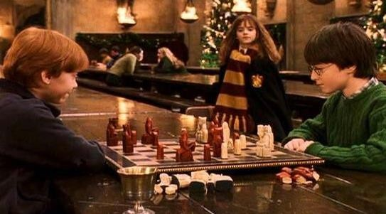
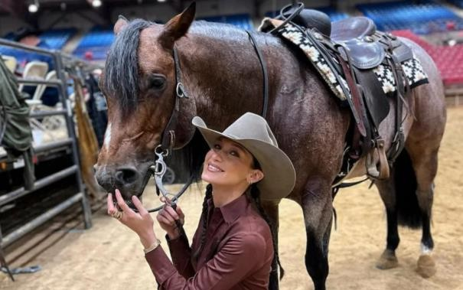

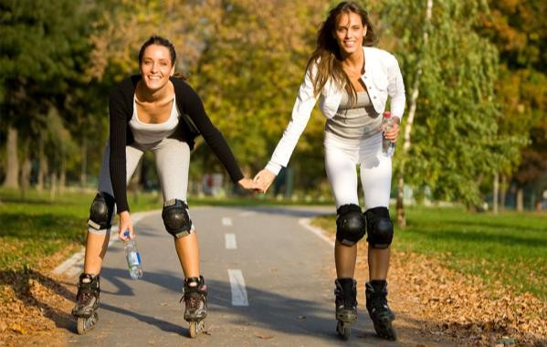

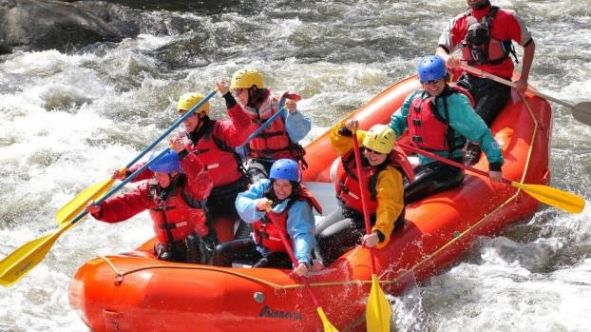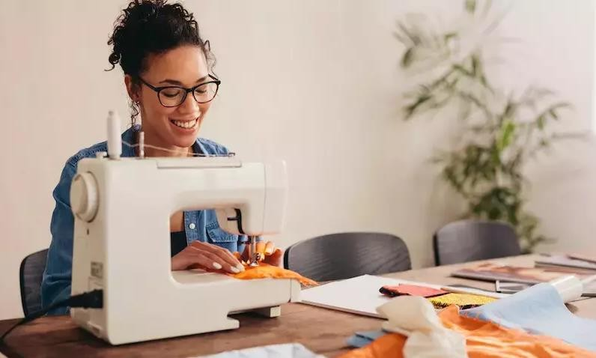

EXERCISE 2. Match the notions with their definitions. Which pastime activities require creativity? Which ones are risky? Are there any activities from this list that you would like to try?

- embroidery | a. the sport or practice of fighting with swords, especially foils, épées, or sabres.
- sledding | b. the activity of riding on a sled down a snowy hill or slope.
- abseiling | c. the art or craft of making objects out of clay by shaping and then firing them in a kiln.
- archery | d. the act of drawing aimlessly or absentmindedly.
- pottery | e. the activity of swimming underwater while using a snorkel to breathe.
- snorkelling | f. the sport or practice of shooting arrows with a bow at a target.
- fencing | g. the art or craft of decorating fabric or other materials with needle and thread or yarn.
- doodling | h. the activity of descending a steep rock face or cliff using a rope.

EXERCISE 3. Fill in the gaps with the collocations and idioms from KEY VOCABULARY
to escape from somebody`s daily routine, to paint the town red, to let sb`s hair down, to kill time, a party animal, theatregoer, to be really up my street
- While waiting for her flight, Sarah decided by reading a novel.
- After a long week of work, Emma wanted to and enjoy a fun night out with friends.
- Carpentry isn't . I'd rather pay someone else to do it.

- I'm ready with a few of my closest friends after passing an exam successfully.
- Being an avid , Michael never misses a new play at the local theatre.
- John planned a weekend getaway to the mountains .
- Mark is known to be ; he attends every celebration and always stays until the end.

EXERCISE 4 a) Read the five messages on a social networking website written over three days. Fill in the gaps with the Pastime collocations and idioms from Key Vocabulary. Put the messages in the correct order.

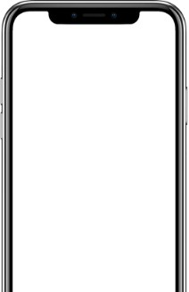

Emily
Active 10 min ago

The baby didn't get sleep till 3.00 a.m.
◻Absolutely must 1) some sleep. Joe says he`ll get up with her tomorrow morning and I can have 2) !

It was lovely seeing M&S tonight. It's always good to 3) with friends and they`re a really lovely couple.

Oh dear, exhausted again this morning - we
4) way too late last night chatting. Will 5) round the park now in the hope that the fresh air wakes me up!

Feel better today for late start. (Not up till 11 :00, thank you, Joe!) 6) with Pia and Beth this afternoon. Bought food from the market as we're having M&S over for dinner tonight.

A walk and some fresh air and I'm a different person! Feeling so energetic, have even 7) for salsa classes. (Hey, you're never too old to
8) a hobby!)

4 b) Answer the questions provided below
- How often do you make time to catch up with friends, and what activities do you enjoy doing together?
- Do you prefer to have a lie-in on weekends, or do you like to start your day early even on your days off? Why?
- What new hobby have you been thinking about taking up, and what sparked your interest in it?
- How often do you hit the shops for leisure, and do you prefer shopping online or in physical stores?
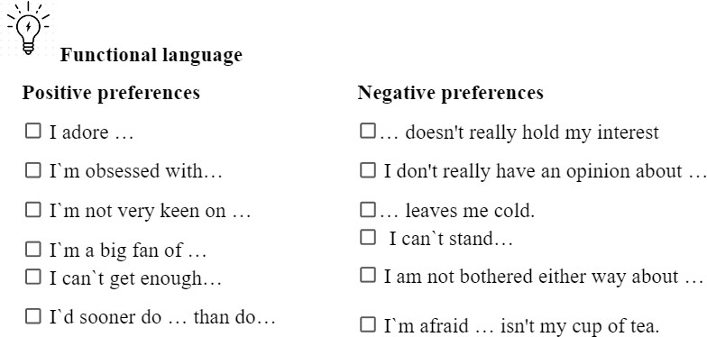

EXERCISE 5. Work in pairs. Create a dialogue using Functional language above providing good and bad points of each hobby from the following table.

Hobby | Good points | Bad points
Chess | relaxing | not get any exercise
Archery | exciting, satisfying | needs special equipment, expensive
Cookery | rewarding, creative | tiring, needs a lot of equipment
Karate | good form of exercise, challenging | high risk of injury, violent
Indoor rock climbing | fascinating way of spending time, rewarding | dangerous, risk of serious injury
Calligraphy | tends to calm the emotions and relieve stress | requires a lot of time to develop a skill

Your variant

Example:
A: What do you like doing in your spare time?
B: Personally, I adore playing chess because it is relaxing and I can always spend time with my friend playing it. What about you?
A: Playing chess doesn't really hold my interest because I don't get any exercise. I`m obsessed with archery…

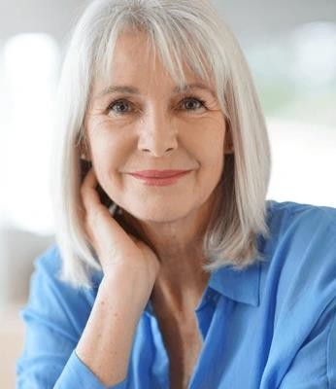
EXERCISE 6. Work in pairs, and decide which of the activities from the table above and Key vocabulary section you would recommend for:
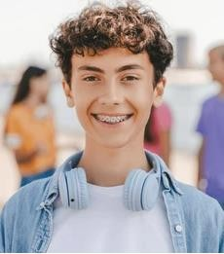


Susan | Bill | Tony
(50-year old housewife) | (17-year old teenager) | (32-year old businessman)

Model:
A: I would definitely recommend pottery for Susan as it is quite creative. What do you think?
B: I agree. Pottery would give her the chance to relax and create at the same time.

TEXT
What's the point of sewing?
Emotionally, socially, and practically, sewing is often proclaimed as a mindful wellbeing hack – but that’s nothing new. So, we spoke to historian and author Barbara Burman about sewing's prominence in the past, and why it still matters today.
“On the middle finger on my left hand, there is a very small, red mark. About 15 years ago, I was working at a sewing machine when I lost focus and put the needle straight through that finger – the puncture never quite healed. It’s the kind of cautionary tale teachers tell rooms full of new sewists, but it also creates a metaphor for a feeling that may be familiar to the 7.7 million people who find sewing as a hobby: the impact of sewing lives on under our skin.”
“My interest in sewing comes from an interest in the history of ordinary people, particularly women’s lives. I feel that it’s a kind of untold story. We’re so used to it that we don’t think about it. We put our clothes on, and there we are. But I wanted to

look at what stitching actually means at an individual level, as well as a more global level” Barbara Burman recalls.
“Mostly because it’s associated so thoroughly with women, and women have always been, as it were, ‘second rate’,” she explains. “We’ve also lived with this quite spurious distinction between working with our brains and working with our hands. So manual work is thought of as secondary to headwork. But, in fact, our hands, and particularly our sense of touch, give us such a huge amount of information and agency in the world.”
These days, we often talk about how beneficial crafts can be for our mental health and wellbeing, with countless studies confirming this link in action. One such example is a 2022 study by Catherine Howard et al, published in the Journal of Textile Design Research and Practice. Researchers worked with pupils in year 9 of a school in Birmingham, who took part in weekly hour-long relaxed stitching sessions across two months. The results were not only a variety of inventive and impressive sewn creations, but also an overall increase in feelings of pride, and improved self-esteem and confidence. Pupils chatted while they worked, and the study became part of a wider mental health campaign in the school – turning into a demonstration of creative approaches to wellbeing working in action.
As part of the project called ‘Our Sewing Stories’, more than 100 people sent their sewing autobiographies to Barbara, sharing what the craft means to them. Many of the stories are dotted throughout her book, each one stirring up familiar feelings.
“So many people told me about the very nurturing sense of somehow belonging through making things,” she says. “Through sewing, they’re making a space for themselves in the world. Sometimes people may not feel completely comfortable in the clothes that the high street is offering. But if they can make things of their own that do express what they feel themselves to be, then they feel they’re much more in a positive place.
“I think, from time to time connection comes through in an unexpected way,” adds Barbara. “A lot of people have told me about their sewing machines and their love of their sewing machines, something that they’ve inherited within their family, or been given to them by friends. That is a kind of connection. You pick up a pair of scissors that were your mother’s, for example. Or when you’re part of a group, you may not know the people, but there is a deep connection, because you share that innate knowledge about what it’s like to stitch.”
When we’re looking to take steps into the future, it can sometimes pay to look back at what’s behind us. For the young or old, fresh or seasoned, for practical reasons or for our sense of wellbeing, without a doubt we can say: sewing matters.
Adapted from happiful.com Issue 83

READING COMPREHENSION QUESTIONS

I. Discuss the following questions:
- Have you ever found a hobby that, like sewing, left a lasting impact on you, both physically or emotionally? What was it, and how did it affect you?

- How do you think manual work, like sewing, compares to more intellectual work in terms of personal fulfilment and meaning?
- Have you ever felt a strong connection to an object, like Barbara describes with her sewing machine? What was the object, and why was it significant to you?
- In what ways do you think creating something with your hands can help you feel more grounded or connected to yourself and others?
- Have you ever used a creative activity, like sewing, to improve your mental well- being? If so, how did it make a difference in your life?
- Do you think that modern society undervalues manual crafts and skills? Why or why not?
- How important is it for you to express your identity through the things you create or wear?
- Have you ever felt that a hobby or craft provided you with a sense of belonging or community? What was that experience like?
- How do you think learning a skill like sewing could change the way you view the clothes you wear every day?
- Have you ever inherited a skill or tool from a family member that made you feel connected to them? How did it influence your relationship with that craft or skill?

Classroom extra: Scan the Qr code and watch a video “50 things to do before you die”, take some notes if needed
Discuss the following questions:
  - What`s one thing you`ve always wanted to try, and one place you`ve always wanted to visit?
  - What`s stopped you from doing both of these things?

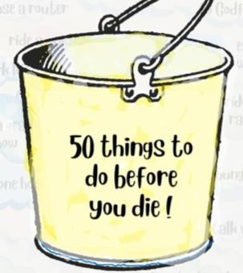


SPEAK OUT
You are new in your group and want to find friends. One girl/boy approaches you and asks about your hobbies. You have a lot in common but she/he tries to persuade you to start a hobby you don`t like.
Task: Complete the dialogue between two groupmates discussing different hobbies. Explain why you don't want to start a new one. Use Key Vocabulary

UNIT 2 EMBRACE YOUR NATURAL BEAUTY

KEY VOCABULARY
Facial features: broad, narrow, lined forehead; rosy, chubby, hollow cheeks; high cheekbones; double, pointed, split chin; false, long eyelashes; bushy, pencil-thin, plucked eyebrows; straight, aquiline, snub nose; almond, round, close-set, wide-set, squint, puffy eyes; thin-faced, round-faced, dark-faced, pale, tanned, light-skinned (complexion); full, thin lips; wrinkles, freckles, a wart, mole/birthmark, pimples, a scar, a bruise
Hair: thick, thin hair, auburn, ginger, ash-blonde, dyed hair, curly, wavy, straight, with permanent waving, spiky, shoulder-length, receding hairline, bald patch, glossy, greasy, with split ends, hair in plaits, in a bun, back-combed, crew-cut, stubble; clean- shaven, bald, with a ponytail, with side parting, long sideboards, fringe, moustache
Adjectives and phrases: be the spitting image of someone/to look like two peas in a pod, to be like chalk and cheese, to be easy on the eyes/a sight for sore eyes, beauty is only skin-deep, looks can be deceiving, to have a bad hair day, to wear one's hair down, to go grey; curvy, skinny, slender, thin, slim, plump, a bit overweight, obese (constitution); handsome, scruffy, stocky/well-built, muscular, smart

Comment on the following quotation. To what extent do you agree with that? “Beauty is in the eye of the beholder“ – Margaret Wolfe Hungerford

EXERCISE 1. Describe people below by using the words from KEY VOCABULARY
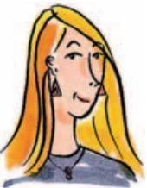
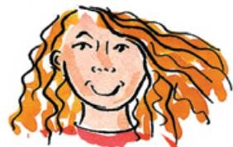
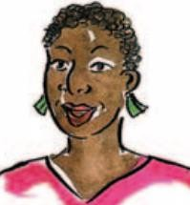
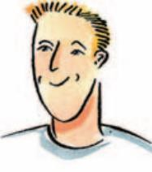
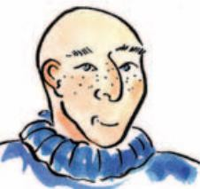
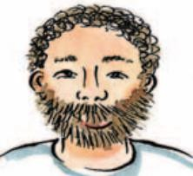
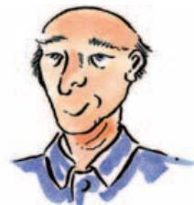
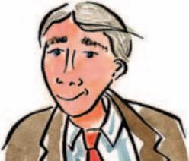

Example
He used to have black hair but now it’s gone grey, almost white.

EXERCISE 2. Read a witness statement made to the police about a robbery and underline collocations to match the phrases 1-10.
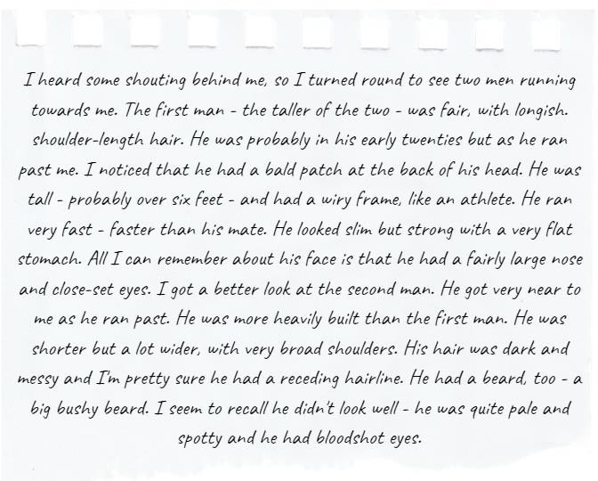
- a line where the hair starts on a man's forehead which is higher than usual because some hair has fallen out
- having a body that is wide and strong
- a wide top of the back
- no fat on the front of the body
- an area of thick hair on a man's chin
- eyes which are red on the part that should be white
- quite long hair that reaches the bottom of the neck
- an area on the head where there is no hair
- a body that is thin but strong
- eyes that are nearer to each other than is usual

EXERCISE 2b Answer the questions
- Do you find any features described in the text above attractive?
- Have you ever faced the problem of being judged by your appearance?
- Do you think people can be biassed towards people with pleasant appearance?
- If a criminal was drop-dead gorgeous would a judge reduce the sentence for him?

EXERCISE 3a. A magazine interviewed three men, asking them to describe their appearance and say what they thought was their 'best feature' (most attractive part, usually of the face). Read their descriptions and match the pictures A-C to the texts 1-3.

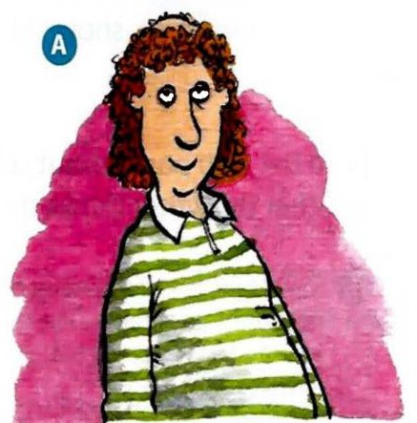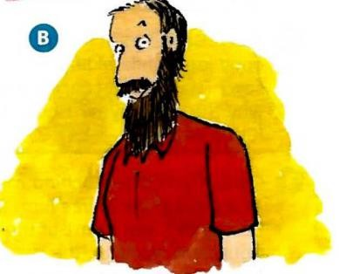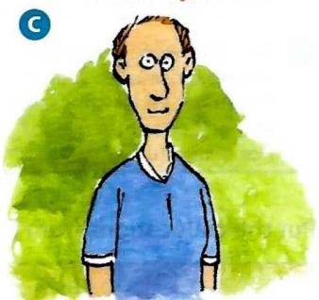
JOHN I'm quite heavily built, though I don't think you'd describe me as fat. I inherited my father's broad shoulders which I'm quite proud of. I've got a few lines around my eyes now I'm in my forties but I've got very little grey hair, which is lucky at my age. I have a beard which used to be quite long but I keep it neatly trimmed nowadays. I'm not sure what my best feature is - perhaps my dark hair?
MARCO I suppose I'm of medium height for a man and, like both my parents, pretty slim. I used to do a lot of running when I was younger and I have the typical long-distance runner's wiry frame. I have blond hair from my mother's side of the family which I'm quite proud of. My eyes are probably my best feature - they're quite big and people say they're very expressive.
HENK I've always struggled with my weight. but I've been going to the gym a lot recently so I've got a fairly flat stomach. I've still got a lot of hair and it is quite nice and curly. It's always been my best feature so I keep it a bit longer than most men my age. I've improved my diet a lot recently and I think it's really made a difference to my appearance. My skin is looking better and my eyes are bright.
EXERCISE 3b. Are the descriptions in Exercise 3a accurate? Complete the notes in the table for each man. Your notes should include all ten collocations from Exercise 2.

Name | Accurate information | Inaccurate information | Missing information
John | heavily built broad shoulders | says: neatly trimmed beard  but truth is: bushy beard

Marco
Henk

EXERCISE 3c. Work in two teams. Describe the appearance of 2 people from the opposite team so they can guess who you are talking about.

EXERCISE 4. Read the web posts about celebrities spotted by members of the public. Decide whether the writer thinks the celebrity is looking good or not.
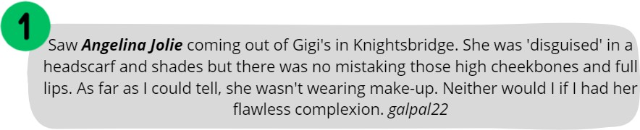
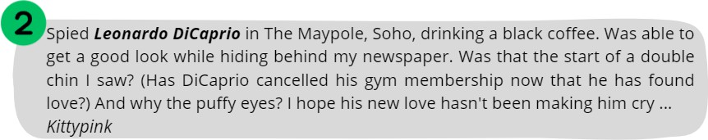
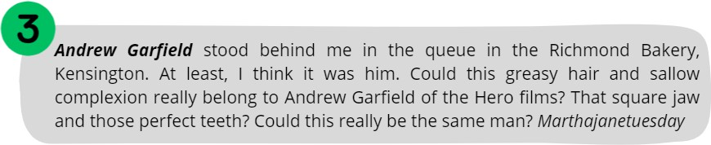

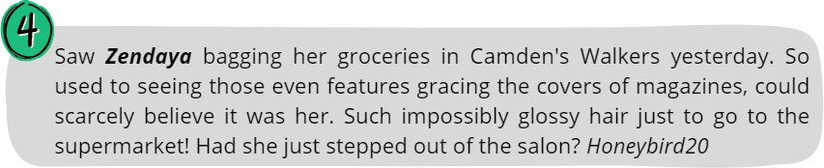
EXERCISE 5. Complete the sentences with words from the box. You may consult with Exercise 4
puffy • even • glossy • flawless • greasy • high • double • square • full • sallow

- She looks like a model with her wonderful cheekbones.
- I assumed from her eyes that she'd been crying.
- Rachel's sister had a slightly bent nose and a very big mouth but Rachel had lovely

features.
- What shampoo do you use to get such gorgeous hair? It's so shiny!
- This lip gloss will help you make the most of those lovely lips.
- He had horrible hair that badly needed a wash.
- In the summer, Marta goes brown very easily but in the winter she has quite a

complexion.
- He was handsome with strong features and a jaw.
- He'd put on weight, his face was fatter and he had a bit of a chin.
- Your skin doesn't need make-up, Sophie -you have a complexion!

EXERCISE 6. Write 3 sentences to describe facial features, hair, and constitution that come to mind when you imagine a typical:
  - boss d) an actor in a romcom
  - Queen e) housewife
  - musician f) grandmother/grandfather

EXERCISE 7. Use the words presented in a box to fill in the gaps according to the context
puffy eyes, like chalk and cheese, false eyelashes, pimples, long sideboards, fringe, split chin, aquiline nose, wart, the spitting image of
- During her teenage years, she struggled with that affected her confidence.
- He had a on his left hand that he planned to have removed.
- Her new hairstyle included a that perfectly accentuated her eyes.
- His was a distinctive feature that he inherited from his father.
- For the photoshoot, she decided to wear to enhance her look.
- His gave his profile a striking and classical look.

- Jane is her grandmother, with the same bright blue eyes and warm smile.
- After a long night of studying, she woke up with that no amount of makeup could fully conceal.
- He had a vintage look with his , reminiscent of the classic styles from the 1970s.
- Even though they are twins, Sarah and Emily are when it comes to their personalities.

TEXT

The idea of beauty is always shifting. Today, it’s more inclusive than ever
The definition of beauty has continued to expand, making room for women of color, obese women, women with vitiligo, bald women, women with grey hair and wrinkles. We are moving toward a culture of big-tent beauty. One in which everyone is welcome. Everyone is beautiful. Everyone’s idealised version can be seen in the pages of magazines or on the runways of Paris.
We have become more accepting because people have demanded it, protested for it, and used the bully pulpit of social media to shame beauty’s gatekeepers into opening the doors wider. Beauty is, of course, cultural. What one community admires may leave another group of people cold or even repulsed. What one individual finds irresistible elicits a shrug from another. Beauty is personal. But it’s also universal. There are international beauties—those people who have come to represent the standard.
For generations, beauty required a slender build but with a generous bosom and a narrow waist. The jawline was to be defined, the cheekbones high and sharp. The nose angular. The lips full but not distractingly so. The eyes, ideally blue or green, large and bright. Hair was to be long, thick, and flowing—and preferably golden. Symmetry was desired. Youthfulness, that went without saying.
This was the standard from the earliest days of women’s magazines, when beauty was codified and commercialised. The further one diverged from this version of perfection, the more exotic a woman became. Diverge too much and a woman was simply considered less attractive—or desirable or valuable. And for some women—black and brown or fat or old ones—beauty seemed impossible in the broader culture.
We know that beauty has financial value. We want to be around beautiful people because they delight the eye but also because we think they are intrinsically better humans. We’ve been told that attractive people are paid higher salaries. In truth, it’s a bit more complicated than that. It’s really a combination of beauty, intelligence, charm, and collegiality that serves as a recipe for better pay. Still, beauty is an integral part of the equation.
But on a powerfully emotional level, being perceived as attractive means being welcomed into the cultural conversation. You are part of the audience for advertising and marketing. You are desired. You are seen and accepted. When questions arise about someone’s looks, that’s just another way of asking: How acceptable is she? How relevant is she? Does she matter?
Today suggesting that a person is not gorgeous is to risk social shunning or at least a social media lashing. What kind of monster declares another human being unattractive?

To do so is to virtually dismiss that person as worthless. It’s better to lie. Of course you’re beautiful, sweetheart; of course you are.
We have come to equate beauty with humanity. If we don’t see the beauty in another person, we are blind to that person’s humanity. It’s scary how important beauty has become. It goes to the very soulfulness of a person.
Beauty has become so important today that denying that people possess it is akin to denying them oxygen.
Adapted from National Geographic

READING COMPREHENSION QUESTIONS

I. Discuss the following questions:
- How has the definition of beauty expanded in recent years, according to the text? Do you agree with this expansion? Why or why not?
- In what ways has social media influenced the acceptance of diverse beauty standards? Do you think this influence is primarily positive or negative?
- How do you personally define beauty? Has this definition changed over time? If so, what influenced the change?
- The text mentions “international beauties.” Who are some individuals that you think represent these universal beauty standards, and why?
- How has the fear of social shunning or backlash on social media changed the way people discuss beauty and attractiveness?
- Discuss how the expansion of beauty standards might influence other aspects of society, such as fashion, entertainment, and personal relationships.
- The text suggests it is better to lie about someone's beauty to avoid social backlash. Do you think this approach is sustainable or ethical? Why or why not?
- How do you think the changing standards of beauty will impact future generations? Will these changes be for the better or worse?

Classroom extra: Scan the Qr code and watch the video. Would you like to take part in the same experiment?


SPEAK OUT
Do a project about beauty standards of different decades all around the world

UNIT 3
GET THE IMPRESSION

KEY VOCABULARY
Positive traits: affable, affectionate, agreeable, courteous, courageous, determined, easy-going, fair-minded, faithful, fearless, frank, gregarious, impartial, inquisitive, quick-witted, persistent, reliable, self-confident, sensible, sensitive, modest, sincere, sociable, candid, tidy, wise, kind-hearted, laid-back, tactful, good-natured, imaginative, daring, perceptive, thorough, strong-willed, level-headed, obedient
Negative traits: reserved, aloof, arrogant, belligerent, boastful, bone-idle, callous, conceited, envious, furious, grumpy, gullible, impatient, indecisive, indignant, irresponsible, jealous, mean, naughty, obstinate, quarrelsome, resentful, rude, ruthless, shy, vengeful, humble, insecure, self-conscious, moody, short-tempered, vain, narrow- minded, spiteful, timid
Phrases and idioms: to make people feel at ease, think outside the box, have a love of learning, to excel in, to be the life and soul of the party, to be larger than life, to be good fun to be around, to be full of yourself, to be a people person, to be cool as a cucumber, to be the pain in the neck, to be a chatterbox, to be a nerd, to be an eager beaver, to be a buzzkill, to be full of beans, to be a heart of gold, to be faint of heart

Comment on the following quotation. To what extent do you agree with that? “Personality is to a man what perfume is to a flower“ – Charles M. Schwab

EXERCISE 1a. Describe what is happening in each of the photographs. Then discuss the questions below.


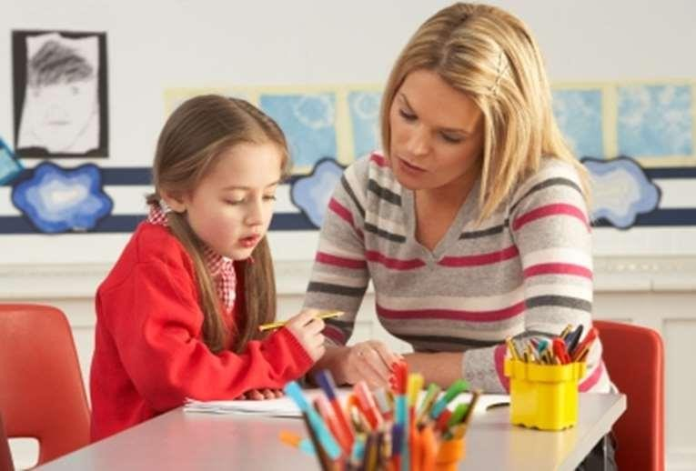

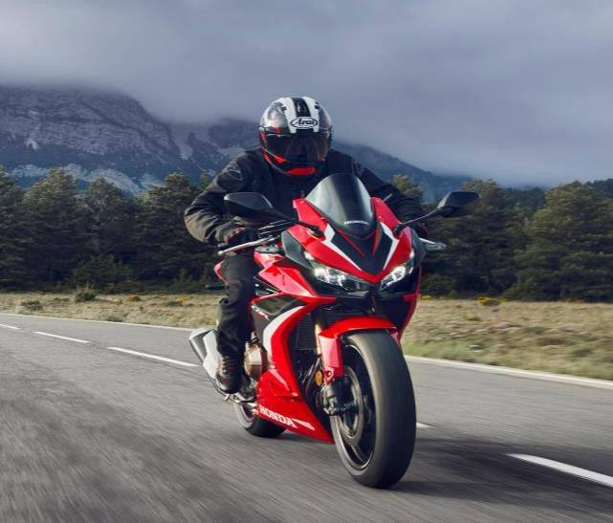
- Do the photographs give you any clues about the personalities of the people in them?
- Which, if any, of the people would you like to be friends with? Why?

EXERCISE 1b. Use KEY VOCABULARY to describe personality traits that these people might have.

EXERCISE 2a. Do the personality test below. Share your results with groupmates KNOW YOURSELF PERSONALITY TEST
How well do you really know yourself? Read each sentence carefully and circle the symbol next to it if you feel it truly describes the real you.


I learn new things fast I feel others’ emotions  I do jobs straight away. I like being alone.

I have a vivid imagination. I make people feel relaxed.
I like telling funny stories.
I know myself well. I pay attention to detail.
I love partying.



I come up with new ideas. make new friends easily.
I prefer small groups of people. I have a soft heart.
I usually start conversations.
I love helping others.
I enjoy the arts.
I keep my things tidy. I think before I speak.
I plan things in advance.

KEY The symbols represent five different personality types. How many of each symbol did you choose?

I

AGREEABLE
You’re kind-hearted and sensitive to the needs of others. Being relaxed, trusting and laid-back, you work well with others. In difficult situations , you’re tactful and avoid hurting people. In fact, you’re very good at making people feel at ease. You’re affectionate and show your feelings. You’re good-natured, friendly and popular.

IMAGINATIVE
You’re artistic and creative and so you have the ability to think outside the box. You’re daring and you’re not afraid to do adventurous things. You’re also quite perceptive and intellectual and have a love of learning.

ORGANISED
You’re thorough – you like to plan things carefully. Being quite strong-willed, you usually get what you want. You’re level-headed and you think things through carefully. In future, you will excel in leadership positions.

DEEP
You’re a deep thinker and you’re not comfortable with small talk. You’re not insecure, but you are quite humble, and you can be a little self-conscious or even self-critical at times. You enjoy your own company, but you’re not a loner – you like being with close friends. Above all , you’re fair-minded and if you feel strongly about something, you’re not afraid to speak up.

SOCIABLE
You’re the life and soul of the party and love being the centre of attention. People enjoy your company because you’re witty and spontaneous. You’re larger than life and good fun to be around. However, on bad days you can be moody and short-tempered. Also, there are times when you appear a little self-centred and full of yourself.

EXERCISE 2b. Write a short sentence that summarises your results. Compare your results with a partner and then discuss the questions.
I am quite deep and fairly conscientious.
- How accurate do you think this personality test is?
- Why do you think people like doing personality tests?
- Can you learn more about a person from a fifteen-minute personality test or a fifteen-minute chat?

EXERCISE 3. Read the descriptions and choose the correct option. Do you have friends that have the same traits of character?

- Megan is brave enough to say things that shock people. She’s quite daring / insecure.
- Janet understands difficult concepts and enjoys debating serious topics. She’s
intellectual / witty.
- Tom is diplomatic and is unlikely to upset or embarrass people. He’s very
thorough / tactful.
- Sue has a very gentle, loving nature. She’s extremely perceptive / affectionate.
- Rick never talks about his achievements. He’s very humble / moody.
- Harry believes that most people are good and honest. He’s very spontaneous / trusting.

EXERCISE 4. Draw 3 animals that first come to your mind. Give some characteristics to them by using the adjectives to describe traits of character.
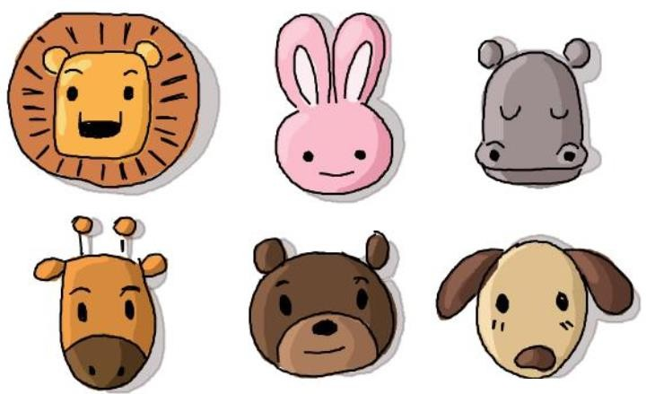
EXAMPLE: A rabbit is very gullible, it trusts everything one can say to it. It is extremely shy and insecure, it is always afraid to talk to strangers or make new people.

EXERCISE 5. Replace the underlined phrases with words from KEY VOCABULARY. Which statements do you agree with and why? Discuss with a partner.
- It’s up to teachers, not parents, to inspire and encourage having a desire for knowledge in children.
- Computers will never replace humans because they can’t view things creatively.
- People often perform better in oral exam situations when they feel comfortable.
- People who have a really high opinion of themselves rarely make good friends.
- Everybody would like to be entertaining on social occasions.

EXERCISE 6. Unscramble the letters to make adjectives that can describe personality and fill in the gaps with the most appropriate word. Do you find any of these qualities in your friends` personalities?
- ggrroieuas - 5. lueaosj -

- ewsi - 6. ltufiahf -
- thuagyn - 7. idandc -
- eulnfvge - 8. coaulls -
- Even though he often speaks his mind bluntly, his honesty is refreshing and appreciated by his friends.
- She always looks to make new friends and loves being around others, thriving in social gatherings due to her nature.
- Despite her calm demeanour, she quietly harbours a strong desire to get back at those who have wronged her, revealing her side.
- Known for his playful pranks and mischievous behaviour, he's always the life of the party, showing a spirit.
- He shows little care for others' suffering, often appearing indifferent and
.
- She remains loyal and devoted to her friends, standing by them through thick and thin, showing she is .
- He is often suspicious and envious of others' success, feeling of their achievements.
- With years of experience and knowledge, his advice is sought by many who value his insight and judgement.

EXERCISE 6. John is looking for a partner that's why he put up some information about himself on social media. Fill in the gaps with appropriate adjectives. Do you think he is a good person?
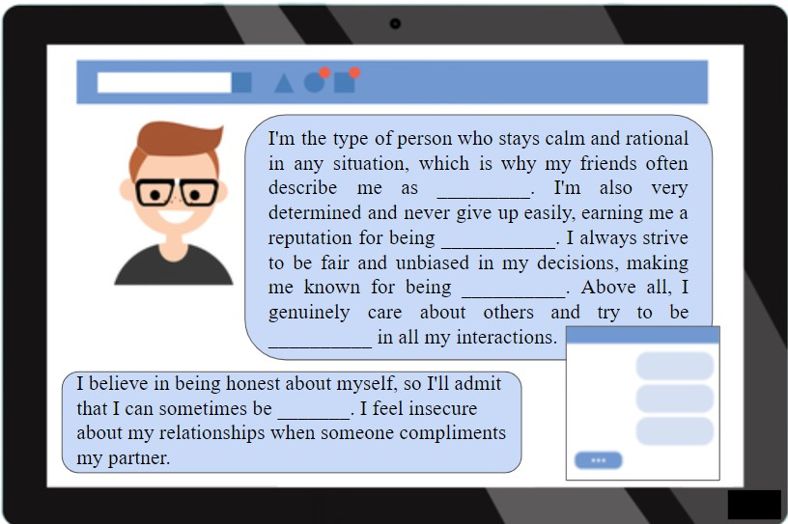

TEXT
From attention-seekers to peace-makers, what your sibling birth order says about your personality
How our rank within our families can determine our personality traits
If you've got siblings, you're probably more than aware of how different each of you are. Whether you're the oldest, youngest or middle child, scientists are convinced that our rank within our families can determine our personality traits.

The first-born child
According to a study by the University of Illinois, eldest siblings tended to be more extroverted, agreeable and conscientious.
The study also found that firstborn children tend to have a higher IQ than those born later - although it was only by a point or so.
Another study by the University of Essex, came to a similar conclusion, noting that the eldest child, especially if female, is statistically more likely to be the most ambitious and well-qualified of their family, as they tend to carry higher aspirations.
The level of attention that parents devote to firstborns is usually much higher, but these children will also be on the receiving end of their parent’s anxieties and the overwhelm of being new parents. Oldest children usually enjoy a period of exclusive attention. Being first gains a child some degree of status in the sibling hierarchy which remains even after their siblings come along.
As older siblings were often left in charge or asked to look after younger siblings, “elder siblings are more likely to feel more organised and able to prioritise their own lives.” Key characteristics of a first-born are: extroverted, smart, ambitious, enjoy taking the lead, organised.

The middle child
According to Jahara, middle children are usually more invested in getting on with others and negotiating for what they need due to being used to sharing resources with their siblings. She says: “Middle children have never known what it is like to have the parent’s exclusive attention, so they come into a world where they are expected to share from the start. Middle children are often called peace-keepers within the family. A middle child may also compete for attention due to their “middle status’ - they are neither the baby or the eldest so they will need to find a way to stand out.”
In the book The Secret Power Of Middle Children, Psychologist Catherine Salmon and journalist Katrin Schumann spoke about how middle children are often dubbed as neglected (we've all heard of ‘middle child syndrome.') Speaking about their research on Psychologies, Schumann said: “Although middles are neglected, both by parents and researchers, they actually benefit from this in the long run. They become more independent, think outside the box, feel less pressure to conform, and are more empathetic. “This gives them great skills as employees and also makes them excellent team players and partners.” She added that, due to their ranking, middle children are more patient, as well as “savvy, skillful manipulators." Key characteristics of a middle child: team players, patient, independent, empathetic, skillful manipulators.

The youngest child
By the time the third child comes along, parents are usually more relaxed about raising their youngest. The older siblings will also play a role in their sibling’s

upbringing and so the burden isn’t exclusively on the parents. With the first born being the ‘responsible high achiever', and the middle child the 'peace-maker', the pressure is usually off the youngest. However, this can also lead to them feeling like they are ‘lagging behind’ or are insignificant.
Researchers at the universities of Reading and Birmingham concluded that the baby of the family is more likely to take risks when it comes to business – and, according to The Sunday Times, more likely to become an entrepreneur.
This is supposedly thanks to having a ‘born to rebel’ personality trait that makes them “exploratory, unconventional and tolerant of risk”.
A YouGov study also concluded that the youngest child in a family tends to be more chilled out and have a funny sense of humour. Key characteristics of a younger child: easy-going, funny, risk-takers, entrepreneurial.

The only child
Only children have different influences, no sibling competition, and are the sole focus of parental investment,” Dr. Salmon says. “As a result, parental expectations and pressure can be high, driving them toward traits shared with firstborns.” Smelser says some of these include being ambitious, independent, bossy, and strong-willed.
However, because only children don’t have other siblings to play with or compete against growing up, they may be less competitive. But on the flip side, only children can be independent and mature, since they are often around more adults than kids. Key birth order traits of only children: mature, loyal, independent, confident, leader, cautious, curious, sensitive.
Adapted from Glamour

READING COMPREHENSION QUESTIONS

I. Discuss the following questions:
- Do you think birth order has a significant impact on personality? Why or why not?
- In your experience, do the characteristics of first-born children mentioned in the article match those of any first-borns you know?
- Do you agree that middle children are often peace-keepers? Can you think of any examples from your own life or people you know?
- How do you feel about the idea that youngest children are more likely to be risk- takers and entrepreneurs?
- According to researchers at the universities of Reading and Birmingham, what is a common career tendency for the youngest child?
- How important do you think sibling relationships are in shaping a person's personality and future success?
- How do you think parents can balance their attention among multiple children to avoid favouritism or neglect?

Classroom extra. Scan the Qr code. Watch the video and be ready to discuss.
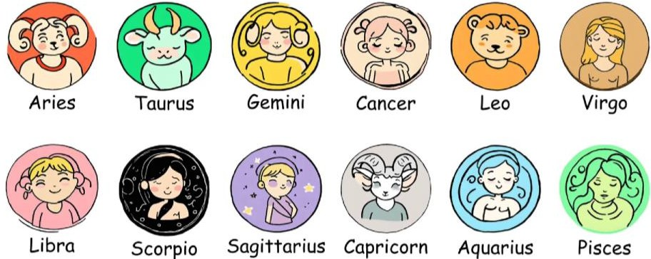

SPEAK OUT
Make up a dialogue using one of the scenarios or your own idea:
- A dialogue between siblings who are having a disagreement. Use character trait adjectives to express their feelings and frustrations with each other.

- Simulate a job interview scenario where one student is the interviewer and the other is the interviewee. The interviewee can highlight their character traits as strengths for the position.
- Friends discussing the planning of a surprise party for a mutual friend. You can use character trait adjectives to assign tasks based on each person's strengths.

UNIT 4 UNDERSTANDING HUMAN BONDS

KEY VOCABULARY
Family ties: an extended family, an immediate/nuclear family, a close-knit family, maternal instinct, late husband/wife, stable upbringing, physical resemblance, striking resemblance, family gatherings, to nurture, in-laws, marital status, separated, widowed, a patchwork family, a widow/widower
Relationships - positive aspect: soul mate/kindred spirit, to be inseparable, to admire, to adore, to worship, to date with sb, to rely on sb, love at first sight, to fall head over heels in love with sb, to be infatuated with sb, to get on like a house on fire, to be an apple of sb's eye, to be faithful to sb, to have its ups and downs, to hit it off, to be on the same wavelength, to have a soft spot for someone, to enjoy each other's company, to have a lot in common, to get to know each other, to pop the question, to settle down, to get married with sb, to tie the knot, to be a shoulder to cry on, to clear the air, to bury the hatchet, through thick and thin, to look up to sb, to have eyes for sb, significant other, engagement/to be engaged to sb

Relationships - negative aspect: to be incompatible, adultery, to be separated, to be bitter rivals, to look down on sb, to humiliate, to split up, not to see eye to eye with sb on sth, family feud, to feel aversion, to be on bad terms with sb, to have grudge against sb, to be fed up with sb, to betray, to be indifferent of, to give sb a cold shoulder, to fall out with sb, unrequited love, rivalry, to drift apart

Comment on the following quotation. To what extent do you agree with that? “Some people come into our lives and leave footprints on our hearts and we are never ever the same.” – Flavia Weedn

EXERCISE 1. Look at the pictures below. What kind of problem is depicted?
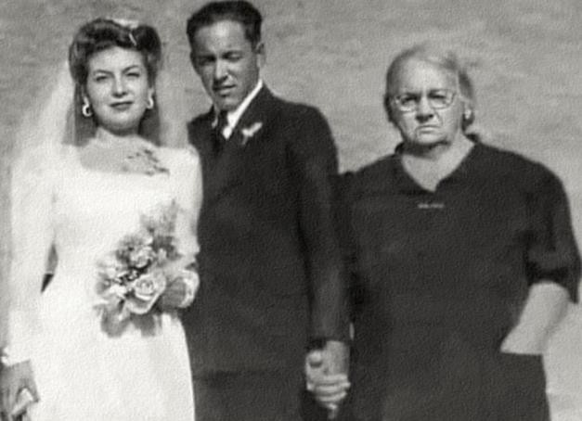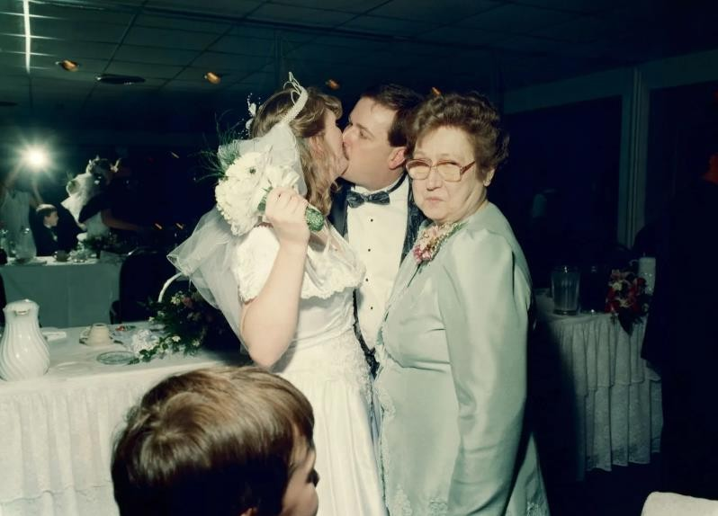

- What is your view on marriage? Do you believe it is old-fashioned to make it official?
- Are there more benefits or drawbacks to getting married in Ukraine nowadays?
- What is the right age to get married in Ukraine? And to have children?
EXERCISE 2. Match words on the left with words on the right to complete the expressions. Then use the expressions to complete the questions below and provide your opinion.
  - bitter a) family
  - bury b) love
  - love c) on the same wavelength
  - striking d) head over heels in love with somebody
  - unrequited e) the hatchet
  - be f) rivals
  - close-knit g) status
  - fall h) at first sight
  - marital j) other
  - significant k) resemblance
- Can two people with a history as truly move on and build a healthy romantic relationship?
- When is it appropriate for ex-partners to and become friends, and what are the potential risks involved?
- Do you believe in , or is it just an infatuation that fades over time?
- Does a between partners in a relationship indicate compatibility, or is it merely a coincidence?
- Can be considered a form of emotional abuse if one person persistently pursues another?
- How important is it for couples to about major life decisions, and can a relationship survive if they are not?
- In a , is it acceptable for individual members to prioritise their own ambitions over family expectations?
- Is it healthy to without truly knowing their character and values?
- Should be a significant factor in professional opportunities and social standing in modern society?
- In what ways can a positively or negatively influence one's social circles and friendships within a relationship?

EXERCISE 3. Complete the groups of collocations with words from the box.
family relative acquaintance friends

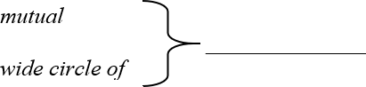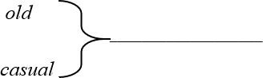
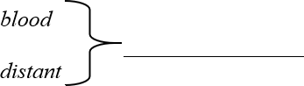
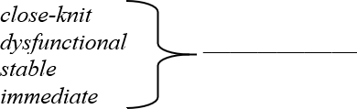

Read the facts stated below. Can you relate to them? If not, change them to make them true for you.
  - Brad Pitt met an old acquaintance from his school days at a festival.
  - Taylor Swift often avoids talking to casual acquaintances she only met once or twice.
  - Beyoncé spends holidays with her blood relatives every summer.
  - Leonardo DiCaprio recently learned about a distant relative living in Ukraine, Odesa.
  - Chris Hemsworth comes from a close-knit family that enjoys spending time skiing.
  - John Legend loves cooking meals for his immediate family on weekends.
  - Drew Barrymore has often shared stories about her childhood in a dysfunctional family.

EXERCISE 4. Match the problems 1-8 to the advice a-h. What else can you suggest to solve the problems?
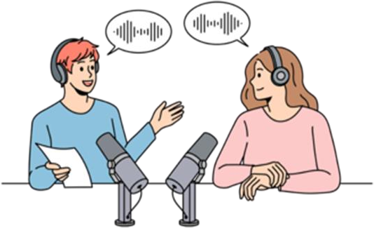
Need advice? Not sure what to do or who to turn to? Remember, a problem shared is a problem halved.

1. I`m madly in love with my best mate`s boyfriend. I`ve tried not to be but I'm crazy about him - I think about him all the time. I feel so guilty. What should I do?
2. I met a woman while I was holidaying in Spain earlier this summer and I am completely and utterly in love. Do holiday romances ever last? Is there just one person out there who met the love of their life on holiday? Please say there is.
3. I met a girl on a train last week and I swear, the moment I looked at her face, I knew she was the one for me. Could this be possible? Does love at first sight actually happen in real life?
4. I`ve fallen in love with my boss. I know it's wrong but I`m crazy about him and I strongly suspect the feeling is mutual.
5. I moved cities last year to be with a guy that I`d had a whirlwind romance with. I left my friends and my job - everyone said I was crazy at the time. The thing is, the passion has started to cool and I'm now wondering whether they were right…
6. I`m finally single again after a particularly messy divorce and feeling very cynical about relationships generally. Will these negative feelings pass?
7. Three months after a quickie divorce, my best mate has started a new relationship and she's already talking about marriage. How can I talk sense into her?
8. Romance has recently blossomed between two of my best friends and I`m ashamed to say, I`m feeling a bit left out. Am I being silly here?
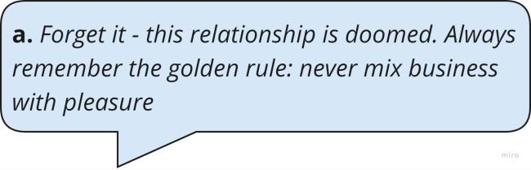
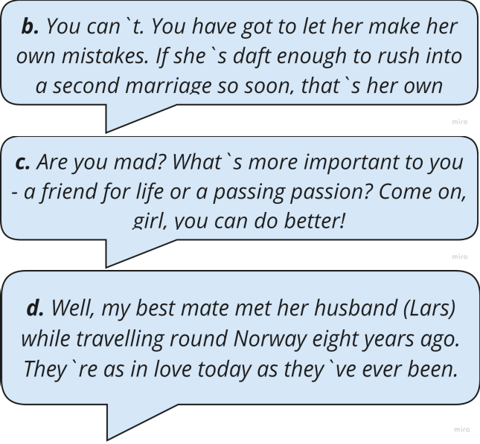
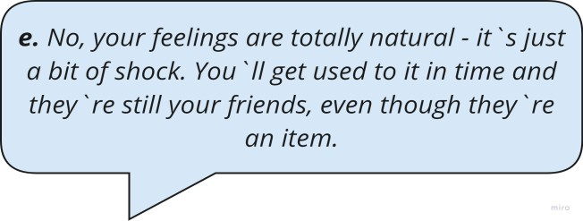
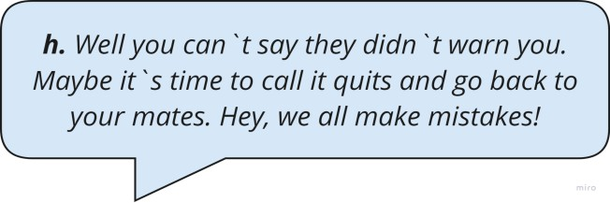
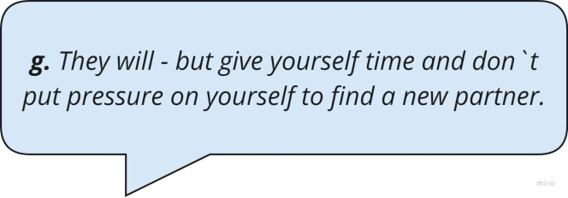
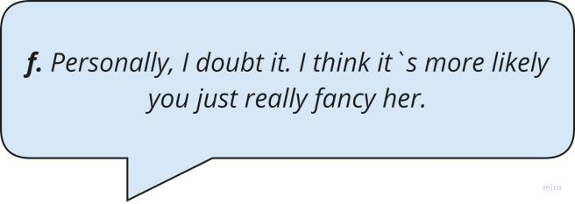

EXERCISE 5. Read the dialogue below between Sarah and Emily, two friends discussing the complicated friendship between their mutual friends, Lisa and Jane. Feel in the gaps with the words from the box. Finish it up with your own ideas.
kindred spirit
to get on like a house on fire a shoulder to cry on
to be on the same wavelength
rivalry to drift apart
to have a grudge against sb bury the hatchet


Sarah: Emily, have you heard about Lisa and Jane? They used to

1) back in high school.

Emily: Oh, I remember! They were always 2) about everything.

Sarah: But something happened. Lisa told me that Jane was her
3) during her breakup with Mark.

Emily: Really? I heard they started to 4) after college.

Sarah: Yeah, but Lisa still considers Jane her 5) . However, their old 6) over Alex resurfaced at the reunion.

Emily: And Lisa never 7) Jane for that. But did you hear about Jane's secret?

Sarah: No, what secret?

Emily: Apparently, Jane has been hiding something major from Lisa. Now Lisa doesn’t know if she can trust her again.

Sarah: Wow, I wonder if they can 8) and move forward.
Maybe they should…

EXERCISE 6. Study the table below and answer the following questions. Then at home scan the QR code and do the questionnaire to identify your personal love language.
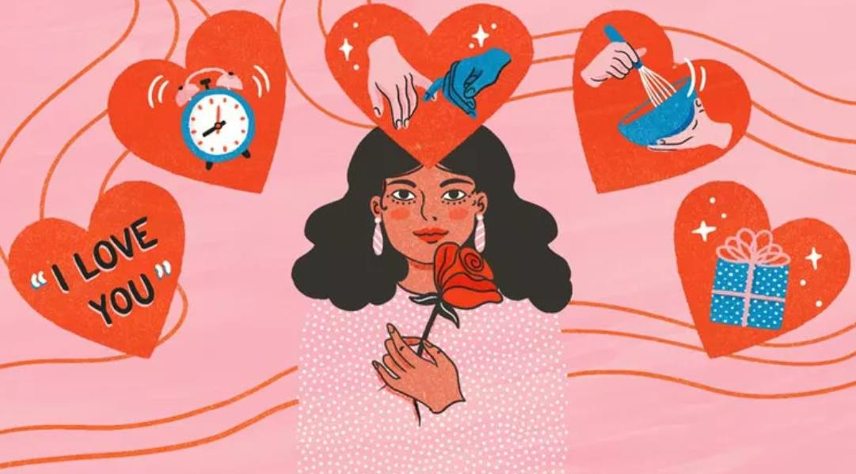

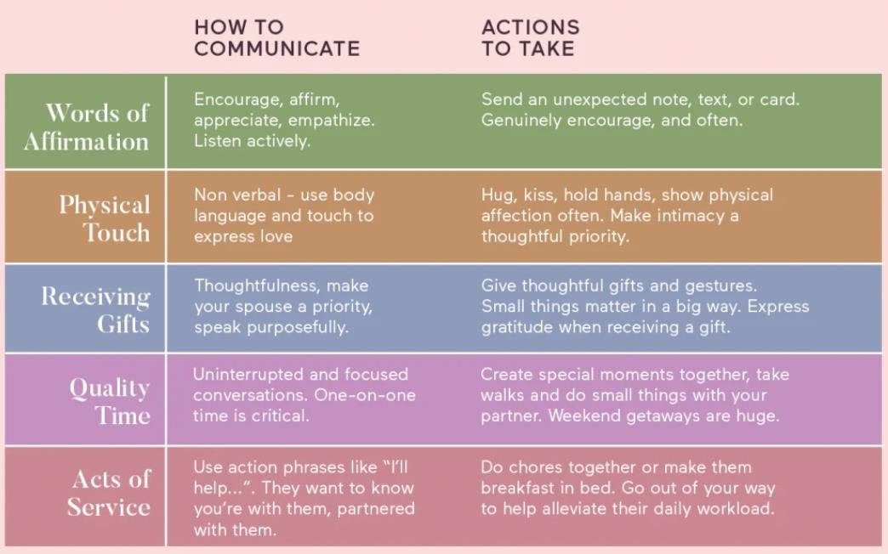

- Which love language do you think you identify with the most: Words of Affirmation, Acts of Service, Receiving Gifts, Quality Time, or Physical Touch?
- Do you think love language can differ in accordance with expressing it to your family or friends?
- How do you prefer to show love to your partner?
- How does your partner’s love language differ from yours?
- Can you share an example of a time when a family member expressed their love in a way that was meaningful to you?
- How do you and your siblings support each other’s love languages?

TEXT

Live a family life, not a long-distance one: stories of Ukrainian couples in long- distance relationships
When the war broke into the lives of Ukrainians, the relationships of hundreds of thousands of couples changed to the format of long-distance relationships. Here are collected the stories of three couples who must fit their love into correspondence and short calls, miss each other and build a family despite thousands of kilometres. According to the Ministry of Justice statistics, in 2022, 17,893 couples decided to end their marriage. This is much less than the previous year, but, as psychologists note, official statistics for Ukraine do not show the actual state of affairs because now, spouses often break up via phone without submitting documents for an official divorce. Kharkiv residents Victoria and Yevhen have been married for 16 years. In April 2022, a Viktoria with two children — a 3.5-year-old daughter and a 14-year-old son
— evacuated from the city, mercilessly bombed by the russian invaders, to Poland. Victoria's husband stayed to defend Ukraine.
"Before the start of the full-scale invasion, we were an ordinary family. Zhenya is an event hosted by trade. He never had any military experience but could not just sit at home, so he went to the Military Commissariat to join the Armed Forces of Ukraine ranks," Viktoria continues. "We stayed in the Kharkiv region for a month and then decided to go to Warsaw to visit our children's godparents. Zhenya said he would feel better if we were safe." Viktoria shares.
Over the past year, Victoria saw her husband once — in the summer. He is a material support sergeant and went to the west of Ukraine to get a car, and his family came to see him. What helps them maintain a long-distance relationship?
"It's difficult, but we are constantly working on this issue," admits Victoria and shares her life hacks. "I always listen when he needs to share something. We send a video on Telegram every morning wishing him a quiet and peaceful day — this is our tradition." I give him little surprises on all our family dates; he doesn't always receive them on the exact day, but a family friend who stayed in Kharkiv helps me by being my courier. And, of course, we always try sending each other something romantic and intimate, only ours with my husband. Long-distance relationships are tough. But now there is no other way" concludes Victoria.
Andrii has been in the ranks of the Armed Forces for several years, and Valentyna is now in Kyiv. They met in 2018 and have been together for four years. Andrii survived captivity and the Battle of Ilovaisk, one of the bloodiest battles of the Ukrainian resistance in the east of Ukraine in August 2014.
"Andrii spends at home about ten days every half a year. This format of relations is not everyone's cup of tea, and the war only adds complications, but we try to cope with it," Valentyna continues. "In our relationship, I decided not to be a victim, saying, 'I'm so unhappy because I'm dealing with a child here alone.' On the contrary, I try to support and encourage my husband because it is not easy for him there. He promised to cook me borscht someday. He must protect himself, at least for this purpose! I tell him how much I want borscht, but I don't have time to cook it with a child… Honestly, he's worried I'll get tired of waiting because many women can't handle that kind of long- distance family life. But I have my arguments for these fears: I've been waiting for a

man for 40 years, I've dreamed about him to the last detail, and when I met you, I was shocked that everything I thought of came true. And now I have to leave you?" Valentyna says.
As for daily routine, Valentyna shares that the family has an agreement: in the morning, Andrii must find an Internet source and text "good morning" and something pleasant. If he knows there will be no reception soon, he warns Valentyna, so she doesn't worry. "Humour helps a lot in living apart. For example, our little son knows his dad is "at work." He also waits for him and often tells me how dad will come and go to the store himself, and we will rest and play. So I tell my husband to take care of himself because we will be without food if something happens to him," Valentyna continues. "Of course, sometimes we fight like everyone else. But in such cases, I tell him: I have a baby in my arms and don't have time for a divorce. If you want it, come and do it yourself. That's how we make up," the woman laughs.
Dana and Roman are from the Volyn region. They have been married for a year and a half, but they have been together for four years. Roman is at the front in the Donetsk direction. Dana waits for him at home, volunteers, and collects funds for the necessary equipment for her husband's unit.
"Honestly, I don't even know what our secret is. Long-distance relationships during wartime are tough, especially when you know your loved one is risking their lives daily," Dana continues. "For those who, like me, are not with their husband now, I can only advise believing in victory, believing in your loved one, and supporting him at any opportunity. Hold on so that he does not worry and is focused on what he is doing," Dana says. "I always wait for his message because it means he is okay. To be honest, this is the first time we have lived apart. But if your love is true and mutual, then the distance is a stage, after passing which, the relationship will only become stronger." "In fact, it's very simple," says Anna Chechenina, a psychologist. "It's just that the same things have changed their format and require a little more investment of time, energy, and finances to keep a long-distance relationship. Doing everything you used to do for each other is very important because a person's unconscious will always hold on to those thoughts and habits of peaceful life."
Adapted from Rubryka

READING COMPREHENSION QUESTIONS

I. Discuss the following questions:
- How do long-distance relationships during wartime differ from those in peacetime?
- What strategies do the couples in the article use to maintain their connection?
- How important is it to have shared traditions or rituals in a long-distance relationship?
- In what ways can couples show care and affection despite the distance?
- What are some red flags that may indicate a long-distance relationship isn’t working?
- How can couples prepare for the transition from a long-distance relationship to living in the same place?

- Do you know any examples of distance relationships in films or literature? Were they successful?

Classroom extra:
Debates
  - "Should individuals seek advice from their parents, who have experienced a happy marriage, about marital problems, even if the parents might be biassed and instructive, or should they handle their marital issues privately without involving others?" (MARRIAGE)

  - "What are the benefits and drawbacks of living in a nuclear family compared to living in an extended family?" (FAMILY)

  - "Is it easier to make friends as a child or as an adult?" (FRIENDSHIP)

SPEAK OUT
Do a project working in a pair or group of 3 about Cultural Differences in Relationships.
How do different cultures view relationships and marriage?
What are the customs and traditions related to relationships in various cultures?

TERM 2
UNIT 1
THE PLEASURE OF FOOD

KEY VOCABULARY
Fruit and vegetables: pawpaw, almond, persimmon, blackberry, bilberry, blueberry, raspberry, gooseberry, raisins, pineapple, pomegranate, tangerine, pear, fig, plum, prune, date, artichoke, aubergine/eggplant, onion, leek, peas, asparagus, parsnip, turnip, cauliflower, marrow, horse-radish, radish, yam, bell pepper
Meat and fish: beef, pork, venison, ham, bacon, smoked meat, game, lard, hare, quail, partridge, white/oily/freshwater fish, cod, plaice, pike, trout, tuna, hake, salmon, swordfish, sardine, sea bass, eel, mackerel, herring, cuttlefish, lobster, octopus, shrimp, prawn, squid, oyster, clam, mussel, caviar
Cereals and dairy products: barley, buckwheat, grain, millet, oat, porridge (oatmeal), rye, semolina, wheat, cottage cheese, condensed milk, custard, skim milk

Verbs, adjectives, and idioms: to baste, to peel, to scale (fish), to thaw (frozen chicken), to chop, to slice, to dice, to grate, to boil, to simmer, to stuff, to strain (through a sieve), to sprinkle, to knead, to stew, to pour, to stir, to whisk, to chew, lean, spicy, bland, rotten, bitter, salty, stale, raw, ripe, crunchy, tough, greasy, nourishing, to be as cool as a cucumber, to be full of beans, to take everything with a pinch of salt, to have a sweet tooth, to have one's cake and eat it too, hard nut to crack, a bad egg, to be the cream of the crop
Others: pinches of sth, handfuls of sth, poached eggs, scramble, boiled eggs, separate yolk and white, a filling, a dressing, icing, pastry, gravy, Jacket potato, creamed/mashed potato, self-rising flour

Comment on the following quotation. To what extent do you agree with that? “ Food is the ingredient that binds us together.” – Betty Crocker

EXERCISE 1a. Read the riddles below and guess the words from Key Vocabulary. Then form a key word from every first letter taken from your answers
Riddle word:
- I’m a tropical fruit that’s spiky on the outside but sweet and yellow on the inside.
- I’m a small, dried fruit, often found in cookies and cereals. In your pastry I look like dots.
- I am a vegetable. My colour is purple. I have a green crown on my head and I am the King of vegetables. Who am I?
- I’m a sea creature with a curved tail, often served in a pasta dish. What am I?

- I’m long and slippery, often found in sushi rolls. I live in the water and have slimy, smooth skin. What am I?
- I’m a small, red fruit that’s sweet and tart, with tiny little seeds all over my heart. Found in desserts and jams, I’m a treat, what am I?
- I’m the meat of a deer, often enjoyed in a hearty stew. Known for my rich, gamey taste, what am I?
- I’m a veggie with a name that sounds like "artist’s joke," but I’m actually a green, spiky plant you eat. What am I?
- I’m a citrus fruit that’s easy to peel and bright orange. I’m often enjoyed as a snack. What am I?
- I’m a sweet, smooth layer that coats your cake or cookies, making them look and taste divine.
- I’m a green vegetable that has layers and can make you cry when cut.
- I’m a word that means helping you stay healthy and strong, like good food does. What am I?

EXERCISE 1b. Discuss the questions
  - Have you ever tried preserving food yourself? What method did you use, and how did it turn out?
  - Do you think food preservation can help in reducing food waste?
  - How did people preserve food before modern refrigeration and canning?
  - Does canning impact the nutritional value of food?

EXERCISE 1c. Name the products below the pictures. Is there any fruit or vegetable that you don't like eating? Add more fruit and vegetables to each colour
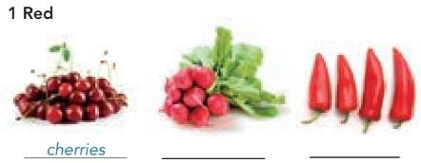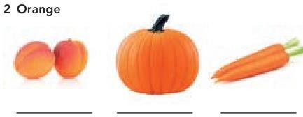
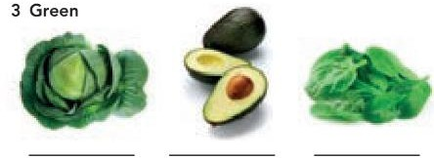

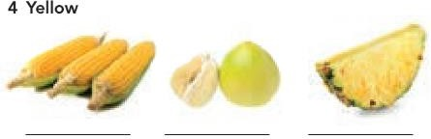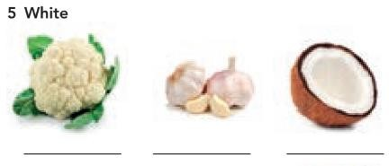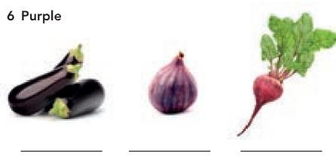
EXERCISE 2. Use the following words to fill in the gaps:
trout, swordfish, pork, semolina, custard, filling, self-rising flour, mackerel, bell pepper, caviar
- The restaurant's special today is grilled (a large, meaty fish) with a lemon butter sauce.
- When I was in kindergarten I hated eating . It had no taste and too many lumps.
- I caught a beautiful (a type of freshwater fish) in the river yesterday and grilled it for dinner.
- At the fancy dinner party, they served on small toasts as an appetiser.
- We had smoked (a type of oily fish) for breakfast, served with fresh bread and butter.
- For our family barbecue, we marinated some chops overnight.
- The recipe calls for a diced to add colour and flavour to the salad.
- To make the cake rise perfectly, you need to use instead of regular flour.
- I love pouring warm over my apple pie for an extra sweet treat.
- The pastry was rich and creamy, making the dessert irresistible.

EXERCISE 3a. SPEAKING
Discuss the questions.
- Who is the best cook in your family?
- What dishes can you cook?

Read the blog post and discuss which celebrity diet you think is:

  - the most appealing • the easiest to do • the least appealing

STRANGE CELEBRITY DIETS
When I read about the weird and wacky diets of famous celebrities, I think that being in the public eye can make people a bit crazy. And it’s nothing new – more than two centuries ago, the romantic poet Lord Byron wanted to be pale and thin, so he only ate stale, dry biscuits, soda water and potatoes covered in vinegar – yuck! So sour! No wonder he died at the age of thirty-six!
Here’s my list of today’s top five strangest celebrity diets.
#5 Once, when Beyoncé was preparing for a video shoot, she went on a detox. This involved living on lemon juice, sweetened with maple syrup and made a little less bland with cayenne pepper. Give that woman some chocolate cake!
#4 Gwyneth Paltrow, Jennifer Aniston and Reese Witherspoon choose the baby food diet which involves eating fourteen jars of baby food a day, and one low- calorie meal of lean meat or fish and green salad.
#3 American singer Jennifer Hudson thinks the Cookie Diet™ is more fun – instead of breakfast, lunch and snacks, you have six biscuits. But these are not delicious, crunchy biscuits with milk chocolate on top. Dr Siegal, the inventor of the Cookie Diet, was careful to make his cookies taste good, but not too good.
#2 Katy Perry keeps in shape with the mushroom diet, but instead of enjoying a bowl of delicious mushroom soup, she swaps one meal a day with raw mushrooms for fourteen days at a time.
#1 – MY FAVOURITE! Christina Aguilera does the seven-day colour diet, eating food of a different colour every day for a week. Day one is white, but that means white fruit and vegetables, not white bread or white rice! This is followed by red, green, orange, purple, yellow and on the seventh day, all of the colours. This diet might encourage you to try new things, like deep-red cherries, ripe avocados or fresh figs, and you’d get plenty of vitamins. I think this is the only one I would actually try.

EXERCISE 3b. Complete the sentences with an appropriate adjective from the blog post. Which sentences are true for you? Provide some details
- Thai and Indian curries are too spicy for me. I know it’s boring but I prefer
food.
- My friend likes anything : she particularly loves ice cream and chocolate.
- The taste of dark chocolate or strong coffee is too for me.
- If we have any old, bread, we feed the birds.
- I’ve never tried sushi. I don’t like the idea of eating fish.
- I can’t eat salad if the dressing has a lot of vinegar. It’s too for me.
- I don’t like bananas that are too . I prefer them to be white and firm.
- I only like meat so I cut off the fat and leave it on the side of my plate.

EXERCISE 4. Do the crossword below and create three own definitions to any words from Key Vocabulary.
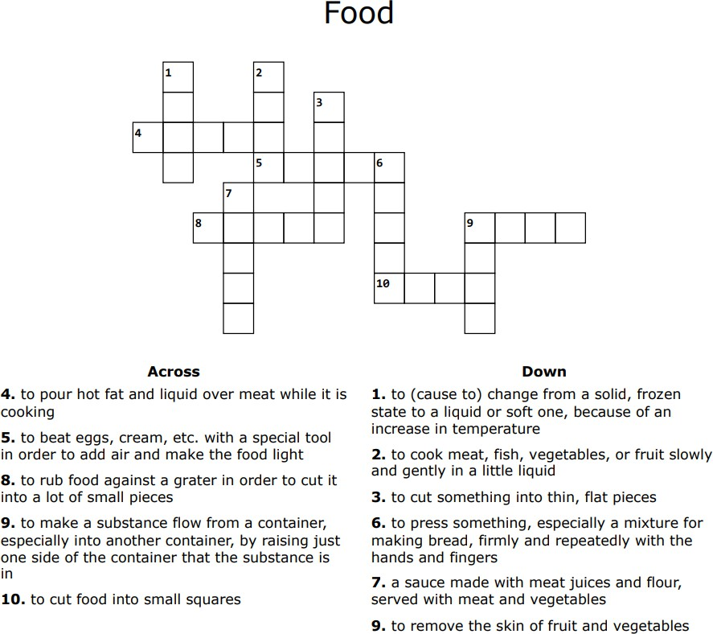
EXERCISE 5a. Take The Healthy Diet Test and compare your results with a partner.

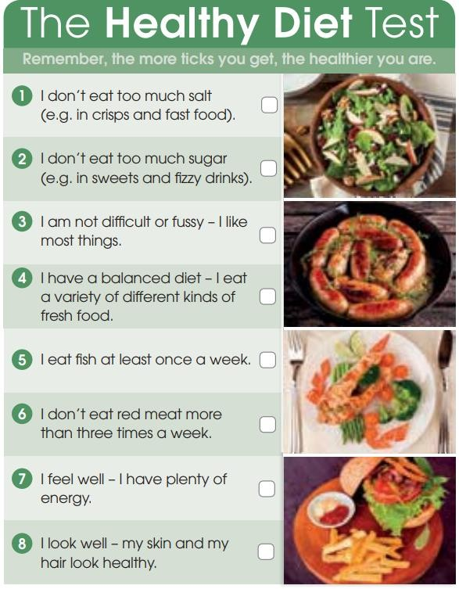

EXERCISE 5b. Answer the questions
  - What are the ways of maintaining a healthy diet that you use?
  - Have you ever thought of becoming a vegetarian? Why or why not?
  - Are you a fussy eater? As a child were you encouraged to eat everything on your plate? Why or why not?

EXERCISE 6. Complete the sentences with the idioms from the box:
to have his cake and eat it too/to have such a sweet tooth/ as cool as a cucumber
/ to be the cream of the crop/ to be full of beans / to take with a pinch of salt/ to be a bad egg / to be a hard nut to crack

- Despite the heated debate, Emma remained , never losing her temper.
- After his morning run, David and ready to tackle the day's challenges.

- Lucy's friends often tease her because she and can never resist chocolate.
- When listening to rumours, it's wise everything
to avoid misinformation.
- Mark wanted to by keeping his high-paying job while also travelling the world.
- The new project turned out to , requiring extensive research and collaboration.
- Despite his charming demeanour, everyone soon realised that Jake
who couldn't be trusted.
- In her class, Sarah's essays are always , consistently earning top marks.

Answer the questions below:
  - What is something you do that you consider the cream of the crop?
  - Do you have a sweet tooth? What is your favourite sweet treat?
  - Can you think of a time when you had to take something with a pinch of salt? What was it?
  - What is a hard nut to crack that you have faced recently? How did you deal with it?
  - Have you ever met someone who seemed nice at first but turned out to be a bad egg? What happened?
  - How do you stay as cool as a cucumber during stressful situations?
  - When do you feel full of beans and energetic?
  - Have you ever wanted to have your cake and eat it too? How did you try to balance different desires?

Read UK TODAY and discuss the questions.
- Which facts do you find most shocking?
- Do you think the situation is similar or different in Ukraine?
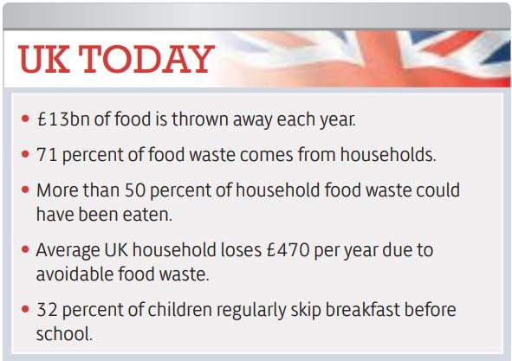

TEXT

The freegans' creed: waste not, want not

It’s midnight, I have a torch and I’m sifting through the bins behind my local Tesco in search of food. The idea of picking through discarded packets of cakes and cheese in a pair of marigolds may seem pretty disgusting. But for a small section of society, standing in bins at night – or freeganism, as it is more widely known – has become a way of life. Stuart became a freegan at Cambridge (he read English) and as a student acquired most of his food from the bins of his local Sainsbury's.
Freegans avoid buying anything as much as possible in order to boycott the economic system and be eco-friendly. For many young freegans, this can mean asking supermarkets for their discarded food, which is often left in bins.
In the US especially, freegans are often called "dumpster divers", though many freegans insist that the practice of extracting food from dustbins represents only one strand of what they do; other freegan practices include co-operative living, squatting and "freecyling", or matching things that people want to get rid of with things other people need.
Most people would admit that wasting food is not good. But surely, they'd say, the problem can't be that serious? Isn't rooting around in rubbish bins a somewhat extreme – and unpleasant – reaction? Stuart would disagree. Addressing food waste, he says, is a vital step when it comes to sorting out many of these other problems, and it's hard to disagree with his logic. If we waste less food, we'll need less land to grow it on, and hence will cut down fewer trees; we'll use less water to irrigate that land and less carbon to transport and process the food it produces. On a more basic level, food waste is an issue of equality. If we didn't waste so much food, there would be more available, which means fewer people in the world would go hungry.
This situation could be dramatically improved, Stuart says, with the introduction of a few quite simple measures. Supermarkets should be required to report how much food they waste and should be compelled to set (and keep to) waste reduction targets. Or surplus stock could be redistributed. In the US, such schemes have long been popular. Giving away surplus food is a well-established practice among US supermarkets and many towns and cities have "food banks' ' where the homeless and those on low incomes can pick up this surplus for free.
In Britain, retailers and producers have been much slower catching on to the idea, and until recently redistribution was only ever undertaken on an individual, piecemeal basis – shops and restaurants allowing the homeless to take away unsold items at the end of the day, for example. Adopting a freegan lifestyle can go a long way towards stretching out your student loan. Even just doing so part-time could be a great way of supplementing your weekly shop.
If you are interested in getting started, it’s easy to find your local freegan group online. There are plenty of ways to participate in the movement that don’t involve taking a shower afterwards – you don’t have to start dumpster-diving straight away. In fact, doing so is something of a legal grey area.
Free, usable stuff is everywhere, all you have to do is open your eyes.
Freeganism is just the beginning of a long struggle to change the way we consume and to start appreciating what we have on our plates.
Adapted from The Guardian

READING COMPREHENSION QUESTIONS
  - Have you ever considered the impact of food waste on the environment? How do you feel about the idea of freeganism as a way to combat this issue?
  - Would you ever participate in an activity like dumpster diving or freecycling? Why or why not?
  - How do you think society would change if more people adopted a freegan lifestyle? Do you think it would make a significant difference in reducing waste?
  - Have you ever felt conflicted about the amount of food or resources you personally waste? What steps, if any, have you taken to reduce this?
  - Do you believe that freeganism is an effective way to protest against the current economic system? What other methods do you think could be more impactful?
  - How would you react if someone you know decided to adopt a freegan lifestyle? Would you support them, or would you have concerns?
  - In what ways do you think your own consumption habits contribute to larger issues like food waste and inequality?
  - How do you feel about the idea of redistributing surplus food to those in need? What role do you think individuals and businesses should play in this effort?
  - Would you be willing to challenge societal norms and adopt practices that might be seen as extreme, like freeganism, if you believed it could make a positive difference?
  - How important is it to you to appreciate and make the most of the resources you have? Do you think this mindset is common in your community or society at large?

Classroom extra: Scan the Qr code below and watch the video. What Ukrainian products would you like to give celebrities to try? What do you think would be their reactions?


SPEAK OUT
Make up a dialogue using one of the scenarios or your own idea:

- Characters: A waiter at a fancy restaurant with exquisite speciality dishes and a very scrupulous and demanding client
Situation: The client comes to the restaurant: he wants to make a proposal to his/her fiancè(e) after the meal. The fiancè(e) is very picky and also allergic to some

seasonings and products. The waiter tries to please and be as nice as possible, even when the client is being rude.
- Characters: A sous-chef, the applicant, and a chef, the interviewer
Situation: There is a vacancy at the French/Italian/Japanese restaurant and the chef himself is interviewing applicants for the position of a sous-chef. The person should be innovative and experienced, so the chef is asking specific questions about recipes and the cooking process and the applicant is trying to give detailed and extraordinary answers.

UNIT 2 WEATHER THE STORM

KEY VOCABULARY
Weather and climate: annual precipitation, unsettled, marvellous, beastly, sultry, sweltering, mild, arid, windy, humid, chilly, overcast, still
Snow and weather phenomena: avalanche, snowflake, sleet, snowdrop, icicle, ringing frost, hoarfrost, hail, hailstones, snowdrift, slush, blizzard, thaw, to melt, slippery, scorcher, heat, dew, drizzle, downpour, to vapour, to clear up/to brighten up, haze, fog, gale, a flash of lightning, a clap of thunder, a gust of wind, hurricane, flood, drought, whirlwind
Idioms: to be under the weather, to rain on someone's parade, to be under a cloud, to be hot under the collar, to blow hot and cold, to make heavy weather of something, every cloud has a silver lining, to have head in the clouds, a fair-weather friend, it never rains but it pours, to be snowed under, to steal one's thunder, to take a rain check
Environmental issues and effects: oil slicks, emission of/ to emit poisonous chemicals, greenhouse gases, smog, toxic waste, deforestation, contamination of food, water, soil, acid rains, endangered species, overuse of pesticides, solar/wind power, genetically engineered foods, face extinction, make a difference, a poacher

Comment on the following quotation. To what extent do you agree with that? “We don’t inherit the earth from our ancestors, we borrow it from our children.” – Chief Seattle
EXERCISE 1a. Look at the pictures and name the types of weather
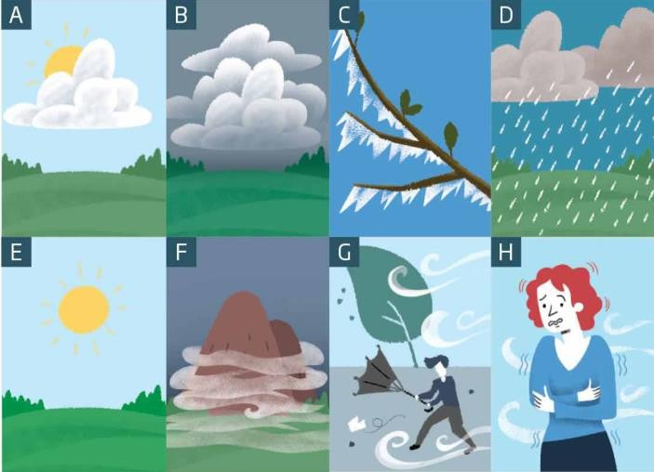

EXERCISE 1b. Answer the following questions:
  - What seasons are these weather conditions typical for?
  - Are you weather dependent or does the weather affect your physical state at all?

  - Under which weather conditions do you feel most productive?

EXERCISE 2a. Guess the weather phenomenon hidden in the following riddles. Do you know any other weather riddles about the words from Key vocabulary?
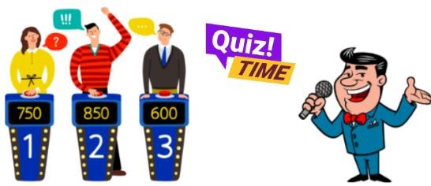
- I howl and roar with a mighty force, Bending trees and changing course. Stronger than a breeze,
I set ships to sail,
What am I, with my powerful wail?
- I fall from the sky, unique and bright, A frozen star in the cold, dark night.
No two are the same, a wonder to see, I’m delicate and small, what could I be?
- What falls from the sky but isn't rain or snow?
- I am a phenomenon where small ice crystals fall from the sky and look like small crystals. What am I?
- I am a type of storm that can produce strong winds and heavy rain, and can cause damage. What am I?
- I am a type of cloud that is low to the ground and can cause poor visibility. What am I?
- I am never seen, but always heard. I am never touched, but often felt. What am I?
- I am a force of nature, but not always welcome.
I can be gentle and soothing, or fierce and destructive. I come from the sky, but I am not a bird.
I can be accompanied by thunder and lightning, or I can fall silently. What am I?

EXERCISE 2b. Read the beginnings of weather lores and match them with their endings. What are their meanings? Do you know any Ukrainian weather lores?

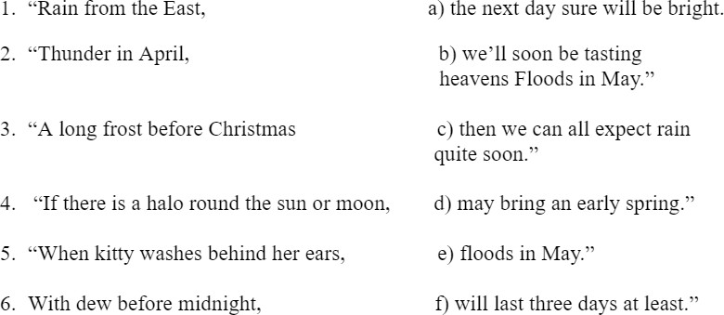

EXERCISE 3a. Read the sentences and match the words in bold with the correct weather category, underline the words/phrases that helped you to decide:
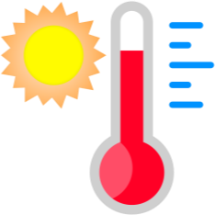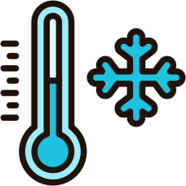

hot cold sunny wet windy
  - It was blowing a gale when we got to the top, so I didn't go too close to the edge.
  - I couldn't sleep at night because it was so sticky and humid.
  - It brightened up in the morning and then the rest of the weekend it was absolutely glorious.
  - Apart from one brief sunny spell, it was pretty miserable most of the time.
  - Oh, it was really bitter! I almost froze to death while we were watching the game,
  - It started spitting, so we decided to pack everything up, but then it started pouring down before we could get inside. We all got soaked.
  - It was a bit chilly at night. We definitely needed the extra blanket.
  - There was a frost on the ground in the morning and it was a lovely, clear crisp day.
  - It was so still. There wasn't even the slightest breeze.
  - There was a huge thunderstorm that flooded the pitch, so the game was called off.

EXERCISE 3b. Answer the questions about the words related to weather conditions
- Which word describes a small amount of wind and which a small amount of rain?
- What might happen if it's blowing a gale outside?

- If it's spitting and it then gets worse, how do you describe the weather? And what about if it then gets better?

EXERCISE 3c. Choose 3 of the following topics and provide some details related to them:
  - The weather you`ve had in Ukraine this year
  - The weather you had the last time you went on holidays
  - Any weather stories you have heard about in the news
  - A great weather experience you`ve had
  - A terrible weather experience you`ve had

EXERCISE 4. Complete the crossword puzzle below. Create 3 definitions for any words from Key Vocabulary. Read them out for your groupmates to guess
the words.
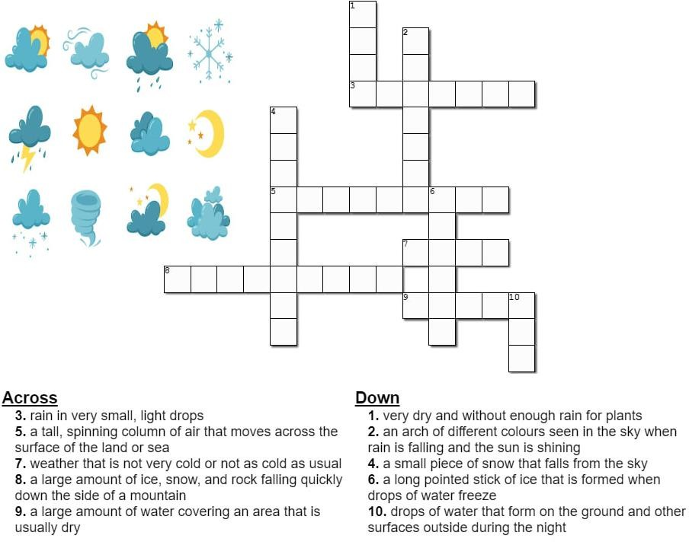

EXERCISE 5. Fill in the gaps with the appropriate idioms from Key Vocabulary.
- She didn't mean to , but she had to tell him that the concert was cancelled.
- I'm sorry I can't join you for dinner tonight. Can I and reschedule for next week?

- It's hard to trust him because he tends to about important decisions.
- I can't come to the party tonight because I . I just need to stay at home for a couple of days.
- When I needed help, she was nowhere to be found; she's just .
- First, the car broke down, and now the roof is leaking.
- Even though losing his job was tough, he realised when he found a better one.
- I can't take on any more projects right now because I'm completely with work.
- He's always daydreaming and seems to during meetings.
- When he heard the accusation, he and started shouting. I can't believe he was that angry.
- He has been ever since he was caught cheating in the exam. Everyone looks at him strangely and it will take him a long time before he is trusted again.
- She tends to of simple tasks and ends up taking much longer than necessary.
- She worked hard on the presentation, but her colleague by presenting her ideas as his own.

EXERCISE 6. Choose the right word from a couple of similar-looking ones.
- slush, sleet
  - The under my feet was awful. I had an impression that I was walking through a muddy sea.
  - The rain changed into . Wet snowflakes were falling on the ground and melted there.
- ice draft, snowdrift
  - The path was hedged by two long . They were like two mountain ranges.
  - The started at night. In the morning the children ran to the river to look at the huge blocks of ice drifting across the water.
- icing, icicle
- There was heavy on the road and all cars were moving very slowly.
- After a thaw there appeared on the edge of the roof; they looked like sparkling needles.
- frost, harshfrost
  - Three branches were covered with and the forest looked enchanting and somewhat mysterious.
  - The was biting the nose and the cheeks. It was impossible to sty long in the street.
- draught, drought
  - Severe killed the crops. Not a drop of rain fell on the ground for a month.
  - When the door opened, the blew off the papers down on the floor.

- to freeze, to be freezing
  - In winter all rivers and lakes in these parts always .
  - The temperature was quite low and I felt that I was .
- blizzard, drizzle
  - Boring spoiled the day. It was too wet and dull.
  - The was blinding us. Snowflakes were swirling in the air.
- rain, hail
  - Small pellets of ice that fall from the sky during a storm are called .
  - Droplets of are shimmering on grass blades.

EXERCISE 7. Use the phrases from the box to complete the following sentences
face extinction/ toxic waste/ short supply/ genetically engineered/ take effect
- Tonnes of is produced every year by factories.
- The new law regarding hunting will next month.
- Because of pollution of their habitat, many animal species .
- Food is in in many developing countries.
- Most goods are expensive.

Classroom extra:


1. 2. 
Watch the first video and tell why animals are so happy that human beings were kept at home due to worldwide pandemic? Then watch the second video and discuss the impact of people on nature. Use the vocab from the previous exercise and Environmental issues and effects section.
What would you do to help?

To make the world greener,
  - Name something you could give up.
  - Name something you could cut down on.
  - Name something you shouldn't throw away.

TEXT
Coldplay have shared new figures that show the celebrated British band have reduced their carbon emissions by nearly half with their eco-friendly world tour.
The band had previously announced that they were looking to make their tours more ecologically friendly by reducing carbon emissions through several methods, including powering their shows from bicycles and electricity-producing dancefloors, building sets from bamboo, and planting a tree for every ticket sold. Coldplay have emitted 47 per cent less carbon emissions on their world tour so far, compared to their tour in 2016 and 2017, after which they said they would not be touring again until they could do so more sustainably.
They added that they have started to run the entire show (audio, lights, lasers etc) “from an electric battery system that allows us to use 100 per cent renewable energy as efficiently as possible” and that they have been electric vehicles and alternative fuels “wherever we can, as well as reducing waste and plastic usage to a minimum.”
Coldplay have also thanked their fans, who have “helped charge the show batteries on the power bikes and kinetic dance floors; travelled to shows by foot, bicycle or public transport; used the recycling bins; ride-shared; brought refillable water bottles; returned the LED wristbands after the show. And just by coming you have had a tree planted, and helped a range of environmental organisations like The Ocean Cleanup and ClientEarth (a team of lawyers who defend the environment).”
The latest results are “scientifically rigorous,” according to Professor John E. Fernandez of the Massachusetts Institute of Technology, who is monitoring the study.
Fernandez said that the institute’s Environmental Solutions Initiative “endorses this work as an important and substantive step toward a new era of eventually achieving carbon neutral music events by major artists. The band deserves significant praise in commissioning the work and acting as the vanguard for the global music industry as it begins to take seriously the reality of living and making music in the Anthropocene.”
Coldplay are not the first band to aim for net-zero touring and who have gone beyond surface-level greenwashing. Massive Attack have been working with climate scientists to explore ways to put on “super low carbon” events by handing over years' worth of touring data to Manchester University’s Tyndall Centre for Climate Change Research to assess how the industry can do better, while Billie Eilish had been planning an eco-friendly tour for 2020 before COVID decided to make the artist entirely sustainable. As for another love-or-loathe-them band, The 1975 have also been making efforts: their pandemic-derailed summer festival in London’s Finsbury Park was set to be the first ever UK event powered entirely by a sustainably sourced biofuel, Hydrotreated Vegetable Oil (HVO), and solar panels. They also introduced the concept of repurposing merchandise, as their fans have been offered the chance to bring their old band t-shirts to shows and have them screen printed with new branding at no cost. World tours have always been an environmental nightmare, due to the transportation of crew, and equipment. Studies have shown that the majority of touring emissions – often over 90 per cent – come from the travelling involved, and Coldplay

have pledged to minimise air travel and use “sustainable aviation fuel” where flying is unavoidable.
However imperfect, these gestures from major bands can bring about change and hopefully, Coldplay’s touring parameters can become, at the very least, the benchmark for other artists who go on tour. Environmentally conscious concert goers can also hold the artists they go to see live to a certain level of accountability.
With this in mind, how about a new award at the Grammys, for example? The Fix You Coldplay Chalice of Keeping A Sky Full Of Stars... Or something like that... Catchier title pending.
Adapted from Euronews

READING COMPREHENSION QUESTIONS
- How do you feel about the idea of making music tours more eco-friendly? Would you be more likely to support an artist who takes these efforts seriously?
- Have you ever considered the environmental impact of attending a concert or festival? Does this information change the way you think about live music events?
- If you were an artist, would you prioritize sustainability on your tours, even if it meant higher costs or more effort? Why or why not?
- How important is it to you that artists and bands use their platform to promote environmental causes? Do you think it makes a difference?
- Would you be willing to participate in eco-friendly initiatives at a concert, like using a power bike or kinetic dance floor to generate energy? Why or why not?
- How do you think fans can encourage more artists to adopt sustainable practices on their tours? What role do you think fans should play in this movement?
- Do you believe that the efforts made by bands like Coldplay and The 1975 can inspire real change in the music industry? Or do you think it’s just a trend?
- How do you feel about the idea of a new Grammy award for sustainability in music? Do you think it would encourage more artists to focus on eco-friendly practices?
- Have you ever thought about how your own travel habits, like attending concerts or festivals, contribute to your carbon footprint? Would this influence your decisions in the future?
- Do you believe that major artists should be held accountable for the environmental impact of their tours? How much responsibility should they bear compared to other industries?

SPEAK OUT
Choose one of suggested projects below, work in pairs and present your work during the lesson
  - Shoot the video of a weather forecast for a week and present it as if you are meteorologists on TV.
  - Choose an environmental issue (like deforestation, pollution, or endangered species) and create a report and presentation on its impact and possible solutions.

UNIT 3 LIVING CONDITIONS

KEY VOCABULARY
Types of houses and buildings: cottage, bungalow, flat, barn, council house, suite, castle, chalet, igloo, wigwam, convent, monastery, mansion, studio, dormitory, semi- detached, villa, patio, porch, stable
Rooms: cellar, guest room, pantry, bedroom, yard, hall, living room, kitchen, garage, attic, balcony, dining room, utility room, study, nursery, basement, workshop
Inside the house: a carpet (fitted), a coffee table, draped curtains, attractive/faded wallpapers, a chest of drawers, ottoman, washbasin, double glazed windows, pine sideboards, tiles, central heating, upper lights, sockets, sewer, mantelpiece, cupboard, double/bunk bed, built-in wardrobe, floor lamp, dressing table, easel, cushion, upholstered sofa, polished wooden floors, a rug, shutters, bedside table, chandelier, dish drainer, dish washer, cabinet, counter, bookcase, armchair, wardrobe
Adjectives: bare, spacious, cosy, traditional, comfortable, cramped, impersonal, stylish, modern, crowded, fully-equipped, fully-furnished, affordable, easily accessible, peaceful, newly-built, well-kept, restored
Building metaphors and idioms: to be a brick wall, to put a ceiling on sth, to go through the roof, to live in an ivory tower, to be a tower of strength, to do something by the backdoor, to hit home, to hold the keys to sth, to cement one`s partnership, to be a key figure, to lay the foundation for, to be a wall of silence, to get a new lease of life, home truths are hard to swallow

Comment on the following quotation. To what extent do you agree with that? “A house is made of bricks and beams. A home is made of hopes and dreams.” – Ralph Waldo Emerson

EXERCISE 1. Read the definitions below and match them with the names of the buildings from Key Vocabulary. In what type of these houses would you like to live in and why? Can you name the dwellers of these houses?
- a small, one-room apartment that combines the living, sleeping, and kitchen areas into a single space.
- a building or complex where monks live, work, and worship.
- a type of housing provided by the government for people with low incomes, often found in the UK.
- an apartment or a set of rooms forming an individual residence, typically on one floor within a larger building.

- a large building at a college or university where students live.
- a large strong building, built in the past by a ruler or important person to protect the people inside from attack.
- a circular house made of blocks of hard snow, especially as built by the Inuit people of northern North America.

EXERCISE 2. Read the text below and answer the questions that follow
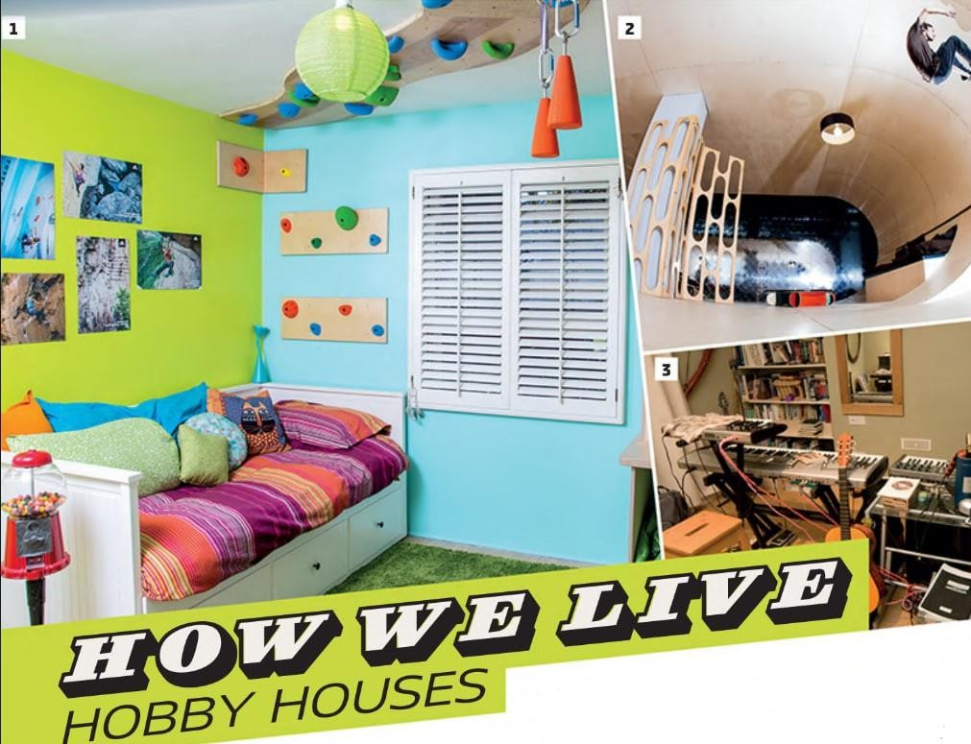
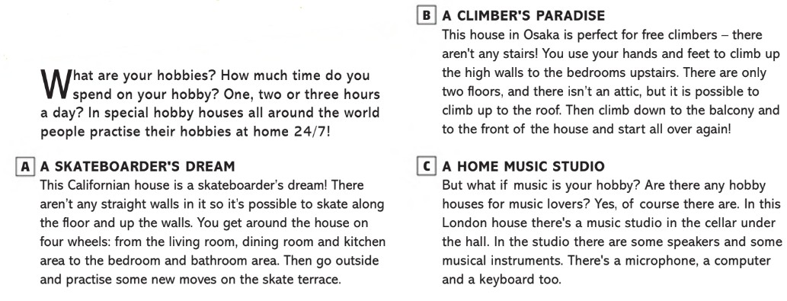

- Which of the hobby houses described in the text would you prefer to live in and why?
- Are there any other hobbies you think could have a specially designed house? What would it look like?
- How do these hobby houses inspire people to pursue their passions more seriously?
- What do you think are the practical challenges of designing and maintaining a hobby house?

EXERCISE 3. Use the vocabulary to describe the houses in the pictures
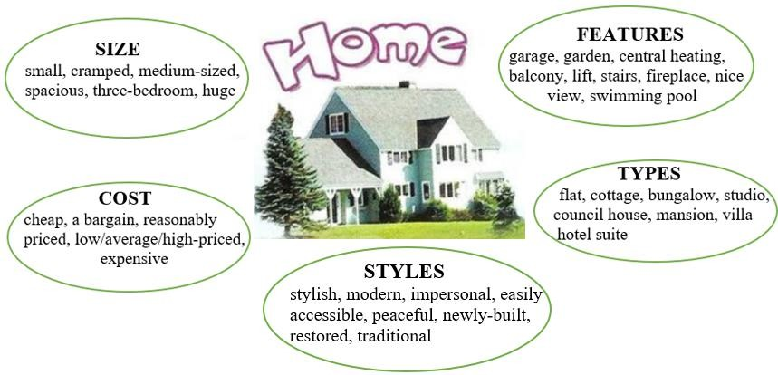
For example, in picture X, I can see a modern semi-detached house. It looks quite spacious and probably has two or three bedrooms. It has a small front garden and a garage. I think it's reasonably priced.
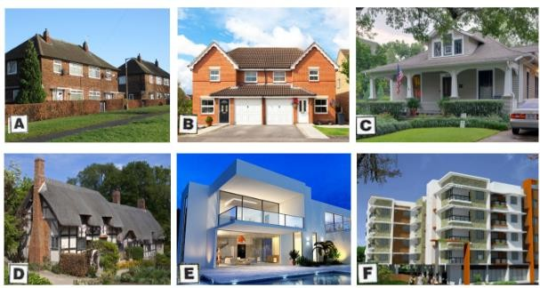
  - What are the advantages and disadvantages of living in each type of house?
  - Where is it better to live: at the seaside or in the mountains? Why?
  - What are the advantages of living in the country?
  - What are the advantages of living in the city centre?
  - Is a lift a must in a block of flats?
  - What can you do to make your house or flat more homely?
  - What kind of home can you call charming?
  - What are the disadvantages of living in a large home?

  - What problems might you have when you live in a small home?

EXERCISE 4a. Work in pairs and discuss the following questions
- Have you ever rented a flat to/from somebody? Did everything go smoothly?
- What is involved in renting a flat? What are some possible sources of conflict between landlord and landlady and a tenant? Make a list.
- What can happen if the relationship between landlord/landlady and tenant turns sour? What options do they each have?

EXERCISE 4b. Listen to a conversation between a landlady and a tenant. What sources of conflict did they mention?


EXERCISE 5. Rewrite the underlined parts of these sentences using one of the building metaphors and idioms from Key Vocabulary.
  - The company's profits increased dramatically last quarter.
  - Despite the crisis, she remained very supportive for her family.
  - He tends to ignore reality and live in his own world.
  - The team strengthened their cooperation by working together on this project.
  - She always gets what she wants by taking secretive actions.
  - The shocking news finally made an impact on him.
  - He is the person in control of the organisation.
  - The teacher's strict rules acted as a barrier to creative thinking.
  - The strict regulations limit the company's growth.
  - The new CEO gave the company new energy.
  - He is a crucial person in the negotiations.
  - The administration has remained completely silent about the issue.
  - The criticism was difficult to accept, but it was necessary.
  - Their early research established the basis for future discoveries.

EXERCISE 5b. Work in a group of 4 students. Choose one scenario and create a short dialogue (6 lines) using any 6 idioms from Key Vocabulary.
Scenario 1: Real Estate Consultation
Situation: A couple is meeting with a real estate agent to discuss buying their first home.

Scenario 2: Home Renovation Discussion
Situation: A family is discussing their plans to renovate their home to better suit their hobbies and lifestyle.
Scenario 3: Moving to a New City
Situation: A person is talking to a friend about moving to a new city for a job and finding a new place to live.

EXERCISE 6. Do you pay attention to the design of someone's house while visiting it? Does it change your attitude to that person? Watch the video below about Ashley Tisdayle`s home and answer the following questions.


Listening comprehension questions
- How many rooms has the actress shown?
- How long did it take for the family to renovate the house?
- Which room consists of 2 parts? What picture does this room have?
- Where is the hallway leading into (to which room)? What can be found on its walls?
- What is situated in the TV room? Why does couple like this room?
- Which room is the actress's favourite one? Why?
- Where does the actress usually meditate?
- Which room was created out of the bedroom?
- Why did the owners decide to change the window in the bathroom?
- What colours prevail in the house? Which room is completely different?

EXERCISE 6b. Work in pairs. Discuss the questions below and share your feedback
  - Do you enjoy renovating and redecorating your living space?
  - How important is it for you to have a cosy and comfortable bedroom/kitchen?
  - Would you like to see a house of any celebrity? If so, whose house would it be?

EXERCISE 7. Look at the picture and fill in the gaps with the words that describe the location of items of furniture in the following picture:

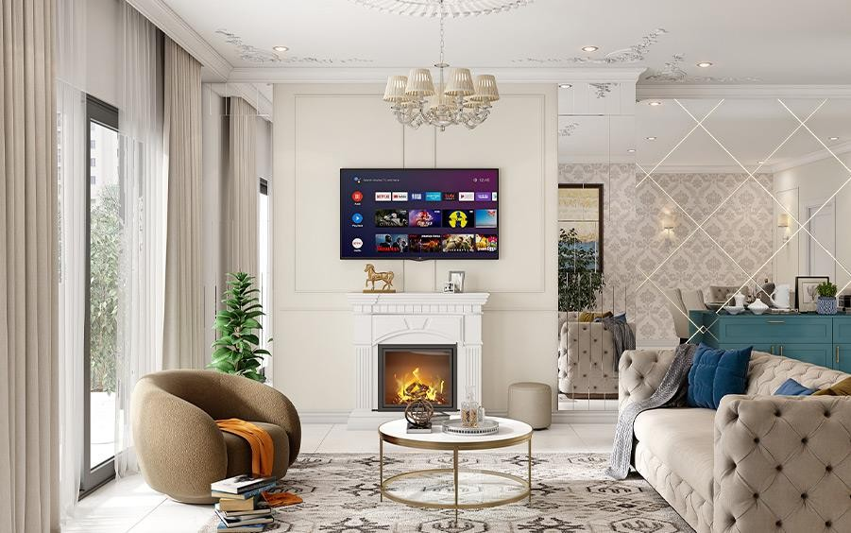
In photo 1, the room has a cosy and elegant setup with various objects:
- is at the foot of the bed.
- There are on either side of the bed, each with a lamp on it.
- The is on the right side of the room.
- The are behind the two armchairs and allow plenty of natural light into the room.
- A is to the right of the armchairs, near the chest of drawers.
- The are placed in front of the windows, with a small table between them.
- A hangs from the ceiling, adding a touch of elegance to the room.
In the photo 2, the room has a luxurious and stylish setup with various objects:
- The is in the centre of the room, with a television mounted above it and a small decorative item (a horse statue) on top.
- The is in front of the sofa, holding some decorative items and a couple of books.
- The is on the floor beneath the coffee table and sofa, adding warmth and style to the space.
- There are on the sofa, adding comfort and colour to the seating area.
- The room has on the far wall, enhancing the room's elegance.
- are on the left side of the room, covering large windows or sliding doors.
- The is next to the mantelpiece on the right side, serving as an extra seat or footrest.
- The hangs from the ceiling, adding a touch of sophistication to the room.
EXERCISE 7b. Describe your favourite room, use the words from Key Vocabulary

TEXT
Inside The Keret House - the World's Skinniest House
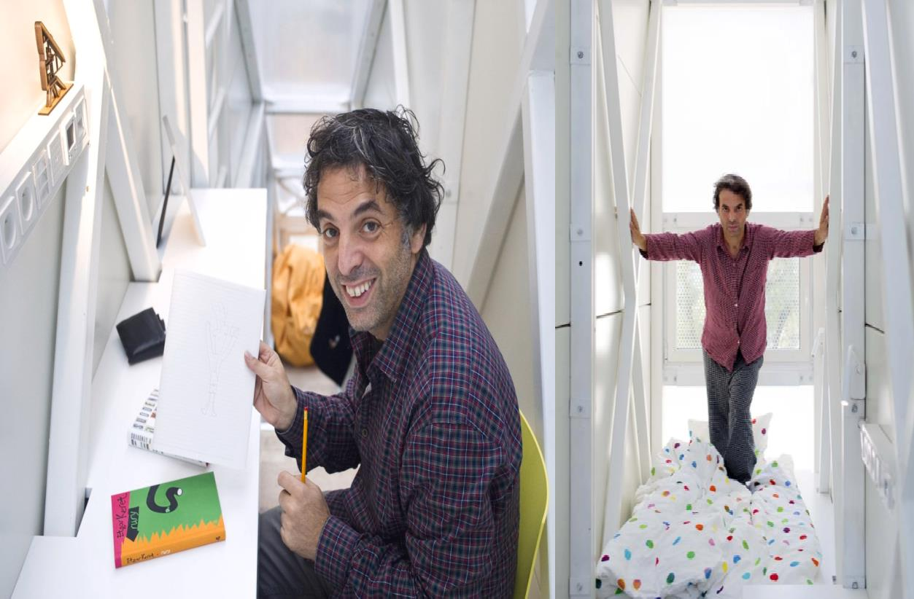
CENTRAL WARSAW IS TRULY CRAMMED for space, and many downtown developers are turning horizontal space into vertical space by building tall skyscrapers. But in no other setting in the world is a building’s height to width ratio as insanely preposterous as that of Warsaw’s Keret House. Welcome to the skinniest house in the world.
Earlier this week, we announced the completion of the world’s narrowest house in Warsaw, Poland. The Keret House was first conceived as a seemingly impossible vision of the Polish architect Jakub Szczesny of Centrala, who first presented the idea as an artistic concept during the WolaArt festival in 2009. Now, three years later, the vision has become a reality and is drawing a significant amount of international attention to the city of Warsaw.
Built between two existing structures from two historical epochs, the narrow infill is more of an art installation that reacts to the past and present of Warsaw. Although the semi-transparent, windowless structure’s widest point measures only 122 centimetres, it’s naturally lit interior doesn’t seem nearly as claustrophobic as one would think.
The Keret House will serve indefinitely as a temporary home for travelling writers, starting with Israeli writer Etgar Keret.
Keret House is the installation art in the form of an insert in between two existing buildings. The project was launched on Saturday 20th of October in Warsaw. It is led by the Israeli writer Etgar Keret.
Keret House is fully functional space in which one can live as well as create. It is located between buildings at Chlodna 22 Street and Zelazna 74 Street. “We deeply believe it will become a symbol of modern Warsaw ingrained in its complicated history. The House attracts attention of media from the entire world. He hopes it will show the most fascinating side of Warsaw”, said project curators Sarmen Beglarian and Sylwia Szymaniak from Polish Modern Art Foundation.

The House is located on the plot measuring 92 centimeters in its narrowest point and 152 centimeters in its widest point. “That is why at first it seems that the construction of living space within such premise is impossible. Keret House is to contradict that false image, simultaneously broadening the concept of impossible architecture”, says the architect Jakub Szczesny. The house itself is 72 centimeters in the narrowest and 122 centimeters in the widest point.
With just 46 square feet of floor space and a world record for narrowness under its name, the Keret House manages to fit a bedroom, a bathroom, a kitchen, and a two- beverage refrigerator in the span of three floors. The first floor features nothing but a staircase to the second. However, when the staircase is retracted it makes for a pleasant (yet claustrophobic) living room. To get from the second floor to the third, you must climb a white ladder.
Since the Keret House is so minuscule, it has no room for traditional electrical and sewage appliances. Szczęsny’s makeshift solution to the electrical dilemma involved obtaining electricity from the two buildings it’s sandwiched in between. To dispose of sewage, the Keret House avoids city standards and instead uses an innovative customized design.
Built in 2012, Szczęsny’s narrow masterpiece is legally classified as an “art installation” because it doesn’t meet Polish housing codes, but, in practice, it serves as a residence nonetheless. Constructed as a memorial to his family killed in the Holocaust, the Keret House is named after Etgar Keret, the Israeli filmmaker and author who was spontaneously asked by Szczęsny to be the house’s first tenant. After Keret agreed to the deal and lived there for a number of weeks, the Keret House became open to travelling writers for the night’s stay. As of today, the Keret House is open to all visitors to Warsaw, so long as it’s not undergoing maintenance.
It all started one afternoon on my way to a nearby club. I stumbled upon this strange gap between a post-war co-op prefab building and a pre-war ex-Jewish tenement block. The house is located between two buildings from two historical epochs. “The first is a brick building on Zelazna Street – a fragment of the pre-world war II city, almost no longer existing. The second – a cooperative concrete apartment building, an element of an “imposed structure”, which was aimed at negating the previous city landscape. Their adjacency is coincidental – like many architectural structures in Warsaw. Suddenly I thought: “How can one make these two buildings communicate? By putting life in-between”. A voice said: “Sure, but how?” It should be a space for one person, a loner, a hermit, a writer! Someone to be close to reality, but distant at the same time… What kind of writer would like to stay in something as narrow as this? Someone with a pretty good sense of humour, for sure…
Keret House is a perfect example of the so-called “non-matching” in the city’s urban fabric. Another reason is the city’s war history – where the house is located, two ghettos – the large ghetto and the small ghetto met. Only a few steps from the house, a bridge connecting the two closed spaces, stood”, explains Jakub Szczesny. The Keret House project was run by the Polish Modern Art Foundation. Founded by Piotr Nowicki in the fall of 1985, PMAF is one of the first, independent non-profit organizations operating in the art field. Its main goal is and always has been the

promotion of those artists whose activity contributes to the development of contemporary art.
Adapted from ArchDaily

READING COMPREHENSION QUESTIONS
- How do you feel about the concept of living in such a small, confined space like the Keret House? Could you see yourself staying there for a while?
- What do you think the Keret House says about the intersection of art and architecture? Do you believe architecture can be a form of artistic expression, or should it serve purely practical purposes?
- The Keret House is described as a space for someone "close to reality, but distant at the same time." Have you ever felt the need for such a space in your own life? What would it look like for you?
- How do you think living in such a narrow space would affect your daily routine or mental well-being? Would the challenge of living there appeal to you?
- The Keret House is built between two buildings from different historical epochs. What do you think this symbolises about the relationship between past and present in a city like Warsaw?
- The house was created as a memorial to those who were lost during the Holocaust. How do you think architecture can serve as a way to remember and honour history?
- Do you believe that small, unconventional living spaces like the Keret House could become more common in crowded urban areas? What are the potential benefits and drawbacks of such a trend?
- How do you feel about the idea of art installations being used as functional living spaces? Do you think this blurs the line between art and everyday life?
- The Keret House is designed to be a temporary home for travelling writers. How do you think the environment of such a unique space might influence a writer’s creativity or work?
- The house's narrowness forced the architect to come up with innovative solutions for utilities and space management. How do you think constraints like these can drive creativity in design and other areas of life?

SPEAK OUT
Describe your dream home. Think of the aspects below. Next, tell your groupmates what your dream home looks like by creating a presentation or .
  - location • views • appearance • rooms • size • amenities

UNIT 4
YOUR STYLE, YOUR STATEMENT

KEY VOCABULARY
Items of clothing: button, pocket, cuff, collar, sleeve, hem, lapel, zip, belt, hood, buckle, suspenders, laces, tights, slippers, heel, sole, anorak, cardigan, dressing-gown, overcoat, overalls, waist coat, shawl, scarf, gloves, mittens, hat, a dress/frock, vest, knickers, panties, trunks, robe, turtleneck, padded shoulders, tie, trainers, garment, tracksuit
Materials and Patterns: silk, cotton, velvet, corduroy, denim, leather, wool, linen, fur, suede; striped, pin-striped, flowery, polka-dotted, checked, spotted, tartan, plain, waterproof, shrink-resistant
Discussing clothes: smart-casual clothes, label clothes, clothes off the peg, fashionable, skimpy, baggy, snazzy, scruffy, chic, cropped, trendy, loose, tight, to put on, to take off, to hang sth up, to try on, to fit, to suit, to match, to let out/down, to take in, to change out of sth into sth, to grow out of sth, sophisticated, mundane, impractical, cutting-edge fashion
Idioms and phrases: to burst at the seams, to roll up our sleeves, to buckle down, to hit below the belt, to keep it under sb`s hat, to lose one’s shirt, to fit sb like a glove, to wear one's heart on one's sleeve, to be in sb's shoes, to be fashion-conscious, to be a trendsetter, to be a passing trend, to be considered/ to go out-of-date, to be affected by fashion trends, a must-have item, to have an eye for fashion, to dress for the occasion, to be all the rage
Comment on the following quotation. To what extent do you agree with that? “Style is a way to say who you are without having to speak.” — Rachel Zoe

EXERCISE 1. For each sentence, choose the best word or phrase to complete the gap from the choices below
trainers coat vest shorts mittens
- It's raining. Take your when you go out.
- Jack wears on his feet when he goes running.
- People often wear for sports, or in hot weather.
- I wear a around my neck in cold weather.
- In winter, when it's cold, I sometimes wear a/an under my shirt to keep warm.

hat tie boots cardigan tracksuit
- You wear a on your head.
- A is similar to a sweater, but you can open it at the front.
- Some people wear a when they are doing sports.
- My father wears a with a shirt when he goes to work.

- Women often wear on their feet in winter or when it’s raining.

EXERCISE 2. Complete the sentences with the most suitable words about clothes
- Martha looked very in her elegant silk dress.
a. plain b. casual c. tight d. chic
- After I'd my shirt, I hung it up in my wardrobe.
a. suited b. ironed c. folded d. zipped up
- You should wear blue more often. It really you.
a. suits b. fits c. matches d. hangs
- Sam was wearing a shirt that was covered in red and white squares.
a. striped b. plain c. checked d. spotted
- Tight shorts and T-shirts are very at the moment.
a. chic b. casual c. loose d. trendy
- I prefer wearing shirts to ones with patterns or logos on them.
a. matched b. striped c. plain d. tight
- Cara is a dresser. She always looks so elegant.
a. stylish b. trendy c. casual d. baggy
- As a teen, I liked to wear clothes. Nowadays, though, I prefer comfortable ones.
a. fashionable b. casual c. checked d. spotted
- Those boots your belt. They are the exact same shade of green.
a. suit b. fit c. match d. fold
- My jeans were really because I had lost so much weight.
a. tight b. formal c. loose d. classic

EXERCISE 3. Look at the pictures. What famous people can you see in these pictures? What are they wearing? Describe their styles in detail.
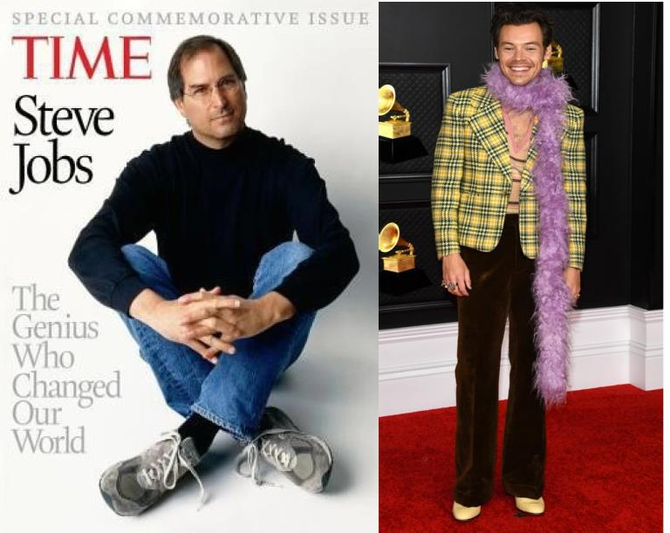

EXERCISE 4a. Match the clothes in the picture with the words below. Then write the items of clothes under each name
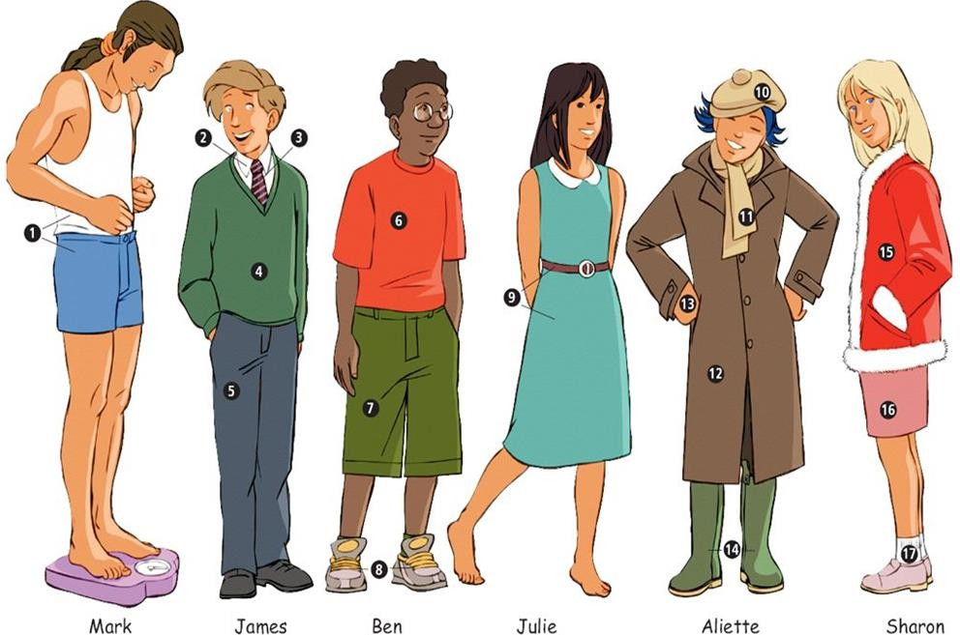
trousers / trainers / shirt / dress / shorts / coat / jacket / tie / gloves / skirt / shoes / T-shirt / underwear / socks / scarf / beret / boots / V-neck sweater
EXERCISE 4b. Fill in the blanks with the correct word from the list provided
  - Mark is wearing and .
  - James has a on over his .
  - Ben’s are green and he is wearing on his feet.
  - Julie’s is blue and she is not wearing .
  - Aliette is wearing a with a and
.
  - Sharon is wearing a red and a pink .

EXERCISE 4c. Answer the following questions
- How do you think your friends or family influence your clothing choices?
- Have you ever tried a fashion trend that you later regretted? What was it?
- Do you choose clothes more for comfort or for style? Why?
- How important are accessories like scarves, gloves, or hats in your daily outfits?
- Do you have a piece of clothing that holds a special memory for you? What is it and why is it special?
- Can you remember the first time you bought an item of clothing with your own money? What was it?
- What is your go-to outfit for a cold winter day?
- Do you have a favourite outfit for special occasions? Describe it.

EXERCISE 5. Have you ever heard about fast fashion? What are the consequences of this problem? Watch the video below and answer the following questions

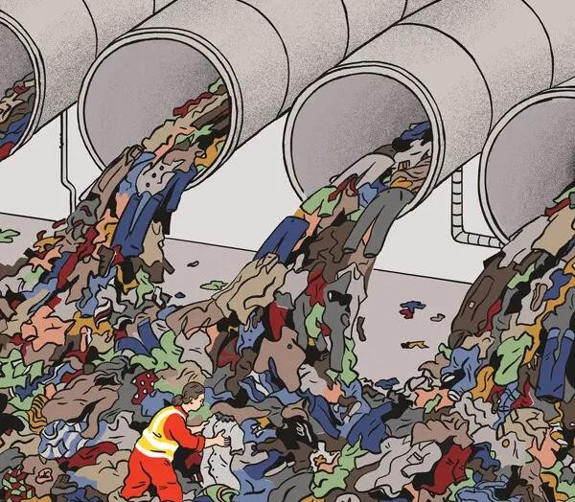
- Have you ever thought about what happens to clothes when you throw them away?
- How do you think making a lot of cheap clothes quickly can harm the environment?
- Why do you think some people have to work in poor conditions to make fast fashion clothes?
- Have you ever bought something just because it was cheap, even if you didn’t need it?
- How important is it for you to wear the latest trends? Do you think it’s possible to look good and be fashionable without buying new clothes all the time?
- How do you feel about the idea of having a smaller wardrobe with only your favourite clothes?

EXERCISE 6. Work in pairs. Choose any two occasions from the list below and discuss how you would get ready for them. Enumerate all the articles of your clothing in details and mention the way you would describe the clothes using adjectives from Key Vocabulary

formal business meeting | a Saturday night out with your friends
beach party | job interview
workout session at the gym | attending a wedding
travelling on a plane | an evening at the theatre

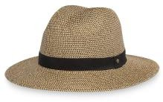
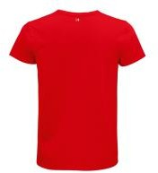
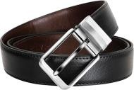
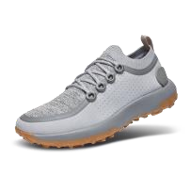
EXERCISE 7. Match the idioms with their definitions. Make up three sentences using any of the given idioms in the context.
- to burst at the seams
- to roll up our sleeves
- to buckle down
- to hit below the belt
- to keep it under sb’s hat
- to lose one’s shirt
- to fit sb like a glove
- to wear one’s heart on one’s sleeve
- to be in sb's shoes

  - To work hard and with determination.
  - To experience something the same way as another person.
- To be extremely full or crowded.
- To hit someone unfairly or below the expected standard of behaviour.
- To prepare for hard work or action.
- To keep a secret.
- To lose a lot of money.
- To express one’s emotions openly.
- To fit perfectly.

EXERCISE 8a. Fill in the gaps using words from the box. Change the form of the phrases according to the grammar rules.
be fashion-conscious
go out-of-date
be a trendsetter
be a passing trend
be affected by fashion trends a must-have item
have an eye for fashion to dress for the occasion be all the rage
  - Emma always knows what’s in style; she really .
  - In the 90s, slap bracelets , but now they are rarely seen.
  - Celebrities often and influence what everyone else wears.
  - Skinny jeans are starting , with more people opting for looser fits.
  - Those who might spend a lot of money to keep up with the latest styles.
  - The new smartwatch is this season.
  - Sometimes it’s hard because what’s popular changes so quickly.
  - People who can mix and match pieces to create unique looks.
  - For the formal event, you need appropriately.

EXERCISE 8b. Answer the questions
- Do you think having an eye for fashion is a natural talent or something that can be developed? Explain.

- How important is it to dress for the occasion? Can you give an example of a time when it was crucial to do so?
- What is a must-have item in your wardrobe? Why do you consider it essential?

EXERCISE 9. Answer the following questions:
- Do you or anyone in your family own a hoodie?
- When and why do you wear it?
- What is the link between the hoodie and:
American footballers? break-dancers? graffiti artists? skate-boarders? a high-profile social media boss?
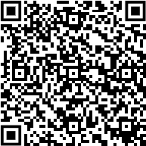
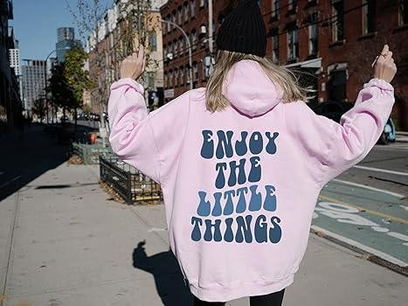
Listen to a podcast called History of Streetwear: the Hoodie and check your ideas to questions

EXERCISE 10. Guess the answers to questions 1–5 below. Then read the article and check your ideas.
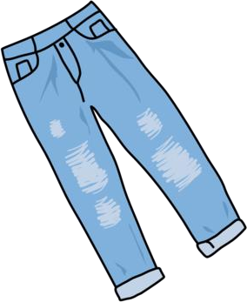
- Why is a T-shirt called a T-shirt?
- Which was the first profession to wear leather jackets?
- How is the phrase ‘blue jeans’ connected to France?
- When did young people start wearing jeans as fashion items?
- Why are these clothes still popular with young people?

TEXT

Icons of fashion
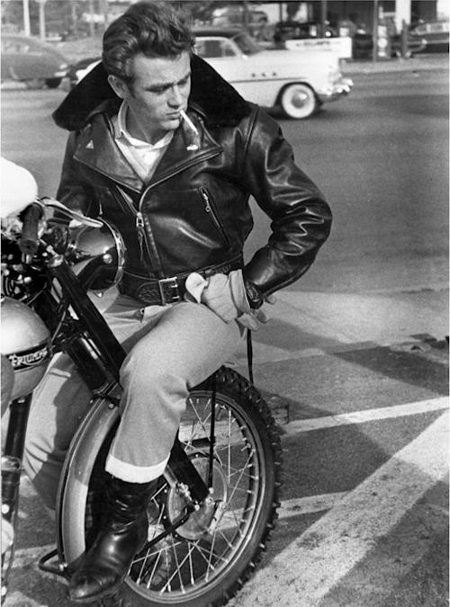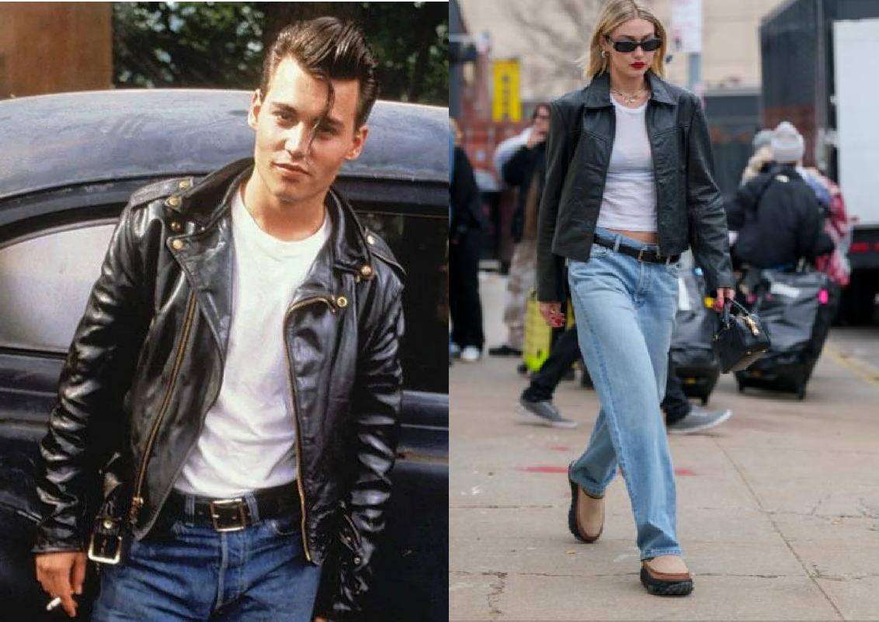

We think we look so cool, so modern and just a little rebellious in our jeans, white T-shirt and black leather jacket. But we’re not as original as we think we are – this look goes back to the 1970s, right? Well, no, not exactly – as a matter of fact, you can trace most of it back to 100 years ago.
Take the white T-shirt and leather jacket. Both started life in the military. The T- shirt (so-called because of its shape like a T) was in fact underwear. In the American Navy, it was worn under a uniform. Until the early 20th century, underwear was woollen, but a revolution in textile production produced cotton jersey, a fast-drying fabric which fits tightly to the body and kept sailors warm. The short-sleeved T-shirt was born. Leather jackets were worn by fighter pilots in the First World War – they were hard-wearing, warm and fur-lined for maximum protection from the elements. Then, in 1928, an American raincoat company, Schott, designed the first leather motorcycle jacket with a zip.
By the 1950s both garments had reached iconic status when famous actors like Marlon Brando and James Dean wore them in films. Later, in the 1960s and 1970s, bands from the Beatles to the Ramones adopted the leather jacket, and it moved from motorcycle sports to teenage rebellion. In the 1970s T-shirts got a colourful update: brightly-coloured T-shirts were particularly popular as well as T-shirts with band logos and political slogans. Having started out as an undergarment for men, T-shirts became unisex in the 1970s and have been part of everyone’s wardrobe since then.
You may think your fashionably distressed jeans are cutting-edge fashion items, but they can be traced even further back in history. In the 1800s denim, the material jeans are made of, was a kind of cotton made in Nîmes, France (‘de Nîmes’). The first blue denim trousers were worn by sailors in Genoa – ‘Gênes’ in French. ‘Bleu de Gênes’ became ‘blue jeans’.
Blue jeans as we know them originated during the 1849 Californian Gold Rush. They were developed by German storekeeper Levi Strauss and Latvian tailor Jacob Davis. Levi Strauss never wore a pair of jeans himself – he was a wealthy businessman, and jeans were only worn by manual workers and cowboys. But then their popularity spread after the Second World War. Young people started wearing jeans to imitate young Hollywood stars. However, they were associated with rebellious behaviour and were banned in schools.
With trends and influencers gaining and losing popularity quicker than ever, a look back at style icons of decades past reminds us that style is forever. However, the icon gets thrown around far too often. To qualify as one, especially in the now oversaturated realm of fashion, their singular style must evoke images, stories, and other memorable moments we carry throughout our lifetimes. No one broke the style mould quite like the outspoken trailblazer Katharine Hepburn. She adopted a wardrobe of American sportswear staples such as sharp button-down shirts, tailored suit jackets, and perhaps most controversially, pants. We might not think of wearing pants as very forward-thinking, but in the 1930s and '40s, a woman of her prestige refusing the societal fashion norms of modest "ladylike" dressing seemed simply unfathomable. However, with Hepburn leading the charge, wearing pants eventually became not only widely accepted but an essential wardrobe staple for women all over the world.

Born Lesley Lawson, the model who earned her "Twiggy" nickname from a hairdresser, became the personification of the overwhelming dominant trend of the time, "Mod" fashion during the swinging 1960s.. Characterised by shift dresses, miniskirts, knee-high boots, and bold geometric patterns on brightly coloured clothes, the "Mod" trend was a radical departure from the demure day dresses of the previous decade. Twiggy became what many associate with the trend, and it is still to this day.
David Bowie was a true fashion chameleon, constantly reinventing himself and pushing the boundaries of style. From his flamboyant stage costumes to his avant-garde streetwear, Bowie’s fearless approach to fashion made him a true iconoclast. With his androgynous style, bold makeup, and eclectic wardrobe, Bowie challenged traditional notions of masculinity and femininity, inspiring generations of artists, musicians, and fashion designers. With his enduring influence on popular culture, Bowie remains one of the most iconic and influential figures in the world of fashion.
Fashion has always been more than just clothing; it’s a form of expression, an art, and a reflection of culture. Throughout history, certain individuals have emerged as fashion icons, shaping trends, setting standards, and inspiring millions around the world. From glamorous Hollywood starlets to groundbreaking designers, these icons have left an indelible mark on the world of fashion, creating styles that transcend borders and stand the test of time.
Adapted from Instyle and The World`s best

READING COMPREHENSION QUESTIONS
- Think about your favourite fashion trends today. How do they compare to the timeless combination of jeans, white T-shirts, and leather jackets mentioned in the text? What do you think makes a fashion trend endure for so long?
- The white T-shirt started as military underwear. How do you think clothing originally designed for practical purposes becomes fashionable over time?
- Actors like Marlon Brando and James Dean made the T-shirt and leather jacket iconic in the 1950s. Can you think of any modern celebrities who have a similar influence on fashion today? How do they shape trends?
- After World War II, jeans were banned in schools due to their association with rebellious behaviour. Can you think of any clothing items today that might have similar connotations? Why do you think certain clothes are seen as rebellious?
- Katharine Hepburn popularised wearing pants for women in the 1930s and '40s. How do you think fashion can challenge societal norms and promote change? Can you think of a current fashion trend that is doing this?
- David Bowie’s androgynous style challenged traditional notions of masculinity and femininity. How do you think fashion can be used as a tool for personal expression and breaking boundaries?
- The text mentions that fashion is more than just clothing; it’s a form of expression and a reflection of culture. How do your clothing choices reflect your personal identity and the culture you are part of?

Classroom extra. Watch the video below. Discuss what trends you used to follow.


SPEAK OUT
Describe the trends in clothing throughout the century. Dwell on trendsetters who influenced the perception of fashion at that time
Current style trends of Gen Z

