SIMULATION OF CHANGE IN PERFORMANCE INDICATORS (NET PROFIT, LAND AREA, NUMBER OF EMPLOYEES) OF AGRICULTURAL COOPERATIVES OF UKRAINE

Diana Shelenko¹, Ivan Balaniuk², Oleksandr SHPYKULIAK³, Liudmyla SAS ⁴, Мariana Humeniuk⁵, Petrо MATKOVSKYI⁶

^{1,2,4,6}Vasyl Stefanyk Precarpathian National University, 57 Shevchenko str., Ivano-Frankivsk, 76010, Ukraine, Phone/Fax:+380990662326,+380503733282,+380503714824; E-mail: diana.shelenko@pnu.edu.ua, ivan.balaniuk@pnu.edu.ua, liudmyla.sas@pnu.edu.ua
³National Scientific Centre “Institute of Agrarian Economics”, 10, Heroiv Oborony str., 03127 Kyiv, Ukraine, Phone/Fax:+380679386887, Е-mail: shpykuliak@ukr.net
⁵Yuriy Fedkovych Chernivtsi National University, 2 Kotsyubynsky str., Chernivtsi, 58012; Precarpathian State Agricultural Experimental Station of the Agricultural Institute in Carpathion Region of NAAS, 21-A Bandera str. Ivano- Frankivsk, 76000, Ukraine, Phone/Fax: :+380979000963; E-mail: maryana.gumenyuk@gmail.com

Corresponding author: diana.shelenko@pnu.edu.ua

Abstract

The assessment of potential opportunities for the development of agricultural cooperatives until 2030 has been made in the article. The importance of modeling the forecast parameters of development in time to ensure the effective functioning of cooperatives was substantiated. It was found that the size of their net income is most affected by: the area of agricultural land, the number of enterprises, the number of employees and the total cost of production. A research using the STELLA program showed that the number of agricultural cooperatives will reduce 13.1 times by 2030, according to the area of agricultural land they will decrease 1.5 times, and the amount of profits will increase significantly in contrast to losses. This is due to the processes of concentration of cooperative structures, automation of production and implementation of innovative technologies.

Keywords: prediction, agricultural cooperatives, dynamic model, STELLA

introduction

Market transformations are accompanied by changes in all sectors of Ukraine's economy, including agriculture. The organizational structure of production, management system and land relations, which affect the development of agricultural cooperatives, have undergone significant transformations.
Today, the issues of ensuring the conditions for the revival, stabilization and further development of cooperation, which should provide realization of collective [31] personal and public interests, are relevant for Ukraine.
Agricultural cooperatives are specific form of property relations with a special mechanism of functioning and dynamics between members of the cooperative, business entities and the state. The purpose of their creation is to reduce the costs of members of the cooperative for consumer and production needs; increase in return, labor income and economic growth of cooperative members [30]. This is confirmed by proposals for the introduction of new production facilities to agricultural enterprises on a corporate basis [16].
Zinovchuk V. [40] considers an agricultural cooperative as a voluntary combination of efforts and resources of organizational and legal forms of management interested in achieving certain results, in particular to obtain a net profit.
The founder of the cooperative movement, the French economist Charles Gide [14], expressed the view that "neither capitalism nor socialism, only cooperation" can ensure the development of the village. N. Nelson considered the mission of cooperation to make people moral and promote economic relations [5]. M. Tugan-Baranovsky [36], in turn, argues that agricultural cooperatives help increase agricultural productivity and have a greater ability to survive in competition with monopolists. M. Popov believes that the peasants see in the cooperative social and economic protection from monopolists [6].
The role of cooperation in the formation of vertical integration structures and business environment is important, due to the performance of cooperatives social function [21].
The development of agricultural cooperatives in rural areas was facilitated by a number of factors, in particular: the difficulty of access to markets, given their monopolization; price disparity for industrial and agricultural products; the need for cheap loans that could be provided by credit unions [23].
However, the development of agricultural cooperation in Ukraine is accompanied by problematic issues. These are high prices for machinery, fertilizers, fuel and planting material, weak resources, difficulties in selling agricultural products and lack of proper state support.
"Bottlenecks", which are inherent in agricultural cooperatives, highlights Yu.V. Ushkarenko [37] - weak material and technical base, unsatisfactory financial support and insufficient investment attractiveness [22].
Social, economic, organizational and other difficulties faced by agricultural cooperatives in Ukraine in their production activities negatively affect the results of their management. Under these conditions, the role of forecasting as an important component of planning activities of business entities has been increasing [33].
Forecasting is a responsible step in planning and determining the most important factors that affect the economic activity of agricultural cooperatives, as it deals with probabilistic judgments about the state of their development in the future.
It is important for the country's economy to what extent the development of cooperation will meet domestic needs in the nearest future. In particular, the level of profitability and stability of production will depend on the dynamics of consistency of forecast indicators of cooperation development. Therefore, the issues of forecasting the main indicators of their development are relevant.
The methodical approach to ensuring the effective functioning of cooperatives is based on the application of a program of system dynamics aimed at direct modeling of forecast parameters of their development in time and allows tracking the relationship between variables, in particular those that have a significant impact on agricultural production. Agrarian business needs significant support for the processes of reproduction of resource potential, and the main place is occupied by the provision of fixed assets in particular: land, and employees, which we have included in the forecasting program STELLA.
The purpose of the article is to highlight the results of forecasting the net profit of agricultural cooperatives of Ukraine until 2030 using the software STELLA.
The hypothesis of the study is the assumption that in a competitive environment on the efficiency of agricultural cooperatives, which is expressed in net profit, the most important influence is: the area of agricultural land, number of enterprises, number of employees and total cost of production.

MATERIALS AND METHODS

Our research is practical. It was conducted quantitatively and qualitatively on the principles of complexity in the organization of development of agricultural cooperatives. In this investigation, the category of "complexity" can be observed as one that leads to the inclusion in the production of the whole set of social and production elements (composition), which, acting as a single goal, must achieve a specific intermediate or final goal.
A detailed description of STELLA programs is also given in publications [8, 9, 10, 11, 18, 27, 38, 19, 24, 28].
Five indicators of activity of agricultural cooperatives in the STELLA program were selected for modeling, with the value p ≤ 0.05 (ie only those that are estimated as statistically reliable). These are such indicators as: area of agricultural land (AREA), number of enterprises (ENTERPRISES), number of employees (EMPLOYEES), cost (VALUE) and net profit (NET PROFIT). Due to the fact that the general indicator of the effective operation of agricultural cooperatives is the net profit, its forecasting for the future is important.
STELLA (Structural Thinking, Experiential Learning Laboratory with Animation) has created a model of system dynamics with feedback, in which processes take place over time [34]. The latter is achieved through a specific discrete variable - "time". This program set both the simulation period - the total simulation time of 40 years, and the simulation step - 1 year - an hour of simulation step (elementary unit of time).
We chose STELLA because of its accuracy and reliability of calculations, intuitive and user-friendly interface, and widely recognized iconography modeling.

RESULTS AND DISCUSSIONS

The model allowed to create the formula needed to study the impact on net income (Converter) such indicators as: area of agricultural land (AREA), number of enterprises (ENTERPISES), number of employees (EMPLOYEES), as well as cost (COST PRICE). The Graphical Function, the graphical element of the STELLA program, such as (Graph Pad) and the tabular element (Tabel Pad) which show results of the forecast has been used.
Data for 1990-2017 were used for modeling. To verify the created model, statistical information for 2017 was introduced, ie the results of the forecast for 2017 were compared with the real performance indicators for 2017. After testing the model, a forecast of possible changes in the studied indicators for the period up to 2030 was made.
Statistical processing of the collected data, gave us the opportunity to obtain a mathematical equation, which characterizes the relationships that exist between the selected indicators. It should be noted that the collected data were analyzed for dependent indicators to exclude cases that could violate the established regression equation. In the end, after the elimination of insignificant samples, the regression equation is constructed. All indicators were tested on a probability test p ≤ 0.05 to eliminate those that showed a lack of statistical accuracy.
To create a model in the STELLA program, we used the Stock (Stock) element, for which the initial value of NET PROFIT agricultural cooperatives has been set since 1990. The formula, which was previously calculated in the Statistica 13.1 program, all elements were connected using Arrovs (Action Connector).
Statistically significant results with p ≤ 0.05 were obtained for all 4 analyzed parameters. We are watching almost zero values of p in the results of regression analysis for the dependent variable NET PROFIT (Table 1).
Based on beta testing, we conclude that the most important in the further development of

Table 1. Results of regression analysis for NET PROFIT
Source: authors' own calculations.

agricultural cooperatives is the calculation of net income using variables such as number of employees (EMPLOYEES) and cost price (COST PRICE) (Table 2).

Table 2. Essential results for AREA, ENTERPISES, EMPLOYEES and COST PRICE
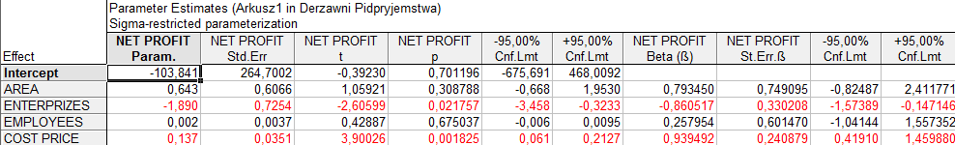
Source: authors' own calculations.

Created in Statistica 13.1. the formula has the following form:
NET PROFIT = -956.110261781+0.222583100314*AREA+0.0317929447539*"ENTERPRIZES"-0.00365882303718*"EMPLOYEES"+0.531263339584*"COST PRICE" (1)

Analysis of standardized endpoints for the dependent variable showed the absence of values exceeding ± 3 sigma (Fig. 1), which indicates the absence of significant data deviations.

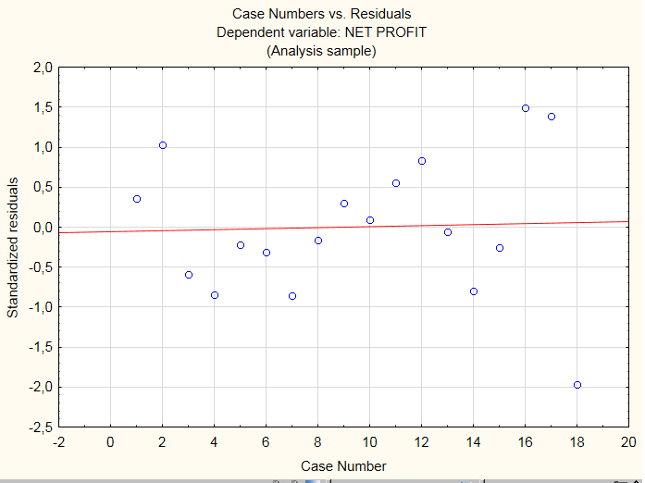

Fig. 1. Results of regression analysis, variable dependent NET PROFIT
Source: authors' own calculations.
This formula was entered in the Inflows NP (Fig. 2) in the model.
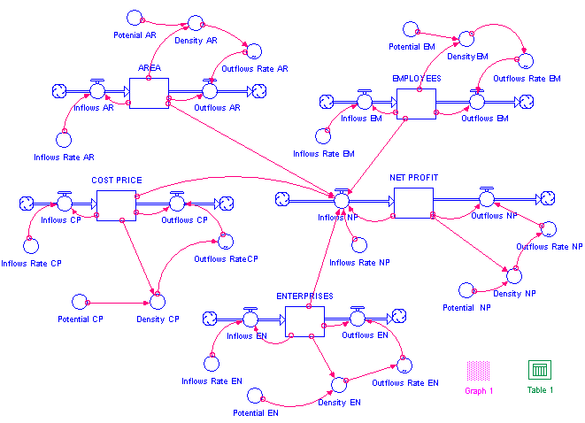

Fig. 2. Created a model in the STELLA program
Source: authors' own calculations.

In Fig. 2 shows a block diagram of the model. Relationships between variables are displayed as graphical functions in STELLA. The convenience of this method is that the appearance of the function can be changed directly on the computer screen with the mouse cursor. We see the production rectangle created in the model as a stock for agricultural products (UAH million). This stock is replenished by the inflow Net profit with the feedback arrow. The flow is influenced by 3 elements of the model (AREA, ENTERPRISES, EMPLOYEES, COST PRICE). On the right - a graph element (Graph Pad) and a table element (Tabel Pad).
Тhe model's verification consisted of a comparison of real data from 2017 (as data from 2018 were absent) with data forecasted in the model for 2017. We see that the model for 95-100 % hit the real data in 2017.
The results of the forecast showed the possible decrease in the AREA (Fig. 3) from 3787 in 2000 to 365,30 thousand hectares in 2030 (Table 3).

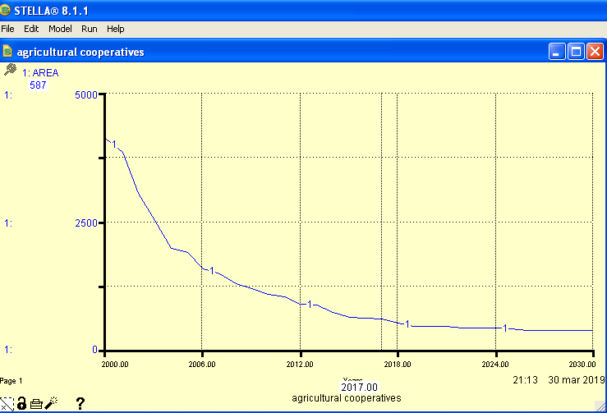
Fig. 3. Graphical representation of forecasting of AREA in STELLA program
Source: authors' own calculations.

In 2017, real statistics amounted to 549,1 thousand hectares and were included in the model for verification of this year's figure, respectively, 587,3 thousand hectares. The analyzed variables by 2030 can also be seen in the table (the special character separates the thousands of values).
Reducing the area of agricultural land is possible due to the termination of contracts of landowners with tenants or reorganization of agricultural cooperatives into other forms of management.
According to N. Bondina [3], the most efficient use of land resources plays an important role in ensuring the normalization of cooperatives, as well as helping to protect soils and increase their fertility.
Table 3. Table view of forecasting results for AREA in STELLA program

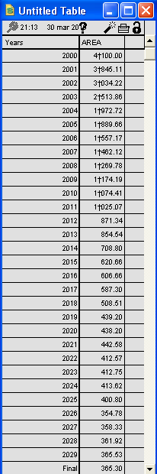
Source: authors' own calculations.

One of the main indicators for assessing the state of development of agricultural cooperatives is the change in the number of cooperatives. At the same time, the number of enterprises (Fig. 4) tends to decrease from 3136 in 2000 to 240 enterprises in 2030. In 2017, the statistics obtained were 448 and were modeled in the model for the verification of this year, respectively, 471 enterprises.
For comparison, in 2006-2017 the number of cooperatives in Spain decreased by 8%, their turnover increased by 56%. At the same time, large cooperatives have increased exports and their dynamism [4].

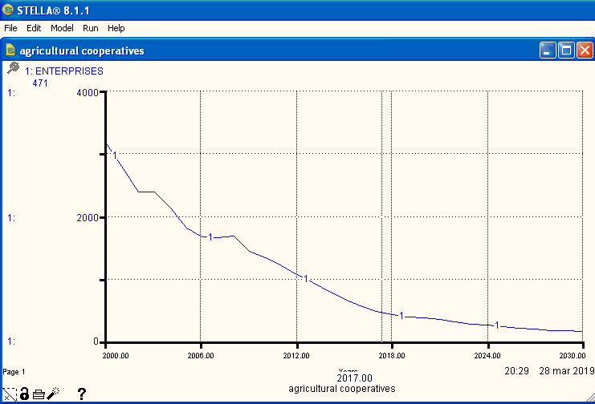

Fig. 4. Graphical representation of forecasting of agricultural cooperatives in STELLA program
Source: authors' own calculations.

The results of the forecast (Fig. 5) showed a possible reduction of the number of employees from 338446 in 2001 to 9000 in 2030, a reduction of 37.6 times, indicating the mechanization and optimization of agricultural processes and mass layoffs of workers.

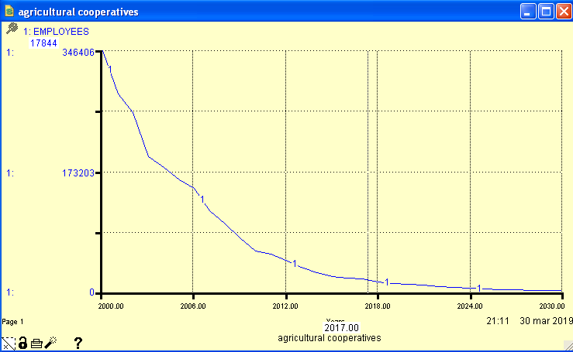

Fig. 5. Graphical representation of forecasting of EMPLOYEES in STELLA program
Source: authors' own calculations
In 2017, real statistics were 17213 people, and in the model for verification of this year, people were calculated accordingly 17844.
Fig. 5 testifies that in agricultural cooperatives the number of employees of a highly skilled managerial staff is mainly reduced due to the low wages, they are forced to look for other ways of earning money. Automation and mechanization of production processes, including agriculture, leads to layoffs. In order to preserve jobs, taking into account not only economic but also social aspects of enterprises, as an option, we can consider the expansion and diversification of their activities.
At the same time, the forecast of the growth of the cost price of agricultural products and services (Fig. 6) from 2319.7 million UAH in 2000 will increase to 13529 million UAH in 2030. In 2017, the collected statistical data amounted to UAH 5,814.3 million. After that, the model provided for a further increase in cost. UAH 6,106 million was taken into account in the model for verification.

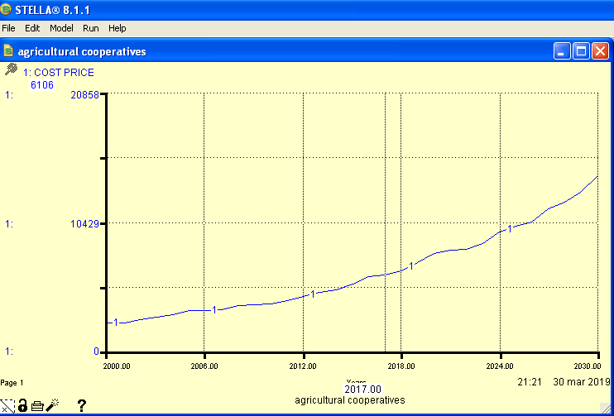

Fig. 6. Graphical representation of forecasting of COST PRICE in STELLA program
Source: authors' own calculations.

Net profit (Fig. 7) will increase in the predicted model and will make 7625 million UAH in 2030. In 2017, the statistic data obtained amounted to 1893.7 million UAH, and simulated in the model for verification of this year were accordingly 1758 mln UAH. After that, the model predicted the next increase in net profit.

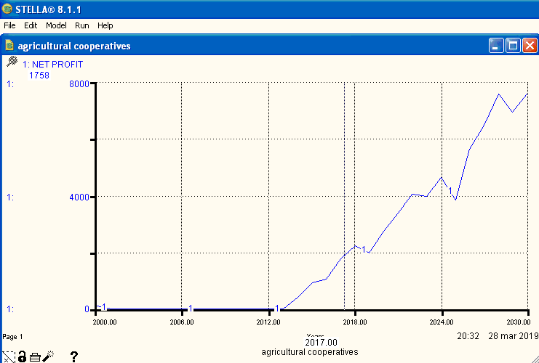
Fig. 7. Graphical representation of forecasting of NET PROFIT in STELLA program
Source: authors' own calculations.

As we see (Figure 3-7), the model predicts that at decrease of the number of agricultural cooperatives (ENTERPRISES) and the number of their employees (EMPLOYEES), and even with rising costs of agricultural products and services in Ukraine, there may be positive changes - increase the net profit. The growth of the cost of agricultural products and services is influenced by inflationary processes, which are observed every year.
As we can see, the Model assumes (Fig. 3-7) that with a decrease in the number of agricultural cooperatives (ENTERPRISES) and, accordingly, the number of employees (EMPLOYEES), despite the growth in the cost of agricultural products and services, there may be positive changes to increase net profit. The cost growth is justified, because it is caused by the increase of the state-regulated minimum wage and the cost of material and technical resources used in the production process. The cost growth of agricultural products and services may be influenced by an increase in production, which, given the automation of production processes and increase the scale of production, can be ensured even by reducing the number of cooperatives. The cost growth is also due to the significant impact of inflation.
The results of the study showed that in agricultural cooperatives after 2019 is projected to grow net income compared to its size in 2017. In particular, by 2030, compared to 2017, it will increase 596 times.
The results of forecasting the main indicators of development of agricultural cooperatives for the period up to 2030, allowed the following conclusions:
1. According to the forecast, the number of agricultural cooperatives by 2030, compared to 2017, will decrease to 240, ie 1.9 times. Due to a significant reduction in the number of agricultural cooperatives in 2017 to stimulate an increase in their number, the Cabinet of Ministers of Ukraine adopted the “Concept of the Development of Farmers and Agricultural Cooperatives for 2018-2020” [25], which should contribute to their future growth.
2. The area of agricultural land will decrease to 365.3 thousand hectares, or 1.5 times.
This decrease in the area of agricultural land is due to both natural phenomena (waterlogging, soil erosion, which manifests itself in the destruction of soil cover and demolition of its particles by water flows (water erosion) or wind (wind erosion)), exacerbated by human economic and industrial activities transport and housing construction, soil contamination with chemical and biological components, mineral development, etc.
3. The number of employees will decrease by 1.9 times by 2030, compared to 2017. In addition to automation and mechanization of production processes, the development of agritourism, which promotes self-employment in rural areas, can have a significant impact on the projected reduction of STELLA workers in agricultural cooperatives [19].
4. The projected total cost of agricultural products and services of agricultural cooperatives will increase from UAH 2,319.7 million. in 2000 to UAH 14,099 million in 2030. In 2017, according to real statistics, the cost of agricultural products and services amounted to 5814.3 million UAH.
The growth of the total cost of agricultural products and services of agricultural cooperatives in 2017, compared to 2000, occurred 2.5 times, and the growth in 2030, compared to 2000, according to the forecast, may be 6.1 times.
The cost growth analyzed in the program may be influenced by inflation. In general, for the period 2014 - 2017, the overall level of consumer prices according to official data increased by 129% [35]. In 2019, consumer inflation slowed to 4.1% (from 9.8% in 2018) - the lowest level in six years [17]. In September 2021, annual consumer inflation accelerated to 11% (from 10.2% in August). On a monthly basis, prices rose by 1.2% [7].
5. The net profit of cooperatives is projected to increase 4 times by 2030, compared to 2017. Net income will tend to increase due to increased agricultural production and rising purchase prices, as well as - the introduction of advanced technologies of labor organization, the use of new cost-effective machines and mechanisms, comprehensive quick-pay equipment, which will increase productivity.
It is proved that agricultural cooperatives play an important role on the way to the market, in particular for: forming consignments of goods for the best selling price; coordination on the production of the product range; ensuring systematic deliveries throughout the year; development of primary and deep processing; creation of a proper procurement and marketing material and technical base; reduction of production costs; independent access to the end user; opportunities to attract funding and improve cash flow [1]. However, this is not confirmed by the data of our forecast model.
Existing agricultural cooperatives do not yet have a significant impact on rural development. The main obstacles to their development are: monopolization and oligarchization of markets, poverty and aging of peasants, weak ability of the population to reconcile the interests of joint activities, a large number of intermediaries, lack of economic and legal instruments at the stage of transition to the bioeconomy [26, 39] absence of economic benefits for further development [20, 2]. Ignoring the problems of development of agricultural cooperatives as a system can lead to a decrease in the efficiency of agricultural production and the weakening of the traditionally formed rural system.
The problems analyzed in the article are relevant for Ukraine at the stage of its accession to the EU. The most important thing should be further systematic study of organizational, social and other measures designed to ensure the effective functioning of agricultural cooperatives [29, 32], which will contribute to the growth of net income. Among such measures, we consider it appropriate to use elements of marketing that include various marketing tools and allow you to compete and properly distribute net profits [15]. In addition, the components of the marketing strategy significantly affect the economic development of all activities of agricultural cooperatives.

Conclusions

The main performance indicator of agricultural cooperatives is net profit. In order to forecast net income in agricultural cooperatives of Ukraine, an original model was created in the STELLA program. Using this model, the influence of the number of agricultural cooperatives, land area, cost of agricultural products and services on their net profit was determined.
Our study showed possible trends to increase net income while reducing the number of agricultural cooperatives, the area of agricultural land, the number of employees and increasing the total cost of agricultural products and services in agricultural cooperatives by 2030.
The activities of agricultural cooperatives should be focused on priority areas and ensure the growth of quality of life and well-being of rural areas where they operate. As a result of the process of strategic management, the activities of agricultural cooperatives should reach a new level of development, with the definition of priority areas. Public authorities of Ukraine should concentrate their efforts for ensuring the development of agricultural cooperatives, as well as promote their quantitative and qualitative growth.
We believe that a negative factor is the reduction in the number of agricultural cooperatives, as they should help to improve relations in local communities, aimed at maintaining adequate living conditions and improving the social infrastructure of rural areas.

References
[1] Balaniuk, I., Kozak, I., Balaniuk, S., Kozak-Balaniuk, I., Sas, L., Shelenko, D. (2020). The role of united territorial communities in the functioning of agricultural enterprises. Management Theory and Studies for Rural Business and Infrastructure Development, Vol. 43. No. 1: 52-66.
[2] Balaniuk, I., Kyrylenko, V., Chaliuk, Y., Sheiko, Y., Begun, S., Diachenko, L. (2021). Cluster analysis of socio-economic development of rural areas and peasant farms in the system of formation of rural territorial communities: a case study of volyn region, Ukraine. Scientific Papers. Series "Management, Economic Engineering in Agriculture and rural development", Vol. 21 Is. 3:177-188.
[3] Bondina, N., Bondin, I., Lavrina, O., Zubkova, T. (2020). Modeling the use of working capital in order to ensure stabilization of the reproduction process in agriculture. Scientific Papers Series Management, Economic Engineering in Agriculture and Rural Development Vol. 20, Is. 2: 89-93.
[4] Chiurciu, I.-A., Soare, E., Vlad I.-M., Toma, E. (2020) The main trends in the activity of agri-food cooperatives in almería, Spain. Scientific Papers Series Management, Economic Engineering in Agriculture and Rural Development Vol. 20, Is. 2: 150-154.
[5] Cooperation and pages of history. (1991). Moscow: Politizdat. 123 p.
[6] Cooperation theory. (1928). 2-e ed. Moscow.
[7] Comment of the National Bank on the inflation rate in September 2021. URL: https://bank.gov.ua/ua/news/all/komentar-natsionalnogo-banku-schodo-rivnya-inflyatsiyi-u-veresni-2021-roku
[8] Costanza, R., Gottlieb, S. (1998). Modelling ecological and economic systems with STELLA: Part II. Ecol. Model. 112: 81–84. DOI: 10.1016/S0304-3800(98)00073-8.
[9] Costanza, R., Voinov, A. (2001). Modelling ecological and economic systems with STELLA: Part III. Ecol. Model. 143: 1–7. DOI: 10.1016/S0304-3800(01)00358-1.
[10] Costanza, R., Duplisea, D., Kautsky, U. (1998). Ecological Modeling on modelling ecological and economic systems with STELLA. Ecol. Model. 110: 1–4.
[11] Forester, Dzh. (1978). World Dynamics. Moscow: Nauka.
[12] Galluzzo, N. (2017). The Common Agricultural Policy and employment opportunities in Romanian rural areas: the role of agritourism. Bulgarian Journal of Agricultural Science, 23(1): 14–21.
[13] Gettelman, A., Rood, R. B. (2016). Demystifying Climate Models. A Users Guide to Earth System Models. Springer-Verlag GmbH Berlin Heidelberg, 271 p.
[14] Gide, C., Ryst, C. (1995). History of Economic Thought. Moscow, Economy.
[15] Glazyrin, V. L., Shkrabyk, I. V., Sakhatskyi, M. P., Sakhatskyi, P. M. (2018). Marketing aspects of urban planning and agglomeration development. Conference Meeting32 nd International Scientific Conference on Economic and Social Development (ESD). Location Odessa, Ukraine. Economic and social development. Book Series International Scientific Conference on Economic and Social Development. Jun 21-22: 253-261.
[16] Humeniuk М., Shelenko D., Nemish D., Balaniuk I. (2021). Improving the efficiency of agricultural entrepreneurship by processing rapeseed to biodiesel. Scientific Papers. Series “Management, Economic Engineering in Agriculture and Rural Development”, Vol. 21(3). рр. 431–438.
[17] Inflation report for January 2020. – https://bank.gov.ua/admin_uploads/article/IR_2020-Q1.pdf? v = 4 [2021.03.06]
[18] Kozak, I., Parpan, V. (2009). Ecological modelling using STELLA program. Ivano-Frankivsk, Plai.
[19] Kumar, J.L.G., Wang, Z.Y., Zhao, Y.Q., Babatunde, A.O., Zhao, X.H., Jørgensen, S.E. (2011). STELLA software as a tool for modelling phosphorus removal in a constructed wetland employing dewatered alum sludge as main substrate. J Environ Sci Health A Tox Hazard Subst Environ Eng. 46(7):751-7. - https://pubmed.ncbi.nlm.nih.gov/21644152/ [2020.10.09]
[20] Lupenko, Yu.O., Shpykuliak, O.H., Mesel-Veseliak, V.Ya. et al. (2019). Perspective forms of organization of economic activity in the countryside. Kyiv, NSC “IAE”.
[21] Malik, M., Shpykuliak, O., Nepochatenko, O., Ptashnyk, S., Tretiakova, S. (2019). Formation of effective organizational and economic environment of innovative support of enterprise competitiveness in Ukraine. Proceedings of the 33rd International Business Information Management Association Conference, IBIMA 2019: Education Excellence and Innovation Management through Vision 2020. 33rd IBIMA Conference: 10-11 April 2019 Granada, Spain. Editor Khalid S. Soliman. pp. 332-342.
[22] Mishchuk, I., Hamova, O., Tkachenko, S., Skliar, N., Bulhakova, O., Levandivskyi, O. (2021). Influence of vertical integration of enterprises on change of their financial indicators and economic security. Academy of Accounting and Financial Studies Journal, 25(S5): 1-08.
[23] Moldavan, L. (2000). The role of agricultural service cooperatives in the process of reorganizing the CAE. Kyiv.
[24] Naimi, B., Voinov, A. (2012). StellaR: A software to translate Stella models into R open-source environment. Environmental Modelling & Software. Vol. 38: 117-118.
[25] Order of the Cabinet of Ministers of Ukraine of September 13, 2017 № 664-r. On approval of the Concept of development of farms and agricultural cooperation for 2018-2020. –https://zakon.rada.gov.ua/laws/show/664-2017-%D1%80#Text [2020.12.08]
[26] Strategic challenges for sustainable governance of the bioeconomy: preventing conflict between SDGs. Maksymiv, Y., Yakubiv, V., Pylypiv, N., Hryhoruk, I., Piatnychuk, I., Popadynets, N., Sustainability, 2021, 13(15): 8308.
[27] Richmond, B. (2001). An Introduction to Systems Thinking. High Performance Systems, Inc, STELLA.
[28] Ruth M., Lindholm J. (2002) Modeling in STELLA. In: Ruth M., Lindholm J. (eds) Dynamic Modeling for Marine Conservation. Modeling Dynamic Systems. Springer, New York, NY. https://doi.org/10.1007/978-1-4613-0057-1_2
[29] Sakovska, O. Shpykuliak, O., Ushkarenko I., Chmut A. (2018). Socio-economic institutions for development of cooperation, Financial and credit activities: problems of theory and practice. Vol. 4, No. 27: 513-521. – https://fkd.ubs.edu.ua/index.php/fkd/article/view/1595 [2021.06.05]. DOI: 10.18371/fcaptp.v4i27.154368.
[30] Savchenko, V.D. (2002). Organization of agricultural enterprises. Kharkiv, Kharkiv National Agrarian University. V.V. Dokuchaev.
[31] Shpykuliak, O., Bilokinna, I. (2019). “Green” cooperatives in the formation of an institutional mechanism of envelopment of alternative power engineering in the agrarian sector of the economy. Baltic Journal of Economic Studies, No. 2. (5): 249–255.
[32] Sodoma, R., Shmatkovska, T., Dziamulych, M., Vavdiiuk, N., Kutsai, N., Polishchuk, V. (2021). Economic efficiency of the land resource management by agricultural producers in the system of their non-current assets analysis: a case study of the agricultural sector of Ukraine. Scientific papers-series management economic engineering in agriculture and rural development. Vol. 21, Issue 2: 577-588.
[33] Sokolovska, Z.M. (2011). Computer and information networks and system manufacturing automation: Imitation modelling of business processes in complex economic systems. Works of Odessa Polytechnic University. 3(37): 135–141.
[34] STELLA (Systems Thinking for Education and Research). Website for more information: http://www.iseesystems.com/ [2021.03.12].
[35] The analysis of inflation processes in Ukraine in the first quarter of 2018. (2018). Expert analytical center “Optima”. Kyiv. – http://optimacenter.org/userfiles/Аналіз%20інфляційних%20процесів%20в%20Україні%20у%20І%20кварталі%202018%20р_.pdf [2021.02.04]
[36] Tuhan-Baranovskyi, M.I., (1989). Social fundamentals of cooperation. Moscow, Economics.
[37] Ushkarenko, U.V. (2009). Agricultural cooperation in an evolutionary dimension: Kherson, Aylan.
[38] Walters, J.P., Archerb, D.W., Sassenrathc, G.F., Hendricksond, J.R., Hansond, J.D., Hallorane, J.M., Vadas, P., Alarcon, V.J. (2016). Exploring agricultural production systems and their fundamental components with system dynamics modelling. Ecological Modelling 333: 51–65. DOI:10.1016/j.ecolmodel.2016.04.0150304-38.
[39] Yakubiv, V., Panukhnyk, O., Shults, S., Maksymiv, Y., Hryhoruk, I., Popadynets, N., Bilyk, R., Fedotova, Y., Bilyk, I. (2019). Application of Economic and Legal Instruments at the Stage of Transition to Bioeconomy. Advances in Artificial Intelligence, Software and Systems Engineering. AHFE Advances in Intelligent Systems and Computing. Springer Nature Switzerland. In: Ahram T. (eds), 965: 656–666.
[40] Zinovchuk, V. (2001). Organizational fundamentals of the agricultural cooperative. Kind. II. Kyiv, Logos.

