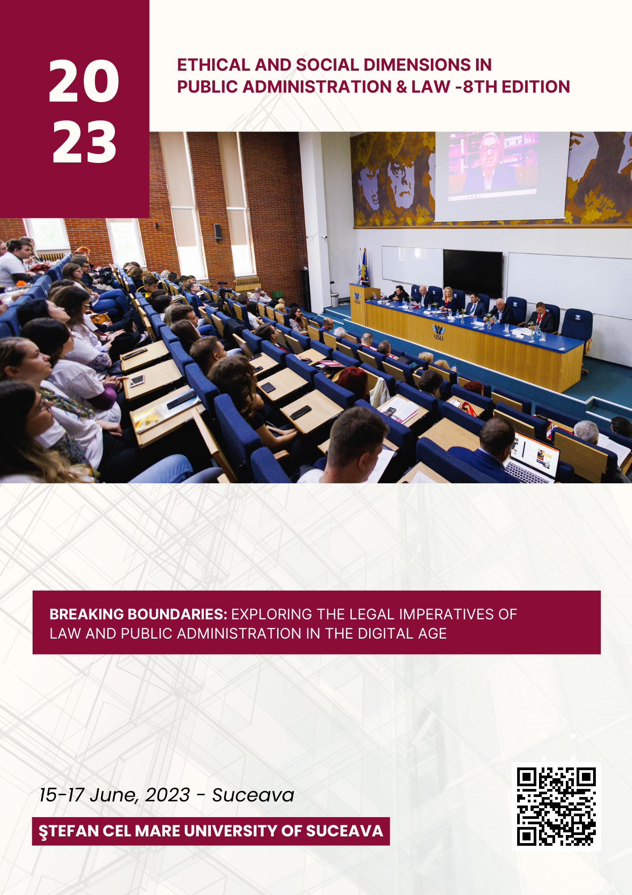
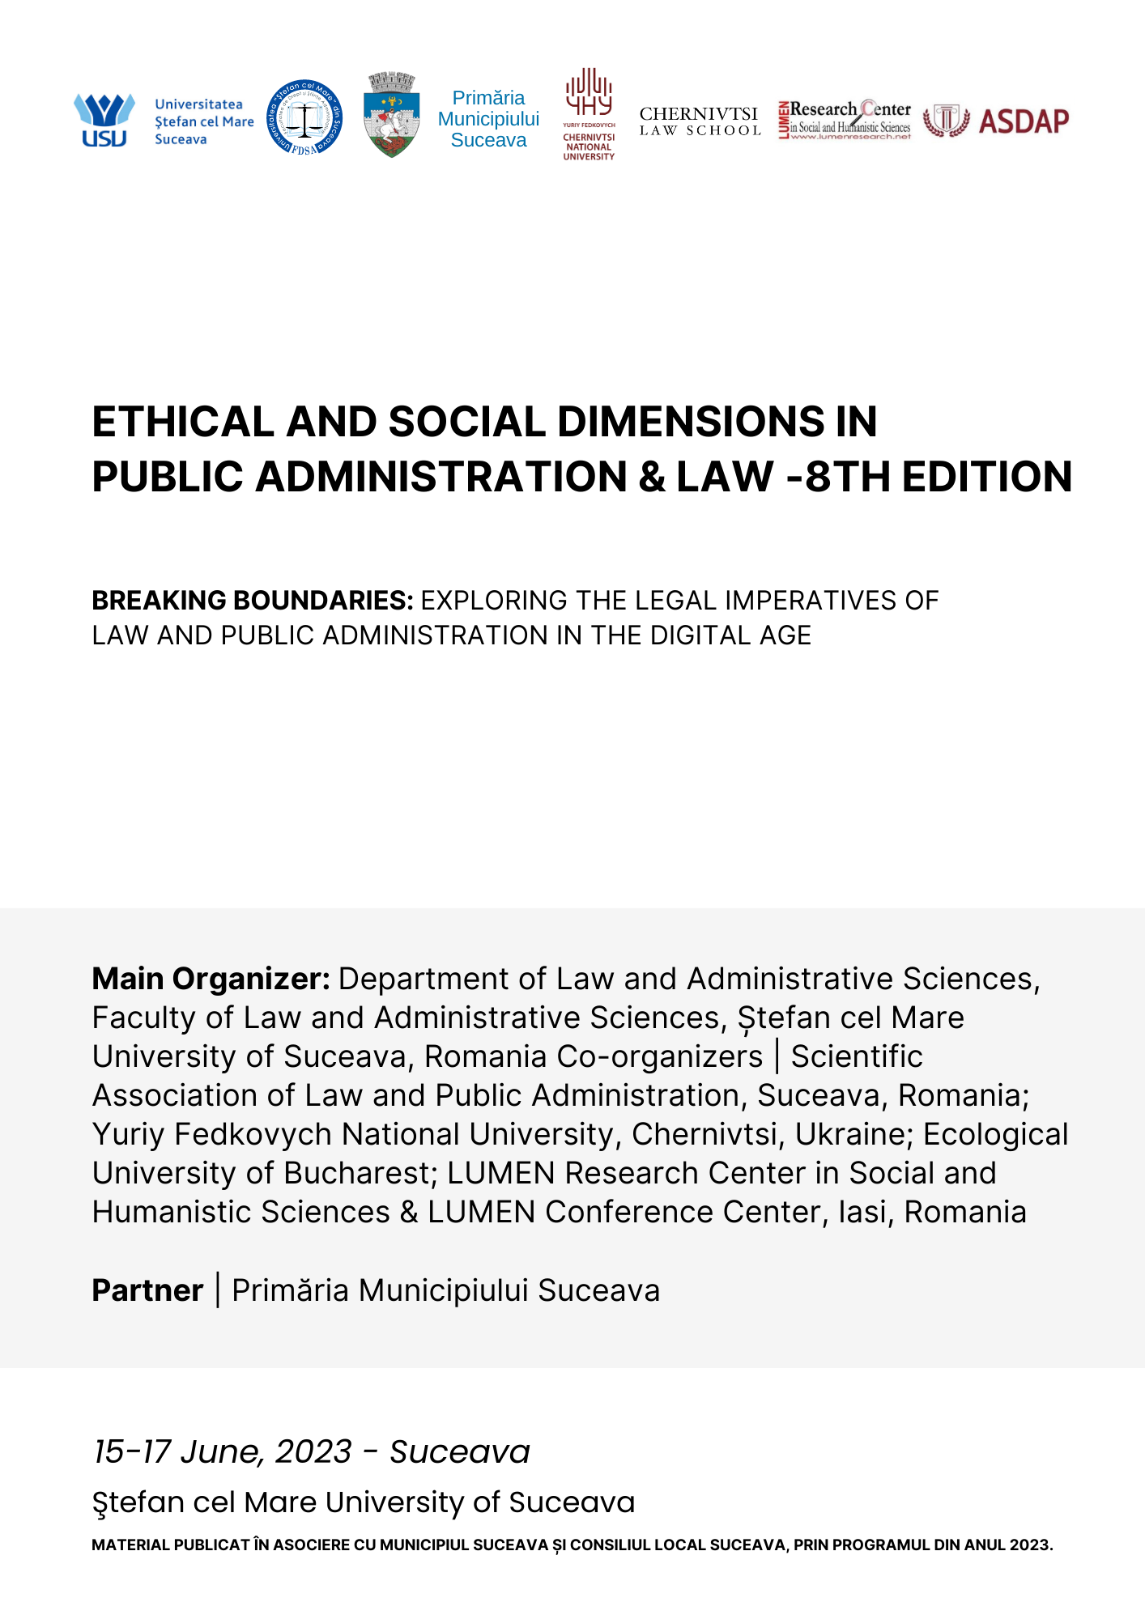
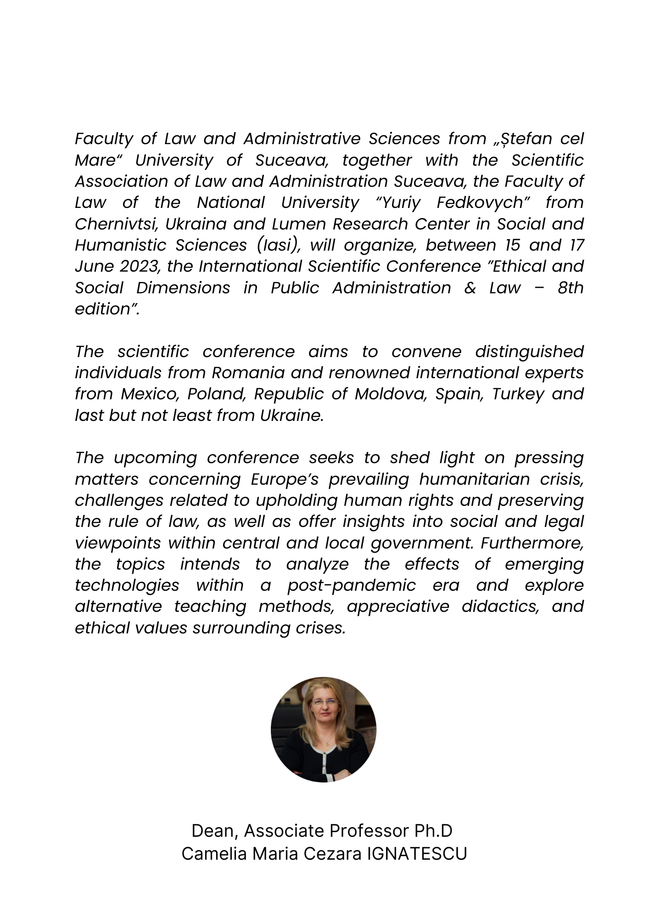

Director
- Camelia Maria Cezara IGNATESCU, Associate Professor Ph.D, Dean of Faculty of Law and Administrative Sciences, Ștefan cel Mare University from Suceava, Romania
- Antonio SANDU, Professor Ph.D Hab., “Ștefan cel Mare” University of Suceava, Romania; President of LUMEN Association, Iași

Organizing Team
- Ionuț CROITORU, System Engineer, Ștefan cel Mare University from Suceava (ROMANIA)
- Liana-Teodora PASCARIU, Associate Professor, PhD, Ștefan cel Mare University from Suceava (ROMANIA)
- Razvan VIORESCU, Associate Professor, PhD, Ștefan cel Mare University from Suceava (ROMANIA)
- Raluca ONUFREICIUC, Associate Phd candidate, Ștefan cel Mare University from Suceava (ROMANIA)
- Luiza CURELUSĂ, Associate Phd candidate, Ștefan cel Mare University from Suceava (ROMANIA)
- Irina BILOUSEAC, Associate Professor, PhD, Ștefan cel Mare University from Suceava (ROMANIA)
- Alunica MORARIU, Associate Professor, PhD, Ștefan cel Mare University from Suceava (ROMANIA)
- Gabriela NEMTOI, Associate Professor, PhD, Ștefan cel Mare University from Suceava (ROMANIA)
- Oana NEDELEA, Lecturer, PhD, Ștefan cel Mare University from Suceava (ROMANIA)
- Cristina BALANEASA, Lecturer, PhD, Ștefan cel Mare University from Suceava (ROMANIA)
- Maria DUMITRU, Associate Professor, PhD, Ștefan cel Mare University from Suceava (ROMANIA)
- Lacramioara BĂLAN, Lecturer, PhD, Ștefan cel Mare University from Suceava (ROMANIA)
- Petronela SCUTARIU, Lecturer, PhD - Ștefan cel Mare University, Suceava (ROMANIA)
- Dumitrita FLOREA, Lecturer, PhD, Ștefan cel Mare University from Suceava (ROMANIA)
- Narcisa GALES, Lecturer, PhD, Ștefan cel Mare University from Suceava (ROMANIA)
- Daniela CATAU VERES, Lecturer, PhD, Ștefan cel Mare University from Suceava (ROMANIA)
- Ciprian UNGUREANU, Lecturer, PhD, Ștefan cel Mare University from Suceava (ROMANIA)

Conference Committee
- Associate Professor Ph.D Camelia Maria Cezara IGNATESCU - Ștefan cel Mare University of Suceava / Suceava, ROMÂNIA;
- Professor Ph.D, HC, Mircea DUȚU - Director of the Legal Research Institute " Acad Andrei Radulescu " of the Romanian Academy, President of the Ecological University of Bucharest, (ROMANIA), President of the Right to Nature Foundation, President of the Romanian Environmental Law Association, Director - founder of the Romanian Journal of Environmental Law
- Professor Ph.D, HC, Ovidiu PREDESCU, Frm. Adviser to the General Prosecutor of Romania, honorary scientific researcher of the Institute of Legal Research „Acad. Andrei Rădulescu” of the Romanian Academy, Founding director of the publication „Dreptul”
- Professor PhD, HC, Alexandru ȚICLEA, Ecological University of Bucharest
- Doctor of Juridical Sciences, Professor, Vitalii VDOVICHEN, Dean of Law School at Yuriy Fedkovych Chernivtsi National University (Chernivtsi, Ukraine)
- Doctor of Juridical Sciences, Professor, Serhiy MELENKO, Law School, Yuriy Fedkovych Chernivtsі National University, (Chernivtsi, Ukraine)
- Associate Professor Ph.D, Ivan TORONCHUK, Law School, Yuriy Fedkovych Chernivtsі National University, (Chernivtsi, Ukraine)
- Doctor of Juridical Sciences, Professor Svitlana KARVATSKA, Law School, Yuriy Fedkovych Chernivtsі National University, (Chernivtsi, Ukraine)
- Associate Professor PhD. Andrei DUȚU BUZURA, National University of Political Studies and Public Administration Bucharest
- Lecturer PhD, Gabriel MANU, Ecological University of Bucharest
- Associate Professor Ph.D. Constanța MATUȘESCU, Faculty of Law and Administrative Sciences of the "Valahia" University, Targoviste
- Professor Ph.D. Hab. Daniel-Mihail ȘANDRU, Scientific researcher gr. I, Coordinator at the Center for European Law Studies (CSDE) of the Institute for Legal Research „Acad. Andrei Rădulescu” of the Romanian Academy, ad-hoc judge at ECHR
- Maria DUMITRU, Associate Professor, PhD, Ștefan cel Mare University from Suceava (ROMANIA)
- Professor Ph.D. Mehmet ȘAHiN, Faculty of Education, Curriculum and Instruction Dept, Mersin University
- Professor Ph.D Dan TOP, Faculty of Law and Administrative Sciences of the "Valahia" University, Targoviste
- Professor Ph.D, Nadia-Cerasela ANITEI, Faculty of Law, Social and Political Sciences, "Dunarea de Jos" University of Galați
- Professor, Ph.D Aurora CIUCA, Faculty of Law, “Ștefan cel Mare” University of Suceava
- MB Lukas VALEK, University of Hradec Kralove, Faculty of Informatics and Management, Hradec Kralove, CZECH REPUBLIC;
- Assistant Professor PhD Segil BAL TASTAN, Marmara University, Faculty of Business Administration, Department of Business Administration, Istanbul, TURKEY;
- Professor, Ph.D Călin SCRIPCARU, “Ștefan cel Mare” University of Suceava (ROMANIA)
- Professor, Ph.D, Constantin ANECHITOAE, Faculty of Law and Administrative Sciences, Ovidius University of Constanta
- Associate Professor, Ph.D Nicolae PLOEȘTEANU, University „Petru Maior” Târgu Mureș
- Professor, Ph.D, Ioan CHELARU, President of the Romanian Lawyers Union, Frm. vice-president of UNBR and Dean of the Barou Neamț
- Associate Professor, Ph.D. Raul Felix HODOS, "1 Decembrie 1918" University, Alba Iulia

Thursday, 15 June 2023
Opening session 10:00 - 11:00 - Aula Corp A
- Valentin POPA, Professor Ph.D, ing., Rector of „Ștefan cel Mare” University of Suceava, Romania
- Camelia IGNATESCU, Associate Professor, Ph.D, Dean of Faculty of Law and Administrative Sciences, „Ștefan cel Mare„ University of Suceava, Romania
- Ion LUNGU, Mayor of Suceava Municipality
- Ion M. ANGHEL, Professor, PhD, HC, Honorary Member of the Romanian Academy of Scientists, President of the Association of Career Ambassadors and Diplomats of Romania
- Veaceslav ZAPOROJAN, Associate Professor, PhD, Dean of the “General Economics and Law” Faculty of the Academy of Economic Studies from Moldova
- Antonio SANDU, Professor Ph.D, habil., “Ștefan cel Mare” University of Suceava, Romania; President of LUMEN Association, Iași
- Vitalii VDOVICHEN, Doctor of Juridical Sciences, Professor, Dean of Law School, Yuriy Fedkovych Chernivtsi National University, Ukraine
- Stella KELBIA, Associate Professor, Ph.D, Dean of Faculty of Law, Bukovina University of Chernivtsi, Ukraine

Plenary Session 1 - Public Law - 11:15 - 14:15 - Aula Corp A
For the participants | The sessions will take place also online on Google Meet (please check your email address for the access link).
Moderator: Associate Professor Ph.D Liana-Teodora PASCARIU, Faculty of Law and Administrative Sciences, “Ștefan cel Mare” University of Suceava
Language of Presentation - Romanian/English
- Augustin ZEGREAN, H.C, Faculty of Law and Administrative Sciences “Ștefan cel Mare” University of Suceava, Fmr. President of the Constitutional Court of Romania
Reserved Title
- Professor Ph.D Mircea DUȚU, HC, Legal Research Institute " Acad Andrei Rădulescu " of the Romanian Academy, President of the Right to Nature Foundation, President of the Romanian Environmental Law Association, Director - founder of the Romanian Journal of Environmental Law
Reserved Title

- Professor Ph.D HC, Ovidiu PREDESCU, Frm. Adviser to the General Prosecutor of Romania, honorary scientific researcher of the Institute of Legal Research „Acad. Andrei Rădulescu” of the Romanian Academy, Founding director of the publication „Dreptul”, Lecturer Ph.D Gabriel MANU, Ecological University of Bucharest
Public law facing the challenges of artificial intelligence
- Professor Ph.D Mehmet ȘAHiN, Faculty of Education, Curriculum and Instruction Dept, Mersin University, Turkey
Going beyond boundaries and borders
- Professor Ph.D, Antonio SANDU, Faculty of Law and Administrative Sciences, ”Ștefan cel Mare” University of Suceava, Romania; PhD Candidate Doctoral School of Law, Titu Maiorescu University, Bucharest, Romania
Informed consent in the era of artificial intervention

- Associate Professor Ph.D Claudia Simona TIMOFTE, Faculty of Law, University of Oradea, Romania
Some considerations on the presence of women in public decision-making

- Assistant Professor Ph.D Nicolae PLOEȘTEANU, University of Medicine, Pharmacy, Science and Technology „G.E. Palade” from Târgu Mureș”, Romania
Discrimination issues in the context of the Russian-Ukrainian war

- Associate Professor Ph.D Stella KELBIA, Dean of Faculty of Law, Bukovina University of Chernivtsi, Ukraine, Romina ZELIA, Bukovina University of Chernivtsi, Ukraine
Violation of human and citizen freedom rights during martial law

- Lecturer Ph.D Bogdan BODEA, Faculty of Law, University of Oradea, Romania
The (in)equality before the law. A perspective over criminal law derived form article 7 of the European Convention of Human Rights

- Assistant Professor Ph.D Vitalii YAREMCHUK, Department of International Law and Comparative Law Studies, Law School, Yuriy Fedkovych Chernivtsi National University
Youth Diplomacy: United Nations Perspectives

- Lecturer Ph.D Decebal Manole BOGDAN, "1 Decembrie 1918" University, Alba Iulia, Romania
Public administration and the digitalisation challenge towards smart cities

- Assistant Ph.D Samuela ROSTAȘ, Faculty of Law, "1 Decembrie 1918" University, Alba Iulia, Romania
Ethics - a prerequisite for innovation in public administration

- Assistant Ph.D Ana Maria CORDOȘ, Faculty of Law, "1 Decembrie 1918" University, Alba Iulia, Romania
Reserved title

- Lecturer Ph.D Lucian STĂNESCU, Faculty of Law and Administrative Sciences, “Ștefan cel Mare” University of Suceava, Romania, Lecturer PhD. Daniela CĂTĂU VERES, Faculty of Law and Administrative Sciences, “Ștefan cel Mare” University of Suceava, Romania
Semiotics of the oath of the head of state in Romanian constitutions - discursive, political and legal sources and meanings

- Lecturer Ph.D Hector CALLEROS-RODRIGUEZ, University of Warsaw, American Studies Center
Reserved title

- Associate Professor Ph.D Camelia IGNĂTESCU, Dean of Faculty of Law and Administrative Sciences “Ștefan cel Mare” University of Suceava
Reserved Title

- Ph.D Candidate Daniela HUDELCU, Faculty of Law, University of Bucharest
Implications of new technologies for tax policies

[Lunch Break] – 14:15 – 16:00

Plenary Session 2 - Business Law - 16:00 - 19:00 - Aula Corp A
For the participants | The sessions will take place also online on Zoom (please check your email address for the access link).

Moderator: Associate Professor, Ph.D, Felix Raul HODOS, "1 Decembrie 1918" University, Alba Iulia, Romania
- Associate Professor Ph.D Maria DUMITRU, Faculty of Law and Administrative Sciences, “Ștefan cel Mare” University of Suceava
Disputes concerning the application of Article 349 of the Civil Code with regard to companies governed by Law 31/1990

- Associate Professor Ph.D Oksana RUDENKO, Department of International Law and Comparative Law Studies, Law School, Yuriy Fedkovych Chernivtsi National University, Ukraine
Development and evolution of non-contractual obligations in roman law

- Attorney-in-residence, Florian GHEORGHE, Entrepreneur & Investor, Romania
Reserved title

- Associate Professor, Ph.D Felix Raul HODOS, "1 Decembrie 1918" University, Alba Iulia, Romania, Associate Professor Ph.D Nicolae PLOEȘTEANU, University of Medicine, Pharmacy, Science and Technology „G.E. Palade” from Târgu Mureș”
From transparency to personal data protection in public communication

- Associate Professor Ph.D Răzvan VIORESCU, Faculty of Law and Administrative Sciences, “Ștefan cel Mare” University of Suceava
Lawyers' access to electronic databases or other information systems held by public administration authorities and public institutions

- Ph.D Andrei SĂVESCU, Society of Romanian Legal Sciences
Aptenodytes

Plenary Session 3 - Human Rights - 11:15 - 14:00 - Auditorium JS Corp F
For the participants | The sessions will take place also online on Google Meet (please check your email address for the access link).

Moderator: Assistant Ph.D Loredana Terec VLAD, Faculty of Law and Administrative Sciences, “Ștefan cel Mare” University of Suceava/Titu Maiorescu University of Bucharest
- Professor Ph.D Valerii KOLPAKOV, Head of the Department of Constitutional and Administrative Law of Zaporizhzhya National University, Ukraine
Generation of human rights & administrative law

- Assistant Professor Ph.D, Maryna ILIKA, Department of International Law and Comparative Law Studies, Law School, Yuriy Fedkovych Chernivtsi National University, Ukraine
The genocide of the Ukrainian people is a crime under the jurisdiction of the ICC
- Assistant Lecturer Ph.D Olha DONCHENKO, Department of Theory of Law and Human Rights, Faculty of Law, Yuriy Fedkovych Chernivtsi National University, Ukraine, Associate Professor Ph.D Oleksandr MAKSYMIUK, Department of Theory of Law and Human Rights, Faculty of Law, Yuriy Fedkovych Chernivtsi National University, Ukraine
Freedom as a Condition of Gender Equality

- Doctor of Law, Associate Professor, Svitlana ZADOROZHNA, Department of International Law and Comparative Law Studies, Law School, Yuriy Fedkovych Chernivtsi National University, Ukraine
Legal regulation of Ukraine's cooperation with Frontex

- First-year Master`s Student in International Law, Victor Aleks DANCHUK, Law School, Yuriy Fedkovych Chernivtsi National University, Ukraine
Hybrid warfare: international legal aspects

- Ph.D. Candidate, Luiza-Florentina CURELUȘĂ, Assistant Professor, Faculty of Law and Administrative Sciences, “Ștefan cel Mare” University of Suceava, Romania
Some reflections on Citizenship by Investment - A comparative overview of the European and the International Approach

- First-year Master`s Student in International Law Borys KOVBINKA, Law School, Yuriy Fedkovych Chernivtsi National University, Ukraine
International legal regulation of the end of hostilities and the state of war

- First-year Master`s Student in International Law Antonina-Loredana TYMCHUK, Law School, Yuriy Fedkovych Chernivtsi National University, Ukraine
Peculiarities of settlement of family disputes in the conditions of martial law

- First-year Master`s Student in International Law Kostia DIACHENKO, Law School, Yuriy Fedkovych Chernivtsi National University, Ukraine
International humanitarian law and protection of the civilian population during the war in Ukraine

- First-year Master`s Student in International Law Anna TARNOVETSKA, Law School, Yuriy Fedkovych Chernivtsi National University, Ukraine
International law and protection of sovereignty

- First-year Master`s Student in International Law Tetiana PESHKO, Law School, Yuriy Fedkovych Chernivtsi National University, Ukraine
Fighting terrorism in EU

- First-year Master`s Student in International Law Khrystyna PATAK, Law School, Yuriy Fedkovych Chernivtsi National University, Ukraine
Protection of the rights of prisoners of war

- First-year Master`s Student in International Law Liubov HOLOVATA, Law School, Yuriy Fedkovych Chernivtsi National University, Ukraine
Protection of children's rights in time of war

- First-year Master`s Student in International Law Karina CHUBREI, Law School, Yuriy Fedkovych Chernivtsi National University, Ukraine
Protecting the rights of prisoners of war during a full-scale russian invasion of Ukraine, 2022

- First-year Master`s Student in International Law Yevhen HORIANIN Law School, Yuriy Fedkovych Chernivtsi National University, Ukraine
International law and energy security of Ukraine

- First-year Master`s Student in International Law Yevhen KOLODII, Law School, Yuriy Fedkovych Chernivtsi National University, Ukraine
Post-war reformation in Ukraine

- Fourth-year Bachelor`s Student in International Law Ruslan KARIAKA, Law School, Yuriy Fedkovych Chernivtsi National University, Ukraine
Agressor in the UN Security Council: how to guarantee peace and security?

- Second-year Bachelor`s Student in International Law Sofiia MATUSHAK, Law School, Yuriy Fedkovych Chernivtsi National University, Ukraine
Sexual violence of the Russian military in Ukraine and the challenges of documenting and investigating sexual violence in conflict

- Third-year Bachelor`s Student in International Law Yuliia STROICH, Law School, Yuriy Fedkovych Chernivtsi National University, Ukraine
The experience of international tribunals in the context of the future tribunals against criminals of the Russian-Ukrainian war

- Third-year Bachelor`s Student in International Law Valentyn FOYCHUK, Law School, Yuriy Fedkovych Chernivtsi National University, Ukraine
The international aspect of protecting children's rights in time of war

- Assistant Ph.D Loredana Terec VLAD, Faculty of Law and Administrative Sciences, “Ștefan cel Mare” University of Suceava/Titu Maiorescu University of Bucharest
New medical technologies and reproductive rights from a human rights perspective

Plenary Session 4 - Environmental Law - 16:00 - 19:00 - Aula Corp E
For the participants | The sessions will take place also online on Zoom (please check your email address for the access link).

Moderators: Lecturer Ph.D Decebal Manole BOGDAN, "1 Decembrie 1918" University, Alba Iulia, Romania

- Lecturer, Ph.D, Evghenia GUGULAN, Department of Private Law, „Ștefan cel Mare” of Ministry of Internal Affairs”, Associate Professor, Ph.D, Igor TROFIMOV, „Ștefan cel Mare” of Ministry of Internal Affairs”
Legal issues regarding damages caused to the animal kingdom

- Lecturer Ph.D Ciprian Gabriel UNGUREANU, Faculty of Law and Administrative Sciences, “Ștefan cel Mare” University of Suceava
Reserved title

Special Workshop
17:00-18:00 (E224)
Adina LUPU, Direcția Generală Anticorupție
Etica și integritatea - argumente pentru funcția publică

Workshops
Emerging technologies and their impact on new generations
17:00 - 20:00 (E 201)

Global perspectives on fundamental rights in digital era
17:00 - 20:00 (E 028)

Constitutionality control in Romania versus the system of constitutionality control specific to another European country
17:00 - 20:00 (E 016)

Resilience, development and prosperity - major objectives of the Romanian Government
17:00 - 20:00 (PB4 )

The effectiveness of the application of the General Data Protection Regulation in a connected society
17:00 - 20:00 (PB7)

Business challenges in relation to the authorities
17:00 - 20:00 (ED001)

Trends and evolutionary periods in the contemporary family
17:00 - 20:00 (E006)

European legislative perspectives on climate change
17:00 - 20:00 (B310)

Promoting human rights and equality in the context of humanitarian crises
17:00 - 20:00 (B307)

Awareness of the boundaries between public and private life
17:00 - 20:00 (Amf. 129)

Friday, 16 June 2023
Plenary session 4 - International and European Law - 10:00 - 13:00 - Aula Corp A
For the participants | The sessions will take place also online on Google Meet (please check your email address for the access link).

Moderator: Professor Ph.D Aurora CIUCĂ, Faculty of Law and Administrative Sciences, “Ștefan cel Mare” University of Suceava, Professor Ph.D Daniel-Mihail ȘANDRU, Scientific researcher gr. I, Coordinator at the Center for European Law Studies (CSDE) of the Institute for Legal Research „Acad. Andrei Rădulescu” of the Romanian Academy, ad-hoc judge at ECHR

Language of Presentation - Romanian/English

- Professor, Ph.D, Ion M. ANGHEL, HC, Honorary Member of the Romanian Academy of Scientists, President of the Association of Career Ambassadors and Diplomats of Romania
The Treaty of Trianon

- Doctor of Juridical Sciences, Professor, Svitlana KARVATSKA, Department of International Law and Comparative Law Studies, Yuriy Fedkovych Chernivtsi National University, Ukraine, Doctor of Juridical Sciences, Professor Vitalii VDOVICHEN, Dean of Law School, Yuriy Fedkovych Chernivtsi National University, Ukraine, Postgraduate Student, Ruslan IVANIUK, Yuriy Fedkovych Chernivtsi National University, Ukraine
Рrotection of human rights in conditions of armed conflicts

- Assistant Professor, Mariia STROICH, Department of International Law and Comparative Law Studies, Law School, Yuriy Fedkovych Chernivtsi National University, Ukraine
Violation of Private Human Rights in Conditions of War

- Professor Ph.D Daniel-Mihail ȘANDRU, Scientific researcher gr. I, Coordinator at the Center for European Law Studies (CSDE) of the Institute for Legal Research „Acad. Andrei Rădulescu” of the Romanian Academy, ad-hoc judge at ECHR
European Union citizenship – pillar of the personal data protection and privacy

- Assistant Professor, PhD, Tetyana HNATYUK, Department of International Law and Comparative Law Studies, Law School, Yuriy Fedkovych Chernivtsi National University, Ukraine
International legal aspects of children adoption

- Lecturer Ph.D Bogdan BODEA, Faculty of Law, University of Oradea, Romania
The (in)equality before the law. A perspective over criminal law derived form article 7 of the European Convention of Human Rights

- Associate Professor, Doctor of Law, Oksana VAITSEKHOVSKA, Department of International Law and Comparative Law Studies, Law School, Yuriy Fedkovych Chernivtsi National University, Ukraine
The role of the International Monetary Fund in the processes of stabilizing the economy of Ukraine: international legal aspect

- Professor Ph.D Aurora CIUCĂ, Faculty of Law and Administrative Sciences, “Ștefan cel Mare” University of Suceava
A Triple Jurisprudential Landmark at the ICC – The Ongwen Case

- Professor Ph.D Tetiana KOLOMOIETS, Honored Lawyer of Ukraine, Corresponding-member of the National Academy of Legal Sciences of Ukraine, Dean of the Faculty of Law of Zaporizhzhia National University, Ukraine
Multilingual capability as a condition for admission to public service: the European legal standard and the practice of its implementation in the national legislation of the EU countries

- Associate Professor Ph.D Alexandru ARMEANIC, Head of Law Department, Academy of Economic Studies of Moldova, Republic of Moldova
The scope of international treaties for the avoidance of double taxation

- Associate Professor, Ph.D Ivan TORONCHUK, Department of International Law and Comparative Law Studies, Law School, Yuriy Fedkovych Chernivtsi National University, Ukraine, Assistant Professor, Ph.D Tetiana HREKUL-KOVALYK, Department of Theory of Law and Human Rights, Yuriy Fedkovych Chernivtsi National University, Ukraine
Denys Kvitkovskyi on "modern genocide": history and today's reality

- Professor Ph.D Vsevolod MITSIK, Distinguished Figure of Science and Technology of Ukraine, Head of the International Law Department, Educational and Scientific Institute of International Relations at Taras Shevchenko National University of Kyiv, Ukraine
The so-called "special military operation" of the RF on the territory of Ukraine is a war crime, а crime of aggression and the crime against international peace

Plenary session 5 - Civil law and civil procedural law - 10:30 - 13:30 Aula Corp E
For the participants | The sessions will take place also online on Google Meet (please check your email address for the access link).

Moderator: Associate Professor Ph.D Răzvan VIORESCU, Faculty of Law and Administrative Sciences, “Ștefan cel Mare” University of Suceava, Ph.D Andrei SĂVESCU, Society of Romanian Legal Sciences

Language of Presentation - Romanian/English

- Assistant Professor Ph.D Ana-Maria GOLDAN, Faculty of Law, „Alexandru Ioan Cuza” University of Iasi, Romania
Protecting the rights of refugee children - top priority for European states

- Assiatant Professor Ph.D Elena Tania NĂVODARIU, Faculty of Law, „George Bacovia” University of Bacău, Romania
Protective measures for people with intellectual and psychosocial disabilities in the light of new legislative changes

- Assistant professor Ph.D Liudmyla OSTAFIICHUK, Department of procedural law, Faculty of Law, Yuriy Fedkovych Chernivtsi National University, Ukraine
Principles of good faith, reasonableness, and fairness in legal relations with an electronic person (individual)

- Associate Professor Ph.D Aurika PASKAR, Faculty of Law, Yuriy Fedkovych Chernivtsi National University, Ukraine
Electronic Document Management in Administrative Judiciary

- Ph.D сandidate Pavlo SERHIYOVYCH IVANITSKYI, Faculty of Law, Yuriy Fedkovych Chernivtsi National University, Ukraine
Peculiarities of ensuring children's rights in the Internet environment

- Associate Professor Ph.D Oksana MELENKO, Candidate of Law Sciences, Department of Public Law of Yuriy Fedkovych Chernivtsi National University, Ukraine
Ethical Basics of Mediator's Professional Activity

- Professor, Ph.D Nadia-Cerasela ANITEI, Faculty of Law, Social and Political Sciences, ”Dunarea de Jos” University, Romania
Reserved title

- Ph.D, Lawyer Mircea GROZAVU, Moldova State University
Comparative analysis between the irrevocable offer to contract and the irrevocability of the vote expressed in deliberative bodies

- Ph.D Candidate Raluca ONUFREICIUC, Assistant Professor, Faculty of Law and Administrative Sciences, “Ștefan cel Mare” University of Suceava, Romania
Smart legal contracts

- Ph.D Candidate Maria - Cristina ICHIM (BĂLĂNEASA), The Bucharest University of Economic Studies, Romania
Social insurance of temporary employees

- Associate Ph.D Carmen DIACONU, Iasi University of Life Sciences
Legislative proposals to amend the way in which Local Land Commissions fulfil their obligations under Article 5 of GD 890 of 2005

- Lecturer Ph.D, Adelina DUȚU, Dean of Faculty of Psychology, Ecological University of Bucharest
Changes to the labor code with impact for 2023

- Ph.D Candidate Cosmin Mihai DUȚU, Titu Maiorescu University of Bucharest
Aspects regarding the retirement of military personnel

Plenary session 6 - Criminal law and criminal procedural law - 15:00 - 18:00 - Aula Corp A
For the participants | The sessions will take place also online on Google Meet (please check your email address for the access link).

Moderator: Lecturer Ph.D Bogdan BODEA, Faculty of Law, University of Oradea, Romania, Lecturer Ph.D Cristian CUCOREANU, Faculty of Law and Administrative Sciences, “Ștefan cel Mare” University of Suceava

Language of Presentation - Romanian/English

- Professor Ph.D Vasile PĂVĂLEANU, Faculty of Law and Administrative Sciences, “Ștefan cel Mare” University of Suceava
Reserved title

- Associate Professor Ph.D. Hab. CS II Ion IFRIM, Legal Research Institute "Acad Andrei Rădulescu" of the Romanian Academy, “Ștefan cel Mare” University of Suceava
Reserved title
·
- Lecturer Ph.D Ion BURLUI, Faculty of Law and Administrative Sciences, “Ștefan cel Mare” University of Suceava
Cooperation and attitude - defining elements of the local police officer's mission

- Lecturer Ph.D Mihai ȘTEFĂNOAIA, Faculty of Law and Administrative Sciences, “Ștefan cel Mare” University of Suceava
The limit of the presumption of legality and thoroughness of the administrative report on the infringement - comparative analysis of Romanian vs. EU legislation on contraventions

- Assistant Ph.D candidate, Roxana MOISOIU, Goethe German College, Bucharest, Romania
Expressions of the temporality of criminal and social policies in crime prevention action

- Associate Professor Ph.D Călin SCRIPCARU, Faculty of Law and Administrative Sciences, “Ștefan cel Mare” University of Suceava
Reserved title

- Assistant, Andrei CEOBANU, Faculty of Law and Administrative Sciences, “Ștefan cel Mare” University of Suceava, Romania
Mental Illness: A Cause of Terrifying Crime. Case Study

- Lecturer Ph.D Cristian CUCOREANU, Faculty of Law and Administrative Sciences, “Ștefan cel Mare” University of Suceava
Criminal investigation - from theory to practice

- Assistant, Florin CAZACU, Faculty of Law and Administrative Sciences, “Ștefan cel Mare” University of Suceava, Romania
Refugee status and the right to asylum

Plenary session 8 - Family Law - 15:00 - 18:00 - Aula Corp E
For the participants | The sessions will take place also online on Google Meet (please check your email address for the access link).

Moderator: Professor, Ph.D Nadia-Cerasela ANITEI, Faculty of Law, Social and Political Sciences, ”Dunarea de Jos” University, Romania

Language of Presentation - Romanian/English

- Assistant Ph.D Loredana Terec VLAD, Faculty of Law and Administrative Sciences, “Ștefan cel Mare” University of Suceava/Titu Maiorescu University of Bucharest
Surrogacy in the context of reproductive rights

- Professor, Ph.D Nadia-Cerasela ANITEI, Faculty of Law, Social and Political Sciences, ”Dunarea de Jos” University, Romania

Workshops
Emerging technologies and their impact on new generations
17:00 - 20:00 (E 201)
Global perspectives on fundamental rights in digital era
17:00 - 20:00 (E 028)
Constitutionality control in Romania versus the system of constitutionality control specific to another European country
17:00 - 20:00 (E 016)
Resilience, development and prosperity - major objectives of the Romanian Government
17:00 - 20:00 (PB4 )

The effectiveness of the application of the General Data Protection Regulation in a connected society
17:00 - 20:00 (PB7)
Business challenges in relation to the authorities
17:00 - 20:00 (ED001)
Trends and evolutionary periods in the contemporary family
17:00 - 20:00 (E006)
European legislative perspectives on climate change
17:00 - 20:00 (B310)
Promoting human rights and equality in the context of humanitarian crises
17:00 - 20:00 (B307)
Awareness of the boundaries between public and private life
17:00 - 20:00 (Amf. 129)

Students’ Scientific Session - E224

For the participants | The sessions will take place also online on Google Meet (please check your email address for the access link).
Moderator: Associate Professor Ph.D Camelia IGNĂTESCU, Dean of Faculty of Law and Administrative Sciences “Ștefan cel Mare” University of Suceava, Assistant PhD. Candidate Raluca ONUFREICIUC, Faculty of Law and Administrative Sciences, “Ștefan cel Mare” University of Suceava
Language of Presentation - Romanian/English
- Student Sofiia Matushak, Faculty of Law, Yuriy Fedkovych Chernivtsi National University, Ukraine
Sexual violence of the Russian military in Ukraine and the challenges of documenting and investigating sexual violence in conflict

- Student Ana-Maria Grigoraș, Faculty of Law and Administrative Sciences, “Ștefan cel Mare” University of Suceava, Romania
Respectarea libertății de exprimare în mediul online – provocare în status quo

- Student Florin Daniel BRĂDĂȚAN, Faculty of Law and Administrative Sciences, “Ștefan cel Mare” University of Suceava, Student Florin CIURARU, Faculty of Law and Administrative Sciences, “Ștefan cel Mare” University of Suceava, Romania
Criminal profiling - theoretical aspects and practical cases

- LLM Student Vanesa POPESCU, Faculty of Law and Administrative Sciences, “Ștefan cel Mare” University of Suceava, Romania
Reserved title

Saturday, 17 June 2023
Plenary session 9 - Public administration and administrative law - 10:00 - 13:00 - Aula Corp A/E224
For the participants | The sessions will take place also online on Google Meet (please check your email address for the access link).
Moderator: Associate Professor Ph.D Gabriela NEMȚOI, Faculty of Law and Administrative Sciences, “Ștefan cel Mare” University of Suceava, Lecturer PhD. Marilena Oana NEDELEA, Faculty of Law and Administrative Sciences, “Ștefan cel Mare” University of Suceava
Language of Presentation - Romanian/English
- As. Ing. Ionuț CROITORU, “Ștefan cel Mare” University of Suceava, Romania, Student Ștefan CÎMPANU, “Ștefan cel Mare” University of Suceava, Romania
The impact of new technologies in Local Public Administration in Suceava County

- Lecturer Ph.D Petronela SCUTARIU, Faculty of Law and Administrative Sciences, “Ștefan cel Mare” University of Suceava, Master student Anca BODNARESCU, Faculty of Law and Administrative Sciences, “Ștefan cel Mare” University of Suceava
A micro-research on Hofstede's cultural dimensions in local public administration

- Professor Ph.D, Ionel BOSTAN, Faculty of Law and Administrative Sciences, “Ștefan cel Mare” University of Suceava
Government measures to strengthen the protection of the European Union's financial interests in Romania

- Lecturer Ph.D Maria Cristina BALANEASA, Faculty of Law and Administrative Sciences, “Ștefan cel Mare” University of Suceava, Romania
Contemporary aspects regarding collective labor conflicts in Romania

- Associate Professor Ph.D Gabriela NEMȚOI, Faculty of Law and Administrative Sciences, “Ștefan cel Mare” University of Suceava
Reserved title

- Lecturer PhD. Marilena Oana NEDELEA, Faculty of Law and Administrative Sciences, “Ștefan cel Mare” University of Suceava
The Peculiarities of the Diplomatic Archives of the Ministry of Foreign Affairs

- Professor Ph.D, Ionel BOSTAN, Faculty of Law and Administrative Sciences, “Ștefan cel Mare” University of Suceava
OLAF's cooperation with relevant actors in anti-fraud actions

- Lecturer Ph.D Ciprian Gabriel UNGUREANU, Faculty of Law and Administrative Sciences, “Ștefan cel Mare” University of Suceava
Reserved title

- Lecturer Ph.D Dumitrița FLOREA, Faculty of Law and Administrative Sciences, “Ștefan cel Mare” University of Suceava, Lecturer Ph.D Narcisa GALEȘ, Faculty of Law and Administrative Sciences, “Ștefan cel Mare” University of Suceava
Violation of the principle of sovereignty legitimising the actions of the Security Council

- Associate Professor Ph.D Irina Adriana BILOUSEAC, Faculty of Law and Administrative Sciences, “Ștefan cel Mare” University of Suceava
Reserved title

- Ph.D candidate Andreea BURUIANĂ (cas. RUSU), Faculty of Law, Titu Maiorescu University of Bucharest, Faculty of Law and Administrative Sciences, „Ştefan cel Mare” University of Suceava, Romania
Reserved title

- Associate Professor Ph.D Alunica MORARIU, Faculty of Law and Administrative Sciences, “Ștefan cel Mare” University of Suceava
Interconnecting public administration IT systems as a prerequisite for delivering high-quality digital services to citizens and businesses

Plenary session 10 - Education and Research - 14:00 - 17:00 - Aula Corp A/E224
Moderator: Lecturer Ph.D Maria Cristina BALANEASA, Faculty of Law and Administrative Sciences, “Ștefan cel Mare” University of Suceava, As. Ing. Ionuț CROITORU, “Ștefan cel Mare” University of Suceava, Romania

- Lecturer Ph.D Dumitrița FLOREA, Faculty of Law and Administrative Sciences, “Ștefan cel Mare” University of Suceava, Lecturer Ph.D Narcisa GALEȘ, Faculty of Law and Administrative Sciences, “Ștefan cel Mare” University of Suceava
International standards on gender equality according to CEDAW

- Associate Professor Ph.D Irina Adriana BILOUSEAC, Faculty of Law and Administrative Sciences, “Ștefan cel Mare” University of Suceava
Reserved title

- Associate Professor Ph.D Liana-Teodora PASCARIU, Faculty of Law and Administrative Sciences, “Ștefan cel Mare” University of Suceava
Reserved title

- Associate Professor Ph.D Alunica MORARIU, Faculty of Law and Administrative Sciences, “Ștefan cel Mare” University of Suceava
Excessive use of temporary/delegated management, a major factor affecting administrative independence

- Lecturer Ph.D. Georgeta CREȚU, Faculty of Law and Administrative Sciences, “Ștefan cel Mare” University of Suceava
Reserved title

Workshops
Emerging technologies and their impact on new generations
17:00 - 20:00 (E 201)
Global perspectives on fundamental rights in digital era
17:00 - 20:00 (E 028)
Constitutionality control in Romania versus the system of constitutionality control specific to another European country
17:00 - 20:00 (E 016)
Resilience, development and prosperity - major objectives of the Romanian Government
17:00 - 20:00 (PB4 )

The effectiveness of the application of the General Data Protection Regulation in a connected society
17:00 - 20:00 (PB7)
Business challenges in relation to the authorities
17:00 - 20:00 (ED001)
Trends and evolutionary periods in the contemporary family
17:00 - 20:00 (E006)
European legislative perspectives on climate change
17:00 - 20:00 (B310)
Promoting human rights and equality in the context of humanitarian crises
17:00 - 20:00 (B307)
Awareness of the boundaries between public and private life
17:00 - 20:00 (Amf. 129)

