Лопатюк Н.І.

ADVANCED GRAMMAR GUIDE
(part 1)

Навчальний посібник

Чернівці
2026
Друкується за ухвалою методичної ради кафедри англійської мови Чернівецького національного університету імені Юрія Федьковича

Упорядник:

Лопатюк Н. І. – кандидат філологічних наук, доцент кафедри англійської мови факультету іноземних мов Чернівецького національного університету імені Юрія Федьковича

Advanced grammar guide (part 1) / Упор.: Н. І. Лопатюк. Чернівці, 2026. 98 с.

Цей навчальний посібник містить правила та комплекс вправ з граматики сучасної англійської мови, спрямованих на засвоєння особливостей вираження гіпотетичних дій як протилежних діям реальним. Вправи супроводжуються зразками їх виконання та співвідносяться з відповідним граматичним коментарем-довідкою. Збірник може бути також використаний для самоперевірки пройденого матеріалу студентом або здійснення поточного чи підсумкового контролю викладачем.
Посібник призначений для студентів 2-го курсу факультету іноземних мов з вивченням англійської мови як 1-ої іноземної та студентів 3-го курсу з вивченням англійської мови як 2-ої іноземної.

CONTENTS
§ 1. The present subjunctive ………………………………………………..  § 1.1. The optative subjunctive use ……………………………………  § 1.2. The suppositional subjunctive use ………………………………  § 1.3. The mandative subjunctive use ………………………………….  § 1.4. Putative should………………………………………………......  § 2. The past subjunctive in conditional clauses (= conditionals) …………..  § 3. Expressing wishes with wish and if only ……………………………….  § 4. Expressing wishes with It’s (high) time, It’s about time ……………….  § 5. HAD BETTER / BEST........………………………………………….....  § 6. WOULD RATHER, etc. ………………………………………………..  § 7. ADVERBIAL CLAUSES OF PURPOSE ……………………………...  § 8. Adverbial Clauses of Concession = contrast clauses …….  § 9. Adverbial CLAUSES OF MANNER ……………………………...  EXERCISES ………………………………………………………………..  Revision exercises…………………………………………………………....  Revision Test………………………………………………………………..  Compendium………………………………………………………………....  Bibliography………………………………………………………………....... | 4  4  5  6  7  8  16  18  18  20  21  23  24  27  75  86  89  94

"As with the misuse of whom instead of who . . . using the subjunctive wrongly is worse than not using it all, and will make you look pompous and silly."
(David Marsh and Amelia Hodsdon, Guardian Style, 3rd ed. Guardian Books, 2010)

Modals are also used where some languages would use the subjunctive mood.

MOOD
English has three moods of verbs: indicative, imperative, and subjunctive.
The indicative applies to most verbs in declarative sentences and to verbs in interrogatives and exclamatives.
The imperative has the base form of the verb.
Subjunctive : https://www.youtube.com/watch?v=q-FOsRON-7A
https://www.youtube.com/watch?v=OUwkVFgaL5E&t=256s
Subjunctive means constituting a verb form or set of verb forms that represents a denoted act or state not as fact but as contingent or possible or viewed emotionally (as with doubt or desire).
There are two subjunctives: the present subjunctive and the past subjunctive.
The present subjunctive has the base form of the verb (speak, live, translate, etc.), and the past subjunctive is restricted to were.

§ 1. The present subjunctive
The present subjunctive has three uses:

§ 1.1. The optative subjunctive expresses a wish. It is largely restricted to a few fixed expressions.
https://www.classicfm.com/discover-music/british-national-anthem-lyrics/
Normal word order is found with such expressions:
God help me ...– Боже, допоможи мені...
God bless you! – Нехай благословить вас Бог!
Success attend you! – Успіхів!
Manners be hanged! –Тут не до церемоній!
Woe betide (smb. who ...)! – Будь проклятий той, хто.../ Горе тому, хто ...
God forbid! = Heaven forbid! – Боже борони! Grammatically, notice that the part which follows "God forbid" is in the simple present tense or with should: God forbid we (should) go.

There may be subject-verb inversion:
Long live the Queen! – Хай живе Королева!
So help me God! – Боже, допоможи мені!
So be it. – Нехай буде так.
Hallowed be your name! – Нехай святиться ім’я твоє!
Far be it from me to ... – мені й на думку не спадає ...; ні за що ..., Я далекий від того, щоб...
Suffice it to say that …– Достатньо сказати, що ...
Damn it! – Чорт забирай!

An alternative—and less restricted—formulaic way of expressing a wish is with may and subject-*operator inversion (1-2):
e.g. (1) May you never have reason to regret your decision. – Нехай у вас ніколи не буде причин жалкувати про прийняте рішення!
(2) May success attend you! – Успіхів!
(3) Be / Happen what may! – Що буде, те буде!
(4) Come what may / will! – Будь, що буде!
(5) Be that as it may – Що буде, те буде. Як би там не було.

* operator The operator is a verb that is being used for negation, interrogation, emphasis, and abbreviation. When the main verb be is the only verb in the verb phrase, it can function as operator (is in He isn't in and Is he in?). In British English in particular, the main verb have can similarly function as operator (has in Has he any children?). Otherwise, the operator is the first (or only) auxiliary in the verb phrase (may in May I come in? and Is in Is it raining?). In the absence of another potential operator, the dummy operator do is introduced (did in Did you see them? does in He does know what he wants).

§ 1.2. The suppositional subjunctive expresses a supposition, and is occasionally used in adverbial clauses, particularly in conditional and concessive clauses: e.g. I shall not do it unless I be instructed; 'I can teach him, even though it be inconvenient for me.'
If need be ('if need exists', 'if there is need') and be it remembered ('it should be remembered', with subject-verb inversion) are fixed expressions:
e.g. (1) . . . you can teach him if need be.
(2) The Labour Party's 1983 election manifesto, which committed it to a nonnuclear defence policy and, be it remembered, to withdrawal from the European Community, became known as the "longest suicide note in history".
The present subjunctive is accompanied by subject-verb inversion in the absence of a subordinator:
e.g. If you opt for using the local supply, be it dirty, moderate or first-class, there is one exercise which will improve them all. ('whether it be dirty, moderate or first-class')
Remember: The present indicative is far more usual than the subjunctive in these contexts.
§ 1.3. The mandative subjunctive

https://www.youtube.com/watch?v=h92oGJAhS7M

The mandative subjunctive is used in that-clauses that convey an order, request, or intention: e.g. They demanded that he appear before them for interrogation.
The only auxiliary that can be in the subjunctive is auxiliary be, which may function as the progressive auxiliary or the passive auxiliary:
e.g. (1) The technology of hard disk systems requires that the disk be spinning at about 3,000 revolutions per minute. – the progressive auxiliary
(2) Bankers expect packaging to flourish, primarily because more customers are demanding that financial services be tailored to their needs. – the passive auxiliary

Here are some further examples:
(3) The lawyer, Thomas Ward, was arrested here last week by U.S. agents in response to a request from the British government that he be extradited for trial, according to U.S. officials.
(4) The latest absurdity grows out of a demand by Mr. Fernandez's lawyers that for a fair trial they be allowed to use secret government data in his defense.
In British English the usual — and more common — alternative to the mandative present subjunctive is putative should with the infinitive, but the indicative is sometimes used:
e.g. (1) They insisted that I (should) stay the whole week. (2) But they recommend that any work by the water, electricity and gas authorities (should) be done before the scheme is started.

Here are examples of words followed by that-clauses with the mandative subjunctive:
§ 1.3.1. – verbs: advise, ask ('request'), beg, command, decide, demand, direct, insist, instruct, intend, order, prefer, propose, recommend, request, require, stipulate, suggest, urge, warn

- A-
(1) I suggest (that) he should / shouldn’t apply for the job. (should)
(2) I suggest (that) he apply / not apply for the job. (subjunctive)
(3) I suggest (that) he applies/doesn’t apply for the job. (indicative – present)

- B-
(1) I suggested (that) he should / shouldn’t apply for the job. (should)
(2) I suggested (that) he apply / not apply for the job. (subjunctive)
(3) I suggested (that) he applied / didn’t apply for the job. (indicative – past)

§ 1.3.2. — nouns: decision, demand, insistence, proposal, recommendation, request, requirement, suggestion; condition, idea, aim, advice, warning, wish, etc.:
(1) My recommendation was that he should / shouldn’t apply for the job. (should)
(2) My recommendation was that he apply / not apply for the job. (subjunctive)

(3) The police issued an order that all weapons (should) be handed in immediately.
(4) The weather forecast gave a warning that people (should) prepare for heavy snow.

§ 1.3.3. — adjectives: advisable, crucial, desirable, essential, imperative, important, necessary, vital, urgent, required.
Adjectives referring to desirability or urgency follow the same models of usage as the verbs in § 1.3.1.
- A-
(1) It is vital (that) we should be present. (should)
(2) It is vital (that) we be present. (subjunctive)
(3) It is vital (that) we are present. (indicative – present)

-B-
(1) It was vital (that) we should be present. (should)
(2) It was vital (that) we be present. (subjunctive)
(3) It was vital (that) we were present. (indicative – past)

§ 1.4. Putative should
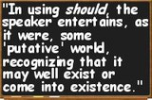
Putative should (also called "emotional should " or "attitudinal should") occurs not only in subordinate clauses as an alternative to the subjunctive after expressions of suggesting, advising, etc. listed above but also in that-clauses after expressions of emotion (sorrow, joy, displeasure, surprise, wonder, etc. – I am sorry, glad, pleased, vexed, I regret that, I am surprised that, it is surprising that, it is strange that; it is annoying that, it is impossible that, it is unnatural that, it is fortunate, etc.), and is often accompanied by intensifying expressions such as so, such, like this/that, ever, or at all.
E.g. It is lucky that the weather should be so fine.
I am surprised that she should do that.

Putative should can also be used in why-clauses and how-clauses: e.g. Why should she have done that? – this is a rhetorical question (I do not know why.)
When one refers to the objective event the indicative is used:
cf. (a) It is lucky that the weather should be so fine. (the speaker is happy)
(b) It is lucky that the weather is so fine. (a mere fact)

Remember: should expressing emotions can be followed by different infinitive forms. It is never followed by the subjunctive.

§ 2. The past subjunctive in conditional clauses (= conditionals)

https://www.youtube.com/watch?v=FH3ThwR99LM
https://www.youtube.com/watch?v=vXp0ETWXbWo
Conditionals are clauses introduced with if. The main types of conditionals are: Typе 0, Type 1, Type 2 and Type 3. Conditional clauses consist of two parts: the if - clause (hypothesis) and the main clause (result). When the if-clause comes before the main clause, the two clauses are separated with a comma. When the main clause comes before the if-clause, then no comma is necessary:
If the weather is good tomorrow, we will go to the beach.
We will go to the beach if the weather is good tomorrow.

When we add an if-clause after a main clause as an additional comment, we can use a comma to show that the if-clause is separate:
I’d like to get a ticket, if they still have some. Kate always goes to work, even if she feels bad.

Typе 0 Conditionals = Factual Conditionals (General Truth)

If - clause | Main clause
If + present tense  If + past tense | present tense  past tense

☺We can use when (=whenever) instead of if.
e.g. If / when it rains, the roads get slippery and dangerous.
If / when you heat water to 100 degrees Celsius, it boils.

☺Unless is possible: She can’t drive unless she has her glasses.

☺We can use different present tenses in both clauses:
If John is cursing, it means that he is very angry.
Prawns are very risky to eat if they haven’t been kept at the right temperature.
If she’s travelling abroad on business, she always phones me every evening.

☺We can use modal verbs in either case, especially can and may:
If you can read this, you’re driving too close to me!

☺Examples with past tenses:
If I got home late, my mom scolded me.
If she was sad, she just stared into the distance without saying a word.

Typе 1 Conditionals = Predictive Conditionals
If - clause | Main clause
If + present simple | future / imperative
If + present cont. / going to | going to
If + present perfect | can / may / might / must /should / could + present bare infinitive
If + present perfect cont.
If + past simple
They may be used to express real or very probable situations in the present or future: e.g. If we work hard, we’ll finish the project on time. If John comes earlier, ask him to wait.

First conditional sentences with going to in the main clause:
If you don’t get ready soon, we’re going to be late!

The present continuous and going to in the if-clause:
If you’re going to the shop, can you buy me some cola?
If you’re going to pay him, make sure you get a receipt.

The present perfect in the if-clause:
If you’ve finished your work, you can go home.
If he has sent you an invoice, you should pay him.

The past simple in the if-clause:
If you studied for the test, you won’t have any problems.

Note: Mind the difference between conditional clauses with if and time clauses with when: we use if to show that something might happen; we use when to show that something will definitely happen.
e.g. If Steve calls, tell him I'll be back in ten minutes. (Steve might call.)
When Steve calls, tell him I'll be back in ten minutes. (It is certain that Steve will call.)

If so, if not, etc.
When we want to refer back to something which has already been mentioned, we can reduce the if-clause. There are several ways of doing this:
- Some books may have missing pages. If so, they can be exchanged.
- Rules really must be enforced. If not, they can easily be ignored. (If the rules aren’t enforced...)
- I think you should take the job. If you do, I’ll help you get started. (If you do take the job).

Typе 2 Conditionals (unreal present)
Sometimes we use past tenses (active and passive) to describe things in the present, past or future which are imagined or unreal. We refer to this use of past tenses as the ‘unreal’ past.

If - clause | Main clause
V.1. if + past simple / past continuous  V.2. if + were / was | would / could / might + present bare inf.

They are used to express imaginary situations which are contrary to facts in the present and, therefore, are unlikely to happen in the present or future. They are also used to give advice.
e.g. Richard is daydreaming. He thinks, ‘If I didn’t have to work such long hours, I wouldn’t be so tired.’

The past subjunctive were is the hypothetical subjunctive used in hypothetical conditional clauses (Type 2). It is distinct from the past indicative of the main verb be only in the first and third personal singular, where the indicative is was (I was, she was): If I were you, I wouldn't go.
We use If I were you ... when we want to give advice. e.g. If I were you, I wouldn't travel on my own.

Were is a subjunctive auxiliary — progressive or passive — when used as the first or third person singular. E.g.:
All this would be great news if oil were selling at $40 a barrel. — progressive
These options would look more attractive if the capital-gains tax were reduced. — passive

The same applies if were is part of semi-auxiliaries as in were to and were going to:
e.g. (1) He said Sony would not object even if Columbia were to make a movie critical of the late Emperor Hirohito, although he added that people in Japan might not want to see it.
(2) If he were going to write of his life in Africa, he would ask me for assistance.

♦ If + were to
In formal situations, we can use if + were to when we talk about things that might happen but which we think are unlikely. In other words, we use if + were to to talk about imaginary or improbable future situations.
e.g. If the Prime Minister were to resign, there would have to be a general election within 30 days.

if-clause: were to / was to  - condition to be satisfied - | main clause: would / should / might / could  - likely outcome -
If he was / were to ask, | he would ...

In even more formal styles, we use were + subject-verb inversion + to-infinitive:
e.g. Were we to give up the fight now, it would mean the end of democracy in our country. (If we gave up the fight now …)
Were the economy to slow down too quickly, there would be major problems. (If the economy slowed down too quickly …)

Remember: There is no negative construction (NOT If we were not to give up, ...) but negative inversion is possible with the full form: Were we not to give up, ... .

♦ The past indicative was is more usual than subjunctive were in contexts that are not formal. However were is preferable in:
(1) purely imaginary statements: If I were the Queen of Sheba, you’d be King Solomon;
(2) if I were you / in your position / Jane / in Jane’s position;
(3) if it were not for / if it weren’t for (the fact that). In formal contexts: Were it not for your help (NOT weren’t in this case of inversion)
(4) as it were (used parenthetically) – немов би, нібито, так би мовити: e.g. He was silent, as it were, oppressed.
Besides being used in hypothetical conditional clauses, the past subjunctive were is also used in other hypothetical constructions: Suppose he were free now, would you invite him to the party? I wish it were over now. If only Jane were here now. I felt as if I were standing in the grim grocery store. It's as though there were a garden round him.

The use of Type 2 Conditionals suggests that the situation is less probable, impossible, or imaginary. Compare the examples:
e.g. a) If I meet Brad Pitt, I'll ask him about his next film. (comment made by a reporter who is going to Hollywood)
If I met Brad Pitt, I would ask for his autograph. (comment made by a teenage fan)

b) If I win the money, I'll buy a new car. (comment made by a contestant on a TV game show)
If I won the money, I would buy a new car. (comment made by a member of the audience)

Typе 3 Conditionals (unreal past)
If - clause | Main clause
if + past perfect / past perfect contin. | would / could / might + perfect bare inf.
They are used to express imaginary situations which are contrary to facts in the past. They are also used to express regrets or criticism.
e.g. Simon made a big mistake because he wasn't careful. Simon says, ‘If I had been more careful, I wouldn't have made such a big mistake.’

♦ We can form conditionals by using words / expressions such as

https://www.youtube.com/watch?v=U2zbq0V6DfE

а) unless – we use unless to say ‘except under the following circumstances’ or ‘except if’. It is used to draw attention to the condition as an exception and sometimes means the same as if … not:
Unless you help me, I won't finish on time. (= If you don't help me, ...)

Warning: unless is more limited than if…not. We don’t use unless:
- for impossible conditions: If the government had not raised food prices, there would not have been so many protests. Not: Unless the government had raised food prices …
- when there is a negative cause or reason: If he didn’t have such big ears, he’d be handsome. Not: Unless he had …
- when we begin the main clause with then: If they cannot agree on the terms of the contract, then a strike is inevitable. Not: Unless they can agree

b) providing / provided (that) – I'll water the plants providing / provided (that) I have time this afternoon. (... if I have time ...)
Providing (that) is more common in speaking; provided (that) is more formal and more common in written language. Provided conveys a strong idea of limitation or restriction.
First Conditional:
[talking about rail travel in the UK]
- You can get a senior citizen’s reduction providing you’ve got a railcard.
- They may do whatever they like provided that it is within the law.
- You can camp here, provided you leave no mess.

Second Conditional (unreal or hypothetical situations in the present or future):
- Providing (that) you worked harder, you would achieve your goals.
- Provided (that) he studied more, he would pass the exam.

Third Conditional (unreal or hypothetical situations in the past):
- Providing (that) you had prepared earlier, you would have done better.
- Provided (that) she had taken the train, she would have arrived on time.

c) so / as long as – e.g. So / As long as you promise to be back by midnight, you can go to the party. (If you promise ...)
So long as she didn’t question his decisions, she would be able to work with him. You can play in the living room as long as you don’t make a mess. So long as a tiger stands still, it is invisible in the jungle.

d) on (the) condition (that) – He agreed to work Saturdays on condition that he was paid overtime. (... if he was paid...)
The bank lent the company 100,000 pounds on condition that they repaid the money within six months.

NOTE: The conjunctions c and d are NOT used with the 3-rd conditional, as they can only refer to present or future conditions.

e) what if = say:
(1) – 'I'll take Dad's car tomorrow night.'
– What if he needs it?' (= What will you do if he needs it?)
(2) What if you were to run out of money?

f) suppose / supposing are used in Type 1, 2 and 3 conditionals – Suppose / Supposing you were fired, what would you do? (= If you were fired, ...)

g) otherwise – We'd better leave now. Otherwise we'll miss our flight. (If we don't leave now, we'll miss our flight)
She has the power of ancient healers to return to life that which otherwise wouldn't live.
We are committed to the project. We wouldn’t be here otherwise.

h) or (else) – Don't do that again or (else) I'll punish you. (If you do that again ...)
Yes, she loved him, or else how could that have happened which had happened?

i) and – Do that again and I'll punish you. (If you do that again ...)

j) but for – But for your advice, I wouldn't have been able to solve my problems. (If you hadn't advised me,...)

If it were not for… / But for … | somebody would do something
If it had not been for… / But for … | somebody would have done something

k) even if – I wouldn’t go to the party even if they invited me.

l) assuming – Assuming the rest of the world continues to grow, this sector may benefit. Assuming (that) he worked harder, he would get a promotion. Assuming (that) they had left earlier, they would have caught the bus.
m) in case of (less formal) / in the event of (more formal) – In case of / In the event of a fire, sound the alarm. (If there is a fire, ...)

"In case" is used to express precaution or preparation for a possible situation, while second and third conditionals are typically used to talk about hypothetical situations or past events that didn’t happen.

Second Conditional
The second conditional is used for unreal or hypothetical situations in the present or future. When you use "in case" in this context, you're talking about taking precautions for something that might happen.
Example:
- Normal second conditional:
"If I had a map, I could find the way."
- With "in case":
"I would bring a map in case I got lost."
(This means you’re preparing for the possibility of getting lost.)

Third Conditional
The third conditional is used for unreal situations in the past—things that didn’t happen. "In case" can still work here, but it would indicate that you would have taken a precaution if you had known a situation could arise.
Example:
Normal third conditional:
"If I had known, I would have told you."
With "in case":
"I would have brought an umbrella in case it had rained."
(This means you would have taken the umbrella as a precaution, even though it didn’t actually rain.)

Key Difference Between "If" and "In Case":
"If" introduces a condition: e.g. "I would take an umbrella if it rained." (You only take it if it’s raining.)
"In case" introduces a precaution: "I would take an umbrella in case it rained." (You take it whether or not it rains, just to be safe.)
So, "in case" expresses precaution or preparation, not a direct condition like "if."

♦ We do not normally use will, would or should in an if-clause. However, we can use will or would after if to make a polite request or express insistence, willingness or uncertainty (usually with expressions such as I don't know, I doubt, I wonder, etc.) In this case, if means whether. We can also use should after if to talk about something which is possible, but not very likely to happen:
a) If you will wait a minute, Mr Carrington will be able to see you. (Will you please wait... - polite request)
b) If you will go on making so much noise, I'll send you out. (If you insist on making ... - insistence)
- If you would tell me what the problem is, I would help you. (If you would tell me – willingness)
- I wonder if he'll call me tomorrow. (I wonder whether... - uncertainty)
- If Paul should turn up, tell him to wait for me. (I don't really expect Paul to turn up.) - Якщо трапиться так, що Пол прийде, скажи йому зачекати на мене.

♦ We can omit if and use inversion in Type 1, 2 and 3 Conditionals with should, were, had:
1. Should he fail to be re-elected, it will be a great disappointment for him.
2. Were he more careful, he would make fewer mistakes.
3. Had she been asked, she would have given her permission.
https://www.youtube.com/watch?v=4OXIOZJUojc
Inversion is more common in formal English:
- Inversion with should: Should you feel hungry, ... (equivalent to If you (should) feel hungry)
- Inversion with were as past subjunctive: Were you here, ... (equivalent to If you were here, ...)
- Inversion with were in compound forms:
- Were he to shoot ,... (equivalent to If he were to shoot, i.e. If he shot)
- Were he to have lied, ... (equivalent to If he were to have lied)
- Were he to be promoted, ... (equivalent to If he were promoted)
  - Inversion with had in Type 3 conditionals: Had he written, ... (equivalent to If he had written)

In negative clauses with inversion, we DON’T USE contracted forms:
- Should you not feel hungry, ... (equivalent to If you shouldn’t feel hungry)
- Were you not here, ... (equivalent to If you weren’t here,...)
- Were he not to shoot, ... (NO contracted equivalent : see if + were to on p.11)
- Were he not to be promoted, ... (equivalent to If he weren’t promoted)
- Were it not for your help, ... (equivalent to If it weren’t for your help)
- Had he not written, ... (equivalent to If he hadn’t written)
- Had the people not been informed, ... (equivalent to If the people hadn’t been informed).
♦ We can form mixed conditionals https://www.youtube.com/watch?v=_Mv7fBqauvc , if the context permits it, by combining an if-clause from one type with a main clause from another.
If-clause | Main clause
Type 1  If it isn’t too late,  If it’s OK with you, | Type 2  we’d like to watch the news on TV.  I’d rather stay here.
Type 2  If you were more sensible, | Type 3  you wouldn’t have spoken to your boss like that.
Type 3  If she hadn’t missed the bus, | Type 2  she would be here now.

§ 3. Expressing wishes with wish and if only

https://www.youtube.com/watch?v=LJcXRxy-nDU
https://www.youtube.com/watch?v=QyO6Tr5301Y
https://www.youtube.com/watch?v=B6Si3Op79Sw
We use the verb wish and the expression if only to express a wish. If only is more emphatic than I wish.
♦ wish / if only + past simple / past continuous
This structure is used when we want to say that we would like something to be different in the present
e.g. I wish (wished, will wish) / if only I didn’t have to take the train to work every day. (I have to take...)
Notes:
- We can use were instead of was after wish or if only: e.g. I wish (wished, will wish) he were/was more careful.
- wish / if only + past continuous can also refer to the future: e.g. She wishes she were coming with us. (She is not coming...).
I wish I were coming with you tomorrow. (I am not coming with you tomorrow)

♦ wish / if only + past perfect
This structure is used to express regret that something happened or did not happen in the past.
e.g. I wish (wished, will wish) / if only I hadn’t stolen the motorbike.

♦ wish / if only + would
This structure is used:
a) for a polite imperative: e.g. Teacher to students: I wish you would pay more attention!
b) to express our desire for a change in a situation or someone's behaviour: I wish / If only my boss wouldn't give me so much work.
c) to complain about a situation or about things that people do repeatedly: e.g. The phone has been ringing for five minutes. I wish somebody would answer it.
I wish you wouldn’t keep interrupting me.
d) wish + inanimate subject + would is used to express the speaker's lack of hope, or disappointment): e.g. I wish it would stop raining. (But I'm afraid it won't stop raining. - wish implying disappointment)

Notes:
♦ 'Wish' and 'would' should have different subjects. We never say: I wish I would, He wished he would, etc. e.g. I wish I could travel abroad. (NOT: I wish I would travel...)
♦ We use I wish ... would ... to say that we want something to happen. But we do NOT use I wish ... would ... to say how we would like things to be. Compare:
I wish Jane would come. (I want her to come)
but I wish Jane was / were here now. (NOT I wish Jane would be )
I wish somebody would buy me a car.
but I wish I had a car. (NOT I wish I would have)
The change we desire must be possible, even if unlikely. We cannot use would for an impossible change, e.g. one which the subject has no control over:
I wish sports cars weren’t so expensive.
I wish sports cars wouldn’t be so expensive. (cars don’t control prices)

♦ wish + could + bare infinitive:
• I wish I could (do something ) = I regret I cannot do it:
e.g. I’m sorry I have to go. I wish I could stay longer. (but I can’t)

• I wish I could have (done something ) = I regret I could not do it:
e.g. I hear the party was great. I wish I could have gone. (but I couldn’t go)

Though wish and if only are often used interchangeably, if only expresses more strongly the idea that the situation wished for doesn’t exist, whereas wish is used for something that might happen.

§ 4. Expressing wishes with It’s (high) time, It’s about time

https://www.youtube.com/watch?v=uVJGPtkSfTE
https://www.youtube.com/watch?v=RcCkHCP6TDY

We use It’s (high) time, It’s about time to express present or future wishes, or to express our impatience about things that haven’t happened yet.
These expressions can be followed by:
a) the Infinitive
e.g. It’s time to begin (the correct time has come)

b) the “for” phrase
e.g. It’s time for us to begin.

c) a clause with a predicate in the past tense
e.g. It’s time we started. (It’s a little late)
It’s high time we started. (emphasizes the idea)
It’s about time we started. (makes the criticism stronger)
Some more examples: It was high time someone invited me to lunch.
It's high time you got that bad knee of yours looked at by a doctor!
Notes:
1) these expressions are mainly used in formal contexts. In less formal situations, we are more likely to use a form with let: Let’s begin;
2) we cannot use a negative after it’s time: It’s time we didn’t begin.

§ 5. Had Better / Best
https://www.youtube.com/watch?v=9r88YWp9XQo
https://www.youtube.com/watch?v=uJ4yvTzW_Xw

We use “had better” plus the infinitive without “to” to give advice. Although “had” is the past form of “have”, we use “had better” to give advice about the present or future.

- You'd better tell her everything.
- I'd better get back to work.
- We'd better meet early.

The negative form is “had better not”.
- You'd better not say anything.
- I'd better not come.
- We'd better not miss the start of his presentation.

We use “had better” to give advice about specific situations, not general ones. If you want to talk about general situations, you must use “should”.

- You should brush your teeth before you go to bed.
- I shouldn't listen to negative people.
- He should dress more appropriately for the office.

When we give advice about specific situations, it is also possible to use “should”.
- You shouldn't say anything.
- I should get back to work.
- We should meet early.

However, when we use “had better” there is a suggestion that if the advice is not followed, something bad will happen. So, had better implies the idea of warning or threat of possible bad consequences and expresses more urgent and stronger advice than “should/ought to” but it is not as strong as must. In The gas tank is almost empty. We had better stop at the next service station: If we don't stop at a service station, there will be a bad result. We will run out of gas.

Some more examples:
- You'd better do what I say or else you will get into trouble.
- I'd better get back to work or my boss will be angry with me.
- We'd better get to the airport by five or else we may miss the flight.

Notes on the use of had better:

- It has a present or future meaning.
- It is followed by the simple form of a verb.
- It is more common in speaking than writing.
- had best can be used instead of had better but is less common.
- informally, better or subject + better often occur without had:
e.g. Mr Murphy will be here any minute. – Better get his file then.
You better stop arguing and do as you’re told.

§ 6. Would Rather / Sooner / Would Just As Soon
https://www.youtube.com/watch?v=0-sWG2R8xYs
https://www.youtube.com/watch?v=yg_9mfaL6DA
https://youtu.be/VsXhdK01W74?si=pRARo6MKaj4_oOf1

Would rather / sooner do something (would rather / sooner not do something) – радше б; скоріше / скорше б; волів би – expresses preference.
When the subject of would rather is also the subject of the following verb, we use the following constructions:
a) would rather + present bare infinitive (present / future)
e.g. I’d rather do my shopping tomorrow.
Continuous Usage: We use progressive form when we wish to be doing something else. We express boredom or our hope to be doing a new activity. We usually use be + verb ing with this structure.
e.g.
I would rather be walking in the forest than (be) reading this.
She'd rather be listening to music now than doing this boring job.
Mike would rather be lying on the beach than be going to the summer school.
Mom would rather be cleaning the house than gossiping.
We'd rather not be sitting here.

b) would rather + perfect bare infinitive (past)
e.g. I’d rather not have gone to the dinner party last night.

c) would rather + bare infinitive + than (+bare infinitive)
e.g. I’d rather watch a comedy than (watch) a thriller.

When the subject of would rather is different from the subject of the following verb, we use the following constructions:
a) would rather + past tense (present / future)
e.g. I’d rather Kate stayed with us tonight.

b) would rather + past perfect (past)
e.g. I’d rather Sam hadn’t taken his father’s car yesterday.

More example sentences:
- I would just as soon stay in - I'm not feeling very well.
- I'd just as soon stay at home as go out tonight.
- I'd just as soon work at home and not have the hassle of the subway every morning.
- I would just as soon not hear about it
- She'd sooner share a house with other students than live at home with her parents
- I would sooner (that) my son became a doctor.
George Strait I'd Just As Soon Go
https://www.youtube.com/watch?v=hDA9SvE23bQ
lyrics https://genius.com/George-strait-id-just-as-soon-go-lyrics

§ 7. ADVERBIAL CLAUSES OF PURPOSE
https://www.youtube.com/watch?v=V1dK9_bPb18

These clauses answer the questions What for? and For what purpose? and can be introduced by the following conjunctions: so (that), in order that, in case, lest and for fear (that).

– Sequence of verb forms in adverbial clauses of purpose–
When the verb in the main clause is in the present, present perfect or future, so that and in order that can be followed by may, can, will or the present:
main clause | subordinate clause
the imperative,  the present, present perfect or future | may, can, will or the present
So that is more common than in order that: e.g. I’ve arrived early so that / in order that I may / can / will get / get a good view of the procession.

When the verb in the main clause is in the simple past, the past progressive, or the past perfect, so that and in order that are followed by should, could, might or would:
main clause | subordinate clause
the simple past, the past progressive, or the past perfect | might, could, would or should
e.g. I arrived early so that / in order that I should / could / might / would get a good view of the procession.
The negative after so that and in order that: might not, should not, would not BUT NOT could not.
e.g. I arrived early so that / in order that I might not / should not / would not miss anything.

— IN CASE, LEST, FOR FEAR —
Should, might or the present must be used after IN CASE when there is a future reference:

future reference | in case + present / should / might
past reference | in case + past
e.g. (1) We’ve installed an extinguisher next to the cooker in case there is ever a fire. (there should / might ever be)
(2) He took a jumper in case it got cold.

LEST (relatively rare) means (1) for fear that, or (2) in order to avoid. It is followed by something the speaker thinks should be avoided.
Should is optional after lest. The subjunctive could also be used after lest:
e.g. Don’t push people too hard, lest you (should) damage close friendships unnecessarily.
I avoided mentioning the subject lest he be offended.
I asked him to ring first lest we were out.

FOR FEAR is usually followed by might, but the same idea can be expressed more easily with in case + past:

for fear (that) + might = in case + past
e.g. I bought the car at once for fear (that) he might change his mind. = I bought the car at once in case he changed his mind.

Note: Alternatively, purpose can be expressed with to, in order to and so as to which are much simpler than those with that and are generally preferred.
So as to and in order to are variations on the to-infinitive, not conjunctions. They do not introduce a group of words containing a finite verb.

+ Use to, so as to, and in order to to express purpose in the affirmative form.
Examples:
- He is looking for a part time job to save some pocket money.
- She wakes up early in order to be on time to work.
- They visited him so as to offer their condolences for the death of his wife.

– Use so as not to and in order not to to express purpose in the negative form.

Examples:
- They woke up early in order not to be late.
- She exercises regularly so as not to get fat.
- He helped the new policewoman so as not to fail in her first mission.

When we want to include a subject before the infinitive verb, we can begin a purpose clause with in order for and a noun phrase (1) or a pronoun (2):
(1) In order for the team to succeed, they must work together. (NOT In order to succeed the team...)
(2) In order for you to win, we will need to pray for a miracle. (NOT In order you to win ...)
Clauses of purpose follow the rule of the sequence of tenses, like time clauses. E.g. He borrowed some money so that he could pay his phone bill.
Note: We can express negative purpose by using:
    - E.g. She covered the sofa with a sheet to prevent it (from) getting dirty.
    - E.g. They set off early in the morning to avoid getting stuck in traffic.

§ 8. Adverbial Clauses of Concession = contrast clauses
https://www.youtube.com/watch?v=nX8N9RiGCZg

Adverbial clauses of concession introduce an element of contrast into a sentence and are sometimes called contrast clauses. They are introduced by the following conjunctions:
- though
- although
- even though
- even if
- considering (that)
- while
- whereas
- however much / badly / good, etc.
- no matter how much, etc.

In clauses of concession either the Indicative Mood is used or may (a present reference) / might (a past reference) + Infinitive.
e.g. Though the news was shocking, nobody seemed to be interested in it.
Though the news might be shocking, nobody seemed to be interested in it.

Even if clauses follow the rules of conditionals (types 1, 2, 3). They combine conditional with concessive meaning. We cannot therefore assume that what they describe is factual. In this respect they differ from even though clauses.
We use even if (‘despite the possibility that’) to say that a condition may exist, but it won’t affect the future or possible situation described in the main clause: We’ll have a great time even if it rains. (it may rain, but it won’t stop us). Even if British History wasn’t a required subject, I’d enjoy learning about it. Even if he were right, I wouldn’t trust him. Even if I had seen him do it, I wouldn’t have told anybody about it.

We use even though (‘despite the fact that’) to talk about the existence of a condition that won’t affect the past or present situation in the main clause: We had a great time even though it rained. (It rained, but it didn’t stop us.) Even though Tom never studies, he passes all the tests. I like her, even though she can be annoying at times.

Even though is probably more usual than though / although in speech:
e.g. Even though / though / although I felt sorry for him, I was secretly pleased that he was having difficulties.

However combines with numerous adjectives and adverbs:
e.g. However far it is, I intend to drive there tonight. However harshly he may speak to you, you can be sure that he has only your best interests at heart.

No matter can combine with question words (who, when, where, etc.) to introduce clauses of concession: e.g. No matter where you go, you can’t escape from yourself.

Compounds with –ever can introduce clauses of concession in the same way as No matter: e.g. Whatever I say, I seem to say the wrong thing. (No matter what ...)

As and though to mean 'regardless of the degree to which' can be used after some adjectives, adverbs and verbs to introduce clauses of concession in formal style:
e.g. Unlikely as it sounds / may sound, what I’m telling you is true. (i.e. Though it sounds/may sound unlikely ...)
Beautiful though the necklace was, we thought it was over-priced so we didn’t buy it. (i.e. Though the necklace was beautiful ...)
Try as he might, he couldn’t solve the problem. (i.e. Though he tried he couldn't ...)
The subjunctive could also be used in concessive clauses (see §1.2.): e.g. Whoever he be, he shall not go unpunished.

§ 9. Adverbial CLAUSES OF MANNER
https://www.youtube.com/watch?v=mech0nEPOXQ&t=66s

Clauses of manner are introduced by the conjunctions as if and as though (the latter is more literary).
– You can use as if or as though to say how somebody or something looks / sounds / feels:
That house looks as if it's going to fall down.
Helen sounded as if she had a cold, didn't she?
I've just got back from holiday, but I feel very tired. I don't feel as though I've had a holiday.

– You can also use like in all these examples:
That house looks like it's going to fall down.
Helen sounded like she had a cold, didn't she?
I've just got back from holiday, but I feel very tired. I don't feel like I've had a holiday.

As if and as though are more formal than like.

– You can say It looks like .. / It sounds like ...:
Sarah is very late, isn't she? It looks like she isn't coming.
We took an umbrella because it looked like it was going to rain.
The noise is very loud next door. It sounds like they're having a party.

You can also use as if or as though:
It looks as if she isn't coming. or It looks as though she isn't coming.
It looked as if it was going to rain.
It sounds as though they're having a party.

– You can use like / as if / as though with other verbs to say how somebody does something (run, talk; be, act, appear, behave, seem, smell, taste):
He ran like he was running for his life.
After the interruption, the speaker went on talking as if nothing had happened.
When I told them my plan, they looked at me as though I was mad.

– After as if (or as though), we sometimes use the past when we are talking about the present: I don't like Tim. He talks as if he knew everything.

The meaning is not past in this sentence. We use the past (as if he knew) because the idea is not real: Tim does not know everything. We use the past in the same way in other sentences with if and wish. Like is not normally used in this way.

Some more examples:
She's always asking me to do things for her - as if I didn't have enough to do already. (I do have enough to do)
Gary's only 40. Why do you talk about him as if he was an old man? (he isn't an old man)
When you use the past in this way, you can use the subjunctive were instead of was:
Why do you talk about him as if he were (or was) an old man?
They treat me as if I were (or was) their own son. (I'm not their son)
They stared at me as if I were crazy. (I’m not crazy, but people looked at me like I was crazy.)

Compare the ways to express real and unreal situations after as if / as though:
He looks as if he knew the answer. (he gives the impression that he knows the answer, but he (probably) doesn't know or we don't know whether he knows or not)
He looks as if he knows the answer. (he knows the answer)

If we put the verb preceding as if / as though into the past tense (looked), both sentences will read as follows: He looked as if he knew the answer.
Consequently, the meaning of this sentence (whether he knew the answer or not) can only be deduced from the context.

The past perfect after as if / as though is used to refer to an unreal past situation. If the situation is true, we use a real tense to express past time:
He seems as if he hadn't slept for days. (it seems that he hasn't slept for days, but he (probably) has or we don't know whether he has or not)
He seems as if he hasn't slept for days. (he hasn't slept for days)

If the preceding verb is put into the past tense, the present perfect hasn't slept changes into the past perfect: He seemed as if he hadn't slept for days.

It must be noted that in subordinate clauses referring to present time that are introduced by as if or as though, the present indicative is an alternative to subjunctive were: e.g. As time has passed, it feels as though there is unfinished business here.

We can use the expressions with as if / as though to be critical, ironic or sarcastic: It isn’t as if he’s in any position to pass judgement! (=He probably isn’t in a position to do this.)
EXERCISES

The Subjunctive Mood

§ 1. The present subjunctive
§ 1.1. The present subjunctive (the optative subjunctive use)

Exercise 1. Translate into Ukrainian:
1. My old father - God rest his soul – was a noble man. 2. Far be it from me to advise you what you should do, but I think the book is worth buying. 3. In his cable, the King expressed his deep sorrow and heartfelt condolences over the passing away of the princess. May God rest her soul in peace and paradise. 4. May his soul rest in eternal peace and may Almighty give his family the strength to bear this irreplaceable loss. 5. If anyone does not love the Lord - a curse be on him. 6. The King is dead. Long live the King! (Proclamation of Accession) 7. I drink my love to you all and every blessing and success attend you. 8. Gosh, a fellow must have some air, come what may. 9. Woe betide anyone who disturbs him! 10. Damn it all, you don’t look like a doctor! 11. Suffice it to say, this woman and her classes kept me interested in exercise for years to come. 12. Long may flourish our team and so continue winning all its matches!
13. God save our gracious Queen, Long live our noble Queen,
God save the Queen: Send her victorious, Happy and glorious,
Long to reign over us: God save the Queen (British Anthem)
14. God bless the Master of this house and Mistress also;
God bless the little children that round the table go;
God bless their friends and kindred, that come from far and near;
May the Lord send a happy New Year, Happy New Year,
May the Lord send a happy New Year (English Traditional carol).

Exercise 2. Fill the gap with the phrase that you think fits best: God forbid = Heaven forbid; Far be it from me; God rest his soul; Damn it all; woe betide, Suffice it to say.
- My late father, ______, was a well-known man about town.
- _________ to complain, but it's getting stuffy in here.
- _________ that the tornado pulls off the roof.
- That was the rule, and _________ anyone who ignored it!
- ________ that the judge was furious when the invitation was withdrawn.
- Please remember to take your phone with you. ________ something bad happens to you and you can't contact us.
- ___________ to conceal the truth!
Exercise 3. Translate into English:
1. Я пам’ятаю, як мій дядько, царство йому небесне, колись говорив про це. 2. Боже борони, щоб ми коли не-будь повернулись до тих часів! 3. Боже борони, щоб він загубився в лісі вночі! 4. Горе тому, хто виконує свою роботу недбало! 5. Хай живе і процвітає наша держава! 6. Нехай успіх і щастя супроводжують вас на довгі роки! 7. Боже, допоможи нам справитись з цією роботою. 8. Нехай Бог благословить вас усіх в наступаючому році! 9. Я далекий від того, щоб казати тобі, що робити, але чи не думаєш ти, що тобі слід вибачитись? 10. Боже борони забути вимкнути двигун на автозаправній станції. 11. Горе тобі, якщо ти будеш дурити людей! 12. Досить сказати, що кулінарія зараз є моїм улюбленим заняттям. 13. Мені доведеться погодитися на їхні вимоги. Нехай буде так.

§ 1.2. The present subjunctive (the suppositional subjunctive use)

Exercise 4. Read the following sentences and provide alternatives for the subjunctive. Translate into Ukrainian.
1. If need be, we'll rent a car. 2. "If music be the food of love, play on." (William Shakespeare, Twelfth Night) 3. Bush has said he is prepared to act unilaterally if need be. 4. Meadow Pines will meet incoming flights at local airport or in Shreveport, if need be. 5. I’ll work from morning till night if need be. 6. If need be, I will come early tomorrow morning. 7. Be it remembered, (therefore), that definitions are only needed when their absence might lead to a misunderstanding; that they need only be precise enough to serve their purpose.... Be it also remembered that definitions do not create problems; only facts do this.
Note: the suppositional subjunctive use is also reflected in other exercises in this manual.

§ 1.3. The present subjunctive (the mandative subjunctive use)

§ 1.3.1. The mandative subjunctive after verbs: ask ('request'), decide, demand, intend, insist, order, propose, recommend, request, require, suggest, urge

Exercise 5. Use the verb in brackets in the correct form.
Model:
They request that we (should) be in time for the conference.
1. I suggest that Frank (read) the directions carefully before assembling the bicycle. He doesn't want the wheels to fall off while he is riding down a hill. 2. Mrs. Finkelstein demanded that the heater (repair) immediately. Her apartment was freezing. 3. The monk insisted that the tourists (enter) the temple until they had removed their shoes. 4. It's a little difficult to find the restaurant. I propose that we all (drive) together so that nobody gets lost along the way. 5. I am not going to sit here and let her insult me. I demand that she immediately (apologize) for what she just said. 6. The woman insisted that the lost child (take) to the store's information desk so his parents could be paged. 7. The nutritionist recommended that Sally (reduce) her daily fat intake. 8. The sign at the pool recommended that you (swim) after eating a large meal. 9. The sun is scorching today. I suggest you (put) on sunblock immediately before you get a sun burn. 10. John insists that Sarah (invite) to the wedding; otherwise he will not attend.

Exercise 6. Say what instructions and recommendations a young teacher was given at her practical course at school.
Model: The school principal recommended (suggested, demanded, insisted, requested, ordered, required, was anxious) that we should come to school half an hour before the lessons.
Prompts: to fulfill various functions of professional and social activity, to work out new methods of teaching, to plan different types of lessons, to conduct different types of lessons, to use visual aids at different stages of the lesson, to use computer assisted learning, to act as class tutors, to carry out educational work in out-of school hours, to keep in touch with the pupil’s parents, to take part in the school life, to discuss plans of the lessons, to analyse lessons thoroughly, to analyze the causes of successes and failures, to enrich theoretical knowledge.

Exercise 7. Use the verb in brackets in the correct form.
1. Tom suggested that his friends (to stay over) for the night. 2. Sam proposes that Tom (to telephone) his accountant. 3. She recommended that he (to go and see) a doctor. 4. The manager requested that everyone (to put) their requests in writing. 5. The manager insists that the car park (to be locked) at night. 6. I suggest that she (to be) there at two o'clock ...7. The board of directors recommended that he (to join) the company. 8. We insist that a meeting (to be held) as soon as possible. 9. He demanded that the car (to be repaired). 10. I suggest that John (to arrive) on Tuesdays this month. 11. I suggest that she (to find) a better way to say it. 12. We insist that he (to take) the exam. 13. They recommend that Mr. Smith (to send) an application for the job. 14. Peter is demanding that we (to be served) immediately. 15. The Smiths are proposing that Jill (to visit) them in August.

Exercise 8. Translate into English.
1. Йшов новий спектакль в нашому театрі. Я запропонував подивитися його. 2. Бібліотекар наказав, щоб всі студенти повернули книги в бібліотеку перед тим, як вони поїдуть на канікули. 3. Вчитель попросив, щоб учні сказали своїм батькам підписати щоденники. 4. Класний керівник наполягав, щоб усі батьки відвідували класні збори. 5. Діти дуже хотіли, щоб їх вчитель хімії показав їм новий дослід. 6. Я наполягаю, щоб ти одягла нову сукню на новорічну вечірку. 7. Шкільний лікар вимагав, щоб діти ходили на прогулянку, якщо погода буде гарною. 8. Було пізно, і я наполягав, щоб збори перенесли на наступний день. 9.День дуже вітряний. Я наказав дітям, щоб вони надягли куртки. Я боявся, аби вони не застудились. 10. Наш учитель англійської мови порекомендував, щоб ми повторили попередній граматичний матеріал, аби не припуститися помилок в контрольній роботі. 11. Я вимагав, щоб діти не виходили на вулицю в таку холодну погоду. 12. Менеджер нашої компанії попросив, щоб ми не робили цю роботу нашвидкуруч. 13. Наші батьки наполягали, щоб ми уникали компанії Боба. 14. Мати порадила, щоб я не витрачав так багато грошей на сувеніри.

§ 1.3.2. The mandative subjunctive after nouns: decision, demand, insistence, proposal, recommendation, request, requirement, suggestion; condition, idea, aim, advice, wish

Exercise 9. Complete the sentences using the appropriate form of the verb.
Note: in the following sentences that-clauses function as predicative clauses.
1. His deep wish is that his daughter ____ to university (to go). 2. My advice is that the company ____ in the new equipment (invest). 3. The doctor’s advice is that they _____ eating fat food and fried food if they want to avoid the complication of sugar diabetes (to stop). 4. My captain’s suggestion was that we ____ the next day (to sail off). 5. Whose idea was that they _____ a meeting for Monday? (arrange) 6. Their urgent demand is that the troops _____ withdrawn from the occupied territory (to be). 7. Their aim was that they _____ the region’s deposits and use them for the benefits of people (to explore). 8. The chairman’s proposal was that the decision _____ postponed till next week ( to be).

Exercise 10. Fill in the blanks with the verbs in brackets. Translate the sentences into Ukrainian.
Note: in the following sentences that-clauses function as attributive (relative) clauses modifying the nouns in italics.
1. The requirement that he _________ (to find) work will be hard to meet. 2. The demand that she __________ (to complete) the report has been carried out. 3. The request that we ______ (to be) ready to leave at six is a nuisance. 4. The proposal that she ______ (to meet) us has merit. 5. Mary’s wish that we________ (stay) at her place as long as possible did not find support among the guests. 6. Your advice that he _______ (to wait) till next week is reasonable. 7. His idea that we _______ (to keep) to the subject found unanimous approval. 8. Jane’s suggestion that we _______ (to work) overtime did not discourage us. 9. Sir Alex Smith was offended by suggestions that he ____ (to retire). 10. The opposition was inspired by fear of a requirement that debts _____ paid in gold and silver (to be).

Exercise 11. Translate into English.
1. Пропозиція режисера полягала в тому, щоб ми негайно розпочали репетиції в нашому театрі. 2. Вимога міністерства в тому, щоб комп’ютерна безграмотність була повністю ліквідована. 3. Він виступив з ідеєю, щоб ми об’єднали свої зусилля в ліквідації наслідків весняної повені. 4. Моя порада в тому, щоб ви встановили добрі зв’язки з нашими партнерами. 5. Бажання профспілкового комітету в тому, щоб побутові умови шахтарів були покращені. 6. Пропозиція адміністрації заводу полягає в тому, щоб витрати на виробництво продукції були зменшені. 7. Ваша ідея полягає в тому, щоб не продовжували роботу над цим проектом, а моя пропозиція в тому, щоб ми використовували новітні технології при його розробці. 8. Вимога дирекції школи, щоб усі учні носили шкільну форму. 9. Моя вам порада ніколи не підводити своїх друзів. 10. Однією з умов переговорів є підписання обома сторонами нового контракту.

§ 1.3.3. The mandative subjunctive in SUBJECT CLAUSES after adjectives: advisable, crucial, desirable, essential, imperative, important, necessary, vital, urgent, required

Exercise 12. Rewrite the following sentences without changing the meaning.
Model: It is necessary that he go there as soon as possible. – It is necessary that he should go there as soon as possible. - It is necessary that he goes there as soon as possible.
1. It's necessary that he meet as many local people as possible. 2. It's important that you have your car checked by a mechanic. 3. It is essential that we have a first-aid kit in the car. 4. It’s advisable that we travel in two different cars. 5. It is requested that you make your application as early as possible. 6. It is vital that the documents arrive by tomorrow. 7. It is important that people call after ten. 8. It’s important that you remember this rule.

Exercise 13. Use the corresponding mood form instead of the infinitive in brackets. Provide alternatives.
1. It is important that the child (to go) to kindergarten. 2. It is required that the meeting not (to be held) tomorrow. 3. It is urgent that they (to engage) a new employee. We have a lot of work to do. 4. It is required that you (not to cancel) the engagements. 5. It is required that you (to take steps) to avoid the forthcoming danger. 6. It is desirable that we (not to deal) with this company again. It is not reliable. 7. It is obligatory that all the students of the group (to attend) this conference. 8. It is advisable that you (to be) frank with her. 9. It is requested that we (to arrange) everything for the party. 10. It is necessary that she (to apologize) to the teacher for being rude. 11. He is one of the best workers and it is recommended that he (to be awarded) a prize. 12. It is required that you (to return) all my books to me at the end of the term. 13. It is necessary that you never (to put off) till tomorrow what you can do today. 14. It is vital that drivers (to know) the traffic rules well.

Exercise 14. Rewrite the following sentences without changing the meaning.
Prompt: After certain adjectives and nouns the meaning of the structure for+object+to-infinitive can be expressed by a that-clause with the present subjunctive or putative should + infinitive

a- It is vital that you keep the secret (a that-clause with the present subjunctive)
b- It is vital that you should keep the secret (putative should + infinitive)
c- It is vital for you to keep the secret (for+object+to-infinitive)
These sentences have all the same meaning, but a and b are much more formal in style than c.

- It is desirable for players to understand the rules before starting the game. It is desirable ______ before starting the game.
- It's important for you to be on time for the exam. It's important ______ on time for the exam.
- It's vital for young people to have a lot of friends. It's vital _______ a lot of friends.
- It is imperative for me to speak to you as soon as possible. It is imperative ______ to you as soon as possible.
- It is vital for the team to get a new trainer if they want to win. It is vital ______ a new trainer if they want to win.
- It is really important for him to pass all his exams. It is really ______all his exams.
- It is essential for us to speak English if we want to work in tourism. It is essential ________ English if we want to work in tourism.
- The plan is for him to meet us at the restaurant. The plan is _________us at the restaurant.

Exercise 15. Fill the gaps with the correct form of the verb in brackets.
1. It's important that she (remember)____________ to visit her doctor regularly.
2. It's vital that Ukraine (focus) _________ on improving people’s welfare.
4. It is imperative that the world (solve) ______ the problems connected with environmental protection.
5. It is necessary that you (be) _________ able to come with us.
6. It is obligatory that you (to observe) _____ the doctor’s prescription.
7. It is desirable that you (see) ______ a doctor once in a while.

Exercise 16. Give instructions to the students.
Model: to attend the ceremony – It’s necessary (obligatory, advisable, etc.) that you should attend the ceremony.
Prompts: to come to lectures on time, to leave your student’s cards at the Dean’s Office, to take part in the competition, to attend your lectures regularly, to be there to meet the guests, to attend the meeting, to act as guides for the delegation, to show the guests round the city, not to miss classes, to work more in the library, not to remain here for long, to be attentive in class.

Exercise 17. Translate into English.
1. Було надзвичайно важливо, щоб судді врахували усі вагомі докази стосовно цієї справи. 2. Просять, щоб гості сіли до столу. 3. Усім хворим рекомендовано дотримуватись овочевої дієти. 4. Для вас життєво важливо пройти медичний огляд. 5. Джону терміново слід зв’язатися зі своїм шефом. 6. Бажано, щоб ви відвідали свого товариша, який зараз у лікарні. 7. Дуже важливо, щоб хворий дотримувався дієти. Це допомогло б йому швидше одужати. 8. Вкрай важливо, щоб наша компанія підтримувала зв’язки з іноземними фірмами. 9. Рекoмендують, щоб студенти займалися мовною практикою з носіями іноземної мови. 10. Бажано, щоб ніхто не розголошував цієї таємниці.

https://www.businessenglishresources.com/subjunctive-exercises/
§ 1.4. Putative should expressing emotions ("emotional should" or "attitudinal should")

Exercise 18. Complete the sentences using emotional should. Use all possible forms of the Infinitive.
1. It is annoying that they … . 2. It was strange that she … . 3. It is impossible that he … . 4. It is surprising that the monitor of the group … . 5. It is annoying that the weather … . 6. It is wonderful that she … . 7. It is fortunate that the child … . 8. It is unfortunate that they …9. It was unnatural that John … 10. It is wonder that they … 11. It’s a pity that you …12. It’s a shame that they …13. I am sorry that you … 14. I am vexed that they … 15. It was strange that they … .

Exercise 19. Say that you are sorry your friend did it.
Model: to miss the train – It’s a pity that he should have missed the train.
Prompts: to miss the chance, to miss the talk that was worth hearing, to fail the examination, to lose his job, to fail to meet them, to change his mind, to fail to read the instruction before he started answering the questions.

Exercise 20. Translate into Ukrainian.
1. Дивно, що ви забули привітати свою подругу з днем народження. 2. Неможливо, щоб ви виконали це завдання за такий короткий час. 3. Чудово, що ви захоплюєтесь цим видом спорту. 4. Який сором, що вони так з повелися зі своїми родичами. 5. Мені шкода, що знайомим Максима довелося так багато страждати. 6. Щастя, що вона вчасно зуміла знайти вихід із цього скрутного становища. 7. Мене охоплює гнів, що окремі політики не дотримуються законів нашої держави. 8. Я такий радий, що вам вдалося побувати на цьому концерті. 9. Було дивно, більш ніж дивно, що колишні суперники стали добрими друзями. 10. Мене дратує те, що він так марнує дорогоцінний час.

§ 2. The past subjunctive in conditional clauses (= conditionals)

Exercise 21. Match the items in column A with those in column B in order to make correct Type 0 conditional sentences, as in the example.
A
1-d If you wash woollen clothes in hot water, they shrink.
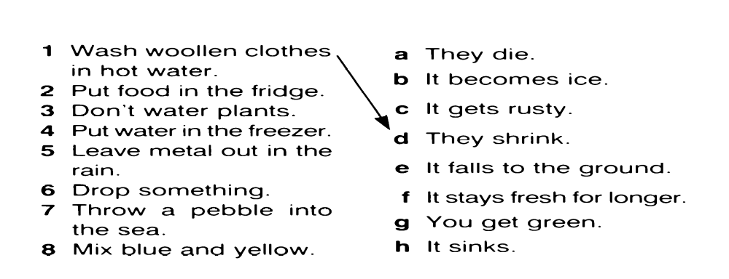
B
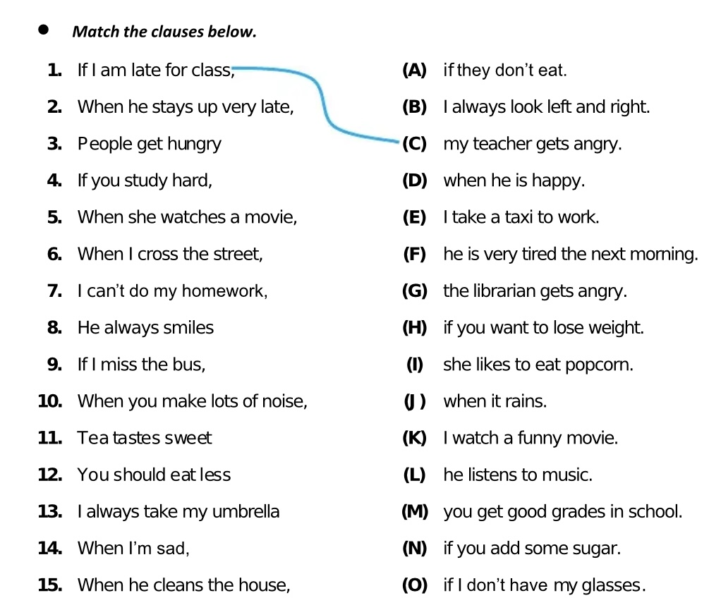

https://wordwall.net/resource/13116647/zero-conditional

Exercise 22. A friend of yours is going to Monaco. You have been there before. What info do you give him / her? First, match the items in column A to the ones in column B, then make sentences, as in the example.
e.g. If you want to stay at a five-star hotel, go to the Hotel de Paris. It’s very luxurious…
We will stay home if it rains c 1 - condition We will stay home when it rains - time
Exercise 23. Fill in the gaps with if or when and a verb in the present tense.
- We might go for a walk tomorrow. _____, we will take the dog with us.
- The guests will arrive soon. _____, we will greet them at the door.
- I am going to phone Sam in a minute. _______ him, I want you to leave the room.
- I might visit Pamela tomorrow. ______, I will buy her a present.
- The bus comes at eight o'clock. _____, we will all get on it.
- She might invite us to her party. _____ us, we will go.
- The film will start soon. ____, I will record it.
- Mark may lend me some money. ____ some money, I will buy that jacket.

https://wordwall.net/uk/resource/53652929/conditional-1

https://test-english.com/grammar-points/b1-b2/zero-first-conditional-future-time-clauses/

Exercise 24. In pairs, ask and answer questions about what you would do in each of the following situations, as in the example. Use your own ideas. SA: What would you do if you saw someone committing a robbery?
SB: If I saw someone committing a robbery, I would call the police.
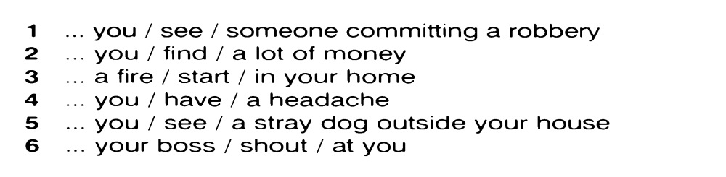
С 0, 1, 2 https://learningapps.org/6002876 - If I were you…

Exercise 25. Read the headlines and make a conditional sentence for each, as in the example
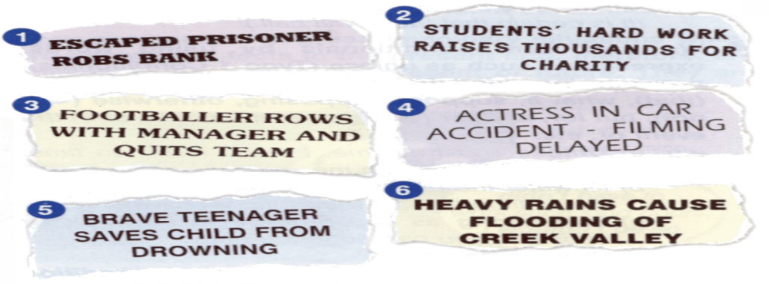

Exercise 26. Underline the correct form of the verb.
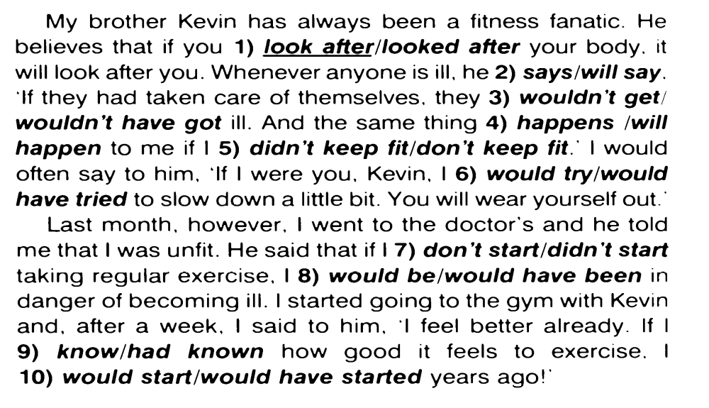
Exercise 27. Put the verbs in brackets into the correct tense.
Exercise 28.
A Underline the correct word or expression.
1. I'll lend you the money on condition that / unless you pay it back soon.
2. Even if / But for her help, I’d be in trouble now.
3. Unless / Provided it stops raining, we won't be going to the park.
4. I couldn't lend them the money even if / or I wanted to.
5. Try to be here on time, and / otherwise we'll miss the beginning of the film.
6. 'I'll wear Mum's necklace for the party.' 'What if / Otherwise you lose it?'
7. Supposing / Providing we went to London - what could we do there?
8. Be late again provided / and you'll have to see the manager.
9. In case of / On condition that an emergency, call this number.
10. You can go to the party in case of / as long as you are home before 11 pm.
11. Don't shout or / what if you'll wake the baby.

B Choose the correct word – if, when, or in case
Fill in the blanks with if, when, or in case.
- I'll call you ___ I get home.
- Take an umbrella ___ it rains later.
- ___ you see Anna, tell her I’m looking for her.
- We’ll leave early ___ there is traffic.
- I always wear gloves ___ it gets cold.
- ___ he finishes the project on time, he’ll get a bonus.
- Bring a snack ___ you get hungry during the trip.
- ___ she arrives, give her the message.
- You should set an alarm ___ you fall asleep.
- I'll help you with your homework ___ you want.

https://english-practice.net/english-grammar-exercises-in-case/#google_vignette

UNLESS - ONLY IF - EVEN IF https://www.liveworksheets.com/w/en/english-second-language-esl/7159494 - 1 mistake in #1

Exercise 29. Put the verbs in brackets into the correct tense.

https://www.liveworksheets.com/worksheets/en/English_as_a_Second_Language_(ESL)/Second_conditional/Second_conditional_vy181cc
https://www.liveworksheets.com/worksheets/en/English_as_a_Second_Language_(ESL)/Third_conditional/Third_conditional_fp182cd

https://test-english.com/grammar-points/b1-b2/second-third-conditionals/
Exercise 30. Choose the correct answer.
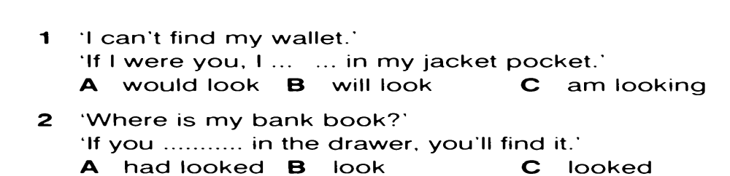
https://test-english.com/grammar-points/b2/unless-even-if-provided-as-long-conditionals/
Conditionals - speaking:
https://wordwall.net/resource/36584915/revision-of-1st-conditional
https://wordwall.net/resource/15312253/second-conditional-what-would-you-do-if-
https://wordwall.net/uk/resource/35782112/first-and-second-conditionals-questions
https://wordwall.net/resource/2417002/third-conditional
https://www.baamboozle.com/game/8139?page=2

Mixed Conditionals

Exercise 31. Translate mixed conditionals into Ukrainian.
1. If you had learned the rules better, you would feel more confident now. 2. If John were less experienced, he would not have managed the task properly. 3. If I were you, I would have accepted this job offer. 4. If I had won the lottery, I would be rich. 5. If I had taken French in high school, I would have more job opportunities. 6. If she had been born in the United States, she wouldn't need a visa to work here. 7. If I were rich, I would have bought that Ferrari we saw yesterday. 8. If Sam spoke Japanese, he would have translated the letter for you. 9. If I weren't going on my business trip next week, I would have accepted that new assignment at work. 10. If my friend weren't making us a big dinner tonight, I would have suggested that we go to that nice Chinese restaurant.

Exercise 32. Rewrite the following as mixed conditional sentences.
1. She didn’t study hard. She won’t pass the exams.
2. You didn’t wake me up. Now I’m late for my appointment.
3. She isn’t well-qualified. She didn’t get the job.
4. We didn’t go to the restaurant. We don’t like fast food.
5. She didn’t bring her umbrella. Now, she is getting wet.
6. I don’t know him very well, so I didn’t go to the party.
7. He isn’t at the lecture because he wasn’t told about it.
8. They didn’t take a map with them. They are lost now.
9. The driver isn’t careful. He crashed his car into a wall.
10. I didn’t buy tickets. We can’t go to the theatre tonight.
11. He didn’t reserve a table. He has to wait for an hour.
12. Sue forgot to go to the bank. Now she can’t go shopping.
13. They missed their flight. They won’t arrive until tomorrow.

Exercise 33. Translate into English.
1. На твоєму місці я б давно розповів йому правду. 2. Якби він не був егоїстом, він би не з'їв все сам. 3. Зараз ти почувався б набагато краще, якби приймав ці ліки впродовж минулого тижня. 4. Якби ти вчора передав йому моє повідомлення, він би не був такий сердитий тепер. 5. Якби вона не була така обдарована, вона б не вступила до цієї академії. 6. Якби я добре знав французьку, я б переклав цю статтю ще вчора. 7. Наш будинок виглядав би не дуже добре, якби ми його не полагодили минулого літа. 8. Якби в банку вчора не був вихідний день, у мене зараз було б достатньо коштів. 9. Якби на початку літа не було дощів, то зараз ми б мали добрий урожай. 10. Що б ти зараз робив, якби твої родичі не позичили тобі гроші? 11. Ти б зараз нічого не знав з цієї теми, якби ти не прийшов на лекцію вчора.

Exercise 34. SHOULD after IF.
Model: If by any chance they miss the 7 o’clock train, they will hire a taxi.
If they should miss the 7 o’clock train
If by any chance they should miss the 7 o’clock train, they will hire a taxi. - - Should they miss- Не встигнуть вони на потяг о 7 …

1. If by any chance you need my help, let me know. 2. If by any chance he calls while I’m out, ask him to come later. 3. If by any chance I forget my promise, please, remind me about it. 4. If by any chance you happen to be in Chernivtsi, come and see me. 5. If by any chance you fail to translate the text, ask your friend to help you. 6. If by any chance Mary asks me to her birthday party, I’ll have to refuse to come. 7. If by any chance he discovers the truth, God save me! 8. If by any chance my plan fails, I’ll have to make up another one. 9. If by any chance Steve fails his examination, he will be expelled from the university. 10. I’m sure they won’t come this week. But if by any chance they arrive tonight, let me know at once.

Exercise 35. Write the sentences. Show that something is not very likely to happen (use if … should)
1. We have no jobs at present. (the situation / change), we will contact you. 2. I’ve hung the washing out to dry on the balcony. (it / rain), can you bring the washing in, please? 3. I think everything will be ok. (there / be / any problems), I’m sure we’ll be able to solve them. 4. I don’t want anyone to know where I’m going. (anyone ask), just say that you don’t know.

Exercise 36. Translate into English. Show that something is not very likely to happen.
1. Якщо трапиться так, що він відмовиться виконувати цю роботу, звільніть його негайно. 2. Якщо Петро все ж прийде до тебе, попроси його, щоб він зателефонував мені. 3. Якщо все ж піде дощ, ми залишимось вдома. 4. Якщо буде сонячно, давай підемо на пляж. 5. Якщо станеться так, що Джон спізниться, його батько засмутиться. 6. Якщо станеться так, що ти не розв’яжеш задачу, дай мені знати, я тобі допоможу. 7. У випадку, якщо ви будете мати більше інформації, негайно зателефонуйте мені. 8. Якщо станеться так, що ви заблукаєте, подзвоніть нам. 9. Якщо все ж піде дощ, будь ласка, занеси білизну знадвору. 10. У випадку, якщо вони приїдуть до Києва, я покажу їм багато цікавих місць міста.

INVERSION

Exercise 37. Complete the following sentences.
Model:
1. If I __________ him to do it, he would have obeyed me. (to order) – If I had ordered him to do it ...
2. _____ it not ______ yesterday, we would have raked the leaves. (to snow) – Had it not snowed yesterday ... .
3. If ______ in your position, I would start learning English immediately. (to be) – If I were…
4. ____ I in your position, I would start learning English immediately. (to be) – Were I in your position ... .

1. I would not have got lost if I ______________ the map. (to study)
2. _______ he _________ at home, we would have visited him. (to be)
3. He would have applied for the job if he _______ the advertisement. (to see)
4. We would not have ordered tea, _____ we ____ how late it was. (to know)
5. _____ it not _____, they would have held the party in the park. (to rain)
6. We would have agreed with you if we _____________ what you meant. (to understand)
7. If you _______ salt on the steps, they would not have been so slippery. (to put)41 (
8. ____ he ____ to us, we would have known when to expect him. (to write)
9. If he _______ to take the course, he would have had to work hard. (to choose)
10. _____ I in your position, I would not be so easy-going with him. (to be)
11. ______I you, I wouldn’t lend him money. (to be)

Exercise 38. Using subject-verb inversion, rewrite the following sentences without changing the meaning.
1. If you should see John, give him my best regards. 2. If you were to earn a huge salary, what would you do with money? 3. If he had not squandered all his savings, he wouldn’t be poor now. 4. If he were promoted, his salary would double. 5. If you need assistance, please, let us know. 6. If he is accepted for the job, he will go out and celebrate. 7. If I had not chosen to learn English, I would not be doing this exercise now. 8. If it hadn’t been so strange, I would have remembered it. 9. If I were in your shoes, I would tell the truth.
Exercise 39. Translate into English.
1. Як слизько! Якби не йшов дощ, так слизько не було б. 2. Якби море не штормило, ми попливли б до острова. 3. Якби в нас не було так багато валіз, ми могли б піти пішки на вокзал. 4. Якби не було так темно, ми б продовжували грати в футбол. 5. Якби ви були зацікавлені у вивченні мов, ви б займалися англійською кожного дня. 6. Якби ви читали вчорашні газети, ви б натрапили на статтю нашого колишнього викладача. 7. Якби він був хворий, він зараз не грав би у футбол. 8. Якби ти мені не подзвонив, я не знав би, що ти повернувся з Англії. 9. Якби у мене не болів зуб, я б склав вам компанію на концерт. 10. Якби ви їй не заважали, вона не була б така сердита на вас. 11. Якби у мене був словник, я б переклав статтю вчора. 12. Якщо б не було так темно, ми б не заблукали в лісі. 13. Якби багаж не був такий важкий, ми б не брали таксі. 14. Якби у мене не боліла голова, я б прийшов до тебе вчора. 15. Якби він був вчора в місті, він зайшов би до нас. 16. Якби не було так слизько, я б не впав і не пошкодив собі ногу. 17. Якби туристи не розклали багаття, вони не змогли б відлякати вовків. 18. Якби не було так пізно, ми б пішли зараз в кіно. 19. Якби я не чекав на свого товариша, ми пішли б прогулятися.

Exercise 40. Translate into English.
1. На вашому місці я б не ходив туди вчора. 2. Я б і раніше прийшов, але змушений був провідати свого друга в лікарні. 3. Я давно б закрив вікно. 4. Він домовився б з вами про зустріч ще минулого разу. 5. Ще тиждень тому ми б не займалися цими питаннями. 6. Минулого тижня вона зробила б цю роботу відразу. 7. В той час він прийняв би вашу пропозицію стати торговим агентом. 8. Я був би вас не турбував. Я не знав, що ви зайняті на конференції. 9. Він би вже поїхав на море відпочивати, але директор компанії попросив його показати гостям з Англії наше чудове місто.

Exercise 41. Translate the following sentences into Ukrainian.
1. If I were to choose between those two cars, I'd choose the black one. 2. If I were to express my opinion, I wouldn't say that you have made a smart move. 3. If I were to do something bad, what would you imagine it would be? 4. If you were to invite three people to a dinner party, who would it be and why? 5. If I were to contact your former employee, what would you want me to tell him? 6. If I were to ask your professors to describe you, what would they say about you? 7. If you were to see me walking down the street, call me. 8. If you were to see a car accident on the road, are you more likely to stop and help, or keep driving? 9. If we were to visit our old school, we would like to see all the teachers that taught us.

Exercise 42. Translate into English.
1. Якби мені довелось зустріти його, я був би дуже здивований. 2. Якби сталося так, що мені запропонували б цю роботу, я був би в захваті. 3. Що б ви зробили, якби йому довелось просити у вас допомоги? 4. Якби мені довелось розповісти вам, що вона накоїла, ви були б шоковані. 5. Якби йому судилося побачити її знову, він би розказав їй все, що знає про цю справу. 6. Чи досягли б ви успіху, якщо б вам довелось виконувати цю роботу нашвидкуруч? 7. Що б ви порадили своєму товаришеві, якщо би йому довелося розчаруватись у результатах своєї праці? 8. Якби я мав вибрати одну з цих книжок, я б узяв першу. 9. Який музей ви б обрали, якби вам довелося організовувати екскурсію? 10. Якщо б мені судилося стати коли-небудь вчителем, я б хотів викладати англійську мову.

Exercise 43. Open the brackets.
1. Suppose no one... there? (to be) 2. Suppose someone…you a box and… you to describe exactly what was inside, what would you do? (to give, to ask) 3. Supposing he…you for a loan, what would you say?" (to ask). 4. Supposing that she … you there, what would you have done? (to see) 5. Suppose he ... you to go to the cinema with him, would you go? (ask) 6. Supposing Trump … the election, could he still be popular? (to lose). 7. Travelling by car is convenient provided (that) you ... somewhere to park. (have) 8. Children will be allowed to use the swimming pool provided they ... with an adult. (to be) 9. We would go hiking this weekend even if the weather ... bad. (to be)

Exercise 44. Translate into English.
1. Припустимо, він би помилився у своїх розрахунках, хто взяв би відповідальність за зрив в роботі? 2. Припустимо, що ви дизайнер, який стиль ви б обрали? 3. Припустимо, ви виграли б мільйон доларів. Щоб ви з ними зробили? 4. Припустимо, вас обрали президентом України. Якими були б ваші перші кроки щодо покращення життєвого рівня народу? 5. Уявіть, що вас би запросили на конкурс «Україна має талант». Що б ви запропонували глядачам? 6. Вам би дали ще одну спробу, якби ви наполягали. Але ви цього не зробили. 7. Якщо б він звернувся до вас вчора, чи змогли б ви вирішити це невідкладне питання? 8. Ви б могли працювати в цій кімнаті, якщо б ви не шуміли.
https://www.liveworksheets.com/w/en/english-second-language-esl/45024
https://test-english.com/grammar-points/b2/all-conditionals-mixed-conditionals-alternatives-if-inversion/
Exercise 45. Paraphrase the sentences using otherwise / or / or else.
Model: а) He likes my paintings that is why he is interested in my exhibition. – He likes my paintings, otherwise he wouldn't be interested in my exhibition at all.
b) She is ill and that is why she hasn’t come to the party. – She is ill, otherwise she would have come to the party
c) I had to hurry up so that I might not miss the train. – I had to hurry up. Otherwise I would have missed the train.
1. He ignored me and I was deeply hurt. 2. Her daughter had failed at the entrance exams. That was why she was so worried. 3. The doctor saved many lives and the number of victims in the accident was not great. 4. He had helped me with my English and I did well in the exam. 5. They were late for classes and took a taxi. 6. He was shy and didn’t dare to say what he really felt about the matter. 7. I don’t know him well enough and can’t trust him. 8. I told them my name. That was why they let me in. 9. I know all the details. That’s why I recommend taking it easy. 10. I am sure he was in a hurry and that’s why he didn’t notice you. 11. No doubt he had learned his speech by heart. That’s why he spoke so well. 12. It was very cold outside and we could not go for a walk.

Exercise 46. Translate into English.
1. Вона знала, що Джон ледве зводив кінці з кінцями, інакше вона не погодилася б допомогти йому. 2. Хворому набагато краще, інакше він не спав би так спокійно. 3. Його докази були переконливими. Інакше я не прийняв би запрошення виступити на конференції. 4. Він, вочевидь, забув, що ми домовились зустрітись о 5 годині, інакше він би вже давно прийшов. 5. Я рада, що я вчасно закінчила роботу, в іншому разі я б зараз не була з вами. 6. Він першим зрозумів слова Анни, інакше він би не пішов. 7. Він пообіцяв, що не розкаже нікому про моє остаточне рішення, інакше я б не відкрила йому свою душу (bare one’s soul to smb.; lay one’s soul bare before smb). 8. Він знав про мій приїзд, інакше він не приїхав би зустріти мене. 9. Я його добре знаю, інакше я б не рекомендувала його вам. 10.Ти не знаєш ще добре Мері, інакше ти б з нею не затоваришував. 11. Ви не читали цієї статті, в іншому разі ви б зараз могли взяти участь в її обговоренні. 12. Вона майже завжди зайнята домашнім господарством, інакше вона прийняла б ваше запрошення. 13. У нього морська хвороба, інакше він би плив зараз з нами. 14. Він не запросив мене, інакше я б пішла з тобою на його день народження. 15. Мені поталанило, що я знайшов такого спеціаліста, інакше моя машина не була б відремонтована за такий короткий час.

Exercise 47. Put the verb in brackets into the correct tense:
1. But for her impatience, she (to be) a good doctor. 2. But for Jane, nobody (to notice) that I had already left the party. 3. He was late. But for it, he (to meet) his former classmate. 4. But for the further explanation, nobody (to understand) the rule. 5. Something went wrong with my car. But for it, I (to arrive) long ago. 6. I know that you are a very experienced teacher. But for it, I (not to apply to) you. 7. But for her slight accent, nobody (to take) her for an American. 8. But for your help and understanding, I (not to manage) the task. 9. But for her weak heart, she (to operate) on that very day. 10. But for the rain, I (to have) a pleasant journey.

Exercise 48. Paraphrase the sentences using If it were not for … If it had not been for ... But for
1. Thanks to my parents’ help I gained recognition in this field of science. 2. The kidnapping idea occurred to them because of the money, they badly needed. 3. The traffic is heavy and we are losing a lot of time. 4. He was so careless. He lost all the money he had. 5. He drew the map of the place and I didn’t lose my way. 6. He had an excellent knowledge of English and did well in his entrance exam. 7. My friend helped me to repair my car and I got home in time. 8. The thunderstorm broke out when we were crossing the field and we got wet through. 9. He has debts and has to cut down his expenses. 10. He was able to enter university thanks to his teacher.

Exercise 49. Complete the following sentences with an appropriate conditional clause.
- Were I you, ____
- If I hadn’t met her, ____
- Only if you work hard, ____
- If they had been more careful, ____
- If I won a lot of money, ____
- Unless it rains, ____
- I would have told you earlier, ____
- But for your suggestions, ____
- Should Annie phone, ____
- If you had tried harder, ____

Exercise 50. Translate into English.
1. Він попередив, що спізниться. Якби не це, я б сама подзвонила йому. 2. Якби не його допомога, вона все ще думала б над вирішенням цього питання. 3. Якби не дощ, ми б не спізнилися. 4. Вона сама запропонувала фінансову підтримку нашого проекту. Якби не це, я б ніколи не звернулася до неї. 5. Якби не її слабке здоров'я, вона б приєдналася до нас. 6. Якби не орфографічні помилки, його переклад був б вдалим. 7. Якби не почервонілі очі, ніхто б не здогадався, що вона плакала. 8. Якби не карта місцевості, ми б заблукали. 9. Якби не сумний погляд, вона б виглядала дуже молодою. 10. Якби не слизька дорога, ми б давно уже прибули на місце призначення. 11. Я вже давно міг би заснути, якби не шум цих автомобілів.

Exercise 51. Translate into English.
1. Якби ми не поквапились, ми б не попали на концерт вчасно. 2. Якби ви прибули раніше, вам би дістались кращі місця. 3. Якщо ви не будете працювати більш наполегливо, ви ніколи не досягнете успіху. 4. Якщо погода не покращиться до суботи, їм доведеться залишитись вдома. 5. Якби ми не одержали субсидію, театр вже давно б закрили. 6. Я б не купив цей будинок, якби родичі не позичили мені грошей. 7. Якби ти зі мною не йшов, я також не йшла б на цю вечірку. 8. Якби мені не потрібно було працювати допізна, я б зустрівся з тобою завтра. 9. Якби я не попередив директора про сьогоднішній шаховий турнір, я б зараз не грав з вами, а був би в своєму офісі. 10. Мері не прийшла б на зустріч, якби я не запросив її.

Exercise 52. Translate into English.
  - Якби ти сказав мені про це раніше, я був би зміг тобі допомогти. 2. Нещасного випадку можна було уникнути, якби він був більш уважний. 3. Якби я вмів водити автомобіль, я не потрапив би в біду. 4. Ми могли б зробити це за вас, якби ви нас попросили. 5. Ви могли б зараз бути вільними, якби не промарнували час. 6. Він зміг би змінити щось у своєму житті, якби було бажання. 7. Він міг би знайти нас, якби спробував. 8. Якби я знала, що цей журнал такий цікавий, я могла б передплатити його ще минулого року. 9. Він міг би навіть стати чемпіоном, якби брав участь у змаганнях минулого року.

Exercise 53. Translate into English.
1. На вашому місці я б старався уникати його. 2. Наступного тижня вона б прочитала більшу частину книги. 3. Через кілька років він став би кваліфікованим робітником. 4. На вашому мiсці я не був би таким відвертим з ним. 5. На вашому місці я б не чекав на нього зараз. Я би залишив йому записку. 6. Джеку варто займатися спортом. Він не був би таким огрядним. 7. Хороша ідея послати його на море. Це принесло б йому користь. 8. Я би радив вам зупинитися в цьому готелі. 9. Ми б порадили вам скористатись цією ситуацією. 10. Я би радив вам бути чесними з вашими торговими партнерами.

https://www.perfect-english-grammar.com/conditional-exercises.html
https://wordwall.net/resource/68269541/third-conditional

§ 3. Expressing wishes with wish and if only

Exercise 54.
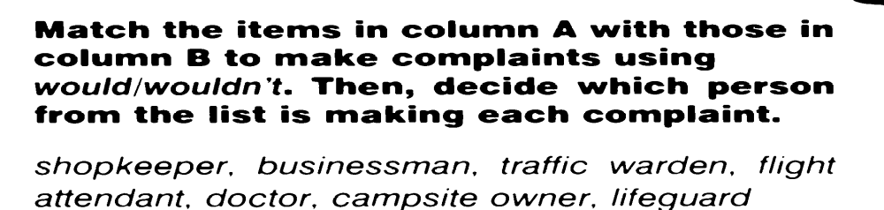
e.g. 1-e … ‘I wish my staff would get to work on time’, says the businessman.
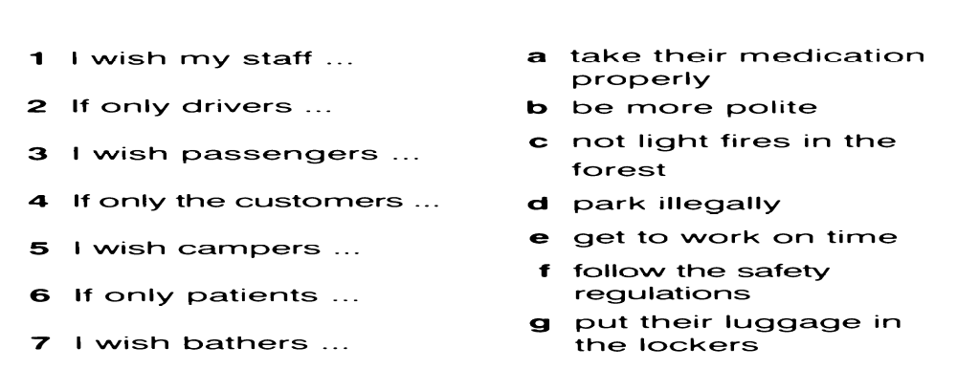

Exercise 55. Put the verbs in brackets into the correct tense.
Model: 1. – I wish Paul ...would tell... (tell) me what is wrong with him.
– Yes. He seems very upset, doesn't he?
2. – I wish I (not/shout) at the children like that.
– Why? They were being very naughty.
3. – I wish you (tidy) your room more often.
– Sorry. I’ll try to.
4. – I wish I (practise) harder before the concert.
– I thought you performed very well.
5. – If only Stuart (call) me.
– Don't worry, I'm sure he'll phone soon.
6. – I wish I (be) back at school again.
– Those were great days, weren't they?
7. – I wish Mark (stop) playing his music so loudly.
– Why don't you ask him to turn it down?
8. – If only I (buy) those shoes we saw today.
– Why not go back and buy them tomorrow?
9. – I wish you (try) harder with your Maths homework.
– Sorry. I find it very difficult.
10. – If only we (go) to France last summer.
– We could go this year if you like.
11. – I wish I ............... (afford) a new i-phone.
– Would you like to borrow some of mine?
12. A: If only it ______ (stop) raining.
B: Yes. Then we could go for a walk.
13. A: Are you going to Joanne’s party on Saturday?
B: No. I wish I _____ (go), because I’m sure it will be fun.
14. A: I wish you ___ (help) with the housework more often.
B: What would you like me to do?
15. A: I’m bored. I wish I ____ (arrange) to go out this evening.
B: I’m going to the cinema. Why don’t you come, too?

Exercise 56. Look at the pictures and complete the wishes. Also make mixed conditional sentences, as in the example
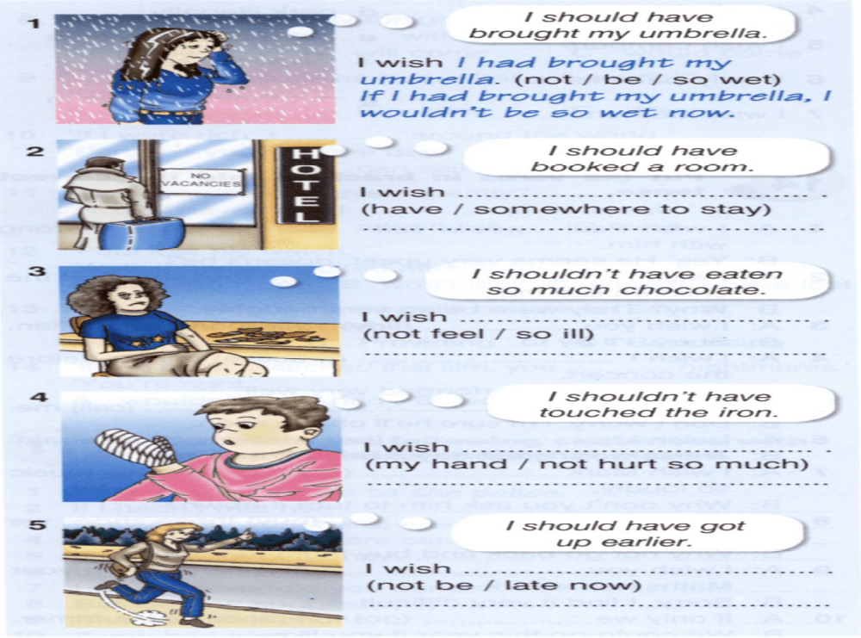

https://learningapps.org/display?v=pmfvadzwn20
https://wordwall.net/resource/13342525/i-wishif-only

Exercise 57. Read the text and complete the sentences below using Type 3 Conditionals, as in the example.
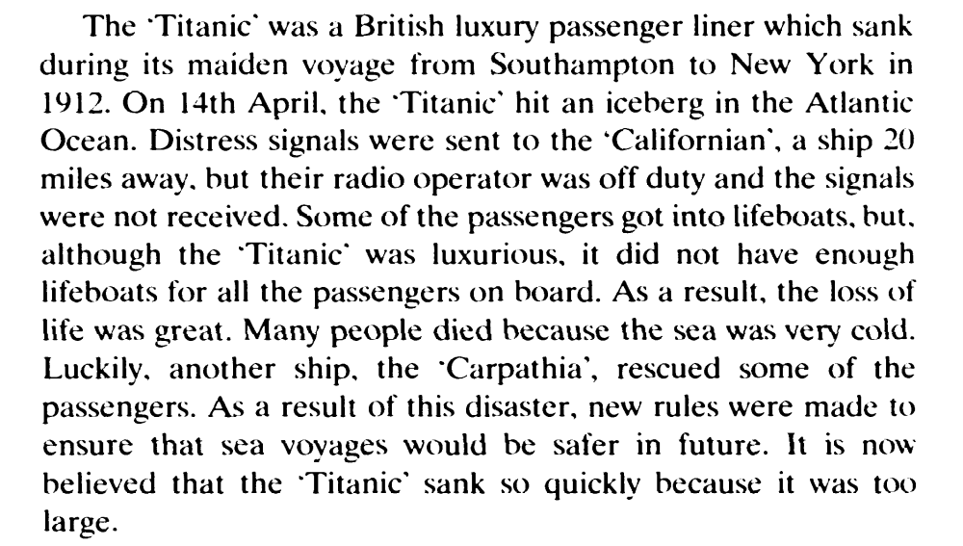
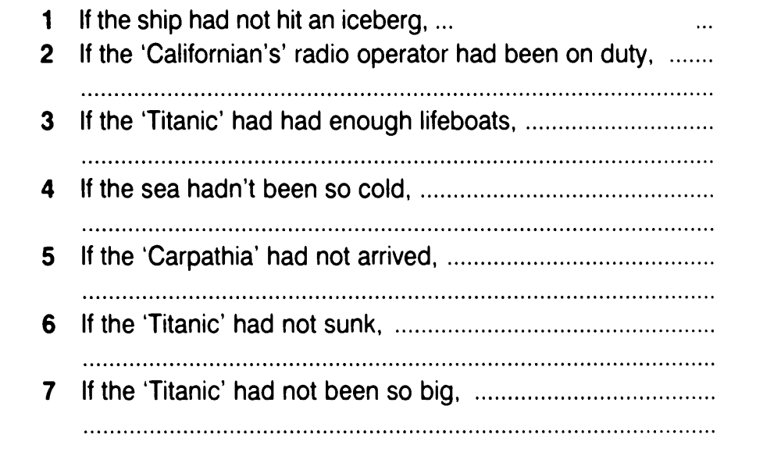
https://www.liveworksheets.com/worksheets/en/English_as_a_Second_Language_(ESL)/Conditionals/I_wish-_If_only_yp1571629vy

https://learningapps.org/10724402

Exercise 58. Open the brackets.
1. I wish I (to be) quite sure that you won’t fail me. 2. She wished nobody (to notice) her embarrassment. 3. I wish you (not to talk too loud) in the room. The child is asleep. 4. I wish I (can) go on a trip round the world. 5. I wish you (to stop) talking. I can hardly hear what she is saying. 6. How I wish you (not to interrupt) me all the time. 7. I wish you (can) stay longer. 8. I wish you (to be a success) next time. 9. I wish you (to quit) smoking immediately. 10. They wish they (to win the football match) yesterday.

Exercise 59. Make dialogues by analogy.
Model: (to live in Chernivtsi)
– Does Mike enjoy living in Chernivtsi?
– Not really. He wishes he lived in Kyiv. He was born there.
1. Does Peter enjoy riding a bicycle? (To drive a car) 2. Does Jane enjoy working at school? (to work at a bank) 3. Does Henry enjoy being a teacher? (to be a doctor) 4. Does Edvard enjoy living in the countryside? (to live in the city) 5. Does your son enjoy working here? (to work in some place else) 6. Does Richard enjoy being single? (to be married) 7. Does Mrs. Smith enjoy teaching math? (to teach English). 8. Do they enjoy having two part-time jobs? (to have one good full-time and well-paid job) 9. Does Ann enjoy studying German? (to study English) 10. Does Mary enjoy working in the footwear shop? (to sell ready-made clothes)

Exercise 60. Say that your friend will regret what he did.
Model A: to go on a journey - You’ll wish you had gone on a journey
Model B: to refuse to go on a journey - You’ll wish you hadn’t refused to go on a journey
Prompts: to spend so much money, to save money; to ring her up, to hurt her feelings; to disobey him, to obey him; to tell the truth, to tell a lie; to buy the house, to sell the house; to lend him money, to borrow money from him; to ask for advice, to follow his advice.

Exercise 61. Say that you share your friend’s opinion.
Model: - John is sorry he didn’t come to our party last Sunday.
- You are quite right. John wishes he had come to our party last Sunday.
1. Mary is sorry she didn’t come to the rehearsal yesterday. 2. Susan is sorry she cancelled the appointment on Saturday. 3. Mary is sorry she didn’t invite Mike to her birthday party. 4. Margaret is sorry she was late for the party. 5. I am sorry I didn’t follow my teacher’s advice. 6. My friend is sorry he didn’t wait for me. 7. Philip is sorry he refused Jan’s invitation to her birthday party. 8. Philip is sorry he didn’t e-mail his friend. 9. Ernest is sorry he didn’t help aunt Cecily. 10. Ann is sorry she didn’t obey her parents that evening.

Exercise 62. Change the following sentences, using “I wish…”
1. It’s a pity you are not with us these days. 2. My friend regrets not having entered university. 3. He was sorry not to have enough time to finish his test paper. 4. We would like to reach home before tea-time. 5. I’m sorry I made you upset by telling you this news. 6. What a pity you don’t know enough physics. 7. Unfortunately they won’t return before Christmas. 8. The student was sorry he had not studied the material better and had shown such a poor knowledge in the examination. 9. It’s a pity that you didn’t send for us last night.
Exercise 63. Fill the gaps choosing the correct alternative from the brackets:
1. I wish you … this book (read, had read). I am sure you would have liked it. 2. I wish you … earlier (came, had come). We would have gone to the museum together. 3. I wish you … time to write to your friend (had, had had). Now you would be able to answer all the questions. 4. I wish she … us about the day of her arrival (informed, had informed). We would have met her at the station. 5. I wish all of you … regularly (work, worked). You would get better knowledge and your speech would be more fluent. 6. I wish you … N (saw, had seen). He would have told you many interesting things. 7. I wish you … a ticket for a plane (bought, had bought). We would go there together. 8. I wish you … with me yesterday (spoke, had spoken). I would have told you some facts and you would not feel ill at ease now.
https://learningapps.org/7599290

Exercise 64. Complete the following sentences using would.
For example:
1. They wished the sun ___. (to shine). They wished the sun would shine.
2. Does she wish it ___? (to snow). Does she wish it would snow?
3. You will wish the bell___. (to ring). You will wish the bell would ring.
1. They wished she ___ the arrangements. (to make) 2. He will wish you ___ him. (to help) 3. She wishes the mail __. (to come) 4. We wished they____. (to hurry) 5. You will wish the door _______. (to open) 6. They wish we____ for them. (to wait) 7. I wish you____ to me. (to write) 8. Will she wish you____ her? (to join)

Exercise 65. Paying attention to the underlined adverbs indicating time, complete each of the following sentences with the correct form of the verb in brackets.
1. I wish he ___ here now. (to be) 2. I wish that you ___ here yesterday. (to be) 3. We wish you ___ tomorrow. (to come) 4. You will wish you ___ earlier. (to leave) 5. They wished he ___with them the next day. (to come) 6. We wish you ___ yesterday. (to arrive) 7. I wish that he ___ us next year. (to visit) 8. She wishes that she ___ at home now. (to be) 9. You wish that he ___ you last week. (to help) 10. He will always wish he ___ rich. (to be) 11. The boy wished that Mary ___ the competition the next day. (to win) 12. She will wish she ___ the arrangements earlier. (to make) 13. I wish the weather ___ warmer now. (to be) 14. We always wished we ___ fluent in other languages. (to be) 15. They wish he ___ them next week. (to telephone) 16. They wished they ___ not ___ to come to the appointment last Saturday. (to forget) 17. We wish it ___ yesterday. (to snow) 18. She wished she ___ not ___ the window. (to keep open). She caught a cold. 19. I wished I ___ the unpleasant news yesterday. (not to hear) 20. You wish you ___ what to do now. (to know).

Exercise 66. Put the verb in the correct form.
1. I feel sick. I wish (I, not, eat) … so muсh cake.
2. I’m fed up with this rain. I wish (it, stop) … raining.
3. It’s a difficult question. I wish (I, know) … the answer.
4. I should have listened to you. I wish (I, take) … your advice.
5. I wish (Katy, be) … here. She’d be able to help us.
6. Aren’t they ready yet? I wish (they, hurry up) … .
7. It would be nice to stay here. I wish (we, not, have) … to go now.

Exercise 67. Put the verb in the correct form.
1. When we were in Madrid last year, we didn’t have time to see all the things we wanted to see. I wish (we, have) … more time.
2. It’s freezing today. I wish (it, not, be) … so cold. I hate cold weather.
3. What’s her name again? I wish (I, can) … remember her name.
4. What I said was stupid. I wish (I, not, say) … anything.
5. (in a car) You’re driving too fast. I wish (you, slow down) … a bit.
6. It was a terrible film. I wish (we, not, go) … to see it.
7. You’re always tired. I wish (you, not, go) … to bed so late.

Exercise 68. Open the brackets using wish….
1. I wish I (to know) … German.
2. I wish I (not to drink) … so much coffee in the evening: I couldn’t sleep half the night.
3. I wish you (to read) … more in future.
4. I wish I never (to suggest) … this idea.
5. I wish I (to be) … at yesterday’s party: it must have been very funny.
6. I wish we (to meet) … again next summer.
7. Don’t you wish you (to see) … that performance before?
8. They wished they (not to see) … this horrible scene again.
9. The unfortunate pupil wished he (not to forget) … to learn the rule.
10. I wish I (to have) … a season ticket to the Philharmonic next winter.
11. I wish I (to consult) … the teacher when I first felt that mathematics was too difficult for me.
12. I love sunny weather. I wish it (to be) … warm and fine all year round.
13. I wish I (not to lend) … Pete my watch: he has broken it.
14. I wish you (to send) … word as soon as you arrive.
15. I wish I (not to have) … to do my homework every day.
16. I wish you (to go) … skiing with me yesterday: I had such a good time!
https://learningapps.org/display?v=pmfvadzwn20

Exercise 69. Paraphrase the following sentences to express wish or regret.
1. We were very disappointed that she had failed her entrance exams. 2. What a pity you cannot stay longer! 3. It’s a pity we shan’t be able to get out of these difficulties ourselves. 4. As nobody told him anything about this affair, he wasn’t involved in it. 5. You shouldn’t have left your pretty girl alone in that strange town. 6. She just sits on the bench doing nothing. 7. I didn’t know how important it was. 8. She didn’t take any advice and failed. 9. Nobody advised her how to get in touch with the boss. 10. I wasn’t present at the meeting yesterday. 11. What a pity! I missed such a wonderful chance yesterday. 12. I’m sorry to say that he does not keep his word. 13. It’s a pity you couldn’t talk him into giving up the foolish idea. 14. It would be nice if he agreed to deliver a lecture on Modern Literature.

Exercise 70. Translate into English:
1. Хоч би вчитель не задав мені це питання на іспиті. 2. Прикро, що мені ніхто не сказав про сьогоднішню зустріч з президентом. 3. Якби тільки Джон знав тоді відповідь на це просте питання. 4. Прикро, що наші родичі не зустріли нас на вокзалі. 5. Якби ви хоч на хвилину перестали скаржитись на все й усіх! 6. Якби тільки-но ви кинули курити. 7. Прикро, що в тебе немає комп’ютера. 8. Якби тільки завтра потеплішало. 9. От якби ви перестали сваритись зі своїми сусідами. 10. Якби він тільки прийшов і допоміг мені. 11. Прикро, що ви не попередили мене раніше про бажання звільнитися. Зараз уже пізно. 12. Як би мені хотілось, щоб ви змінили ваше ставлення до підлеглих! 13. Прикро, що Том зараз не з нами. 14. Як хочеться, щоб ваша команда виграла цей матч. 15. Прикро, що в мене немає автівки.

Exercise 71. Show that you are sorry the action took place or didn’t take place in the past:
1. He couldn’t attend the lecture. He was ill. 2. What a pity! You have lost the football match. 3. He lost all the documents on his property. He couldn’t do anything. 4. My friend missed the train. 5. My car was not in good condition. 6. He could not inform them about the accident. 7. I was not able to warn her about the forthcoming danger. 8. We found no taxi. 9. I could not help her. 10. I forgot to put down my homework in English.
Exercise 72. Translate into English.
  - На мить я пошкодував, що не запросив його. 2. Мені б хотілося, щоб ви продовжували свою роботу замість того, щоб переривати мене весь цей час. 3. Як він хотів, щоб вони дали йому можливість спокійно пообідати! 4. Вона майже пошкодувала, що запросила їх на вечірку. 5. Ви одержали мого листа? – Так, краще б ви мені його не писали. 6. Шкода, що він задав мені те питання. 7. Мені б хотілося, щоб він не поводився зі мною, як з дитиною. 8. Він стояв на розі вулиці, ніби він щось забув. Шкода, що я не заговорив до того чоловіка. Шкода, що я не задав йому питання, як він дійшов до того, що став безхатьком. 9. Шкода, що ви запросили Джона на вечірку. Він все зіпсував. 10. Прикро, що я так грубо повівся з Томом. 11. Джон пошкодував, що він продав свого велосипеда. 12. Якби він припинив курити! Я ледве дихаю. 13. Вона жалкує, що їх немає на вечірці. 14. Шкода, що я не навчився грати на скрипці ще в школі. 15. Якби ви звернулись до мене раніше! Я б міг вам допомогти. 16. Як би мені хотілося скористатися вашою порадою, але це неможливо. 17. Якби вона змогла скоріше пережити всі невдачі! 18. Шкода, що ви образились. Він не мав на увазі завдати вам болю. 19. Вони пошкодували, що не склали нам компанію. 20. Вона пошкодувала, що пішла на цю зустріч, коли зрозуміла мету запрошення.

§ 4. Expressing wishes with It’s (high) time, It’s about time

Exercise 73. Change the sentences according to the model.
Model: It's time for us to go home. – It’s high / about time (that) we went home.
1. It's time for the plane to take off. 2. It’s time for us to feed the pigs. 3. It's time for him to do his homework. 4. It's time for the farmers to gather the harvest. 5. It's time for birds to fly to the South. 6. It’s time for the professor to start the lecture. 7. It’s time for you to pay me back. 8. It's time for him to stop chatting on the telephone. 9. It’s time for Jane to write a letter to her friends. 10. It’s time for the children to go for a walk.

Exercise 74. Supply a correct form of the verb in brackets.
- It’s time you (to do) your lessons. 2. Isn’t it high time your son (to stop) idling? 3. It’s time she (to go) home. It’s too late. 4. Look! They are still playing. Isn’t it time they (to start) working? 5. It’s about time he (to take) a decision on this matter. 6. It’s time for you (to solve) the problem. 7. Dinner is ready. It’s time we (to sit down) to table. 8. We’ve packed all the things. It’s time (to take) a taxi. 9. It’s time for the second course (to serve). 10. It’s time we (to take) some preventive measures. 11. It’s time for us (to repair) the house. 12. It’s time for her (to tidy up) the room. 13. It’s time he (to get) his suit cleaned. 14. It’s time for you (to speak) English fluently. 15. It’s high time the lesson (to begin), but the teacher has not come yet.

Exercise 75. Paraphrase the sentences using it is (about, high) time:
1. You must begin reading books in the original. 2. You should start working immediately. 3. You don’t realize the importance of the talks. 4. Why can’t you translate such simple things into English yet? 5. Don’t you think that the team should start training? 6. Stop making noise! Everybody is annoyed. 7. It’s 10 o’clock. You must be already in bed. 8. Don’t you know such simple things yet? 9. It’s one o’clock. Let’s go and have dinner. 10. It’s getting dark. We should go home.

Exercise 76. Translate into English using it is (about, high) time:
1. Час вам пояснити, що ви маєте робити. 2. Тобі не здається, що нам час збирати речі? 3. Йому час подумати про своє особисте життя. 4. Час повернутися до гостей і представити вас. 5. Давно настав час його провчити. Він діє мені на нерви. 6. Вам час мати почуття відповідальності. 7. Час припинити цю марну суперечку. 8. Йому час самостійно заробляти на життя. Адже він не дитина. 9. Прийшов час відмовитися від думки бачитися з ним. Він не та людина, з якою можна мати справу. 10. Мені час покласти край його стражданням. Я повинна розповісти всю правду. 11. Дітям вже давно час вивчати математику. 12. Учням час писати контрольну з англійської мови. 12. Ваш будинок старий. Вже давно прийшов час його відремонтувати. 13. Ти вже давно мав дати їй відповідь щодо цієї важливої справи. 14. Чи не час вам зайнятися цією доленосною справою? 15. Я думаю, що вам давно належало поміняти автомобіль.

§ 5. Had Better / Best

Exercise 77. Comment on the following sentences and translate them into Ukrainian.
1. It's going to rain. You'd better stay home. 2. You look tired. You'd better have a rest. 3. We had better hurry up. We may miss the train. 4.You’d better call the doctor immediately. 5. She'd better not come here again. 6. I’d better do my homework now. I may not have time later. 7. You'd better consider it thoroughly before you take a final decision. 8. You'd better not think too long. I can change my mind. 9. Tom had better not swim in this whirlpool. It's dangerous. 10. I’d better get up earlier; otherwise I may be dismissed from my work.

Exercise 78. Change the sentences according to the model.
Model: I advise you to phone him now. – You'd better phone him now.
1. І advise you not to work on the computer too much. It's bad for your eyes. 2. I warn you not to be late. 3. It would be best for you to keep diet. 4. It would be good for you to take pain-relief pills now. 5. It would be wise of you not to miss English lessons. 6. It would be unwise of them to give up gymnastics. 7. I advise you to give up smoking immediately. 8. I warn you not to fight in class again. 9. I think it would be better for us to move to another flat. This one is too small. 10. It would be better for you to consult a doctor. 11. Don’t sign any papers until you have seen and read them.

Exercise 79. Make a choice between had better and should:
1. I’ve got a terrible cold. - You … not go to work then. 2. There is a speed limit. You … not drive so fast. 3. Thank you for coming to see us. You … come more often. 4. She’ll be offended if we don’t invite her. You … invite her too. 5. Drivers … wear seat belts. 6. The road is dangerous. You … wear your seat belts. 7. You … not eat this salad. It’s not fresh. 8. You … eat more vegetables if you want to be young. 9. You … not buy these vegetables. They don’t look fresh.

Exercise 80. Translate into English.
1. Їм слід посадити більше кущів смородини в саду. 2. Вам слід би вивчити ще одну іноземну мову. 3. Я краще куплю побільше поштових марок, щоб не ходити кожного разу на пошту. 4. Вам краще не наполягати на вашій пропозиції. Її ніхто не прийме. 5. Дітям краще не дивитись телепередачі надто довго. Це шкідливо позначиться на їх здоров’ї. 6. Їм би краще дослухатись вашої поради. У вас розумний підхід до вирішення цього питання. 7. Людям слід би краще дбати про тварин та рослин, які вимирають. 8. Нам не слід було б забруднювати навколишнє середовище. 9. Вам би краще взятися за справу негайно, щоб закінчити ремонт до початку навчального року.

https://test-english.com/grammar-points/b1/had-better-its-time/

§ 6. WOULD RATHER / SOONER.

Exercise 81. Translate the following into Ukrainian.
1. I’d rather go to the theatre than to the cinema. 2. - Would you rather drink beer or wine with the curry? - I'd rather drink beer. 3. They'd rather have the strawberries by themselves, but I'd prefer to have them with cream. 4. I would rather not go to the opera tonight. 5. Where would you rather sleep? 6. I’d rather we had never met. 7. The weather was nasty. We’d rather not have gone hiking. 8. Would you rather have fish or meat for dinner today? 9. I‘d rather pay in cash than by credit card for the dress. 10. I’d rather read the Guardian than the Time magazine. 11. I'd rather Sam had not taken his father's car yesterday. 12. I would rather you came to me tomorrow. 13. He would rather I did not go out. 14. I would rather you got in touch with our business partners. 15. I would rather you were more reserved.

Exercise 82. Translate into English.
1. Я б волів відповідати першим. 2. Ви б хотіли розказати їй правду? 3. Я б охоче залишилась вдома в таку погоду. 4. Що б ви хотіли на обід? 5. Вона швидше б посадила тут квіти, а не овочі. 6. Підеш з нами в кіно? Ні, я б радше пішов до театру. 7. Вона б воліла піти до ресторану, ніж готувати вдома. 8. Він волів б скоріше померти, ніж відмовитись від цієї ідеї. 9. Де б ви скоріше зупинились, у свого друга чи в готелі? 10. Я б скорше пішов гуляти, ніж вчити правила вживання умовного способу. 11. Я б не волів бути на її місці. 12. Я за те, щоб Катя залишилася з нами сьогодні. 13. Краще б я не ходив на цей концерт. Він був нецікавим. 14. Я за те, щоб він нікуди не їздив вчора. 15. Що б ти хотів, щоб я був написав йому? 16. Краще б я не викликав поліцію. Та тепер вже пізно.

Exercise 83. Put the verbs in brackets into the correct form.
- A: I’m going out in a minute.
B: So am I, so you’d better …... (take) your keys with you.
- A: Do you watch much television?
B: No. I prefer …..… (read) books to (watch) … television.
- A: I didn't enjoy the concert much.
B: Nor did I! I would rather they ….…(play) more modern music.
- A: Shall we go to that new restaurant this evening? Good idea.
B: We had better ………. (book) a table.
- A: Shall I tidy your bedroom for you?
B: I'd rather you .......... (not/tidy) it. I'll do it later.
- A: Shall we go for a walk this afternoon?
B: No. I would prefer ___ (stay) here and read a book.
- A: My brother prefers ________ (play) games to ____ (do) his homework.
B: So does mine.
- A: Did you enjoy the play last night?
B: No. I'd rather ______ (go) to the cinema.
- A: I’d rather you _____ (not/make) so much noise.
B: Sorry. I’ll try to be quiet.
- - You had better ___ (work) hard at your new job.
- I will. I want to make a good impression.

https://www.liveworksheets.com/search.asp?content=would+rather

https://test-english.com/grammar-points/b1-b2/would-rather-would-prefer/

https://test-english.com/grammar-points/b2/unreal-uses-past-tenses/
prefer to do (life choice) = prefer doing (enjoy) https://wordwall.net/uk/resource/89359865/англійська/would

§ 7. Adverbial CLAUSES OF PURPOSE

Exercise 84. Analyze the following sentences and translate them into Ukrainian.
1. I asked him to stop the car, so that I could get out. 2. She turned away, lest anyone should see she had been crying. 3. Speak a bit slower, so that I can understand what you are driving at. 4. The gates are never locked in order that the children may come and go whenever they like. 5. She spoke in a whisper, lest anybody should overhear them. 6. I gave him the address, so that he could find the house easily. 7. Please, explain the rule to me, lest I should be mistaken. 8. We brought some blankets so that we could keep warm. 9. Read your text silently so that you may not disturb the others. 10. Put on your coat so that you may not catch a cold. 11. We shall be looking for you in case you lose your way. 12. Their parents took some cakes in case their children were hungry. 13. I recorded the program in case you missed it. 14. I gave him a very famous book in case he wanted to read it.

Exercise 85. Translate the sentences into Ukrainian.
1. The girl was talking in a low voice lest somebody should overhear her. 2. Jack was afraid to turn back lest he should see something that might frighten him. 3. The two students were talking in undertones lest the teacher should overhear what they were saying. 2. Lest you should think I am telling you a lie, I have brought two witnesses with me. 3. I advised them to hire a taxi lest they should miss the train. 4. I kept my little puppy at home lest it should get into trouble. 5. I had to put everything in writing lest they should understand me incorrectly. 6. The teacher spoke slowly lest we should miss some important information. 7. She chose to tell him the truth lest he should be informed about it by someone else. 8. She closed the window lest she should catch a cold. 9. He gave us a detailed map of the area lest we should lose our way. 10. He turned his head away lest he should see her cry. 11. We’re going to proofread this twice lest we make errors that hurt our credibility. 12. He was seized with alarm lest something should have happened to the child while he was reading the letter. 13. It was common sense: never piss off the woman who could see the future, lest she alter it and make your life hell. 14. He closed his eyes lest he see her face.

Exercise 86. Underline the correct word.
It was three o’clock on Saturday afternoon and Ben was in the park. He had taken his sister, Katy, with him 1) so that/ for she could play on the swings. While they were playing, Ben noticed that a small bird was sitting near a tree. He walked towards it 2) in order to/ so that have a closer look. He walked slowly and quietly 3) not to / so as not to frighten it. The bird had a broken wing, so Ben and Katy went home and got a box 4) for/ to carry it in.
When they had put it in the box, they took it to the vet 5) to / for treatment. The vet was very gentle 6) in order to/ so that he wouldn’t hurt it. The bird recovered a few weeks later and the vet released it in the park again.

Exercise 87. Join the sentences using the word (s) in brackets.
- He got the car out of the garage. He wanted to wash it. (so that)
- I always lock the doors and windows. I don’t want to be burgled. (avoid)
- The doctor examined the patient. He wanted to find out what was wrong with him. (so as to)
- I’ve taken out a loan. I want to buy a car. (to)
- We’ll take some food with us. We might get hungry. (in case)
- She is studying medicine. She wants to become a doctor. (so that)
- He put his keys in his briefcase. He didn't want to lose them. (in order not to)
- They will take some magazines with them. They may get bored. (in case)
- She set her alarm clock. She didn't want to oversleep. (so that)
- We put the letters on the table. We didn’t want to forget to post them. (so as not to)

Exercise 88. Complete each sentence with two to five words, including the word in bold.
Exercise 89. Replace the infinitive in brackets by the correct verb forms.
1. I tell you this so that you (to understand) that I was right. 2. She left the lamp on the window-sill, so that he (to see) it from afar. 3. She gave him the magazine so that he (to have) something to read on the journey. 4. I gave him the toy to play with so that he (to be) quiet. 5. I went there yesterday so that I (to see) it myself. 6. He told me the whole story so that I (to explain) to you what has happened. 7. He adjusted the lamp so that he (to see) in shadow. 8. He kept watching the large mirror, which faced the entrance so that he (to see) her the moment she entered. 9. She wound the scarf around her throat so that the damp October wind (not to get) at it. 10. The hunters stood there motionless in order that they (not to frighten) the deer away. 11. Bring him in at once so that I (to see) my only daughter’s son at last. 12. She is hurrying to the university now in order that she (not to be late) for classes. 13. I’ll ask him to take you to the station in his car so that you (not to have) to walk all the way. 14. Copy out the examples and study them thoroughly so that you (not to make) mistakes in your rendering. 15. Peter, you must go to bed earlier tonight, so that you (not to be late) for school tomorrow. 16. He told me the truth, so that I (to know) what measures to take. 17. I left a message for him, lest he (to forget) about our appointment. 18. She kept her head averted, so that we (not to see) she had been crying. 19. She spoke in a low voice, so that the baby (not to wake up). 20. Keep the matches away from the child, lest he (to play) with them. 21. You’d better hurry, lest you (to miss) the train. 22. He gave her another glance from the corner of his eye, so that she (not to see) he was looking at her. 23. I like to know what new books are being published, so that I (to ask) for them in the library. 24. The boy went over to his mother and leaned over her, so that he (to speak) into her ear. 25. Close the window, lest the child (to catch) a cold. 26. Don’t let the baby play with the cup so that he (not to break) it.

Exercise 90. Make up sentences according to the model.
Model: to leave a message for your brother (to worry):
Why do you want to leave a message for your brother? – I want to leave a message for my brother lest he (should) worry.
Prompts: to be in a hurry (to miss the 10 o’clock train, to pack your things now, to leave anything), to look through the pupils’ tests so thoroughly (to miss mistakes), to go for a walk so late (to have a sleepless night), to be going to take a taxi (to be late) for my friend’ birthday party, to ask her to your place (to feel lonely), to open the window (to be stuffy in the room), to close the door (to overhear what we are saying), to accompany them (to lose their way), to ring him up (to forget about the appointment).

Exercise 91. Change the Infinitive phrases and the Infinitive of purpose into clauses of purpose.
1. He left the book on the table for me to see.
He left the book on the table, so that I could see it.

2. I’ve taken some books to read on the train.
I’ve taken some books, so that I can read them on the train.

3. She spoke in a whisper so as not to wake him up.
She spoke in a whisper, lest she (should) wake him up.

1. I’m telling this for you to understand everything. 2. He kept the gate closed for the pigs not to get into the garden. 3. She rang off for her mother not to know who she had been talking to. 4. He spoke loudly and clearly for everybody to hear. 5. I went there yesterday to see everything myself. 6. You should wear warm clothes in winter so as not to catch a cold. 7. Buses stop at different places for the passengers to get on and out wherever they want. 8. He ran fast to catch the bus. 9. You should work hard to get promotion.

Exercise 92. Answer the following questions. Each answer must contain a clause of purpose.
1. What do you do when it is frosty in order that you may not catch cold? 2. Why do they put the sign “On sale” in shops at the end of a month? 3. Why do we often take a taxi when we have little time left? 4. Why are you telling me all this nonsense? 5. Why do you take sleeping pills? 6. Why do your friends learn English? 7. Why is the teacher speaking so slowly? 8. Why have you shut the window? 9. Why do you always wear a scarf round your neck? 10. Why did you give the children those toys? 11. Why did the sick man go to the seaside? 12. Why does he work so hard? 13. Why do ships carry lifeboats? 14. Why should cars not travel fast along busy streets? 15. Why did he have to take exercises? 16. Why do businessmen advertise their goods? 17. Why do some people wear spectacles? 18. Why did you go to bed so early last night? 19. Why should students work hard every day? 20. Why did the doctor examine you so carefully?

Exercise 93. Translate into English.

  - Ви повинні бути дуже уважні, щоб не припуститися помилок. 2. Я залишу для нього повідомлення, щоб він не забув про нашу конференцію. 3. Я намагаюся не перебувати на сонці, щоб не мати проблем з серцем. 4. Не купляйте мені морозива, щоб я не захворів. 5. Зачиніть вікно, щоб діти не сиділи на протязі. 6. Ми виїхали рано вранці, щоб доїхати до порту до темряви. 7. Заберіть дитину з драбини, щоб вона не впала і не травмувалася. 8. Покладіть книжку в сумку, щоб ви її не загубили. 9. Давайте візьмемо носильника, щоб ми не несли такі важкі валізи самі. 10. Покажи гостю його кімнату, щоб він міг відпочити. 11. Учитель знову пояснив правило, щоб учні добре його зрозуміли. 12. Він прикинувся, що говорить з кимось, щоб я йому не заважав.13. Я залишу лист на столі, щоб він одразу його побачив. 14. Якщо затримаєшся на роботі допізна, подзвони, щоб я не хвилювався. 15. Ми були змушені взяти таксі, щоб не спізнитися на поїзд. 16. Будь ласка, говори повільніше, щоб я міг зрозуміти, що ти говориш. 17. Перед тим як піти, подзвони, щоб я могла знати, коли на тебе чекати. 18. Ми вирішили подорожувати на машині, щоб побачити якомога більше. 19. У випадку, якщо ви не зможете перекласти ці вірші, дайте мені знати. 20. На випадок, якщо вам потрібні будуть гроші купити квартиру, зверніться до банку.

https://wordwall.net/resource/56048680/infinitive-of-purpose https://wordwall.net/uk/resource/34035118/clauses-of-purpose https://wordwall.net/resource/33485895/clauses-of-contrast-purpose https://wordwall.net/uk/resource/17646292/upper-clauses-of-contrast-and-purpose

https://www.liveworksheets.com/zj224686gs
https://www.liveworksheets.com/yv1254916qx
https://www.liveworksheets.com/zt1261394rj

§ 8. Adverbial Clauses of Concession = contrast clauses

Exercise 94. Choose the correct answer.

Exercise 95. Complete the sentences.

Exercise 96. Rewrite the sentences using the words in brackets.

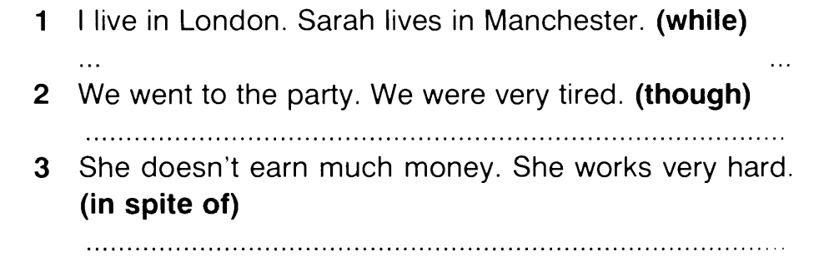
Exercise 97. Rephrase the sentences using the words in brackets, as in the example

https://test-english.com/grammar-points/b1-b2/clauses-contrast-purpose/

Exercise 98. Use the verb in brackets in the correct form. Translate the sentences into Ukrainian.
1. I am prepared to listen to all your objections, however unreasonable they … (to be). 2. Doctors say that nowadays very few people are perfectly well, although they … they are (to imagine). 3. Whatever you … once …, today you are a student and you are to obey the orders issued by the University administration. (to be). 4. It was plain that however hardworking and perseverant John …, however desperately hard and intelligently he … , he would never get promotion (to be, to work). 5. He had to admit to himself that whatever her faults …, she was the right sort of a girl to take to a restaurant (to be). 6. Though you … towns, villages, you cannot conquer a nation (to occupy). 7. The poor little woman will stand up for this man, whatever he … (to be). 8. Your father tells me you think highly of his accomplishments whatever they … (to be). 9. Later that evening, he got still another confirmation that he must be on the right track no matter what anyone else … (to say). 10. Whatever Rose …, she is not now a responsible scholar (to be). 11. Even іf I … уοu, I know уοu won’t believe (to tell). 12. Even if I … to prevent you from making these mistakes, I would not do it (to want). Happen what may! 13. Even if he … present here, even then he would only be a suspect, not an accused (to be). 14. Even though he … the rule twice, he could not avoid making mistakes (to read). 15. Even though he … his foot, he continued to move forward (to hurt).

16. No matter what you ____ ( say)
No matter what you _____ (do)
Wherever you ____ ( go)
My heart will follow you.
17. Some things, however, are true no matter how hard you … to block them out, and a lie is always a lie, no matter how prettily it … told (to try, to tell). 18. However hard he … to fulfill the task the result was deplorable (try). 19. Whomever a person may … or may … to or even whatever he may … in the past should have no bearing on whether or not he committed the crime for which he is now charged (to know, to speak, to do). 20. The Church sees everything with tolerance and seeks to help each person, whatever he may… , however sinful he may …(to do, to be) . 20. No matter how hard you … , how much you … or how much you …, the drug addicts continue to use drugs (to try, to give, to care).

Exercise 99. Translate into English.
1. Я хочу, щоб ви знали, що б не трапилось, я залишусь з вами. 2. Я готовий до всього, що б не сталося. 3. Хоча він і кохає її палко, але схоже на те, що знайдуться інші люди, які не дозволять їм одружитися 4. Як би ти не старався, ти не зможеш зупинити мене. 5. Як би ти не почувався, піднімайся, одягайся й іди на роботу 6. Які б непорозуміння чи труднощі не виникали, він і його побратими неодмінно їх подолають 7. Хоча ви й намагалися завантажити файл, жодного файлу не було одержано. 8. Які б проблеми не існували, ми радимо вам не здаватися. 9. З якими б людьми ти не зустрівся, будь до них толерантним. 10. Хоча ви можете й не сидіти в затінку, посадіть дерево для тих, хто буде. 11. Хоча ви можете й бути праві певною мірою, але все ж це питання мусить бути вирішено спільно з іншою стороною конфлікту. 12. Ким би він був чи не був – все це відносно, коли він вже в моїх руках (once I get my hands on him). 13. Яку б наукову роботу він не провів за останнє десятиліття, він ніде не оприлюднював її результати. 14. Я підтримую людину з найкращими намірами, хто б вона не була. 15. Не вір людям, які лестять, хто б вони не були. 16. Кого б людина не знала, чи з ким би не говорила, чи навіть, що б не зробила в минулому, не має відношення до того, чи вона скоїла чи не скоїла злочин, в якому її звинувачують.

Exercise 100. Use the verb in brackets in the correct form. Translate the sentences into Ukrainian.
1. Whenever you … (go), whatever you … (do), I will be right here waiting for you. 2. Whenever you … me, whenever you …me , you know you can call me, I'll be there shortly (need, to want) 3.Whenever you … I will be waiting for you (come). 4. Wherever you …, lift up your hand for me (be). 4. Kelley is a leader, wherever he … (to go). 5. May the peace of the Lord Christ go with you: wherever he … send you (to send). 6. He was determined to answer truthfully any question that was asked, wherever it … (to lead). 7. I will follow him, follow him wherever he ... (go). 8. Whenever I ... (get) an idea for a story, I jot it down in a notebook.

Exercise 101. Translate into Ukrainian.

1. Куди б ви не вирушили в цей день – скрізь знайдеться що-небудь захоплююче. 2. Перш за все, куди б ви не їхали — до сусідньої області чи за кордон, треба вірно обирати туроператора. 3. Куди б ви не відправилися: до ваших друзів, нічний клуб або ресторан, вам доведеться із Попелюшки стати Принцесою. 4. Куди б він не приїжджав, йому одразу вдавалося знайти хороших друзів. 5. Пам`ятайте! Куди б ви не пішли і де б не перебували, ви можете опинитись у екстремальних умовах. 6. Як би ми не були зайняті, завжди знайдеться час для розваг. 7. Звідки б він не був родом, Джон дуже кмітливий. 12. Звідки б він не приїжджав, він завжди привозить мені сувеніри. 8. Всюди, де б ви не працювали, вас будуть оточувати люди, з якими вам доведеться будувати приязні стосунки. 9. Коли б ви до нас не прийшли, вас завжди тепло зустрінуть. 10. Коли б ви її не зустріли, завжди застанете її в чудовому настрої.

§ 9. Adverbial CLAUSES OF MANNER

Exercise 102. What do you say in these situations? Use the words in brackets to make your sentence.
1. You meet Bill. He has a black eye and some plasters on his face. (look / like / be / a fight)
You say to him: You look like / as if / as though you’ve been in a fight.
2. Claire comes into the room. She looks absolutely terrified. (look / like / see / a ghost) You say to her: What's the matter? You __________________
3. Joe is on holiday. He’s talking to you on the phone and sounds happy. (sound / as if / have / a good time) You say to him: You ______________
4. You have just run one kilometre. You are absolutely exhausted. (feel / like / run / a marathon) You say to a friend: I ______________

Exercise 103. Make sentences beginning It looks like ... / It sounds like ...
you should see a doctor there's been an accident they're having an argument
it's going to rain she isn't coming we’ll have to walk

1. Sarah said she would be here an hour ago. You say: It looks like she isn't coming.
2. The sky is full of black clouds. You say: It ___________
3. You hear two people shouting at each other next door. You say: It ___________
4. You see an ambulance, some policemen and two damaged cars at the side of the road. You say: ___________
5. You and a friend have just missed the last bus home. You say: ___________________
6. Dave isn't feeling well. He tells you all about it. You say: ___________________

Exercise 104. Complete the sentences with as if. Put the verbs in the correct form.
she / enjoy /it I / go / be sick he / not / eat / for a week
he / need / a good rest she / hurt/ her leg he / mean / what he / say
I / not / exist she / not / want / come

1. Mark looks very tired. He looks as if ___________
2. I don't think Paul was joking. He looked ___________
3. What's the matter with Amanda? She's walking __________
4. Peter was extremely hungry and ate his dinner very quickly. He ate ____________
5. Tanya had a bored expression on her face during the movie. She didn't look _________
6. I've just eaten too many chocolates. Now I don't feel well. I feel ____________
7. I phoned Liz and invited her to the party, but she wasn't very enthusiastic about it. She sounded _______
8. I went into the office, but nobody spoke to me or looked at me. Everybody ignored me __________

Exercise 105. Complete each sentence using as if.
Model: 1. Andy is a terrible driver. He drives as if he were the only driver on the road.
2. I’m 20 years old, so please don't talk to me ____ I ______ a child.
3. Steve has never met Nicola, but he talks about her _______________ his best friend.
4. It was a long time ago that we first met, but I remember it ____________ yesterday.

Exercise 106. Put the verbs in brackets into the correct tense.

https://test-english.com/grammar-points/b1-b2/verbs-of-the-senses/

Exercise 107. Comment on the use of the clauses of manner.
1. She looked so fresh and clean as though nothing had happened to her. 2. It seems as if he knew everything about the matter. 3. When he finally broke the silence, his voice sounded as though he had been shouting inside himself. 4. It was as if someone he had never known had written the story. 5. Her stillness and her strange words made me feel as if I were still dreaming. 6. She sounded as if she were unwilling to accept the invitation. 7. It sounds as though they were fighting upstairs. 8. Don’t get offended. It’s not as if I could do anything for you. 9. It seemed as if she had made her decision and nothing in the world could make her change it. 10. He looked as if he hadn’t had a meal for a week, and I hadn’t the heart to refuse him.

Exercise 108. Say why you dislike him / her.
Model: He is not an expert on everything: He behaves (talks, acts, speaks) as if he were an expert on everything.
Prompts: 1. Alex does not own the place. 2. Nick is not the brightest student in the group. 3. Mary does not have the right to teach me on morals. 4. Eric doesn’t have friends everywhere. 5. Frank doesn’t have the best collection of pictures in the world. 6. George is not the headmaster of the school. 7. Herbert does not enjoy the confidence of his group-mates. 8. James is not the best sportsman in the group. 9. Lewis can’t play the piano well. 10. Martin can’t be relied on. 11. Nicholas is lazy. 12. Robin doesn’t study well.

Exercise 109. Fill in the blanks using the verb in brackets in the correct form.
1. She spoke in such a low voice as if she … afraid of being heard (was, were). 2. She said something so softly as if she … afraid that somebody would hear her (was, were). 3. She acted on the stage so calmly as if she … before (acted, had acted). 4. She is cross with me as if I (did her some harm, had done her some harm). 5. He looked at me so strangely as though I … him many times before (didn’t meet, had not meet). 6. She looked at him so triumphantly as if she … something very important (did, had done). 7. She was crying so bitterly and such large tears were rolling down her cheeks as though somebody … her (offended, had offended). 8. She knows these parts well as though she (visited, had visited them) before. 9. Why are you looking at me as if you … (never heard, had never heard) about it. 10 He looked tired as though he (was working, had been working) all the time. 11. She looked at me with a puzzled expression as if she (had never seen, never saw) me.

Exercise 110. Complete each sentence with as if / as though.
Model A: (English is not her native tongue). She speaks English: She speaks English as if (as though) it were her native tongue.
Model B: (Jane didn’t break the toy). They are looking at Jane: They are looking at Jane as if she had broken the toy.
1. (French is not her native tongue). She speaks French … .
2. (Animals are not people). My friend talks to her pets… .
3. (He is absent-minded). Sometimes he acts … .
4. (You are not running a high temperature). What’s the matter? You are shaking … .
5. (John isn’t her son). Mary takes care of John … .
6. (I didn’t break the vase). They are looking at me … .
7. (He doesn’t know anything about the incident). He’s acting … .
8. (Money doesn’t grow on trees). He buys everything he wants … .
9. (He is not ill). They treat him … .
10. (I wasn’t run over by a ten-ton truck). I feel terrible. I feel … .
11. (I didn’t climb Mt. Everest). When I reached the fifth floor. I was breathing ….

Exercise 111. Use the verb in brackets in the correct form.
1. Her eyes were full of joy as though she (to win) a super prize. 2. He went into the house by the back door as though he (to be afraid) of being noticed. 3. They continued to live as if nothing (to happen). 4. The old man’s face was red and swollen as if he (to be angry). 5. She speaks of the book as if she (to read) it. 6. My words made him turn back and he looked at me as if I (to go mad). 7. He didn’t say a word as though he (not to hear) my question. 8. He fixed the knife on the chain as if he (to be afraid) of losing it. 9. She kept trying on hat after hat as if she (not to make up) her mind from the very beginning which she would take. 10. He spoke French as if I (to be) a Frenchman or (to spend) most of my life over there. 11. She could discuss the latest novel as though she (to read) it. 12. She spoke as if she (to know) everyone there. 13. She behaved as if she (to graduate) from the university long ago. 14. I felt a touch of coldness inside me, as if I suddenly (to become) aware of the eyes of some dangerous creature.

Exercise 112. Complete the following sentences.
1. They spoke so quietly as if … 2. She smiled at me in a friendly way as if … 3. Will you stop discussing me as if I …? 4. She was breathless as though … 5. They greeted us as though … 6. She was breathing deep and fast as though … 7. Don’t treat him as if he … 8. He stared at me as if …9.She speaks English as if … 10. He was working fast, as if….

Exercise 113. Paraphrase the underlined parts so as to use clauses of manner.
1. On hearing the news he stood as if shocked. 2. “What’s wrong with you?” she asked as if not knowing the reason. 3. He stood motionless as if struck. 4. I like to be treated like a child. 5. The man bent low as if looking for something. 6. He kept looking at his watch as if in a hurry. 7. He paid no attention to my words as if having heard the news several days before. 8. He recognized the handwriting and hesitated as if afraid to open it. 9. He smiled at me as though understanding my thoughts.

Exercise 114. Open the brackets using the correct form of the verb.
1. He looked as if he (to step) from the pages of a magazine. 2. It looks as though they (not to expect) us. 3. Her mother knew the young man very well but it seemed as if she (not to want) to admit it. 4. She was at a loss. She felt as if she (to lose) something. 5. It was as if she (to receive) a physical blow and (to rock) on her feet. 6. Whenever I saw them it looked as though they (to be) on friendly terms. 7. She looked very pale as if she (not to sleep) much lately. 8. Though we had known each other for a long time she looked as if she (not to believe) me. 9. Don’t blame yourself. It’s not as if you (to do) it on purpose. 10. The child looks as if he (to be) feverish.

Exercise 115. Complete the sentences using the correct form of the verb.
1. He looked as if … (he / to be surprised). 2. Her voice sounds as if … (she / to be upset). 3. Why do you look as if … ? (you / not to believe). 4. She felt as though … (she / to be seen). 5. The meat tasted as though … (it / to be not fresh). 6. It was as if … (we / not to know each other). 7. It seemed as though … (the man / to be afraid of) something. 8. He feels as if … (he / to be fooled). 9. The air smells as though … (it / to be spring). 10. Why do you look as if … ? (you / to be angry). 11. The soup tastes as if … (it /not to salted). 12. He looks as if … (he / to be running). 13. I feel as though … (I / not to sleep). 14. It seems as though … (the weather / to break). 15. His words sounded as if … (he / to be offended). 16. She looked as though … (his movements/ to irritate). 17. She looks is as if … (she / to deceive). 18. It was as though … (somebody / to strike) me. 19. It seemed as if … (I / not to be) there. 20. It’s not as if … you (to understand). 21. It’ not as if you … (to do) it.

Exercise 116. Complete the following sentences.
1. He greeted me warmly and I felt as if … 2. When I met him the next day he looked as if … 3. … as if it were the only thing to do. 4. … as though she expected me to go there with her. 5. It won’t be as if … 6. … as though she had slept in her clothes. 7. Don’t you feel as if … 8. How can you speak like this? It’s not as if … 9. Why are you in a hurry? It’s not as if … 10. You are wet through. It looks as if …

Exercise 117. Translate into English.
1. Він виглядав так, ніби ось-ось заплаче. 2. Чому ти так говориш? Адже ти ж не дитина. 3. Кімната виглядала так, ніби в ній ніколи не жили. 4. Здається, вони вже пішли, на вулиці нікого немає. 5. Чому ви засмутилися? Адже ніхто не зміг би зробити це краще за вас. 6. Здавалося він не був проти нашої пропозиції. 7. Адже я ж вам нічого не обіцяв. 8. Здається я знаю вас багато років. 9. Він виглядав так, наче ніколи не чув про це. 10. Здається всі вже пішли, адже ми ж так не домовлялися. 11. Здавалося, що він нікому не вірив. 12. Він почувався так, ніби він вперше приїхав в це місто. 13. Вона виглядає так, ніби вона повернулася з курорту. 15. Скидалося на те, що тиша ночі діяла їй на нерви.

Exercise 118. Translate into English.
1. Він говорив так, ніби знав, де вона була. 2. Він так подивився на мене, наче ніколи мене не бачив. 3. Чому ти говориш так, ніби ніколи не помиляєшся? 4. Він рухався так, наче був зроблений зі скла. 5. Ти кажеш, що довіряєш Тому, але в той же час так поводишся з ним, наче він твій ворог. 6. Не дивуйся, він буде поводитись так, ніби це не була його провина, наче він зробив все, щоб врятувати ситуацію. 7. Чому ви вдаєте, наче ніколи не бачили його? 8. За кілька днів він буде говорити так, наче нічого не сталося. 9. Спантеличений, він стояв на розі вулиці, немов не знав куди йти. 10. Мама з подивом подивилася на нас, немов не розуміла, що відбувається. 11. Спека мучила нас. Було душно, здавалося, ніби ліс горів під променями сонця. 12. Він говорить про Рим, наче він там побував.
https://www.liveworksheets.com/w/en/english-language/327492
https://www.liveworksheets.com/node/6964856

REVISION EXERCISES

Exercise 1. Recast the sentences using It’s time, if-clauses, wish, if only, no matter..., so that-clauses, it looks as if:
1. It’s time for the computer assisted teaching to be introduced into our work. 2. She is absent-minded. She cancelled all our arrangement for tomorrow. 3. I’m sorry you are so disobedient. You no longer are a child. 4. When we saw her, she sat there as if thinking about something important. 5. She was sorry she had caused so much inconvenience. 6. What a pity, he did not avail of the opportunity to visit Great Britain. 7. He spoke loudly and clearly for all to hear. 8. I knew that he preferred to stay at home on such a rainy day. 9. They were sorry they hadn’t taken a taxi and had missed their train. 10. It’s raining cats and dogs. We can’t go on an excursion to our local museum. 11. The new assistant is difficult to deal with. They refused to work with him. 12. It’s time for her to learn how to this work. 13. This man is rather pale. He looks ill. 14. He was not a handsome man. He was not tall enough. 15.Thanks to your help I coped with the task. 16. I’d like you to come another time. 17. He has no right to be rude despite his position. 18. I am rather young and people don’t believe my story. 19. Everybody was surprised that she had said it. 20. She closed the window so as not to catch a cold.

Exercise 2. Use the correct form of the verb in brackets:
1. If you (to take) this dictionary earlier, you would have translated this article. 2. If you (to ring up) me yesterday, I would have told you the whole truth. 3. If all the students (to take part) in this discussion, it would have been more interesting. 4. If the manager (to come) yesterday, that problem would have been resolved. 5. If I (to know) about this, I would never have asked him for advice. 6. If your sister (to book) tickets, we would go to the theatre tonight. 7. If she (to have) much work to do, she would not have gone to the cinema yesterday but would have stayed at home and worked. 8. If I (to know) him, I would have asked him to do this. 9. If he (to remember) about his promises, he would not fail his friends. 10. If you (to help) me to translate this article, I would have done it long ago.

Exercise 3. Use the correct form of the verb in brackets:
1. Don’t you think it (to be) very much better if you and I (to help) our friend out of this predicament? 2. If I (to realize) it was to be like this, I (not to come). 3. The road was slippery and they were driving slowly so that they (not to have) an accident. 4. She was unaware of their arrival or she (meet) them at the station. 5. But for their previous engagement they would (to take part) in the conference. 6. How wonderful it (to be) to win the football match. 7. If only he (to be) less stubborn, we could find a solution. 8. It is very important that all employees (be dressed) in their proper uniforms. 9. Some people wish I (to remember) anything. 10. It's about time Bill (to retire).

Exercise 4. Use the correct form of the verb in brackets:
1. If I (to be) you, I (to work) harder. 2. If I (to go) to London, I (to visit) the British Museum. 3. If your son (not to be lazy), he (to get) good marks. 4. It is necessary that she (to apologize) to the students of the group for being rude. 5. It’s time we (to take) some preventive measures. 6. When he finally broke the silence, his voice sounded as though he (to shout) inside himself. 7. They demanded that he (to leave) the room. 8. She wished nobody (to notice) her embarrassment. 9. They wished the sun (to shine). 10. Her eyes were sparkling as though she (to laugh) at us. 11. She speaks of the book as if she (to read) it. 12. I would like to know what new books are being published, so that I (to ask) for them in the library.

Exercise 5. Choose the correct answer:
1. They ….. themselves much more if they had a party of their own.
a) would enjoy b) will enjoy c) enjoyed
2. They didn’t arrive yesterday. Everyone ….. if they had arrived.
a) would know b) would have known c) knew
3. Should you see Ann, ….. her anything.
a) don’t ask b) won’t ask c) wouldn’t ask
5. What countries would you choose if you ….. to go abroad?
a) will have to b) were to c) are to
6. Would you have made so many mistakes if you ….. the rule?
a) learnt b) will learn c) had learnt
8. Had I known about the conference, I ….. it.
a) would have attended b) will attend c) attended
9. Suppose you ….. the wallet. What would you do?
a) lost b) would lose c) will lose
10. He took the map of the place with him otherwise he ….. lost.
a) would have got b) got c) would get

Exercise 6. Choose the correct answer:
1. I didn’t enjoy the performance. I wish …..
a) hadn’t gone b) didn’t go c) shouldn’t go
2. You ….. go and see your friend. She is ill.
a) had better b) had better to c) would rather
3. I ….. read a book than go to the cinema.
a) had better to b) would rather c) would rather to
4. He looked so pale as if he ….. for a long time.
a) was ill b) had been ill c) would have been ill
5. It is about time he ….. about the event
a) informed b) has informed c) will inform
6. Stop asking such silly questions! It is not as if you …..
a) is a child b) were a child c) will be a child
7. They are having an argument again.
- I wish they …. to it.
a) would put an end b) put an end c) will put an end
8. I would rather he ….. anybody about it.
a) won’t tell b) didn’t tell c) wasn’t telling
9. - Let’s have some pizza for lunch.
- I would rather ….. hamburger.
a) to have b) had c) have
10. He looked at me as if he….. me before.
a) had never seen b) never saw c) would never see

Exercise 7. Complete each sentence with a suitable word or phrase.
1. _______ I in your position, I would go with them. 2. I’d rather the students ________so many mistakes in the last test. 3. Suppose I _____ half the money I owe you. Will that be enough? 4. This is an awful hotel. I wish we ____ to another one. 5. It is very ______ you contact our head office as soon as possible. 6. It’s high time we _____ for our journey. 7. You ______ go and see a doctor once you have headache. 8. I’d rather you _____ smoke here if you don’t mind. 9. _____ your help, I wouldn’t have coped with this task so quickly. 10. _________ to disagree with a well-respected gentleman, who is a well-known man about town. 11. _______ anyone who disobeys his orders. 12. ______ you in whatever you may do!

Exercise 8. Complete the following sentences with one word.
1. It’s _____time you learned to behave properly. 2. I wish you ____ try to listen to me just for once. 3. I _____rather not go by train, I would _____ go by plane. 4. I wish Jane ____ here to see you all. 5. We wish you _____stay longer. 6.You ______ as if you had been playing the match instead of watching it. 7. If ___ they would offer you the job of managing director! 8. I really wish we _____ engaged. 9. I ______ you didn’t object to helping them. 10. It’s thundering and lightning! If ______he wouldn’t lose his way in the forest!

Exercise 9. Correct the errors in the following sentences.
1. I wish I bought that house long ago.
2. I’d rather you don’t do all the work for her.
3. It’s high time I go.
4. I wish I own this land.
5. I wish we are not leaving in the morning.
6. Jack would rather watching TV than reading.
7. Come what comes, I’ll be on your side.
8. I hope it would stop snowing.
9. I wish I didn’t listen to you before.
10. Woe betides anyone who plays Ann's CDs without her permission!
11. He was tired, as it was, rather exhausted.

Exercise 10. Translate into English.
1. Скажи мені ще раз свою адресу, щоб я знав, де тебе знайти. 2. Якби мені було байдуже, я б не просив у вас допомоги 3. Він зробив вигляд, ніби він не помітив, що Аня була розгублена. 4. Вам варто було попередити нас про ці труднощі. Ми б змогли знайти спосіб уникнути їх. 5. – Ви не будете ризикувати своєю кар’єрою. – Ні, буду. Що б не сталося, я доведу, що я правий. 6. Куди б ви поїхали, якби ви мали фінансову можливість зробити це? 7. Вам слід вибачитись перед вашим товаришем. Адже ви зробили йому ведмежу послугу. 8. Боюсь, аби не спізнитись на вечірку. Було б нерозумно примушувати всіх чекати мене. 9. Якби ви зробили цю роботу вчора, ви б зараз були вільні. 10. Він все давно розповів би вам, якби у вас були дружні стосунки. 11. Мені б хотілось, щоб ви все таки зайнялися знову цією проблемою. Здається, вас цікавить ця тематика. 12. Я за те, щоб ви не судили людину за зовнішнім виглядом. 13. Було б мило з вашого боку, якби ви познайомили мене зі своїми друзями. 14. Як би я хотів, щоб ніхто не прискіпувався до мене. Адже я вже на дитина. 15. Я тепер шкодую, що послухалася їх. Якби не це, я була б зараз вільна і насолоджувалась свіжістю моря. 16. У мене таке відчуття, ніби я зробив щось не те. 17. Я могла розказати вам про це раніше, але я не хотіла вас засмучувати. Крім того, мені здається, що вам би краще не знати нічого. 18. Кімната виглядала так, ніби в ній ніхто ніколи не жив. 19. О, якби тільки я знала його краще, я б ніколи не дозволила б йому переступити поріг мого дому. 20. Якщо раптом виникнуть якісь труднощі, дай мені знати. Я допоможу тобі, яким зайнятим я б не був.

Exercise 11. Translate into English.
1. Мені й на думку не спало сперечатись зараз з тобою, якби я сама цього не бачила. 2. Ти не маленька дитина, щоб так поводитись. Адже я не хочу, щоб ти знову попала в халепу. Час тобі зрозуміти це. 3. Необхідно, щоб студенти знали всі тонкощі англійської граматики, в іншому разі вони не зможуть володіти нею на відповідному рівні. 4. Поясни їй все знову, щоб вона чогось не переплутала. Боже борони, щоб вона знову припустилася цієї помилки! 5. Нам би краще поквапитись. Погода міняється на гірше, а попасти під дощ не хотілося б. 6. Нам краще заправити авто тут, щоб нам вистачило доїхати до місця призначення. 7. Через кілька хвилин після того, як він зник, вона глянула на мене так, ніби не зрозуміла, що сталося. 8. Що б тоді не відбувалося, я знаю, що він міг би вийти з тієї скрутної ситуації, але, як на зло, ніхто не порадив йому, щоб він мав зробити. 9. Він заблукав коридорами і проходами готелю, інакше він би не спізнився на сніданок. 10. Якби не батьки, він ніколи б не досяг такого успіху. Досить сказати, що вони слідкували за кожним його кроком. 11. Як я шкодую, що написав йому того листа, розказавши йому про своє рішення. Його відповідь звучала так, ніби він був незадоволений ним, інакше він не був би таким грубим до мене. 12. У вечірній тиші панував спокій, ніби природа відпочивала від виснажливої праці. Мені захотілося, щоб і мене не турбували хоча б один день. 13. Якби не його остання репліка, вона б так не образилася. Я просто попросив її, щоб вона стрималась і не заплакала. 14. Якби Соня знала англійську мову, вона б не почувалася так ніяково. 15. Прохання, щоб ви тут не смітили, інакше вас можуть оштрафувати. 16. За щасливим збігом обставин туристи уникли торнадо біля берегів Японії. Якби хтось постраждав, у місцевої влади виникли б значні проблеми. 17. Коли я їх зустрічав, скидалося на те, що між ними дружні стосунки. 18. Я дуже хочу, щоб ви зрозуміли ситуацію і перестали звинувачувати мене в тому, чого я ніколи не робив. 19. Я б волів, щоб ніхто не заважав мені працювати. 20. Нехай благословить вас Бог у вашому навчанні. Успіхів вам у всьому, що б ви не робили, де б ви не були, і кого б не зустріли у своєму житті.

The Unreal PRESENT and PAST
Exercise 12. Underline the correct tense

Exercise 13. Put the verbs in brackets into the correct form

Exercise 14. Complete each sentence with two to five words, including the word in bold
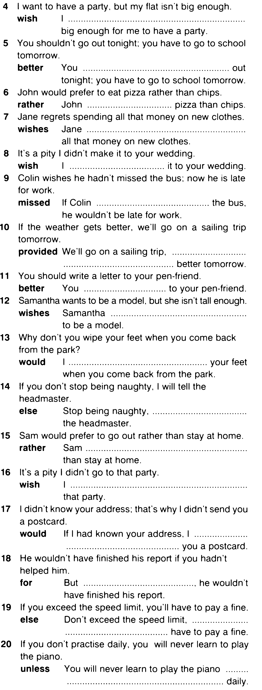
Common mistakes

Exercise 15. Correct the mistakes.

Exercise 16. Cross out the unnecessary word.
Revision Test
Choose the best answer to complete the sentence:
1. It’s about time he ____ playing on the computer game!
a) had stopped b) would stop c) stopped d) stopping

2. If he ___ you an invoice, you should pay him.
a) had sent b) would send c) ‘s sent d) were sent
Конец формы

3. He suggests ___ now.
a) to leave b) that we leave c) we’re leaving d) us to leave

4. Are they insisting that you ____ ?
a) should pay b) paid c) are paying d) would pay

5. If anyone _____ him that evening going up the steps, he would have been surprised at how he had aged.
a) would see b) has seen c) saw d) had seen

6. Isn’t it high time you ______ to bed this evening?
a) has gone b) went c) have gone d) are going

7. You’d better _____ thinking about your homework.
a) to start b) start c) started d) should start

8. She suggests that Michael ___ to the sales department.
- moving b) move c) to move d) would move

9. He took an umbrella in case it…
a) rains b) will rain c) rained d) is raining

10. I wish Michael… my motorbike last week.
a) took b) hasn’t taken c)hadn’t taken d) has taken

11. She’d rather you… her dress.
a) take b) haven’t taken c) didn’t take d) won’t take

12. She spoke in a whisper, lest she ... him up.
a) wake b) will wake c) shall wake d) wakes

13. Andy is a terrible driver. He drives as if he ... the only driver on the road.
a) would be b) were c) should be d) is being

14. I avoided mentioning the subject lest he ... .
a) be offended b) should be offend c) is offended d) offends

15. I arrived early so that I ... miss anything.
a) cannot b) could not c) might not d) won’t

16. Suppose I _____ you to marry me, what _____ you say?
a) had asked, were b) will ask, should c) am asked, will d) asked, would

17. I _____ you gave me a refund.
a) 'd sooner b) ‘ll sooner c) ‘ll rather d) ‘d soon

18. If only you _____ so fast yesterday!
a) hasn 't been driven b) aren’t driving c) haven’t been driving d) hadn 't been driving

19. I’d rather Sam ______ his father’s car yesterday.
a) were taking b) took c) hasn’t taken d) hadn’t taken

20. If I ____ you, I ____ her out of that school.
a) was, would take b) were, would take c) had been, will be taken d) will be, will take

21. It's time we _____.
a) leave b) will leave c) left d) had left

22. He talks to the children _____ they were imbeciles.
a) as though b) provided c) providing d) in case

23. If only he _________ the situation through our eyes.
a) would be seeing b) could see c) have seen d) was seen

24. Though the news ______, nobody seemed to be interested in it.
a) may be shocking b) may be shocked c) might be shocking d) was to be shocked

25. It's necessary that he ____ as many local people as possible.
a) met b) would meet c) is met d) meet

26. At yesterday's hearing the judge insisted Mr Grant _____ evidence despite his relationship to the accused.
a) give b) had given c) had been giving d) is giving

27. If you ___________ more slowly yesterday, you _________ in time.
a) 'd been driving, could stop b) ‘d driven, could stop c) were driving, could stop
d) 'd been driving, could have stopped

28. If Fleming ______ penicillin, there _____ far more fatalities every year than there actually are.
a) had discovered, would be b) discovered, would be c) hadn't discovered, would be
d) discovered, would have been

29. If the island ____ still a tourist attraction, last week's earthquake ________ far more deaths.
a) were, would have caused b) were, would cause c) would be, would have caused
d) had been, would cause

30. God forbid we _____.
a) went b) should go c) would go d) would have gone

31. You can teach him if _____.
a) needs would be b) need be c) will need d) had needed

32. My recommendation was that he ______ for the job.
a) not applies b) don’t apply c) won’t apply d) not apply

33. The police issued an order that all weapons _________ immediately.
a) should be hand in b) would be to be handed in c) should be handed in
d) had been to hand in
34. It looks as____ everything is going to turn out okay.
- if b) should c) if only d)you wish

35. The weather forecast gave a warning that people ____ for heavy snow.
a) would prepare b) prepares c) would have had to prepare d) should prepare

36. I wish I _________ with you.
a) would stay b) would have stayed c) could stay d) would be staying
37. If _______ down by eight, can you come up to wake me?
- I'm not b) I wasn't c) I weren't d) I won't be

38. ____ listened, this wouldn't have happened.
- I'd b) If only I'd c) Wish I'd d) When I’d
d)d)Конец формы

39. She is ill, _____ she would have come to the party.
a) unless b) otherwise c) provided d) and
40. Be late again ____ you'll have to see the manager.
a) and b) provided c) providing d) suppose
COMPENDIUM
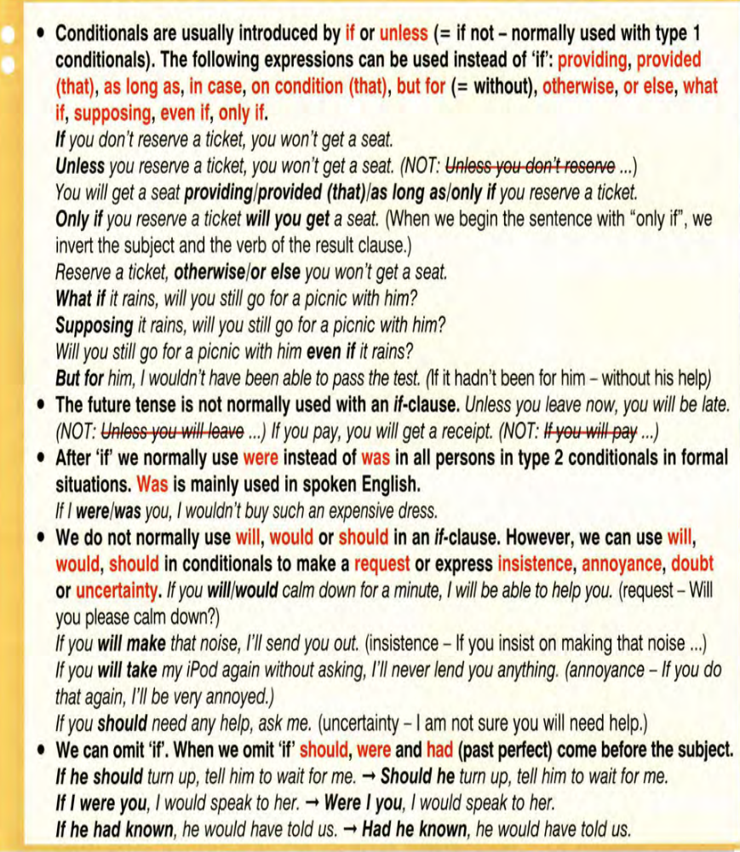

We use prefer/would prefer + noun or to + infinitive to talk about specific preference, i.e. what we prefer on a specific occasion.
- I would prefer to stay in a hotel near the airport. (or I would rather stay…)
- Most clients prefer to have breakfast in their bedroom.
We can use prefer/would prefer with rather than or instead of to show the choices we have.
- I would prefer to be too early rather than be too late.
- I prefer to go with Dad instead of staying here with Mum.

Bibliography:
- Alexander L.G. Longman English Grammar / Alexander L.G. – Harlow: Pearson Education Limited, 2004. – 374 p.
- Ansell Mary ENGLISH GRAMMAR: EXPLANATIONS AND EXERCISES / Anshell M. – 2000 (Second edition). – Режим доступу: http://www.wordpower.ws/grammar/gramdex.html
- Azar B. Understanding and Using English Grammar / B. Azar [3rd ed.]. – NY: Pearson Education, 2002. – 428 p.
- Collins Cobuild English Language Dictionary. – The University of Birmingham: Harper Collins Publishers, 1987. – 1703 p.
- Conditional : free exercise for ESL/EFL learners. – Режим доступу: http://www.tolearnenglish.com/english_lessons/conditional-mood
- Conditional Exercises. – Режим доступу: http://www.agendaweb.org/verbs/conditional-verbs-exercises.html -
- Davtyan A. The use of the Subjunctive Mood in Modern English (Reference book). – The Yerevan State Language University, 2007. – 114 p. – Режим доступу: http://brusov.arminco.com/docs/A.Davtyan-book-engl.pdf

Dooley J., Evans V. Grammarway. – Newbury: Express Publishing, 1999. – 276 p.

Grammar Exercises - Conditional sentences – if. – Режим доступу: http://www.englisch-hilfen.de/en/exercises_list/if.htm
- Greenbaum S. The Oxford English Grammar / Sidney Greenbaum. – Oxford : OUP, 1996. – 652 p.
- Hewings M. Advanced Grammar in Use. – 2nd ed. – Cambridge: Cambridge University Press, 2005. – 294 p.
- Murphy Raymond. English Grammar in Use. – 4-th ed. Cambridge : CUP, 2012. – 380 p.
- New Round-Up 6 / Virginia Evans and Jenny Dooley. – Harlow: Pearson Education Limited, 2011. - 260 p.
- http://englishtips.org
- http://folk.uio.no/hhasselg/terms.html
- http://englishstandarts.blogspot.com/
- https://www.grammarbank.com/
- http://testenglish.info/
- http://guidetogrammar.org/

Навчальне видання

Лопатюк Н.І.

ADVANCED GRAMMAR GUIDE
(part 1)

навчальний посібник

Папір офсетний. Формат 60х84/16.
Ум. друк. арк. 5,58. Тираж прим. Зам. №
Виготівник: Яворський С. Н.
Свідоцтво суб’єкта видавничої справи ЧЦ №18 від 17.03.2009 р.
58000, м. Чернівці, вул. І. Франка, 20, оф.18, тел. 099 73 22 544

