Т.І. Pavlovych

Home Reading

LITTLE WOMEN
by Louisa May Alcott

for the fourth-year students

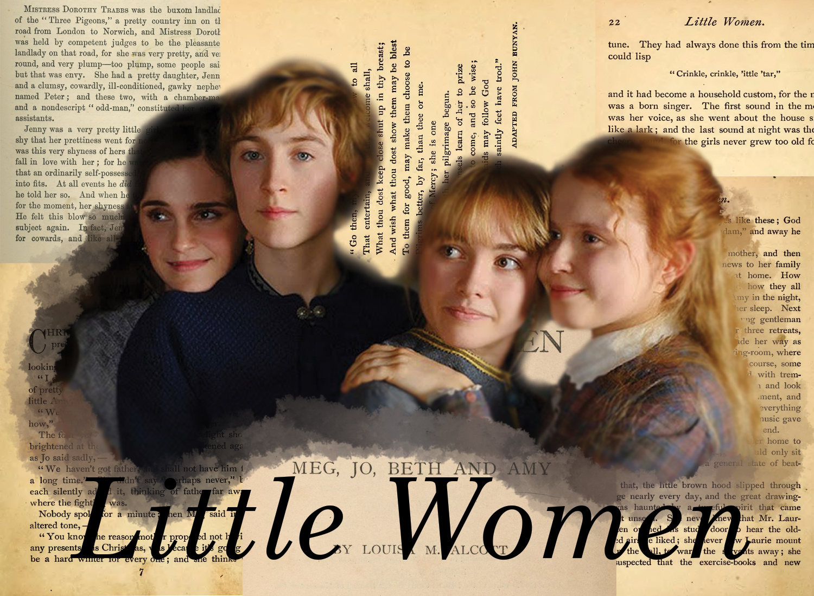

Chernivtsi – 2026

УДК 811.111(076)
ББК 81.432.1-932
П693

Друкується за ухвалою редакційної-видавничої ради Чернівецького національного університету імені Юрія Федьковича

Укладач: Павлович Т.І., к.ф.н., доцент кафедри англійської мови ЧНУ ім. Юрія Федьковича

Відповідальний за випуск: Павлович Т.І., кандидат філологічних наук, доцент

Практичний курс англійської мови як першої іноземної П693 (домашнє читання), 4 курс: Навчальний посібник / Укладач: Павлович Т.І. Чернівці. 2026. 197 с.

Навчальний посібник з домашнього читання містить комплекс завдань та вправ спрямованих на розвиток комунікативних навичок когерентного мовлення, використання сформованих діалогічних та монологічних компетенцій на систематизацію і розширення словникового запасу.
Запропонований посібник призначено для студентів четвертого курсу факультету іноземних мов, що вивчають англійську мову як першу іноземну.

УДК 811.111(076)
ББК 81.432.1-932

Louisa May Alcott
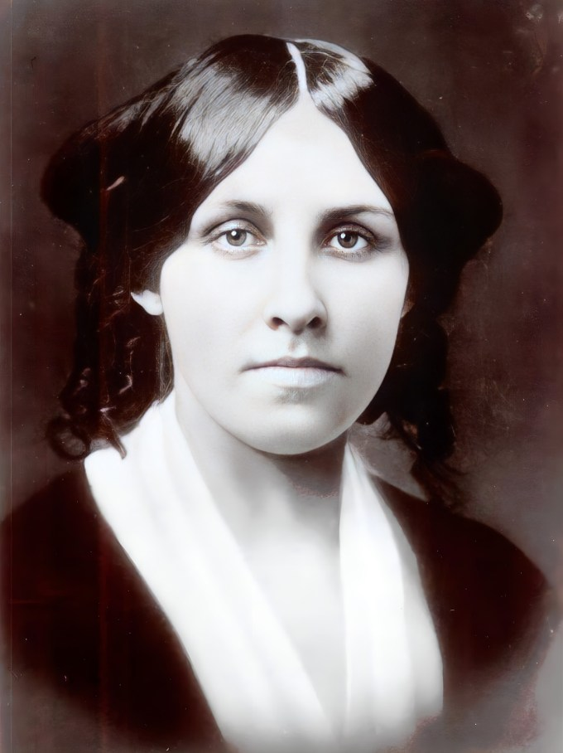
- She was a Union Army nurse, an abolitionist who hid freedom seekers, and wrote a series of steamy, Gothic thrillers under a male pseudonym.
- Political trailblazer: one of the first women ever to register to vote in Concord, Massachusetts. Even in the face of her own family’s poverty, Alcott was deeply committed to social reform. She was a fervent suffragette who actively registered women to vote, and she was also deeply involved in abolitionist activities.
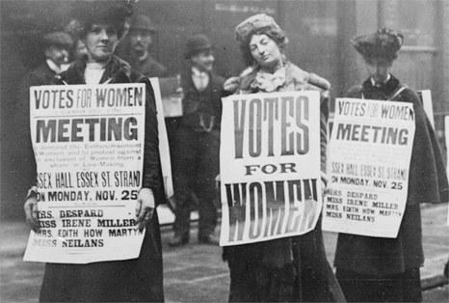
- L. Alcott was born into a family that was deeply entrenched in the Transcendentalist movement, a significant philosophical movement that championed the inherent goodness of individuals and nature, a belief system that would go on to profoundly colour her writing and outlook.
- Alcott’s father, Bronson, lived life in search of spiritual perfection. His boldest attempt to create an ethical heaven on earth was Fruitlands, a communal farm that he co-founded in 1843. The Alcotts were in residence there when Louisa turned 11. Committed to the nonexploitation of all living creatures, the Fruitlanders subsisted on a vegetable diet and refused to wear wool, which they felt was the rightful property of the sheep. They also swore off cotton because it was grown and harvested by slave labor. Half-starved and half-frozen, the commune broke apart in January 1844, barely seven months after it began.
- Her first book was for Ralph Waldo Emerson’s daughter: long before Little Women, her 1849 writing debut was a collection of fairy tales titled Flower Fables, which she wrote specifically for the daughter of her family’s famous friend.
- Prior to her remarkable success as an author, Alcott undertook various jobs to financially support her family. She served as a teacher, a seamstress, a governess, and even a nurse. These diverse experiences provided rich material for her writings, often permeating her narratives.
- Louisa May Alcott never married because she deeply valued her independence and wanted to avoid the legal and financial restrictions placed on wives in the 19th century. She preferred being a “free spinster” and used her own earnings to support her family, famously stating, “Liberty is a better husband than love”.
- Desire for financial autonomy: under the laws of the 1800s, a woman’s earnings and property legally belonged to her husband upon marriage. Remaining single allowed Alcott to manage her own wealth, retain control of her copyrights, and comfortably support her parents and sisters.
- Alcott’s commitment to service led her to serve as a nurse during the Civil War. Unfortunately, she contracted typhoid fever during her tenure, a harrowing experience that deeply affected her. It also inspired her first published book, the insightful “Hospital Sketches”.
- She was born on her father’s birthday and died two days after him… under eerie circumstances. Alcott was born on November 29, 1832 – the same day that her father turned 33. In 1882, not long before his 83rd birthday, Bronson suffered a crippling stroke. He lingered on in broken health for another five and a half years. When Alcott went to see him for the last time, she found him smiling. With his good hand, he gestured upward and said, “I am going soon. Come with me!” Alcott replied, “I wish I could.” Three days later, Bronson passed away. That afternoon, before news of his death could reach her, Alcott felt a headache and lay down for a nap. She slipped into a coma. Two days later, on the same day as Bronson’s funeral, Louisa May Alcott did, indeed, “come up.”

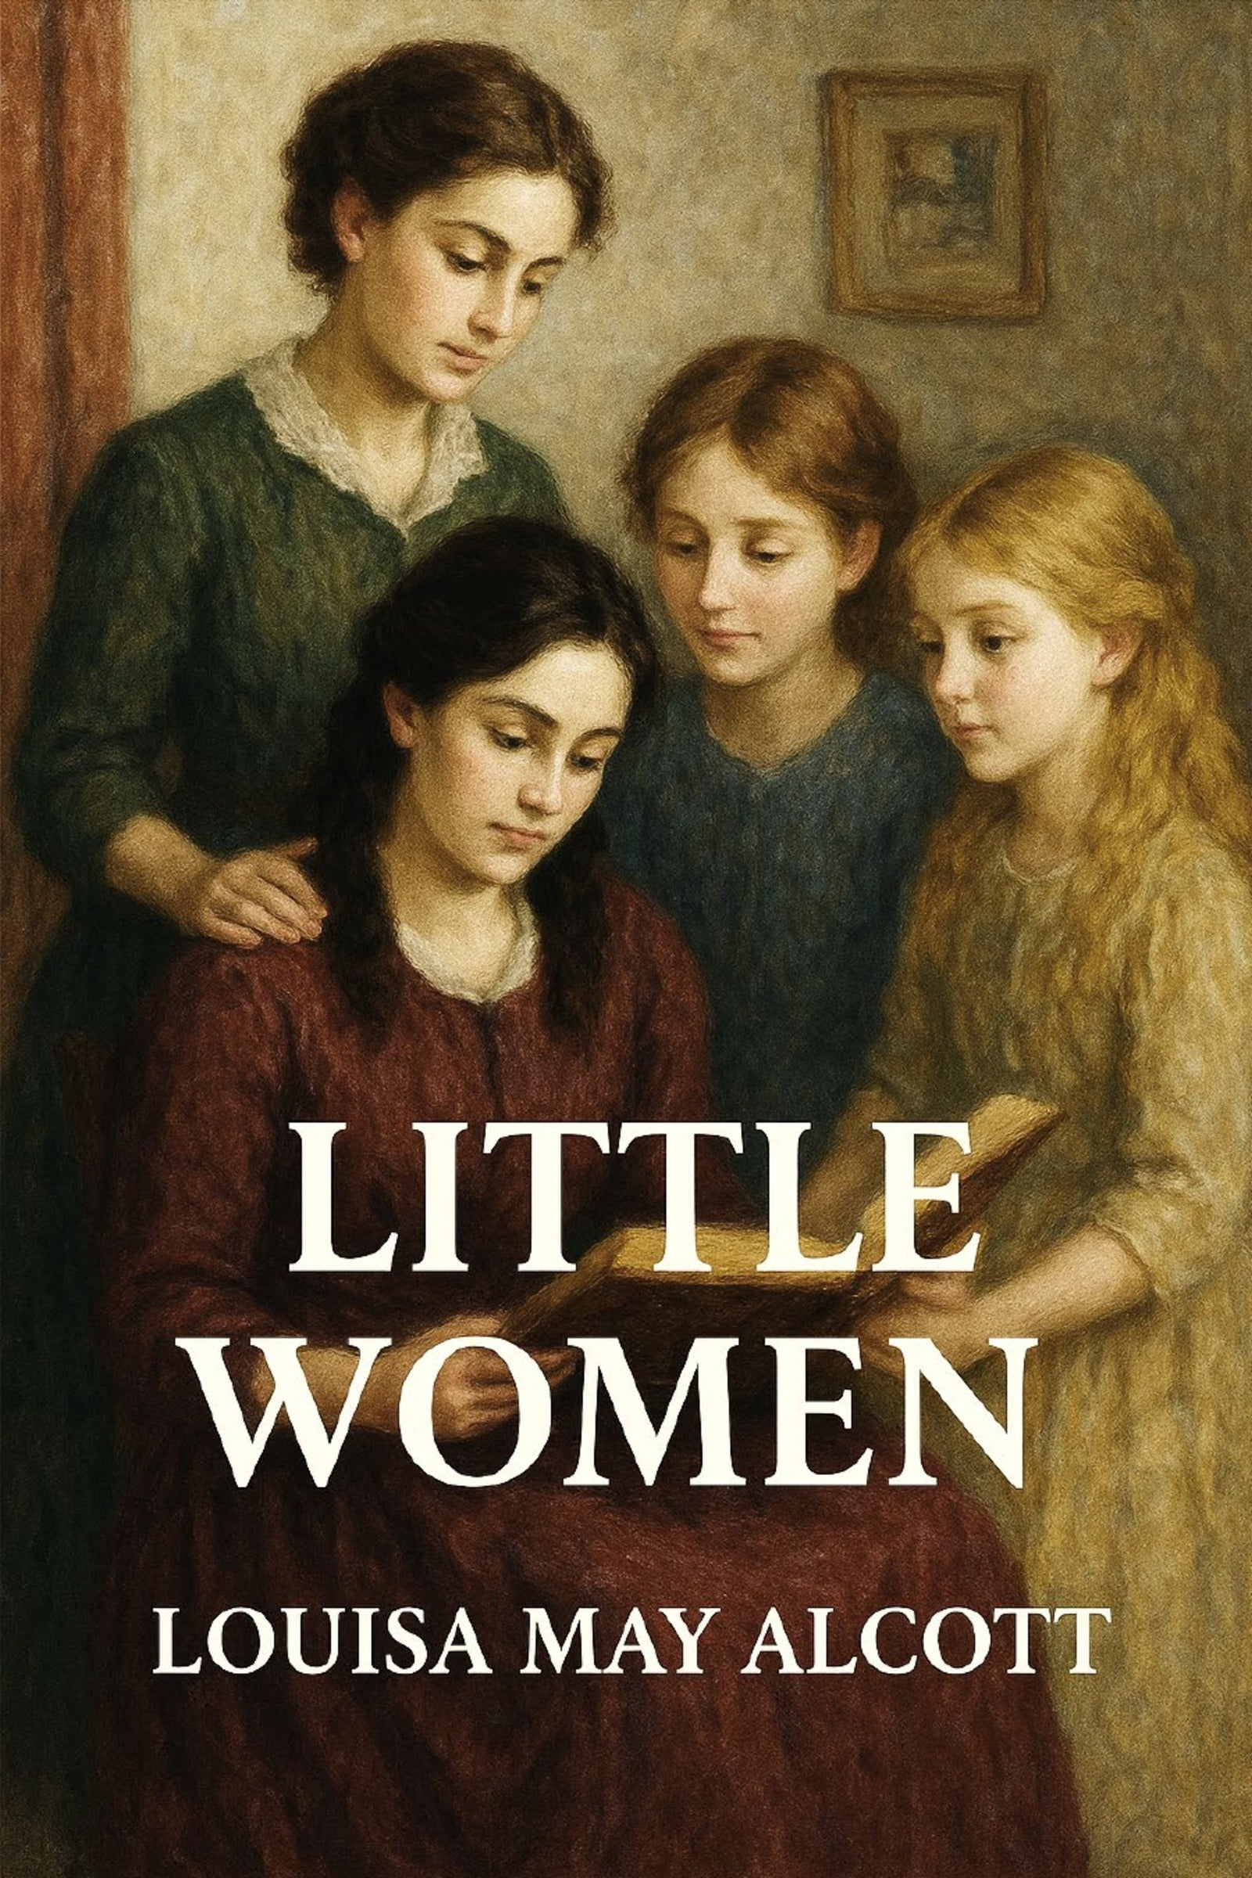
- Louisa May Alcott originally wanted to write gothic thrillers and only penned Little Women because her publisher requested a “girl’s book” in exchange for publishing her father’s philosophy. She wrote the 1868 classic in just under three months, initially expecting it to flop. The publisher’s niece saved it: both Alcott and her publisher thought the first chapters were dull, but a quick review by the publisher’s niece and other young girls convinced them to proceed with publication.
- “Little Women” took just 10 weeks to write. Alcott began writing the book in May 1868. She worked on it day and night, becoming so consumed with it that she sometimes forgot to eat or sleep. On July 15, she sent all 402 pages to her editor. In September, a mere four months after starting the book, Little Women was published. It became an instant bestseller and turned Alcott into a rich and famous woman.
- The March family, their stories, and their famous home were heavily drawn from the author’s real life. Meg, Beth, and Amy March were based on Alcott’s sisters.
• Meg was based on Louisa’s sister Anna, who fell in love with her husband John Bridge Pratt while performing opposite him in a play. The description of Meg’s wedding in the novel is supposedly based on Anna’s actual wedding.
• Beth was based on Elizabeth (or Lizzie), who contracted scarlet fever in 1856. Though she recovered, the disease permanently weakened her; Lizzie passed away in her sleep from a “wasting condition” on March 14, 1858 – just shy of her 23rd birthday. Like Beth, Lizzie caught the illness from a poor family her mother was helping.
• Amy was based on May (Amy is an anagram of May), an artist who lived in Europe and whose paintings were displayed in the Paris Salon.
• Jo, of course, is based on Alcott herself.
- Jo wasn’t supposed to marry: Alcott was a staunch anti-romantic and did not want Jo to marry anyone. But while she was working on the second half of Little Women, fans were clamoring for Jo to marry the boy next door, Laurie. “Girls write to ask who the little women marry, as if that was the only aim and end of a woman’s life,” Alcott wrote in her journal. “I won’t marry Jo to Laurie to please anyone.” But then she wrote to a friend, “but so many enthusiastic young ladies wrote to me clamorously demanding that she should marry Laurie, or somebody, that I didn’t dare refuse & out of perversity went & made a funny match for her.”) Laurie ends up with Amy.
- When she got older, Alcott worked as a paid companion and governess, like Jo does in the novel, and sold “sensation” stories to help pay the bills. She also took on menial jobs, working as a seamstress, a laundress, and a servant. Even as a child, Alcott wanted to help her family escape poverty, something Little Women made possible. To support her family, she wrote sensational, passionate pulp fiction with dramatic plots under the pseudonym A. M. Barnard.
- She raised her real-life “Amy’s” child: Alcott’s sister May died young after giving birth to a daughter in Europe. Louisa May Alcott obtained consent to adopt the little girl (also named Louisa but nicknamed Lulu) and raised her until her own death.
- You can still visit Orchard House, where Alcott wrote Little Women.

Orchard House in Concord, Massachusetts, was the Alcott family home. In 1868, Louisa reluctantly left her Boston apartment to write Little Women there. (The book made her so famous that fans flocked to the home hoping to catch a glimpse of her; Alcott would occasionally pretend to be a servant in an attempt to get people to leave.) Today, you can tour the house and see May’s drawings on the walls, as well as the small writing desk that Bronson built for Louisa to use.

PART 1

Class 1

I. Read chapters 1-3 (“One playing pilgrims”, “A Merry Christmas”, “The Laurence Boy”). Find some information about L. Alcott’s life and creative activity.

II. On the first page of your exercise-book write out the names of the characters you come across in the book (provide a brief explanation of who they are / what they do if necessary) Keep on doing this while reading the subsequent chapters.

III. Memorize the following words and phrases:
  - sniff – to draw air audibly up the nose, often showing disapproval
  - to trot – to move quickly with small, rapid steps
  - impertinent – rude, disrespectful, or lacking proper manners
  - libel – a written statement that unjustly harms a person’s reputation
  - reprove – to reprimand, scold, or express dissatisfaction
  - prim – very formal, precise, and stiffly proper
  - trail round – to walk around while letting long clothing drag behind
  - peck at one another – to bicker, nag, or constantly criticize each other
  - niminy-piminy chits – young girls who act overly refined, delicate, or fake
  - poky – small, cramped, dull, or uncomfortably confined
  - tomboy – a girl who enjoys rough activities traditionally associated with boys
  - castanet – a musical instrument consisting of two small wooden pieces tied together with string, played by being knocked together), or one of the two pieces that form a pair of castanets
  - colt – a young horse; used to describe awkward, energetic movements
  - cologne – a light, scented perfume liquid
  - dressing-up frolics – playful games or theatricals involving costumes
  - villain of the piece – the character or thing responsible for all the trouble
  - arsenic – a notorious and highly deadly poison
  - trapdoor – a sliding or hinged door built into a floor or stage
  - chaplain – a member of the clergy attached to a specific group, like an army
  - gruel – a cheap simple food made, especially in the past, by boiling oats with water or milk
  - impetuously – acting quickly and without thought or care.
  - abashed – embarrassed, disconcerted, or ashamed.
  - pious – devoutly religious; having or showing a dutiful spirit of reverence.
  - ingenuity – the quality of being clever, original, and inventive
  - rapturous – characterized by, feeling, or expressing great pleasure or enthusiasm.
  - wistful – having or showing a feeling of vague or regretful longing.
  - bequeath – to leave something to a person or beneficiary by a will; to pass something on.
  - tumultuous – making a loud, confused noise; excited, confused, or disorderly.
  - pervade– to spread through and be perceived in every part of a space.
  - petulant – childishly sulky or bad-tempered.
  - forlornly – in a pitifully sad, abandoned, or lonely manner.
  - mortified – cause someone to feel embarrassed, ashamed, or humiliated.
  - blithely – in a happy, carefree manner.
  - exertion – physical or mental effort.
  - dwindle – diminish gradually in size, amount, or strength.

IV. Recall the contexts in which the first 5 words listed in the column occur.

V. Write out and learn synonyms to the following words: to grumble, contentedly, to fret, to make one’s cross, dauntless.

VI. Character Matching (The March Sisters)
In Little Women, the four March sisters have very distinct personalities. Based on the definitions of the words, match each sentence or description to the vocabulary word that best fits the character’s behavior:
tomboy, prim, colt, abashed, pious, niminy-piminy chits, impetuously, petulant, blithely, trail round
- Jo rushed out into the snowstorm ___________ without even stopping to put on her boots or coat.
- Meg liked to ___________ the parlor in her old silk gown, pretending she was a grand lady at a ball.
- Because she was a total ___________, Jo completely despised the idea of wearing tight corsets and sitting quietly.
- Amy threw a ___________ fit and stomped her foot when she was told she couldn’t have any drawing paper.
- The sisters often made fun of the wealthy, snobbish schoolgirls, calling them nothing but ___________.
- Beth was a deeply ___________ child who read her pilgrim’s textbook quietly by the window every morning.
- Jo awkwardly knocked over the tea table, looking wild and leggy like an untrained ___________ in a small room.
- Amy always kept her collar perfectly clean and sat in a stiff, ___________ posture to look elegant.
- Meg felt utterly ___________ and blushed a deep crimson when her friends caught her wearing a patched dress.
- Beth ___________ hummed a little tune as she went about her sweeping, entirely unbothered by their poverty.

VII. The Melodrama Monologue
Jo March loves writing dramatic plays for her sisters to perform in the attic. Fill in the blanks using the correct words from the list to complete Jo’s 10-sentence theatrical masterpiece.
arsenic, villain of the piece, trapdoor, reprove, impertinent, dressing-up frolics, libel, chaplain, gruel, castanet
“Silence, you 1. ___________ scoundrel, and do not dare to 2. ___________ me for defending my honor!” cried the brave hero. “I know your dark secret – you slipped deadly 3. ___________ into the old Duke’s evening 4. ___________!” The wicked Count laughed, a sharp sound that echoed through the room like a clicking 5. ___________. “Your words are pure 6. ___________, and no one will believe a penniless peasant!” he snarled. "We shall see about that, for I am the 7. ___________ who will expose your crimes,” the hero declared bravely. With a sudden kick, the hero triggered a secret lever, causing the rogue to plunge straight through a hidden 8. ___________ in the floor. “Call the 9. ___________ to pray for his soul!” shouted the director from backstage. The sisters cheered, thrilled by another successful afternoon of their wonderful 10. ___________.

VIII. Upgrade the Sentence. Replace the underlined words or phrases in each sentence with a single, powerful vocabulary word from your list to elevate the writing style:

pervade, forlornly, tumultuous, dwindle, exertion, ingenuity, wistful, rapturous, peck at one another, trot
- The wonderful scent of fresh apple pie began to spread through and fill every part of the chilly kitchen.
- After their mother left, the little girl sat on the porch step and stared down the empty road in a pitifully sad and lonely manner.
- The crowd in the theater became loud, excited, and completely disorderly when the curtains finally opened.
- As the winter woodpile began to gradually diminish in size and amount, the family worried about the cold.
- Sweeping the entire house and carrying heavy buckets of water required a great deal of physical effort.
- With a bit of clever creativity and inventiveness, Jo managed to turn old sheets into grand theater curtains.
- Meg cast a longing and slightly regretful glance at the beautiful silk fabric in the shop window.
- The audience burst into wildly enthusiastic and joyful applause at the end of the amateur play.
- It was stressful to watch the two stressed sisters bicker and constantly criticize each other over chores.
- Beth watched the little mice move quickly with small, rapid steps across the old hearth rug.

IX. “Whose line is it anyway?” Read each dialogue or scenario below. Based on the emotion, tone, or action described, identify which vocabulary word fits perfectly:

sniff, petulant, mortified, poky, impertinent, abashed, blithely, wistful, rapturous, impromptu (Note: bequeath from your list fits perfectly for legacy contexts)
- Scenario: Amy sticks her nose high in the air and makes a sharp, noisy gasp through her nostrils to show her total disapproval of Jo’s slang.
Word: ___________
- Dialogue: “I don’t care about being good, and I don’t care about dinner either! Everything is ruined!” grumbled the child, crossing her arms and pouting.
Word: ___________
- Dialogue: “Oh my goodness, I am so completely humiliated... my face is burning red and I wish the ground would swallow me up,” whispered Meg.
Word: ___________
- Scenario: The four girls tried to stretch their arms out, but the bedroom was so incredibly small, cramped, and crowded that they kept hitting the walls.
Word: ___________
- Dialogue: “How dare you speak to your elders in such an insolent, rude, and disrespectful tone, young lady!”
Word: ___________
- Scenario: When praised by her mother in front of everyone, Beth immediately looked down at the floor, completely overwhelmed by shy embarrassment.
Word: ___________
- Dialogue: “Tra-la-la! What a lovely day to go for a walk, and I don’t have a single care or worry in the entire world!”
Word: ___________
- Dialogue: “If only we were rich again, and could have beautiful things like we used to,” sighed Meg, looking out at the snow with a sad longing.
Word: ___________
- Scenario: The girls jumped up and down, screaming with absolute delight and pure joy when they found the Christmas breakfast surprise.
Word: ___________
- Dialogue: “Before I pass away, I want to formally state in my will that I leave my favorite leather book to my dearest sister”.
Word: ___________

X. Antonym Showdown. Select the word that is the opposite of the bold vocabulary word.
- blithely a) cheerfully b) miserably c) lightheartedly
- ingenuity a) unimaginativeness b) cleverness c) skillfulness
- poky a) cramped b) crowded c) spacious
- rapturous a) depressed b) ecstatic c) delighted
- impetuously a) rashly b) cautiously c) wildly
- pious a) irreligious b) devout c) holy
- tumultuous a) rowdy b) peaceful c) noisy
- dwindle a) shrink b) decrease c) grow
- reprove a) scold b) praise c) criticize
- prim a) formal b) proper c) untidy

Creative Tasks:

- Design a playbill for “The Operatic Tragedy”
The March sisters put an incredible amount of ingenuity into building their cardboard tower, creating tinfoil armor, and acting out multiple roles. Create or write out the text for a 19th-century theater playbill (poster) advertising their play.
Requirements: Your playbill must include:
- a dramatic, sensational title for the play.
- a brief, dramatic synopsis of the acts (mentioning the gloomy wood, Hugo the villain, Hagar the witch, and the tragic tower collapse).
- a “Cast & Crew” section showing how Jo and Meg cleverly split up the roles.
- a funny “Safety Warning” at the bottom regarding the sturdiness of the seating.

- The modern-day “Breakfast Sacrifice” podcast script
Imagine you are hosting a modern podcast about human kindness and social responsibility. Act out a 2-minute opening script for an episode titled “….”. Use the March sisters’ Christmas morning as your central case study. Discuss whether modern society has lost this sense of immediate empathy, or how people can make similar “impetuous” acts of kindness today.

- The “Hiding in the Alcove” dialogue extension
Present a witty, banter-filled narrative scene of the first interaction between Jo and Laurie behind the curtain before they realize who each other is and where they awkwardly discover they are both party-haters. Jo slips into the curtained recess to hide her dress, only to find Laurie already sitting there, trying to escape the formal crowd.

- Meg’s fashion vs. comfort reflection - let us be elegant or die
Elucidate Meg’s perspective. It should contrast her desire to look “aristocratic” with the comical disasters of the night (her burnt hair, her split glove arrangement with Jo, and her physical pain). The tone should be slightly embarrassed but ultimately grateful for Laurie’s rescue.

5. The “Party Etiquette Guide” rewrite by Jo March
Meg gives Jo a lot of strict rules before entering the party: “Don’t put your hands behind you, or stare, or say “Christopher Columbus”!” Create a satirical “Anti-Etiquette Guide for Young Ladies” written by Jo in her garret journal after returning home. Your guide should feature 5 “rules” based on her experiences at the party. Keep it in Jo’s characteristically bold, rebellious voice.

Class 2

