UDC 364.054
The nature and the mechanism of the venture philanthropy
Iryna Tkachuk
PhD, Associate Professor
Affiliated honorary research fellow
Fil. Dr. Jan-U. Sandal Institute
provost@janusandal.no
Associate Professor
Finance and credit department
Yuriy Fedkovych Chernivtsi National University
i.tkachuk@chnu.edu.ua

Despite the further rapid development of venture philanthropy in the world, its understanding is still vague, and interpretations of the content differ significantly not only in different countries and regions, but also in the approaches of different researchers. However, most modern approaches to understanding venture philanthropy in one way or another represent the approach of scientists who first presented the concept. For example, the European Venture Philanthropy Association treats venture philanthropy as a high-engagement, long-term approach in which an investor supports a social organization to help it maximize its own social impact [4]. The online resource "Investopedia" explains it as the application or transfer of the principles of traditional venture investment to achieve charitable endeavours [5]. A similar (but somewhat broader) approach to explaining the content of venture philanthropy is followed by experts from SOPACT (Social Purpose), which aims to promote the activities of social purpose organizations. They define it as "a type of investment with a high level of interaction, which includes elements of traditional investment, venture capital and general business strategies" [6].
Analysing the above-mentioned approaches to the interpretation of the category "venture philanthropy", let us outline the common characteristics for them (or most of them), namely: application of principles and approaches used in traditional investment; long-term nature; focus on achieving social goals.
It should be noted that scientists have criticized venture philanthropy, as a practical phenomenon and as a theoretical concept, since the beginning of the first venture funds. The basis of the early critique of venture philanthropy was its difference from traditional philanthropy, which is why it was primarily incomprehensible to the non-profit sector. For example, Michael Bailin, the Edna McConnell Clark Foundation spokesman, noted that philanthropists who use a venture approach are often unfamiliar with the problems and needs of the non-profit sector and do not understand how it works [1].
In contrast, other scholars have emphasized that, in essence, venture philanthropy is not a new method of charity, but simply a "new term" used in the process of grant formation.
Gradually, this attitude changed as the non-profit sector realized the main benefits of using venture philanthropy.
To sum up, the critique of venture philanthropy is mainly due to a lack of understanding of how the approaches used in the profitable sector can be combined with the non-profitable one. After all, traditionally venture funds work for profit, and charity is non-profit. Thus, before venture philanthropy, there were no "points of intersection" between the two spheres (apart from patronage and donations to charities).
Already in 2006, P. Grenier from the European Venture Philanthropy Association, having explored the main obstacles and opportunities offered by venture philanthropy, identified 4 main advantages, which are the following [3]: attracting new financial resources and experience to the non-profit sector; impact on existing donor practices; creating new types of relationships between non-profit organizations and their supporters; increasing the impact of the non-profit sector and the efficiency of NGOs.
The mechanism of venture philanthropy involves the presence of a so-called "investor for impact", which, in particular, can be represented by a fund of social influence. The investor for impact, applying the approach of venture philanthropy to charity, directs its own resources (financial and non-financial) to support social purpose organizations. Such organizations are most often social enterprises, NGOs (most often public and charitable organizations), etc.
In their activity, social purpose organizations identify significant problems, usually of a social nature, and to solve which they direct their own efforts and available resources. The solution to these problems is not situational, and their results bring long-term benefits to the final beneficiaries. Since the problems are usually not local in nature, the groups of beneficiaries are quite wide. Beneficiaries can be various minorities, members of vulnerable social groups, people with disabilities, and so on.
Eventually, the investor for impact may receive social and financial returns (the latter is often not direct.)
The mechanism of actual venture philanthropy is given in Fig. 2.
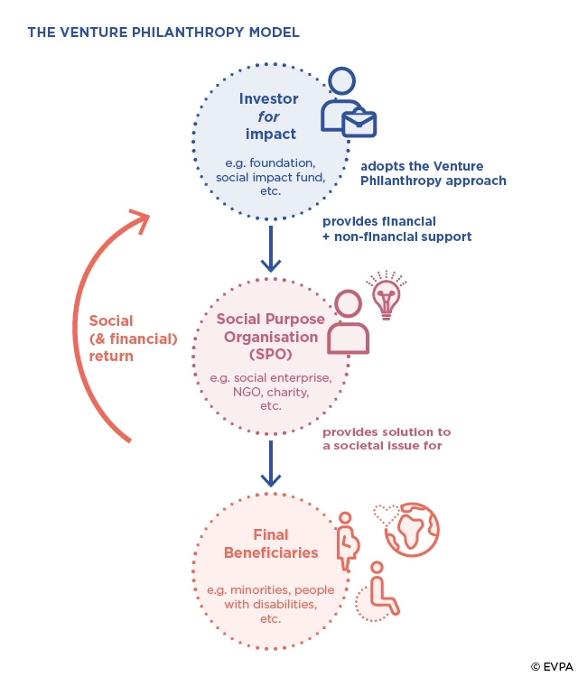
Fig. 1. Venture philanthropy model of the European Venture Philanthropy Association [2]
Thus, venture philanthropy is a charity mechanism that not only solves the problems of a narrow group of charitable recipients (as in the case of the traditional approach to charity), but also creates long-term benefits for the society as a whole and for the investor himself.
References
- Carrington, David (2003) Venture Philanthropy: A new concept or an old idea re-wrapped? Speech given at ACF Conference, Nottingham, 9 April.
- EVPA. Offiacial site. URL: https://evpa.eu.com.
- Grenier P. Venture philanthropy in Europe: obstacles and opportunities. 2006. European Venture philanthropy Association. 58 p. URL: http://www.psm.org.mx/wp-content/uploads/downloads/VenturePhilanthropyinEuropeObstaclesandOpportunities.pdf.
- What is venture philanthropy? European Venture Philanthropy Association. Retrieved from: https://evpa.eu.com/about-us/what-is-venture-philanthropy.
- What is venture philanthropy? Investopedia. Retrieved from: https://www.investopedia.com/terms/v/venture-philanthropy.asp.
- What is venture philanthropy? Sopact. Retrieved from: https://www.sopact.com/venture-philanthropy.

