ЧЕРНІВЕЦЬКИЙ НАЦІОНАЛЬНИЙ УНІВЕРСИТЕТ
ІМЕНІ ЮРІЯ ФЕДЬКОВИЧА

ВІТВІЦЬКА Н. М.
ЛІННІКОВА В. О. БУРТНИК С. Я.
БУРТНИК Б. Я.

Practical Course of Basic English:
Analytical Reading and Conversation

ЧЕРНІВЦІ – 2025
УДК 36.016:811.111-028.31(076)
П 693

Друкується за ухвалою редакційної-видавничої ради Чернівецького національного університету імені Юрія Федьковича

Укладачі: Вітвіцька Наталя Мирославівна, асистент кафедри англійської мови
Ліннікова Вікторія Олександрівна, асистент кафедри англійської мови
Буртник Софія Ярославівна, асистент кафедри англійської мови
Буртник Богдана Ярославівна, асистент кафедри англійської мови
Відповідальний за випуск: Єсипенко Н.Г., доктор філологічних наук, доцент

Practical Course of Basic English: Analytical Reading and Conversation
П693 | Практичний курс основної іноземної мови: аналітичне читання та усне мовлення/ Навч. посіб. / Укл. Вітвіцька Н.М. та ін. Чернівці, 2025. 140 с.

Навчальний посібник з аналітичного читання та усного мовлення містить комплекс завдань та вправ спрямованих на розвиток комунікативних навичок когерентного мовлення, використання сформованих діалогічних та монологічних компетенцій на систематизацію і розширення словникового запасу.
Запропонований посібник призначено для студентів першого курсу факультету іноземних мов, що вивчають англійську мову як першу іноземну.
УДК 36.016:811.111-028.31(076)

CONTENTS

ANALYTICAL READING
Unit 1  Online Persona …………………………………………………………………………… | 5
Unit 2  Understanding stereotypes………………………………………………………………….. | 20
Unit 3  Education…………………………………………………………………………………… | 34
Unit 4  Artificial intelligence……………………………………………………………………….. | 53
CONVERSATION
Term 1
Unit 1  Making the most of your time……………………………………………………………… | 72
Unit 2  Embrace your natural beauty………………………………………………………………. | 79
Unit 3  Understanding human bonds……………………………………………………………… | 86
Unit 4  Get the impression………………………………………………………………………… | 95
Term 2
Unit 1  The pleasure of food……………………………………………………………………… | 103
Unit 2  Living conditions…………………………………………………………………………… | 112
Unit 3  Weather the storm………………………………………………………………………… | 120
Unit 4  Your style, your statement………………………………………………………………….. | 127
Appendix…………………………………………………………………………………… | 135

Analytical Reading

UNIT 1

ONLINE PERSONA
SPEECH PATTERNS

Ex.1. Game ‘Find someone who…’. Mingle with your groupmates and try to find someone who matches each statement. Write their name in the space provided. You get 5 minutes to complete the task. The person who gets the most names is the winner. Look carefully through the categories. You may start only after the teacher sets the timer.

Find someone who...
... likes neither coffee nor tea. ____________
... can either play the guitar or the piano. ____________
... neither owns a car nor knows how to drive. ____________
... is learning English and is also studying another foreign language. ____________
... doesn't like spicy food and doesn't like very sweet food either. ____________
... can either speak Chinese or Japanese. ____________
... has neither been to the United States nor Europe. ____________
... loves both reading books and watching movies too. ____________
... is either left-handed or ambidextrous. ____________
... likes both classical and rock music too. ____________
…is either a morning person or a night owl. ________
… has neither broken an arm nor a leg. ____________
... has neither dyed their hair nor gotten a tattoo. ________
... is either an only child or the youngest in their family. _______

Ex. 2. Look at the rules. Go to the previous activity and try to explain the usage of ‘also, too, either, neither’
Also
- Used to add information or include something extra in affirmative sentences.
- Usually placed in the middle of a sentence, after the subject or auxiliary verb.
I love macaroons. I also love pizza.
I am also studying economics.
The coroner also helped us.
The barrister should also be there.
Too
- Similar to "also," used for addition in affirmative sentences.
- Typically placed at the end of a sentence or clause.
- Can be used in the middle of a sentence for emphasis, often set off by commas.
I love macaroons. I love pizza too.
If he wants to go too, he should meet us at 8:00.
Mr. Jones wanted the contract. Ms. Jackson, too, thought it was necessary.
Donna is working on a solution to the problem. I, too, am trying to find a way to resolve the conflict
Either
- Used in negative contexts to add negative information or show similarity in negative situations.
- Can also be used to present choices (often paired with "or").
I don’t love macaroons. I don’t love pizza either.
Take either book. I don’t mind which.
He is lazy. He doesn’t study either. That’s why he doesn’t do well in school.
Either the father or the mother has to attend the meeting.
Neither
- Used to express that two or more things are not true or do not apply.
- Can be used as a pronoun, determiner, or in parallel structures with "nor."
- Often triggers subject-auxiliary inversion in responses.
Neither of the statements is true.
He isn’t ready to go. Neither are we.
We accepted neither offer.
Neither Brian nor his wife mentioned anything about moving house.

Ex. 3. Complete the sentences using also/too/either:

1. Henry is very athletic. He loves swimming, surfing, snowboarding and skiing. Jason _____ loves to swim and surf, but he hates all winter sports because he can’t stand cold weather. 2. I am taking a great art history class at the junior college downtown. Sarah is in the class _____. We both love it. 3. I don’t really like tomatoes. My brother doesn’t like them _____.4. Frank didn’t like the layout of the apartment. He _____ thought the location was rather inconvenient, so he decided to keep looking for a place to live. 5. Mr. Harris doesn’t speak a word of French! He doesn’t have any international experience _____. So, I really feel he is not the right candidate for the job. 6. Three experts came to the conclusion that the project had to be terminated at once. I,_____, finally realized the project was too dangerous to proceed. 7. Sharon was exhausted from a hard day’s work and she wasn’t in a party mood _____, so we decided to stay in and have a quiet evening at home. 8. Dave has been living and working in Poland for over five years. He has _____ been taking night classes in Polish the entire time, so he speaks Polish very well. 9. Sam has a guidebook and a map of the region. He has a compass _____, so I think we should let him guide us out of here. 10. Sharon realized her boss had been embezzling money from the company and she wanted to go to the authorities. Doug, _____ ,thought it was time to call in the police.

Ex. 4. Choose the right option:

1. The estate manager stated it was / was not neither a wolf nor a dog. 2. Neither Anne nor the maids considers / consider the plant a nuisance. 3. Either the director or the actors is / are responsible for the film's success.4. Neither the paintings nor the sculpture was / were damaged in the fire. 5. Either my sister or my brothers is / are going to pick me up from the airport.6. Either the red shoes or the black boots goes / go well with that dress. 7. Either the book or the articles provides / provide the information you need. 8. Neither the hotel nor the restaurants in the area offers / offer vegetarian options. 9. Neither the principal nor the teachers approves / approve of the new policy. 10. Either the flowers or the chocolates makes / make a great gift for Mother's Day.

Ex. 5. Story Continuation:Work as a group. Read the story starter below.
Continue the story by adding one sentence at a time. Each sentence you add must include at least one of the following structures: also, too, either, neither, either...or, neither...nor. Try to use a different structure for each sentence if possible. If you can’t make up a sentence, you’re out of the game.

Story Starter:
Sarah woke up on Saturday morning, excited about the day ahead. She had plans to either go hiking with her friends or visit the new art exhibition in town…
Example continuation:
She also thought about inviting her sister to join her.
Neither the weather forecast nor her mood could spoil her enthusiasm.
Sarah decided to call her friend Emma to see what she wanted to do too.

Ex. 6. Most of the sentences below have mistakes. Find and correct them.

- I like pizza too I like pasta.
- Neither he or she wants to go to the party.
- I don't like coffee. I don't like too tea.
- She can either sing nor dance.
- I also am learning French.
- Either you can come with us or stay at home.
- I don't like neither spinach or broccoli.
- Neither the dog nor the cat are allowed inside.
- He can neither speak English or Spanish.
- I also enjoy swimming. I enjoy hiking too also.
- She doesn't like coffee. Tea neither.
- You can take either the red one and the blue one.
- Either we go now either we miss the train.
- He's not tall. He's not short neither.
- They neither called nor didn't send a message.

Ex. 7. Translate from Ukrainian into English:

1. Я теж згоден. Містер суддя теж думає, що це важливо. 2. Другокурсниця теж неправильно вимовила це слово. 3. Містер Джонсон теж вважав це необхідним. 4. Ти можеш випити ананасовий чи персиковий сік. 5. Він теж ніколи не катався на ковзанах. 6. Джек багато користується комп’ютером; його асистент теж працює на комп’ютері, але не так багато як Джек. 7. Я був на зборах. Ви теж там були? 8. Він ні риба, ні м’ясо. 9. У вас морська свинка або черепашка? Ні те, ні інше. У мене вівчарка. 10. Ми з Тімом не їли багато; жоден з нас не був голодний. 11. Я можу говорити англійською, а також французькою. 12. Ти можеш або залишитися вдома, або піти з нами. 13. Ні Джон, ні Мері не прийшли на вечірку. 14. Ні собаки, ні кішки не дозволені в цьому готелі. 15. Вона теж не знає відповіді на це питання. 16. Ви можете взяти або червону, або синю сорочку. 17. Або ти приходиш зараз, або ми йдемо без тебе. 18. Ні лікар, ні медсестра не змогли пояснити симптоми.

READING COMPREHENSION EXERCISES

Warmer ‘Speed dating’. Move around the room and interview at least 4-5 different groupmates about their social media habits using the four discussion questions. Remember to be respectful of personal boundaries—it's okay if someone prefers not to answer a particular question. Focus on discovering patterns, differences, and interesting insights about how your generation deals with digital spaces.
1. What social media platforms do you use the most?
2. How do you choose what to post on your profiles?
3. Do you think your online profile reflects your true self? Why or why not?
4. Have you ever tried to portray a different version of yourself online? How did it feel?

Follow-up questions:
- What surprised you most about others' social media habits?
- Did you notice any common patterns in how people present themselves online?
- How do our generation's social media habits compare to what you expected?

Reading strategies. Skimming the text. 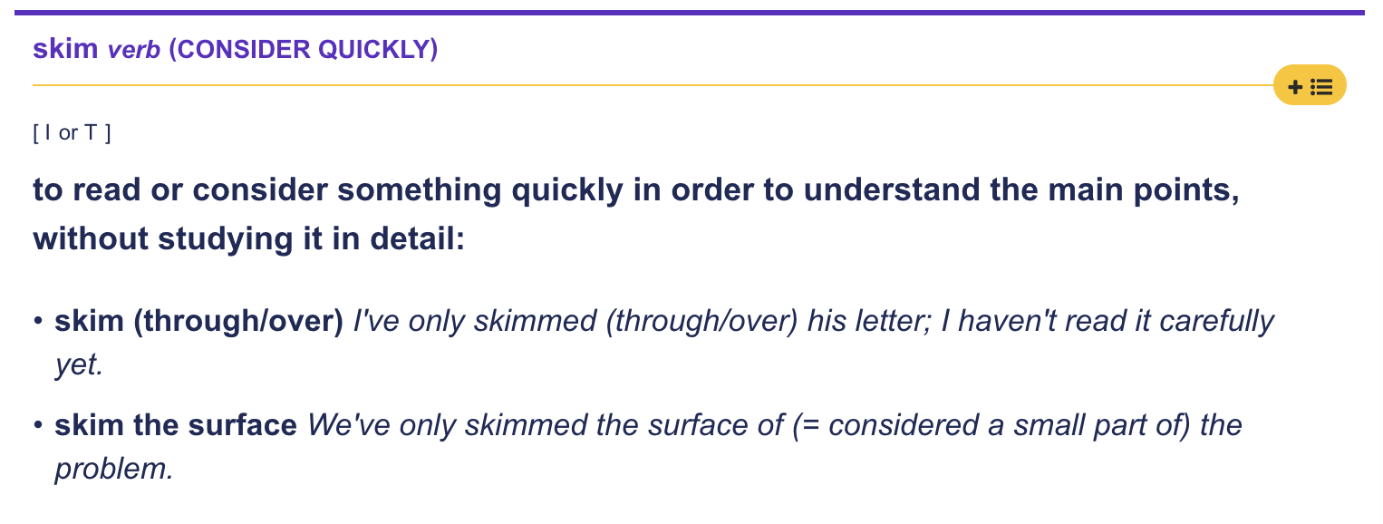
Ex. 1. Read the title and first and last sentences of each paragraph. Look at words in bold. Do not read the whole text yet. What information do you expect to find out? Work in pairs. Write 3-4 questions you would like to get answers to while reading the text.

Why and How to Sync Your Online Persona with Your True Self
by Kate Skurat

We are all unique and have multiple identities: occupation, religion, sexual orientation, age, race, gender, values, likes and dislikes, and so on. For example, you can identify yourself as a woman, a daughter, a blood donor, a booklover, Tom’s acquaintance, and a person who likes coffee and values honesty. And there’s nothing wrong with selectively revealing your identities online and adding virtual ones to this list. However, aligning your online persona — how and what you project yourself as virtually — with your true self is important because neglecting your true self can affect your mental well-being, self-esteem, and vitality.

You can’t control how others perceive you off- or online or what image of you they carry. But you do have the power to act in alignment with your authenticity and depict yourself the way you want. You’re the one to create the self-image you consider true for yourself. While posting something, ask yourself, “Can I recognize myself in that? Is it really me?”

“Being authentic means matching your true self,” says Oksana Levchuk, a certified Gestalt therapist, “You know what you want, where you go, what you value, what you feel. You make decisions based on how you and others react. You know why you do this or that, and your decisions match your true self.” That advice is quite hard to follow in the digital space when society’s striving for perfection. That’s why people can be very deliberate in picking the photos they share. They choose to hide some of the best moments of their lives because they’re afraid of ruining a polished self-image, being vulnerable, and showing insecurities.

Self-awareness is the foundation for living a joyful life as the person you truly are. It’s the ability to take an honest look at your life, to reflect, and tune in to different aspects of the self: feelings, thoughts, motives, desires, passions, weaknesses, beliefs, personal experience and so on. And self-awareness means more than having some general ideas about yourself. It also helps with going beyond approval-seeking habits, building a healthy sense of self, recovering self-worth, and embracing yourself as a unique person.
So, it’s a good idea to find the line between virtuality and reality. Remind yourself where you are physically and focus on your feelings. Catch yourself fantasizing, exaggerating, and getting lost in dreams. Rely on reality and remember that what you see is not the whole context. There’s more underneath. The digital space can be a fun and useful tool to introduce your authentic self to the world and discover new facets of yourself. But sometimes it’s hard to be truly authentic online because you may battle with anxiety, depression, trauma, shame, guilt, imposter syndrome, etc.

Abridged from https://calmerry.com/blog/self-esteem/why-and-how-to-sync-your-online-persona-with-your-true-self/#9_Meet_your_online_persona

Ex. 2. Choose the correct option according to the context of the text.
1. The text discusses having multiple identities online and offline. What is the author's main point about this?
A) You should always show all parts of your personality online to be completely honest with everyone
B) Online identities are always fake and harmful, so people should avoid social media completely
C) It's okay to choose which parts of yourself to share, but stay true to who you are
D) Having different identities online makes authentic self-expression completely impossible in digital spaces

2. According to Oksana Levchuk, what does it mean to be authentic?
A) Always doing exactly what other people expect you to do in every situation
B) Know yourself and make choices that match who you are
C) Only thinking about your own desires without considering other people's feelings
D) Following whatever trends are most popular on social media platforms

3. The text says self-awareness helps people go beyond "approval-seeking habits." What does this mean?
A) Learning to take better photos and create more engaging content for social media
B) Getting more likes, followers, and positive comments on your posts
C) Stop needing others' approval and build confidence in yourself
D) Making your online and offline personalities exactly identical in every way

4. Why do people sometimes hide their happiest moments from social media, according to the text?
A) They don't have good enough cameras
B) They're worried it might ruin their perfect online image and make them look weak
C) Happy moments are less interesting than other content
D) Social media sites don't allow personal photos

5. When the text says "what you see is not the whole context," what point is it making?
A) Digital photos are always poor quality
B) What people show online is only part of their real life, so don't believe everything you see
C) Face-to-face talking is always better than online communication
D) You can't trust any information you find online

6. The text mentions that mental health issues like anxiety and depression can make it hard to be authentic online. What does this suggest?
A) People with mental health problems shouldn't use social media
B) You need perfect mental health to be real online
C) How you feel inside affects how honestly you can show yourself online
D) Social media causes all mental health problems

7. What does the author mean by "find the line between virtuality and reality"?
A) The online world and real world are completely separate
B) You need to balance your online life with your real life carefully
C) The difference between online and offline doesn't really exist
D) Technology will solve this problem in the future

8. The text says you can't control how others see you, but you can control how you show yourself. This shows the author believes:
A) Other people completely control how you feel about yourself
B) You have total control over your image and reputation
C) You have some power over your self-presentation, even if you can't control everything
D) It's impossible to show your real self online

9. Based on how the text describes self-awareness (knowing your feelings, thoughts, values, etc.), what does the author think identity is like?
A) Something that's mostly decided by your job and social roles
B) Something complex inside you that takes work to understand
C) Something that never changes no matter what situation you're in
D) Something that's mainly created through social media

10. What is the text's overall message about being authentic online?
A) Never use social media because it's all fake
B) Social media is perfect and you should use it without thinking
C) Be thoughtful and self-aware when creating your online identity
D) Focus only on getting the most likes and followers possible

Ex. 3. Read the article again, then work with a partner and use the prompts below to discuss online authenticity and digital identity in your own words.

- The text mentions we can identify as "a woman, a daughter, a blood donor, a booklover." List 5-6 ways you identify yourself. Which of these do you show on social media and which do you keep offline? Share an example with your partner.
- The article says people hide good moments because they're "afraid of ruining a polished self-image." Have you or someone you know ever avoided posting something fun because it didn't look "perfect"? Tell your partner about this experience.
- The article suggests "find the line between virtuality and reality" and "focus on your feelings." Describe to your partner a moment when you felt too caught up in your online world. How did you bring yourself back to reality?
- The text mentions "approval-seeking habits." Be honest with your partner: Do you check how many likes your posts get? How does this make you feel? Share a specific example.
- Think about the difference between how you act in real life versus how you present yourself online. Share with your partner one way they're similar and one way they're different. Which feels more comfortable to you and why?

Ex. 4. Prepare a summary of the text, using the guidelines and phrases from Appendix 1.

ACTIVE VOCABULARY

Ex. 5. Scanning the Text. Look at the sentences with these words in the text and translate them in accordance with the context

- occupation
- selectively
- perceive
- authenticity
- consider
- recognize
- strive
- deliberate
- vulnerable
- insecurity
- embrace
- reflect
- exaggerate
- facet
- anxiety
- imposter syndrome

Ex. 6. Match the words with their definitions.
Words | Definitions
1. occupation ____ | A. To think carefully about something before making a decision
2. selectively ____ | B. A job or profession; what someone does for work
3. perceive ____ | C. To make something seem bigger, better, or worse than it really is
4. authenticity ____ | D. To try very hard to achieve something
5. consider ____ | E. Choosing carefully; picking only certain things and not others
6. recognize ____ | F. To see, notice, or understand something in a particular way
7. strive ____ | G. Done on purpose; planned and intentional
8. deliberate ____ | H. Being real and true to yourself; not fake or pretending
9. vulnerable ____ | I. To accept something willingly and positively
10. insecurity ____ | J. To think deeply about something; to look back on experiences
11. embrace ____ | K. One side or aspect of something; a particular part of a whole
12. reflect ____ | L. The feeling that you're not good enough or that you don't belong, even when you're successful
13. exaggerate ____ | M. Easily hurt physically or emotionally; open to being harmed
14. facet ____ | N. To know or identify someone or something you've seen before
15. anxiety ____ | O. Feeling nervous, worried, or scared about something
16. imposter syndrome ____ | P. Lack of confidence; feeling uncertain about yourself

Ex. 7. Rephrase each sentence using Active Vocabulary
1. People choose carefully which parts of their identity to share online. 2. It's important to think carefully about whether your post represents who you really are. 3. Many people try very hard to create the perfect online image. 4. Being real and genuine online can be challenging in today's digital world. 5. Social media users often make their experiences seem better than they actually were. 6. People sometimes feel worry and nervousness before posting something personal. 7. Sharing personal moments can make you feel easily hurt by others' reactions. 8. It's important to think deeply about your online behavior and its effects. 9. Your job or profession is just one aspect of who you are as a person. 10. People often make planned and intentional choices about what photos to post. 11. You should accept and welcome all parts of yourself, not just the perfect ones. 12. Others might see and understand your posts differently than you intended. 13. Lack of confidence can prevent people from sharing their true selves online. 14. Can you identify yourself in the content you share on social media?

Ex. 8. Complete the word families by filling in the missing forms. Some boxes may not have common forms (mark with X if no common form exists).

Noun | Verb | Adjective | Adverb
occupation | _______ | occupational | _______
_______ | select | selective | selectively
perception | _______ | _______ | _______
authenticity | _______ | _______ | authentically
consideration | _______ | _______ | _______
recognition | recognize | _______ | _______
_______ | _______ | deliberate | _______
vulnerability | _______ | _______ | vulnerably
insecurity | _______ | _______ | insecurely
_______ | embrace | _______
reflection | _______ | _______ | reflectively
exaggeration | _______ | _______ | _______
anxiety | _______ | _______ | anxiously

Bonus Challenge: Create sentences using different word forms from the same family.
Example: The artist's reflection on social media made her reflect more deeply, leading to more reflective posts that reflectively showed her true personality.

Ex. 9. Complete each sentence by forming an appropriate word from the table

1. Social media users often __________ share only the best moments of their lives, hiding the difficult times. 2. It's important to __________ carefully before posting something personal that might make you feel __________ to criticism. 3. The therapist encouraged her clients to __________ on their online behavior and think about whether it truly represents their __________ selves. 4. Different people may __________ the same post in completely different ways, which can lead to misunderstandings. 5. Your __________ is just one __________ of your identity - you are much more than just your job. 6. Some influencers __________ their lifestyle, making their lives seem more glamorous than they really are. 7. Learning to __________ all aspects of yourself, including your flaws, is an important part of mental health. 8. The study found that teenagers make very __________ choices about their profile pictures, spending hours deciding which one to use. 9. Can you __________ yourself in the content you share, or are you trying to be someone you're not? 10. Building __________ online requires being honest about both your strengths and weaknesses. 11. Many people feel __________ before posting something meaningful because they worry about others' reactions. 12. Social media can be a useful tool for self-discovery if you approach it __________ and thoughtfully.

PHRASAL VERBS

put

aside

through

up

up with

away

off

out

Ex. 10. Look at the diagram above. Use the dictionary to help you choose the correct phrasal verb to complete each sentence.

1) The concert has been __________ until next month due to bad weather.
a) put aside b) put off c) put away

2) Could you please __________ your books after you finish studying?
a) put away b) put up c) put through

3) I'm trying to __________ some money each month for my vacation.
a) put out b) put aside c) put up with

4) The firefighters worked all night to __________ the forest fire.
a) put out b) put off c) put through

5) My grandmother can __________ six people in her big house.
a) put away b) put up c) put aside

6) I can't __________ his constant complaining anymore!
a) put up with b) put through c) put off

7) The company __________ all new employees __________ a week-long training program.
a) puts / aside b) puts / through c) puts / away

8) Let's __________ our disagreement and work together on this project.
a) put off b) put out c) put aside

9) Can you __________ me __________ to the customer service department?
a) put / up b) put / through c) put / away

10) She decided to __________ cleaning her room until the weekend.
a) put off b) put out c) put up
Ex. 11. Rewrite each sentence using different words but keeping the same meaning. Use the phrasal verbs in your new sentence.

1. We need to save some money for our vacation next year. 2. The store will reserve the item for you until tomorrow. 3. They decided to forget their past disagreements for the project's sake. 4. Please tidy up your room before the guests arrive. 5. The company postponed the launch event due to technical issues. 6. The firefighters quickly extinguished the flames in the building. 7. The job applicants endured a series of difficult tests. 8. We can provide accommodation for you during your stay. 9. I can no longer tolerate the constant noise from our neighbors. 10. She managed to ignore the distractions and focus on her work.

Ex. 12. Fill in the blanks with the appropriate phrasal verb or vocabulary word from Active Vocabulary.
1. Many professionals suffer from __________ and feel like they don't deserve their success in their chosen career. 2. Sarah decided to __________ her fears about public speaking and accept the challenge. 3. As part of his new __________, he had to complete extensive training that was quite demanding. 4. She couldn't __________ his constant criticism anymore, which made her feel insecure. 5. When choosing information online, it's important to be __________ about your sources. 6. The professor asked students to __________ how their experiences shaped their worldview. 7. This __________ of her personality only emerged when she felt truly comfortable. 8. His __________ about his abilities prevented him from applying for the promotion. 9. The way people __________ success varies greatly across different cultures. 10. Being honest about your mistakes can make you feel __________ but also authentic. 11. The hotel manager promised to __________ the guests for the night despite the booking error. 12. The training program will __________ all new employees through challenging scenarios. 13. Please __________ your documents in a safe place after reviewing them. 14. The persistent feeling of __________ made it difficult for him to enjoy social gatherings.

Ex. 13. Look at each Ukrainian sentence and identify which Ukrainian words/phrases correspond to the English phrasal verbs and vocabulary from the word bank. Write them down or highlight them. Then translate the sentences into English, using the identified phrasal verbs and vocabulary words.

Example:
Ukrainian sentence: Вона вирішила відкласти зустріч через тривогу.
Active vocabulary identified: відкласти (put off), тривогу (anxiety)

1. Студенти часто перебільшують складність майбутніх іспитів. 2. Мати не могла терпіти безладу в дитячій кімнаті. 3. Ресторан може розмістити весільну вечірку на 100 осіб. 4. Кожен аспект цього проекту вимагає ретельної уваги. 5. Художник прагне передати справжні емоції у своїх картинах. 6. Пожежники швидко погасили вогонь у лісі. 7. Її щирість у спілкуванні завжди вражає оточуючих. 8. Спортсмен довго розмірковував над своїми помилками в грі. 9. Навмисне ігнорування порад може призвести до проблем. 10. Фермер відклав збір врожаю через дощову погоду. 11. Не відкладай на завтра те, що можна зробити сьогодні. 12. Нова співробітниця поступово приймає корпоративну культуру компанії. 13. Багато людей страждають від синдрому самозванця у своїй професії. 14. Вона вирішила відкласти частину зарплати на випадок непередбачених витрат.

ESSENTIAL VOCABULARY
- acquaintance - /əˈkweɪn.təns/ - знайомство, знайомий. Honest criticism is hard to take from a relative, a friend, an acquaintance, or a stranger. to acquaint with an affair - вводити в курс справи. Please acquaint your colleagues with the affair. to get acquainted with/to acquaint with - познайомитись/ознайомитись. You need to acquaint the police with the facts
- experience - /ɪkˈspɪə.ri.əns/ - досвід. She has years of experience in the computer industry. to get/gain experience - отримати/здобути досвід. You need to get more management experience. from past/previous/personal experience - з минулого/попереднього/власного досвіду. Helen knew from past experience that there was no point in arguing with him.
- align - /əˈlaɪn/ - вирівнювати, узгоджувати. I need to align my actions with my personal values. to align yourself with - приєднатися до, підтримати. He decided to align himself with people who share his identity. in alignment with - у відповідності з, згідно з. She made life choices in alignment with her core beliefs.
- identity - /aɪˈden.tɪ.ti/ - особистість, ідентичність. Her cultural identity is very important to her. to reveal one's identity - розкрити свою особистість. The witness refused to reveal his identity.
- self-awareness - /ˌself əˈweənəs/ - самосвідомість. Developing self-awareness is crucial for personal growth. to become self-aware - стати самосвідомим. Through therapy, she became more self-aware of her patterns.
- self-esteem - /ˌself ɪˈstiːm/ - самооцінка. Building healthy self-esteem takes time and practice. to have low/high self-esteem - мати низьку/високу самооцінку. People with low self-esteem often struggle with their identity. to boost/improve self-esteem - підвищити/покращити самооцінку. Therapy helped her boost her self-esteem significantly.
- depict - /dɪˈpɪkt/ - зображувати, описувати. The painting depicts a scene from rural life. to depict something as - зображувати щось як. The media often depicts teenagers as irresponsible.
- value - /ˈvæljuː/ - цінувати, цінність. She values authenticity above everything else in relationships. of great/little value - цінний/малоцінний. The ring was actually of very little value. values - цінності Christian/Western/Islamic values.
- battle - /ˈbætl/ - боротися, битися. She has been battling with depression for years. to battle with problems/difficulties - боротися з проблемами/труднощами. The company is battling with financial difficulties.
- decision - /dɪˈsɪʒn/ - рішення. It was a difficult decision to make. to make/take a decision - прийняти рішення. We need to make a decision about the new project soon. final/tough/important decision - остаточне/складне/важливе рішення. The judge will announce his final decision tomorrow. decision-making - процес прийняття рішень. Good decision-making skills are essential for managers

Ex. 1. a) Match each phrase in bold (1-10) with its correct definition (A-J).

Phrases | Definitions
1. to acquaint with an affair | A. to struggle or fight against difficulties or challenges
2. to get/gain experience | B. to show or portray something in a particular way
3. to align yourself with | C. to inform someone about a situation or matter; to introduce someone to the details of something
4. to reveal one's identity | D. very important, precious, or worth a lot
5. to become self-aware | E. to choose between different options; to reach a conclusion about what to do
6. to have low self-esteem | F. to join or support a group, cause, or set of beliefs
7. to depict something as | G. to lack confidence in one's own worth or abilities
8. of great value | H. to disclose or make known who you really are
9. to battle with problems | I. to develop understanding of one's own thoughts, feelings, and behaviors
10. to make a decision | J. to acquire knowledge or skills through practice or exposure to situations
b) Use three of the phrases from the exercise above to write your own sentences. Make sure your sentences show that you understand the meaning of each phrase
Ex. 2. Find synonyms and antonyms to the underlined words:
Choose the synonym:

1. She needs to align her actions with company policies.
a. match b. oppose c. ignore

2. The witness refused to reveal his true identity to the police.
a. hide b. disclose c. forget

3. Therapy helped him develop better self-awareness about his behavior patterns.
a. self-consciousness b. self-criticism c. self-understanding

4. People with low self-esteem often struggle in social situations.
a. self-worth b. self-control c. self-discipline

5. The artist wanted to depict the scene as realistically as possible.
a. destroy b. portray c. ignore
6. She values honesty above everything else in relationships.
a. treasures b. questions c. avoids

7. He has been battling depression for several years now.
a. ignoring b. fighting c. accepting

8. Making important decisions requires careful consideration.
a. choices b. mistakes c. assumptions

9. Her extensive experience in marketing made her the ideal candidate.
a. education b. background c. uncertainty

10. They became close friends after their initial acquaintance at university.
a. meeting b. argument c. separatio

Choose the antonym:
11. She decided to acquaint with the new company policies thoroughly.
a. familiarize b. distance from c. learn about

12. He tried to gain experience in the competitive marketing field.
a. acquire knowledge b. lose expertise c. develop skills

13. The politician chose to align yourself with the popular movement.
a. support b. oppose c. join
14. The celebrity refused to reveal her identity during the interview.
a. disclose b. conceal c. expose

15. Through meditation, she learned to become self-aware of her emotions.
a. develop consciousness b. remain ignorant c. gain insight

16. After therapy, he no longer seemed to have low self-esteem.
a. lack confidence b. possess high confidence c. feel insecure

17. The documentary tried to depict something as completely accurate.
a. portray b. misrepresent c. show

18. This family heirloom is of great value to our heritage.
a. precious b. worthless c. important

19. She continued to battle with problems throughout her recovery.
a. fight difficulties b. surrender to issues c. confront challenges

20. The committee needs to make a decision about funding soon.
a. reach a conclusion b. avoid choosing c. determine

Ex. 3. Read each sentence carefully and choose the word that best fits the context. Use the clues in the sentence to help you make the right choice.

1. The painting _______ the suffering of war victims very powerfully, showing their pain through dark colors and distorted faces.
a) aligns b) depicts c) battles
2. She needs to _______ her personal goals with the company's mission if she wants to succeed in this organization.
a) depict b) experience c) align
3. After years of therapy, he finally learned to _______ his emotions and understand why he reacts the way he does.
a) battle with b) become self-aware of c) make decisions about
4. The witness was afraid to _______ because she worried about her safety and her family's security.
a) gain experience b) reveal her identity c) have low self-esteem
5. This old photograph is _______ to me because it's the only picture I have of my grandmother.
a) of great value b) self-aware c) aligned
6. He has been _______ his addiction for three years, attending meetings and working with a counselor.
a) depicting b) battling with c) aligning with
7. Children who are constantly criticized often _______ and may struggle with confidence throughout their lives.
a) reveal their identity b) have low self-esteem c) make decisions
8. You need to _______ in customer service before applying for this management position.
a) depict something b) align yourself c) gain experience
9. At the networking event, she managed to _______ several influential people in her industry.
a) depict b) get acquainted with c) align with
10. The documentary _______ climate change _______ the most urgent crisis facing humanity today.
a) depicts / as b) aligns / with c) battles / with
11. She _______ honesty and integrity above all other qualities in both friends and colleagues.
a) depicts b) values c) battles
12. His extensive _______ in international business made him the perfect candidate for the overseas assignment.
a) self-esteem b) acquaintance c) experience

Ex. 4. Look at each Ukrainian sentence and identify which Ukrainian words/phrases correspond to the Essential Vocabulary. Write them down or highlight them. Then translate the sentences into English, using the identified phrasal verbs and vocabulary words.

1. Наше знайомство відбулося випадково на вечірці у спільного знайомого. 2. Керівник вирішив ввести в курс справи нового співробітника щодо поточних проектів. 3. Щоб здобути досвід у програмуванні, вона вирішила пройти стажування в IT-компанії. 4. Психолог допоміг їй узгодити свої дії з особистими цінностями. 5. Свідок боявся розкрити свою особистість через побоювання за власну безпеку. 6. Діти, яких постійно критикують, часто мають низьку самооцінку у дорослому житті. 7. Художник хотів зобразити сцену якомога реалістичніше у своїй новій картині. 8. Ця статуетка дуже цінна для нашої родини. 9. Вона бореться з проблемами залежності вже три роки поспіль. 10. Комітет має прийняти рішення щодо фінансування проекту до кінця тижня. 11. На конференції йому вдалося познайомитися з кількома впливовими експертами галузі. 12. Документальний фільм зображує зміну клімату як найбільшу загрозу людству. 13. Компанія цінує чесність і професіоналізм понад усе інше у своїх працівників. 14. Його великий досвід у міжнародному бізнесі зробив його ідеальним кандидатом. 15. Вона вирішила приєднатися до руху за захист навколишнього середовища.

Ex. 5. Prepare a short speech (1-2 minutes) discussing one of the quotations below. Use at least 10 units of Essential Vocabulary.
1. "To be yourself in a world that is constantly trying to make you something else is the greatest accomplishment." (Ralph Waldo Emerson) What challenges do people face in maintaining their identity in today's society?
2. "We are becoming slaves to our online personas and forgetting who we really are offline." - Anonymous. How does social media influence our sense of identity? Discuss the gap between online presentation and authentic self.
3. "Comparison is the thief of joy." - Theodore Roosevelt. How does seeking validation through likes and comments affect our self-esteem? Discuss the battle between authentic self-expression and popularity.
4. “Knowing yourself is the beginning of all wisdom." - Aristotle. How can we develop genuine self-awareness in an age of constant external feedback? Consider the value of offline experiences and reflection.

Sample Speech Structure:

"On the internet, nobody knows you're a dog"
1. Opening: Introduce the quotation and your interpretation
"Peter Steiner's famous quote 'On the internet, nobody knows you're a dog' depicts how different we can be online. This shows us how the internet can change our identity and the way we act, which can be both good and bad."
2. Personal connection: Share relevant experience or observation
"From past experience, I know people who battle with shyness in real life but become confident online. They can share their values without worry. But I've also seen people make decisions online that they would never make face-to-face with an acquaintance."
3. Main points: Develop 2-3 key ideas related to the quote
"First, anonymous online spaces can help self-esteem. People can get acquainted with others who share their interests without fear. They can align themselves with groups that value the same things. But there's also a problem. Without showing who they really are, some people forget their good values. We need self-awareness about how being anonymous changes us and make sure our online actions align with our real identity."
4. Conclusion: Summarize your thoughts and end with impact
"Whether we're anonymous or not online, our experience shapes who we become. The decision to be responsible online shows our true identity."

Tips:
- Practice your speech several times to sound natural
- Mark where you'll use each vocabulary word
- Time yourself to stay within 1-2 minutes
- Focus on clear pronunciation and confident delivery
- Use gestures and eye contact to engage your audience
- If you feel nervous, pause and take one quiet deep breath - the audience won't mind
- When nervous, we tend to speak too fast. Remind yourself to speak slowly and clearly
- Everyone gets nervous speaking - it's completely normal! The audience wants you to succeed. Instead of worrying about being perfect, focus on sharing your ideas - this reduces anxiety 😉

UNIT 2

UNDERSTANDING STEREOTYPES

Ex. 1. Opinion poll. Your teacher will read out a series of statements. For each statement, you need to decide whether you agree or disagree. If you agree with the statement, move to the right side of the room. If you disagree, move to the left side. After everyone has moved, discuss your reasons with the people around you. You will be asked to provide a short feedback after each discussion. You need to stand up for this activity.
Suggested statements
"Social media is too addictive."
"Online learning is effective enough."
"It's such a nice day that we should go outside."
"People should save money in order to buy a house."
"Public transportation is unreliable because of frequent delays."
"As it is getting hotter, we should use more air conditioning."
"Working from home is productive since there are fewer distractions."
"Exercise is too important to skip, even on busy days."

Ex. 2. Look at the example sentences. Work in pairs and try to explain the usage of ‘too/enough, so/such, in order to/so that, because/due to/as/since’

The movie was too long and too boring to keep my attention.
The presentation was too complicated and too technical for the audience to understand.
She wasn’t confident enough to speak in public, but her ideas were brilliant enough to be noticed.
The room wasn’t big enough for the party, but it was cozy enough to make everyone feel comfortable.
The lecture was so fascinating that I didn't want it to end.
The weather was so cold that we decided to stay indoors.
It was such a fascinating lecture that I didn't want it to end.
It was such cold weather that we decided to stay indoors.
She studied every night in order to pass the exam.
They moved to the city so that they could find better job opportunities.
She studied every night and as a result, she passed the exam with flying colors.
He saved money and therefore, he was able to buy a new car.
The game was canceled because of the rain.
She was late due to the traffic.
As the weather was bad, they left early.
Since there was heavy traffic, she was late.

Ex. 3. Choose the correct phrase (A, B, C, or D) to complete each sentence:

1. The concert was ______ that the audience demanded multiple encores.
A) too amazing B) amazing enough C) so amazing D) such an amazing
2. The instructions weren't ______ for beginners to understand.
A) too clear B) clear enough C) so clear D) such clear
3. It was ______ day that everyone wanted to be outside.
A) too beautiful a B) beautiful enough a C) so beautiful a D) such a beautiful
4. The museum had ______ exhibits that we couldn't see them all in one day.
A) too many B) many enough C) so many D) such many
5. The party was ______ that people were still talking about it weeks later.
A) too fun B) fun enough C) so fun D) such fun
6. The solution was ______ to solve our problem completely.
A) too effective B) effective enough C) so effective D) such effective
7. She studied hard ______ pass the entrance exam.
A) in order to B) so that C) therefore D) due to
8. The concert was canceled ______ the severe weather conditions.
A) in order to B) so that C) because of D) therefore
9. ______ he was feeling ill, he decided to stay home.
A) In order to B) As C) Therefore D) Due to
10. The company increased its marketing budget, ______ sales improved significantly.
A) so that B) because C) therefore D) because of
11. The flight was delayed ______ technical issues with the aircraft.
A) in order to B) so that C) due to D) as
12. They installed solar panels ______ reduce their electricity bills.
A) in order to B) so that C) therefore D) since
13. The team trained intensively ______ they would be prepared for the championship.
A) in order to B) so that C) therefore D) due to
14. The project was completed ahead of schedule, ______ the team received a bonus.
A) as B) since C) therefore D) because of
15. She set multiple alarms ______ oversleep on the day of her important presentation.
A) in order not to B) so that C) therefore D) because of

Ex. 4. Match the sentence beginnings in Column A with their appropriate endings in Column B. Create your own sentences using the same patterns.

Column A (Beginnings)  The movie was too long...  She wasn't experienced enough...  The concert was so amazing...  It was such a difficult exam...  They moved to the city in order to...  He studied hard, therefore...  The game was canceled because of...  As the traffic was heavy,...  Since she had prior commitments,...  The room wasn't big enough...  The weather was so cold...  Due to the unexpected delay,... | Column B (Endings):  A. ...that many students failed.  B. ...to handle the project alone.  C. ...find better job opportunities.  D. ...she couldn't attend the party.  E. ...that we decided to stay indoors.  F. ...for everyone to sit comfortably.  G. ...the meeting was postponed.  H. ...she left home earlier than usual.  I. ...to keep the audience engaged.  J. ...that the audience demanded several encores.  K. ...he passed the test with flying colors.  L. ...the heavy rain.

Ex 5. Identify and correct the error in each sentence.

- The music was enough loud that we couldn't hear each other speak.
- She studied hard so to pass the exam.
- The room was such small that we couldn't fit all the furniture.
- Due to it was raining, we decided to stay indoors.
- The movie was too interesting that I didn't want it to end.
- He wasn't tall enough for reaching the top shelf.
- They moved to the city because to find better job opportunities.
- It was so a difficult problem that no one could solve it.
- The car was expensive enough to buy without a loan.
- As result of his hard work, he got a promotion.
- The coffee was too hot for drink immediately.
- They arrived early in order that get good seats.
- The instructions weren't clear enough for understand.
- Since of the heavy traffic, we missed our flight.
- It was such an interesting book which I couldn't put it down.

Ex. 6. Use the following prompts to create a short story. Try to incorporate as many of the following patterns as you can: "too," "enough," "so," "such," "in order to," "so that," "therefore," "as," "since," "because of," and "due to."
Story Prompts:

A surprise birthday party
An unexpected rainstorm
A lost pet
A new job opportunity
A misunderstanding between friends

Here's an example of how to start the story:
"It was such a beautiful day that Sarah decided to organize a surprise birthday party for her best friend, Tom. She wanted the party to be perfect, so she started planning weeks in advance. However, as the big day approached, Sarah realized she hadn't invited enough people to make it a truly spectacular event. Therefore, she reached out to more of Tom's friends and colleagues..."

Now, continue the story using the remaining prompts and incorporating as many of the target patterns as possible. Try to use each pattern at least once, and aim for a coherent narrative that connects all the prompts.

Ex. 7. Work in pairs. Look through the questions and choose 2 the most interesting for you. Discuss the questions with your partner. Use at least 3-4 of the speech patterns in your responses

1. Describe a time when you weren't prepared enough for something important. What happened, and what did you learn from the experience? 2. Talk about an event that was so exciting that you'll never forget it. What made it so memorable? 3. Discuss a goal you're working towards. What steps are you taking in order to achieve it? 4. Recall a situation where you or someone you know was too nervous to do something. What was the outcome? 5. Describe a movie or book that had such an impact on you that it changed your perspective on something. 6. Talk about a time when you had to change your plans due to unexpected circumstances. How did you adapt? 7. Discuss a skill or hobby that you find challenging. Is it too difficult to master, or do you think you'll improve with enough practice? 8. Describe a place you've visited that was so beautiful that you'd love to return. What made it special? 9. Talk about a decision you made that had unintended consequences. What happened as a result of your choice? 10. Discuss a time when you helped someone so that they could achieve their goal. How did it make you feel? 11. Describe a situation where you had to work extra hard because of a mistake you made earlier. What did you learn? 12. Talk about a tradition in your family or culture that is important to you. Why is it significant, and how do you maintain it? 13. Discuss a time when you received such good advice that it significantly influenced your decisions. 14. Describe a situation where you or someone you know succeeded because of perseverance and determination. 15. Talk about a time when you had to explain something complicated to someone. How did you make sure they understood?

Ex. 8. Look at each Ukrainian sentence and identify which Ukrainian words/phrases correspond to Speech Patterns. Write them down or highlight them. Then translate the sentences into English, using the identified speech patterns.

1. Фільм був настільки нудним, що я заснув. 2. Вона недостатньо досвідчена, щоб керувати цим проектом. 3. Щоб встигнути на потяг, ми вийшли рано. 4. Концерт скасували через погану погоду. 5. Оскільки була сильна злива, ми залишились вдома. 6. Це була така цікава книга, що я не міг її відкласти. 7. Вода була занадто холодною для купання. 8. У нього не було достатньо грошей, щоб купити новий телефон. 9. Вона вчилася допізна, аби скласти іспит. 10. З огляду на затори, ми вирішили поїхати на метро. 11. Суп був надто гарячий, щоб його їсти відразу. 12. Вона співала так красиво, що всі були зачаровані. 13. Ми приїхали рано, щоб отримати хороші місця. 14. Через затримку рейсу ми пропустили важливу зустріч. 15. Оскільки він не підготувався, він провалив іспит. 16. Вечірка була такою гучною, що сусіди викликали поліцію. 17. У нього не було достатньо часу, щоб закінчити проект вчасно. 18. Щоб покращити свою англійську, вона дивиться фільми без субтитрів. 19. Вона була занадто втомлена, щоб піти на вечірку. 20. Я купив новий ноутбук, адже старий був недостатньо потужним для моєї роботи.

Ex. 9. Scan the qr-codes for additional practice.
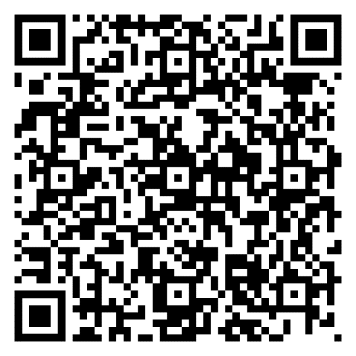
READING COMPRHENSION EXERCISES

Ex. 1. Warmer. Look at the quotation below and answer the questions.
Don't Judge a Book by Its Cover

1. Where have they heard this phrase before?
Can they think of examples where this advice applies?
Are there times when judging by appearance might be useful or necessary?

Ex. 2. Analytical reading skills. THIEVES strategy. Work with the text and complete the worksheet below. Follow it step by step. Do not read the text until you are given instructions to do so.

T - Title: What is the title of the text? What do you think it means?
H - Headings: While there are no explicit headings, what main topics or ideas can you identify from skimming the text?
I - Introduction: Read the first paragraph. What is the main idea introduced?
E - Every first sentence: Read the first sentence of each paragraph.
V - Visuals: Are there any visuals in the text? If not, what kind of visual might be helpful for this topic?
E - End-of-chapter questions: While there are no explicit questions provided, what are 2 questions you think the author wants readers to consider?
S - Summary: Read the last paragraph. What final point does the author make?
Predictions: Based on this preview, what do you think the main message of this text will be?
After reading: How did your predictions compare to the actual content? What surprised you?

Understanding stereotypes
A stereotype makes people give a definition of other persons who they meet for the first time. We easily decide who people are from their appearance, race, gender, where they were born, what kind of families they grew up in, or if they are rich or not. Some stereotypes can bring some advantages for us. We are able to make good impressions on someone who knew about us before. On the other hand, there are still some shortcomings about stereotypes and it will bring some influences occasionally in our lives.

For instance, we automatically assume that all Germans are punctual, that Italians are passionate about food, or that Americans are confident and outgoing. Due to gender stereotypes, many people believe women are more nurturing while men are more logical and decisive. We also make assumptions about social class, thinking that wealthy individuals are automatically more educated or sophisticated. People often rely on these generalizations so that they can quickly categorize others and feel more comfortable in social situations. While these assumptions might occasionally prove accurate, they create oversimplified views of complex human beings.

However, stereotypes are too harmful to ignore when considering their negative impacts on society. Due to gender-based assumptions, many women face discrimination in leadership positions, while men are often considered too emotional to work in caregiving professions. Racial stereotypes create even more serious problems, as some people may feel too uncomfortable to interact naturally with individuals from different ethnic backgrounds. Due to economic stereotypes, children from low-income families are sometimes considered to be less capable academically, which can become a self-fulfilling prophecy. So, we need to understand that these quick judgments hurt people by stopping them from reaching their goals and making life unfair in schools, jobs, and everyday situations

People today get information from newspapers, TV, and movies, so we can use these media sources to change people's opinions. Due to limited representation, newspapers should report more stories about successful people from all backgrounds - like female scientists, male nurses, or business leaders from different countries. TV producers are too focused on old ideas to create diverse programs easily, but they could plan shows about families where women work as doctors while men stay home with children, or programs about students from poor areas who become successful lawyers or teachers.

Due to movies like "The Help" (2011), many viewers learned about the difficult lives that some people faced in the past. We need more films so that audiences can see Arab engineers, elderly people starting new careers, or disabled athletes achieving great things. Media companies are too slow to change their approach, but they should work harder to show the real world so that people can see individuals from all countries, ages, and backgrounds being prominent, intelligent, and respected in society.

To sum up, changing how we think about stereotypes requires effort from everyone. Instead of just recognizing the problem, we need to take action in our daily lives. When we meet new people, we can choose to be curious about their individual stories rather than making quick assumptions. The key is understanding that stereotypes exist because our brains try to process information quickly, but we can train ourselves to slow down and think more carefully. Change happens gradually through small actions...

Ex. 3. Read the text again and answer the questions.
1. What are stereotypes? Use your own words to explain. 2. List three things people use to create stereotypes about others. 3. Give two examples of stereotypes mentioned in the text. 4. How can stereotypes hurt women and men at work? Give one example for each. 5. What does the author suggest newspapers should do differently? 6. Why do you think people use stereotypes? What makes them useful? 7. The text says stereotypes can "become a self-fulfilling prophecy." What does this mean? Use the example from the text. 8. Do you agree that movies and TV shows can change people's opinions? Why or why not? 9. What does the author mean by "we can train ourselves to slow down and think more carefully"? 10. The text mentions "The Help" (2011). Why does the author think this movie was important? 11. Which solution in the text do you think would work best - changing newspapers, TV, or movies? Explain your choice. 12. Have you ever experienced stereotyping? How did it make you feel? (You don't have to share personal details.) 13. Do you think young people today have fewer stereotypes than older generations? Why or why not?

Ex. 4. Fill in the blanks the following summary of the text.
The text explores how _______ affect people in modern society. It explains that people often make quick _______ about others based on their appearance, race, gender, or social background. The author acknowledges that stereotypes can sometimes bring _______ by helping people process information _______. For example, we might assume that Germans are punctual or that Italians love food.
However, these stereotypes create oversimplified views of complex human beings. The text discusses several types of stereotypes. Gender stereotypes can prevent _______ from getting _______ positions, while _______ are often discouraged from working in caregiving professions. Racial stereotypes create serious problems in social interactions, and _______ stereotypes about children from poor families can become a self-fulfilling prophecy.
The author suggests that _______ sources like newspapers, TV, and movies should show more _______ stories. For example, newspapers should report about successful people from all backgrounds, and TV shows could feature families where women work as doctors while men stay home with children. The text mentions that media companies are too slow to change, but they should work harder to show real-world diversity. More films should feature people from different countries and backgrounds in positive roles. In conclusion, the author believes that changing stereotypes requires effort from everyone. Instead of making quick assumptions, people should be _______ about others' individual stories. The key is understanding that change happens _______ through small actions in our daily lives.
Ex. 5. Summarization Challenge: summarize the entire text in one sentence, then in 50 words, then in 100 words.

Ex. 6. Prepare a summary of the text, using the guidelines and phrases from Appendix 1.

ACTIVE VOCABULARY & PHRASAL VERBS
Ex. 7. Scanning the Text. Look at the sentences with these words in the text and translate them in accordance with the context.

- appearance
- advantage
- shortcoming
- for instance
- nurturing
- decisive
- sophisticated
- occasionally
- accurate
- interact with
- prophecy
- diverse
- disabled
- prominent
- effort
- gradually

Ex. 8. Match each vocabulary word with its synonym. Write the letter of the correct synonym next to each vocabulary word.

Column A:  - appearance ____  - advantage ____  - shortcoming ____  - for instance ____  - nurturing ____  - decisive ____  - sophisticated ____  - occasionally ____  - accurate ____  - interact with ____  - prophecy ____  - diverse ____  - disabled ____  - prominent ____  - effort ____  - gradually ____ | Column B:  a) slowly  b) weakness  c) caring  d) prediction  e) notable  f) benefit  g) look  h) refined  i) varied  j) sometimes  k) attempt  l) for example  m) precise  n) determined  o) communicate with  p) impaired

Ex. 9. Each sentence below contains one error related to the use or spelling of the target vocabulary. Identify the error and write the correct word or phrase.
- The mountain's appearence was breathtaking at sunrise.
- Having a college degree gives you a significant adventage in the job market.
- His biggest shortcomming is his inability to listen to others.
- Many cities have excellent public transportation; for instanse, Tokyo has an amazing subway system.
- The nurtruing mother always made sure her children felt loved and supported.
- The judge was known for making decisiv rulings in difficult cases.
- The art gallery featured sofisticated paintings from renowned artists.
- She ocasionally visits her grandmother on weekends when she has time.
- The GPS system provided acurate directions to the destination.
- Children learn social skills when they interact to their classmates during recess.
- The ancient prophesy warned of a great earthquake that would shake the land.
- The university attracts divers students from all around the world.
- The new building includes elevators and ramps for dissabled visitors.
- Dr. Smith became a prominant researcher after her discovery.
- Despite his best efford, he couldn't finish the marathon.
- The patient's health improved gradualy over the course of treatment.

Ex. 10. Fill in the missing forms in each row using the given vocabulary words. Some words may not have all forms, and some forms may be the same.

Noun | Verb | Adjective | Adverb
appearance | _______ | _______ | _______
_______ | _______ | _______ | advantageously
_______ | nurture | _______ | _______
_______ | _______ | decisive | _______
_______ | _______ | sophisticated | _______
_______ | _______ | _______ | occasionally
_______ | _______ | accurate | _______
_______ | interact | _______ | _______
prophecy | _______ | _______ | _______
_______ | _______ | diverse | _______
_______ | _______ | disabled | _______
_______ | _______ | prominent | _______
effort | _______ | _______ | _______
_______ | _______ | _______ | gradually

Ex. 11. Complete each sentence by filling in the blank with the correct form of the word. Use the word building chart as your reference to determine if you need a noun, verb, adjective, or adverb form.

- The magician's sudden _____________ surprised everyone in the audience. (appear)
- The new business location was _____________ positioned near the shopping center. (advantage)
- Parents _____________ their children with love and care throughout their lives. (nurture)
- The manager made a _____________ choice to restructure the entire department. (decide)
- The _____________ technology impressed all the engineers at the conference. (sophisticate)
- She _____________ visits her grandmother every few months. (occasion)
- The scientist's measurements were completely _____________ and reliable. (accurate)
- It's important to _____________ with your teammates during group projects. (interact)
- The ancient _____________ predicted major changes in the kingdom. (prophecy)
- Our school celebrates its _____________ student population from many countries. (diverse)
- The new ramp made the building accessible to _____________ visitors. (disable)
- The _____________ politician gave speeches at universities across the country. (prominence)
- The team put great _____________ into preparing for the championship game. (effort)
- The river level rose _____________ throughout the spring season. (gradual)

PHRASAL VERBS

TURN

OUT

UP

UP ONE'S NOSE AT

DOWN

IN

OVER

Ex. 12. Choose the correct phrasal verb to complete each sentence from the options given. Use the dictionary to complete the diagram.

1. The meeting __________ to be more productive than we expected.
- a) turned up
- b) turned out
- c) turned down
- d) turned in
2. Can you __________ the radio? I can't hear the news clearly.
- a) turn down
- b) turn up
- c) turn over
- d) turn out
3. She __________ the job offer because she wanted a higher salary.
- a) turned up
- b) turned over
- c) turned down
- d) turned out
4. The criminal decided to __________ himself __________ to the police.
- a) turn / up
- b) turn / over
- c) turn / down
- d) turn / out
5. He __________ at the party two hours late without calling anyone.
- a) turned down
- b) turned in
- c) turned out
- d) turned up
6. Please __________ your homework __________ by tomorrow morning.
- a) turn / up
- b) turn / in
- c) turn / over
- d) turn / down
7. She __________ her nose __________ the idea of working overtime again.
- a) turned / up at
- b) turned / down
- c) turned / over
- d) turned / out
8. __________ the pancake carefully so it doesn't break.
- a) Turn up
- b) Turn down
- c) Turn over
- d) Turn out
9. Thousands of fans __________ for the concert despite the rain.
- a) turned over
- b) turned out
- c) turned up
- d) turned in
10. I'm exhausted, so I think I'll __________ early tonight.
- a) turn up
- b) turn over
- c) turn out
- d) turn in

Ex. 13. Rewrite each sentence using different words but keeping the same meaning. Use the phrasal verbs in your new sentence.

1. After months of planning, the charity fundraiser resulted in a huge success. 2. We waited for an hour when my brother arrived unexpectedly without calling. 3. Could you please increase the volume on the television? I can't hear from the kitchen. 4. Despite the attractive salary, Sarah rejected the job because it required too much travel. 5. After hiding for weeks, the criminal finally decided to give himself to the police. 6. When cooking the fish, remember to flip it carefully after five minutes. 7. The professor reminded students that they must submit their papers by Friday at midnight. 8. Since I have an early meeting tomorrow, I think I'll go to bed around nine tonight. 9. Despite the heavy rain, thousands of fans attended the outdoor music festival. 10. When her colleague suggested working weekends again, Maria showed contempt for the idea.

Ex. 14. Fill in the blanks with the appropriate phrasal verb or vocabulary word from the list below. You may not need to use all of them.
Word Bank:
Phrasal Verbs: turn out, turn up, turn down, turn over, turn in, turn up one's nose at
Vocabulary Words: appearance, advantage, shortcoming, for instance, nurturing, decisive, sophisticated, occasionally, accurate, interact with, prophecy, diverse, disabled, prominent, effort, gradually

1. The weather forecast wasn't very _____________ - it predicted sunshine, but it rained all day. 2. The company's CEO is known for being _____________ and making quick decisions under pressure. 3. Sarah decided to _____________ the job offer because the working conditions were poor. 4. The new building has special facilities designed for _____________ employees who use wheelchairs. 5. Students must _____________ their assignments before the deadline to receive full credit. 6. One major _____________ of living in the city is the excellent public transportation system. 7. _____________, some students prefer to study late at night rather than early in the morning. 8. My grandmother was known for her warm, _____________ personality that made everyone feel welcome. 9.The ancient _____________ predicted that a great leader would emerge during times of crisis. 10. Teachers need to learn how to effectively _____________ students from different cultural backgrounds. 11. What seemed like a disaster at first _____________ to be a valuable learning experience. 12. The _____________ businessman owned several successful companies across the country. 13. We waited for two hours, but unfortunately, nobody _____________ to help us move the furniture. 14. The medication helped the patient recover _____________ over several weeks. 15. The _____________ technology in modern smartphones allows us to do things that seemed impossible years ago.

Ex. 15. Look at each Ukrainian sentence and identify which Ukrainian words/phrases correspond to the English phrasal verbs and vocabulary from the word bank. Write them down or highlight them. Then translate the sentences into English, using the identified phrasal verbs and vocabulary words.

1. Концерт виявився великим успіхом, незважаючи на дощову погоду. 2. Вона відхилила пропозицію роботи, оскільки зарплата була занадто низькою. 3. Студенти повинні здати свої курсові роботи до п'ятниці. 4. Мій брат нарешті з'явився на вечірці через дві години запізнення. 5. Головна перевага цього готелю - його розташування в центрі міста. 6. Поступово студенти почали краще взаємодіяти один з одним. 7. Директор школи відомий своїм рішучим характером та швидкими рішеннями. 8. Злодій вирішив здатися поліції після тижня переховувань. 9. Наприклад, сучасні технології допомагають людям з інвалідністю краще інтегруватися в суспільство. 10. Вона зморщила ніс від ідеї працювати у вихідні дні. 11. Старе пророцтво передбачало прихід великого лідера. 12. Головний недолік цієї квартири - відсутність балкона. 13. Її зовнішність завжди приваблює увагу оточуючих. 14. Видатний науковець доклав великих зусиль для розвитку медицини. 15. Інформація в цій статті не є точною і містить багато помилок. 16. Переверни сторінку, щоб побачити відповіді на вправи.

ESSENTIAL VOCABULARY

1. stereotype - /ˈster.i.ə.taɪp/ - стереотип, шаблон. We need to challenge harmful stereotypes about different cultures. to stereotype - створювати стереотип, стереотипізувати. It's wrong to stereotype people based on their appearance. break/challenge/shatter stereotypes - руйнувати стереотипи. She broke stereotypes by becoming a successful female engineer.
2. assume - /əˈsjuːm/ (US) /əˈʃuːm/ (UK) - припускати, брати на себе, приймати. I assume you've already finished your homework. assumption - припущення. Don't make assumptions without having all the facts.
3. impact - /ˈɪm.pækt/ - вплив, удар, дія. The new law will have a major impact on small businesses. to impact - впливати, діяти на. Climate change impacts every aspect of our lives. feel the impact - відчувати вплив. Families are feeling the impact of rising prices.
4. background - /ˈbæk.ɡraʊnd/ - походження, освіта, досвід; фон, задній план. She comes from a musical background. in the background - на задньому плані, у фоні. You can hear music playing in the background. background information - довідкова інформація. I need some background information before making a decision.
5. judgment (US) / judgement (UK) - /ˈdʒʌdʒ.mənt/ - судження, рішення, розсудливість. Don't rush to judgment without knowing all the facts. to judge - судити, оцінювати. You shouldn't judge people by their appearance. snap/hasty judgment - поспішне судження. Don't make a snap judgment about the situation
6. person - /ˈpɜː.sən/ - особа, людина. She's a very kind person. persons - особи (формальне множина). All persons must show identification. displaced persons - переміщені особи. The war created thousands of displaced persons.
7. capable - /ˈkeɪ.pə.bəl/ - здатний, спроможний. She's capable of handling this difficult situation. capability - здатність, можливість. The team has the capability to finish on time. capable of anything - здатний на все. When angry, he's capable of anything.
8. rely on - /rɪˈlaɪ ɒn/ - покладатися на, залежати від. I rely on my friends for support. rely on luck/chance - покладатися на удачу. Success shouldn't rely on luck alone.
9. achieve - /əˈtʃiːv/ - досягати, здобувати. She worked hard to achieve her goals. achievement - досягнення, здобуток. Winning the championship was his greatest achievement. achieve goals/objectives - досягти цілей. The team achieved all their objectives this quarter.
10. ignore - /ɪɡˈnɔːr/ - ігнорувати, не звертати уваги. Please don't ignore my messages. ignorance - незнання, неосвіченість. Ignorance is not an excuse for breaking the law. ignore the problem - ігнорувати проблему. You can't just ignore the problem and hope it goes away.

Ex. 1. Match the words with their definition
- stereotype  - to stereotype  - break / challenge / shatter stereotypes  - assume  - assumption  - impact  - feel the impact  - background information  - snap / hasty judgment  - capable of anything  - rely on luck / chance  - achieve goals / objectives  - ignore the problem  - ignorance  - in the background | A. To act as if you know something without proof; to take on a responsibility or role.  B. Beliefs about groups of people that are oversimplified and often untrue.  C. To act or speak in a way that reinforces a stereotype.  D. To actively question or remove false beliefs about groups of people.  E. Something you believe to be true without having proof.  F. The powerful effect or influence something has.  G. To experience the results or consequences of something.  H. Facts that help explain a situation or provide context.  I. A quick opinion or decision made without much thought.  J. Having the ability, skill, or potential to do anything (often extreme or unpredictable).  K. To depend on chance or fortune rather than control.  L. To reach or accomplish your aims.  M. To intentionally not deal with or think about a problem.  N. A lack of knowledge, understanding, or awareness.  O. Not in the main focus; happening behind the main scene or activity.

Ex. 2. Read each sentence carefully. The underlined word or phrase is the target vocabulary. Rewrite the sentence so it keeps the same meaning, but use different words (synonyms, phrases, or explanations) instead of the underlined part. You may need to change the sentence structure, but do not change the meaning.

Example:
Original: She ignored the instructions.
Paraphrase: She didn’t pay attention to the instructions.
1. People often stereotype artists. 2. He assumed responsibility for the group’s finances. 3. It’s only an assumption that she will win. 4. The speech had a strong impact on the audience. 5. Read the background information before applying. 6. She made a snap judgment about the situation. 7. He’s capable of anything in a dangerous situation. 8. Don’t rely on luck to pass the test. 9. They achieved their objectives after years of work. 10. He chooses to ignore the problem. 11. You can see the castle in the background of the picture. 12. Displaced persons often need help finding homes. 13. Her background in education helped her career. 14. The law shattered stereotypes about minorities. 15. Try not to rely on other people too much.
Ex. 3. Each sentence has one mistake related to the use of the bold word or phrase or grammar. Find the mistake and rewrite the sentence correctly.

1. He assumed that the meeting will be at 5 p.m., but he didn’t check the schedule. 2. Our assumptions about the company was wrong after we visited it. 3. The speech had a strong impact on changing my mind. 4. The city still feels impact of the flood two years later. 5. Before you start, read the background informations on the topic. 6. She made a snapped judgment and regretted it later. 7. He is capable to do anything when he is motivated. 8. You can’t just rely in luck to win the lottery. 9. They achieved all their objectives in last month. 10. He ignored from the warning signs. 11. Her ignorance about the rules got her into trouble. 12. There is a small dog on the background of the photo. 13. The war has created millions of displacing persons. 14. The teacher gave a very judgement about my essay. 15. She comes from a rich backgrounds. 16. The protest completely shuttered stereotypes about young people. 17. His ignorant of local customs made communication difficult. 18. We relied to our friends for help.

Ex. 4. Complete each sentence with the correct option. Use the correct form of the word if necessary.

rely on • background information • capable of anything • stereotype (v) • assumption • capable • judgment • achieve goals • person • feels the impact • ignorance • challenge stereotypes • in the background • snap judgment • achieve • rely on luck • impact • stereotype (n) • ignore

1. Many people still believe the __________ that all elderly people are bad with technology. 2. The campaign was launched to __________ about immigrants in the workplace. 3. Don’t __________ your health problems — go to the doctor. 4. Without reliable data, his opinion is just an __________. 5. The earthquake had a huge __________ on the region’s economy. 6. In the photo, you can see mountains faintly __________. 7. The article provides useful __________ to help readers understand the main topic. 8. She made a __________ about him before hearing his side of the story. 9. A judge must always give a fair and unbiased __________. 10. You can always __________ him to finish tasks on time. 11. When angry, he is __________ and may act unpredictably. 12. After months of hard work, the team managed to __________. 13. If you just __________, you are unlikely to win the competition. 14. Years later, the town still __________ of the hurricane. 15. People often __________ others by their accent or appearance. 16. The kind stranger was the first __________ to offer help. 17. We must work hard if we want to __________ success in life. 18. His complete __________ of the rules caused several mistakes. 19. She is highly __________ and can solve difficult problems independently.

Ex. 5. Look at each Ukrainian sentence and identify which Ukrainian words/phrases correspond to the Essential Vocabulary. Write them down or highlight them. Then translate the sentences into English, using the identified vocabulary words.

1. Стереотип, що всі французи романтичні, не завжди відповідає дійсності. 2. Цей документальний фільм має на меті кинути виклик стереотипам про біженців. 3. Не можна ігнорувати проблеми зі здоров’ям. 4. Його висновок базувався на неправильному припущенні. 5. Нові правила мали серйозний вплив на малий бізнес. 6. У фільмі можна помітити цікаву деталь на задньому плані. 7. Перед іспитом важливо ознайомитися з довідковою інформацією. 8. Він зробив поспішне судження, навіть не вислухавши співрозмовника. 9. Ми покладаємося на команду, щоб виконати проєкт вчасно. 10. Коли вона роздратована, вона здатна на будь-які вчинки. 11. Після довгої підготовки спортсмени змогли досягти своїх цілей. 12. Якщо покладатися лише на удачу, можна втратити шанс. 13. Люди в цьому районі досі відчувають наслідки економічної кризи. 14. Щоб досягти високого рівня англійської, потрібна щоденна практика. 15. Її незнання місцевих традицій призвело до непорозумінь. 16. Він дуже здібний і може швидко навчитися новим навичкам.

Ex. 6. Choose one of the quotations below. Prepare and deliver a short speech discussing its meaning in relation to stereotypes, assumptions, and how they shape our understanding of others.

Your speech must:
- Use at least 10 units from the Essential Vocabulary list (stereotype, challenge stereotypes, assume, assumption, impact, background, background information, snap judgment, judgment, person, capable, capable of anything, achieve goals, rely on, rely on luck, ignore, ignorance, in the background, feel the impact, achieve).
- Give a clear explanation of the quote in your own words
- Include one real-life example (personal, historical, or current event).

- "Judging a person does not define who they are; it defines who you are." — Wayne Dyer
- "You never really understand a person until you consider things from his point of view." — Harper Lee
- "Labels are for clothes, not people." — Anonymous
- "Judging people you don’t know is like reading the cover of a book and claiming you know the whole story." — Anonymous
- "We are all different, which is great because we are all unique. Without diversity, life would be very boring." — Catherine Pulsifer

UNIT 3

EDUCATION
SPEECH PATTERNS
I. Watch the video and write out the rules of conditionals usage.

First Conditional Usage
1.
2.
Second Conditional Usage
1.
2.
II. Create similar dialogues using 1,2 conditionals.
III. Read the rules and memorise them.

First Conditional Formation:
Affirmative form
If + Present Simple, Future Simple + bare infinitive
If the weather is nice, we will go to the park with you.
If Harry takes one more photo of Jane, I’m sure he will ask her out.
Negative form
If + Present Simple, Future Simple in negative + bare infinitive
If it rains, I won’t go anywhere.
If any Ukrainian singer participates in this concert, believe me I won’t come.
If + Present Simple in negative, Future Simple + bare infinitive
If they don’t stop behaving like this, I will call their mum.
If you don't read the instructions, you will be lost in Zoom settings during the meeting.
Interrogative form
If + Present Simple, Future Simple + bare infinitive?
If you are ill, will you go to the office tomorrow anyway?
Where will David live if he leaves home?

Second Conditional Formation

Affirmative form
If + Past Simple, would + bare infinitive
If I won the lottery, I would buy a new house.
If she had more free time, she would travel around the world.

Negative form
If + Past Simple, would not (wouldn’t) + bare infinitive
If I didn’t have so much work, I wouldn’t feel so stressed.
If they weren’t so tired, they wouldn’t go to bed early.

Interrogative form
If + Past Simple, would + subject + bare infinitive?
If you had the chance, would you move to another country?
Would he help you if you asked him?
Substitutes to “if”
1. When – коли
When I become a boss, I will fire Rose anyway.
2. Unless – поки, допоки
Unless you learn all the words by heart, you won’t play computer games.

Ex. 1. Answer the first conditional questions by choosing the correct number for each one. Just write the CORRECT NUMBER next to each question.

- What will you do if you get a headache?  - What will you do if you feel bored in your English class?  - What will you do if you get toothache?  - What will you do if you get sunburnt?  - What will you do if you can’t sleep at night?  - What will you do if you feel sleepy during the day?  - What will you do if you don’t understand your English teacher?  - What will you do if you don’t want to do your English homework?  - What will your teacher do if you talk in class?  - What will your parents do if you are not in touch regularly?  - What will you do if you oversleep?  - What will your friends do if you forget their birthdays?  - What will you do if you have to prepare for a difficult exam?  - What will you do if you feel hungry at night?  - What will you do if there is nothing on TV?  - What will you do if you cut yourself?  - What will you do if you receive bad service in a restaurant?  - What will you do if something you buy breaks after a few days? | a) I will ask him to speak more slowly.  b) He will tell me to be quiet!  c) I will make an appointment to see the dentist. d) I will call ahead to say I'm late.  e) I will lock my door and study for a week.  f) I will read a book for half an hour.  g) I won’t do anything, but I will never return.  h) I will look out of the window.  i) I will remember how important it is to learn!  j) I will watch a DVD.  k) They will tell me to be more considerate.  l) I will go and lie down.  m) I will eat a few crackers.  n) I will eat something and that will wake me up. o) I will put pressure on the area but nothing else.  p) I will use my mother's face cream to cool my skin.  q) I will go back to the store with it.  r) They will forget mine the next time.

Ex. 2. Discuss your possible future routines and study situations with a partner using the first conditional.

Ask and answer questions about what you will do if certain things happen during your school or university day.
Example Dialogue
Student A: "What will you do if you don’t study for the test?"
Student B: "If I don’t study for the test, I will probably fail. What will you do if the teacher gives too much homework?"
Student A: "If the teacher gives too much homework, I will try to finish it on the weekend."

Ex. 3. Put the verbs in brackets into the gaps. Form a Conditional sentence – type I. Only use the will-future in the main clauses.

- If I ___________ (to study), I ___________ (to pass) the exams. 2. If the sun ___________ (to shine), we ___________ (to walk) into town. 3. If he ___________ (to have) a temperature, he ___________ (to see) the doctor. 4. If my friends ___________ (to come), I ___________ (to be) very happy. 5. If she ___________ (to earn) a lot of money, she ___________ (to fly) to New York. 6. If we ___________ (to travel) to London, we ___________ (to visit) the museums. 7. If you ___________ (to wear) sandals in the mountains, you ___________ (to slip) on the rocks. 8. If Rita ___________ (to forget) her homework, the teacher ___________ (to give) her a low mark. 9. If they ___________ (to go) to the disco, they ___________ (to listen) to loud music. 10. If you ___________ (to wait) a minute, I ___________ (to ask) my parents.

Ex. 4. Put the verbs in brackets into the gaps. Form a Conditional sentence using negative form.

1. If you ___________ (not study) for the test, you will fail. 2. If it ___________ (not rain) tomorrow, we will play soccer. 4. She will not go to the party if she ___________ (not feel) well. 5. We will not be late if we ___________ (leave) now. 6. If you ___________ (not buy) a ticket, you cannot enter the concert. 7. If he ___________ (not apologise), she will be upset. 8. We will not have dessert if we ___________ (not finish) our dinner. 9. If they ___________ (not call) us, we will not know the news. 10. If she ___________ (not wear) a coat, she will be cold. 11. If the bus ___________ (not come) on time, we will take a taxi. 12. If you ___________ (not pay) the bill, they will cut off the electricity. 13. She will not pass the exam if she ___________ (not study) harder. 14. They will not win the game if they ___________ (not practice) enough. 15. If you ___________ (not book) a hotel, we will have nowhere to stay. 16. If it ___________ (not snow) this weekend, we will not go skiing.

Ex. 5. Work in small groups of 3-4. Each group picks a dilemma and discusses possible solutions using the first conditional. Groups present their dilemma and solutions to the class.

Dilemma 1: "You have a big project due next week, but your best friend is throwing a birthday party this weekend."
Dilemma 2: "Your friends are pressuring you to try smoking, but you know it's unhealthy and against your values."
Dilemma 3: "You are part of the school basketball team and the drama club, but both have important events scheduled for the same day."
Dilemma 4: "A classmate has been bullying you, and you are considering telling a teacher or confronting the bully."
Dilemma 5: "You have a lot of homework and you also want to catch up on your favorite TV series, but you need to wake up early for school."

Ex. 6. Put the verbs in brackets into the gaps. Use the Second Conditional.

- If I __________ (to be) you, I __________ (to talk) to the teacher. 2. If she __________ (to study) more, she __________ (to get) better grades. 3. If we __________ (to have) no school tomorrow, we __________ (to go) on a trip. 4. If they __________ (to cheat) on the test, the teacher __________ (to be) angry. 5. If I __________ (to know) the answer, I __________ (to tell) you. 6. If my parents __________ (to understand) English, they __________ (to help) me with homework. 7. If I __________ (to have) more time, I __________ (to join) the debate club. 8. If our teacher __________ (to give) us a surprise test, I __________ (to fail). 9. If I __________ (to live) closer to school, I __________ (to sleep) longer. 10. If the internet __________ (to stop) working, we __________ (to read) books instead.

Ex. 7. Complete the sentences using the negative form. Use the Second Conditional.

- If I __________ (not study), I would not pass the exams. 2. If she __________ (not pay) attention in class, she would not understand the lesson. 3. He would not join the sports club if he __________ (not like) basketball. 4. We would not enjoy the trip if we __________ (not take) part in all activities. 5. If they __________ (not practice), they would not win the competition. 6. If I __________ (not listen) carefully, I would not answer the teacher’s questions. 7. If our teacher __________ (not help) us, we would not finish the project. 8. I would not know the homework if I __________ (not write) it down.

Ex. 8. Discuss imaginary study situations with a partner using the second conditional.

Example Dialogue
Student A: "What would you do if you were the headteacher of your school?"
Student B: "If I were the headteacher, I would make lessons shorter. What would you do if your teacher gave you no homework for a month?"
Student A: "If my teacher gave no homework, I would spend more time reading books I like."

Ex. 9. Work in groups of 3–4. Each group picks a dilemma and discusses possible solutions using the second conditional. Present your ideas to the class.

Dilemma 1: You forgot to prepare for the test, but your best friend offers to let you copy answers.
Dilemma 2: You could change one school rule – which one would it be, and why?
Dilemma 3: You had a chance to study in another country for a year – would you go?
Dilemma 4: Your teacher suddenly asked you to give a 10-minute presentation – what would you do?
Dilemma 5: You had the chance to remove one subject from the timetable – which subject would you choose.

Ex. 10. Match Questions and Answers

1. What would you do if you failed the final exam? ____  2. What would you do if your school had no homework at all? ____  3. What would you do if you could study abroad for free? ____  4. What would you do if your teacher asked you to teach the class for a day? ____  5. What would your parents do if you decided to quit school? ____  6. What would your friends do if you always helped them with homework? ____  7. What would you do if you forgot all your notes before an exam? ____  8. What would you do if the internet stopped working during online lessons? ____  9. What would your classmates do if the teacher never came to class? ____  10. What would you do if you discovered you were the smartest person in the world? ____  11. What would happen if all textbooks became interactive holograms? ____  12. What would you do if you could remember everything you ever read? ____  13. What would your teacher do if every student got perfect grades? ____  14. What would you do if you had to choose between art class and science class forever? ____  15. What would happen if school started at 10 AM instead of 8 AM? ____  16. What would you do if you could attend any university in the world for free? ____  17. What would your family do if you won a scholarship to study in space? ____  18. What would happen if students could design their own curriculum? ____ | - I would celebrate and travel to another country.  - I would be very nervous but I would try my best.  - They would be really disappointed.  - I would ask the teacher to explain again.  - I would prepare some fun activities.  - We would all leave and go home early.  - I would have to guess the answers.  - They would always depend on me.  - I would feel happy because I could spend more time on hobbies.  - I would use my intelligence to solve world problems like climate change.  - Learning would become much more engaging and visual for everyone.  - I would become a walking encyclopedia and help others learn faster.  - She would be suspicious and think we all cheated somehow.  - I would choose science because I love conducting experiments.  - Students would be more alert and perform better in morning classes.  - I would choose Oxford University to study international relations.  - They would be incredibly proud but also worried about my safety.  - Students would focus more on subjects they're passionate about.
Ex.11. Most of the sentences below have mistakes. Find and correct them.

- If I will study hard, I pass the exam.
- If the teacher gives us extra homework, we would complain.
- If my parents find out I fail the test, they will be angry.
- If I have more free time, I would join the debate club.
- She will understand the lesson if she will listen carefully.
- If our class have a trip next month, we will visit a museum.
- If I were the teacher, I will make the lessons shorter.
- If he doesn’t bring his homework, the teacher would be upset.
- If my friends would help me, I could finish the project on time.
- If you explain it again, I will can understand.
- If the internet stops working during the lesson, we would not learn anything.
- If I had a better laptop, I will study online more easily.
- If I don’t understand the word, I will looked it up in the dictionary.
- If she studied harder, she will pass the exam.
- If we will be late for school, the teacher will punish us.
- If I was you, I will ask the teacher for help.
- If the principal cancels classes tomorrow, we would all stay home.
- If students cheat in the test, the teacher would punish them.

Ex. 12 Rewrite the sentences, replacing if with when. Make any other changes necessary.

1. If I finish my homework early, I will go to the library. 2. If the teacher gives us a test, we will study tonight. 3. If we submit the project on time, we will get extra marks. 4. If I pass all my exams, I will celebrate with my friends. 5. If the school opens early, we will have more time to prepare for the competition.

Ex. 13 Rewrite the sentences, replacing if with unless. Remember to adjust the verb form to keep the meaning correct.

1.If you don’t study, you won’t pass the test. 2. If the students are not on time, they will miss the lesson. 3.If I don’t understand the question, I will ask the teacher. 4. If we don’t prepare for the presentation, it will be unsuccessful. 5. If he doesn’t revise his notes, he will forget everything.

Ex. 14 Complete the sentences by choosing when or unless.

- _______ I get my report card, I will know my grades.2. You will fail the exam _______ you study hard.3. _______ the teacher explains the lesson, we will ask questions. 4. We cannot join the competition _______ we register on time. 5. _______ we submit the homework, we will not get marks. 6. _______ the principal announces a holiday, we will go to school as usual. 7. I won’t understand the task _______ you explain it carefully. 8. _______ I complete my revision, I won’t feel ready for the test.

Ex. 15. Translate from Ukrainian into English using First or Second Conditional

1. Якщо я вивчу всі слова, я здам тест. 2.Якщо завтра буде сонячно, ми підемо на шкільну екскурсію.3. Якщо я не підготую домашнє завдання, вчитель буде сердитий.4. Якби я був учителем, я зробив би уроки коротшими.5. Якщо я запізнюсь на урок, вчитель покарає мене.6. Якби у мене було більше часу, я б приєднався до шкільного клубу. 7. Якщо учень не принесе підручник, він не зможе працювати на уроці.8. Якби я знав відповідь, я б відповів учителю. 9. Якщо ми будемо слухати уважно, ми зрозуміємо урок.10. Якби вчитель дав нам менше домашнього завдання, я б встигав більше читати.11. Якщо я отримаю низьку оцінку, я буду готуватися краще наступного разу. 12. Якби я міг обрати будь-який предмет, я б вибрав англійську. 13. Якщо комп’ютер зламається під час онлайн-уроку, ми нічого не навчимося.14. Якби я був директором школи, я б організував шкільну поїздку за кордон.15. Якщо друзі мені допоможуть з проєктом, я закінчу його вчасно.16. Якби вчитель не допоміг нам, ми б не закінчили завдання.17. Якщо завтра сніг не йтиме, ми пограємо в хокей на подвір’ї.18. Якби я отримав можливість навчатися за кордоном, я б поїхав одразу.

READING COMPREHENSION EXERCISES

Ex.1. Before reading the text, match the educational concepts with their examples. This will help you recognize these ideas when you encounter them in the reading.
A. Personal Growth through Education  B. Career Success from Learning  C. Lifelong Learning  D. Holistic Education  E. Critical Thinking Development  F. Self-Discovery in Learning  G. Educational Networking  H. Adaptability in Learning | - Taking online courses after graduation to learn new job skills ____  - Participating in both academic clubs and sports teams to develop different skills ____  - Learning to debate helped a shy student become more confident in expressing opinions ____  - A student discovers their passion for environmental science through a biology class ____  - Building relationships with professors that lead to internship opportunities ____  - Students learn to analyze problems from multiple perspectives before making decisions ____  - Learning technical programming skills that employers specifically look for ____  - Changing study methods when traditional approaches don't work for a particular subject ____

Ex. 2: Think about and discuss these questions with a partner BEFORE reading the text. Your predictions will help you engage more actively with the reading material.

Part A: Personal Reflection (Write brief notes)
1. What do you think is the main purpose of education beyond getting good grades?

2. How do you think education has changed you as a person so far?

3. What does "holistic education" mean to you? (Guess based on the word "holistic")

4. Why might "lifelong learning" be important in today's world?

Part B: Prediction Discussion (Discuss with a partner for 3-4 minutes each)
Discussion Prompts:
- Share your answers from Part A with your partner
- Compare your perspectives on education's role
- Predict what the text might say about these topics
- Discuss: What challenges might education face in preparing students for the future?

Ex. 3. Read the first sentence only of each paragraph in the reading passage. Then, put these paragraphs' descriptions into the same order as the passage itself. Write the number of one paragraph 1-5 beside each one.

____ A. Discusses how education helps individuals discover their passions and develop critical thinking skills.
____B. Explores the importance of lifelong learning and staying adaptable in a changing world.
____C. Introduces the idea that education is a transformative experience shaping identity and future success.
____D. Highlights the role of education in building career-related skills and professional networks.
____E. Emphasizes the value of holistic education that nurtures emotional and ethical development alongside academics.

SHAPE PERSONAL GROWTH AND CAREER SUCCESS THROUGH EDUCATION
By Leonard Reed

1 Education goes beyond simply memorizing facts or acing exams; it is a transformative journey that molds our identity and lays the groundwork for our future endeavors. From the first day of high school to the anticipation of college and everything beyond, recognizing the impact of education on personal development and career achievement can greatly enhance how you engage with your learning experiences. Embracing this understanding enables you to truly capitalize on the opportunities education presents, helping you grow into a well-rounded individual equipped for success in various aspects of life.
2 Embarking on an educational journey allows individuals to explore their interests and discover their strengths. Through various subjects and activities, students learn to identify what they are passionate about and where their talents lie. Education develops critical thinking skills that are essential for personal development. When students engage in problem-solving, analysis, and debate, they learn to approach situations thoughtfully and make informed decisions. These skills help in academics and everyday life, enabling individuals to navigate challenges with resilience and creativity.
3 The connection between education and career success is evident in the skills and knowledge individuals acquire through various educational pathways. Employers value the discipline, dedication, and expertise that education provides, making educated individuals more competitive in the job market. Building relationships with peers, teachers, and industry professionals during your educational journey can open doors to internships, job offers, and mentorships that might otherwise be inaccessible.
4 The concept of education doesn't end with a diploma or degree. Lifelong learning is essential for staying relevant and adapting to new developments in any field. Continuous learning allows individuals to update their skills, embrace new technologies, and remain competitive in the workforce.
Adaptability is key in a fast-changing environment. Whether through formal education, online courses, or self-study, maintaining a learning mindset can significantly impact long-term career growth.
5 Holistic education emphasizes the balance between academic achievements and social-emotional learning. By addressing the whole person, including their emotional, social, and ethical development, holistic education prepares individuals to lead fulfilling lives both personally and professionally.
Focusing solely on academic success can lead to burnout and a lack of essential life skills.

Abridged from https://tellyadder.com/articles/how-education-shapes-personal-growth-and-career-success?utm_source=chatgpt.com

Ex. 4. Multiple choice task. There is one the correct answer for each paragraph.
1. What is the central idea of the first paragraph?
a. Education is mainly about passing exams and memorizing facts.
b. Personal development is unrelated to academic achievement.
c. Education shapes identity and prepares individuals for future success.
d. College is more important than high school.
2. According to the second paragraph, how does education help individuals grow?
a. It guarantees high-paying jobs.
b. It helps individuals discover their interests and develop critical thinking.
c. It eliminates the need for emotional intelligence.
d. It focuses only on academic performance.
3. What does the third paragraph emphasize about education and careers?
a. Education is not necessary for building professional relationships.
b. Employers prefer candidates with no formal education.
c. Education enhances career prospects and opens networking opportunities.
d. Internships are unrelated to academic experiences.
4. What is the main message of the fourth paragraph?
a. Education ends once a degree is earned.
b. Lifelong learning helps individuals stay competitive and adaptable.
c. Online courses are less effective than traditional education.
d. Career growth depends solely on early education.
5. What does the fifth paragraph suggest about holistic education?
a. Emotional and ethical development are distractions from academic success.
b. Holistic education focuses only on social skills.
c. Balancing academics with emotional and ethical growth leads to a fulfilling life.
d. Academic success is the only measure of a good education.

Ex. 5. Complete the summary below using words from the box. There are more words than gaps, so choose carefully based on context.

Word Bank: identity, resilience, diploma, adaptability, creativity, development, lifelong, career, emotional, relationships, strengths, mindset, success, academic, journey, critical, fulfillment, opportunities, informed, personal
Summary
1. Education is more than memorizing facts; it is a transformative __________ that shapes our __________ and prepares us for future __________. Recognizing its impact helps learners make the most of the __________ it offers.
2. Through various subjects and activities, students discover their __________ and passions. Education fosters __________ thinking, enabling individuals to make __________ decisions and face challenges with __________ and __________.
3. The link between education and __________ achievement is clear. Employers value the discipline and expertise gained through learning, and building __________ during this time can lead to internships and mentorships.
4. Earning a __________ is not the end of learning. In today’s world, __________ education is vital for staying current and competitive. A learning __________ helps individuals embrace change and pursue long-term growth.
5. __________ education balances academic success with __________ and ethical growth. Focusing only on __________ performance can lead to burnout and hinder overall __________.

Ex. 6. Prepare a summary of the text, using the guidelines and phrases from Appendix 1.
ACTIVE VOCABULARY
Ex. 7. Scanning the Text. Look at the sentences with these words in the text and translate them in accordance with the context.

- Memorize
- Transformative
- Endeavor
- Anticipation
- Enhance
- Embrace
- Embark
- Approach
- Thoughtfully
- Evident
- Value
- Internship
- Adaptability
- Maintain
- Solely
- Burnout

Ex. 8. Match each word from the list with the correct definition below. The definitions are in random order.

- Memorize ____  - Transformative ____  - Endeavor ____  - Anticipation ____  - Enhance ____  6. Embrace ____  7. Embark ____  8. Approach ____  9. Thoughtfully ____  10. Evident ____  11. Value ____  12. Internship ____  13. Adaptability ____  14. Maintain ____  15. Solely ____  16. Burnout ____ | A. To begin a journey or start something new, especially one that is challenging or important.  B. A temporary position that offers practical experience in a professional setting.  C. To continue or preserve something over time.  D. A serious effort or attempt to achieve something meaningful.  E. To accept or welcome something willingly and enthusiastically.  F. Clearly seen or understood; obvious.  G. To commit information to memory, often by repetition.  H. In a careful, considerate, and reflective manner.  I. Only; exclusively.  J. A state of physical or emotional exhaustion caused by prolonged stress or overwork.  K. Causing a significant change in someone’s life, perspective, or development.  L. A feeling of excitement or expectation about something that is going to happen.  M. To improve or increase the quality, value, or effectiveness of something.  N. To deal with or handle something in a particular way.  O. The ability to adjust to new conditions or changes effectively.  P. To regard something as important or beneficial; to appreciate its worth
Ex. 9. Rephrase each sentence using Active Vocabulary

1.In a rapidly changing world, students need flexibility to face new challenges. 2. Education should not focus only on test results. 3. Before receiving exam results, students wait with great excitement. 4. Students often need to learn by heart a lot of new words in a foreign language. 5. It was clear from her presentation that she had done a lot of research. 6. Many first-year students are ready to begin their academic journey with enthusiasm. 7. Group work can help to improve communication and problem-solving skills. 8. In today’s world, we should learn to appreciate education more than material things. 9. Studying abroad can be a truly life-changing experience for young learners. 10. Too much stress and overwork can lead to student exhaustion. 11. Many university programs require students to complete an on-the-job training period. 12. Good teachers encourage students to accept challenges instead of avoiding them. 13. Teachers must decide which method works best for each type of learner. 14. It is important to keep a balance between study and rest. 15. Students should answer questions carefully and with consideration. 16. Getting a university degree is often seen as a difficult but worthwhile attempt.
Ex. 10. Complete the word families by filling in the missing forms. Some boxes may not have common forms (mark with X if no common form exists).

Noun | Verb | Adjective | Adverb
memory |  | memorable
transformation |  |  | transformatively
 | endeavor
anticipation
 | enhance
 | embrace | embracing/embraced
 | embark
approach |  | approaching
 |  | thoughtful
evidence |  |  | evidently
 | value | valuable/valued
 | adapt |  | adaptably
maintenance |  | maintained
 |  | sole
 |  | burned out

Bonus Challenge: Create sentences using different word forms from the same family.
Example: Students often anticipate graduation with great anticipation, showing anticipatory excitement about their future careers.
Ex. 11. Complete each sentence by forming an appropriate word from the table.

1.The research project was a challenging __________, but it taught the students valuable lessons about teamwork.2. Before defending her thesis, she felt a wave of nervous __________ about standing in front of the committee. 3.Some students try to __________ their knowledge by attending extra workshops and lectures. 4.Teachers encourage learners to __________ new methods of study instead of resisting change. 5.The professor stressed the need to __________ a balance between academic work and personal life. 6. Many graduates gain practical skills through an __________ before applying for full-time jobs. 7.Using group projects in class can be a __________ experience that changes how students see collaboration.8. It became __________ during the exam that several students had not prepared adequately. 9. Students should always __________ their teachers’ feedback, as it can help them improve.10. If you __________ only facts without understanding them, you might struggle to apply your knowledge. 11.Universities now stress the importance of __________, since careers often require shifting skills.12. Starting a degree program means you __________ on a journey that can shape your future.13. Learners should __________ choose their study strategies, rather than copying what others do.14. Some students suffer from academic __________ when they push themselves too hard without rest.15. Success at university doesn’t depend __________ on grades; skills and experiences matter too.16. When students __________ carefully to solving problems, they usually perform better in exams.

PHRASAL VERBS

Phrasal Verb | Meaning | Translation | Example Sentence
go after | to chase or pursue someone/something |  | The police decided to go after the thief.
go along (with) | to agree with or accept a decision or idea |  | I don't really go along with his plan.
go by | to pass (of time);  to follow or act according to |  | Time seems to go by so fast when you're having fun.  You should go by the rules.
go down with | to become ill with a disease |  | She went down with the flu and couldn't come to work.
go for | to try to get or choose something |  | I'm going to go for the job promotion. I think I'll go for the blue shirt.
go off | to explode;  to make a sudden loud noise (e.g., an alarm) |  | The bomb went off unexpectedly.  The alarm went off at 6 a.m.
go through | to experience a difficult or unpleasant situation |  | He's going through a tough time right now.
go without | to not have or not use something you usually have |  | I can't go without my morning coffee.
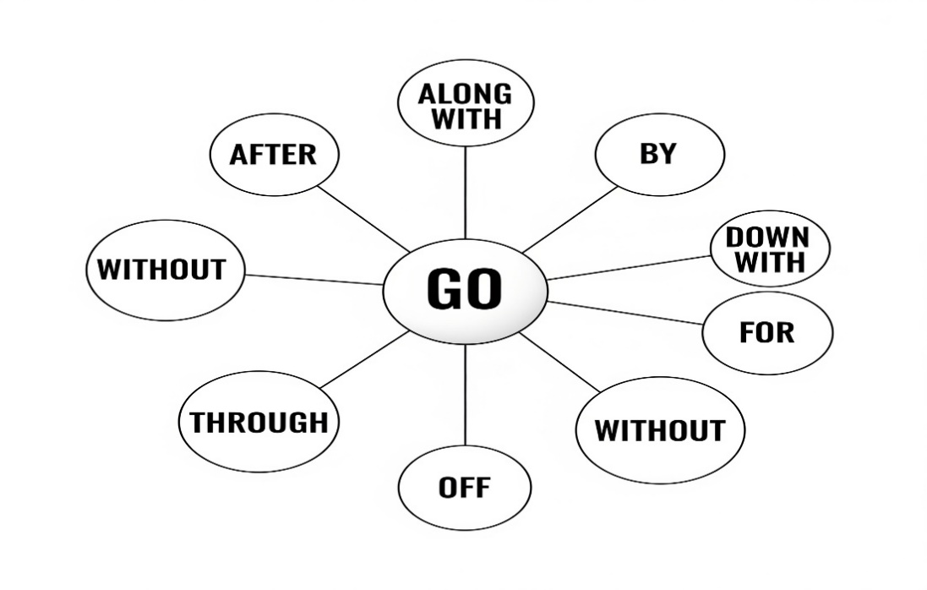
Ex. 12. Look at the diagram above. Use the dictionary to help you choose the correct phrasal verb to complete each sentence.
- The teacher encouraged the students to __________ their notes carefully before the exam.
a) go after b) go through c) go off
- Many students decided to __________ the teacher’s proposal and join the reading club.
a) go along with b) go off c) go without
- If you don’t prepare properly, you may have to __________ a lot of stress during the test.
a) go through b) go off c) go down with
- The alarm in the library suddenly __________ while the students were studying.
a) went off b) went by c) went after
- Sarah didn’t bring her calculator, so she had to __________ it during the math exam.
a) go without b) go after c) go off
- The student decided to __________ medicine as a career because she was inspired by her biology teacher.
a) go after b) go down with c) go through
- Unfortunately, some students couldn’t take the final exam because they had __________ the flu.
a) gone along with b) gone down with c) gone through
- Time seems to __________ very quickly when you are focused on learning something interesting.
a) go by b) go after c) go without
- The school debate team will __________ other schools in the regional competition.
a) go for b) go through c) go after
- The teacher reminded students that they should not just __________ what others say but think critically.
a) go along with b) go by c) go after
Ex. 13. Rewrite each sentence using different words but keeping the same meaning. Use the phrasal verbs with “go” in your new sentence.
1.We need to memorize these historical dates for the exam. 2.The lecture had a transformative effect on the students’ mindset. 3.Completing a degree is a serious endeavor. 4.The students waited in anticipation for the results. 5.These workshops will enhance your study skills. 6.She decided to embrace new methods of learning. 7.He is ready to embark on a new research project. 8.Teachers should approach every lesson thoughtfully. 9.It was evident that the student had not prepared. 10.We should value creativity in education.

Ex. 14. Fill in the blanks with the appropriate phrasal verb or vocabulary word from Active Vocabulary.

1.My university education was a truly _______________ experience, changing my perspective on the world. 2.During the final exams, my alarm clock would _______________ at 5 a.m. every day so I could study. 3.The professor's _______________ to teaching was very interactive, encouraging student participation.4.She had to _______________ a lot of stress during her final year, but she still graduated with honors.5.It's a common _______________ for students to cram for exams, trying to _______________ information the night before.6.You should _______________ a healthy work-life balance to avoid academic _______________.7.The school's new policy requires students to _______________ the rules without question.8.I will _______________ that graduate program once I finish my bachelor's degree.9.He was so dedicated to his studies that he would often _______________ sleep to complete a project.10.The student's passion for the subject was _______________ in every class discussion.11.It's important to _______________ the opportunity to learn from every experience.12.I had to _______________ on a new project to _______________ my resume for the summer _______________.13.The professor’s instructions were very clear; there was no room to _______________ with your interpretation.14.The students waited in eager _______________ for their exam results.15.This semester, I will _______________ a new _______________ to my studies by planning out my week in advance.16. The most valuable skill for any student is _______________ in the face of new challenges.17.During a pandemic, a lot of students _______________ a sickness, which made it difficult to attend online lectures.18.She works so hard that her success cannot be attributed _______________ to luck.

Ex. 15. Look at each Ukrainian sentence and identify which Ukrainian words/phrases correspond to the English phrasal verbs and vocabulary from the word bank. Write them down or highlight them. Then translate the sentences into English, using the identified phrasal verbs and vocabulary words.

Example:
Ukrainian sentence: Студенти повинні не просто запам’ятовувати факти, але й покращувати свої аналітичні навички.
Active vocabulary identified: запам’ятовувати (memorize), покращувати (enhance).
1.Це був переломний період у моєму житті, який змінив мою кар'єру.2.Студентам слід продумано підходити до вибору майбутньої професії.3.Через хворобу вона не змогла піти на стажування.4.Важливо зберегти ентузіазм протягом всього навчання, щоб уникнути емоційного вигорання.5.Недостатньо просто запам'ятовувати інформацію; потрібно розуміти її цінність.6.Він пережив багато труднощів, але його рішучість була очевидною.7.Перед зустріччю з випускниками я був сповнений очікування.8.Я вирішила прийняти цей виклик і розпочати нову освітню справу.9.Вона не змогла обійтися без додаткових лекцій, щоб покращити свої знання.10.Правила в університеті слід дотримуватися, інакше доведеться розплачуватися.11.Адаптивність — це ключова навичка для студента, який прагне досягти успіху.12.Його успіх залежить виключно від його власної праці та зусиль.13.Кожен навчальний рік проходить дуже швидко, особливо під час сесії.14. Студенти часто хворіють, тому онлайн-навчання стало необхідністю.15. Сигналізація в аудиторії спрацювала, перервавши лекцію.
ESSENTIAL VOCABULARY
  - mold - /moʊld/ - формувати, ліпити. Education is a transformative journey that molds our identity. mold the clay into - ліпити глину в (щось). The potter decided to mold the clay into a beautiful vase. be molded into the [shape, form] of - сформований у формі (чогось). The dessert was molded into the shape of a rose. to mold (government) policies - формувати (урядову) політику. The new data will help experts to mold government policies on public health.
  - impact - /ˈɪm.pækt/ - вплив, удар. Education’s and career success’s impact is evident in the skills and knowledge individuals acquire through various educational pathways. achieve an impact - досягти впливу. Her research aims to achieve an impact on public health policy. a lasting impact on - тривалий вплив на. The teacher had a lasting impact on her students' lives. on the initial impact - при першому контакті, спочатку. On the initial impact, the new curriculum seemed too difficult.
  - engage - /ɪnˈɡeɪdʒ/ - залучати, взаємодіяти. Education is a transformative journey that molds our identity and lays the groundwork for our future endeavors... it can greatly enhance how you engage with your learning experiences. engage the services of - найняти послуги когось. The company decided to engage the services of a consultant. engage someone's interest - зацікавити когось. The lecture managed to engage everyone's interest. engage with - взаємодіяти з. It's important to engage with your classmates to learn effectively.
  - passionate - /ˈpæʃ.ən.ət/ - пристрасний, захоплений. Through various subjects and activities, students learn to identify what they are passionate about and where their talents lie. be passionate about - бути захопленим чимось. He is passionate about history and loves reading old books. make a passionate plea to/for - палко благати. The student made a passionate plea to the professor for a second chance.
  - navigate - /ˈnæv.ɪ.ɡeɪt/ - долати, орієнтуватися. These skills help in academics and everyday life, enabling individuals to navigate challenges with resilience and creativity. navigate a challenge - долати виклик. She has to learn to navigate a challenge without her teacher's help. navigate by - орієнтуватися за допомогою. We had to navigate by the stars during the night hike. navigate through - долати щось, проходити крізь. It can be hard to navigate through the complex university bureaucracy.
  - dedication - /ˌded.ɪˈkeɪ.ʃən/ - відданість, присвячення. Employers value the discipline, dedication, and expertise that education provides. dedication to - відданість чомусь. His dedication to his studies is truly admirable. single-minded dedication - цілеспрямована відданість. Her single-minded dedication to the project paid off.
  - competitive - /kəmˈpet.ɪ.tɪv/ - конкурентоспроможний. Continuous learning allows individuals to update their skills, embrace new technologies, and remain competitive in the workforce. remain competitive - залишатися конкурентоспроможним. To remain competitive, you must constantly update your skills. competitive edge - конкурентна перевага. The university's strong alumni network gives its graduates a competitive edge in the job market.
  - inaccessible - /ˌɪn.əkˈses.ə.bəl/ - недоступний. Building relationships with peers, teachers, and industry professionals... can open doors to internships... that might otherwise be inaccessible. virtually inaccessible - практично недоступний. Without a car, the rural campus is virtually inaccessible. inaccessible to - недоступний для. This advanced course is inaccessible to first-year students.
  - relevant - /ˈrel.ə.vənt/ - доречний, актуальний. Lifelong learning is essential for staying relevant and adapting to new developments in any field. relevant to - стосується, має відношення до. This topic is highly relevant to our current research. relevant in today's world - актуальний у сучасному світі. The ability to learn quickly is extremely relevant in today's world.
  - holistic - /hoʊˈlɪs.tɪk/ - цілісний. Holistic education emphasizes the balance between academic achievements and social-emotional learning. take a holistic approach towards - застосовувати цілісний підхід до. The school aims to take a holistic approach towards student development. holistic in nature - цілісний за своєю суттю. The program's design is holistic in nature, combining different fields of study.
Ex. 1. a) Match each phrase (1-10) with its correct definition (A-J).

- navigate a challenge ____  - mold policies____  - engage someone's interest____  - single-minded dedication____  - virtually inaccessible____  - remain competitive____  - a lasting impact on____  - be passionate about____  - take a holistic approach____  - relevant in today's world____ | A. shaping rules  B. staying on par with rivals  C. being extremely devoted  D. overcoming a difficult situation  E. being enthusiastic and committed  F. a long-term influence  G. being nearly impossible to obtain  H. applying a comprehensive method  I. being important in the present time  J. attracting attention or curiosity
b) Use three of the phrases from the exercise above to write your own sentences. Make sure your sentences show that you understand the meaning of each phrase.
Ex. 2. Find synonyms and antonyms to the underlined words:

Choose the synonym:
- The university's policies were molded into the form of a student-centered curriculum. a. shaped b. destroyed c. copied
- The professor's speech had a lasting impact on her students' future careers. a. brief effect b. enduring influence c. temporary result
- A good teacher knows how to engage a student's interest in even a difficult subject. a. lose b. captivate c. bore
- She made a passionate plea to the school board to fund the arts program. a. unemotional b. apathetic c. heartfelt
- Students must learn to navigate challenges to become resilient adults. a. avoid b. overcome c. complicate
- The student's single-minded dedication to their studies earned them a scholarship. a. unwavering commitment b. casual interest c. divided attention
- To remain competitive in the job market, you need to update your skills regularly. a. fall behind b. stay ahead c. surrender
- The course content was inaccessible to first-year students without proper prerequisites. a. available b. understandable c. unattainable
- This research is highly relevant to the current discussion about climate change. a. irrelevant b. applicable c. unrelated
- The school takes a holistic approach to student education, focusing on mind, body, and spirit.
a. isolated b. comprehensive c. fragmented

Choose the antonym:
- The new program was molded by the feedback from both students and faculty. a. formed b. altered c. destroyed
- The speaker's initial impact on the audience was a powerful one. a. first impression b. final impression c. lasting effect
- The professor engaged the services of a professional tutor to help her students. a. hired b. terminated c. utilized
- He is very passionate about his academic field.
a. indifferent b. zealous c. enthusiastic
- It can be hard to navigate through the complex university bureaucracy.
a. steer b. simplify c. get lost in
- The dedication to the project was so intense it led to professional burnout. a. indifference b. commitment c. devotion
- A diverse skill set can give you a competitive edge in the workforce. a. major disadvantage b. benefit c. advantage
- The information in the textbook was inaccessible to the average student. a. understandable b. obscure c. unavailable
- Her outdated skills are no longer relevant in today's digital world. a. pertinent b. antiquated c. obsolete
- The curriculum had a very holistic design, integrating different subjects. a. unified b. specialized c. cohesive
Ex. 3. Read each sentence carefully and choose the word that best fits the context. Use the clues in the sentence to help you make the right choice.

- To truly benefit from your studies, you must __________ with the material and not just read it passively.
a) ignore b) engage c) skip
- The professor's innovative methods helped to __________ the student's mind and prepare them for critical thinking.
a) destroy b) mold c) leave
- The high grades were a clear sign of his great __________ to his academic work. a) apathy b) dedication c) neglect
- The new curriculum is __________ because it focuses on the student's personal growth in addition to academic skills.
a) singular b) partial c) holistic
- She learned to __________ the challenges of college life with grace and resilience. a) avoid b) navigate c) create
- The teacher's words had a significant __________ on my career choice. a) distraction b) impact c) detail
- To __________ in the modern job market, you need to constantly learn new skills. a) fall behind b) remain competitive c) surrender
- The old textbook is no longer __________ to today's technology, so the class uses online resources.
a) pertinent b) relevant c) obsolete
- The new student was so __________ about her major that she spent all her free time in the library.
a) passionate b) careless c) indifferent
- Without the proper background, the advanced physics course was __________ to most of the students.
a) easy b) accessible c) inaccessible
- Her __________ approach to the project, which included all team members' opinions, led to its success.
a) individual b) holistic c) chaotic
- She has a __________ to her studies that is truly admirable.
a) laziness b) dedication c) lack of interest

Ex. 4. Recall the sentences in which these words, phrases are used in the text; b) Use these phrases in the sentences of your own.

mold, a lasting impact on, to engage, be passionate, to navigate challenges, dedication, a competitive edge, inaccessible, relevant, a holistic approach

Ex. 5. Fill in the Blanks with Prepositions and Adverbs

- The student's success was solely dependent _____ their hard work.
- The school aims to take a holistic approach _____ education, focusing on academic and personal development.
- The course content was inaccessible _____ most first-year students due to the high-level prerequisites.
- She made a passionate plea _____ the school board _____ more funding for the arts program.
- A good teacher knows how to engage _____ students and get them to interact with the material.
- The professor's lecture had a lasting impact _____ my career choice.
- His dedication _____ his studies was evident in his consistent grades.
- The new curriculum molds young minds _____ a more flexible and critical way of thinking.
- This skill is no longer relevant _____ the modern job market.
- To remain competitive in the workforce, you have to constantly adapt _____ new developments.
- He learned to navigate a challenging academic environment through sheer will and resilience.
- Focusing too much on academic success can lead _____ student burnout.

Ex.6. Look at each Ukrainian sentence and identify which Ukrainian words/phrases correspond to the Essential Vocabulary. Write them down or highlight them. Then translate the sentences into English, using the identified phrasal verbs and vocabulary words.

1.Якщо ти хочеш бути конкурентоспроможним на ринку праці, ти повинен зберігати актуальність своїх навичок. 2. Школа застосовує цілісний підхід до навчання, який формує не лише знання, але й характер учнів. 3.Якщо ви зацікавите учнів, то їхнє навчання матиме тривалий вплив. 4. Вона була настільки віддана своєму дослідженню, що долала будь-які труднощі. 5. Якщо студент пристрасно ставиться до свого предмету, його навчання ніколи не буде здаватися рутиною. 6. Цей курс недоступний для тих, хто не має попередніх знань, але якщо ви заглибитесь в нього, то він допоможе вам долати майбутні виклики. 7. Якщо ви збережете свою відданість навчанню, це матиме значний вплив на вашу кар'єру. 8. Якби професор зацікавив мене, я б став більш захопленим своєю темою. 9. Якщо ви прагнете успіху, ви повинні формувати свою кар'єру та не чекати, доки це зроблять інші. 10. Якби я застосував цілісний підхід, я б мав більший успіх у своєму навчанні. 11. Цей проєкт актуальний для сучасної науки, і тому він має велике значення для наукової спільноти. 12. Якщо ти хочеш бути конкурентоспроможним, ти повинен взаємодіяти з професіоналами в галузі. 13. Навіть якщо цей курс складний, якщо він актуальний, я хочу його. 14. Якщо ти будеш наполегливо працювати, ти зможеш подолати будь-яку проблему. 15. Навіть якщо інформація недоступна, ми зможемо її знайти. 16. Ця навичка є актуальною і може надати вам конкурентну перевагу. 17. Якщо б ми не прийняли цілісний підхід, ми б не досягли такого впливу. 18. Я можу сказати, що він відданий своїй освіті.

Ex. 7. Prepare a short speech (1-2 minutes) discussing one of the quotations below. Use at least 3 sentences of Speech Patterns, 5 units of Active Vocabulary and Phrasal verbs, 10 units of Essential Vocabulary.

1. Education is the passport to the future, for tomorrow belongs to those who prepare for it today.” — Malcolm X
2. “The beautiful thing about learning is that no one can take it away from you.” — B.B. King
3. “The more that you read, the more things you will know. The more that you learn, the more places you'll go.”— Dr. Seuss
4. “Education is not the filling of a pail, but the lighting of a fire.” — William Butler Yeats
5. “Develop a passion for learning. If you do, you will never cease to grow.” — Anthony J. D’Angelo
Sample Speech Structure
1. Opening: Introduce the quotation and your interpretation
“William Butler Yeats once said, ‘Education is not the filling of a pail, but the lighting of a fire.’ To me, this means that learning isn’t just about memorizing facts or passing exams. It’s about sparking curiosity, passion, and the desire to grow. True education inspires us—it doesn’t just equip us.”
2. Personal connection: Share relevant experience or observation
“I remember a time when I struggled with math. I used to think I just had to ‘fill the pail’—do the homework, get the grades, and move on. But one teacher changed that. She didn’t just teach formulas—she showed us how math could solve real problems. That moment lit a fire in me. I started asking questions, exploring patterns, and even helping classmates. It wasn’t about the grade anymore—it was about discovery.”
3. Main points: Develop 2–3 key ideas related to the quote
• “First, when education is treated like a checklist, students lose motivation. They feel like they’re just collecting facts, not building understanding.”
• “Second, when teachers and mentors ignite curiosity, students become active learners. They start to explore beyond the textbook, ask deeper questions, and connect ideas.”
• “Finally, lighting the fire means making learning personal. When students see how knowledge relates to their lives, they become passionate and confident.”
4. Conclusion: Summarize your thoughts and end with impact
“Education should never be about just filling a container—it should be about lighting a spark that keeps burning. When we treat learning as a journey of discovery, we empower ourselves to grow beyond the classroom. So let’s not just carry the pail—let’s carry the flame.”

UNIT 4

ARTIFICIAL INTELLIGENCE
SPEECH PATTERNS
I.Watch the video and write out the rules of conditionals usage.

Third Conditional Usage
1.
2.
II. Create a similar dialogue using 3 conditional.

III. Read the rules and memorise them.

Third Conditional Formation

Affirmative form
If + Past Perfect, would have + past participle
If she had studied harder, she would have passed the exam.
If I had known about the party, I would have gone.

Negative form
If + Past Perfect, would not (wouldn’t) have + past participle
If they hadn’t left early, they wouldn’t have missed the train.
If he hadn’t been so tired, he wouldn’t have fallen asleep.

Interrogative form
If + Past Perfect, would + subject + have + past participle?
If you had known, would you have told me?
Would she have helped if she had been there?

Substitutes to “if”
- Unless – якщо не
Unless he had taken the wrong turn, he wouldn’t have gotten lost.
- As long as – за умови, що
As long as she had prepared well, she would have succeeded.
- Had – інверсія замість "if"
Had I known you were coming, I would have baked a cake.

Ex. 1. Put the verbs in brackets into the gaps. Use the Third Conditional.
1.If AI ______________________(to develop) earlier, we ______________________(to solve) more global challenges by now. 2. If she ______________________(to research) the AI company more, she ______________________(to know) about its ethical issues. 3. If we ______________________(to use) AI to analyze the data, we ______________________ (to discover) the patterns sooner. 4. If they ______________________ (to implement) the AI system, their productivity ______________________ (to improve) dramatically. 5. If I ______________________ (to have) access to AI-powered learning tools in school, I ______________________ (to master) complex subjects more easily. 6. If AI ______________________ (not to be) so accessible, many small businesses ______________________ (to struggle) to automate their tasks. 7. If the company ______________________ (not to rely) on AI for customer service, they ______________________ (to need) more human staff. 8. If our society ______________________ (to be) better prepared for the rapid rise of AI, we ______________________ (to avoid) some current job market challenges. 9. If I ______________________ (to understand) the potential of AI sooner, I ______________________ (to invest) in tech stocks. 10. If the creators of the AI ______________________ (to build) more safeguards, the system ______________________ (to be) less prone to error. 11. If the AI model ______________________(to get) a more diverse training set, its results ______________________ (to be) less biased. 12. If the company ______________________ (to share) its AI code openly, other researchers ______________________ (to be able to) improve it. 13. If you ______________________ (to listen) to the AI assistant's advice, you ______________________ (to take) a different route. 14. If the government ______________________ (to invest) in AI education, more people ______________________ (to find) jobs in the tech sector. 15. If the robot ______________________ (to fall) during the race, it (to lose) the competition. 16. If we ______________________ (to have) better AI-powered climate models, we ______________________ (to predict) the effects of global warming with more precision.17. If we ______________________ (to have) better AI-powered climate models, we ______________________ (to predict) the effects of global warming with more precision.

Ex. 2. Complete the sentences using the negative form. Use the Third Conditional.
1. If AI ______________________ (not to process) the medical scans, doctors ______________________ (not to detect) the rare condition. 2. If she ______________________ (not to train) the AI model on a diverse dataset, it ______________________ (not to be) so effective. 3. He ______________________(not to get) the job if he ______________________ (not to learn) about AI programming. 4. We ______________________ (not to launch) our product if the AI-driven market analysis ______________________ (not to be) so positive. 5. If they ______________________ (not to have) AI-powered security, their data (not to be) protected from the cyberattack. 6. If I ______________________ (not to use) an AI grammar checker, I ______________________ (not to notice) all the mistakes in my essay. 7. The company (not to lose) so many customers if their chatbot ______________________ (not to be) so unhelpful. 8. I ______________________ (not to finish) the complex report on time if I ______________________ (not to have) an AI assistant. 9. The self-driving car ______________________ (not to crash) if its AI system ______________________ (not to malfunction). 10. The artists ______________________ (not to protest) if the AI art generator ______________________ (not to use) their work without permission. 11. If we ______________________ (not to prepare) for the AI-driven changes in the job market, we ______________________ (to face) more unemployment. 12. If the AI-powered search engine ______________________ (not to be) so fast, people ______________________ (to use) it less often. 13. They ______________________ (not to understand) the complex data if their AI tool ______________________ (not to visualize) it for them.14. If the researchers ______________________ (not to test) the AI rigorously, they ______________________ (not to find) the critical bugs. 15. The AI program ______________________ (not to win) the chess tournament if its creators ______________________ (not to give) it a new strategy. 16. The hospital ______________________ (not to save) so many lives if its AI diagnostic tool ______________________ (not to be) so accurate.
Ex. 3. Work in pairs or small groups. Each scenario represents a different timeline where AI development took a different path. Discuss and debate the consequences using third conditional structures.

Scenario Cards
Card 1: The Cautious Path Timeline: If governments had heavily regulated AI development from 2010...
- Debate: Would we have been safer or would we have missed beneficial innovations?
- Use third conditionals to discuss: medical breakthroughs, job market, privacy, international competition
Card 2: The Open Source Revolution Timeline: If all AI research had been made completely open source from the beginning...
- Debate: Would innovation have accelerated or would security risks have increased?
- Use third conditionals to discuss: global collaboration, cyber security, economic equality, technological progress
Card 3: The Corporate Monopoly Timeline: If only one company had controlled all AI development...
- Debate: Would we have seen faster progress or dangerous concentration of power?
- Use third conditionals to discuss: innovation speed, consumer choice, data privacy, global influence

Ex. 4. Match Questions and Answers
- What would you have done if a powerful new AI had been released while you were studying for your final exam? ____
- What would have happened if AI had been able to perfectly predict the stock market? ____
- What would your family have done if AI had become so advanced that it could manage all household chores? ____
- What would you have done if an AI art generator had created a masterpiece based on your simple sketch? ____
- What would your professor have said if you had submitted an essay entirely written by an AI? ____
- What would have happened if all scientists had shared their AI research openly? ____
- What would you have felt if AI had replaced all your favorite video game characters with more realistic versions? ____
- What would your friends have done if an AI had created a hyper-realistic virtual reality game for them? ____
- What would have been the biggest change in education if AI had been your personal tutor? ____
- What would you have done if a robot powered by AI had helped you with your chores at home? ____
a) They would have been incredibly grateful for the extra free time, but also a little suspicious.
b) She would have been very disappointed and probably given me a low grade.
c) My learning speed would have increased dramatically, and I would have had personalized feedback.
d) They would have spent all their free time playing it and never gone outside.
e) I would have been so excited that I had inspired a machine to create something beautiful.
f) I probably would have missed the charm and personality of the old characters.
g) I would have used the extra time to spend more time on hobbies.
h) I would have used it to summarize all my study materials in an instant.
i) The entire world economy would have been completely revolutionized.
j) The pace of technological innovation would have been much faster.

Ex. 5. Work in groups of 3–4. Each group picks a dilemma and discusses possible solutions using the Third Conditional. Present your ideas to the class.
- Dilemma 1: You had a chance to use an AI to write your final project, but you chose not to. How would your grade and learning experience (to be) different if you (to use) it?
- Dilemma 2: A new AI was released that could perfectly imitate a loved one's voice. What (you / to do) if you (to receive) a call from this AI, and how (you / to feel)?
- Dilemma 3: A company had the chance to automate a thousand jobs with AI, but they decided to retrain the employees instead. What (to happen) to the community if they (to fire) all those people?
- Dilemma 4: You were given the opportunity to program a new AI assistant, but you forgot to include ethical guidelines. What (the consequences / to be) if you (to make) that mistake?
- Dilemma 5: You had the chance to use an AI to design a more sustainable city, but you ignored its suggestions. What (to be) the environmental impact if you (to follow) its advice?

Ex. 6. Rewrite the sentences, replacing "if" with "had" (inversion).
1.If AI had been trained on a larger dataset, its predictions would have been more accurate.2. If we had used an AI for diagnostics, doctors would have caught the disease much earlier. 3. If the company had not had an AI-powered security system, the cyberattack would have succeeded. 4. If you had seen how the AI wrote that code, you would have been amazed. 5.If they had listened to the AI's recommendations, they would have avoided a major financial loss. 6.If our government had regulated AI development sooner, we would have had stronger ethical guidelines. 7. If I had known about the AI-powered editing tool, I would have finished my project hours ago. 8. If the film studio had used AI to generate the special effects, the movie would have looked more realistic. 9. If she had not studied AI engineering in college, she would not have been able to get that job. 10. If the AI had not learned to adapt, it would not have survived the new challenges.

Ex. 7. Create sentences using the Third Conditional with inversion with "Had."
1.(You / tell me / about the AI conference) - (I / attend it). 2. (AI / be able to predict natural disasters) - (thousands of lives / be saved). 3. (The programmer / not made the mistake) - (the AI system / not failed). 4. (We / use an AI assistant / for our research) - (we / finish / the project faster). 5. (The AI robot / been more empathetic) - (it / comfort the user / more effectively). 6. (The company / not invested / in AI development) - (it / lose / its competitive edge).7. (The self-driving car / recognized the obstacle) - (it / not crash). 8. (You / trained the AI model on a better dataset) - (its results / be more accurate). 9. (The medical team / had access to the AI diagnostic tool) - (they / detect the illness sooner). 10. (The students / used the AI writing assistant) - (their essays / be grammatically perfect). 11. (The AI chatbot / been able to answer all questions) - (it / save the company / a lot of money). 12. (The AI voice assistant / understood your command) - (it / open the correct application). 13. (The government / passed the AI regulation bill) - (we / have / better ethical guidelines). 14. (The factory / implemented the AI-powered robots) - (its productivity / increase). 15. (She / not been so afraid of technology) - (she / adopt the AI tools sooner). 16. (The search engine / improved its AI algorithm) - (it / provide / more relevant results). 17. (The artist / learned how to use the AI art generator) - (he / create / amazing new works). 18. (The AI assistant / not malfunctioned) - (I / not lose / my presentation). 19. (The AI assistant / not malfunctioned) - (I / not lose / my presentation).

Ex. 8. Reflect on how AI has affected your life and imagine alternative scenarios. Write a short narrative (150-200 words) using multiple third conditional structures.
Choose one of these prompts and write your story:
Prompt 1: The Recommendation Algorithm Think about how AI recommendations (Netflix, Spotify, social media, shopping) have influenced your choices. Write about how your life might have been different if these systems hadn't existed or had worked differently.
Prompt 2: The Smartphone Revolution Consider how AI features in smartphones (voice assistants, predictive text, camera AI) have changed daily communication and habits. Imagine an alternative timeline where these features had never been developed.
Prompt 3: The Learning Assistant Reflect on AI tools in education or work (translation apps, search algorithms, AI tutors). Write about how your learning journey would have been different without these tools.

Writing Requirements
Your story must include:
- At least 5 third conditional sentences
- A clear cause-and-effect relationship between AI presence/absence and life outcomes
- Personal reflection on both positive and negative consequences
- Creativity in imagining alternative scenarios

Ex. 9. Translate from Ukrainian into English using the Third Conditional.
1.Якби я знав більше про штучний інтелект, я б використав його для свого проєкту.2. Якби компанія впровадила ШІ, вона б не втратила стільки клієнтів. 3. Якби ми не використовували ШІ-асистент, ми б не закінчили звіт вчасно. 4. Якби вчений не зробив тієї помилки в алгоритмі, експеримент був би успішним. 5. Якби уряд більше інвестував у дослідження ШІ, наша країна досягла б більшого прогресу. 6. Якби художники не протестували, компанії б продовжували використовувати їхні роботи без дозволу. 7. Якби розробники ШІ були обережнішими, вони б уникли етичних проблем. 8. Якби ти навчався в університеті з ШІ-програмування, ти б знайшов роботу швидше. 9. Якби я знав, наскільки потужним є цей інструмент ШІ, я б купив його раніше. 10. Якби ШІ-діагностика була доступною раніше, багато життів було б врятовано. 11. Якби ми не мали ШІ-технологій, наш розвиток був би значно повільнішим. 12. Якби він не видалив дані, модель ШІ була б набагато ефективнішою.13. Якби ШІ міг передбачати стихійні лиха, ми б врятували тисячі людей. 14. Якби робот-гуманоїд не зламався, він би завершив своє завдання. 15. Якби вони більше не тренували ШІ, його продуктивність не покращилася б. 16. Якби ШІ-перекладач був точнішим, ми б не мали проблем із спілкуванням. 17. Якби я не скористався ШІ-помічником для моєї роботи, я б не отримав таку високу оцінку. 18. Якби компанія не автоматизувала свої процеси, вона б не збільшила свій прибуток так швидко.

READING COMPREHENSION EXERCISES
Ex.1. Before reading the text, complete this personal inventory. Check all the ways you currently use AI (you might be surprised how much you already use it):
Daily Technology Use:
- Voice assistants (Siri, Alexa, Google Assistant)
- Streaming service recommendations (Netflix, Spotify, YouTube)
- Online shopping suggestions (Amazon, social media ads)
- Navigation apps (Google Maps, Waze)
- Email spam filters and organization
- Social media feeds and content curation
- Photo editing and filters
- Language translation apps
- Chatbots on websites
- Predictive text on your phone
- Online search engines
- Banking fraud detection
- Weather forecasting apps
- Fitness tracking and suggestions
Discussion Questions:
- How many items did you check? Were you surprised by the number?
- Which AI applications do you find most useful? Why?
- Can you think of any AI uses that aren't on this list?
Ex. 2. Look at the title "AI in Daily Life". Predict what the text will discuss:
My Predictions:
- The text will probably discuss: ________________________________
- I expect to learn about: ______________________________________
- Agree / Disagree The main message might be: __________________________________
Ex. 3. Read each statement and mark whether you Agree or Disagree BEFORE reading the text. After reading, you'll return to see if your opinions have changed.
Statement | Before Reading | After Reading
AI makes daily tasks more complicated rather than simpler | Agree / Disagree | Agree / Disagree
AI can be genuinely creative, not just always follow patterns | Agree / Disagree | Agree / Disagree
AI recommendations are always helpful and accurate | Agree / Disagree | Agree / Disagree
AI has improved human communication | Agree / Disagree | Agree / Disagree
The benefits of AI in daily life outweigh the risks | Agree / Disagree | Agree / Disagree
AI integration represents a fundamental change in how we live | Agree / Disagree | Agree / Disagree

ENHANCING EVERYDAY LIFE: HOW AI IS REVOLUTIONIZING YOUR DAILY EXPERIENCE
By BriA'nna Lawson
1 In the fast-paced world we live in, the integration of technology into our daily lives has become an everyday occurrence and is actively a part of our lives. One of the most transformative players in this technological evolution is artificial intelligence (AI). From the moment we wake up to the time we lay our heads to rest, AI is quietly working behind the scenes to make our daily experiences smoother, smarter, and more enjoyable. You may be asking yourself now “ how do I use AI currently?” well here are a few ways :
2 AI is here to help simplify your daily routines to create a smoother experience. From managing your calendar and scheduling appointments to setting reminders and organizing to-do lists, AI-powered virtual assistants have become your personal productivity allies. With natural language processing and machine learning capabilities, these assistants understand your preferences and adapt to your needs, ensuring you stay on top of your tasks effortlessly.
3 The age of generic recommendations is certainly out the door. Thanks to AI, your online experience is now tailored to your preferences and interests. Streaming services recommend movies and shows you're likely to love, online retailers suggest products and services that align with your tastes, and news apps curate articles that match your reading habits and workout apps to help with your workouts and create suggestions based on your analytics.
4 Communication is an integral part of human interaction, and AI is enhancing this fundamental aspect of our lives. Email applications use AI to categorize your messages and prioritize your inbox, ensuring you never miss a critical message. Chatbots on websites and social media platforms offer instant customer support, answering queries and resolving issues promptly. AI-powered language translation tools enable you to bridge communication gaps between people no matter the language that is spoken.
5 AI is not limited to mundane tasks; it's also contributing to creative endeavors. Photo editing applications use AI algorithms to enhance images, suggesting edits that align with your aesthetic preferences. Music composition tools can generate melodies based on your input, inspiring musicians and amateurs alike to explore new artistic horizons. These innovations empower individuals to express themselves creatively with AI as a collaborative partner.
6 The integration of AI into our daily lives is not just a trend; it's a paradigm shift that's redefining how we interact with technology. By streamlining routine tasks, personalizing experiences, enhancing communication, and fueling creativity, AI is opening doors to a more convenient, efficient, and tailored existence. As we embrace AI's transformational power, it's essential to approach its integration with a sense of responsibility, ensuring that its benefits are harnessed for the betterment of society as a whole.

Abridged from https://www.morgan.edu/ceamls/news/enhancing-everyday-life-how-ai-is-revolutionizing-your-daily-experience

Ex. 4. While reading, look for clues about the author's attitude toward AI:
Positive Language: Find and list positive words/phrases the author uses about AI:
- Paragraph 1: _______________________________________________________________
- Paragraph 2: _______________________________________________________________
- Paragraph 3: _______________________________________________________________
- Paragraph 6: _______________________________________________________________
Balanced Perspective:
- Does the author mention any concerns about AI? Where? ____________________________
- What does the author suggest we should be careful about? ___________________________
- Circle the author's overall tone: Enthusiastic / Cautious / Neutral / Critical

Ex. 5. As you read, notice how the author organizes information:
Organizational Pattern: How does the author structure the main body paragraphs (2-5)?
Problem and solution
Chronological order
Categories of AI applications
Cause and effect
Compare and contrast

Ex. 6. Are these sentences true (T) or false (F) according to the article? Correct the false sentences, underlining the corresponding evidence in the text.
- AI's presence in our daily lives is a new and surprising development. T / F
- According to the text, AI-powered virtual assistants are not capable of learning your preferences or adapting to your needs. T / F
- The text suggests that online recommendations from streaming services and retailers are still generic and not personalized. T / F
- The article states that AI-powered communication tools, like chatbots, are limited to only social media platforms. T / F
- AI is not limited to mundane tasks; it's also contributing to creative fields. T / F
- The author believes that the integration of AI is not just a passing trend but a paradigm shift that redefines our interaction with technology. T / F

Ex. 7. Complete the summary below using words from the box. There are more words than gaps, so choose carefully based on context.
Word Bank: creativity, communication, productivity, routine, paradigm, innovation, experiences, mundane, technological, collaboration, digital, personal, enhance, transformative, efficiency, customized, responsible, tailored, convenience, ethical, shift, societal, automate, human, future, benefits, evolution

Summary
- The integration of AI into our daily lives is a significant __________ __________. It is quietly working behind the scenes to make our daily __________ smoother and more enjoyable. From managing calendars to organizing to-do lists, AI helps to simplify our daily __________.
- AI-powered virtual assistants are your personal __________ allies. With machine learning capabilities, these assistants can understand your preferences and adapt to your needs. Thanks to AI, your online experience is now __________ to your preferences and interests, with generic recommendations no longer a part of our daily lives.
- AI is also helping to __________ __________. Email applications use AI to categorize your messages, and chatbots offer instant customer support. Moreover, AI-powered language translation tools help to bridge the gaps in __________ interaction.
- AI's contribution is not limited to __________ tasks; it's also fueling __________ and __________. Photo editing applications use AI to enhance images, and music composition tools can generate melodies. These innovations empower individuals to express themselves creatively with AI as a __________ partner.
- The integration of AI is not just a trend; it's a __________ __________ that is redefining how we interact with technology. By streamlining routine tasks, personalizing experiences, and fueling creativity, AI is opening doors to a more convenient, efficient, and __________ existence. As we embrace AI's power, it is essential to be __________ and __________ to ensure its __________ are used for the betterment of society.
Ex. 8. Prepare a summary of the text, using the guidelines and phrases from Appendix 1.

ACTIVE VOCABULARY
Ex. 1. Scanning the Text. Look at the sentences with these words in the text and translate them in accordance with the context.

- Integration
- Tailored
- Occurrence
- Artificial intelligence
- Currently
- Simplify
- Effortlessly
- Preference
- Integral
- Fundamental
- Application
- Instant
- Mundane
- Algorithm
- Amateur
- Interact

Ex. 2. Match the words with their definitions.

- 1. Integration  - Tailored  - Occurrence  - Artificial intelligence  - Currently  - Simplify  - Effortlessly  - Preference  - Integral  - Fundamental  - Application  - Instant  - Mundane  - Algorithm  - Amateur  - Interact | A. The ability of machines to perform cognitive functions we associate with human minds, such as learning and problem-solving.  B. To make something less complicated or easier to understand.  C. A set of rules or instructions followed by a computer to solve a problem.  D. A person who engages in an activity for pleasure rather than for professional reasons.  E. The act of combining different things so they work together as a whole.  F. Taking place at the present time; now.  G. An event or a happening.  H. To communicate or be involved with someone or something.  I. A choice or a stronger liking for one thing over another.  J. Done or made specifically to meet a particular need.  K. A basic, essential, or core part of something.  L. Done without much physical or mental effort.  M. A task or process that is dull, ordinary, or repetitive.  N. An extremely quick or immediate moment.  O. An essential and necessary part of something.  P. The use of a concept or a theory in a particular situation or for a specific purpose

Ex. 3. Rephrase each sentence using a word from the active vocabulary.
1.The machine learning model is being built to solve complex mathematical equations. 2. The company has adapted its AI assistant to meet the specific needs of each user. 3. The development of a new self-driving car system represents a major change in the automotive industry. 4. AI can process large amounts of data to make things simpler for researchers. 5. AIs can talk to humans through natural language processing. 6. The basic principle of machine learning is to learn from data without being explicitly programmed. 7. The use of AI in healthcare is improving patient diagnostics.b8. A simple computer program is an important part of the automated system. 9. The combination of different AI technologies has created powerful new tools. 10. The occurrence of a specific event can trigger an automated response from an AI system. 11. Machine learning can make complex tasks feel effortless. 12. AI's ability to provide immediate answers is revolutionizing customer service. 13. The boring, everyday tasks of data entry can be automated by AI. 14. The AI system uses a complex set of instructions to analyze large data sets. 15. A hobbyist can now use powerful AI tools that were once only available to professionals. 16. The user's choice for a dark mode is saved by the application.

Ex. 4. Complete the word families.
Noun | Verb | Adjective | Adverb
 | Integrate
Paradigm
 |  | Tailored
Occurrence
Intelligence
 |  | Current
 |  |  | Simply
Effort |  | Effortless
 | Prefer
 |  |  | Integrally
Fundament |  | Fundamental
Application
 | Instant
 |  |  | Mundanely
 |  | Algorithmic
 |  |  | Amateurishly
 | Interact

Ex. 5. Complete each sentence with the correct form of the word in parentheses.
1.The machine learning model's __________________(intelligent) grew with each new data set it processed.2. Data scientists are working on the _______________(integrate) of new algorithms into the system. 3. The company is trying to _______________(simple) its user interface to be more intuitive. 4. The new AI model represents a major _______________(paradigm) in the field of natural language processing. 5. The smart thermostat _______________(effortless) learns a user's habits. 6.The AI assistant provides an _______________(instant) response to a user's query. 7. The _______________ (fundamentally) principle of this AI is its ability to learn from its mistakes. 8. AI is _______________ (current) transforming many industries, including healthcare and finance. 9. The chatbot can _______________ (interaction) with customers and provide real-time support. 10. The system generates _______________ (tailor) content based on the user's past search history. 11. One _______________ (mundane) task that AI excels at is sorting through thousands of data points. 12. The specific _______________ (occur) of a keyword can trigger the automated chatbot. 13. The mobile application is an _______________ (integral) part of the smart home system. 14. A person who uses AI for a hobby is an _______________ (amateur) in the field. 15. The _______________ (algorithmic) processes the search query to find the most relevant results. 16. The user's _______________ (prefer) for certain types of music is used to create a personalized playlist.

PHRASAL VERBS

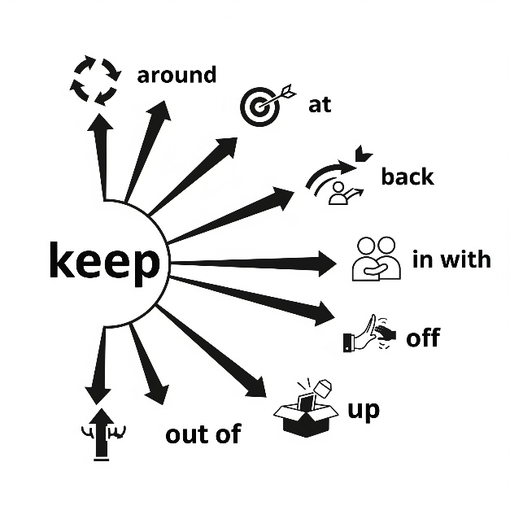
Phrasal Verb | Meaning | Translation | Example Sentence
keep around | to keep something near you or easily accessible. |  | I keep my laptop around for quick access to information.
keep at | to continue working hard at something. |  | It's a difficult project, but you just have to keep at it.
keep back | to hold something in or to prevent someone from moving forward. |  | The security guards tried to keep back the crowd from the stage.
keep in with | to maintain a good relationship with someone, especially to get an advantage. |  | He decided to keep in with his old boss in case he needed a reference.
keep off | to prevent something or someone from touching or being on something. |  | Please keep your feet off the new sofa.
keep out of | to avoid becoming involved in a situation or argument. |  | I try to keep out of any office politics.
keep up | to stay at the same level as others; to continue to do something. |  | It’s hard to keep up with all the new AI developments.

Ex. 6. Look at the diagram above. Use the dictionary to help you choose the correct phrasal verb to complete each sentence.
- Many tech companies try to __________ the latest AI tools so they don’t fall behind in the market.
a) keep up b) keep off c) keep back
- Researchers advise students to __________ cheap AI tools that may provide inaccurate data.
a) keep out of b) keep off c) keep at
- To succeed in programming, you must __________ learning algorithms even if it’s challenging.
a) keep back b) keep at c) keep around
- Some employees try to __________ influential colleagues who understand AI better.
a) keep in with b) keep around c) keep out of
- Companies often __________ older versions of software as a backup in case the new AI system fails.
a) keep at b) keep around c) keep off
- Journalists are told to __________ spreading false AI-related news on social media.
a) keep off b) keep up c) keep back
- Governments want to __________ dangerous groups that misuse AI technology.
a) keep around b) keep in with c) keep out of
Ex. 7. Rewrite each sentence using different words but keeping the same meaning. Use the phrasal verbs with “keep” in your new sentence.

- We need to memorize these historical dates for the exam. 2. You should continue practicing coding if you want to master AI. 3. It’s better to avoid fake AI applications that steal data. 4.The company stores old algorithms just in case they are needed. 5. The university tries to maintain good relationships with AI research centers.

Ex. 8. Fill in the blanks with the appropriate phrasal verb or vocabulary word from Active Vocabulary.
Word bank: algorithm, keep in with, fundamental, simplify, occurrence, tailored, artificial intelligence, amateur, preference, keep at, instant, integral, interact, mundane, currently, keep off, application, effortlessly, integration, keep around, keep back, keep up, keep out of.
1.Developers always try to write a clear __________ so the program produces correct results.2. To succeed in the tech world, it is wise to __________ people who are leaders in AI research.3. Critical thinking is a __________ skill for anyone working with AI systems. 4. Good design should __________ difficult processes so users don’t feel confused. 5. The sudden __________ of errors made the team stop the experiment. 6. Each company wants a __________ solution that matches its own needs. 7. Doctors rely on __________ to diagnose diseases more accurately. 8. Although he was just an __________ coder, he managed to build a chatbot. 9. Every user has a personal __________ for how their search results should appear. 10. If you want to improve your coding skills, you must __________ practicing every day. 11. Thanks to AI, we can now receive __________ responses to complicated questions. 12. Regular updates are an __________ part of keeping systems secure. 13. Many people __________ with chatbots daily without realizing it. 14. Robots are often used to do __________ tasks such as sorting files or entering data. 15. This app is __________ the most widely used AI tool among students. 16. Teachers warned students to __________ unreliable websites that spread AI myths. 16. ChatGPT is one practical __________ of machine learning. 17. The AI translated the long article almost __________ and without mistakes. 18. The smooth __________ of AI into schools has changed how students learn. 19. Companies often __________ older versions of their software in case the new one fails. 20. The government decided to __________ sensitive data about AI projects from the media. 21. It is difficult to __________ with the rapid progress of AI technology. 22. Policymakers are urged to __________ debates that may lead to conflicts about AI ethics.
Ex. 9. Fill in the gaps with the preposition(s) that best complete the phrasal verb
- We need to keep a lot of extra food ______ in case of an emergency.
- She decided to keep ______ her studies, despite the challenges she faced.
- The sign says to keep ______ the grass.
- He's trying to keep ______ ______ the argument between his friends.
- It’s important to keep ______ a positive attitude during difficult times.
- You have to keep ______ with the latest technology trends to succeed in this industry.
- Please try to keep the details of the project ______ for now; it's a secret.

Ex. 10. Look at each Ukrainian sentence and identify which Ukrainian words/phrases correspond to the English phrasal verbs and vocabulary from the word bank. Write them down or highlight them. Then translate the sentences into English, using the identified phrasal verbs and vocabulary words.

Ukrainian sentence: Розробники намагаються спростити складні алгоритми для широкого використання.
Active vocabulary identified: спростити (simplify), алгоритми (algorithm)

1.Сучасні технології дозволяють штучному інтелекту взаємодіяти з користувачами природним чином.2.Розробники намагаються спростити складні алгоритми для широкого використання. 3.Зараз багато компаній використовують ШІ для автоматизації рутинних завдань. 4. Зростаюча інтеграція ШІ в повсякденне життя — це лише питання часу. 5.Цей додаток може миттєво відповідати на запити користувачів, надаючи потрібну інформацію. 6.Основна мета цього проєкту — створити систему, яка працюватиме без зусиль. 7. Завдяки персоналізованим алгоритмам, контент на платформі підлаштовується під уподобання кожного. 8. Цей ШІ-додаток є невід'ємною частиною нашого робочого процесу. 9.Щоб залишатися в курсі подій, треба постійно вивчати нові технології ШІ. 10. Аматорам тепер доступні потужні інструменти ШІ, які раніше використовувалися лише професіоналами. 11. Цей випадок показав, що ШІ може помилятися. 12. Фундаментальний принцип машинного навчання — це здатність вчитися на даних. 13. Щоб уникнути помилок, програмісти повинні триматися подалі від застарілих баз даних. 14. Нова модель ШІ являє собою зміну парадигми в аналізі даних. 15. Розробникам довелося тримати в таємниці деталі проєкту. 16. Незважаючи на труднощі, він продовжував працювати над своєю нейронною мережею. 17. Уявіть, що ШІ може виконувати всі нудні та одноманітні завдання.
ESSENTIAL VOCABULARY
- schedule - /ˈskedʒul/ - планувати, складати розклад. To schedule an important meeting, the CEO relied on an AI assistant that could analyze everyone's calendars for availability. schedule an appointment with - запланувати зустріч з. The new AI system can help schedule an appointment with a client, minimizing wait times and improving efficiency. be scheduled to begin/start/take place - бути запланованим розпочатися/відбутися. The conference on AI ethics is scheduled to begin at 9 a.m. on Tuesday.
- ally - /ˈælaɪ/ - союзник. AI can become a powerful ally for researchers, helping to analyze massive datasets far more quickly than humans can. find/have an ally in sb - знайти/мати союзника в особі когось. Businesses often find an ally in AI to streamline operations and increase productivity. a friend and ally - друг і союзник. The development of AI could be a powerful friend and ally in the fight against climate change, but we must use it responsibly.
- capability - /ˌkeɪpəˈbɪləti/ - здатність, можливість. The new AI model's capability to generate human-like text is a significant breakthrough in natural language processing. beyond your capability - за межами ваших можливостей. Training a sophisticated large language model is often beyond the capability of a single researcher. within one's capability - в межах чиїхось можливостей. This task is well within one's capability with the right tools. capability for - здатність до чогось. We need to assess the new AI's capability for processing complex data sets.
- generic - /dʒəˈnerɪk/ - загальний, типовий. Many users prefer a personalized AI assistant over a generic one that offers a one-size-fits-all approach. generic drugs - дженерики (ліки-аналоги). Generic drugs are often more affordable than their brand-name counterparts, making them more accessible. generic versions - загальні/стандартні версії. Generic versions are easily accessed.
- align - /əˈlaɪn/ - вирівнювати, узгоджувати. To be effective, the AI's goals must align with the company's business strategy. align yourself with sb/sth - узгоджувати свої дії/позицію з кимось/чимось. It's crucial for the development team to align themselves with the company's ethical guidelines. align along - вирівняти вздовж чогось. We can align the servers along the main power line for better efficiency. align with - узгоджуватися з чимось. We need to align the new AI's objectives with our business goals to ensure its effectiveness.
- interaction - /ˌɪntərˈækʃən/ - взаємодія. The new user interface is designed to make the interaction with the AI chatbot as seamless as possible.to improve the interactions between - покращити взаємодію між. AI-powered chatbots are designed to improve the interactions between businesses and their customers by providing quick and accurate responses. patterns of interaction - моделі взаємодії. Researchers are studying patterns of interaction between humans and AI systems to make them more intuitive.
- contribute - /kənˈtrɪbjuːt/ - сприяти, робити внесок. Each member of the AI development team is expected to contribute their unique skills to the project. have little/a lot/much to contribute (to sth) - мати мало/багато що додати до чогось. The user has little to contribute to the chatbot's knowledge base without a proper feedback mechanism. contribute to/towards - робити внесок у/сприяти. The new dataset will contribute to the accuracy of the machine learning model
- input - /ˈɪnput/ - вхідні дані, внесок.The AI's responses are only as good as the input data it receives. input and output - вхід і вихід. The quality of the AI's output depends heavily on the quality of the input. input by sb - дані, внесені кимось. The AI system was built to process input by users in the form of voice commands.
- empower - /ɪmˈpaʊər/ - надавати можливість, наділяти повноваженнями.This new technology will empower small businesses to compete with larger corporations. empower sb to do sth - надати можливість комусь щось робити. AI can empower individuals to make more informed decisions by providing access to vast amounts of data. empower through - наділяти повноваженнями через. This technology will empower small businesses through automation and efficiency.
- harness - /ˈhɑːrnəs/ - використовувати, запрягати (в переносному значенні).Companies are looking for ways to harness the power of big data with machine learning algorithms.be harnessed for - бути використаним для. The vast amount of data generated daily can be harnessed for training more powerful AI models. harness one's abilities - використовувати чиїсь здібності. We can harness AI's ability to analyze data and predict market trends.

Ex. 1. A) Match each phrase in bold (1–10) with its correct definition (A–J).
- schedule an appointment with  - be scheduled to begin  - find an ally in sb  - a friend and ally  - beyond your capability  - capability for  - generic versions  - align with  - patterns of interaction  - empower sb to do sth | A. Someone who is both a companion and a supporter.  B. Standard, non-personalized forms of a product or service.  C. To recognize someone as a supporter or helper.  D. A plan to meet someone at an agreed time.  E. To be in agreement with a set of rules, ideas, or goals.  F. Something that is too difficult for you to achieve.  G. To give someone the power or confidence to do something.  H. The ability to do something specific.  I. Something arranged to start at a particular time.  J. The ways in which people or systems communicate and behave with each other.
B) Use three of the phrases from the exercise above to write your own sentences. Make sure your sentences show that you understand the meaning of each phrase.

Ex. 2. Find synonyms and antonyms to the bolded words.

Choose the synonym:

- The data from the new study helped experts shape government policies on public health. a. imitate b. hinder c. form
- The AI system is able to harness the vast amount of data to predict market trends. a. utilize b. release c. reject
- The team needs to align their efforts with the company's long-term goals. a. diverge b. clash c. coordinate
- The AI system will empower employees by automating routine tasks. a. weaken b. enable c. restrict
- The new AI software has the capability to process information much faster than a human. a. limitation b. inability c. capacity
- The company decided to schedule the system update for a time with low user traffic. a. postpone b. arrange c. cancel
- An AI-powered assistant can become a valuable ally in managing your daily tasks. a. adversary b. opponent c. partner
- The quality of the AI's input directly affects the accuracy of its predictions. a. data b. result c. output
- We need to find a way to improve the interactions between the user and the chatbot. a. communication b. separation c. conflict
- The new research findings will contribute to a better understanding of machine learning. a. subtract b. add c. reduce

Choose the antonym:
- The new software is a generic version of the more specialized program. a. specific b. common c. typical
- The new dataset will contribute to the accuracy of the machine learning model. a. add b. detract c. improve
- The company found an important ally in the technology firm. a. partner b. opponent c. supporter
- The AI system requires user input to generate a personalized response. a. contribution b. output c. feedback
- The system is scheduled to begin the update process at midnight. a. planned b. unplanned c. prepared
- The team needs to align their efforts with the company's long-term goals. a. coordinate b. diverge c. match
- The new AI software has the capability to process information much faster than a human. a. capacity b. ability c. inability
- The AI system will empower employees by automating routine tasks. a. enable b. authorize c. restrict
- The AI system is able to harness the vast amount of data to predict market trends. a. use b. release c. exploit
- The chatbot's interactions with users are becoming more natural and human-like. a. conversations b. communications c. separations
Ex. 3. Choose the word that best fits the context.
- To improve the AI's performance, developers must provide it with high-quality data, as the quality of its ________ directly affects its predictions.
a) output b) input c) interaction
- The company has a very ambitious project _________ to launch next month, which will revolutionize the industry.
a) scheduled b) contributed c) empowered
- The new AI system's primary _________ is its ability to analyze complex datasets in a matter of seconds.
a) limitation b) capability c) input
- A personal AI assistant can become a powerful ________ in managing your daily tasks and boosting productivity.
a) ally b) opponent c) generic
- The new regulations will help ________ businesses to innovate while ensuring ethical use of AI.
a) harness b) schedule c) empower
- We need to make sure that the company's AI development strategy ________ with the new ethical guidelines.
a) clashes b) aligns c) contributes
- The research team is studying the _________ between humans and AI to create more intuitive and user-friendly systems.
a) capability b) generic c) interaction
- The company's success is a direct result of everyone's hard work and the time they ________ to the project.
a) contributed b) empowered c) scheduled
- Unlike more specialized programs, this is a _________ version of the software designed for general use.
a) specific b) aligned c) generic
- The AI system's ability to process massive amounts of data can be _________ to find new patterns and insights.
a) contributed b) harnessed c) scheduled
- To ensure the project's success, we must ________ our team's resources with the goals of the company.
a) clash b) align c) empower
- The data science team provided crucial ________ for the development of the new algorithm. a) output b) interaction c) input
- The company is seeking an _________ in the government to support its new initiative.
a) opponent b) ally c) interaction
- The AI's _________ to learn and adapt is what makes it so powerful.
a) generic b) capability c) input
- The AI-powered chatbot is designed to improve the ________ between customers and the service department.
a) capability b) interaction c) ally

Ex. 4. Recall the sentences in which these phrases are used in the text. b) Use these phrases in the sentences of your own.
schedule, an ally in sb, ally, capability, generic versions, align with, contribute to, empower sb to do sth, harness

Ex. 5. Fill in the Blanks with Prepositions and Adverbs.
- The new AI system can schedule an appointment ___ a client to minimize waiting time.
- The international conference on AI ethics is scheduled to begin ___ 10 a.m. next Monday.
- Many small companies find an ally ___ AI when trying to compete with larger corporations.
- Scientists describe AI as both a friend ___ ally in solving global issues.
- Training a massive AI model is often beyond the capability ___ one individual.
- With modern software, even complex data analysis is well within the capability ___ students.
- Researchers tested the AI’s capability ___ recognizing emotions in speech.
- Many users prefer personalized AI assistants over generic versions that work the same ___ everyone.
- Developers need to align the system ___ the company’s data protection policies.
- Chatbots are designed to improve the interactions ___ customers and service providers.
- The new dataset will contribute ___ better accuracy of the chatbot’s predictions.
- The effectiveness of an AI system depends on the quality of the input provided ___ users.

Ex. 6. Look at each Ukrainian sentence and identify which Ukrainian words/phrases correspond to the Essential Vocabulary. Write them down or highlight them. Then translate the sentences into English, using the identified vocabulary.
1.Нова система ШІ допомагає запланувати зустріч з клієнтом, зменшуючи час очікування. 2. Конференція з питань етики ШІ запланована розпочатися о 9 годині ранку у вівторок. 3. Багато компаній знаходять союзника у ШІ для оптимізації бізнес-процесів. 4. Розробники описують ШІ як друга і союзника у боротьбі зі змінами клімату. 5. Створення складної мовної моделі часто виходить за межі можливостей одного дослідника. 6. Використання чат-бота для простих завдань цілком у межах можливостей кожного студента. 7. Нам потрібно оцінити здатність до обробки складних даних у нової системи. 8. Користувачі надають перевагу персоналізованим асистентам, а не загальним версіям. 9. Команда має узгодити свої дії з етичними стандартами компанії. 10. Нам потрібно, щоб мета штучного інтелекту узгоджувалася з бізнес-цілями. 11. Дослідники вивчають моделі взаємодії між людьми та ШІ для створення інтуїтивних систем. 12. Нові дані допоможуть сприяти підвищенню точності моделі машинного навчання.

Ex. 7. Prepare a short speech (1-2 minutes) discussing one of the quotations below. Use at least 3 sentences of Speech Patterns, 5 units of Active Vocabulary and Phrasal verbs, 10 units of Essential Vocabulary.
  - AI will not destroy jobs, but transform them." – Anonymous
  - "The more AI learns, the less we do." – Anonymous
  - "AI is the ultimate tool, but like any tool, it depends on the hand that wields it." – Anonymous
  - "Artificial intelligence is not a substitute for human intelligence; it is a tool to amplify human creativity and ingenuity." – Kai-Fu Lee
  - "The true power of AI lies not in replacing humans, but in working alongside us to achieve what neither can do alone." – Sebastian Thrun

Sample Speech
Opening
“Someone once said, ‘AI is the ultimate tool, but like any tool, it depends on the hand that wields it.’ To me, this means that artificial intelligence itself is neither good nor bad—it’s powerful, but its impact depends entirely on how we humans choose to use it. Just like a hammer can build a home or break a window, AI can improve lives or cause harm. The tool is neutral; the intention behind it is what matters.”
Personal Connection
“I remember when I first tried an AI writing assistant. At first, I treated it like a shortcut, just asking it to do my work for me. But the results felt empty—it wasn’t my voice, my ideas. Later, I learned to use it differently: as a guide, a helper to brainstorm, to clarify my thoughts, to polish my words. The same tool that once made me feel lazy became something that empowered me. The difference was in how I decided to use it.”
Main Points
- “First, AI can be a force for progress when guided responsibly. Doctors use AI to detect illnesses earlier, and scientists harness it to predict climate patterns. In these cases, the ‘hand that wields it’ is careful, ethical, and focused on human well-being.”
- “Second, AI can also be dangerous when used carelessly or selfishly. From spreading misinformation to invading privacy, AI can magnify human flaws if the person in control doesn’t act with integrity.”
- “Finally, AI reminds us of our responsibility. Tools don’t choose their purpose—we do. The true test is not what AI can do, but what we choose to do with it.”
Conclusion
“So yes, AI may be the ultimate tool. But like a paintbrush in the hands of an artist or a scalpel in the hands of a surgeon, its value lies in the wisdom and ethics of the person using it. If we treat AI as a partner, not a replacement, we can build a future that reflects our best intentions. The question is not whether AI is powerful—it is whether we, the ones who wield it, are ready to use it wisely.”

Conversation

UNIT 1

MAKING THE MOST OF YOUR TIME

KEY VOCABULARY
Interests: abseiling, archery, blogging, boxing, bullet journaling, calligraphy, camping, chess, climbing, colouring, collecting (coins, dolls), cosplaying, crocheting, cookery, cycling, checkers, diving, doodling, draughts, editing (video/photo), embroidery, fencing, gardening, horseback riding, ice skating, indoor rock climbing, jigsaw puzzles, jogging, judo, jewellery making, karate, kayaking, knitting, pottery, stargazing, rollerblading, rowing, scooter riding, scrapbooking, sewing, sightseeing, sketching, skiing, sledding, snorkeling, weightlifting, white-water rafting, window- shopping/shopping for (something), wrestling, woodcarving

Pastime collocations and idioms: to binge-watch a series, to hone a skill, to dedicate time to, to burn the candle at both ends, to step out of your comfort zone, to seize the moment, to be up one's street, to be a cinema/theatregoer, to catch up on some sleep, to catch up with friends, to go for a stroll, to have a lie-in, to have somebody over for dinner, to hit the shops, to let one's hair down, not to be one's cup of tea, to paint the town red, to sign up for sth, to stay up late, to take up (a hobby), to kill time, to have a break from the daily grind, to blow off steam, to have a blast, get into the swing (of things), to lose track of time, to make time for something


Comment on the following quotation. To what extent do you agree with that?

“Leisure is not wasted time, but a time well spent on oneself.” Unknown author

EXERCISE 1. Look at the six photos. Which activities do you consider the most enjoyable? Which activities do you consider the least enjoyable? Explain your reasoning.
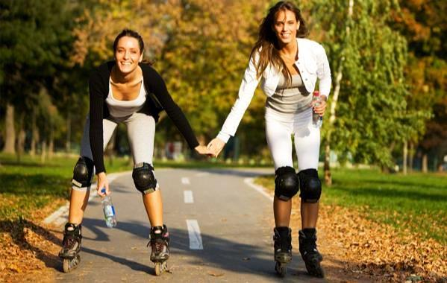

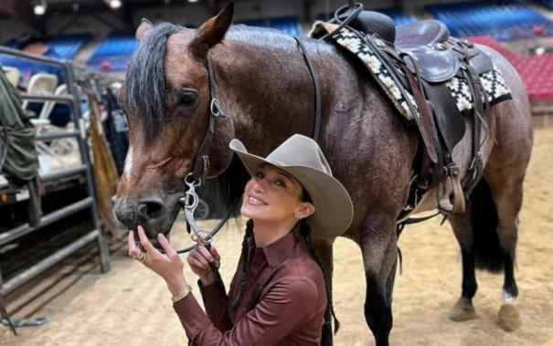
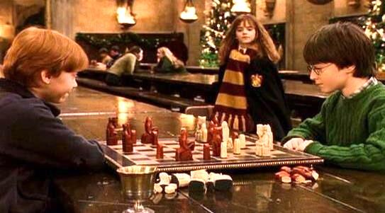

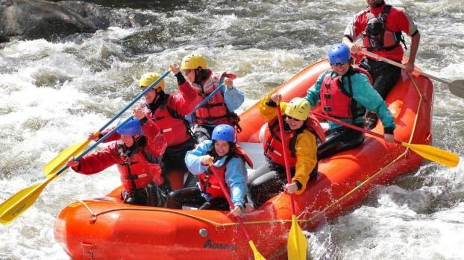

EXERCISE 2. Match the notions with their definitions
- embroidery | a. the sport or practice of fighting with swords, especially foils or épées
- sledding | b. involves collecting, arranging, and decorating photos, memorabilia, and other personal items in a book or album to preserve memories
- abseiling | c. the art or craft of making objects out of clay by shaping and then firing them in a kiln.
- archery | d. the act of drawing aimlessly or absentmindedly.
- pottery | e. the activity of swimming underwater while using a snorkel to breathe
- snorkeling | f. the sport or practice of shooting arrows with a bow at a target.
- fencing | g. the art or craft of decorating fabric or other materials with needle and thread or yarn.
- doodling | h. the activity of descending a steep rock face or cliff using a rope.
- white-water rafting | i. the activity of riding on a sled down a snowy hill or slope.
- scrapbooking | j. an outdoor recreational activity where people navigate a river in an inflatable raft, usually over fast-moving, turbulent water

Which pastime activities require creativity?

Which ones are risky?

Are there any activities from this list that you would like to try?
EXERCISE 3a. Read the words below and decide the hobbies these objects might be helpful for. Answer the question: Which of the following hobbies do you consider expensive to take up?
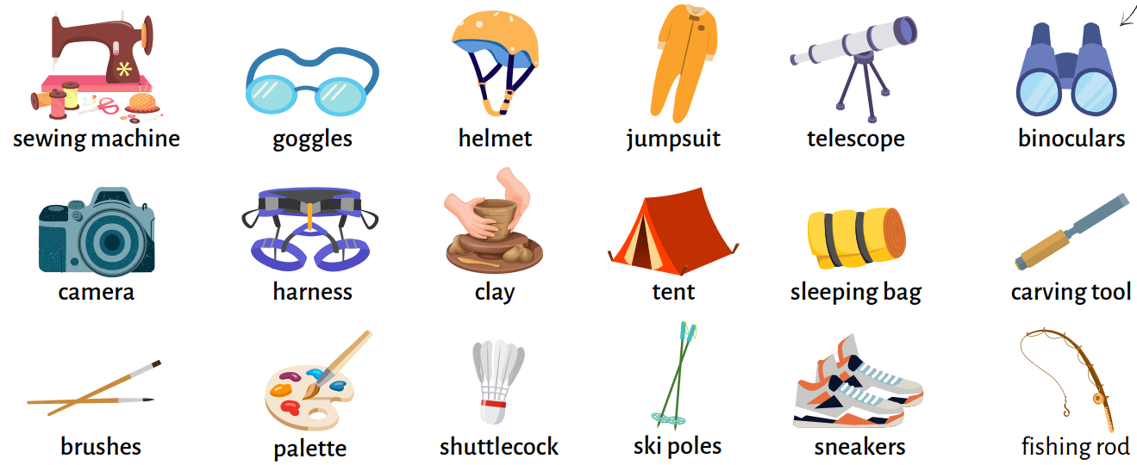

EXERCISE 3b. Work in groups of four.

Explain the given idioms or the hobbies on a card by using Key vocabulary and/or equipment needed for the hobby without naming it. Say if it’s your cup of tea or not and why. Ask your partners if they’ve tried it / would like to try it.

Report your findings.

“In our group, the most interesting hobbies were fencing, scrapbooking, and kayaking. Anna would like to try kayaking because she enjoys water sports, but Dmytro said it’s not his cup of tea because he can’t swim.”

EXERCISE 4. Fill in the gaps with the collocations and idioms from KEY VOCABULARY
to lose track of time, to paint the town red, to kill time, to be really up my street, to burn the candle at both ends, to hone a skill, to sign up for, to seize the moment

- Last year I decided to __________ a yoga class to improve my flexibility, but it was so pricey that I quit after the first class.
- After finishing their exams, the students went out to __________ and celebrate.
- She’s been _____________________ lately, studying all night and working during the day, not thinking about the damage it may cause to her health.
- While waiting for the train, I played a game on my phone just to __________.
- This new course in photography is __________ – I love taking pictures!
- My teacher always says that practicing writing every day helps you __________ and get better at it.
- I was so immersed in reading that I ____________, and suddenly it was midnight, leaving me with no time to do my homework.
- Life is short, so don’t wait too long – sometimes you just have to __________.

Answer the questions provided below
- When was the last time you completely lost track of time doing something fun or interesting?
- Have you ever painted the town red with friends? What did you do that night?
- What’s your favorite way to kill time when you're waiting for something or someone?
- Can you think of a hobby or activity that is really up your street? Why do you enjoy it so much?
- Have you ever felt burned out because you were burning the candle at both ends? What were you juggling at the time?
- Is there a skill you're currently trying to hone? How are you going about improving it?
- Have you ever impulsively signed up for something and ended up loving it? What was it?
- Can you share a time when you decided to seize the moment and do something spontaneous?

EXERCISE 5. Work in pairs. Create a dialogue using Functional language below providing good and bad points of each hobby from the following table.

Hobby | Good points | Bad points
Chess | relaxing | not get any exercise
Archery | exciting, satisfying | needs special equipment, expensive
Cookery | rewarding, creative | tiring, needs a lot of equipment
Karate | good form of exercise, challenging | high risk of injury, violent
Indoor rock climbing | fascinating way of spending time, rewarding | dangerous, risk of serious injury
Calligraphy | tends to calm the emotions and relieve stress | requires a lot of time to develop a skill
Your variant (name of the hobby)
Example:
A: What do you like doing in your spare time?
B: Personally, I adore playing chess because it is relaxing and I can always spend time with my friend playing it. What about you?
A: Playing chess doesn't really hold my interest because I don't get any exercise. I`m obsessed with archery…
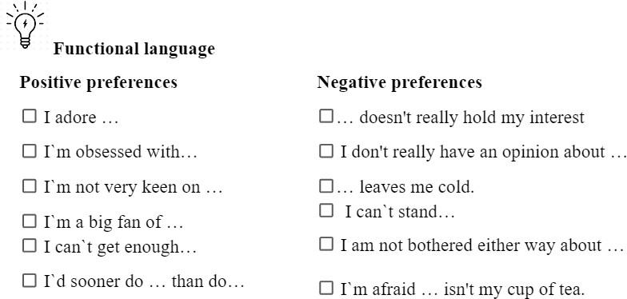

EXERCISE 6. Work in pairs, and decide which of the activities from the table above and Key vocabulary section you would recommend for:
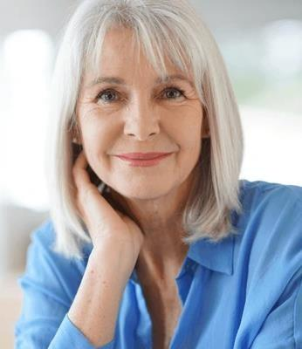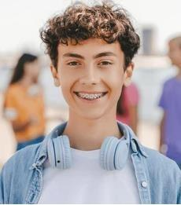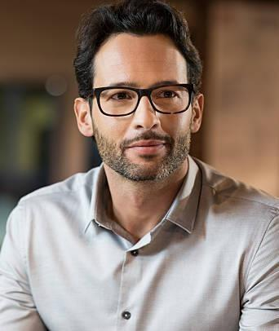
Susan | Bill | Tony
(a 50-year-old housewife) | (a 17-year-old teenager) | (a 32-year-old businessman)

Model:
A: I would definitely recommend pottery for Susan as it is quite creative. What do you think?
B: I agree. Pottery would give her the chance to relax and create at the same time.

TEXT
Pursuing hobbies on your own terms
Turning a hobby into a true leisure activity hinges on one critical feature: freedom of choice. When we get to choose how we engage with a hobby, it can become more than just another pastime or pursuit that can still elevate stress and muddle enjoyment. It can become a source of joy and well-being, with a host of both emotional and physical benefits.
Ideally a hobby allows you to explore—new people, new skills, new ways to think—and also allows you to escape the stressfulness of your thoughts. If we felt we had to live up to a norm on how to do a hobby, this would put us right back in school or in the workplace where we find ourselves doing things we don’t like and may doubt ourselves.
Every hobby has its own world, with people passionate about the activity. Some of those people may try to impose rules or guidelines to tell others what a hobby should look like. For those looking to start a new hobby it can be a bit daunting. We may worry about failing or wasting time and money on something we end up not enjoying.
In general, it would be good to pursue hobbies that we enjoy and to pursue them in a way that fits with our lives—our availability, our skill and engagement levels, our ability to financially commit. But sometimes we don’t know what will make us happy, or maybe we don’t know how to start a new hobby we are intrigued about. The people we are close with sometimes know us better than we know ourselves and can be our guide. They can give us encouragement and the needed boost to try something new. It is about the balance between being challenged to try something versus feeling forced to do something we might not want to do.
Over a couple of generations, Americans have somehow misplaced their free time. The lesson here is that tasks tend to absorb as much time as you’re willing to give them. According to Kurtz, not many of us are legitimately super-busy; instead, we habitually waste time, creating the illusion of busyness. Busyness can be difficult to put aside. Culturally, it seems to be a measure of status and significance. If you’re one of the people stuck in the habit of wasting time, hobbies can help break the dead-end routine. Active leisure can promote that feeling of losing yourself in doing, and that “flow” is one of the things worthy of putting on the schedule.
When exploring a self-selected leisure activity (let’s just call them hobbies), it’s important to find something to give a sense of meaning and purpose, whether that’s through social interaction with others in a volunteer organization or community group, or an activity that brings enjoyment, spurs creativity or encourages physical activity. They help get us out of our heads and stop all the thinking about stress, burning the candle at both ends, that actually seems to be what makes us sick.
Hobbies have proven to be important at any age, especially during transitions through different roles, like becoming a parent or primary caretaker, or after moving or retirement. In all of these situations these hobbies allow us to keep understanding and exploring who we are. Hobbies also give us a chance to create new social bonds and avoid isolation and loneliness that can be so dangerous as we get older.
There can be an element of guilt that some may feel when engaging in hobbies, whether pressure placed from family or friends who think you’re wasting time, or from within yourself a feeling of not being productive enough. In a recent study the guilt puts so much stress on people it is almost better not to do leisure activities at all than to do them and feel guilty about it. So, we need to treat our hobbies as a path to well-being the same as if we were given a prescription to take.
Some people need intensity and excitement to feel engaged. But it’s also true that a thrill-seeking person who loves to jump out of airplanes may also crave calligraphy. Research indicates that any healthy hobby that you enjoy is good for you, so choose based on appeal and the kind of experience you’d like to have. As you hunt for a hobby, clues can be found in your childhood. What did you migrate toward as a tot? Do your favorite memories suggest an activity that you could take up again?
If a hobby initially sounded good but you find it harbors a dread factor, then dump it. You have plenty of things in life that you must do, so your hobby shouldn’t be overwhelming or boring. That said, it’s important to note that hobbies are like any other pursuit in life: you get out what you put in. Before you move on to something else, really give your hobby a chance through passionately engaging it and trying to learn something new.
Adapted from InHabit magazine

READING COMPREHENSION QUESTIONS

I. Discuss the following questions:
- What are some of the benefits of engaging in a hobby that the text mentions? Use the list of hobbies from the KEY VOCABULARY section and name the pros of pursuing at least 4 of them.
- Why might some people feel guilty about pursuing hobbies?
- According to the text, how does “busyness” affect people’s engagement with hobbies?
- What role can friends and family play in helping someone start a new hobby? Has anyone influenced your choice of doing any of your hobbies?
- Have you ever felt pressured to do a hobby by your friends or parents? How did that affect your experience?
- Is there a hobby from your childhood that you’ve considered revisiting? What drew you to it then, and does it still appeal to you now?
- How do you personally balance the desire for productivity with the need for restorative leisure time?
- Why is it important to “give your hobby a chance” before giving up on it?

Classroom extra: Scan the QR code and watch the video and answer TRUE/FALSE questions below

- People are usually really confused when Mike tells them that he owns a fingerboard company.
- Skateboarding makes him feel awesome. It's always a challenge. There are no rules. Finger boarding doesn't have that.
- He wanted to improve and modify his fingerboards and this is how he started his hobby.
- A lot of kids wanted to buy them, so he kind of put a name on them and it grew into this huge business.
- Mike organizes huge events where kids fly in from all over the place to come and fingerboard together.
- He does warm-ups and exercises for his fingers before the contests.
- It makes him super happy, because he can barely believe that he is the reason they are there.

SPEAK OUT
You are new in your group and want to find friends. One girl/boy approaches you and asks about your hobbies. You have a lot in common but she/he tries to persuade you to start a hobby you don`t like.
Task: Complete the dialogue between two groupmates discussing different hobbies. Use Key Vocabulary

UNIT 2
EMBRACE YOUR NATURAL BEAUTY

KEY VOCABULARY
Facial features: broad, narrow, lined forehead; rosy, chubby, hollow cheeks; high cheekbones; double, pointed, split chin; false, long eyelashes; bushy, pencil-thin, plucked eyebrows; straight, aquiline, snub nose; almond, round, close-set, wide-set, squint, puffy eyes; thin-faced, round-faced, dark-faced, pale, tanned, light-skinned (complexion); full, thin lips; wrinkles, freckles, a wart, mole/birthmark, pimples, a scar, a bruise
Hair: thick, thin hair, auburn, ginger, ash-blonde, dyed hair, curly, wavy, straight, with permanent waving, spiky, shoulder-length, receding hairline, bald patch, glossy, greasy, with split ends, hair in plaits, in a bun, back-combed, crew-cut, stubble; clean-shaven, bald, with a ponytail, with side parting, long sideboards, fringe, moustache
Adjectives and phrases: be the spitting image of someone/to look like two peas in a pod, to be like chalk and cheese, to be easy on the eyes/a sight for sore eyes, beauty is only skin-deep, looks can be deceiving, to have a bad hair day, to wear one's hair down, to go grey; curvy, skinny, slender, thin, slim, plump, a bit overweight, obese (constitution); handsome, scruffy, stocky/well-built, muscular, smart
Comment on the following quotation. To what extent do you agree with that? “Beauty is in the eye of the beholder“– Margaret Wolfe Hungerford

EXERCISE 1. Describe people below by using the words from KEY VOCABULARY
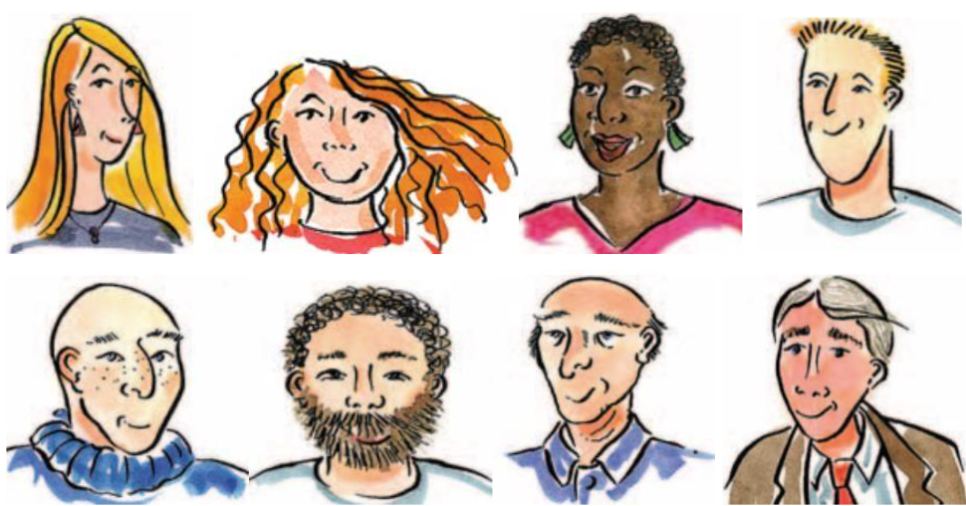
Example
He used to have black hair but now it’s gone grey, almost white.
EXERCISE 2a. Read a witness statement made to the police about a robbery and underline collocations to match the phrases 1-10.

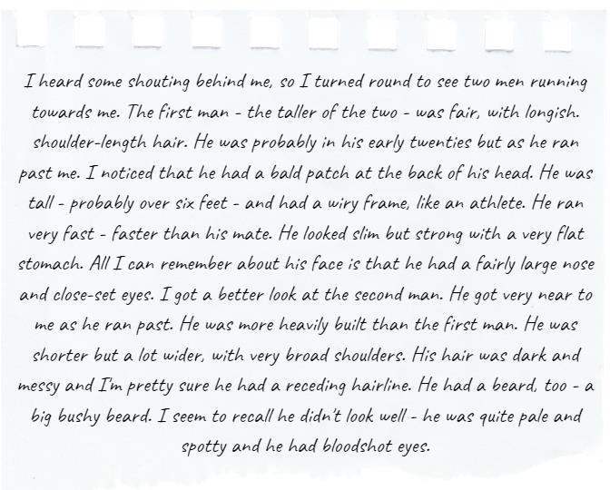

- a line where the hair starts on a man's forehead which is higher than usual because some hair has fallen out
- having a body that is wide and strong
- a wide top of the back
- no fat on the front of the body
- an area of thick hair on a man's chin
- eyes which are red on the part that should be white
- quite long hair that reaches the bottom of the neck
- an area on the head where there is no hair
- a body that is thin but strong
- eyes that are nearer to each other than is usual

EXERCISE 2b. Answer the questions
- Do you find any features described in the text above attractive?
- Have you ever faced the problem of being judged by your appearance?
- Do you think people can be biased towards people with pleasant appearance?
- If a criminal was drop-dead gorgeous would a judge reduce the sentence for him?

EXERCISE 3a. A magazine interviewed three men, asking them to describe their appearance and say what they thought was their 'best feature' (most attractive part, usually of the face). Read their descriptions and match the pictures A-C to the texts 1-3.

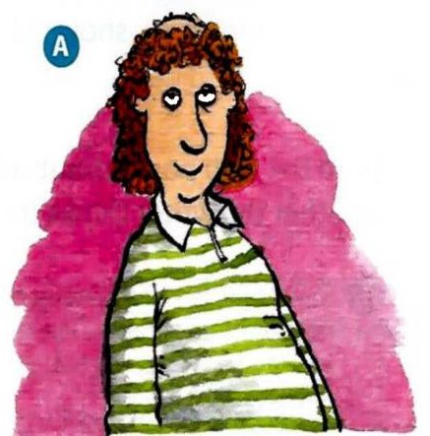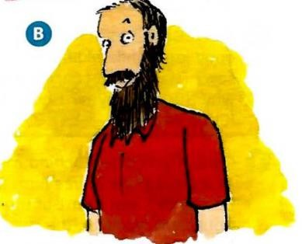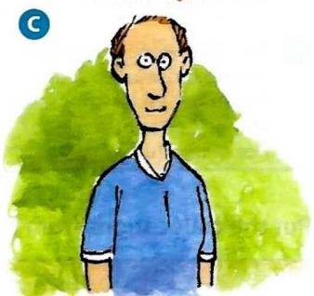

JOHN I'm quite heavily built, though I don't think you'd describe me as fat. I inherited my father's broad shoulders which I'm quite proud of. I've got a few lines around my eyes now I'm in my forties but I've got very little grey hair, which is lucky at my age. I have a beard which used to be quite long but I keep it neatly trimmed nowadays. I'm not sure what my best feature is - perhaps my dark hair?
MARCO I suppose I'm of medium height for a man and, like both my parents, pretty slim. I used to do a lot of running when I was younger and I have the typical long-distance runner's wiry frame. I have blond hair from my mother's side of the family which I'm quite proud of. My eyes are probably my best feature - they're quite big and people say they're very expressive.
HENK I've always struggled with my weight. but I've been going to the gym a lot recently so I've got a fairly flat stomach. I've still got a lot of hair and it is quite nice and curly. It's always been my best feature so I keep it a bit longer than most men my age. I've improved my diet a lot recently and I think it's really made a difference to my appearance. My skin is looking better and my eyes are bright.
EXERCISE 3b. Are the descriptions in Exercise 3a accurate? Complete the notes in the table for each man. Your notes should include all ten collocations from Exercise 2.

Name | Accurate information | Inaccurate information | Missing information
John | heavily built broad shoulders | says: neatly trimmed beard  but truth is: bushy beard
Marco
Henk

EXERCISE 3c. Work in two teams. Describe the appearance of 2 people from the opposite team so they can guess who you are talking about.

EXERCISE 4. Read the web posts about celebrities spotted by members of the public. Decide whether the writer thinks the celebrity is looking good or not.
Then prepare a description of one of these actors’ appearances.
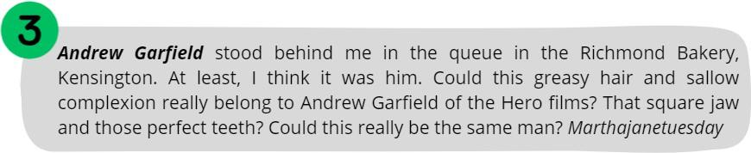
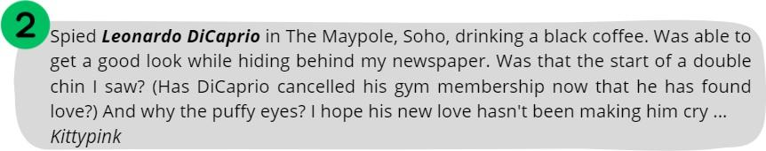
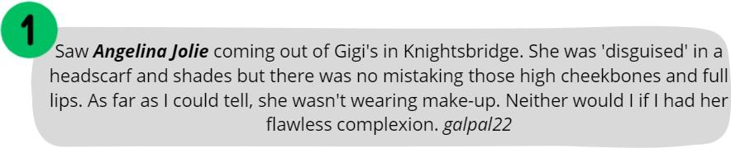

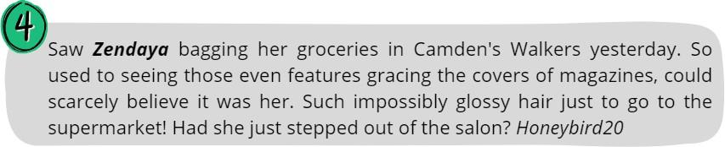

EXERCISE 5. Complete and answer the questions with the words from the box to form collocations. Create your own dilemma question by using KEY VOCABULARY, make it difficult for your groupmates to choose from

“Would You Rather...?”
puffy • bushy • glossy • flawless • greasy • high • double • square • full • sallow • pale

- Would you rather have ________ complexion but constantly _________ hair, or _________ hair but struggle with pimples?
- Would you rather have perfectly _________ cheekbones but a noticeable ______chin, or a strong jaw but very hollow cheeks?
- Would you rather have naturally________ eyes that make you look tired, or a lined forehead that makes you look older?
- Would you rather have stunning ___________ lips but very thin hair, or incredibly thick hair but thin lips?
- Would you rather have a _________ complexion that never tans, or constantly deal with a shiny forehead, no matter the weather?
- Would you rather be praised for your ________ eyebrows and perfect teeth, but have a slightly crooked nose?
EXERCISE 6. Write 3 sentences to describe facial features, hair, and constitution that come to mind when you imagine a typical:
  - boss d) an actor in a romcom
  - Queen e) housewife
  - musician f) grandmother/grandfather

EXERCISE 7. Look at pictures of celebrity siblings. Can you see any differences in their appearance? Describe how similar or different they are


EXERCISE 8. Use the words presented in a box to fill in the gaps according to the context
puffy eyes, like chalk and cheese, false eyelashes, pimples, long sideboards, fringe, split chin, aquiline nose, wart, the spitting image of
- During her teenage years, she struggled with _______________that affected her confidence.
- He had a ____________________on his left hand that he planned to have removed.
- Her new hairstyle included a ____________________ that perfectly accentuated her eyes.
- His __________was a distinctive feature that he inherited from his father.
- For the photoshoot, she decided to wear to enhance her look.
- His_____________gave his profile a striking and classical look.
- Jane is __________her grandmother, with the same bright blue eyes and warm smile.
- After a long night of studying, she woke up with ______________that no amount of makeup could fully conceal.
- He had a vintage look with his , reminiscent of the classic styles from the 1970s.
- Even though they are twins, Sarah and Emily are ____________when it comes to their personalities.

TEXT

The idea of beauty is always shifting. Today, it’s more inclusive than ever
The definition of beauty has continued to expand, making room for women of color, obese women, women with vitiligo, bald women, women with grey hair and wrinkles. We are moving toward a culture of big-tent beauty. One in which everyone is welcome. Everyone is beautiful. Everyone’s idealized version can be seen in the pages of magazines or on the runways of Paris.
We have become more accepting because people have demanded it, protested for it, and used the bully pulpit of social media to shame beauty’s gatekeepers into opening the doors wider. Beauty is, of course, cultural. What one community admires may leave another group of people cold or even repulsed. What one individual finds irresistible elicits a shrug from another. Beauty is personal. But it’s also universal. There are international beauties—those people who have come to represent the standard.
For generations, beauty required a slender build but with a generous bosom and a narrow waist. The jawline was to be defined, the cheekbones high and sharp. The nose angular. The lips full but not distractingly so. The eyes, ideally blue or green, large and bright. Hair was to be long, thick, and flowing—and preferably golden. Symmetry was desired. Youthfulness, that went without saying.
This was the standard from the earliest days of women’s magazines, when beauty was codified and commercialized. The further one diverged from this version of perfection, the more exotic a woman became. Diverge too much and a woman was simply considered less attractive—or desirable or valuable. And for some women—black and brown or fat or old ones—beauty seemed impossible in the broader culture.
We know that beauty has financial value. We want to be around beautiful people because they delight the eye but also because we think they are intrinsically better humans. We’ve been told that attractive people are paid higher salaries. In truth, it’s a bit more complicated than that. It’s really a combination of beauty, intelligence, charm, and collegiality that serves as a recipe for better pay. Still, beauty is an integral part of the equation.
But on a powerfully emotional level, being perceived as attractive means being welcomed into the cultural conversation. You are part of the audience for advertising and marketing. You are desired. You are seen and accepted. When questions arise about someone’s looks, that’s just another way of asking: How acceptable is she? How relevant is she? Does she matter?
Today suggesting that a person is not gorgeous is to risk social shunning or at least a social media lashing. What kind of monster declares another human being unattractive? To do so is to virtually dismiss that person as worthless. It’s better to lie. Of course, you’re beautiful, sweetheart; of course you are.
We have come to equate beauty with humanity. If we don’t see the beauty in another person, we are blind to that person’s humanity. It’s scary how important beauty has become. It goes to the very soulfulness of a person.
Beauty has become so important today that denying that people possess it is akin to denying them oxygen.
Adapted from National Geographic

READING COMPREHENSION QUESTIONS

Discuss the following questions:
- How has the definition of beauty expanded in recent years, according to the text? Do you agree with this expansion? Why or why not?
- In what ways has social media influenced the acceptance of diverse beauty standards? Do you think this influence is primarily positive or negative?
- How do you personally define beauty? Has this definition changed over time? If so, what influenced the change?
- The text mentions “international beauties.” Who are some individuals that you think represent these universal beauty standards, and why?
- How has the fear of social shunning or backlash on social media changed the way people discuss beauty and attractiveness?
- Discuss how the expansion of beauty standards might influence other aspects of society, such as fashion, entertainment, and personal relationships.
- The text suggests it is better to lie about someone's beauty to avoid social backlash. Do you think this approach is sustainable or ethical? Why or why not?
- How do you think the changing standards of beauty will impact future generations? Will these changes be for the better or worse?

Classroom extra: Scan the Qr code and watch the video. Would you like to take part in the same experiment?
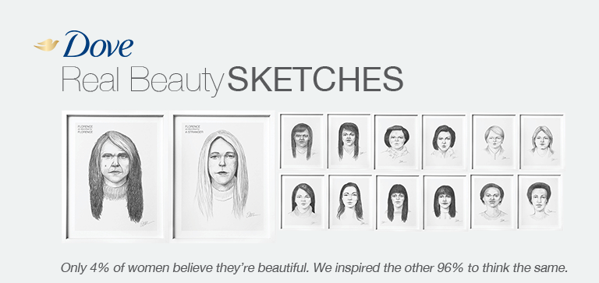


SPEAK OUT
Work in pairs and create two original fictional characters (for a book, movie, or game). Provide description of appearance using detailed vocabulary (face, body, hair, etc.) from Key vocabulary section

UNIT 3

UNDERSTANDING HUMAN BONDS

KEY VOCABULARY
Family ties: an extended family, an immediate/nuclear family, a close-knit family, maternal instinct, late husband/wife, stable upbringing, physical resemblance, striking resemblance, family gatherings, to nurture, in-laws, marital status, separated, widowed, a patchwork family, a widow/widower
Relationships - positive aspect: soul mate/kindred spirit, to admire, to worship, to date with sb, to rely on sb, love at first sight, to fall head over heels in love with sb, to be infatuated with sb, to get on like a house on fire, to be an apple of sb's eye, to be faithful to sb, to go through a rough patch, to hit it off, to be on the same wavelength, to have a soft spot for someone, to enjoy each other's company, to have a lot in common, to get to know each other, to pop the question, to settle down, to tie the knot, to be a shoulder to cry on, to clear the air, to bury the hatchet, through thick and thin, to look up to sb, to have eyes for sb, significant other, engagement/to be engaged to sb, to be joined at the hip, go the extra mile for sb, walk on eggshells around sb

Relationships - negative aspect: to be incompatible, adultery, to be separated, to be bitter rivals, to look down on sb, to humiliate, to split up, not to see eye to eye with sb on sth, family feud, to feel aversion, to be on bad terms with sb, to have grudge against sb, to be fed up with sb, to betray, to be indifferent of sb, to give sb a cold shoulder, to fall out with sb, unrequited love, rivalry, to drift apart, give sb the silent treatment, burn bridges

Comment on the following quotation. To what extent do you agree with that? “Some people come into our lives and leave footprints on our hearts and we are never ever the same.” – Flavia Weedn

EXERCISE 1. Look at the pictures below. What kind of problem is depicted?
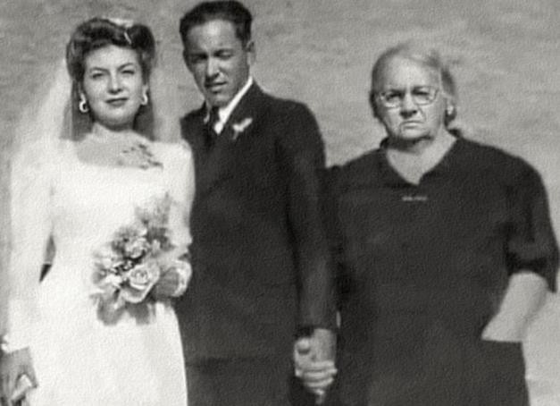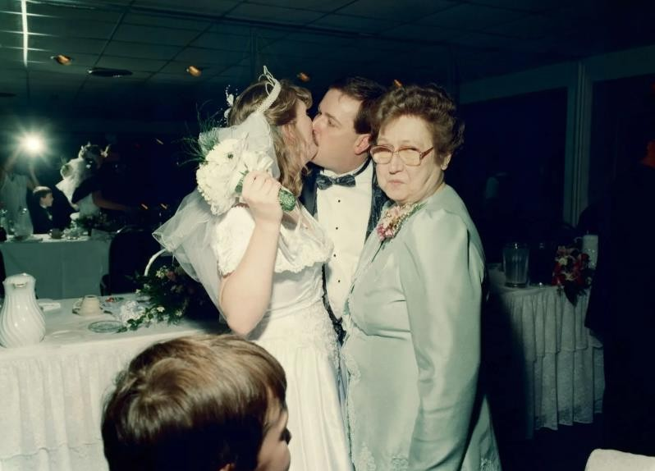

- What is your view on marriage? Do you believe it is old-fashioned to make it official?
- Are there more benefits or drawbacks to getting married in Ukraine nowadays?
- What is the right age to get married in Ukraine? And to have children?

EXERCISE 2. Match words on the left with words on the right to complete the expressions. Then use the expressions to complete the questions below and provide your opinion.
- bitter | a) family
- bury | b) love
- love | c) on the same wavelength
- striking | d) head over heels in love with somebody
- unrequited | e) the hatchet
- be | f) rivals
- close-knit | g) status
- fall | h) at first sight
- marital | j) other
- significant | k) resemblance

- Can ______________ be considered a form of emotional abuse if one person persistently pursues another?
- In what ways can a __________ positively or negatively influence one's social circles and friendships within a relationship?
- Do you believe in ___________, or is it just an infatuation that fades over time?
- Is it healthy to __________ without truly knowing their character and values?
- Can two people with a history as _____________ truly move on and build a healthy romantic relationship?
- Does a __________ between partners in a relationship indicate compatibility, or is it merely a coincidence?
- How important is it for couples to ____________ about major life decisions, and can a relationship survive if they are not?
- Should __________ be a significant factor in professional opportunities and social standing in modern society?
- When is it appropriate for ex-partners to __________ and become friends, and what are the potential risks involved?
- In a _______________, is it acceptable for individual members to prioritise their own ambitions over family expectations?

EXERCISE 3. Complete the groups of collocations with words from the box. Then answer the questions below.

family relative acquaintance friends

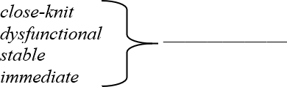
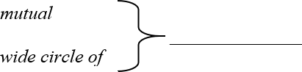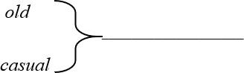
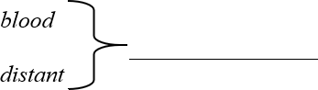

- Do you keep in touch with your distant relatives?
- How many mutual friends do you share with your best friend?
- Do you have a wide circle of friends, or prefer a small group?
- Do you consider any of your old acquaintances as real friends now?
- Have you ever become close with someone who started as a casual acquaintance?

EXERCISE 4. Match the problems 1-8 to the advice a-h. What else can you suggest to solve the problems?
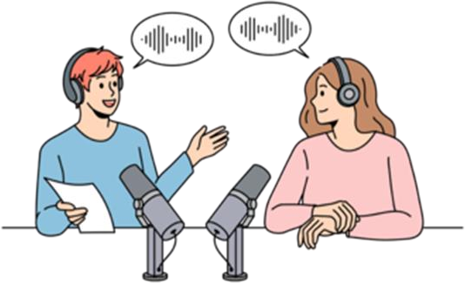
Need advice? Not sure what to do or who to turn to? Remember, a problem shared is a problem halved.
1. I`m madly in love with my best mate`s boyfriend. I`ve tried not to be but I'm crazy about him - I think about him all the time. I feel so guilty. What should I do? | a. Forget it - this relationship is doomed. Always remember the golden rule: never mix business with pleasure
2. I met a woman while I was holidaying in Spain earlier this summer and I am completely and utterly in love. Do holiday romances ever last? Is there just one person out there who met the love of their life on holiday? Please say there is. | b. You can`t. You have got to let her make her own mistakes. If she`s daft enough to rush into a second marriage so soon, that`s her own decision
3. I met a girl on a train last week and I swear, the moment I looked at her face, I knew she was the one for me. Could this be possible? Does love at first sight actually happen in real life? | c. Are you mad? What`s more important to you - a friend for life or a passing passion? Come on, girl, you can do better!
4. I`ve fallen in love with my boss. I know it's wrong but I`m crazy about him and I strongly suspect the feeling is mutual. | d. Well, my best mate met her husband (Lars) while travelling round Norway eight years ago. They`re as in love today as they` ve ever been.
5. I moved cities last year to be with a guy that I`d had a whirlwind romance with. I left my friends and my job - everyone said I was crazy at the time. The thing is, the passion has started to cool and I'm now wondering whether they were right… | e. No, your feelings are totally natural - it`s just a bit of shock. You`ll get used to it in time and they`re still your friends, even though they`re an item.
6. I`m finally single again after a particularly messy divorce and feeling very cynical about relationships generally. Will these negative feelings pass? | f. Personally, I doubt it. I think it`s more likely you just really fancy her.
7. Three months after a quickie divorce, my best mate has started a new relationship and she's already talking about marriage. How can I talk sense into her? | g. They will - but give yourself time and don`t put pressure on yourself to find a new partner.
8. Romance has recently blossomed between two of my best friends and I`m ashamed to say, I`m feeling a bit left out. Am I being silly here? | h. Well you can`t say they didn`t warn you. Maybe it`s time to call it quits and go back to your mates. Hey, we all make mistakes!

EXERCISE 5. Choose the statement in each pair about what love is in your opinion. Explain your answer

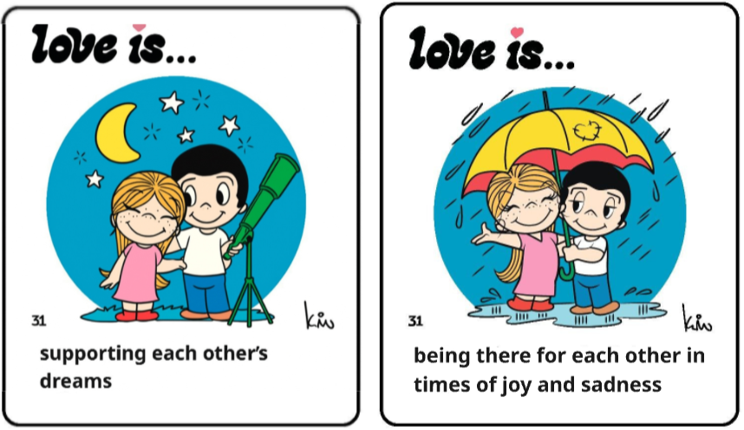
- sharing inside jokes that only the two of you understand OR holding hands while taking a walk
- surprising your partner with a small gift just because OR visiting and helping your partner's parents
- watching your partner's favourite film when you don't really like it OR giving each other space and time when needed
- agreeing to play board games, even if you're secretly terrible at them OR being patient and understanding, especially during difficult moments
- watching your partner's favourite film when you don't like it OR sharing the last piece of dessert.

EXERCISE 6. Read the dialogue below between Sarah and Emily, two friends discussing the complicated friendship between their mutual friends, Lisa and Jane. Fill in the gaps with the words from the box. Finish it up with your own ideas.

kindred spirit to get on like a house on fire a shoulder to cry on to be on the same wavelength to have a grudge against sb rivalry to drift apart to bury the hatchet


Sarah: Emily, have you heard about Lisa and Jane? They used to 1) back in high school.


Emily: Oh, I remember! They were always 2) _________________about everything.

Sarah: But something happened. Lisa told me that Jane was her 3) _____________ during her breakup with Mark.

Emily: Really? I heard they started to 4) after college.

Sarah: Yeah, but Lisa still considers Jane her 5) . However, their old 6) over Alex resurfaced at the reunion.
Emily: And Lisa never 7) Jane for that. But did
you hear about Jane's secret?

Sarah: No, what secret?

Emily: Apparently, Jane has been hiding something major from Lisa. Now Lisa doesn’t know if she can trust her again.
Sarah: Wow, I wonder if they can 8) and move forward. Anyway, do you know what secret she is hiding?

EXERCISE 7. Study the table below and answer the following questions. Then at home scan the QR code and do the questionnaire to identify your personal love language.

 | HOW TO COMMUNICATE | ACTIONS TO TAKE
Words of Affirmation | Encourage, affirm, appreciate, emphasize, listen actively | Send an unexpected note, text, or card. Genuinely encourage, and often.
Physical Touch | Non verbal - use body language and touch to express love | Hug, kiss, hold hands, show physical affection often. Make intimacy a thoughtful priority.
Receiving Gifts | Thoughtfulness, make your spouse a priority, speak purposefully | Give thoughtful gifts and gestures. Small things mater in a big way. Express gratitude when receiving a gift.
Quality Time | Uninterrupted and focused conversations. One-on-one time is critical | Create special moments together, take walks and do small things with your partner. Weekend getaways are huge.
Acts of Service | Use action phrases like “I’ll help…” They want to know you`re with them, partnered with them. | Do chores together or make them breakfast in bed. Go out of your way to help alleviate their daily workload
- Which love language do you think you identify with the most: Words of Affirmation, Acts of Service, Receiving Gifts, Quality Time, or Physical Touch?
- Do you think love language can differ in accordance with expressing it to your family or friends?
- How do you prefer to show love to your partner?
- How does your partner’s love language differ from yours?
- Can you share an example of a time when a family member expressed their love in a way that was meaningful to you?
- How do you and your siblings support each other’s love languages?
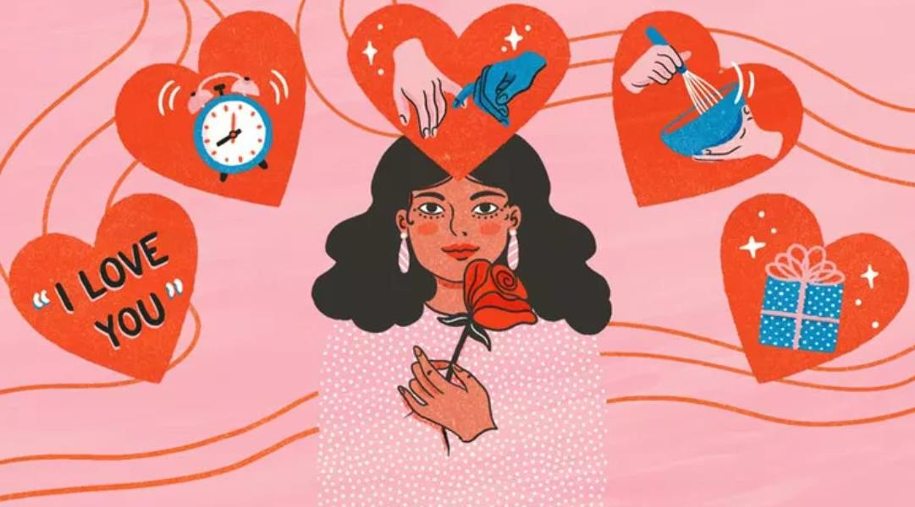


TEXT

Live a family life, not a long-distance one: stories of Ukrainian couples in long- distance relationships
When the war broke into the lives of Ukrainians, the relationships of hundreds of thousands of couples changed to the format of long-distance relationships. Here are collected the stories of three couples who must fit their love into correspondence and short calls, miss each other and build a family despite thousands of kilometres. According to the Ministry of Justice statistics, in 2022, 17,893 couples decided to end their marriage. This is much less than the previous year, but, as psychologists note, official statistics for Ukraine do not show the actual state of affairs because now, spouses often break up via phone without submitting documents for an official divorce.
Kharkiv residents Victoria and Yevhen have been married for 16 years. In April 2022, a Viktoria with two children — a 3.5-year-old daughter and a 14-year-old son — evacuated from the city, mercilessly bombed by the russian invaders, to Poland. Victoria's husband stayed to defend Ukraine.
"Before the start of the full-scale invasion, we were an ordinary family. Zhenya is an event hosted by trade. He never had any military experience but could not just sit at home, so he went to the Military Commissariat to join the Armed Forces of Ukraine ranks," Viktoria continues. "We stayed in the Kharkiv region for a month and then decided to go to Warsaw to visit our children's godparents. Zhenya said he would feel better if we were safe." Viktoria shares.
Over the past year, Victoria saw her husband once — in the summer. He is a material support sergeant and went to the west of Ukraine to get a car, and his family came to see him. What helps them maintain a long-distance relationship?
"It's difficult, but we are constantly working on this issue," admits Victoria and shares her life hacks. "I always listen when he needs to share something. We send a video on Telegram every morning wishing him a quiet and peaceful day — this is our tradition." I give him little surprises on all our family dates; he doesn't always receive them on the exact day, but a family friend who stayed in Kharkiv helps me by being my courier. And, of course, we always try sending each other something romantic and intimate, only ours with my husband. Long-distance relationships are tough. But now there is no other way" concludes Victoria.
Andrii has been in the ranks of the Armed Forces for several years, and Valentyna is now in Kyiv. They met in 2018 and have been together for four years. Andrii survived captivity and the Battle of Ilovaisk, one of the bloodiest battles of the Ukrainian resistance in the east of Ukraine in August 2014. "Andrii spends at home about ten days every half a year. This format of relations is not everyone's cup of tea, and the war only adds complications, but we try to cope with it," Valentyna continues. "In our relationship, I decided not to be a victim, saying, 'I'm so unhappy because I'm dealing with a child here alone.
'On the contrary, I try to support and encourage my husband because it is not easy for him there. He promised to cook me borscht someday. He must protect himself, at least for this purpose! I tell him how much I want borscht, but I don't have time to cook it with a child… Honestly, he's worried I'll get tired of waiting because many women can't handle that kind of long- distance family life. But I have my arguments for these fears: I've been waiting for a man for 40 years, I've dreamed about him to the last detail, and when I met you, I was shocked that everything I thought of came true. And now I have to leave you?" Valentyna says.
As for daily routine, Valentyna shares that the family has an agreement: in the morning, Andrii must find an Internet source and text "good morning" and something pleasant. If he knows there will be no reception soon, he warns Valentyna, so she doesn't worry. "Humor helps a lot in living apart. For example, our little son knows his dad is "at work." He also waits for him and often tells me how dad will come and go to the store himself, and we will rest and play. So I tell my husband to take care of himself because we will be without food if something happens to him," Valentyna continues. "Of course, sometimes we fight like everyone else. But in such cases, I tell him: I have a baby in my arms and don't have time for a divorce. If you want it, come and do it yourself. That's how we make up," the woman laughs.
Dana and Roman are from the Volyn region. They have been married for a year and a half, but they have been together for four years. Roman is at the front in the Donetsk direction. Dana waits for him at home, volunteers, and collects funds for the necessary equipment for her husband's unit.
"Honestly, I don't even know what our secret is. Long-distance relationships during wartime are tough, especially when you know your loved one is risking their lives daily," Dana continues. "For those who, like me, are not with their husband now, I can only advise believing in victory, believing in your loved one, and supporting him at any opportunity. Hold on so that he does not worry and is focused on what he is doing," Dana says. "I always wait for his message because it means he is okay. To be honest, this is the first time we have lived apart.
But if your love is true and mutual, then the distance is a stage, after passing which, the relationship will only become stronger." "In fact, it's very simple," says Anna Chechenina, a psychologist. "It's just that the same things have changed their format and require a little more investment of time, energy, and finances to keep a long-distance relationship. Doing everything you used to do for each other is very important because a person's unconscious will always hold on to those thoughts and habits of peaceful life."
Adapted from Rubryka

READING COMPREHENSION QUESTIONS

I. Discuss the following questions:
- How do long-distance relationships during wartime differ from those in peacetime?
- What strategies do the couples in the article use to maintain their connection?
- How important is it to have shared traditions or rituals in a long-distance relationship?
- In what ways can couples show care and affection despite the distance?
- What are some red flags that may indicate a long-distance relationship isn’t working?
- How can couples prepare for the transition from a long-distance relationship to living in the same place?
- Do you know any examples of distance relationships in films or literature? Were they successful?

Classroom extra:
Debates
- "Should individuals seek advice from their parents, who have experienced a happy marriage, about marital problems, even if the parents might be biased and instructive, or should they handle their marital issues privately without involving others?" (MARRIAGE)
- "What are the benefits and drawbacks of living in a nuclear family compared to living in an extended family?" (FAMILY)
- "Is it easier to make friends as a child or as an adult?" (FRIENDSHIP)

SPEAK OUT
Scenario 1: Family Conflict
You are siblings who are arguing because of a family feud over inheritance. One feels betrayed and wants to split up all ties, while the other wants to clear the air.
Task: Complete the dialogue between two siblings in conflict. Use Key Vocabulary

Scenario 2: First Crush
You are talking to your best friend about a new classmate. You feel it was love at first sight, but your friend thinks you’re just infatuated. You both discuss how relationships can grow.
Task: Complete the dialogue between two friends about first impressions and crushes. Use Key Vocabulary

UNIT 4

GET THE IMPRESSION
KEY VOCABULARY
Positive traits: affable, affectionate, courteous, courageous, determined, fair-minded, faithful, fearless, frank, gregarious, impartial, inquisitive, quick-witted, persistent, reliable, self-confident, sensible, sensitive, modest, sincere, sociable, tidy, kind-hearted, laid-back, imaginative, daring, perceptive, thorough, level-headed, obedient, humble
Negative traits: reserved, aloof, arrogant, belligerent, boastful, bone-idle, callous, envious, furious, grumpy, gullible, impatient, indecisive, indignant, irresponsible, jealous, mean, naughty, obstinate, quarrelsome, ruthless, vengeful, insecure, short-tempered, vain, narrow- minded, stingy
Phrases and idioms: to make people feel at ease, to think outside the box, to excel in, to be larger than life, to be a people person, to be cool as a cucumber, to be the pain in the neck, to be a chatterbox, to be an eager beaver, to be a buzzkill, to be full of beans, to be a heart of gold, to be faint of heart, to wear your heart on your sleeve, to bend over backwards, to have your head in the clouds, to rub people the wrong way, to be set in your ways, to play devil’s advocate, to be thick-skinned, a go-getter, a wimp, a cold fish, a wet blanket, to have a screw loose, a mover and shaker, be set in somebody`s ways, a cheapskate, a happy camper

Comment on the following quotation. To what extent do you agree with that? “Personality is to a man what perfume is to a flower “– Charles M. Schwab



EXERCISE 1a. Describe what is happening in each of the photographs. Then discuss the questions below.


● Do the photographs give you any clues about the personalities of the people in them?
● Which, if any, of the people would you like to be friends with? Why?
EXERCISE 1b. Use KEY VOCABULARY to describe personality traits that these people might have.

EXERCISE 2a. Do the personality test below. Share your results with groupmates
KNOW YOURSELF PERSONALITY TEST
How well do you really know yourself? Read each sentence carefully and circle the symbol next to it if you feel it truly describes the real you.
I learn new things fast. | I come up with new ideas.
I feel others’ emotions. | I make new friends easily.
 I do jobs straight away. | I prefer small groups of people.
I like being alone. | I have a soft heart.
I have a vivid imagination. | I usually start conversations.
I make people feel relaxed. | I love helping others.
I like telling funny stories. | I enjoy the arts.
I know myself well. | I keep my things tidy.
I pay attention to details. | I think before I speak.
I love partying. | I plan things in advance.

KEY The symbols represent five different personality types. How many of each symbol did you choose?

_______ ________ _________ ________________

AGREEABLE
You’re kind-hearted and sensitive to the needs of others. Being relaxed, trusting and laid-back, you work well with others. In difficult situations, you’re tactful and avoid hurting people. In fact, you’re very good at making people feel at ease. You’re affectionate and show your feelings. You’re good-natured, friendly and popular.
IMAGINATIVE
You’re artistic and creative and so you have the ability to think outside the box. You’re daring and you’re not afraid to do adventurous things. You’re also quite perceptive and intellectual and have a love of learning.
ORGANISED
You’re thorough – you like to plan things carefully. Being quite strong-willed, you usually get what you want. You’re level-headed and you think things through carefully. In future, you will excel in leadership positions.
DEEP
You’re a deep thinker and you’re not comfortable with small talk. You’re not insecure, but you are quite humble, and you can be a little self-conscious or even self-critical at times. You enjoy your own company, but you’re not a loner – you like being with close friends. Above all, you’re fair-minded and if you feel strongly about something, you’re not afraid to speak up.
SOCIABLE
You’re the life and soul of the party and love being the center of attention. People enjoy your company because you’re witty and spontaneous. You’re larger than life and good fun to be around. However, on bad days you can be moody and short-tempered. Also, there are times when you appear a little self-centered and full of yourself.

EXERCISE 2b. Write a short sentence that summarizes your results. Compare your results with a partner and then discuss the questions.
I am quite deep and fairly conscientious.
- How accurate do you think this personality test is?
- Why do you think people like doing personality tests?
- Can you learn more about a person from a fifteen-minute personality test or a fifteen-minute chat?

EXERCISE 3. Read the descriptions and choose the correct option. Do you have friends that have the same traits of character?

Megan is brave enough to say things that shock people. She’s quite daring / insecure.
- Janet understands difficult concepts and enjoys debating serious topics. She’s
intellectual / witty.
- Tom is diplomatic and is unlikely to upset or embarrass people. He’s very
thorough / courteous.
- Sue has a very gentle, loving nature. She’s extremely perceptive / affectionate.
- Rick never talks about his achievements. He’s very humble / moody.
- Harry believes that most people are good and honest. He’s very spontaneous / trusting.

EXERCISE 4. Draw 3 animals that first come to your mind. Give some characteristics to them by using the adjectives to describe traits of character.
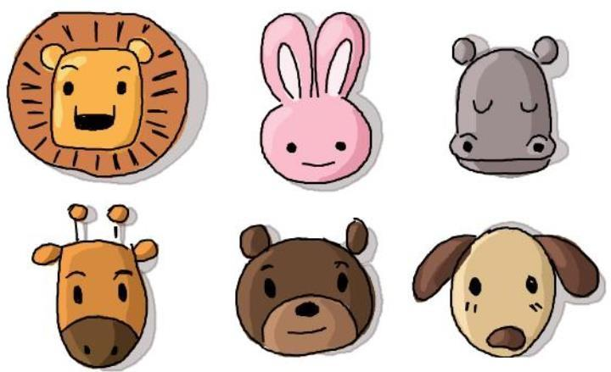

EXAMPLE: A rabbit is very gullible, it trusts everything one can say to it. It is extremely shy and insecure, it is always afraid to talk to strangers or make new people.

EXERCISE 5. Replace the underlined phrases with words from KEY VOCABULARY. Which statements do you agree with and why? Discuss with a partner.
- It’s up to teachers, not parents, to inspire and encourage having a desire for knowledge in children.
- Computers will never replace humans because they can’t view things creatively.
- People often perform better in oral exam situations when they feel comfortable.
- People who have a really high opinion of themselves rarely make good friends.
- Everybody would like to be entertaining on social occasions.

EXERCISE 6. Unscramble the letters to make adjectives that can describe personality and fill in the gaps with the most appropriate word. Do you find any of these qualities in your friends` personalities?
- ggrroieuas - _____________ 5. lueaosj - ______
- ewsi - ________________ 6. ltufiahf - _____
- thuagyn - 7. idandc - _____
- eulnfvge - ______________ 8. coaulls - _____

- Even though he often speaks his mind bluntly, his ___________ honesty is refreshing and appreciated by his friends.
- She always looks to make new friends and loves being around others, thriving in social gatherings due to her _________nature.
- Despite her calm demeanour, she quietly harbours a strong desire to get back at those who have wronged her, revealing her __________side.
- Known for his playful pranks and mischievous behaviour, he's always the life of the party, showing a _________spirit.
- He shows little care for others' suffering, often appearing indifferent and_______.
- She remains loyal and devoted to her friends, standing by them through thick and thin, showing she is _________.
- He is often suspicious and envious of others' success, feeling ________of their achievements.
- With years of experience and knowledge, his advice is sought by many who value his insight and judgement.

EXERCISE 7. Look at the word cloud. Choose the words with any four initial letters from your name that describe you. Add your own words if necessary
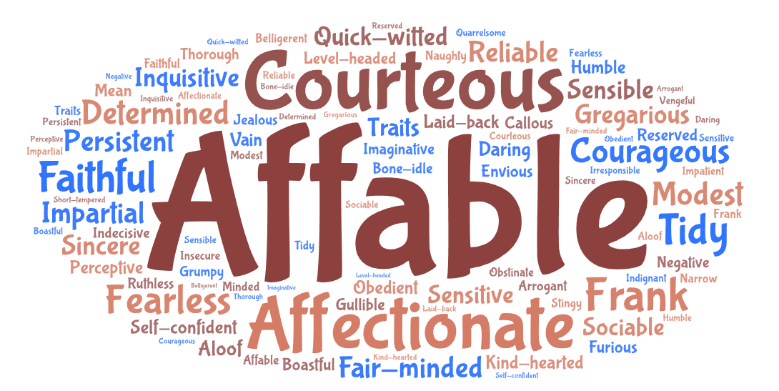

EXERCISE 8. Match the idioms with their meanings

a go-getter | someone who is content, satisfied, and happy with their current situation
a people person | someone who is weak and lacks courage
a wimp | someone who is stingy or unwilling to spend money
a cold fish | someone who is unemotional and distant
a wet blanket | someone who is ambitious, determined, and proactive
to have a screw loose | someone who is influential, powerful, and actively involved in bringing about change
a mover and shaker | someone who enjoys being around and interacting with others
be set in somebody`s ways | someone who is a little crazy or mentally unstable
a cheapskate | someone who is resistant to change
a happy camper | someone who spoils the fun for others with their negative attitude or lack of excitement

EXERCISE 9. Rewrite the following sentences using the personality idioms

1. Jenny is a highly active and influential person in the business world, always thinking of new ideas and ways to improve her industry.

2. She's very stingy with her money and never likes to spend it, so she always looks for bargains.

3. Ever since he was young, he's been always striving for success and working hard to achieve his goals.

4. After receiving a promotion at work, Tom was overjoyed and couldn't wait to celebrate with his friends and family.

5. Every morning, she goes to the same coffee shop, orders the same drink, and sits in the same seat. She hates even the slightest changes.

6. Emma is great at networking and making connections with people, which is why she excels in her job as a sales manager.

7. My neighbour seems a bit paranoid because he keeps complaining about aliens and insists that they're spying on him.

8. Mark was too scared to confront anyone when he was younger, and he regrets not standing up to his bully.

9. Jake always brings negativity into every conversation, which is why his friends don't invite him out as much anymore.

10. Sophia can seem really unemotional, but once you get to know her, you realize she's just shy and has a hard time opening up to new people.

TEXT
From attention-seekers to peace-makers, what your sibling birth order says about your personality
How our rank within our families can determine our personality traits
If you've got siblings, you're probably more than aware of how different each of you are. Whether you're the oldest, youngest or middle child, scientists are convinced that our rank within our families can determine our personality traits.

The first-born child
According to a study by the University of Illinois, eldest siblings tended to be more extroverted, agreeable and conscientious.
The study also found that firstborn children tend to have a higher IQ than those born later - although it was only by a point or so.
Another study by the University of Essex, came to a similar conclusion, noting that the eldest child, especially if female, is statistically more likely to be the most ambitious and well-qualified of their family, as they tend to carry higher aspirations.
The level of attention that parents devote to firstborns is usually much higher, but these children will also be on the receiving end of their parent’s anxieties and the overwhelm of being new parents. Oldest children usually enjoy a period of exclusive attention. Being first gains a child some degree of status in the sibling hierarchy which remains even after their siblings come along.
As older siblings were often left in charge or asked to look after younger siblings, “elder siblings are more likely to feel more organised and able to prioritise their own lives.” Key characteristics of a first-born are: extroverted, smart, ambitious, enjoy taking the lead, organised.

The middle child
According to Jahara, middle children are usually more invested in getting on with others and negotiating for what they need due to being used to sharing resources with their siblings. She says: “Middle children have never known what it is like to have the parent’s exclusive attention, so they come into a world where they are expected to share from the start. Middle children are often called peace-keepers within the family. A middle child may also compete for attention due to their “middle status’ - they are neither the baby or the eldest so they will need to find a way to stand out.”
In the book The Secret Power Of Middle Children, Psychologist Catherine Salmon and journalist Katrin Schumann spoke about how middle children are often dubbed as neglected (we've all heard of ‘middle child syndrome.') Speaking about their research on Psychologies, Schumann said: “Although middles are neglected, both by parents and researchers, they actually benefit from this in the long run. They become more independent, think outside the box, feel less pressure to conform, and are more empathetic. “This gives them great skills as employees and also makes them excellent team players and partners.” She added that, due to their ranking, middle children are more patient, as well as “savvy, skillful manipulators." Key characteristics of a middle child: team players, patient, independent, empathetic, skillful manipulators.

The youngest child
By the time the third child comes along, parents are usually more relaxed about raising their youngest. The older siblings will also play a role in their sibling’s upbringing and so the burden isn’t exclusively on the parents. With the first born being the ‘responsible high achiever', and the middle child the 'peace-maker', the pressure is usually off the youngest. However, this can also lead to them feeling like they are ‘lagging behind’ or are insignificant.
Researchers at the universities of Reading and Birmingham concluded that the baby of the family is more likely to take risks when it comes to business – and, according to The Sunday Times, more likely to become an entrepreneur.
This is supposedly thanks to having a ‘born to rebel’ personality trait that makes them “exploratory, unconventional and tolerant of risk”.
A YouGov study also concluded that the youngest child in a family tends to be more chilled out and have a funny sense of humour. Key characteristics of a younger child: easy-going, funny, risk-takers, entrepreneurial.

The only child
Only children have different influences, no sibling competition, and are the sole focus of parental investment,” Dr. Salmon says. “As a result, parental expectations and pressure can be high, driving them toward traits shared with firstborns.” Smelser says some of these include being ambitious, independent, bossy, and strong-willed.
However, because only children don’t have other siblings to play with or compete against growing up, they may be less competitive. But on the flip side, only children can be independent and mature, since they are often around more adults than kids. Key birth order traits of only children: mature, loyal, independent, confident, leader, cautious, curious, sensitive.
Adapted from Glamour

READING COMPREHENSION QUESTIONS

I. Discuss the following questions:
- Do you think birth order has a significant impact on personality? Why or why not?
- In your experience, do the characteristics of first-born children mentioned in the article match those of any first-borns you know?
- Do you agree that middle children are often peace-keepers? Can you think of any examples from your own life or people you know?
- How do you feel about the idea that youngest children are more likely to be risk- takers and entrepreneurs?
- According to researchers at the universities of Reading and Birmingham, what is a common career tendency for the youngest child?
- How important do you think sibling relationships are in shaping a person's personality and future success?
- How do you think parents can balance their attention among multiple children to avoid favouritism or neglect?

Classroom extra. Scan the Qr code. Watch the video and be ready to discuss.

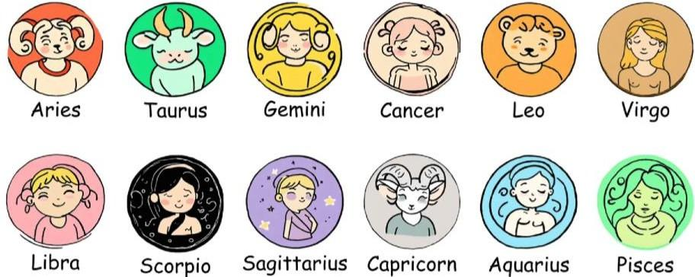

SPEAK OUT
Make up a dialogue using one of the scenarios or your own idea:
- A dialogue between siblings who are having a disagreement. Use character trait adjectives to express their feelings and frustrations with each other.
- Simulate a job interview scenario where one student is the interviewer and the other is the interviewee. The interviewee can highlight their character traits as strengths for the position.
- Friends discussing the planning of a surprise party for a mutual friend. You can use character trait adjectives to assign tasks based on each person's strengths.

TERM 2

UNIT 1

THE PLEASURE OF FOOD

KEY VOCABULARY
Fruit and vegetables: pawpaw, almond, persimmon, blackberry, blueberry, raspberry, gooseberry, raisins, pomegranate, tangerine, pear, fig, plum, prune, date, artichoke, aubergine/eggplant, leek, peas, asparagus, parsnip, turnip, cauliflower, courgette, horse-radish, radish, yam, bell pepper, sea ​​buckthorn, cherry plum
Meat and fish: beef, pork, venison, ham, bacon, smoked meat, game, lard, hare, quail, partridge, white/oily/freshwater fish, cod, plaice, pike, trout, tuna, hake, salmon, swordfish, sardine, sea bass, eel, mackerel, herring, cuttlefish, lobster, octopus, shrimp, prawn, squid, oyster, clam, mussel, caviar
Cereals and dairy products: barley, buckwheat, grain, millet, oat, porridge (oatmeal), rye, semolina, wheat, cottage cheese, condensed milk, custard, skim milk

Verbs, adjectives, and idioms: to baste, to peel, to scale (fish), to thaw (frozen chicken), to chop, to slice, to dice, to grate, to boil, to simmer, to stuff, to strain (through a sieve), to mince, to sprinkle, to knead, to stew, to pour, to stir, to whisk, to chew, to mash, lean, spicy, bland, rotten, bitter, salty, stale, raw, ripe, crunchy, tough, greasy, nourishing, to take everything with a pinch of salt, to have a sweet tooth, to have one's cake and eat it too, to season with herbs/spices, to garnish a dish, to devour a meal, mouth-watering, three-course meal, to go Dutch, food for thought, zesty flavor, the icing on the cake, bite off more than you can chew, butter someone up, piping hot, stone cold, lukewarm, to gulp down a drink, to drizzle with, bite the hand that feeds you, a recipe for disaster
Others: pinches of sth, handfuls of sth, poached eggs, scramble, boiled eggs, separate yolk and white, a filling, a dressing, icing, pastry, gravy, Jacket potato, creamed/mashed potato, self-rising flour, starch, breading
Comment on the following quotation. To what extent do you agree with that? “Food is the ingredient that binds us together.” – Betty Crocker

EXERCISE 1a. Read the riddles below and guess the words from Key Vocabulary. Then form a key word from every first letter taken from your answers
Riddle word:
- I’m a tropical fruit that’s spiky on the outside but sweet and yellow on the inside.
- I’m a small, dried fruit, often found in cookies and cereals. In your pastry I look like dots.
- I am a vegetable. My colour is purple. I have a green crown on my head and I am the King of vegetables. Who am I?
- I’m a sea creature with a curved tail, often served in a pasta dish. What am I?I’m long and slippery, often found in sushi rolls. I live in the water and have slimy, smooth skin. What am I?
- I’m a small, red fruit that’s sweet and tart, with tiny little seeds all over my heart. Found in desserts and jams, I’m a treat, what am I?
- I’m the meat of a deer, often enjoyed in a hearty stew. Known for my rich, gamey taste, what am I?
- I’m a veggie with a name that sounds like "artist’s joke," but I’m actually a green, spiky plant you eat. What am I?
- I’m a citrus fruit that’s easy to peel and bright orange. I’m often enjoyed as a snack. What am I?
- I’m a sweet, smooth layer that coats your cake or cookies, making them look and taste divine.
- I’m a green vegetable that has layers and can make you cry when cut.
- I’m a word that means helping you stay healthy and strong, like good food does. What am I?

EXERCISE 1b. Discuss the questions
- Have you ever tried preserving food yourself? What method did you use, and how did it turn out?
- Do you think food preservation can help in reducing food waste?
- How did people preserve food before modern refrigeration and canning?
- Does canning impact the nutritional value of food?

EXERCISE 1c. Name the products below the pictures. Is there any fruit or vegetable that you don't like eating? Add more fruit and vegetables to each colour

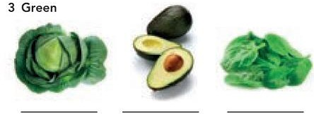
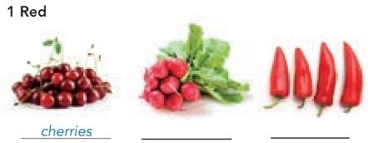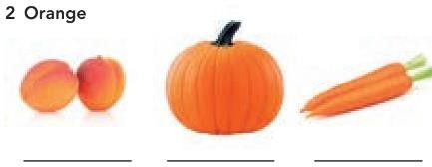

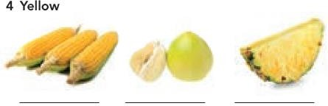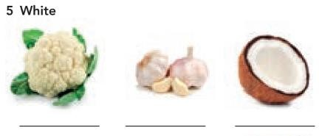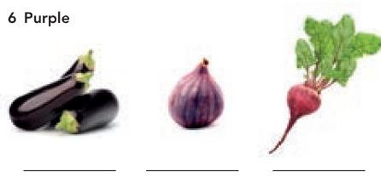
EXERCISE 2. Use the following words to fill in the gaps:
trout, swordfish, pork, semolina, custard, filling, self-rising
flour, mackerel, bell pepper, caviar
- The restaurant's special today is grilled (a large, meaty fish) with a lemon butter sauce.
- When I was in kindergarten I hated eating . It had no taste and too many lumps.
- I caught a beautiful (a type of freshwater fish) in the river yesterday and grilled it for dinner.
- At the fancy dinner party, they served on small toasts as an appetiser.
- We had smoked (a type of oily fish) for breakfast, served with fresh bread and butter.
- For our family barbecue, we marinated some chops overnight.
- The recipe calls for a diced to add colour and flavour to the salad.
- To make the cake rise perfectly, you need to use instead of regular flour.
- I love pouring warm over my apple pie for an extra sweet treat.
- The pastry _____________was rich and creamy, making the dessert irresistible.

EXERCISE 3a. SPEAKING
Discuss the questions.
- Who is the best cook in your family?
- What dishes can you cook?

Read the blog post and discuss which celebrity diet you think is:

  - the most appealing • the easiest to do • the least appealing

STRANGE CELEBRITY DIETS
When I read about the weird and wacky diets of famous celebrities, I think that being in the public eye can make people a bit crazy. And it’s nothing new – more than two centuries ago, the romantic poet Lord Byron wanted to be pale and thin, so he only ate stale, dry biscuits, soda water and potatoes covered in vinegar – yuck! So sour! No wonder he died at the age of thirty-six!
Here’s my list of today’s top five strangest celebrity diets.
#5 Once, when Beyoncé was preparing for a video shoot, she went on a detox. This involved living on lemon juice, sweetened with maple syrup and made a little less bland with cayenne pepper. Give that woman some chocolate cake!
#4 Gwyneth Paltrow, Jennifer Aniston and Reese Witherspoon choose the baby food diet which involves eating fourteen jars of baby food a day, and one low- calorie meal of lean meat or fish and green salad.
#3 American singer Jennifer Hudson thinks the Cookie Diet™ is more fun – instead of breakfast, lunch and snacks, you have six biscuits. But these are not delicious, crunchy biscuits with milk chocolate on top. Dr Siegal, the inventor of the Cookie Diet, was careful to make his cookies taste good, but not too good.
#2 Katy Perry keeps in shape with the mushroom diet, but instead of enjoying a bowl of delicious mushroom soup, she swaps one meal a day with raw mushrooms for fourteen days at a time.
#1 – MY FAVOURITE! Christina Aguilera does the seven-day colour diet, eating food of a different colour every day for a week. Day one is white, but that means white fruit and vegetables, not white bread or white rice! This is followed by red, green, orange, purple, yellow and on the seventh day, all of the colours. This diet might encourage you to try new things, like deep-red cherries, ripe avocados or fresh figs, and you’d get plenty of vitamins. I think this is the only one I would actually try.

EXERCISE 3b. Complete the sentences with an appropriate adjective from the blog post. Which sentences are true for you? Provide some details
- Thai and Indian curries are too spicy for me. I know it’s boring but I prefer ___________ food.
- My friend likes anything __________________: she particularly loves ice cream and chocolate.
- The taste of dark chocolate or strong coffee is too _______________________for me.
- If we have any old, ____________________bread, we feed the birds.
- I’ve never tried sushi. I don’t like the idea of eating _______________________fish.
- I can’t eat salad if the dressing has a lot of vinegar. It’s too_________________for me.
- I don’t like bananas that are too ______________________. I prefer them to be white and firm.
- I only like _____________________ meat so I cut off the fat and leave it on the side of my plate.

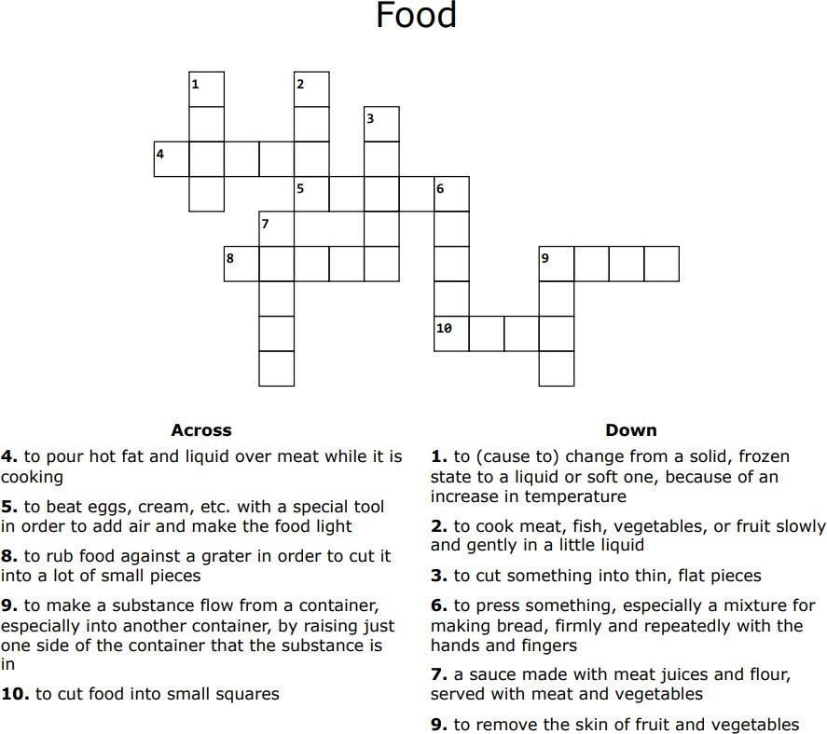
EXERCISE 4. Do the crossword below and create three own definitions to any words from Key Vocabulary.

EXERCISE 5a. Take The Healthy Diet Test and compare your results with a partner.
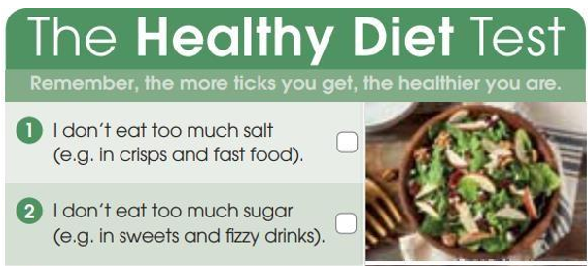
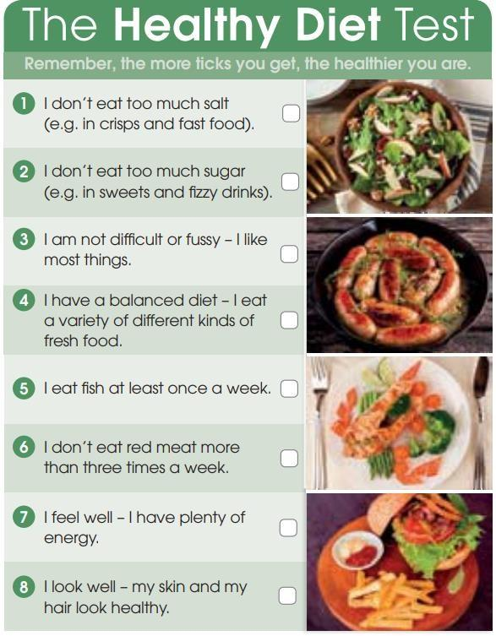

EXERCISE 5b. Answer the questions
- What are the ways of maintaining a healthy diet that you use?
- Have you ever thought of becoming a vegetarian? Why or why not?
- Are you a fussy eater? As a child were you encouraged to eat everything on your plate? Why or why not?

EXERCISE 6. Complete the sentences with the idioms from the box: to have his cake and eat it too/to have such a sweet tooth/ to be the icing on the cake/ to go Dutch/ to butter someone up / to take with a pinch of salt/ to bite off more than you can chew /to have food for thought

- Emma eats chocolate every single day – she really __________________.
- I think you’ve agreed to __________________ when you promised to organise the whole festival alone.
- Don’t believe everything she says; you should __________________.
- Let’s __________________ and each pay for our own meal.
- After a long day, winning the match was great, but the cheering crowd was ________________.
- That documentary gave me __________________ about climate change.
- Mark wants to buy a new car but also refuses to save money – he really wants to __________________.
- He always tries to __________________ the teacher before exams by saying how amazing her lessons are.

Answer the questions below:
- Do you think it’s possible for someone to have their cake and eat it too in life? Can you give an example?
- How do you manage cravings if you have a sweet tooth but want to eat healthily?
- Can you describe a time when something good happened, and then something extra made it even better — the real icing on the cake?
- When you go out to eat with friends, how do you usually split the bill? Do you prefer to go Dutch or have someone pay for everyone?
- Have you ever tried to butter someone up to get help or a favor? Did it work?
- When someone tells you an unbelievable story, do you tend to believe them or take it with a pinch of salt? Can you give an example?
- Have you ever tried to do too much at once and ended up failing? Did you bite off more than you could chew?
- What is an idea, lecture, or story you recently encountered that really gave you food for thought? How did it make you think differently?

Read UK TODAY and discuss the questions.
- Which facts do you find most shocking?
- Do you think the situation is similar or different in Ukraine?

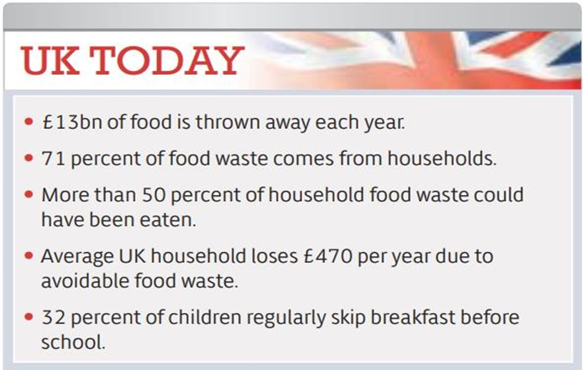

TEXT

The freegans' creed: waste not, want not
It’s midnight, I have a torch and I’m sifting through the bins behind my local Tesco in search of food. The idea of picking through discarded packets of cakes and cheese in a pair of marigolds may seem pretty disgusting. But for a small section of society, standing in bins at night – or freeganism, as it is more widely known – has become a way of life. Stuart became a freegan at Cambridge (he read English) and as a student acquired most of his food from the bins of his local Sainsbury's.
Freegans avoid buying anything as much as possible in order to boycott the economic system and be eco-friendly. For many young freegans, this can mean asking supermarkets for their discarded food, which is often left in bins.
In the US especially, freegans are often called "dumpster divers", though many freegans insist that the practice of extracting food from dustbins represents only one strand of what they do; other freegan practices include co-operative living, squatting and "freecyling", or matching things that people want to get rid of with things other people need.
Most people would admit that wasting food is not good. But surely, they'd say, the problem can't be that serious? Isn't rooting around in rubbish bins a somewhat extreme – and unpleasant – reaction? Stuart would disagree. Addressing food waste, he says, is a vital step when it comes to sorting out many of these other problems, and it's hard to disagree with his logic. If we waste less food, we'll need less land to grow it on, and hence will cut down fewer trees; we'll use less water to irrigate that land and less carbon to transport and process the food it produces. On a more basic level, food waste is an issue of equality. If we didn't waste so much food, there would be more available, which means fewer people in the world would go hungry.
This situation could be dramatically improved, Stuart says, with the introduction of a few quite simple measures. Supermarkets should be required to report how much food they waste and should be compelled to set (and keep to) waste reduction targets. Or surplus stock could be redistributed. In the US, such schemes have long been popular. Giving away surplus food is a well-established practice among US supermarkets and many towns and cities have "food banks' ' where the homeless and those on low incomes can pick up this surplus for free.
In Britain, retailers and producers have been much slower catching on to the idea, and until recently redistribution was only ever undertaken on an individual, piecemeal basis – shops and restaurants allowing the homeless to take away unsold items at the end of the day, for example. Adopting a freegan lifestyle can go a long way towards stretching out your student loan. Even just doing so part-time could be a great way of supplementing your weekly shop.
If you are interested in getting started, it’s easy to find your local freegan group online. There are plenty of ways to participate in the movement that don’t involve taking a shower afterwards – you don’t have to start dumpster-diving straight away. In fact, doing so is something of a legal grey area.
Free, usable stuff is everywhere, all you have to do is open your eyes. Freeganism is just the beginning of a long struggle to change the way we consume and to start appreciating what we have on our plates.
Adapted from The Guardian
READING COMPREHENSION QUESTIONS
- Have you ever considered the impact of food waste on the environment? How do you feel about the idea of freeganism as a way to combat this issue?
- Would you ever participate in an activity like dumpster diving or freecycling? Why or why not?
- How do you think society would change if more people adopted a freegan lifestyle? Do you think it would make a significant difference in reducing waste?
- Have you ever felt conflicted about the amount of food or resources you personally waste? What steps, if any, have you taken to reduce this?
- Do you believe that freeganism is an effective way to protest against the current economic system? What other methods do you think could be more impactful?
- How would you react if someone you know decided to adopt a freegan lifestyle? Would you support them, or would you have concerns?
- In what ways do you think your own consumption habits contribute to larger issues like food waste and inequality?
- How do you feel about the idea of redistributing surplus food to those in need? What role do you think individuals and businesses should play in this effort?
- Would you be willing to challenge societal norms and adopt practices that might be seen as extreme, like freeganism, if you believed it could make a positive difference?
- How important is it to you to appreciate and make the most of the resources you have? Do you think this mindset is common in your community or society at large?

Classroom extra: Scan the Qr code below and watch the video. What Ukrainian products would you like to give celebrities to try? What do you think would be their reactions?


SPEAK OUT
Make up a dialogue using one of the scenarios or your own idea:

- Characters: A waiter at a fancy restaurant with exquisite speciality dishes and a very scrupulous and demanding client
Situation: The client comes to the restaurant: he wants to make a proposal to his/her fiancè(e) after the meal. The fiancè(e) is very picky and also allergic to some seasonings and products. The waiter tries to please and be as nice as possible, even when the client is being rude.
- Characters: A sous-chef, the applicant, and a chef, the interviewer
Situation: There is a vacancy at the French/Italian/Japanese restaurant and the chef himself is interviewing applicants for the position of a sous-chef. The person should be innovative and experienced, so the chef is asking specific questions about recipes and the cooking process and the applicant is trying to give detailed and extraordinary answers.

UNIT 2

LIVING CONDITIONS

KEY VOCABULARY
Types of houses and buildings: cottage, bungalow, flat, barn, council house, suite, castle, chalet, igloo, wigwam, convent, monastery, mansion, studio, dormitory, semi- detached, villa, patio, porch, stable
Rooms: cellar, guest room, pantry, bedroom, yard, hall, living room, garage, attic, balcony, dining room, utility room, study, nursery, basement, workshop
Inside the house: a carpet (fitted), a coffee table, draped curtains, attractive/faded wallpapers, a chest of drawers, ottoman, washbasin, double glazed windows, pine sideboards, tiles, central heating, upper lights, sockets, sewer, mantelpiece, cupboard, double/bunk bed, built-in wardrobe, floor lamp, dressing table, easel, cushion, upholstered sofa, polished wooden floors, a rug, shutters, bedside table, chandelier, dish drainer, dish washer, cabinet, counter, bookcase, armchair, wardrobe
Adjectives: bare, spacious, cosy, traditional, comfortable, cramped, impersonal, stylish, modern, crowded, fully-equipped, fully-furnished, affordable, easily accessible, peaceful, newly-built, well-kept, restored
Building metaphors and idioms: to be a brick wall, to put a ceiling on sth, to go through the roof, to live in an ivory tower, to be a tower of strength, to do something by the backdoor, to hit home, to hold the keys to sth, to cement one`s partnership, to be a key figure, to lay the foundation for, to be a wall of silence, to get a new lease of life, home truths are hard to swallow
Comment on the following quotation. To what extent do you agree with that? “A house is made of bricks and beams. A home is made of hopes and dreams.” – Ralph Waldo Emerson

EXERCISE 1. Read the definitions below and match them with the names of the buildings from Key Vocabulary. In what type of these houses would you like to live in and why? Can you name the dwellers of these houses?
    - a small, one-room apartment that combines the living, sleeping, and kitchen areas into a single space.
    - a building or complex where monks live, work, and worship.
    - a type of housing provided by the government for people with low incomes, often found in the UK.
    - an apartment or a set of rooms forming an individual residence, typically on one floor within a larger building.
    - a large building at a college or university where students live.
    - a large strong building, built in the past by a ruler or important person to protect the people inside from attack.
    - a circular house made of blocks of hard snow, especially as built by the Inuit people of northern North America.

EXERCISE 2. Read the text below and answer the questions that follow

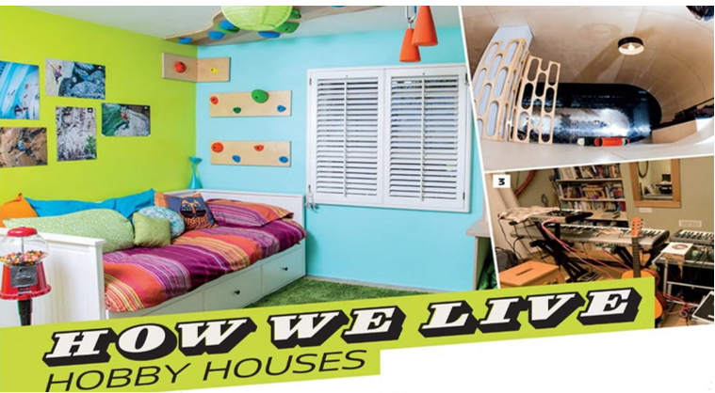
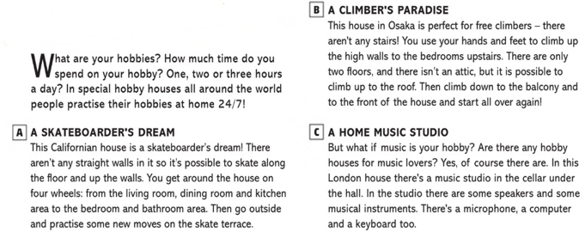

- Which of the hobby houses described in the text would you prefer to live in and why?
- Are there any other hobbies you think could have a specially designed house? What would it look like?
- How do these hobby houses inspire people to pursue their passions more seriously?
- What do you think are the practical challenges of designing and maintaining a hobby house?

EXERCISE 3. Use the vocabulary to describe the houses in the pictures
For example, in picture X, I can see a modern semi-detached house. It looks quite spacious and probably has two or three bedrooms. It has a small front garden and a garage. I think it's reasonably priced.

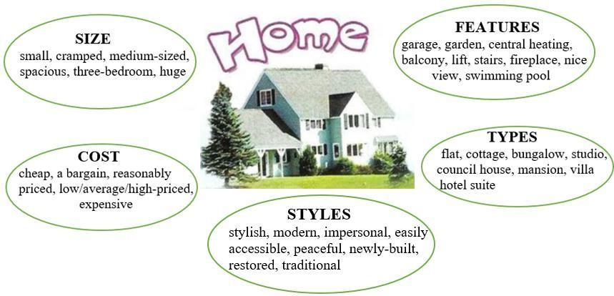
- What are the advantages and disadvantages of living in each type of house?
- Where is it better to live: at the seaside or in the mountains? Why?
- What are the advantages of living in the country?
- What are the advantages of living in the city centre?
- Is a lift a must in a block of flats?
- What can you do to make your house or flat more homely?
- What kind of home can you call charming?
- What are the disadvantages of living in a large home?
- What problems might you have when you live in a small home?

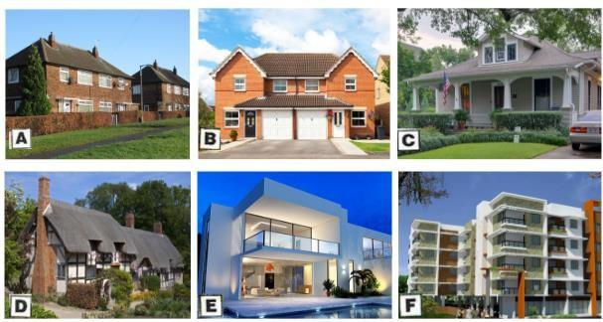
EXERCISE 4a. Work in pairs and discuss the following questions
- Have you ever rented a flat to/from somebody? Did everything go smoothly?
- What is involved in renting a flat? What are some possible sources of conflict between landlord and landlady and a tenant? Make a list.
- What can happen if the relationship between landlord/landlady and tenant turns sour? What options do they each have?

EXERCISE 4b. Listen to a conversation between a landlady and a tenant. What sources of conflict did they mention?

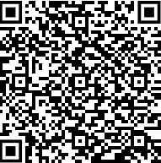
EXERCISE 5a. Rewrite the underlined parts of these sentences using one of the building metaphors and idioms from Key Vocabulary.
- The company's profits increased dramatically last quarter.
- Despite the crisis, she remained very supportive for her family.
- He tends to ignore reality and live in his own world.
- The team strengthened their cooperation by working together on this project.
- She always gets what she wants by taking secretive actions.
- The shocking news finally made an impact on him.
- He is the person in control of the organisation.
- The teacher's strict rules acted as a barrier to creative thinking.
- The strict regulations limit the company's growth.
- The new CEO gave the company new energy.
- He is a crucial person in the negotiations.
- The administration has remained completely silent about the issue.
- The criticism was difficult to accept, but it was necessary.
- Their early research established the basis for future discoveries.

EXERCISE 5b. Work in a group of 4 students. Choose one scenario and create a short dialogue (6 lines) using any 6 idioms from Key Vocabulary.
Scenario 1: Real Estate Consultation
Situation: A couple is meeting with a real estate agent to discuss buying their first home.
Scenario 2: Home Renovation Discussion
Situation: A family is discussing their plans to renovate their home to better suit their hobbies and lifestyle.
Scenario 3: Moving to a New City
Situation: A person is talking to a friend about moving to a new city for a job and finding a new place to live.

EXERCISE 6a. Do you pay attention to the design of someone's house while visiting it? Does it change your attitude towards that person? Watch the video below about Ashley Tisdayle`s home and answer the following questions.


Listening comprehension questions
- How many rooms has the actress shown?
- How long did it take for the family to renovate the house?
- Which room consists of 2 parts? What picture does this room have?
- Where is the hallway leading into (to which room)? What can be found on its walls?
- What is situated in the TV room? Why does couple like this room?
- Which room is the actress's favourite one? Why?
- Where does the actress usually meditate?
- Which room was created out of the bedroom?
- Why did the owners decide to change the window in the bathroom?
- What colours prevail in the house? Which room is completely different?

EXERCISE 6b. Work in pairs. Discuss the questions below and share your feedback
- Do you enjoy renovating and redecorating your living space?
- How important is it for you to have a cosy and comfortable bedroom/kitchen?
- Would you like to see a house of any celebrity? If so, whose house would it be?

EXERCISE 7a. Look at the picture and fill in the gaps with the words that describe the location of items of furniture in the following picture:

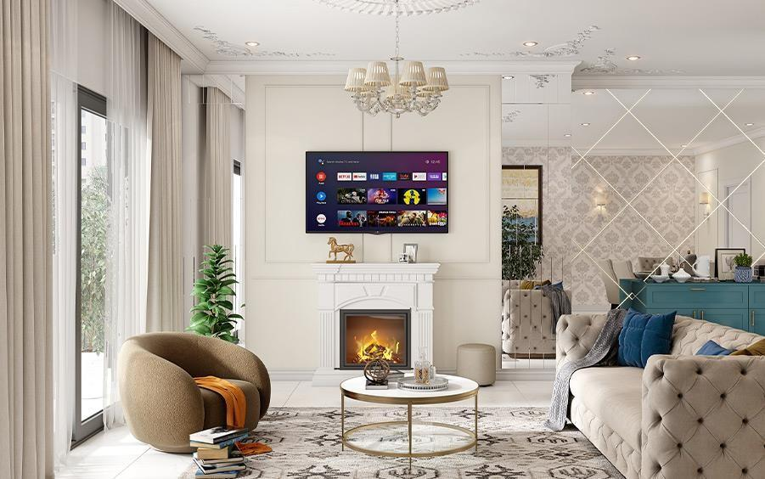
In photo 1, the room has a cosy and elegant setup with various objects:
- ________________is at the foot of the bed.
- There are _____________________on either side of the bed, each with a lamp on it.
- The _________________is on the right side of the room.
- The _______________ are behind the two armchairs and allow plenty of natural light into the room.
- A _______________ is to the right of the armchairs, near the chest of drawers.
- The _______________are placed in front of the windows, with a small table between them.
- A____________ hangs from the ceiling, adding a touch of elegance to the room.
In the photo 2, the room has a luxurious and stylish setup with various objects:
- The is in the centre of the room, with a television mounted above it and a small decorative item (a horse statue) on top.
- The is in front of the sofa, holding some decorative items and a couple of books.
- The is on the floor beneath the coffee table and sofa, adding warmth and style to the space.
- There are on the sofa, adding comfort and colour to the seating area.
- The room has on the far wall, enhancing the room's elegance.
- are on the left side of the room, covering large windows or sliding doors.
- The is next to the mantelpiece on the right side, serving as an extra seat or footrest.
- The hangs from the ceiling, adding a touch of sophistication to the room.
EXERCISE 7b. Describe your favourite room, use the words from Key Vocabulary
TEXT
Inside The Keret House - the World's Skinniest House
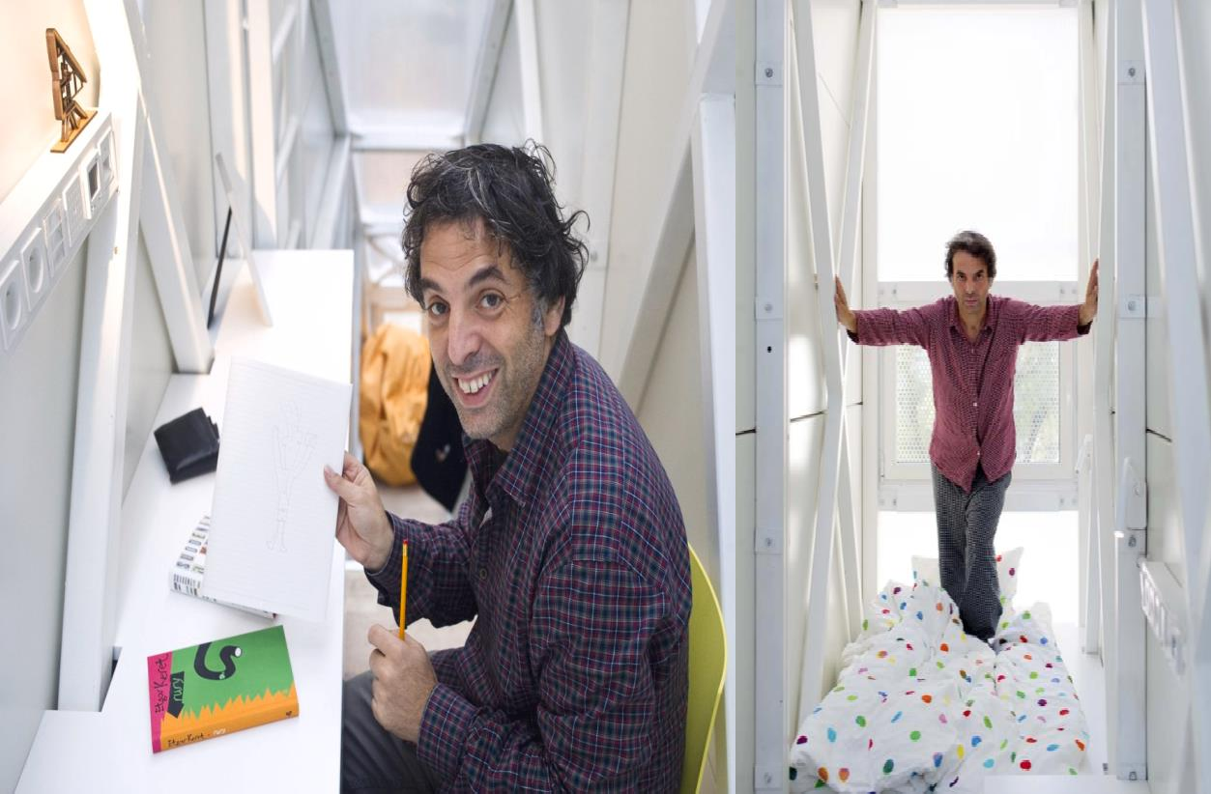
CENTRAL WARSAW IS TRULY CRAMMED for space, and many downtown developers are turning horizontal space into vertical space by building tall skyscrapers. But in no other setting in the world is a building’s height to width ratio as insanely preposterous as that of Warsaw’s Keret House. Welcome to the skinniest house in the world.
Earlier this week, we announced the completion of the world’s narrowest house in Warsaw, Poland. The Keret House was first conceived as a seemingly impossible vision of the Polish architect Jakub Szczesny of Centrala, who first presented the idea as an artistic concept during the WolaArt festival in 2009. Now, three years later, the vision has become a reality and is drawing a significant amount of international attention to the city of Warsaw.
Built between two existing structures from two historical epochs, the narrow infill is more of an art installation that reacts to the past and present of Warsaw. Although the semi-transparent, windowless structure’s widest point measures only 122 centimetres, it’s naturally lit interior doesn’t seem nearly as claustrophobic as one would think.
The Keret House will serve indefinitely as a temporary home for travelling writers, starting with Israeli writer Etgar Keret. Keret House is the installation art in the form of an insert in between two existing buildings. The project was launched on Saturday 20th of October in Warsaw. It is led by the Israeli writer Etgar Keret.
Keret House is a fully functional space in which one can live as well as create. It is located between buildings at Chlodna 22 Street and Zelazna 74 Street. “We deeply believe it will become a symbol of modern Warsaw ingrained in its complicated history. The House attracts media attention of media from the entire world. He hopes it will show the most fascinating side of Warsaw”, said project curators Sarmen Beglarian and Sylwia Szymaniak from Polish Modern Art Foundation.
The House is located on the plot measuring 92 centimeters in its narrowest point and 152 centimeters in its widest point. “That is why at first it seems that the construction of living space within such a premise is impossible. Keret House is to contradict that false image, simultaneously broadening the concept of impossible architecture”, says the architect Jakub Szczesny. The house itself is 72 centimeters in the narrowest and 122 centimeters in the widest point.
With just 46 square feet of floor space and a world record for narrowness under its name, the Keret House manages to fit a bedroom, a bathroom, a kitchen, and a two- beverage refrigerator in the span of three floors. The first floor features nothing but a staircase to the second. However, when the staircase is retracted it makes for a pleasant (yet claustrophobic) living room. To get from the second floor to the third, you must climb a white ladder.
Since the Keret House is so minuscule, it has no room for traditional electrical and sewage appliances. Szczęsny’s makeshift solution to the electrical dilemma involved obtaining electricity from the two buildings it’s sandwiched in between. To dispose of sewage, the Keret House avoids city standards and instead uses an innovative customized design.
Built in 2012, Szczęsny’s narrow masterpiece is legally classified as an “art installation” because it doesn’t meet Polish housing codes, but, in practice, it serves as a residence nonetheless. Constructed as a memorial to his family killed in the Holocaust, the Keret House is named after Etgar Keret, the Israeli filmmaker and author who was spontaneously asked by Szczęsny to be the house’s first tenant. After Keret agreed to the deal and lived there for a number of weeks, the Keret House became open to travelling writers for the night’s stay. As of today, the Keret House is open to all visitors to Warsaw, so long as it’s not undergoing maintenance.
It all started one afternoon on my way to a nearby club. I stumbled upon this strange gap between a post-war co-op prefab building and a pre-war ex-Jewish tenement block. The house is located between two buildings from two historical epochs. “The first is a brick building on Zelazna Street – a fragment of the pre-world war II city, almost no longer existing. The second – a cooperative concrete apartment building, an element of an “imposed structure”, which was aimed at negating the previous city landscape. Their adjacency is coincidental – like many architectural structures in Warsaw. Suddenly I thought: “How can one make these two buildings communicate? By putting life in-between”. A voice said: “Sure, but how?” It should be a space for one person, a loner, a hermit, a writer! Someone to be close to reality, but distant at the same time… What kind of writer would like to stay in something as narrow as this? Someone with a pretty good sense of humour, for sure…
Keret House is a perfect example of the so-called “non-matching” in the city’s urban fabric. Another reason is the city’s war history – where the house is located, two ghettos – the large ghetto and the small ghetto met. Only a few steps from the house, a bridge connecting the two closed spaces, stood”, explains Jakub Szczesny. The Keret House project was run by the Polish Modern Art Foundation. Founded by Piotr Nowicki in the fall of 1985, PMAF is one of the first, independent non-profit organizations operating in the art field. Its main goal is and always has been the promotion of those artists whose activity contributes to the development of contemporary art.
Adapted from ArchDaily

READING COMPREHENSION QUESTIONS
- How do you feel about the concept of living in such a small, confined space like the Keret House? Could you see yourself staying there for a while?
- What do you think the Keret House says about the intersection of art and architecture? Do you believe architecture can be a form of artistic expression, or should it serve purely practical purposes?
- The Keret House is described as a space for someone "close to reality, but distant at the same time." Have you ever felt the need for such a space in your own life? What would it look like for you?
- How do you think living in such a narrow space would affect your daily routine or mental well-being? Would the challenge of living there appeal to you?
- The Keret House is built between two buildings from different historical epochs. What do you think this symbolises about the relationship between past and present in a city like Warsaw?
- The house was created as a memorial to those who were lost during the Holocaust. How do you think architecture can serve as a way to remember and honour history?
- Do you believe that small, unconventional living spaces like the Keret House could become more common in crowded urban areas? What are the potential benefits and drawbacks of such a trend?
- How do you feel about the idea of art installations being used as functional living spaces? Do you think this blurs the line between art and everyday life?
- The Keret House is designed to be a temporary home for travelling writers. How do you think the environment of such a unique space might influence a writer’s creativity or work?
- The house's narrowness forced the architect to come up with innovative solutions for utilities and space management. How do you think constraints like these can drive creativity in design and other areas of life?

SPEAK OUT
Describe your dream home. Think of the aspects below. Next, tell your groupmates what your dream home looks like by creating a presentation of your house on any online resource.
  - location • views • appearance • rooms • size • amenities

UNIT 3

WEATHER THE STORM

KEY VOCABULARY
Weather and climate: annual precipitation, unsettled, marvellous, beastly, sultry, sweltering, mild, arid, windy, humid, chilly, overcast, still
Snow and weather phenomena: avalanche, snowflake, sleet, snowdrop, icicle, ringing frost, hoarfrost, hail, hailstones, snowdrift, slush, blizzard, thaw, to melt, slippery, scorcher, heat, dew, drizzle, downpour, to evaporate, to clear up/to brighten up, haze, fog, gale, a flash of lightning, a clap of thunder, a gust of wind, hurricane, flood, drought, whirlwind
Idioms: to be under the weather, to rain on someone's parade, to be under a cloud, to be hot under the collar, to blow hot and cold, to make heavy weather of something, every cloud has a silver lining, to have head in the clouds, a fair-weather friend, it never rains but it pours, to be snowed under, to steal one's thunder, to take a rain check
Environmental issues and effects: oil slicks, emission of/ to emit poisonous chemicals, greenhouse gases, smog, toxic waste, deforestation, contamination of food, water, soil, acid rains, endangered species, overuse of pesticides, solar/wind power, genetically engineered foods, face extinction, make a difference, a poacher
Comment on the following quotation. To what extent do you agree with that? “We don’t inherit the earth from our ancestors, we borrow it from our children.” – Chief Seattle
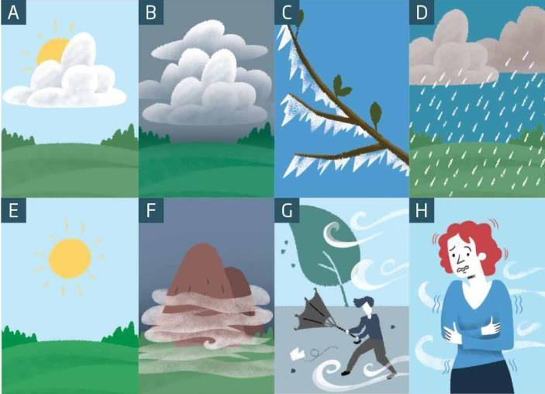
EXERCISE 1a. Look at the pictures and name the types of weather

EXERCISE 1b. Answer the following questions:
- What seasons are these weather conditions typical for?
- Are you weather dependent or does the weather affect your physical state at all?
- Under which weather conditions do you feel most productive?

EXERCISE 2a. Guess the weather phenomenon hidden in the following riddles. Do you know any other weather riddles about the words from Key vocabulary?
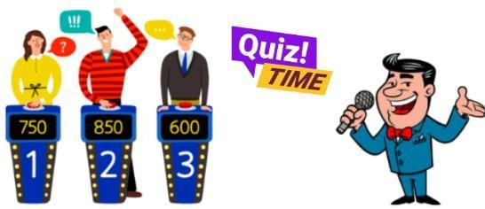
- I howl and roar with a mighty force, bending trees and changing course. Stronger than a breeze,
I set ships to sail,
What am I, with my powerful wail?
- I fall from the sky, unique and bright, A frozen star in the cold, dark night.
No two are the same, a wonder to see, I’m delicate and small, what could I be?
- What falls from the sky but isn't rain or snow?
- I am a phenomenon where small ice crystals fall from the sky and look like small crystals. What am I?
- I am a type of storm that can produce strong winds and heavy rain, and can cause damage. What am I?
- I am a type of cloud that is low to the ground and can cause poor visibility. What am I?
- I am never seen, but always heard. I am never touched, but often felt. What am I?
- I am a force of nature, but not always welcome.
I can be gentle and soothing, or fierce and destructive. I come from the sky, but I am not a bird.
I can be accompanied by thunder and lightning, or I can fall silently. What am I?

EXERCISE 2b. Read the beginnings of weather lores and match them with their endings. What are their meanings? Do you know any Ukrainian weather lores?
“Rain from the East, | - the next day sure will be bright.”
“Thunder in April, | b) we`ll soon be tasting heavens tears”
“A long frost before Christmas | c) then we can all expect rain quite soon”
“If there is a halo round the sun or moon, | d) may bring an early spring”
“When kitty washes behind her ears, | e) floods in May”
“With dew before midnight, | f) will last three days at least”

EXERCISE 3a. Read the sentences and match the words in bold with the correct weather category, underline the words/phrases that helped you to decide:
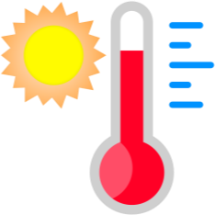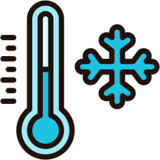

hot cold sunny wet windy

  - It was blowing a gale when we got to the top, so I didn't go too close to the edge.
  - I couldn't sleep at night because it was so sticky and humid.
  - It brightened up in the morning and then the rest of the weekend it was absolutely glorious.
  - Apart from one brief sunny spell, it was pretty miserable most of the time.
  - Oh, it was really bitter! I almost froze to death while we were watching the game,
  - It started spitting, so we decided to pack everything up, but then it started pouring down before we could get inside. We all got soaked.
  - It was a bit chilly at night. We definitely needed the extra blanket.
  - There was a frost on the ground in the morning and it was a lovely, clear crisp day.
  - It was so still. There wasn't even the slightest breeze.
  - There was a huge thunderstorm that flooded the pitch, so the game was called off.

EXERCISE 3b. Answer the questions about the words related to weather conditions
- Which word describes a small amount of wind and which a small amount of rain?
- What might happen if it's blowing a gale outside?
- If it's spitting and it then gets worse, how do you describe the weather? And what about if it then gets better?

EXERCISE 3c. Choose 3 of the following topics and provide some details related to them:
  - The weather you`ve had in Ukraine this year
  - The weather you had the last time you went on holidays
  - Any weather stories you have heard about in the news
  - A great weather experience you`ve had
  - A terrible weather experience you`ve had

EXERCISE 4. Fill in the gaps with the appropriate idioms from Key Vocabulary.
- She didn't mean to , but she had to tell him that the concert was cancelled.
- I'm sorry I can't join you for dinner tonight. Can I and reschedule for next week?
- It's hard to trust him because he tends to _____________________about important decisions.
- I can't come to the party tonight because I ______________. I just need to stay at home for a couple of days.
- When I needed help, she was nowhere to be found; she's just ___________________.
- First, the car broke down, and now the roof is leaking. It seems _________________.
- Even though losing his job was tough, he realised ___________________when he found a better one.
- I can't take on any more projects right now because I'm completely_____________with work.
- He's always daydreaming and seems to __________________during meetings.
- When he heard the accusation, he __________and started shouting. I can't believe he was that angry.
- He has been _____________ ever since he was caught cheating in the exam. Everyone looks at him strangely and it will take him a long time before he is trusted again.
- She tends to ______________of simple tasks and ends up taking much longer than necessary.
- She worked hard on the presentation, but her colleague __________by presenting her ideas as his own.

EXERCISE 5. Complete the crossword puzzle below. Create 3 definitions for any words from Key Vocabulary. Read them out for your groupmates to guess the words.
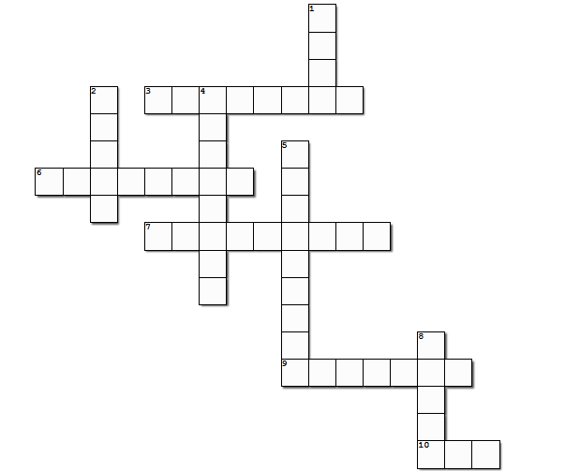
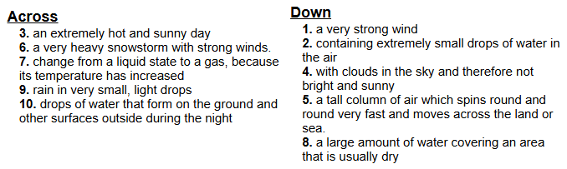

EXERCISE 6. Choose the right word from a couple of similar-looking ones.
- slush, sleet
  - The _________under my feet was awful. I had an impression that I was walking through a muddy sea.
  - The rain changed into . Wet snowflakes were falling on the ground and melted there.

ice draft, snowdrift
  - The path was hedged by two long . They were like two mountain ranges.
  - The ___________ started at night. In the morning the children ran to the river to look at the huge blocks of ice drifting across the water.

icing, icicle
- There was heavy on the road and all cars were moving very slowly.
- After a thaw there appeared on the edge of the roof; they looked like sparkling needles.

frost, hoarfrost
  - Three branches were covered with and the forest looked enchanting and somewhat mysterious.
  - The _______was biting the nose and the cheeks. It was impossible to stay long in the street.

draught, drought
  - Severe killed the crops. Not a drop of rain fell on the ground for a month.
  - When the door opened, the blew off the papers down on the floor
6) to freeze, to be freezing
  - In winter all rivers and lakes in these parts always .
  - The temperature was quite low and I felt that I was .

7) blizzard, drizzle
  - Boring spoiled the day. It was too wet and dull.
  - The_______________was blinding us. Snowflakes were swirling in the air.

8) rain, hail
  - Small pellets of ice that fall from the sky during a storm are called____________.
  - Droplets of are shimmering on grass blades.

EXERCISE 7. Use the phrases from the box to complete the following sentences
face extinction/ toxic waste/ short supply/ genetically engineered/ take effect

- Tonnes of is produced every year by factories.
- The new law regarding hunting will next month.
- Because of pollution of their habitat, many animal species _____________.
- Food is in in many developing countries.
- Most goods are expensive.

Classroom extra:

1.  2. 
Watch the first video and tell why animals are so happy that human beings were kept at home due to worldwide pandemic? Then watch the second video and discuss the impact of people on nature. Use the vocab from the previous exercise and Environmental issues and effects section.
What would you do to help?

To make the world greener,
  - Name something you could give up.
  - Name something you could cut down on.
  - Name something you shouldn't throw away.

TEXT
Coldplay have shared new figures that show the celebrated British band have reduced their carbon emissions by nearly half with their eco-friendly world tour.
The band had previously announced that they were looking to make their tours more ecologically friendly by reducing carbon emissions through several methods, including powering their shows from bicycles and electricity-producing dancefloors, building sets from bamboo, and planting a tree for every ticket sold. Coldplay have emitted 47 per cent less carbon emissions on their world tour so far, compared to their tour in 2016 and 2017, after which they said they would not be touring again until they could do so more sustainably.
They added that they have started to run the entire show (audio, lights, lasers etc) “from an electric battery system that allows us to use 100 per cent renewable energy as efficiently as possible” and that they have been electric vehicles and alternative fuels “wherever we can, as well as reducing waste and plastic usage to a minimum.”
Coldplay have also thanked their fans, who have “helped charge the show batteries on the power bikes and kinetic dance floors; travelled to shows by foot, bicycle or public transport; used the recycling bins; ride-shared; brought refillable water bottles; returned the LED wristbands after the show. And just by coming you have had a tree planted, and helped a range of environmental organisations like The Ocean Cleanup and ClientEarth (a team of lawyers who defend the environment).”
The latest results are “scientifically rigorous,” according to Professor John E. Fernandez of the Massachusetts Institute of Technology, who is monitoring the study.
Fernandez said that the institute’s Environmental Solutions Initiative “endorses this work as an important and substantive step toward a new era of eventually achieving carbon neutral music events by major artists. The band deserves significant praise in commissioning the work and acting as the vanguard for the global music industry as it begins to take seriously the reality of living and making music in the Anthropocene.”
Coldplay are not the first band to aim for net-zero touring and who have gone beyond surface-level greenwashing. Massive Attack have been working with climate scientists to explore ways to put on “super low carbon” events by handing over years' worth of touring data to Manchester University’s Tyndall Centre for Climate Change Research to assess how the industry can do better, while Billie Eilish had been planning an eco-friendly tour for 2020 before COVID decided to make the artist entirely sustainable. As for another love-or-loathe-them band, The 1975 have also been making efforts: their pandemic-derailed summer festival in London’s Finsbury Park was set to be the first ever UK event powered entirely by a sustainably sourced biofuel, Hydrotreated Vegetable Oil (HVO), and solar panels.
They also introduced the concept of repurposing merchandise, as their fans have been offered the chance to bring their old band t-shirts to shows and have them screen printed with new branding at no cost. World tours have always been an environmental nightmare, due to the transportation of crew, and equipment. Studies have shown that the majority of touring emissions – often over 90 per cent – come from the travelling involved, and Coldplay have pledged to minimise air travel and use “sustainable aviation fuel” where flying is unavoidable.
However imperfect, these gestures from major bands can bring about change and hopefully, Coldplay’s touring parameters can become, at the very least, the benchmark for other artists who go on tour. Environmentally conscious concert goers can also hold the artists they go to see live to a certain level of accountability.
With this in mind, how about a new award at the Grammys, for example? The Fix You Coldplay Chalice of Keeping A Sky Full Of Stars... Or something like that... Catchier title pending.
Adapted from Euronews

READING COMPREHENSION QUESTIONS
            - How do you feel about the idea of making music tours more eco-friendly? Would you be more likely to support an artist who takes these efforts seriously?
            - Have you ever considered the environmental impact of attending a concert or festival? Does this information change the way you think about live music events?
            - If you were an artist, would you prioritize sustainability on your tours, even if it meant higher costs or more effort? Why or why not?
            - How important is it to you that artists and bands use their platform to promote environmental causes? Do you think it makes a difference?
            - Would you be willing to participate in eco-friendly initiatives at a concert, like using a power bike or kinetic dance floor to generate energy? Why or why not?
            - How do you think fans can encourage more artists to adopt sustainable practices on their tours? What role do you think fans should play in this movement?
            - Do you believe that the efforts made by bands like Coldplay and The 1975 can inspire real change in the music industry? Or do you think it’s just a trend?
            - How do you feel about the idea of a new Grammy award for sustainability in music? Do you think it would encourage more artists to focus on eco-friendly practices?
            - Have you ever thought about how your own travel habits, like attending concerts or festivals, contribute to your carbon footprint? Would this influence your decisions in the future?
            - Do you believe that major artists should be held accountable for the environmental impact of their tours? How much responsibility should they bear compared to other industries?

SPEAK OUT
Choose one of suggested projects below, work in pairs and present your work during the lesson
  - Shoot the video of a weather forecast for a week and present it as if you are meteorologists on TV.
  - Choose an environmental issue (like deforestation, pollution, or endangered species) and create a report and presentation on its impact and possible solutions.

UNIT 4

YOUR STYLE, YOUR STATEMENT

KEY VOCABULARY
Items of clothing: button, pocket, cuff, collar, sleeve, hem, lapel, zip, belt, hood, buckle, suspenders, laces, tights, slippers, heel, sole, anorak, cardigan, dressing-gown, overcoat, overalls, waist coat, shawl, scarf, gloves, mittens, hat, a dress/frock, vest, knickers, panties, trunks, robe, turtleneck, padded shoulders, tie, trainers, garment, tracksuit
Materials and Patterns: silk, cotton, velvet, corduroy, denim, leather, wool, linen, fur, suede; striped, pin-striped, flowery, polka-dotted, checked, spotted, tartan, plain, waterproof, shrink-resistant
Discussing clothes: smart-casual clothes, label clothes, clothes off the peg, fashionable, skimpy, baggy, snazzy, scruffy, chic, cropped, trendy, loose, tight, to put on, to take off, to hang sth up, to try on, to fit, to suit, to match, to let out/down, to take in, to change out of sth into sth, to grow out of sth, sophisticated, mundane, impractical, cutting-edge fashion
Idioms and phrases: to burst at the seams, to roll up our sleeves, to buckle down, to hit below the belt, to keep it under sb`s hat, to lose one’s shirt, to fit sb like a glove, to wear one's heart on one's sleeve, to be in sb's shoes, to be fashion-conscious, to be a trendsetter, to be a passing trend, to be considered/ to go out-of-date, to be affected by fashion trends, a must-have item, to have an eye for fashion, to dress for the occasion, to be all the rage
Comment on the following quotation. To what extent do you agree with that? “Style is a way to say who you are without having to speak.” — Rachel Zoe

EXERCISE 1. For each sentence, choose the best word or phrase to complete the gap from the choices below
trainers coat vest shorts mittens
- It's raining. Take your when you go out.
- Jack wears on his feet when he goes running.
- People often wear for sports, or in hot weather.
- I wear a ___________________around my neck in cold weather.
- In winter, when it's cold, I sometimes wear a/an _____under my shirt to keep warm.

hat tie boots cardigan tracksuit
- You wear a on your head.
- A is similar to a sweater, but you can open it at the front.
- Some people wear a when they are doing sports.
- My father wears a with a shirt when he goes to work.
10. Women often wear on their feet in winter or when it’s raining.

EXERCISE 2. Complete the sentences with the most suitable words about clothes
- Martha looked very in her elegant silk dress.
a. plain b. casual c. tight d. chic
- After I'd _______________my shirt, I hung it up in my wardrobe.
a. suited b. ironed c. folded d. zipped up
- You should wear blue more often. It really you.
a. suits b. fits c. matches d. hangs
- Sam was wearing a shirt that was covered in red and white squares.
a. striped b. plain c. checked d. spotted
- Tight shorts and T-shirts are very at the moment.
a. chic b. casual c. loose d. trendy
- I prefer wearing shirts to ones with patterns or logos on them.
a. matched b. striped c. plain d. tight
- Cara is a ____________ dresser. She always looks so elegant.
a. stylish b. trendy c. casual d. baggy
- As a teen, I liked to wear clothes. Nowadays, though, I prefer comfortable ones.
a. fashionable b. casual c. checked d. spotted
- Those boots your belt. They are the exact same shade of green.
a. suit b. fit c. match d. fold
- My jeans were really because I had lost so much weight.
a. tight b. formal c. loose d. classic

EXERCISE 3. Look at the pictures. What famous people can you see in these pictures? What are they wearing? Describe their styles in detail.
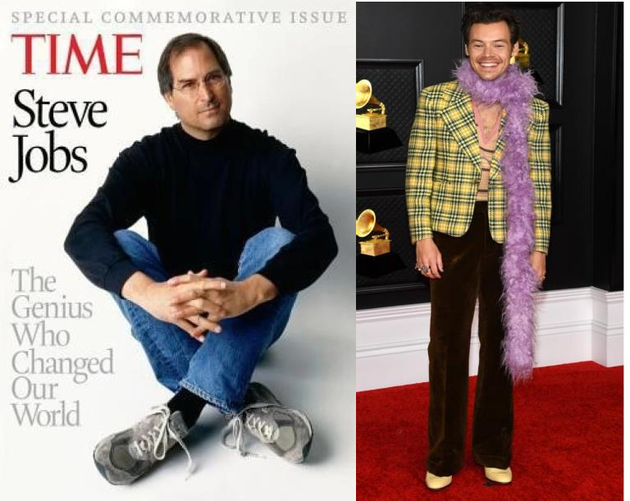
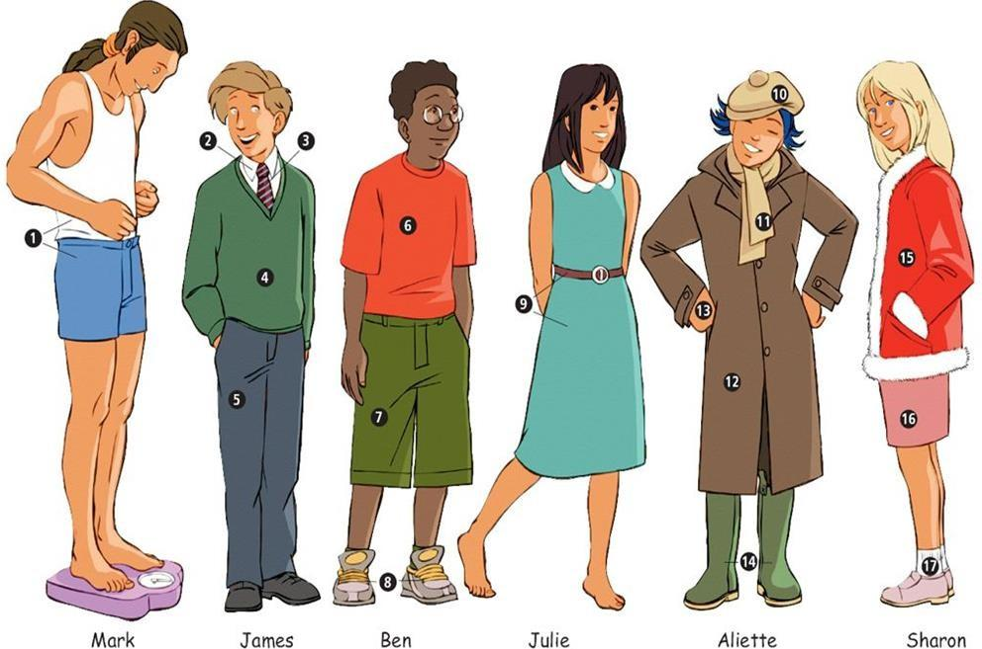
EXERCISE 4a. Match the clothes in the picture with the words below. Then write the items of clothes under each name

trousers / trainers / shirt / dress / shorts / coat / jacket / tie / gloves / skirt / shoes / T-shirt / underwear / socks / scarf / beret / boots / V-neck sweater
EXERCISE 4b. Fill in the blanks with the correct word from the list provided
  - Mark is wearing and .
  - James has a on over his .
  - Ben’s __________are green and he is wearing_____________on his feet.
  - Julie’s _____________is blue and she is not wearing ____________.
  - Aliette is wearing a ____________with a _______and __________________.
  - Sharon is wearing a red and a pink .

EXERCISE 4c. Answer the following questions
- How do you think your friends or family influence your clothing choices?
- Have you ever tried a fashion trend that you later regretted? What was it?
- Do you choose clothes more for comfort or for style? Why?
- How important are accessories like scarves, gloves, or hats in your daily outfits?
- Do you have a piece of clothing that holds a special memory for you? What is it and why is it special?
- Can you remember the first time you bought an item of clothing with your own money? What was it?
- What is your go-to outfit for a cold winter day?
- Do you have a favourite outfit for special occasions? Describe it

EXERCISE 5. Have you ever heard about fast fashion? What are the consequences of this problem? Watch the video below and answer the following questions
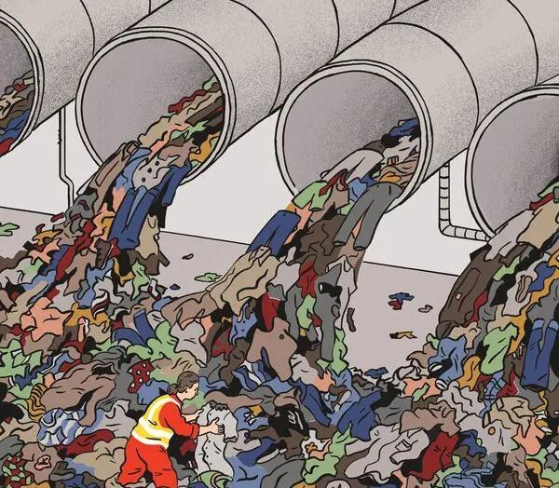

- Have you ever thought about what happens to clothes when you throw them away?
- How do you think making a lot of cheap clothes quickly can harm the environment?
- Why do you think some people have to work in poor conditions to make fast fashion clothes?
- Have you ever bought something just because it was cheap, even if you didn’t need it?
- How important is it for you to wear the latest trends? Do you think it’s possible to look good and be fashionable without buying new clothes all the time?
- How do you feel about the idea of having a smaller wardrobe with only your favourite clothes?

EXERCISE 6. Work in pairs. Choose any two occasions from the list below and discuss how you would get ready for them. Enumerate all the articles of your clothing in details and mention the way you would describe the clothes using adjectives from Key Vocabulary

formal business meeting | a Saturday night out with your friends
beach party | job interview
workout session at the gym | attending a wedding
travelling on a plane | an evening at the theatre
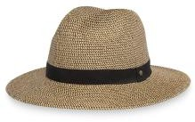
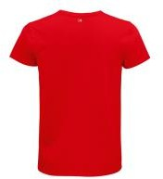
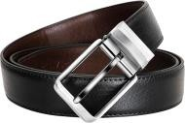
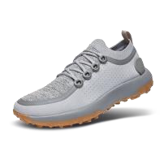
EXERCISE 7. Match the idioms with their definitions. Make up three sentences using any of the given idioms in the context.
- to burst at the seams
- to roll up our sleeves
- to buckle down
- to hit below the belt
- to keep it under sb’s hat
- to lose one’s shirt
- to fit sb like a glove
- to wear one’s heart on one’s sleeve
- to be in sb's shoes
  - To work hard and with determination.
  - To experience something the same way as another person.
- To be extremely full or crowded.
- To hit someone unfairly or below the expected standard of behaviour.
- To prepare for hard work or action.
- To keep a secret.
- To lose a lot of money.
- To express one’s emotions openly.
- To fit perfectly.

EXERCISE 8a. Fill in the gaps using words from the box. Change the form of the phrases according to the grammar rules.

be fashion-conscious be a trendsetter be a passing trend go out-of-date
be affected by fashion trends a must-have item to have an eye for fashion to dress for the occasion be all the rage

  - Emma always knows what’s in style; she really .
  - In the 90s, slap bracelets , but now they are rarely seen.
  - Celebrities often and influence what everyone else wears.
  - Skinny jeans are starting , with more people opting for looser fits.
  - Those who__________might spend a lot of money to keep up with the latest styles.
  - The new smartwatch is____________________this season.
  - Sometimes it’s hard because what’s popular changes so quickly.
  - People who can mix and match pieces to create unique looks.
  - For the formal event, you need appropriately.

EXERCISE 8b. Answer the questions
- Do you think having an eye for fashion is a natural talent or something that can be developed? Explain.
- How important is it to dress for the occasion? Can you give an example of a time when it was crucial to do so?
- What is a must-have item in your wardrobe? Why do you consider it essential?

EXERCISE 9. Answer the following questions:
- Do you or anyone in your family own a hoodie?
- When and why do you wear it?
- What is the link between the hoodie and:
American footballers? break-dancers? graffiti artists? skate-boarders? a high-profile social media boss?
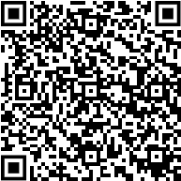
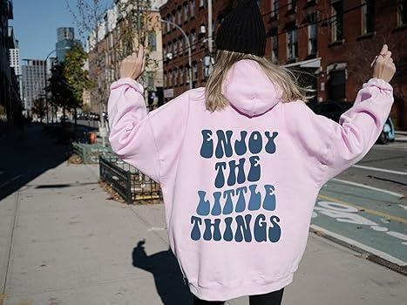
Listen to a podcast called History of Streetwear: The Hoodie and check your ideas to questions

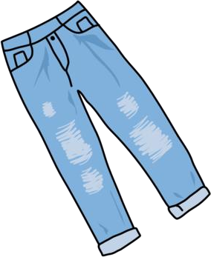
EXERCISE 10. Guess the answers to questions 1–5 below. Then read the article and check your ideas.
- Why is a T-shirt called a T-shirt?
- Which was the first profession to wear leather jackets?
- How is the phrase ‘blue jeans’ connected to France?
- When did young people start wearing jeans as fashion items?
- Why are these clothes still popular with young people?

TEXT

Icons of fashion

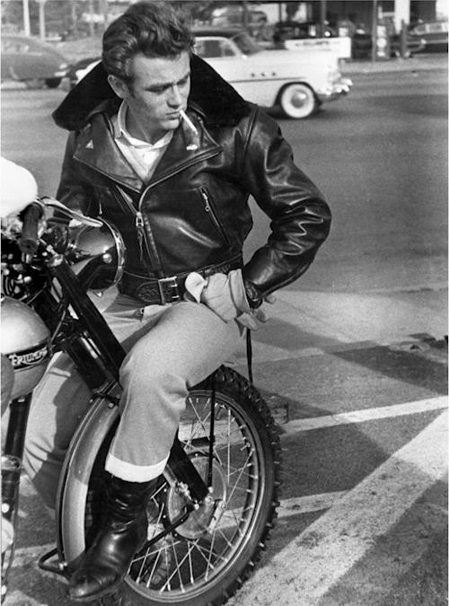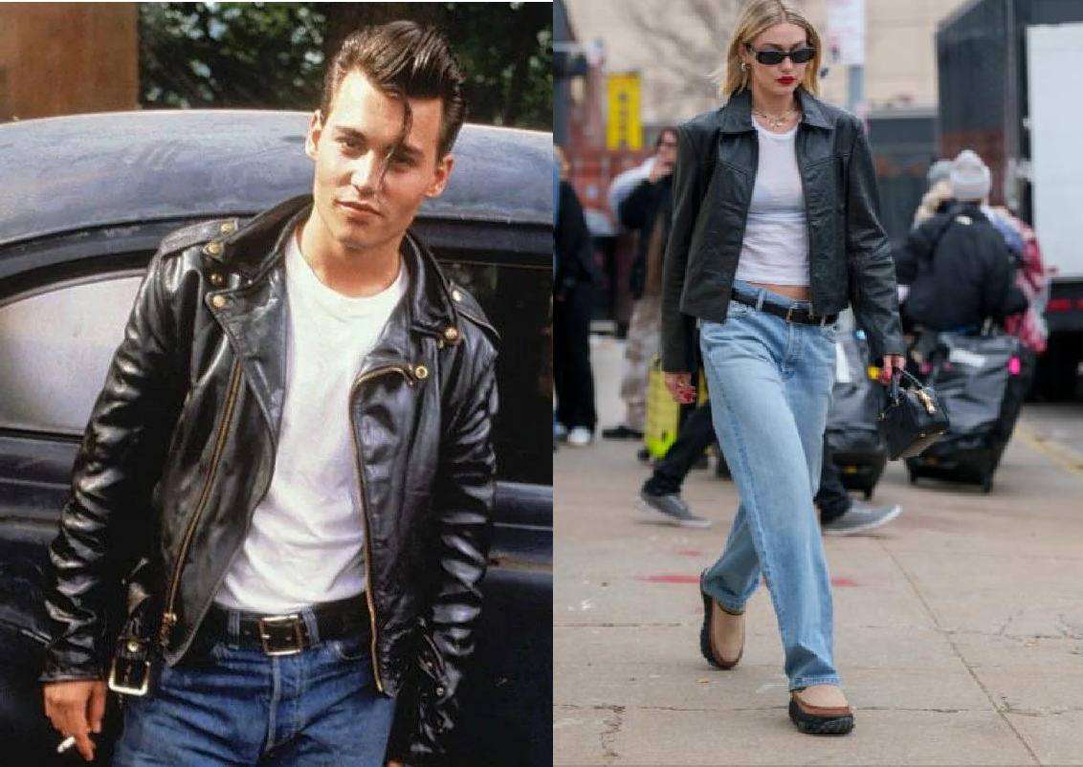

We think we look so cool, so modern and just a little rebellious in our jeans, white T-shirt and black leather jacket. But we’re not as original as we think we are – this look goes back to the 1970s, right? Well, no, not exactly – as a matter of fact, you can trace most of it back to 100 years ago.
Take the white T-shirt and leather jacket. Both started life in the military. The T- shirt (so-called because of its shape like a T) was in fact underwear. In the American Navy, it was worn under a uniform. Until the early 20th century, underwear was woollen, but a revolution in textile production produced cotton jersey, a fast-drying fabric which fits tightly to the body and kept sailors warm. The short-sleeved T-shirt was born. Leather jackets were worn by fighter pilots in the First World War – they were hard-wearing, warm and fur-lined for maximum protection from the elements. Then, in 1928, an American raincoat company, Schott, designed the first leather motorcycle jacket with a zip.
By the 1950s both garments had reached iconic status when famous actors like Marlon Brando and James Dean wore them in films. Later, in the 1960s and 1970s, bands from the Beatles to the Ramones adopted the leather jacket, and it moved from motorcycle sports to teenage rebellion. In the 1970s T-shirts got a colourful update: brightly-coloured T-shirts were particularly popular as well as T-shirts with band logos and political slogans. Having started out as an undergarment for men, T-shirts became unisex in the 1970s and have been part of everyone’s wardrobe since then.
You may think your fashionably distressed jeans are cutting-edge fashion items, but they can be traced even further back in history. In the 1800s denim, the material jeans are made of, was a kind of cotton made in Nîmes, France (‘de Nîmes’). The first blue denim trousers were worn by sailors in Genoa – ‘Gênes’ in French. ‘Bleu de Gênes’ became ‘blue jeans’.
Blue jeans as we know them originated during the 1849 Californian Gold Rush. They were developed by German storekeeper Levi Strauss and Latvian tailor Jacob Davis. Levi Strauss never wore a pair of jeans himself – he was a wealthy businessman, and jeans were only worn by manual workers and cowboys. But then their popularity spread after the Second World War. Young people started wearing jeans to imitate young Hollywood stars. However, they were associated with rebellious behaviour and were banned in schools.
With trends and influencers gaining and losing popularity quicker than ever, a look back at style icons of decades past reminds us that style is forever. However, the icon gets thrown around far too often. To qualify as one, especially in the now oversaturated realm of fashion, their singular style must evoke images, stories, and other memorable moments we carry throughout our lifetimes. No one broke the style mould quite like the outspoken trailblazer Katharine Hepburn. She adopted a wardrobe of American sportswear staples such as sharp button-down shirts, tailored suit jackets, and perhaps most controversially, pants. We might not think of wearing pants as very forward-thinking, but in the 1930s and '40s, a woman of her prestige refusing the societal fashion norms of modest "ladylike" dressing seemed simply unfathomable. However, with Hepburn leading the charge, wearing pants eventually became not only widely accepted but an essential wardrobe staple for women all over the world.
Born Lesley Lawson, the model who earned her "Twiggy" nickname from a hairdresser, became the personification of the overwhelming dominant trend of the time, "Mod" fashion during the swinging 1960s.. Characterised by shift dresses, miniskirts, knee-high boots, and bold geometric patterns on brightly coloured clothes, the "Mod" trend was a radical departure from the demure day dresses of the previous decade. Twiggy became what many associate with the trend, and it is still to this day.
David Bowie was a true fashion chameleon, constantly reinventing himself and pushing the boundaries of style. From his flamboyant stage costumes to his avant-garde streetwear, Bowie’s fearless approach to fashion made him a true iconoclast. With his androgynous style, bold makeup, and eclectic wardrobe, Bowie challenged traditional notions of masculinity and femininity, inspiring generations of artists, musicians, and fashion designers. With his enduring influence on popular culture, Bowie remains one of the most iconic and influential figures in the world of fashion. Fashion has always been more than just clothing; it’s a form of expression, an art, and a reflection of culture. Throughout history, certain individuals have emerged as fashion icons, shaping trends, setting standards, and inspiring millions around the world. From glamorous Hollywood starlets to groundbreaking designers, these icons have left an indelible mark on the world of fashion, creating styles that transcend borders and stand the test of time.
Adapted from Instyle and The World`s best

READING COMPREHENSION QUESTIONS
- Think about your favourite fashion trends today. How do they compare to the timeless combination of jeans, white T-shirts, and leather jackets mentioned in the text? What do you think makes a fashion trend endure for so long?
- The white T-shirt started as military underwear. How do you think clothing originally designed for practical purposes becomes fashionable over time?
- Actors like Marlon Brando and James Dean made the T-shirt and leather jacket iconic in the 1950s. Can you think of any modern celebrities who have a similar influence on fashion today? How do they shape trends?
- After World War II, jeans were banned in schools due to their association with rebellious behaviour. Can you think of any clothing items today that might have similar connotations? Why do you think certain clothes are seen as rebellious?
- Katharine Hepburn popularised wearing pants for women in the 1930s and '40s. How do you think fashion can challenge societal norms and promote change? Can you think of a current fashion trend that is doing this?
- David Bowie’s androgynous style challenged traditional notions of masculinity and femininity. How do you think fashion can be used as a tool for personal expression and breaking boundaries?
- The text mentions that fashion is more than just clothing; it’s a form of expression and a reflection of culture. How do your clothing choices reflect your personal identity and the culture you are part of?


Classroom extra. Watch the video below. Discuss what trends you used to follow.

SPEAK OUT
Describe the trends in clothing throughout the century. Dwell on trendsetters who influenced the perception of fashion at that time
Current style trends of Gen Z

APPENDIX

Guidelines for writing a summary of a text
The purpose of a summary is to give the reader, in a about 1/3 of the original length of an article/lecture, a clear, objective picture of the original lecture or text. Most importantly, the summary restates only the main points of a text or a lecture without giving examples or details, such as dates, numbers or statistics.
Before writing the summary:
For a text, read, mark, and annotate the original:
- highlight the topic sentence
- highlight key points/key words/phrases
- highlight the concluding sentence
- outline each paragraph in the margin
Take notes on the following:
- the source (author--first/last name, title, date of publication, volume number, place of publication, publisher, URL, etc.)
- the main idea of the original (paraphrased)
- the major supporting points (in outline form)
- major supporting explanations (e.g. reasons/causes or effects)
Writing your summary:
- Organize your notes into an outline which includes main ideas and supporting points but no examples or details (dates, numbers, statistics).
- Write an introductory paragraph that begins with a frame, including an in-text citation of the source and the author as well as a reporting verb to introduce the main idea. The reporting verb is generally in present tense.
- Support your topic sentence with the necessary reasons or arguments raised by the author/lecturer but omit all references to details, such as dates or statistics.
- Use discourse markers that reflect the organization and controlling idea of the original, for example cause-effect, comparison-contrast, classification, process, chronological order, persuasive argument, etc.

HOW TO WRITE A SUMMARY: USEFUL EXPRESSIONS
First |  | argues
At the beginning | the author | writes, states | that
In the introduction |  | explains, mentions | why
 | the reader | is informed
In the next part
In the main part | the reader is informed about | the theory
Second; First | the author goes on with | the data / question | that
Then; Afterwards | we are told about | the statistics | what
Moreover; | we read / hear about | the belief | why
In addition to that | the author examines | the argument | if
Further on | he/she analyses | the opinion / topic
Next | discusses | the problem
In the end | the author | emphasises
Finally | the writer | concludes | that
At last | the poet | finds the solution | what
The final part, section | the journalist | adds / stresses | why
As a conclusion | the reporter | pretends | if
Summing up his / her thoughts | the scientist | hints

Text analysis guidelines
Morphological features (parts of speech analysis)
- verbs:
- specify the tenses used in the text (state the prevailing one and why);
- passive voice structures (to be + past participle);
- modal verbs (can, could, may, might…)
- marginal modals/semi-modal verbs (have to, need to, used to, be able to…)
- nouns: find examples of
- countable/uncountable
- singular/plural
- proper/common/collective (team, class, family, crew, committee, audience, flock, bunch)
- concrete/abstract nouns
- possessive case
- adjectives:
- comment on the use of of degrees of comparisons (positive, comparative, superlative)
- find the examples of fact/opinion adjectives
- adverbs:
- comment on the use of of degrees of comparisons (positive, comparative, superlative)
- find the examples of adverbs belonging to different categories
        - manner (slowly, quickly)
        - degree (incadescently, very, extremely, highly)
        - frequency (always, usually, often, sometimes)
        - place (here, there, everywhere)
        - time (yesterday, tomorrow, soon, already)
- pronouns: illustrate
  - personal (subject: I, we, you, they, he, she, it + object: me, you, us, them, him, her, it)
  - possesive (mine, yours, his, hers, its, ours, theirs)
  - demonstrative (this, that, these, those)
  - reflexive (myself, yourself, herself, himself, itself, ourselves…)
  - reciprocal (each other, one another)
  - indefinite (anyone, someone, everyone, nobody, nothing, something, all, some, many, few, several)
  - relative (who, whom, whose, that, which…)
  - interrogative (who, what, which…)
  - negative pronouns (no, none, neither, nowhere…)
- numerals: exemplify cardinal and ordinal numerals
- functional parts of speech:
- find prepositions of different categories
- place (at, on, in, between, behind, over)
- time (at, on, in, since, during, until, by)
- direction/movement (to, into, onto, towards, out of)
- manner/agent/instrument (by, with, via)
- cause/reason/purpose (because of, due to, on account of)
- comparison/contrast (like, unlike, as, than)
- possession (of, to)
- measure/standart/rate (by, at, per)
- find conjuctions
- coordinating = сурядні (and, but, or, so)
- subordinating = підрядні (because, since, although, while, when, if, unless)
- correlative (either…or, neither…nor, not only…but also, both…and)
- find particles (can be found in phrasal verbs, negative particle ‘not’, full infinitive ‘to’
- find interjections (Wow! Nope! Ew!)
- comment on the use of articles (definite, indefinite, zero)

The Freshmen's Exam Journey
Last semester [time adverb], a group of hardworking freshmen [collective noun] faced their first big challenge [abstract noun]: the end-of-term exam [common noun]. Everyone [indefinite pronoun] knew [verb, past simple] it would be difficult [fact adjective], but they were determined to succeed.

Every day [frequency adverb], they studied together [adverb of manner] in the library [preposition of place], reviewing the material [uncountable noun] and solving practice tests [plural noun]. “We have to [semi-modal verb] give it our best shot,” one of them [personal pronoun] said, encouraging the group.

Although [subordinating conjunction] the workload was overwhelming [opinion adjective] at times, they managed to stay focused. Each evening, they would revise thoroughly and quiz one another [reciprocal pronoun] on key topics. Their efforts paid off [phrasal verb] when the exam day finally arrived.

The test was not as difficult as they had thought. Thanks to their preparation, they could answer [modal verb, ability] every question confidently. Even the trickiest parts were manageable because they had learnt all the material [concrete noun].

By the end of the day [preposition of time], they were proud of themselves [reflexive pronoun]. “Wow [interjection], we did it!” exclaimed the class representative [singular]. It was a rewarding experience that proved hard work truly pays off.

a) Verbs
- Tenses:
  - Past simple: knew, studied, managed (prevailing tense for narration).
  - Past perfect: had thought, had learnt (for actions completed before another past action).
- Modal verbs:
  - Could answer
- Marginal modals/semi-modals:
  - Have to give it our best shot (obligation).

b) Nouns
- Countable/Uncountable:
  - Countable: freshmen, questions, topics.
  - Uncountable: material, preparation.
- Singular/Plural:
  - Singular: day, workload.
  - Plural: tests, efforts.
- Proper/Common/Collective:
  - Proper: None in this text.
  - Common: exam, library, workload.
  - Collective: group, class.
- Concrete/Abstract:
  - Concrete: library, material.
  - Abstract: challenge, preparation.

c) Adjectives
- Degrees of Comparison:
  - Positive: hardworking.
  - Comparative: not as difficult as.
  - Superlative: best
- Fact/Opinion:
  - Fact: difficult.
  - Opinion: overwhelming workload.

d) Adverbs
- Degrees of Comparison:
  - None in this text.
- Categories:
  - Manner: thoroughly, confidently.
  - Degree: not as difficult.
  - Frequency: every day.
  - Place: in the library.
  - Time: last semester, finally.

e) Pronouns
- Personal: them, they.
- Possessive: None in this text.
- Demonstrative: None in this text.
- Reflexive: themselves.
- Reciprocal: one another.
- Indefinite: everyone.
- Relative: None in this text.
- Interrogative: None in this text.
- Negative: None in this text.

f) Numerals
- None in this text.

g) Functional Parts of Speech
- Prepositions:
  - Place: in the library.
  - Time: by the end of the day.
  - Direction: None in this text.
  - Manner: Thanks to.
  - Cause/Reason: because.
  - Comparison: as…as.
- Conjunctions:
  - Coordinating: and.
  - Subordinating: although, because.
  - Correlative: None in this text.
- Particles:
  - Phrasal verb: paid off.
  - Infinitive: to succeed.
- Interjections:
  - Wow!
- Articles:
  - Definite: the workload (Specific, defined noun)
  - Indefinite: a group of (Introducing a non-specific singular noun, one of many)
  - Zero: freshmen (Plural, countable noun used generally)

