Т.І. Pavlovych

Home Reading
FIGHT CLUB by Chuck Palahniuk

for the fourth-year students

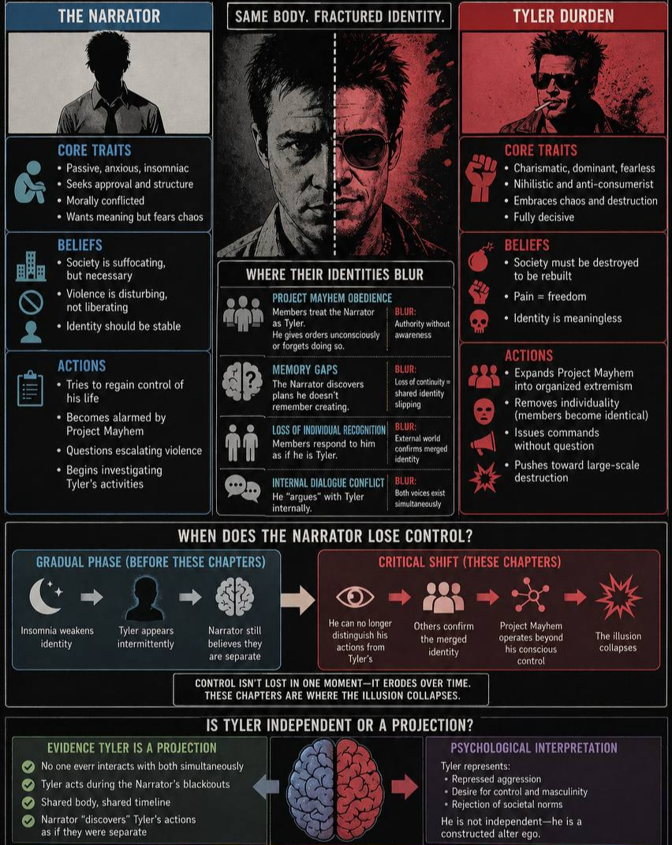

Chernivtsi – 2026

УДК 811.111(076)
ББК 81.432.1-932
П693

Друкується за ухвалою редакційної-видавничої ради Чернівецького національного університету імені Юрія Федьковича

Укладач: Павлович Т.І., к.ф.н., доцент кафедри англійської мови ЧНУ ім. Юрія Федьковича

Відповідальний за випуск: Павлович Т.І., кандидат філологічних наук, доцент

Практичний курс англійської мови як першої іноземної П693 (домашнє читання), 4 курс: Навчальний посібник / Укладач: Павлович Т.І. Чернівці. 2026. 197 с.

Навчальний посібник з домашнього читання містить комплекс завдань та вправ спрямованих на розвиток комунікативних навичок когерентного мовлення, використання сформованих діалогічних та монологічних компетенцій на систематизацію і розширення словникового запасу.
Запропонований посібник призначено для студентів четвертого курсу факультету іноземних мов, що вивчають англійську мову як першу іноземну.

УДК 811.111(076)
ББК 81.432.1-932

Ch.24-26

Dwell upon:
How everything you ever love will reject you or die.
Everything you ever create will be thrown away.
Everything you’re proud of will end up as trash.
Why did I cause so much pain?
Didn’t I realize that each of us is a sacred, unique snowflake of special unique specialness?
Can’t I see how we’re all manifestations of love?
I look at God behind his desk, taking notes on a pad, but God’s got this all wrong.
We are not special.
We are not crap or trash, either.
We just are.
We just are, and what happens just happens.
Learn the words:
- to smother
- to kill someone by covering the person’s face, making it impossible to breathe.
- to cover most or all of a surface: The pasta was smothered with a creamy sauce.
- to stop a fire from burning by covering it with something that prevents air from reaching it: Firefighters smothered the blaze with chemical foam.
- to stalk
- to follow an animal or person as closely as possible without being seen or heard, usually in order to catch or kill them: The police had been stalking the woman for a week before they arrested her.
- to illegally follow and watch someone over a period of time: He had stalked her for several months before he was arrested.
- to walk in an angry or proud way: She refused to accept that she was wrong and stalked furiously out of the room.
- collarbone – a bone between your shoulder and neck on each side of your body
- The Elgin Marbles are a collection of Ancient Greek sculptures from the Parthenon and other structures from the Acropolis of Athens, removed from Ottoman Greece in the early 19th century
- sledgehammer – a large, heavy hammer with a long handle, used for breaking stones or other heavy material, or for hitting posts into the ground, etc.
- crook – inf. a very dishonest person, especially a criminal or a cheat: These politicians are just a bunch of crooks.
- the crook of your arm – the inside part of your arm where it bends
- crook – a long stick with a curved end, especially one carried by a shepherd or a bishop: shepherd’s crook
- leer – to look at someone in an unpleasant or offensive way
- ragged
- (of clothes) torn and not in good condition: The children were wearing dirty, ragged clothes.
- (of a person) untidy, dirty, and wearing old, torn clothes: Two ragged children stood outside the station, begging for money.
- (not straight, especially of an edge) not smooth or straight: The leaves of this plant have ragged edges.
- (of a sound) not regular or controlled: The patient's breathing was ragged and uneven.
- capillarity / capillary action – the force that causes liquid to rise in a tube or other narrow space against the force of gravity
- martyrdom – an occasion when someone suffers or is killed because of their religious or political beliefs
- whop – to hit someone or something hard, to defeat someone easily
- epiphany a moment when you suddenly feel that you understand, or suddenly become conscious of, something that is very important to you / a powerful religious experience
- Epiphany – a Christian holy day in January (traditionally 6 January in Western Christianity) that celebrates the revelation of the baby Jesus to the world
Match the words (A–J) with definitions (1–10):

Words:
A. smother
B. stalk
C. collarbone
D. sledgehammer
E. crook (criminal)
F. crook (arm)
G. leer
H. ragged
I. martyrdom
J. epiphany
Definitions:
- ___ a sudden moment of understanding
- ___ a bone between shoulder and neck
- ___ a dishonest person
- ___ to follow secretly
- ___ torn or uneven
- ___ to cover completely / stop breathing
- ___ suffering for beliefs
- ___ inside part of the arm
- ___ to look in an unpleasant way
- ___ a heavy tool for breaking things

Choose the correct meaning of the word in each sentence:
- He leaned on his crook while walking.
a) criminal b) stick c) arm
- The police arrested the crook.
a) criminal b) stick c) arm
- The baby slept in the crook of her arm.
a) criminal b) stick c) arm
- She stalked out of the room angrily.
a) followed secretly b) walked angrily c) hunted
- The tiger stalked its prey.
a) followed secretly b) walked proudly c) escaped
- He had been stalking her online.
a) illegal following b) hunting animals c) walking
- The fire was smothered with sand.
a) covered to stop burning b) hit c) ignored
- The dish was smothered in sauce.
a) covered b) destroyed c) dried
- He tried to smother the victim.
a) kill by blocking air b) chase c) scare
- Her breathing was ragged.
a) smooth b) uneven c) silent

Gap Fill (smother, stalk, leer, ragged, whop, epiphany, crook, sledgehammer, collarbone, martyrdom)
- He hit the door with a __________.
- She gave him an uncomfortable __________.
- The man had been __________ his victim for days.
- His clothes were dirty and __________.
- He broke his __________ in the accident.
- The idea came to him in a sudden __________.
- The flames were __________ with foam.
- The police finally caught the __________.
- He __________ the table in anger.
- The story describes his __________ for his beliefs.

Collocation Builder

- smother →
- heavy →
- sudden →
- ragged →
- break →
- commit →
- unpleasant →
- powerful →
- illegal →
- curved →
a) breathing
b) sledgehammer
c) epiphany
d) clothes
e) collarbone
f) martyrdom
g) leer
h) experience
i) stalking
j) crook
Choose the closest synonym:
- leer → a) stare unpleasantly b) smile c) glance
- stalk → a) follow secretly b) run c) sit
- ragged → a) torn b) clean c) soft
- smother → a) cover completely b) open c) lift
- crook (criminal) → a) thief b) teacher c) doctor
- whop → a) hit hard b) whisper c) look
- epiphany → a) realization b) problem c) mistake
- martyrdom → a) sacrifice b) success c) comfort
- sledgehammer → a) heavy hammer b) knife c) rope
- stalk (walk sense) → a) walk angrily b) sleep c) jump
Discussion:
- The Narrator is both a victim and a creator of destruction. Discuss this statement with reference to Chapters 24–26.
- Analyze how control and power shift between the Narrator and Tyler in Chapters 24–26. Support your answer with specific events.
- Is Tyler a separate character or a manifestation of the Narrator’s mind?
- Why does the Narrator begin to fear Project Mayhem at this stage? What specific events make him realize things are out of control?
- Why does the Narrator try to stop Project Mayhem, and why does he fail? What forces are working against him?
- How does the behavior of Project Mayhem members change in these chapters? What does this suggest about the loss of individuality?
- Why do the members refuse to acknowledge the Narrator as separate from Tyler? What does this reveal about both the organization and the Narrator’s identity?
- How does Tyler’s attitude toward death and control become clearer in these chapters? What examples support this?
- What role does fear play in these chapters and who is actually afraid? Compare the Narrator, Tyler, and the followers.
- How do these chapters develop the theme of identity fragmentation? What clues suggest the Narrator is losing control over himself?
- Do these chapters present Tyler as a leader, a destroyer, or something else entirely? Support your answer with specific plot details.
- Why does the Narrator feel conflicted about Marla? What does Marla reveal about the Narrator that he cannot see himself? What emotions define Marla’s character in these chapters?
- How is the idea of God presented in the final chapter? Is God depicted as present, absent, or replaced by something else?
- What role does suffering play in the ending? Can it be interpreted as a form of religious experience or “martyrdom”? Is martyrdom ever justified?
- Does the ending resemble a form of afterlife (heaven, hell, or something else)?
What evidence supports your interpretation?
- How does the novel challenge traditional religious beliefs about meaning and salvation?
- The ending of the novel represents a form of spiritual rebirth. Defend or challenge this interpretation.
- Analyze the use of religious imagery and symbolism in the final chapter. How do these elements contribute to the meaning of the ending?
- What evidence suggests a heaven- or hell-like setting in the ending?
- To what extent does the ending suggest the need for meaning or faith? Support your answer with textual interpretation.

Tasks:

“Epiphany Speech”. Deliver a short speech (1–2 minutes): describe a moment of sudden realization (real or fictional).

Choose a key moment from Chapter 26. What is really happening beneath the surface? What emotions are hidden? How would this scene look from an outsider’s perspective?

Cultural Reflection: Elgin Marbles. Use at least 3 vocabulary words metaphorically in your argument. Should cultural artifacts be returned to their country of origin? Is taking them preservation or theft?

Crime Case File. Create a fictional police report using these words: stalk, crook (criminal meaning), leer, snap, ragged, collarbone, sledgehammer, smother, epiphany. Include: suspect description, timeline, witness statement

Project work: Modern Society on Trial
Roles:
- Judge
- Prosecutor (society is guilty)
- Defense (society is necessary)
- Witness 1 (Narrator perspective)
- Witness 2 (Tyler perspective)
- …
Outcome: Deliver a verdict with justification.

