Wavefront aberration in the reconstructed images of holograms on DMDs

Beom-Ryeol Lee, Wookho Son, Gwanghee Heo, Tetiana Venkel, and Jung-Young Son, Member, IEEE

Abstract—Wavefronts of the reconstructed images from holograms displayed on both rhomb and square pixel type Digital Micromirror Devices (DMDs) are visually identified with a color phase map obtained with a Shack-Hartmann wavefront sensor to show wavefront aberration induced by DMDs’ unique pixel structure and working principle. The wavefronts of different holograms show color phase maps very similar to each other. However, the phase maps clearly reveal the presence of the aberration and indicate that the square pixel DMD that is around two times bigger in dimension compared with the rhomb one, reveals that its wavefronts are aberrated more than those of the rhomb. In addition to this revelation, they also inform that the aberration is appearing along the DMDs’ pixel rotation directions. This aberration causes blurring and distortion of the reconstructed images. Nevertheless, when the phase maps are compensated by that of the reflected beam from the On-states of the DMD surfaces without any hologram loading, the reconstructed images become more distinguished and identified for both DMDs.

Index Terms— Reconstructed image, holograms, rhomb and square pixel DMD, Shack-Hartmann wavefront sensor, color phase map, wavefront aberration.

I. INTRODUCTION
L
ike a Fresnel zone plate, a point hologram recorded with a collimated reference beam that is normally incident to the surface of the hologram can be used as a standard pattern for other point objects. The surface profile of an object intended to be made to a hologram can be discretized to an array of dots, in which each of the dots can be considered as a point. Then a point hologram of the distance corresponding to each point forming the object is added to each other by shifting it to the distance between the dots for the object's CGH calculation. Hence, the hologram of an array of points consists of a number of the localized standard patterns corresponding to that of the points in the array.
To reconstruct the CGH, it is displayed on a spatial light modulator (SLM) in electro-holographic displays [1], and the collimated reconstruction beam of the same wavelength, but directed opposite to the reference beam, reconstructs the real image of the object at the object location. The phase-conjugated beam from the hologram will consist of the number of the localized standard patterns. However, for the case of a DMD as the SLM, the reconstruction beam should be directed in the same direction as the reference beam. Nevertheless, DMD can still reconstruct the real image because each pixel of DMD is a surface coated mirror, and the hologram fringe pattern has a physical shape due to the switching action of each pixel. Hence the beam propagation direction of the incoming reconstruction beam is reversed, and phase conjugated image is generated by the pixels forming the physical shape of the fringe pattern. In this way, the effect of reducing the focus distance of the reconstructed image to a half by the reconstruction beam passing the hologram two times will not be aroused [2].
The beams from the DMD surface consist of three different patterned beams: the first one is the beam directly reflected from the pixels forming the physical shape; the second one is the beam diffracted from the physical shape and the third one is the diffracted beam generated by the regular pixel arrangement of the physical shape. The beam reflected from DMD will bring the trace of the physical shape because the illuminating beam is only reflected by the shape. The diffracted beam generated by the regular pixel arrangement consists of an array of rectangles duplicating the display surface of the DMD. Each rectangle in this array is inscribed by the fringe pattern of the hologram. The reflected beam from the shape will be overlapped on the 0th order diffracted beam, because they are directing to the same normal to the surface of the shape. Since the beam reflected from the shape is collimated by the reconstruction beam, it is matched to the surface of the 0th order diffracted beam irrespective of the propagation distance for the ideal case. The reconstructed image is the diffracted beam from the shape and is accompanied by each of the rectangles.
As described above, DMD is a unique SLM, which displays images by a high-speed On-Off action of the pixels consisting of its active surface. Each pixel is directing the illuminating beam on its surface to either 2ⅹm˚ for On-state or –2ⅹm˚ for Off-state direction with the reference beam when “m” is the rotation angle of each pixel. This On-Off action makes the DMD a binary display device [3]. To display a gray level image, the On-Off action is repeated consecutively for 8 times. The typical value of m is ±12˚. DMD has two different pixel arrangements: one is having a rhomb shape pixel and the other – a square shape. The rotating axis of each pixel is one of its diagonals for both arrangements.
Hence, the On-Off action directs an image projected normally on its surface to both ±24˚ in horizontal directions: one image represents the bright part of the image while the other – the dark part. I.e., if the hologram fringe pattern is in a binary form, one image corresponds to bit “1” and the other – to bit “0”. The pixel arrangement itself physically forms the image shape corresponding to bit “1” in one direction and bit “0” in the other direction. Thus, the images will not differ greatly, because they correspond to its bright and dark parts, respectively. Consequently, two similar images separated by 48˚ in horizontal direction [4] for the rhomb and by either 45˚ or –45˚ direction for the square are projected. When the image displayed on DMD is a hologram, which is calculated with a collimated reference beam normally incident to the active surface of the DMD, the reconstructed image will appear at 24˚ and –24˚ directions along the horizontal axis, with the reflected beam directly from the mirrored surfaces of the pixels. Each direction pixels will represent either the bright or the dark part of the hologram fringe pattern.
If the hologram is for a point object, it will have a certain part of a point hologram pattern due to the finite size of the DMD. Since the phase-conjugated rays from the point hologram pattern form the reconstructed image, the phase-conjugated rays will have the beam inscribed with the pattern that is the same as the point hologram. The phase-conjugated beam would be uniformly contracted to the object position to reconstruct a point image comparable to the object point.
This phase-conjugated pattern can be identified by putting a diffuser/a detector at any position of the path to its focus [5]. However, the converging angle of the contracting conjugated beam is expected to be bigger than that defined by the dimensions of the DMD display surface, because the conjugated beam has a bigger dimension than the display surface due to the recovered part of the hologram pattern in the reconstruction process. This will be the reason why the contracting of the phase-conjugated beam cannot last to the object position, but stops before reaching the object position and then expands. In addition, the shape of the conjugated beam at the stopping position should have the contracted shape with that of the hologram pattern, but the presence of astigmatism prevents from having the shape.
The pixel rotation along one of its diagonals causes virtual shrinkage of the hologram pattern in the rotation direction in DMDs. This shrinkage makes the focus distance of the plane of the rotation direction to be slightly shorter than that of the rotation axis plane. This can be a reason causing the astigmatism. This astigmatism forces the reconstructed image to be the circle of least confusion (CLC) between two focused lines perpendicular to each other. Since these focused line images are the result of pressing one direction harder than the other, the hologram pattern is not smoothly, but forcefully contracted. Hence, the CLC has a finite size and has a compressed hologram pattern. The CLC also appears at shorter distance than the object distance. The first focused line expands and rotates to form the CLC, but the 2nd focused line expands to recover its hologram pattern [5]. The continued expansion finally forces it to disappear. Due to this astigmatism and the converging angle difference, the wavefront of the conjugated beam is aberrated and therefore, the reconstructed image will be distorted. In addition to this, the wavefronts of the reflected beam and the diffracted beam will be added to the reconstructed image. Thus, the wavefront of the reconstructed image will be distorted due to the added and aberrated wavefronts. There were efforts to eliminate the phase distortions in DMDs as a beam shaping device [6, 7] but none are found for DMDs as a SLM.
In this paper, the wavefronts of reconstructed images from a hologram displayed on both rhomb and square type DMDs are measured using a Shack-Hartmann wavefront sensor [8,9] supplied with a mirrorless camera [10]. The quantity of the wavefront aberrations introduced by the DMDs is shown by a color phase map, and the method to minimize the aberration is introduced. The method consists in compensating the measured wavefronts by the white beam reflected from the On-state of each DMD pixels without any hologram loading to clear out the wavefront aberration caused by the DMD themselves. The white beam effectively reduces the wavefront aberrations in the reconstructed image similarly to adaptive optics [11,12] and makes the image more identifiable.

II. LIGHT FIELDS ALONG THE PATH TO THE RECONSTRUCTED IMAGE IN DMDS
When the reconstruction beam illuminates the hologram displayed on a DMD, light fields demonstrating the image reconstruction process of the hologram appear along the path of reconstructing the object image. Fig. 1 shows the light fields appearing at the specified distances from the hologram along the path for the reconstructing image, for the case of an on-axis hologram of a point object, which is on the normal axis of the hologram, at the distance of 500 mm from the hologram.

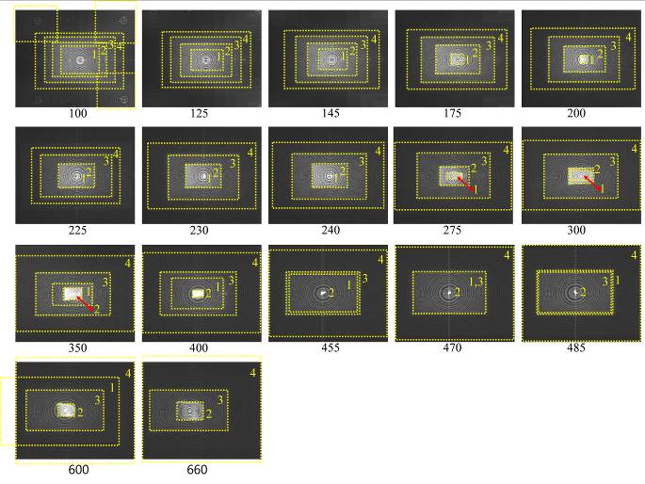
Fig. 1. Light field distribution along the path for reconstructing image of a point object for the case of the on-axis hologram. The object distance 500 mm from the hologram along the normal axis of the hologram.

The DMD used has a rhomb shape pixel array of 1280 x 800 with the pixel size of 7.637 ㎛ [13]. This results in 10 mm (Horizontal) x 6 mm (Vertical) as the DMD’s surface dimension with 10.8 ㎛ as its diagonal. Each pixel rotates with the vertical diagonal as its rotation axis [3]. The light field at 100 mm shows the 0th- and four 1st-order diffracted beams shown at the four corners of the image. The patterns in these beams reveal the hologram fringe pattern overlapped with several other reconstructed fringe patterns. Since the intensity of the 0th-order beam is much higher than that of 1st-order beams, the overlapped patterns are not clearly shown in the 1st-order beams. For the case of 0th-order beam, there are four working independently point hologram fringe patterns specified by rectangles in broken boundary lines. The rectangles 2, 3 and 4 represent the phase-conjugated hologram fringe patterns that have already been contracted due to the 100 mm travelling, the beam reflected from the DMD surface, which is inscribed with the hologram fringe pattern, and the hologram fringe pattern added with partly recovered fringe pattern, respectively, as explained before.
It looks that the hologram regenerates the phase-conjugated rays, generates newly several other phase-conjugated beams with shorter focus distances, and partially recovers the missing part of the fringe pattern as soon as the reconstruction beam illuminates it. The amount of the recovered part of the fringe pattern increases more until the reconstructed image appears but after the 2nd line image at 485 mm formed, it no longer exists. The size and pattern of rectangle 3 remains the same during the entire process because it is reflected from the DMD surface by a collimated reconstruction beam.
Rectangle 2 is contracted to a horizontal line image at 455 mm, to a CLC image at 470 mm and to a vertical line image at 480 mm. The distance of 470 mm is slightly shorter than the designed one of 500 mm. These three focused images reveal the presence of astigmatism. After the 2nd line image, rectangle 2 recovers its original size but with inversed pattern of the original hologram pattern and then expands more until it disappears as shown in the images at 600 mm and 660 mm.
Rectangle 1 represents one of new point hologram patterns that are focused at shorter distances as in the Fresnel zone pattern [14]. For rectangle 1, its CLC image appears at 230 mm. The line images appear at 225 mm in vertical and at 240 mm in horizontal. The line image order is opposite to that of rectangle 2 case. After the 2nd focused line, the original pattern expands to exceed the DMD surface and then disappears. The horizontal line in the center of the image at 100 mm shows another extra pattern focused at slightly shorter than 100 mm when considering the line image order of rectangle 2. Therefore, the light field expands more than the DMD surface size due to the recovered parts of the fringe pattern and expanded phase-conjugated fringe patterns focused at shorter distances than the designed object distance.
Since the expanded phase-conjugated fringe patterns are overlapped with the phase-conjugated beam of the object point, they can add extra wavefronts to that of the phase-conjugated beam. However, they may not change the wavefront of the phase-conjugated beam because they are independently working with the phase-conjugated beam, i.e., they are diverging while the phase-conjugated beam is converging. The converging angle of the phase-conjugated beam for the 1st and 2nd line images cannot exceed 0.6296˚ and 0.5907˚, respectively, when their focusing distances and the DMD dimension are considered. The converging angle for the CLC image may not be greater than two angle values when considering the finite size of the image.
The light fields for the square pixel DMD are not different from those in Fig. 1, except their bigger CLC image and the line image directions of ± 45˚ [3]. The DMD with square pixels has the pixel size of 10.8 ㎛, which corresponds to the diagonal size of the rhomb pixel and the resolution of 1920 x 1080 [15]. The surface area of this DMD is approximately 20 mm (Horizontal) x 10 mm (Vertical). The rotation axis of each pixel is its diagonal, so the rotation axis is directed to -45˚ in CCW direction. The DMD surface sizes indicate that the converging angle will be within 0.3438˚(Vertical) and ±0.573˚(Horizontal) for rhomb pixel DMD, and ±1.1458˚(Horizontal) and 0.573˚(Vertical) for square pixel DMD when the object point is located on the normal line of the DMD surface at 500 mm distance from the surface. When the object position is at the left (top) or right (bottom) edges of the DMD surface, the angles will be doubled. For the case of an off-axis point, the angle can be almost two times greater than the vertical converging angle of each DMD. Table 1 summarizes the expected converging angles of the reconstructed image for the DMDs used assuming that the object position is 500 mm from the DMDs.

Table 1. Converging angles defined by DMD dimensions

When the wavefronts of reconstruction, object and reference beams at different coordinate positions in hologram recording and reconstruction geometries are expressed as 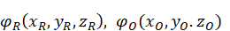and 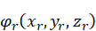, respectively, the wavefront of the reconstructed image represented as 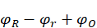 for the virtual image and for the real image are expressed as [16],
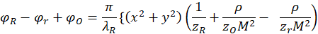
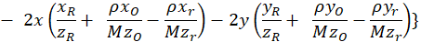
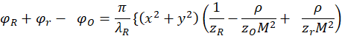
(1)
where, $x$, $y$, $λ_{R}$, $ρ(=\frac{λ_{R}}{λ_{r}})$ and $M$ represent the position of a point in hologram on DMD surface, the wavelength of reconstruction wave, the ratio of reconstruction to reference wave wavelengths and hologram magnification, respectively. When the wavefront aberration introduced by the DMD and the reconstruction beam is expressed as $w(x,y)$, the wavefront of the reconstructed image will be expressed as $φ_{R}-φ_{r}+φ_{O}+(\frac{2π}{λ}) w(x,y)$ for virtual image and $φ_{R}+φ_{r}- φ_{O}+(\frac{2π}{λ})w(x,y)$ for real image. When the reference and reconstruction waves are collimated, $z_{R}$ and $z_{r}$ become infinite, and hence $φ_{R}$ and $φ_{r}$ will be set to zero. Furthermore, when reference and reconstruction beams have the same wavelength, and the hologram is not magnified, i.e., $M=1$, Eq. 1 becomes
$φ_{O}=\frac{π}{λ_{R}}\{\left(x^{2}+y^{2}\right)\left(\frac{1}{z_{O}}\right) - 2x\left(\frac{x_{O}}{z_{O}}\right)-2y\left( \frac{y_{O}}{z_{O}}\right)\}$,
(2)
for the virtual image and
$φ_{O}=\frac{π}{λ_{R}}\{\left(x^{2}+y^{2}\right)\left(\frac{1}{z_{O}}\right)- 2x\left( \frac{x_{O}}{z_{O}} \right)-2y\left( \frac{y_{O}}{z_{O}} \right)\}$,
(3)
for the real image.
The image location is represented as ($x_{O},y_{O }, z_{O})$ for the virtual and ($x_{O},y_{O }, - z_{O})$for the real images. Considering Eqs. 2 and 3, and the wavefront aberration, the light field of conjugated beam forming the reconstructed image, $E_{I}\left(x_{I},y_{I }, z_{I}\right)$for the case when the reference and reconstruction waves have unit amplitudes, will be expresses as,
$E_{I}\left(x_{I},y_{I }, z_{I}\right)=E_{O} \left\{\exp\left(-i{(φ}_{O}+\left(\frac{2π}{λ}\right)w\left(x,y\right)\right)\right)+εexp⁡(-iδ)\}≈ E_{O}\left(1-i{(φ}_{O}+\left(\frac{2π}{λ}\right)w\left(x,y\right)\right)$,
(4)
where $εexp⁡(-iδ)$ represents wavefront aberration introduced by the expanded phase conjugated fringe patterns. In Eq. 4, the approximation is working because $εexp⁡(-iδ)$ is small enough to be neglected as mentioned before; $φ_{O}$ is lesser than 2.3˚ even considering the reconstructed image located at either side of the DMD with 500 mm distance, and $\left(\frac{2π}{λ}\right)w\left(x,y\right)$ cannot exceed $φ_{O,}$ because the CLC distance 470 mm does not exceed the object distance 500 mm very much. Eq. 4 indicates that the wavefront aberration can be eliminated by subtracting it.

III. WAVEFRONT SENSOR
The wavefront sensor is a Shack-Hartmann wavefront sensor used for estimating the wavefront aberration added to the reconstructed image and for eliminating it. The sensor consists of a microlens array plate with 77 x 51 microlenses and a detector with 6000 x 4000 resolution. Each lens in the array has a square shape with 300 ㎛ length for each side and focal length of 2 mm. The detector is a part of a mirrorless camera that has a pixel size of 3.89 ㎛ [10]. The typical inner body structure of the mirrorless camera has the shape of a rectangular parallelopiped cave. At the end of the cave, the detector with the dimension of 23.5 mm x 15.6 mm is located. This dimension is bigger than those of the DMDs, but the light fields from the DMDs’ surfaces can still cover the dimension because of the recovered parts of the fringe pattern and expanded phase-conjugated fringe patterns focused at shorter distances than the designed object distance, as mentioned above.
However, since the intensities of these expanded light fields are small, the focused light spots incurred by these light fields are not always processed. The threshold intensity value of the light spot determines its involvement in the processing. The microlens array is located at 2mm above the detector’s pixel surface. Since 77 x 51 lens array covers 6000 x 4000 pixel array, each microlens in the array covers a pixel cell of 77 x 77 pixel array. The center of the cell is on the optical axis of the microlens. According to the microlens’ focal length and detector’s pixel size, the pixel array can cover up to ±4.29˚ of wavefront deviation and each pixel corresponds to approximately 0.11˚.

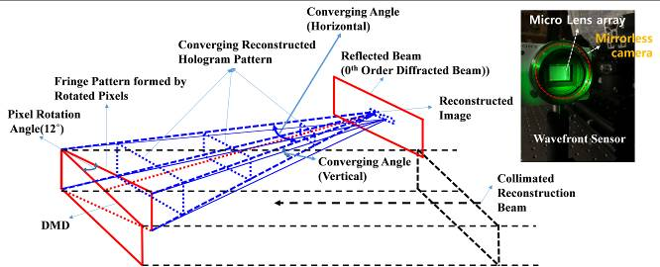
Fig. 2. Schematic of the experimental set-up for measuring wavefront aberration and the Shack-Hartmann wavefront sensor installed in a mirrorless camera.

The converging angle of the reconstructed image as shown in Fig. 2 can exceed 2.3˚, which are calculated considering that the object points are located at either left or right edge side of the square pixel DMD, due to recovered and expanded hologram patterns as shown in Fig. 1. However, ±4.29˚ is still large enough to cover the wavefront of the reconstructed image from the hologram displayed on the DMDs used here considering the converging angles of DMDs specified in Table 1.
Fig. 2 shows the schematic of the experimental set-up for measuring wavefront aberration and the Shack-Hartmann wavefront sensor installed in a mirrorless camera. When a collimated beam normally illuminates the on-state DMDs surfaces, the reconstructed image is directed to both 24˚ and -24˚ from the normal direction. The sensor is located at the image plane of the hologram near the CLC with the angle of 24˚ in horizontal direction: the sensor’s optical axis matches the normal direction of the On-state DMD pixels. This 24˚ difference makes the set up easier because of the separation between the reconstruction beam and the reconstructed image. This angle difference provides about 210 mm separation between the beam and the image at 500 mm distance. This separation leaves enough space to install the sensor without disturbing the reconstruction beam. That is why the holograms are calculated to reconstruct the image at 500 mm.
When a well-collimated light beam is incident on the microlens array, it will be focused at the focal point of each microlens in the array and a light spot will appear at the center of each cell for the ideal case. However, when the collimated beam passes through or is reflected from an object, the focused light spot on each cell is no longer in its center, because the wavefront of the collimated beam had already been aberrated by the object’s optical characteristics. Hence, the position of the spot in each cell reflects the wavefront aberrations acquired by the object. Fig. 3 shows two focused light spots arrays corresponding to the white beams of both DMDs. The numbers of light spots in the arrays should approximately be 66 x 33 for the square pixel DMD and 33 x 20 for rhomb pixel DMD, if they correspond to the real sizes of the DMDs. However, the clearly visible light spots arrays for the square and the rhomb appeared to be 73 x 45 and 34 x 22, respectively, as shown in Fig. 3.

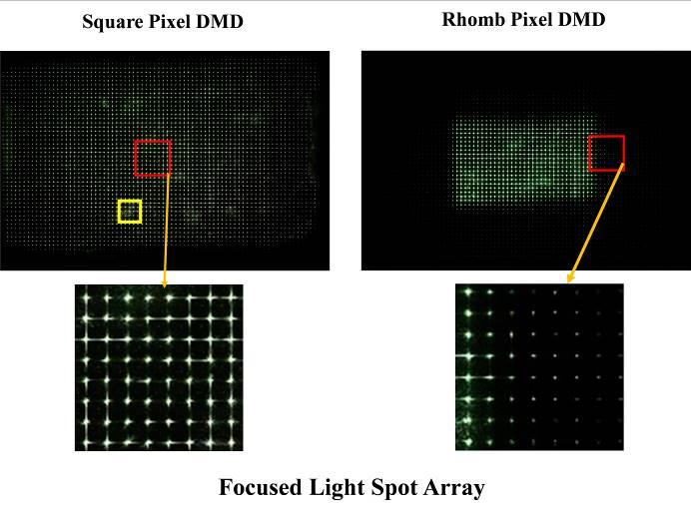
Fig. 3. Two focused light spots arrays corresponding to the white beams of square and rhomb pixel DMDs. The small light spots arrays are magnified images of the boxes indicated by the arrows.

For the rhomb pixel DMD, many faint light spots outside of the clearly visible spots are shown in the enlarged view of the square in the light spots array. This means that the number of light spots will be more than 34 x 22. Thus, the light spot numbers are much bigger than those defined by the physical size of the DMDs due to the recovered hologram parts and the expanded early focused conjugated patterns.
The enlarged views of the square in each focused light spots arrays show that each spot has a non-negligible area within its cell and light lines in both vertical and horizontal directions due to the diffraction effect. The number of spots used for further processing is 69 x 43 out of 77 x 51 to eliminate light spots formed by the damaged lenses in the near edges of the microlens array plate. Several light spot lines close to four edge sides are removed. The number of the removed light spot lines in each side is selected based on the brightness of the focused spots. The total number of the removed lines in each direction is 8. The 69 x 43 array corresponds to 20.7 mm x 12.9 mm. This dimension is still bigger than that of the the square pixel DMD.
To find the wavefront aberration from the light spot images, the accurate determination of the position of each light spot in its cell is necessary. For this purpose, the actual position of the light spot should be found first. This is a problem of finding the centroid. The centroid can be found in two ways. The first way is the conventional method of three-step calculations such as 1) the sum of each light point position multiplied by light intensity for all light points constituting the spot; 2) the sum of light intensity of the light points in the spot and 3) dividing 1) by 2) [17]. The second way consists in finding the crossing point of the diffracted lines.
In Fig. 4, the centroid positions calculated by the two ways with the spots array on the left are compared with the spots within the square in the square pixel DMD in Fig. 3. The left 5 x 5 light spots array represents those within the square but they are processed to make the pixels making up each spot have the highest gray level value, i.e., 255, if their intensities are not less than 90% of the highest intensity of the spots array but less than 0. The spots array in the right side is the centroid map of the spots in the left side. The red, green and blue squares represent the center of each cell, and the centroids calculated by the first method and by the line-crossing method, respectively.
The square has 7 x 7 pixels. The vertical and horizontal lines are drawn with 77-pixel distance. They define the cell boundaries. Since the 7 x 7 pixels are too small to identify the difference between the two ways, the magnified images are shown in the upper left side of each cell. As it is shown in the centroid maps, the centroids from the two ways match well even if the light spot has unclear light lines in both horizontal and vertical directions, as in most spots in the 1st to 5th lines, except the 2nd line because the square boxes are filled with cyan, i.e., green + blue. But for the 2nd line, and the 2nd and 3rd spots of the 3rd line, two centroids show clear differences between them because the light spot has several bodies, so that no common vertical and/or horizontal lines can be drawn. The reasons of causing these problems are not yet clear. So the conventional way is used to build phase maps shown further.

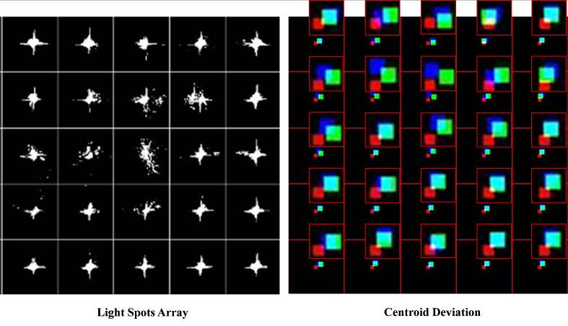
Fig. 4. Centroid positions calculated from two ways with the light spots array in left.

IV. WAVEFRONT ABERRATION IN RECONSTRUCTED IMAGE, INDUCED BY THE DMD
To find the wavefront aberration in the reconstructed image, five holograms of an on-axis point (1 P), three on-axis points in horizontal (3 P (H)) and vertical (3 P (V)) directions, five points (5 P) by combining three-point holograms and one off-axis point (1 P (off)) are calculated. Two other holograms composed of several hundred points such as a dolphin and a plane are also made for the square pixel DMD. These holograms are displayed on both DMDs, and the wavefront of the light fields along the path of the reconstructed image is measured with the sensor. The output from the sensor is an array of a focused light spots as shown in Fig. 3. By considering the DMDs size difference, the distance between points is set to 250 pixels for the square pixel DMD and 167 pixels for the rhomb one. These pixel distances correspond to 3 or 4 cells for 250 pixels and 2 or 3 cells for 167 pixels. When considering the pixel size of each DMD, the 250 and 167 pixels correspond to 2.7 mm and 1.275 mm, respectively. Fig. 5 shows the parts of light spots arrays showing the reconstructed images of point holograms when a collimated reconstruction beam is normally incident to the surface of the DMDs.
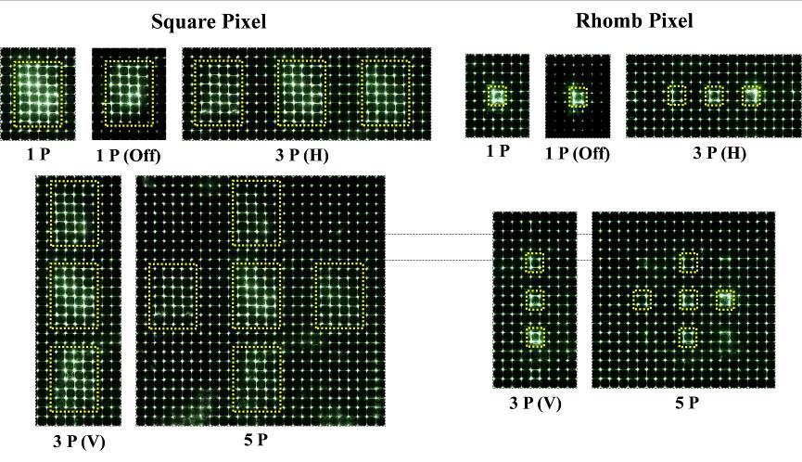
Fig. 5. A part of light spots arrays showing reconstructed images of the point holograms.

The light spots consisting of the reconstructed images are brighter than other spots because of more light rays directed to the microlens, which is responsible for each brighter spot. Among the light spots constituting the reconstructed point images, the following have almost the same intensity: all four light spots for 1 P; three light spots in the left and bottom for 1 P (off); three top light spots in the right side of the left image point for 3 P(H) and 5 P; and four light spots in the bottom point image of 3 P (V). They are the brightest in each hologram’s reconstructed point image(s) for the rhomb pixel DMD.
For the square pixel DMD, the central light spots in the center point image of each hologram reveal the highest brightness. These brighter light spots indicate that the light spots constituting the reconstructed images are 7(Vertical) x 5(Horizontal) for the square pixel DMD and 2 x 2 for the rhomb pixel one as indicated by broken rectangles and squares. However, for the 3 P (V) and 5 P of the square pixel DMD, the top and bottom point images have only 7 x 4 light spots. These 4 light spot columns are aligned to the most left (right) column of the center point image for top (bottom) point images, respectively. These spots indicate that the reconstructed image of a point has the maximum size of 2.1 mm x 1.5 mm for the square pixel DMD and 0.6 mm x 0.6 mm for the rhomb pixel DMD. The gap between points is a 2-cell distance in vertical direction for both DMDs. However, in horizontal direction, it is 4 cells for the square pixel DMD and 2 cells for the rhomb one, though there is an exception for 5 P on the rhomb pixel DMD, i.e., a 3-cell gap between the left and center point images.
The center point distance between point images is the 9-cell and 4-cell width for the square and rhomb pixel DMDs, respectively, in both horizontal and vertical directions. Since 9 and 4 cells correspond to 2.7 mm and 1.2 mm, respectively, they match very closely their corresponding object point distances. The 3-cell gap in 5 P hologram could be introduced to compensate the mismatch between the pixel and microlens distances, 0.075 mm (1.275 mm – 1.2 mm).
To eliminate $\left(\frac{2π}{λ}\right)w\left(x,y\right)$ and other added wavefront terms in Eq. 4, the DMDs are set to On-state without any hologram loading and then the wavefront of the reflected light from each DMD is measured with the wavefront sensor. The reflected light will be named a white beam in this paper. The white beam comprises the wavefront of the reconstruction beam modified by the pixel characteristics of each DMD. Hence, the wavefront of the white beam will be the aberrated wavefront of the reconstructed beam by the pixel characteristics. Thus, subtracting the centroid deviation of each hologram’s reconstructed image from the white beam will produce the effect of eliminating the $\left(\frac{2π}{λ}\right)w\left(x,y\right)$ in Eq. 4 that is induced from both the reconstructed beam and the pixel characteristics. This subtraction plays the same role as the adaptive mirror in the adaptive optics system [11]. The result obtained from the subtraction is specified here as compensated.
To visualize the centroid deviations, a color phase map is drawn as shown in Fig. 6. Fig. 6 shows the color phase maps of the collimated beam as the reconstruction beam and the white beam for both DMDs, derived from the light spots arrays in Fig. 3. The phase map represents the centroid position deviation from the center of each cell with different colors in the amount proportional to deviation. The map is drawn to the unit of 2.5 pixels visualizing the wavefront deviations. For the better visualization, each cell is colored depending on its centroid position deviation. The white, blue, green, red, sky blue, pink and yellow colors in the square pixel DMD represent 2.5, 5, 7.5, 10, 12.5, 15 and 17.5 pixels deviations from the cell center, respectively.

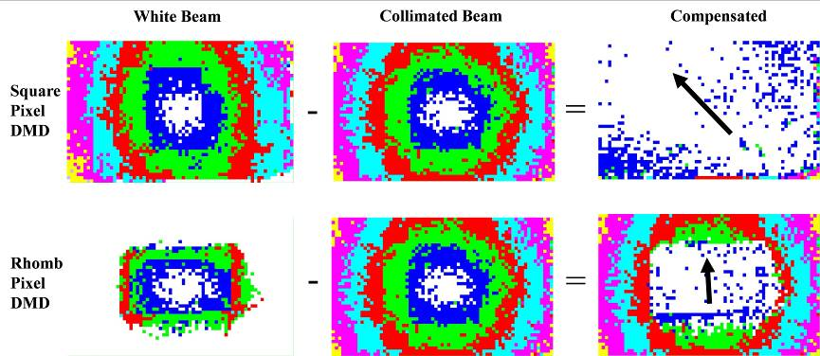
Fig. 6. Color phase maps of the collimated beam and the white beam for both DMDs.

For the square pixel DMD the colors are arranged in concentric rings with the white in its center area, while for the rhomb one, – in concentric squares with the white in its center. Since the wavefront deviation angle corresponds to 2.5 pixels is 0.279˚, the wavefront deviation angles of different colors are 0.278˚ multiplied by the number obtained from dividing their corresponding pixel numbers by 2.5. The rhomb pixel DMD reveals 4 colors – white, blue, green and red – in horizontal direction, and 3 colors – white, blue and green – in vertical direction. This indicates that the total wavefront deviation angles in horizontal and vertical directions do not exceed 1.116˚ (4 x 0.279˚) and 0.837˚ (3 x 0.279˚), respectively. Since the 17.5 pixels correspond to 1.953˚, the maximum wavefront deviation angle of the square and the rhomb pixel DMDs are ±1.946˚ and ±1.112˚. The phase maps of the two beams are very similar to each other but the collimated beam shows better concentric ring pattern than the white beam. When the centroid deviation of the white beam is subtracted from that of the collimated beam, the compensated phase map will represent the wavefront aberration introduced by the DMD itself.
For the square pixel DMD, the wavefront deviation angle is mostly under 0.556˚ and is introduced mostly to the upper right corner and lower left corner areas. The cells showing higher wavefront aberration are also presented. However, since they are mostly in the bottom line, they do not add any wavefront aberration to the reconstructed image. This aberration is probably related with the DMD’s pixel rotation, because -45˚ direction, as specified by an arrow, is the normal direction of the pixel rotation.
For the case of the rhomb pixel DMD, since the phase map of the collimated beam is bigger than the DMD surface area, only the central part of the phase map corresponding to the DMD surface area, represented as a rectangle is compensated. The cells composing the rectangle are mostly white, i.e., under 0.279˚ wavefront deviation angle, and a few of them are under 0.558˚, but they are scattered. However, the scattered distribution looks somewhat dispensed to the left and right sides of the rectangle, though it is not very apparent. This means that the aberration also appears along the pixel rotation direction. In Fig. 7, the phase maps of 5 holograms from Fig. 5 are shown for both square and rhomb pixel DMDs.

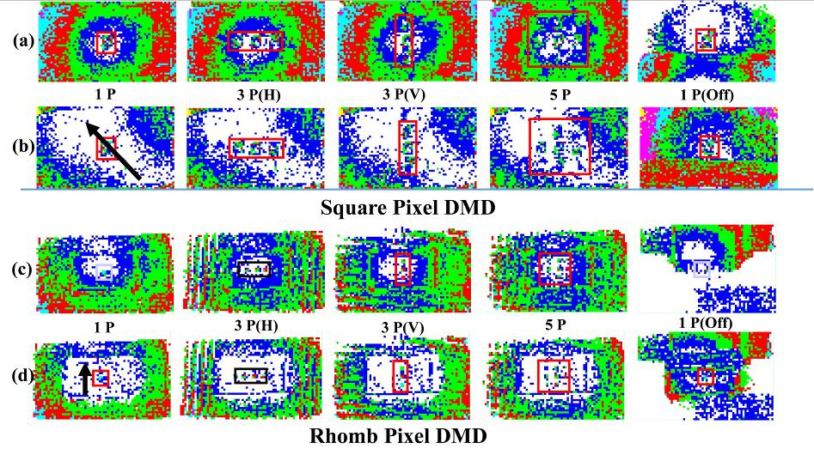
Fig. 7. Phase maps of the 5 holograms in Fig. 5 for both square and rhomb pixel DMDs: (a) and (c) initial phase maps, and (b) and (d) Compensated phase maps
Fig. 7 (a) and (c) are the phase maps from their corresponding centroid maps. Fig. 7 (b) and (d) show the compensated phase maps: the centroid deviation of each cell in each hologram’s light spots array is subtracted by that of its corresponding cell in white beam’s light spots array. The box in each phase map specifies the reconstructed image. The reconstructed image of each point is identifiable because it has colors other than the white color areas surrounding it. However, since the white color area barely surrounds the reconstructed image, the reconstructed image is not separated completely from its surroundings. Nevertheless, the image point is almost completely separated from its surroundings because the white area increases much more by extending its area from the upper left corner to the lower right corner for the square pixel DMD and by covering the entire surface of the rhomb pixel DMD as shown in Fig. 7 (b) and (d), respectively. The white area is stretched to -45˚ direction for the square and vertical direction for the rhomb as specified by the arrow. These directions correspond to the pixel rotation directions of their corresponding DMDs. However, this white color extension does not apply to the off-axis point case because the light fields from the hologram are concentrated on its reconstructed image, and the lower part of the reflected beam is responsible for the upper part of the focused light spots array. These reasons result in either very faint or no light spots in the lower part of the reconstructed image and further increased wavefront aberration in the upper part of the compensated phase map. This is shown in Fig. 7(b) and (d) for 1P (off). To demonstrate the compensation effect more clearly, only the reconstructed images in Fig. 7 are compared to each other. This is presented in Fig. 8.

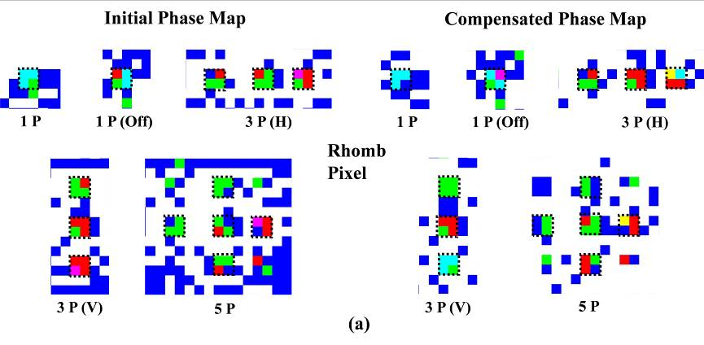
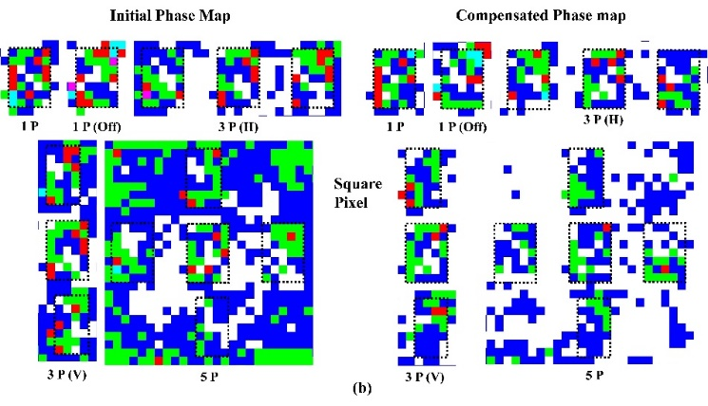
Fig. 8. Magnified images of the reconstructed image in each box in Fig. 7: (a) Rhomb Pixel DMD and (b) Square Pixel DMD
Fig. 8 presents the magnified images of the reconstructed image of each box in Fig. 7. The images are cut to have two extra cells in each side for the rhomb pixel DMD and one extra cell for the square pixel DMD. The cells representing the image point are specified with dashed squares.
Fig. 8 (a) is for the rhomb pixel DMD case. The difference between the phase map from the centroid map (it will be referred to as initial phase map) and the compensated phase map for 1 P is not apparent, and it looks even worse for 1 P (off) case. However, as the number of the image points increases, the image points are more distinctively identified, especially for 3 P (V) and 5 P for the compensated phase map. For 3 P (V) and 5 P, the wavefront deviation angle can be up to 1.953˚ (yellow cell in the most right side of the image point). This angle is much bigger than the converging angle defined by the DMD size. The wavefront deviation angle range of the phase map from centroid map is within 0.279˚ to 1.674˚(Pink in 3 P(H and V) and 5 P, but for the compensated map – 0.279˚ to 1.953˚. This deviation angle is much bigger than the converging angle 1.146˚(10 mm) defined by the DMD size.
Since these reconstructed images consist of many cells, when average wavefront deviation angle for each image point is calculated, it is given as 1.395˚. This angle corresponds to 12.2 mm. This size can be brought by the recovered parts of the hologram as shown in 100 mm distance of Fig. 1. However, a question still remains: why the size increases as the distance increases while the phase-conjugated pattern shrinks. The reconstructed image now accompanies less background cells, i.e., noises, than the initial phase map. The reconstructed images are more distinguished and are identified by the compensation. However, the distinguishedness and the identifiability are much improved, but it cannot be claimed that the wavefront aberration introduced by the DMD is completely removed. This is because the pixels consisting of the hologram fringe pattern are around a half in number of those for the white beam due to the On/Off switching action of DMDs.
This will be the same for the square pixel DMD as shown in Fig. 8(b). The initial phase maps are noisier than those of the rhomb one: since the point images are too mingled with the background cells, only the center point images in 3 P(V and H) and 5 P are barely identified. But the point images in the upper and lower parts, and the left and right are enough separated from the background cells to be clearly identified for the compensated maps, for 3 P(V and H) and 5 P. Even for 1 P, the point image is defined better for the compensated map than the centroid map.
However, for the 1 P (off), it is opposite to the 1 P case. As shown in Fig. 8 (b), the compensation is more effective for the square pixel DMD than for the rhomb pixel DMD, though they are still noisy. This compensation informs clearly that the wavefront aberration is more introduced by the square pixel DMD. The wavefront deviation angle range is 0˚ to 1.395˚ for both compensated and the initial phase map. The 1.395˚ is much smaller than the converging angle 2.292˚ from the DMD 20 mm. Furthermore, for the 3 P(V and H) and 5 P, the wavefront deviation angles of the cells are mostly under 0.558˚ (blue and green colors). This angle range is the same as that from the initial phase map case in the rhomb pixel DMD, but the maximum deviation angle is much smaller than that of the square pixel DMD.
To show the effects of the compensation more comprehensively, two off-axis holograms with more than 100 object points, such as an airplane and a dolphin, are prepared only for the square pixel DMD. These images are not prepared for the rhomb pixel DMD, because the white beam can cover only small part of the sensor area as shown in Fig. 3. These images can cover much wider areas of the sensor than the point images in Fig. 5. In fact, the dolphin image covers most of the sensor area. This means that the white beam compensation will be more effective for these images.
Fig. 9(a) and (b) show the focused light spot array, phase maps for both initial phase map and the compensated one, and a 3-D colored surface map from the centroid map are given for the airplane and dolphin holograms, respectively. The 3-D colored surface map is named as “surfc” in Matlab [18]. Here “surfc” image is not different from the phase map but the color combination is better than that of the phase map, and the edges of the reconstructed image are more enhanced.
As shown in Fig. 9, the light spots arrays clearly demonstrate the presence of an airplane and a dolphin but the initial phase map can only show the tail part and the bottom wing part of the airplane, and left half profile of the dolphin. Hence, they are hardly identified as an airplane or a dolphin. However, when they are compensated, identifiable airplane and dolphin images are recovered. The images from “surfc” provide more visible airplane and dolphin images than the phase map. It is noticed that the airplane is formed only by the blue color and the dolphin – by mostly blue and green with very few red and sky blue colors for back and fin. For the compensated map, the entire airplane becomes identifiable though the airplane is formed by only blue color cells. Thus, the wavefront deviation angle of these images is mostly under 0.556˚. This deviation angle is the same as that of the 3 P(V and H) and 5 P in Fig. 8(b).

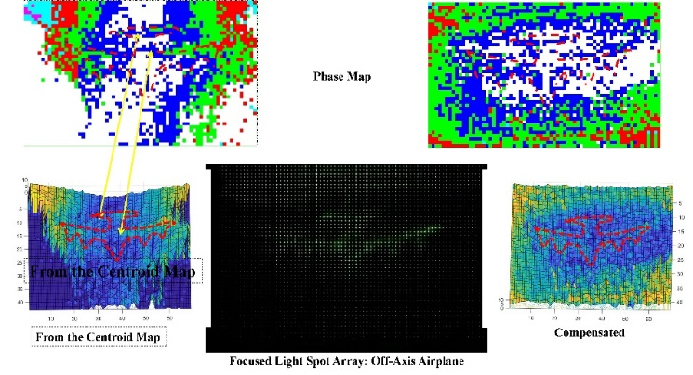
(a)
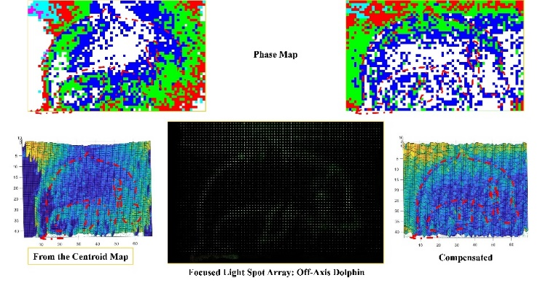
(b)
Fig. 9. Focused light spot array and phase maps for both the initial and compensated phase maps, and “surfc”: (a) Airplane and (b) Dolphin
Fig. 10 shows phase maps and “surfc” images of the airplane and dolphin images, compensated by both collimated and white beams to compare their qualities. In these maps and images, the airplane’s and dolphin’s profiles that appeared at their focused light spots arrays are overlapped on them. To show how well the images appeared at the phase maps and “surfc” images, they are matched with their corresponding profiles. The images appeared at the phase maps and “surfc” demonstrate that the white beam compensated image matches the profiles better than the collimated beam compensated image. For the case of the airplane, the phase map image of the airplane closely matches its profile for the white beam compensated image, but it is hard to find a recognizable match for the collimated beam.
The “surfc” image shows the same trend as the phase map. For the dolphin case, its belly fin, nose and mouth parts are defined more clearly for the white beam compensated than those from the collimated beam. The “surfc” image shows the same features. From these images, it can be said that the square pixel DMD introduces recognizable wavefront aberration. The aberration amount is enough to cause image blurring in the reconstructed image. For the rhomb pixel DMD, no collimated beam case is tested, because the DMD surface area is too small for the sensor area. Because of this size, the off-axis image cannot be made to cover most of the sensor area like the square pixel DMD does. However, as mentioned before in Fig. 8(a) explanation, the wavefront aberration introduced by the rhomb pixel DMD will be smaller than that introduced by the square pixel DMD.

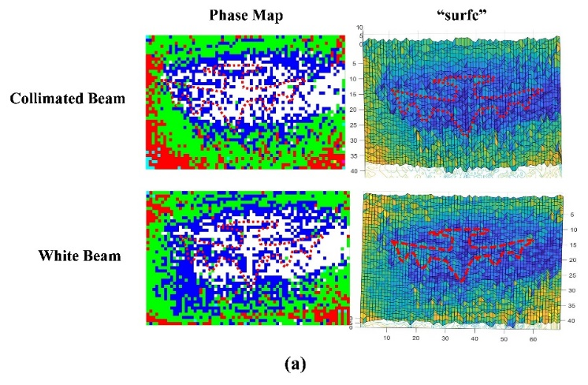
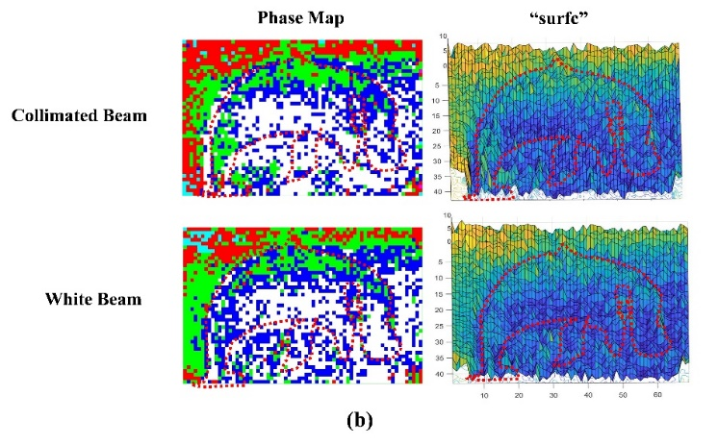
Fig. 10. Comparison of phase map and “surfc” images compensated by the white beams with by the collimated beam: (a) Airplane and (b) Dolphin

V. Conclusion
The wavefront aberration and its amount can be visualized by color phase map obtained with the centroid deviation of the focused light spots from a Shack-Hartmann sensor. When this map is compensated by that of the white beam reflected from the surface of the pixel array at On-state of DMDs under the illumination of a collimated beam on its normal direction, the map clearly visualizes the wavefront aberration on the reconstructed image from the hologram on the DMDs. The DMDs can introduce some amount of the wavefront aberration to the reconstructed image. However, its large part can be removed by the white beam. If the two DMDs having square pixel and rhomb pixel are considered, the square pixel DMD introduces more wavefront aberration than the rhomb pixel. This is probably caused by the bigger image size of the square pixel DMD brought by its larger surface and pixel sizes compared with those of the rhomb pixel DMD.
The next task is getting the answer to why the converging angle defined by the DMD size and the wavefront deviation of the reconstructed image do not correspond to each other.
References
- Jung-Young Son, Hyoung Lee, Beom-Ryeol Lee, and Kwang-Hoon Lee, "Holographic and Light-FIeld Imaging as Future 3-D Displays," Proc. of the IEEE, vol. 105, no. 5, pp. 789-804, 2017.
- F. A. Jenkins, H. E. White, Fundamental of Optics, Korean Student Edition, McGraw- Hill, New York, 1976.
- Technical Document DLP4501. http:/www.ti.com/DLPLightCommander.
- 4. Min-Chul Park, Beom-Ryeol Lee, Jung-Young Son, and Oleksii Chernyshov, "Properties of DMDs for Holographic Displays", Journal of Modern Optics, vol. 62, no. 19, pp. 6000-6007, 2015.
- Jung-Young Son, Wook-Ho Son, Jae-Han Kim and Hyongon Choo, "Image reconstruction in an electro-holographic display," Journal of Optics, vol. 19, no. 5, pp. 1-18, 2017.
- Stirling Scholes, Ravin Kara, Jonathan Pinnell, Valeria Rodríguez-Fajardo, Andrew Forbes, “Structured light with digital micromirror devices: a guide to best practice,” Opt. Eng. vol. 59, no. 4, 041202, 2019.
- Brian Vohnsen, Alessandra Carmichael Martins, Salihah Qaysi, and Najnin Sharmin, "Hartmann–Shack wavefront sensing without a lenslet array using a digital micromirror device", Applied Optics, vol. 57, no. 22, pp. 199-204, 2018.
- David Dayton, Bob Pierson, Brian Spielbusch, and John Gonglewski, “Atmospheric structure function measurements with a Shack–Hartmann wave-front sensor”, vol. 17, no. 24, pp. 1737-1739, 1992.
- Jung-Young Son, Dmytro V. Podanchuk, Volodymir P. Dan’ko and Kae-Dal Kwak, “Shack-Hartmann wave-front sensor with holographic memory”, Optical Engineering, vol. 42, no. 11, pp. 3389-3398, 2003.
- https://www.sony.com/electronics/interchangeable-lens-cameras/ilce-6300-body-kit#product _details _default and https://www.sony.com/electronics/interchangeable-lens-cameras/ilce-7sm2#product_details_default.
- Jacques M. Beckers, "Adaptive Optics for Astronomy: Principles, Performance, and Applications," Annual Review of Astronomy and Astrophysics, vol. 31, pp. 13-62, 1993.
- G. Rousset, “Wavefront sensing”, Adaptive Optics for Astronomy, Ed. D. M. Alloin and J.-M. Mariotti, NATO ASI Series: Kluwer Academic, pp. 116-137, 1994.
- www.vivitekcorp.com.
- F. A. Jenkins, H. E. White, Fundamental of Optics, Korean Student Edition, McGraw- Hill, New York, 1976.
- www.visitech.no.
- R. J. Collier, C. B. Burckhardt and L. H. Lin, Optical Holography, Student Edition, New York, U.S.A., Academic Press 1971.
- Geun Young Yoon, Takahisa Jitsuno, Masahiro Nakatsuka, and Sadao Nakai, “Shack Hartmann wavefront measurement with a large F-number plastic microlens array”, Appl. Opt. vol. 35, no. 1, pp. 188-192, 1996.
- https://www.mathworks.com.

Beom-Ryeol Lee received the B.S. and M.S. degrees in electronics engineering from Jeonbuk National University, Jeonju, South Korea, in 1987 and 1989, respectively, and the Ph.D. degree in electronics and information engineering from the Kunsan National University, Kunsan, South Korea, in 2013. From 1989, he worked as a Principal Researcher for ETRI. He is currently an Assistant Professor at the University of Science and Technology, Daejeon, South Korea. His interests include super multiview image and digital holographic content.

Wookho Son received his BS in computer science from Yonsei University in 1987. He received his MS and PhD from Texas A&M University in 1996 and 2001, respectively. He joined ETRI as a principal member of engineering staff in 2001. Currently, he is the director of Content Platform Research Division at ETRI. His research interests include virtual reality, augmented reality, haptic interaction, physically based dynamic simulation and robotics.


Gwanghee Heo received a Ph.D. from the Department of Civil Engineering at the University of New Mexico in 1997. He is currently Professor of Civil Engineering at Konyang University and also Director of the Public Safety Institute of the Konyang University. His research interests lie in Structural Health Monitoring System, Smart Sensing Technology, Smart Structural Dynamics and Control, Vibration Control and Damping System and so on.


Tetiana Venkel is currently an Associate Professor in Department of Linguistics for Science of Chernivtsi National University, Ukraine and Director of Language Learning Centre of Chernivtsi National University since 2015. She got Bachelor degree in Linguistics from Chernivtsi State University in 1985 and PhD in Linguistics for science from Chernivtsi National University in 2004. She teaches English for Specific Purposes (ESP), technical translation/interpretation, and Terminology of the English Language in Computer Science, Engineering, Cybersecurity, Optics and Physics. She is the author and co-author of more than 30 research publications, including research papers including ESP course books and textbooks aimed at teaching the students basic terminology and fundamentals of their major in English.

Jung-Young Son (Member, IEEE) received the B.Eng. degree in avionics from the Korea National Aviation University, Goyang, South Korea, in 1973 and the M.S. degree in electronics and the Ph.D. degree in engineering science from the University of Tennessee, Knoxville, TN, USA, in 1982 and 1985, respectively. From 1980 to 1985, he was a Graduate Research Assistant, and from 1985 to 1989, a Research Scientist at the University of Tennessee Space Institute. From 1989 to 2002, he worked at the Korea Institute of Science and Technology as a Principal Research Scientist in Optics. He is currently a Professor at the Biomedical Engineering Department, Konyang University, Nonsan, Chungnam, South Korea. His primary interests are focused on 3-D image displays, electroholography, millimeter, IR and spectral images for medical applications, and laser-based optical instrumentations and measurements. Dr. Son is Doctor of Technical Science, and Academician of Academy of Technological Sciences of Ukraine, and a Fellow of the International Society for Optics and Photonics (SPIE) and the Optical Society of Korea, and is a member of Sigma Xi, Phi Kappa Phi, and the Optical Society of America. He is also an Associate Editor of the Journal of Display Technology and Optical Engineering.

This work was partly supported by Institute of Information & communications Technology Planning & Evaluation (IITP) grant funded by the Korea government(MSIT) (No.2020-0-00537, Development of 5G based low latency device–edge cloud interaction technology, 50%) and Priority Reseach Centers Program through the National Reseach Foundation of Korea (NRF) funded by the Ministry of Education (Grant Number : NRF-2018R1A6A1A03025542, 50%). Corresponding author: Jung-Young Son. Beom-Ryeol Lee is with Electronics and Telecommunications Research Institute, Daejeon, 34129, Korea (lbr@etri.re.kr). Wookho Son is with Electronics and Telecommunications Research Institute, Daejeon, 34129, Korea (whson@etri.re.kr), Gwanghee Heo is with Public Safety Research center, Konyang University, Nonsan, 32992, Korea (heo@konyang.ac.kr). Tetiana Venkel is Linguistics for Sciences Dept., Chernivtsi University, Chernivtsi, 58012, Ukraine (t.venkel@chnu.edu.ua). Jung-Young Son is with Public Safety Research center, Konyang University, Nonsan, 32992, Korea (jyson@konyang.ac.kr).

